EuroSun2026
SECTOR COUPLING FOR PEAK HEAT SUPPLY IN BIVALENT HP SYSTEMS USING POWER-TO-X ENERGY CARRIERS

Yvonne Isabell Baeuerle (corresponding author), Krisztina Kelevitz, Michel Yves Haller
Affiliation(s) SPF Institute for Solar Technology / Eastern Switzerland University of Applied Sciences (OST), 8640 Rapperswil (Switzerland)
Email(s) yvonne.baeuerle@ost.ch, kriztina.kelevitz@ost.ch, michel.haller@ost.ch
Summary
Winter heating peaks may require large heat-pump (HP) capacities and increase electricity demand when local renewable generation is limited. This study investigates sector coupling through bivalent HP and X-to-Energy systems as a means of reducing both installed HP capacity and winter grid electricity imports, while offering a potential renewable Power-to-X alternative to fossil-fuel peak-load units. A renovated multifamily house in Zurich is simulated using weather data for 2014–2024. Air-source and ground-source HP configurations of 15, 20, and 25 kW are compared with corresponding 50 kW reference systems. Hydrogen, methane, methanol and aluminium are evaluated as long-duration energy-storage carriers. More than 90% of the annual X-carrier consumption occurs between Oct. and March. Hydrogen provides the greatest reduction in winter grid-electricity imports but has the highest system cost, mainly because of compressed-gas storage. Under average economic assumptions, aluminium provides the lowest-cost bivalent configurations: the air-source HP configuration costs approx. 2.7 kCHF/a more than its reference, whereas the ground-source HP configuration costs approx. 1.5 kCHF/a less than its reference monovalent HP system. Nevertheless, economies of scale in energy carrier production and converter manufacturing could improve future competitiveness. X-to-Energy may therefore complement efficient electrification by replacing fossil peak-load supply and reducing winter grid stress, assuming that X-carrier sustainability, site feasibility and additional costs are adequately addressed.
Keywords: Sector coupling, bivalent heating system, HP, renewable peak load heating systems, long-duration energy storage, Power-to-X, X-to-Energy; winter grid-electricity reduction
Field of application for the findings: Multifamily house, district heating networks, sector coupling, Power-to-X, X-to-Energy, long-duration energy storage
Addressed audience: Building owners, Energy system researchers, HP manufacturers, district heating operators, policy makers
- Introduction
Heating plays a crucial role in European energy consumption. Space heating and domestic hot water typically account for approx. 75% of household final energy consumption within the EU residential sector (Eurostat, 2026). In 2022, energy use in buildings caused around 34% of the EU’s energy-related greenhouse gas emissions, including around 400 Mio. tonne CO₂-eq from direct fossil fuel use and 495 Mio. tonne CO₂-eq from indirect emissions linked to electricity and district heat for use in buildings (EEA, 2025). This space heating demand is highly seasonal, with most of it concentrated in winter months (Oct-March); therefore, final energy consumption for heating increases to 66% of total final demand in January, for example, in Switzerland. These peak demand periods determine the required capacity of monovalent heating systems, in which a single heat generator covers the entire heating demand of a building, and therefore strongly influence heat pump (HP) sizing. It also increases electricity demand during winter peak periods (Connolly et al., 2014).
HPs are a key technology for decarbonising low- to medium-temperature heat supply. Monovalent systems are generally dimensioned for the maximum heating load, often including additional safety margins, which may result in oversized systems.
Fig. 1 compares installed specific heating power with heating power derived from measured demand for 251 HP systems, based on measurement periods of 3-9 years. The installed heating capacity is typically higher than the measured requirement, indicating systematic oversizing of HP systems in practice. Field studies of HP systems in more than 600 Swiss multifamily houses (MFH) indicated a median oversizing of approx. 40% compared to heating power derived from measured demand (Bosshard et al., 2023). Oversizing increases investment costs, potentially reduces system efficiency and lifetime due to frequent cycling, and contributes to higher electricity demand during winter peak periods.
One potential approach to reduce HP oversizing is the use of bivalent heating systems, in which peak heating demand is covered by an auxiliary technology rather than increasing the installed HP capacity. Long-duration and seasonal energy storage options include thermal storage and Power-to-X pathways, such as hydrogen, synthetic fuels and renewable metal energy carriers (Baeuerle et al., 2025). This study, therefore, investigates the use of renewable X-to-Energy technologies for peak-load coverage to reduce winter electricity demand. This work was conducted within the Swiss research project “ReWAX – Smaller HP Dimensioning Using X-to-Energy for Peak Load Coverage”. The analysis investigates how integrating these technologies into bivalent HP systems can reduce the required HP capacity and winter electricity demand compared with conventional monovalent systems in multifamily houses, and assesses the resulting system costs (Baeuerle, 2025).

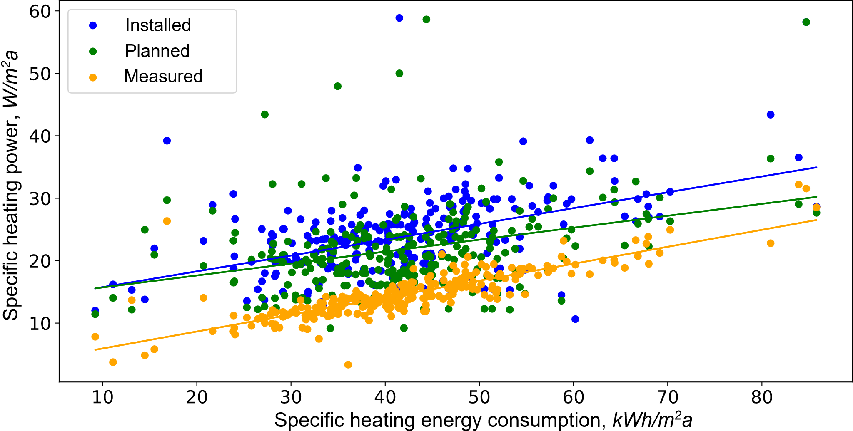
Fig. 1: Specific heating power of 251 HP systems as a function of measured heating energy consumption: installed specific heating power (blue), specific heating power derived from design documents (green), and specific heating power derived from measurement data (orange). The coloured lines represent the average values over measurement periods of 3–9 years. Source: Bosshard et al., 2023.
- Energy system concept and methodology
2.1. Renewable Power-to-X and X-to-Energy concept for bivalent heating systems in MFH
Renewable Power-to-X-to-Energy pathways comprise three principal stages: the conversion of renewable electricity into an energy carrier X, its storage and transport, and its subsequent conversion into useful energy at the point of demand. In the Power-to-X stage, renewable electricity is converted into a chemical or metal energy carrier. The seven carriers considered in the ReWAX technology screening are hydrogen, methane, methanol, ammonia, liquid organic hydrogen carriers (LOHC), aluminium and iron as Renewable Metal Energy Carrier (ReMEC). The characteristics and corresponding Power-to-X pathways, and levelized cost of X-carrier storage (LCOXS) are published in a series of ReWAX factsheets available on the project website. The conversion of energy into an energy carrier X allows renewable electricity generation to be decoupled in time and space from final energy demand (Parra et al., 2017; Al-Breiki and Bicer, 2021).
The storage and transport requirements depend on the physical and chemical properties of the X-carrier. Gaseous and liquid carriers require suitable tanks, storage facilities or transport infrastructure, whereas ReMEC can be stored and transported as solids.
At the point of use, the stored energy carrier X is converted into heat or into a combination of heat and electricity. Heat-only conversion may be provided by boilers or other thermal conversion units, whereas combined heat and power (CHP) systems additionally generate electricity. The generated heat contributes directly to the building’s heat supply. Depending on the conversion pathway, produced electricity may contribute to HP operation, other building electricity demand or battery charging.
Within the bivalent ReWAX system, the HP remains the primary heat generator and supplies most of the annual space heating and domestic hot water demand (DHW) of the MFH. The X-to-Energy unit covers residual heat demand in winter when the required heating power exceeds the available heat-pump output or when battery charging state is insufficient (Fig. 2). The X-carrier is therefore primarily used during winter periods rather than for continuous heat supply.

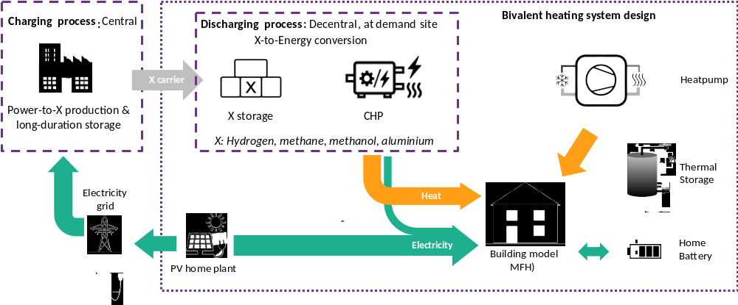
Fig. 2: Analysed bivalent energy system for MFH including photovoltaic (PV), battery, and thermal energy storage (TES). Flows of heat, electricity and material are represented in orange, green, and grey.
The dynamic simulation determines the operation of the bivalent system and the resulting residual energy demand to be supplied by the X-to-Energy unit. The simulations were performed using pysim365, a Python-based sector coupling and building simulation framework developed at SPF/OST. pysim365 builds on the modelling approach applied previously within the REVEAL project, focusing on PV self-consumption and bivalent HP-Alu-to-Energy and fuel cell system (Escher et al., 2025). The present study adapts the framework to the ReWAX system configuration and control strategy. Each system configuration is simulated over a full year with a temporal resolution of 15 min. The model represents the space heating (SH), domestic hot water (DHW) and building electricity demands together with the photovoltaic system (PV), battery, HP, DHW storage, electricity grid and X-to-Energy unit (Fig. 2). Their conversion characteristics and costs are applied to the simulated X-to-Energy demand to determine the required carrier quantities and the resulting system costs.
Aluminium as ReMEC represents one of the four selected pathways, developed, tested and validated within the EU REVEAL project. In the Power-to-Aluminium process, renewable electricity is used to produce metallic aluminium via a CO₂-free Al smelter, which can be stored and easily transported as granules with a volumetric energy density of 15 MWh/m³, requiring very small storage volume and resulting in comparatively low cost (Haller, 2020). During Aluminium-to-Energy conversion, aluminium reacts with water, releasing heat and producing hydrogen that can be converted into electricity in a fuel cell (Haller et al., 2021). The influence of reaction conditions and granule treatments is investigated by Agote-Arán et al. (2025). The resulting aluminium hydroxide is returned to the production pathway, where it is calcined to aluminium oxide and again reduced to metallic aluminium. The energy and material balances of this proposed closed material cycle are described by Escher et al. (2025), while its thermodynamic pathways and conversion options are discussed by Haller et al. (2025).
2.2. MFH case study and bivalent system configurations
The case study is based on an MFH constructed in 1964 and renovated in 2019. It has a heated floor area of 1548 m² and comprises 20 apartments, each represented as a separate thermal zone. The assumed occupancy is 40 people. Time-dependent occupancy, electricity and DHW profiles are assigned to the individual apartments. The associated internal gains are included in the thermal building model, while the apartment-level electricity and DHW profiles are aggregated at MFH level.
The principal building and demand characteristics are summarised in Table 1, while the building insulation properties are provided in Appendix 1.
Table 1 Principal MFH and system assumptions
Category | Parameter | Value
Building | Construction/renovation | 1964/2019
Building | Heated floor area | 1550 m²
Building | Apartments/thermal zones | 20/20
Occupancy | Number of occupants | 40
Climate | Weather data | Zurich, 2014-2024
Space heating | Annual thermal demand | 40–49 MWh/a
Domestic hot water | Annual thermal demand | 37 MWh/a
Electricity | Annual demand | 54 MWhel/a
Photovoltaic | Available roof area/capacity | 380 m²/72 kW_{p}
Battery | Electric capacity/power | 60 kWh/30 kW
DHW/SH storage | Installed volume | 4/4 m³
HP | Technology | air-source/ground-source
X-carriers | X-to-Energy CHP | Al, H₂, CH₄, MeOH

All configurations include a PV system with a nominal capacity of 72 kWp, corresponding to the available roof area of 380 m². Based on preliminary simulations with battery electric capacities of 0, 60 and 90 kWh, a capacity of 60 kWh was selected as a balance between battery utilisation and additional investment cost. The battery has a maximum charging and discharging electric power of 30 kW. The existing central DHW storage has an installed volume of 4 m³, and is retained unchanged in all configurations. Additionally, a SH storage of 4 m³ was assumed.
Both air-source heat pump (ASHP) and ground-source heat pump (GSHP) configurations were simulated using source-specific performance models and boundary conditions. A monovalent 50 kW HP configuration serves as the reference, while HP capacities of 15, 20 and 25 kW were investigated in the bivalent configurations. For the ASHP, these capacities result in parallel bivalence points of around 0, -5 and -9 °C, respectively, based on the temperature-dependent HP output and the unsmoothed hourly SH load, with a max. of approx. 27 kW. The corresponding X-to-Energy peak capacities required to cover the max. residual SH load were 16.5, 12 and 8.5 kW. Based on this initial sizing, X converter thermal capacities between 8 and 20 kW were evaluated dynamically for the weather years 2014-2024. Only configurations meeting the technical-feasibility criteria defined in Section 2.3 were retained. The notation HP20 + X8, for example, denotes an HP with a nominal thermal capacity of 20 kW combined with an X-to-Energy converter with a nominal thermal output of 8 kW.
2.3. Control strategy and technical feasibility
The control strategy implements the bivalent system concept described in Section 2.1. Its objectives are to maintain SH and DHW supply with a reduced HP capacity while prioritising the usage of locally generated PV electricity. A further aim is to reduce grid-electricity imports during winter peak-demand periods, when heating-related electricity demand is high and renewable electricity availability may be limited. The control strategy prioritises X-to-Energy operation during the winter period from October to March, while limited operation outside this period may occur under specific system conditions.
At each simulation time step, PV electricity first supplies the household electricity demand, while the battery balances any remaining demand. DHW supply is prioritised: the HP covers the current DHW demand, charging the DHW storage. During winter, HP output prioritised SH demand coverage to improve operation efficiency.
X-to-Energy operation is triggered if residual SH demand remains or if the battery state of charge decreases to SOC 0.4. It starts only if its nominal heat output can be supplied directly or absorbed by the SH or DHW storage, thus preventing heat dumping. The generated electricity from X supplies the household demand and charges the battery. Operation requested by low battery SOC continues until SOC reaches 0.8, provided that the heat-utilisation condition remains fulfilled. Any SH demand remaining after X-to-Energy operation is covered by the HP using grid electricity.
A configuration is considered technically feasible when the combined unmet thermal SH and DHW demand after a seven-day initialisation period does not exceed 1 kWh/a. This criterion is applied before the economic results are evaluated.
2.4. Economic assessment
The economic assessment combines the annual energy flows obtained from the dynamic simulations with the investment, maintenance and energy-cost assumptions of the respective system configurations. The assessment covers the complete building energy system, including the PV system, stationary battery, heat pump (HP), domestic hot-water thermal energy storage (DHW TES), X-to-Energy converter and X-carrier storage. Annual X-carrier expenditure, grid-electricity purchases and PV feed-in revenues are also included. Detailed economic assumptions are provided in Appendix 2. All costs are reported in CHF (CHF 1 ≈ EUR 1.07, 28 August 2026).
Investment costs are converted into equivalent annual costs using the component-specific annuity factor (AF_{j}):
$AF_{j}=\frac{i{\left(1+i\right)}^{n_{j}}}{{\left(1+i\right)}^{n_{j}}-1}$ (eq.1)
where (i) is the discount rate and n_{j} is the economic lifetime of component (j). A discount rate of 3% is applied, while component-specific lifetimes are used. The annual cost of component j is calculated as:
$C_{annual,j}=CAPEX_{j}\left(AF_{j}+f_{O\&M,j}\right)$ (eq.2)
where f_{O&M,j} represents the annual O&M cost as a fraction of the component CAPEX. Component CAPEX is determined from the installed capacity and the corresponding specific investment cost. As each configuration comprises several components, these annual costs calculated using eq. 2 are summed in eq. 3. Here, (J) denotes the set of components included in the respective configuration: the PV system, battery, HP, SH and DHW storage systems, X-to-Energy converter and X-carrier storage.
Therefore, the total annual system cost is calculated as:
$C_{sys,annual}=\sum_{j∈J}{C_{ann,j}}+C_{X,carrier}+C_{grid}-R_{feed-in}$ (eq.3)
$C_{X,carrier}$ is the annual X-carrier expenditure, $C_{grid}$ is the annual cost of grid-electricity purchases, and $R_{feed-in}$is the annual revenue from electricity exported to the grid.
The annual X-carrier expenditure is obtained from the simulated carrier consumption:
$C_{X,carrier}=m_{X,annual}∙C_{X,carrier}$ (eq.4)
where m_{X,annual} is the annual carrier consumption and c_{X,carrier} is the delivered carrier price.
As the analysed configurations supply both useful heat and electricity, neither the levelized cost of heat nor the levelized cost of electricity alone represents the complete system output. Following the energy-costing method for combined heat and electricity production described by Van Erdeweghe et al. (2019), the levelized cost of energy (LCOEn) is calculated by assigning equal energy-based weighting to useful heat and electricity:
$LCOEn=\frac{C_{sys,annual}}{Q_{SH}+Q_{DHW}+E_{el,building}}$ (eq.5)
where Q_{SH} +Q_{DHW} is the useful annual heat supplied to the building and E_{el,building} is the annual building-electricity demand covered. The LCOEn represents the cost of the complete building energy system relative to the useful heat and electricity supplied. It provides a consistent basis for comparing configurations that supply the same building energy demands but does not account for differences in the thermodynamic quality of heat and electricity.
Each bivalent configuration is compared with the 50 kWth HP reference configuration for the same weather year. The avoided winter grid import is calculated as:
$E_{grid,winter,avoided}=E_{grid,winter,ref}-E_{grid,winter,HP+X}$ (eq.6)
where E_{grid,winter,ref} and E_{grid,winter,HP+X} are the winter grid-electricity imports of the reference and bivalent configurations, respectively. Positive values indicate that the bivalent configuration reduces winter grid-electricity imports relative to the reference configuration.
The corresponding additional annual system cost is calculated as:
$ΔC_{annual}=C_{system,annual,HP+X}-C_{system,annual,ref}$ (eq.7)
Positive values indicate additional annual system costs, whereas negative values indicate annual cost savings relative to the reference configuration.
Winter is defined as the period from Oct. to March. Comparing each bivalent configuration with the reference configuration for the same weather year prevents differences in climatic conditions from being attributed to the system design. Results across the weather years 2014–2024 are evaluated using the median, while the range across the weather years represents interannual climatic variability.
Economic uncertainty is assessed using all nine combinations of low, average and high delivered X-carrier prices and low, average and high specific X-to-Energy converter CAPEX. The resulting combinations show the sensitivity of the annual system cost and LCOEn to the principal X-specific economic parameters. All other economic assumptions remain unchanged unless stated otherwise.
The annual cost of grid-electricity purchases and the revenues from electricity exported to the grid are calculated using time-resolved electricity tariffs. The same tariff profiles are applied to all configurations and weather years. Depending on the temporal distribution of grid imports and electricity exports, the resulting annual effective average prices vary slightly between configurations. Across the investigated cases, the effective grid-electricity price is approx. 0.30 CHF/kWh, while the effective feed-in remuneration is approx. 0.07 CHF/kWh. Grid-purchase costs and feed-in revenues are calculated separately based on the corresponding hourly energy flows. In addition to the baseline grid-electricity purchase tariff, a modified-tariff sensitivity was evaluated to represent a larger seasonal price differential. Relative to the baseline tariff, the purchase price was increased by 0.06 CHF/kWh from Oct. to March and reduced by 0.06 CHF/kWh from April to Sept., resulting in representative winter and summer prices of 0.39 and 0.22 CHF/kWh, respectively, compared with 0.33 and 0.28 CHF/kWh under the baseline tariff. The feed-in tariff remained unchanged. The modified tariff was applied only in the economic assessment; system operation and simulated energy flows were not recalculated.
For each HP source, X carrier, tariff scenario and combination of X-carrier-price and converter-CAPEX assumptions, the technically feasible configuration with the lowest median LCOEn across the weather years was identified. The configuration labels in Fig. 5 indicate the respective optima under the average carrier-price and converter-CAPEX assumptions.
- Results
3.1. Operation of bivalent HP and X-to-Energy configurations
This section presents results for the bivalent configurations.
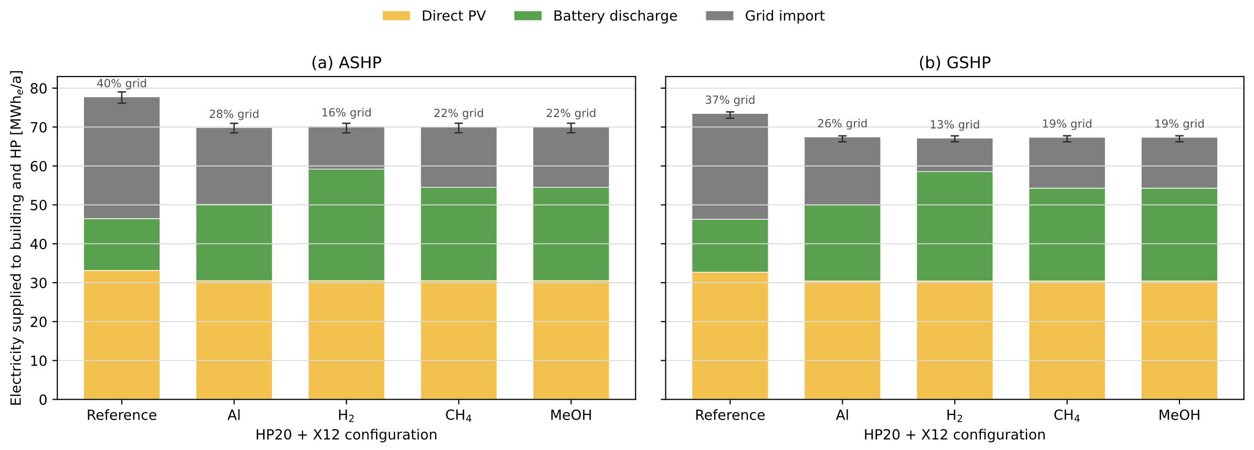
Fig. 3: Median annual electricity supply of the building and HP for the reference and bivalent HP20 X12 configurations with (a) ASHP and (b) GSHP. Error bars indicate the range across the weather years 2014–2024. Battery discharge includes stored electricity originating from both the PV system and the X-to-Energy unit.
Fig. 3 shows the median annual electricity supply and useful heat demand of the building for the reference and bivalent HP20-X1 configurations with (a) ASHP and (b) GSHP. In the reference configurations, grid imports account for 40% of the annual electricity supply for the ASHP and 37% for the GSHP. Electricity generated by the X-to-Energy unit reduces this contribution in the bivalent configurations. For the ASHP, the remaining grid share amounts to approx. 16% for hydrogen, 22% for methane and methanol, and 28% for aluminium. For the GSHP, the corresponding grid shares are approx. 13%, 19% and 26%, respectively. Direct PV use remains constant at approx. 30 MWh/a electric, while battery discharge increases in the bivalent configurations because battery discharge includes stored electricity originating from both the PV system and the X-to-Energy unit.
More than 90% of annual X-carrier consumption occurs between Oct. and March, with the highest monthly values generally occurring in Dec. and Jan. The profiles are similar for the three HP capacities and both HP sources, confirming the seasonal role of the X-to-Energy unit (Fig. 4).
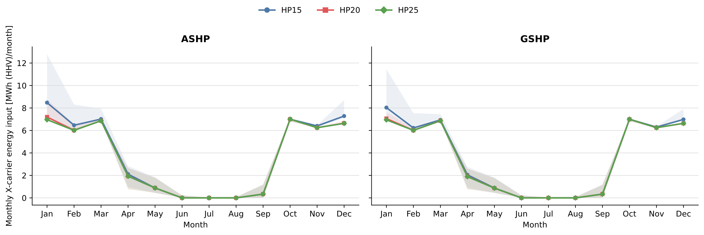
Fig. 4: Monthly X-carrier energy input for the bivalent HP15–X12, HP20–X12 and HP25–X12 configurations with ASHP (left) and GSHP (right). X-carrier energy is calculated on an HHV basis. Lines show median values across the investigated X-carriers and weather years, while shaded areas indicate the range across the weather years 2014–2024.
The equivalent full-load hours of the X-to-Energy converters vary with the HP and converter capacities and between the X-carriers because of their different heat-to-electricity output ratios and rated converter outputs. Across valid bivalent configurations, median values calculated over all weather years range from approx. 1150 to 2905 h/a for the ASHP-X and from 1150 to 2880 h/a for the GSHP-X configurations. The highest values occur for the smaller X8 converters, which operate for longer time periods. The resulting annual X-carrier consumption ranges from 3.4 to 4.5 t/a for aluminium, from 1.1 to 1.5 t/a for hydrogen, from 2.6 to 3.4 t/a for methane and from 6.4 to 8.4 t/a for methanol. Based on these X-carrier demands, the following X-carrier storage capacities were defined assuming a maximum of two deliveries per year (Table 2):
Table 2: Assumed X-carrier storage capacities and corresponding internal storage volumes.
X-carrier | Storage condition | Storage mass, kg | Storage volume ª, m³
Aluminium | Granules; 15 MWh/m³ | 2250 | 1.3 + 2.6 for reaction product
Hydrogen | Compressed gas; 500 bar | 750 | 25
Methane | Compressed gas; 200 bar | 1750 | 10.3
Methanol | Liquid | 4200 | 5.3
ª Volumes represent the internal carrier volume and exclude storage vessels, containment, auxiliary equipment and safety distances.
3.2. Economic evaluation
The economic comparison of the bivalent configurations is evaluated based on the LCOEn of the building, including PV, battery, HP, TES, X-to-Energy converter and X-carrier consumption and storage, relative to the corresponding source-specific HP50 reference configuration. Fig. 5 presents the economically preferred bivalent configuration for each HP source: ASHP20 + X8 and GSHP15 + X12. The circles represent the median LCOEn under the average X-carrier purchase-price and converter-CAPEX assumptions, while the horizontal ranges indicate the results obtained with the low and high assumptions. Filled markers and solid lines represent the baseline grid-electricity purchase tariff, whereas open markers and dash-dotted lines represent the modified tariff. The economic assessment includes the time-resolved grid-electricity costs and feed-in revenues described in Section 2.4.
Under the baseline grid-electricity purchase tariff and average economic assumptions, the ASHP50 and GSHP50 reference configurations have median LCOEn values of approximately 0.19 and 0.24 CHF/kWh, respectively. For the selected bivalent configurations, the median LCOEn is approx. 0.21 CHF/kWh for aluminium, 0.24 CHF/kWh for methanol, 0.25 CHF/kWh for methane and 0.37 CHF/kWh for hydrogen with the ASHP system. The corresponding GSHP values are around 0.23, 0.26, 0.27 and 0.39 CHF/kWh. The modified tariff changes the LCOEn of the bivalent configurations only slightly and does not alter their ranking. The generally higher LCOEn of the GSHP configurations primarily reflects the higher assumed investment cost of the GSHP system.
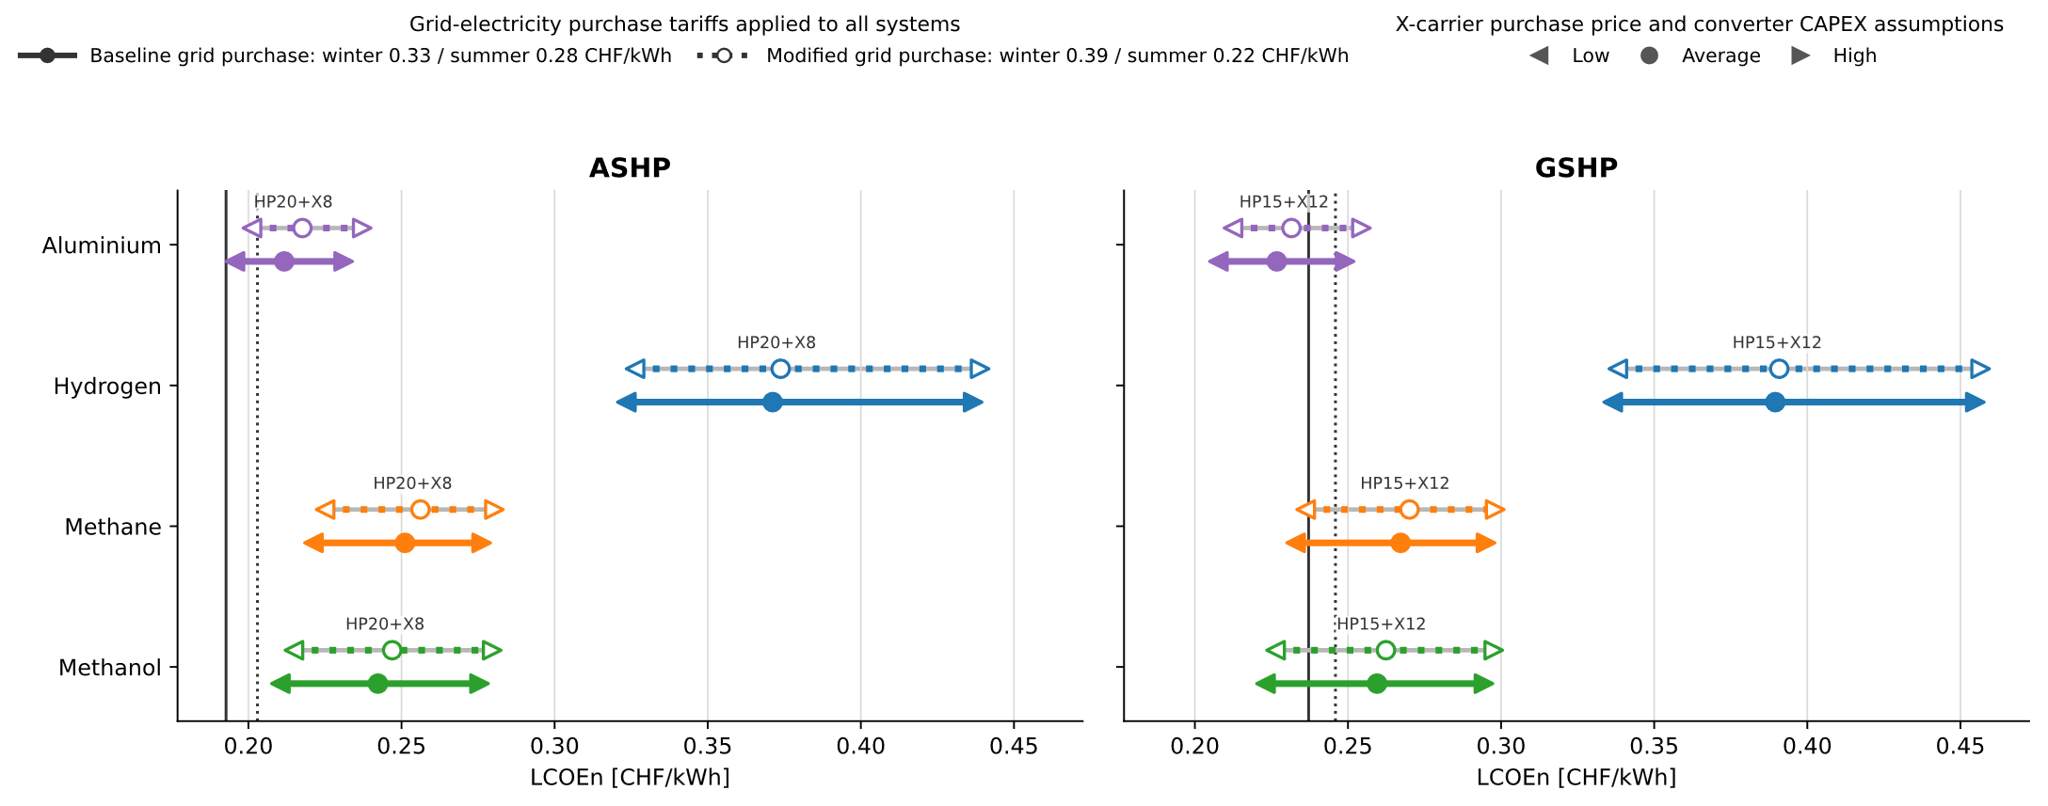
Fig. 5: Median levelized cost of supplied energy (LCOEn), based on the total annual system cost and the useful heat and electricity supplied to the building, for the minimum-cost bivalent configuration of each X-carrier, economic case and grid-electricity purchase tariff. Configuration labels identify the optima under the average cost assumptions: ASHP20 + X8 (left) and GSHP15 + X12 (right). Values represent medians across the weather years 2014–2024. In the modified-tariff sensitivity, the grid-electricity purchase price is increased by 6 Rp/kWh from Oct. to Mar. and reduced by 6 Rp/kWh from Apr. to Sept. relative to the baseline tariff; the feed-in tariff and system operation remain unchanged. Vertical lines indicate the corresponding HP50 references.
Aluminium consequently provides the lowest-cost bivalent configuration under the average assumptions, followed by methanol and methane. Hydrogen has the highest LCOEn despite achieving the greatest reduction in winter grid imports. Its cost disadvantage relative to the other X-carriers is primarily attributable to the high CAPEX of compressed hydrogen storage. The resulting annualised storage cost is approx. 17.4 kCHF/a, compared with 0.7 kCHF/a for aluminium, 1.6 kCHF/a for methanol and 3.3 kCHF/a for methane. The assumed hydrogen purchase price also contributes to its higher LCOEn, whereas insufficient X converter utilisation is not the determining factor.
Relative to the respective HP50 reference, the median additional annual system cost under the average assumptions is approx. 2.7 kCHF/a for aluminium, 6.9 kCHF/a for methanol, 8.2 kCHF/a for methane and 24.3 kCHF/a for hydrogen for the selected ASHP20 + X8 configurations. For the selected GSHP15 + X12 configurations, the corresponding values are: -1.5, 2.9, 4.0 and 20.6 kCHF/a. The higher absolute LCOEn values of the GSHP configurations result primarily from the higher assumed GSHP investment costs. However, replacing the GSHP50 reference with the smaller GSHP15 reduces the annualised HP investment costs sufficiently to offset a larger share of the additional X-to-Energy costs. Consequently, the selected GSHP bivalent configurations show smaller cost increases relative to their reference than the selected ASHP configurations. For aluminium, the resulting savings exceed the additional X-to-Energy costs, producing a median annual system cost around 1.5 kCHF/a below that of the GSHP50 reference.
Economic uncertainty is dominated by the X-carrier price, while variation in converter CAPEX has a smaller influence. Under the low X-carrier price and low converter-CAPEX assumptions, the median LCOEn of the minimum-cost aluminium configurations decreases to around 0.20 CHF/kWh for ASHP15 + X12 and 0.21 CHF/kWh for GSHP15 + X12. Cost parity with the ASHP50 reference is not reached, although the additional median annual system cost of the aluminium configuration decreases to around 0.4 kCHF/a. For the GSHP configurations, aluminium is already less expensive than the GSHP50 reference under the average assumptions. Under the lowest-cost assumptions, its median annual system cost is approximately 4.1 kCHF/a below the reference. The methane and methanol configurations also fall below the GSHP50 reference by approximately 0.6 and 1.9 kCHF/a, respectively, whereas hydrogen remains above the reference.
The modified tariff changes the LCOEn only slightly because system operation is kept unchanged. It increases the value of avoided winter grid imports relative to summer electricity, thereby slightly reducing the economic disadvantage of the bivalent configurations relative to their HP50 references. However, it does not change the ranking of the X-carriers or bring any additional carrier configuration to cost parity under the average economic assumptions; the GSHP aluminium configuration remains the only case below its reference.
- Technology challenges and study limitations
The investigated X-carrier pathways face carrier-specific implementation constraints, as summarised in the ReWAX factsheets (Baeuerle, 2025). Their technological maturity must be distinguished between Power-to-X production and X-to-Energy conversion. Hydrogen production by electrolysis and fuel-cell conversion are commercially available, but renewable hydrogen production and the associated transport and distribution infrastructure remain limited. Its low volumetric energy density additionally results in large and costly high-pressure storage systems. Power-to-Methane is at an early commercial stage, with catalytic methanation being more mature than biological methanation, whereas methane storage tanks and CHP units are commercially available. Renewable methane production is constrained either by the availability of sustainable biomass or, for synthetic methane, by the supply of renewable hydrogen and biogenic or directly captured CO₂. Integrated renewable methanol production is estimated at TRL 6–7, while suitable X-to-Energy conversion technologies are commercially available. Renewable methanol production likewise requires renewable hydrogen and a viable CO₂ source. As most methane and methanol are currently produced from fossil resources, verification of their renewable origin and carbon source is essential. Methanol is also toxic and flammable and therefore requires appropriate handling and storage measures. Aluminium provides high volumetric energy density and can be stored and transported in stable solid form using established bulk-material logistics. However, its suitability as a CO₂-free energy carrier depends on alumina reduction using renewable electricity and carbon-free anodes. The maturity of the relevant carbon-free Power-to-Aluminium technologies ranges from approx. TRL 4 to 6, depending on the production route, while the investigated Aluminium-to-Energy technology is currently at around TRL 5. Certified CO₂-free aluminium is not yet widely available. Furthermore, current CO₂-free aluminium smelting requires comparatively continuous electricity input; seasonal operation limited to periods of renewable electricity surplus is therefore currently not considered as economically advantageous (Haller et al., 2025).
The simulations use fixed X-to-Energy conversion efficiencies and do not represent part-load performance, start-up losses, degradation, downtime or all auxiliary-energy requirements. Reported storage volumes exclude storage vessels, auxiliary equipment and safety distances. The economic assessment uses indicative CAPEX and delivered carrier-price assumptions and does not include all site-specific installation, permitting and safety costs. Moreover, avoided grid imports quantify the effect at building level rather than the resulting benefit for the distribution grid. The results are therefore specific to the investigated MFH, system dimensions, control strategy and climatic conditions.
- Discussion and conclusions
The results demonstrate that bivalent HP and X-to-Energy systems can supply residual winter heat while simultaneously generating electricity, allowing the HP thermal capacity of the investigated MFH to be reduced from 50 to 25, 20, and 15 kW. More than 90% of the X-carrier consumption occurs between Oct. and March. Moreover, decreasing the HP capacity from 25 to 20 kW changes the avoided winter grid electricity import by less than 0.3 MWhel/a. Winter grid electricity reduction is therefore determined primarily by the operating strategy and the heat-to-electricity output ratio of the X-to-Energy pathway, while the investigated HP capacity has a comparatively small influence.
The comparison reveals a trade-off between grid relief and cost. With the chosen dimensioning of the systems, hydrogen provides the greatest reduction in winter grid imports because of its high electricity output, but also has the highest LCOEn, primarily because of the high CAPEX of compressed hydrogen storage. The assumed delivered hydrogen price, which includes storage at the production site and transport to the MFH, further contributes to this result. Aluminium achieves a smaller reduction but provides the most favourable economic performance, while methane and methanol occupy intermediate positions. Under the average economic assumptions, none of the selected ASHP configurations reaches cost parity with the ASHP50 reference. The GSHP15 + aluminium X12 configuration, however, has a median annual system cost approx. 1.5 kCHF/a below that of the GSHP50 reference. The modified tariff slightly improves the position of the bivalent configurations relative to the HP50 references but does not change the ranking of the X-carriers or bring any additional configuration to cost parity under the average economic assumptions. Broader economic viability could be achieved through larger winter–summer electricity-price differentials and/or substantial reductions in Power-to-X-carrier, storage and X-to-Energy converter costs relative to the assumptions applied in this study. Future economic assessments could also examine whether the value of avoided winter electricity demand and peak grid loads can be quantified and incorporated into the economic evaluation.
The building-scale assessment may not fully capture economies of scale. Shared X converters, storage and carrier supply at neighbourhood scale could reduce specific costs, although additional distribution infrastructure would be required. Site feasibility remains particularly critical for high-pressure hydrogen storage; its simulated grid electricity relief potential should therefore not be interpreted as direct feasibility for an individual MFH.
Overall, X-to-Energy should be considered a seasonal complement to efficient HP electrification rather than its replacement. It could potentially replace fossil-fueled peak-load units while reducing winter electricity demand and grid load, assuming that renewable energy carriers are available and site-specific implementation is feasible. Further work should address part-load behaviour, site-specific installation and safety requirements, environmental impacts of the complete carrier cycles, economies of scale and the temporal and spatial value of avoided winter grid electricity imports.
- Acknowledgements
This research was conducted within the ReWAX project, “Smaller heat pump dimensioning using X-to-Energy for peak-load coverage”, funded by the Swiss Federal Office of Energy (SFOE) under contract SI/502836-01 and co-financed by IWB Industrielle Werke Basel, St. Galler Stadtwerke (sgsw), IWK/POWERLOOP, Romande Energie and Realstone SA. The authors thank the members of the ReWAX advisory board and the project partners tend AG and Vaillant Group for their valuable technical input and feedback.
- References
Agote-Arán, et al., 2025. Al6060 cut wire granules for Al-water reaction: Evaluation of reaction conditions and granule treatments. International Journal of Hydrogen Energy 117, 430–441. https://doi.org/10.1016/j.ijhydene.2025.03.117
Al-Breiki, M., Bicer, Y., 2021. Comparative life cycle assessment of sustainable energy carriers including production, storage, overseas transport and utilization. Journal of Cleaner Production 279, 123481.
Baeuerle, Y.I., et al., A review of seasonal energy storage for net-zero industrial heat: Thermal and Power-to-X storage including the novel concept of renewable metal energy carriers. Energies 18, 2204. https://doi.org/10.3390/en18092204
Baeuerle, 2025. ReWAX – Smaller Heat Pump Dimensioning Using X-to-Energy for Peak Load Coverage. Factsheets of Renewable X-Carriers, www.ost.ch/spf/rewax
Bosshard, I., et al., 2023. OptiPower – Optimierte Dimensionierung von Wärmepumpensystemen in Mehrfamilienhäusern. Project final report
Connolly, D., et al., 2014. Heat roadmap Europe: Combining district heating with heat savings to decarbonise the EU energy system. Energy Policy 65, 475–489.

European Environment Agency (EEA), 2025. Greenhouse gas emissions from energy use in buildings in Europe. https://www.eea.europa.eu/en/analysis/indicators/greenhouse-gas-emissions-from-energy, accessed 8 September 2026.
Eurostat, 2026. Energy consumption in households. Statistics Explained. https://ec.europa.eu/eurostat/statistics-explained/index.php?title=Energy_consumption_in_households, accessed 8 September 2026.
Escher, S., et al., 2025. Final report on energy and material balances of aluminium energy storage cycles. REVEAL Deliverable D2.4, Horizon Europe project REVEAL, Grant Agreement No. 101069492.
Haller, M.Y., et al., 2025. Aluminium as a means for chemically storing and transporting renewable energies. In: Proceedings of the ISES Solar World Congress 2025, Fortaleza, Brazil. International Solar Energy Society. https://doi.org/10.18086/swc.2025.02.02
Haller, M.Y., et al., 2021. Combined heat and power production based on renewable aluminium–water reaction. Renewable Energy 174, 879–893. https://doi.org/10.1016/j.renene.2021.04.104
Haller, M.Y., et al., 2020. Seasonal energy storage in aluminium for 100 percent solar heat and electricity supply. Energy Conversion and Management: X 5, 100017. https://doi.org/10.1016/j.ecmx.2019.100017
Parra, D., et al., 2017. An integrated techno-economic and life cycle environmental assessment of power-to-gas systems. The International Journal of Life Cycle Assessment 22, 217–232.
Van Erdeweghe, et al., 2019. Costing methods for combined heat-and-power plants fueled by zero-marginal cost energy sources. Energy Conversion and Management 187, 122–132. https://doi.org/10.1016/j.enconman.2019.03.014
Appendix: SIMULATION ASSUMPTIONS

1. BUILDING MODEL AND SYSTEM CONFIGURATION
Tab. A.1: Principal building, simulation and system assumptions.
Quantity | Value | Unit/description
Simulation time step | 15 | min
Heating limit | 16.5 | °C
Weather years | 2014–2024 | Zurich
Initialisation period | 7 | days
Technical-feasibility limit | 1 | kWhth/a unmet heat
HP performance | temperature-dependent | separate ASHP and GSHP models
DHW grid-budget COP | 2.0 | –
Battery SOC start/stop | 0.4/0.8 | –
X-to-Energy operating period | Oct.–Mar. | primary operating period

HP COP temperature-dependent outdoor-air and sink temperatures

2. ECONOMICS
Tab. A.2: General economic assumptions
Component | Specific CAPEX | O&M, % of CAPEX/a; lifetime, a
PV system | 1400 CHF/kWp | 1%; 30
Stat. battery | 800 CHF/kWh | 1%; 15
ASHP, 15 kW | 2200 CHF/kW | 2%; 20
ASHP, 20 kW | 1900 CHF/kW | 2%; 20
ASHP, 25 kW | 2050 CHF/kW | 2%; 20
ASHP, 50 kW | 1600 CHF/kW | 2%; 20
GSHP, 15 kW | 4250 CHF/kW
GSHP, 20 kW | 4100 CHF/kW | 2%; 20
GSHP, 25 kW | 3850 CHF/kW
GSHP, 50 kW | 3300 CHF/kW
DHW TES | 2000 CHF/m³ | 1%; 30
X-to-Energy converter | see Tab. A.3 | 3–5%; 20
X-carrier storage | see Tab. A.3 | 1%; 20
Discount rate | 3% | –

Electricity tariffs time-resolved ≈0.30 CHF/kWh import; ≈0.07 CHF/kWh export; not fixed tariff inputs.
Additional tariff scenario + 6 Rp./kWh in winter and - 6 Rp./kWh in summer based on predicted future scenario
Currency basis: CHF; indicative exchange rate: 1 CHF ≈ 1.07 EUR (28 Aug. 2026)

Tab. A.3: Carrier-specific economic and storage assumptions. Values are given as low/average/high.
X-carrier | Carrier price and converter assumptions | Storage assumption
Aluminium | 1.60/2.00/2.40 CHF/kg; 850/1,400/2,350 CHF/kW; O&M 5%/a | 2,250 kg; approx. 1.3 + 2.6 m³; 3 CHF/kg
Hydrogen | 8/13/20 CHF/kg; 600/850/1100 CHF/kW; O&M 5%/a | 750 kg at 500 bar; approx. 25 m³; 300 CHF/kg
Methane | 3.00/4.40/5.50 CHF/kg; 750/1000/1250 CHF/kW; O&M 3%/a | 1750 kg at 200 bar; approx. 10.3 m³; 25 CHF/kg
Methanol | 1.20/2.20/2.40 CHF/kg; 850/1100/1400 CHF/kW; O&M 5%/a | 4200 kg liquid; approx. 5.3 m³; 5 CHF/kg
All converter and X-carrier storage systems are assigned an economic lifetime of 20 years. Storage O&M amounts to 1% of CAPEX per year. Storage volumes represent the internal carrier volume and exclude vessels, auxiliary equipment and safety distances.

Tab. A.4: X-carrier higher heating values (HHV) and X-to-Energy conversion efficiencies
X-carrier | HHV, kWh/kg | HHV, kWh/m³ | Heat/electricity efficiency, %
Aluminium granules | 8.7 | 15 000 | 75/25
Hydrogen | 39.4 | 1180 | 50/50
Methane | 15.4 | 2620 | 55/35
Methanol | 6.28 | 4980 | 55/35

www.ost.ch/spf/rewax, accessed 25.08.2026
https://www.reveal-storage.eu/, accessed 25.08.2026

