EuroSun2026
Yield Assessment for Large-Scale Solar Thermal Plants

Stefan Mehnert¹, Sayra Gomez Garcia¹, Gregor Bern¹, Stefan Abrecht², Silas Tamm³
Fraunhofer Institute for Solar Energy Systems (ISE) ¹, Solar Experience GmbH², Solites – Steinbeis Innovation gGmbH³
stefan.mehnert@ise.fraunhofer.de; sayra.andrea.gomez.garcia@ise.fraunhofer.de; gregor.bern@ise.fraunhofer.de; s.abrecht@solar-experience.de; tamm@solites.de
Summary
Despite their substantial decarbonization potential, large-scale solar thermal plants face market and institutional barriers, particularly the absence of standardized, reliable performance verification, insufficient risk mitigation instruments and challenges in integrating plants into hybrid energy systems. This article presents the results from development, validation, and application of straightforward methods for verifying the predicted thermal power output, daily yield and annual yield of large-scale solar thermal plants. It outlines the normative status of these methods as well as implementation examples and operational experience gained with a demo-system. The methods were developed within a public funded research project and implemented in ISO/FDIS 24194 (ISO/FDIS 24194:2026(en)). The work was supported by IEA SHC Task 68 – Efficient Solar District Heating (L. Feierl et al. 2024, S. Mehnert, Stefan Abrecht, 2025, D. Tschopp et al. 2024) and the international standards committee ISO TC 180.
The primary objective of this method development was to provide simplified procedures for yield assessment of large-scale solar thermal systems, including concentrating and tracking collectors. The thermal yields of a demo-system based on field measurements are quantified by the consortium. Measurement data and the application of the developed methods provide validation and practical evidence of performance and reliability in the future-oriented fields of solar district heating and solar process heat. Applying these methods increases stakeholder confidence through quality and efficiency assurance and through standardization, reduces investment risks, and thereby strengthen the competitiveness of large-scale solar thermal plants.
Keywords: large‑scale solar thermal plants, district heating, process heat, yield assessment, performance monitoring, standardization
Field of application for the findings: Sustainable and Efficient Districts | Sustainable Heat for Industrial Process | Solar Thermal and PVT Collectors and Solar Loop Components | Solar Resources and Energy Meteorology
Addressed audience: city planners, civil engineers, energy providing companies, district heating turn-key providers, financiers, risk managers
- Method Development
Three output characteristics were investigated in the project and are described in ISO/FDIS 24194 (ISO/FDIS 24194:2026(en)).
- The Power Check (PC) verifies the instantaneous thermal power output of the collector field under near-stationary, clear-sky conditions.
- The Daily Yield Check (DYC) verifies the daily energy output of the collector field. Unlike the PC, it captures transient effects over a full operating day, including start-up, varying irradiance, and shutdown.
- The Annual Yield Check (AYC) is a correlation method for verifying the predicted annual yield of the collector system. Unlike the PC and DYC, which verify performance under specific favorable conditions, the AYC encompasses all regular operating conditions over an entire year, including planned switch-off times, stagnation periods, and control strategies that reduce heat output.
The PC and DYC were further developed for application to concentrating collectors, while the AYC is a newly developed method. The estimated power and/or yield is calculated using the general collector model of ISO 9806 (ISO 9806:2025). To enable meaningful cross-checks between predicted and measured thermal power and/or yield with low effort and cost, the developed methods are kept as simple as possible. Two different entities apply the principles of the methods within their in-house tools and compare the results. Additionally, the results are compared to results of a TRNSYS-Simulation. The differences between assumptions and defaults are discussed. Therewith, providing an insight into improvement of the method in the next revision and fostering the confidence level and robustness of the method. A complete description of the methos PC, DYC and AYC is given in in ISO/FDIS 24194 (ISO/FDIS 24194:2026(en)).
- Normative Status
The revision of ISO 24194 was initiated to address the above-mentioned shortcomings. The yield assessment methods developed within the publicly funded research project ProSolNetz (FKZ: 03EN603F) by Fraunhofer ISE and Solar Experience GmbH were directly incorporated into the revision process. The revision process of ISO 24194 (ISO 24194:2022).
ISO/FDIS 24194 (ISO/FDIS 24194:2026(en)) reached the Final Draft International Standard (FDIS) stage in Q1 2026. The FDIS ballot opened on 9 March 2026 and closed on 4 May 2026. The voting result showed acceptance on international level, however, a positive vote at European level was missing. Therefore, the standard was published as second edition in September 2026 as ISO/FDIS 24194:2026(en). It cancels and replaces the first edition (ISO 24194:2022) and incorporates the Amendment ISO 24194:2022/Amd 1:2024. The revised standard is applicable to glazed liquid heating flat-plate collectors, evacuated tube collectors, and tracking concentrating collectors. Specific exclusions apply to wind and infrared sensitive collectors (WISC), hybrid PVT collectors, and solar air heating collectors. Following an ISO vote, it was decided to decouple the standard from the Vienna Agreement; consequently, the second edition will not be published as an EN ISO standard for the time being. A decision has already been taken to revise the standard in order to validate it more widely and improve it. The work is being carried out by a joint working group formed by ISO TC 180/SC4 and IEC 117.
- Method Implementation
The yield assessment methods were implemented in a Python-based evaluation routine developed at Fraunhofer ISE. The implementation translates the mathematical framework of ISO/FDIS 24194 (ISO/FDIS 24194:2026(en)) into an automated data processing pipeline that ingests operational monitoring data, applies the filtering and restriction criteria, and produces the verification results for all three methods (PC, DYC, AYC).
The evaluation routine is structured as a modular Python package, as illustrated in Figure 1, comprising four core components:
- Data handling and preprocessing: Reads raw monitoring data, performs unit conversions, resamples data to hourly intervals, and flags missing values and sensor faults based on plausibility checks (e.g., negative irradiance, temperature outliers, mass flow rate discontinuities).
- Solar geometry inputs: Imports incidence angle and incidence angle modifier (IAM) from internal dynamic system simulation tool ColSim (Fraunhofer ISE, https://colsim.org/). Shadow-free periods are determined according to table in ISO/FDIS 24194 (ISO/FDIS 24194:2026(en)).
- PC, DYC, AYC Routines: Implements the performance check procedures defined in Chapters 6–8 of ISO/FDIS 24194 (ISO/FDIS 24194:2026(en)).
- Visualization and reporting module – Generates standardized plots (measured vs. estimated power/yield, annual efficiency curves) and populates reporting templates as specified in the standard.
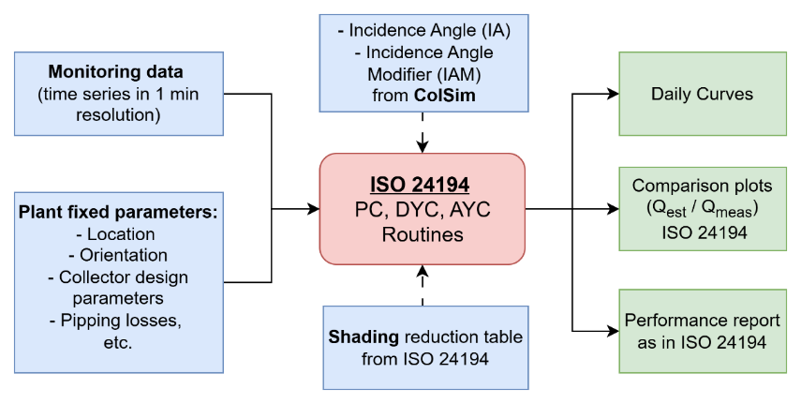
Figure 1: Flow chart of the procedural steps of the ISO 24194 software routines
- The Demonstration System
The demonstration system used for method validation is a parabolic trough collector (PTC) plant manufactured by Protarget AG, located in Limassol, Cyprus (latitude 34.7° N, longitude 33.0° E). The plant supplies heat to the steam network of a beverage manufacturer. It has been in operation since 2018, providing practical evidence of long-term performance and reliability of concentrating solar thermal technology in industrial process heat applications. The solar field consists of two parabolic trough collector rows equipped with Protarget PT950 collectors, aligned -24.7 ° along the North–South axis with single-axis tracking (E–W rotation). The total gross area of the collector field is 288 m², delivering a nominal thermal output of 140 kW under design conditions. Silicone oil is used as the heat transfer fluid (HTF) in the primary loop, enabling operating temperatures of up to 430 °C. Under typical operating conditions during the monitoring period, the HTF was heated to approximately 300 °C. Heated silicone oil is used to generate saturated steam in a steam boiler at temperatures of up to 190 °C for the industrial process. Surplus thermal energy is stored in a concrete thermal energy storage with a capacity of 600 kWh, capable of reaching temperatures up to 380 °C.
The plant is in a coastal mediterranean environment characterized by high annual direct normal irradiation (DNI) but also challenging ambient conditions for optical surfaces. The annual direct irradiation on the collector plane at this location is approximately 1,949 kWh/m². The coastal proximity results in dusty and salty ambient conditions, which accelerate soiling of the collector mirror surfaces and increase the importance of regular cleaning intervals for maintaining optical performance.
The plant operates according to an operation schedule of the connected beverage manufacturer, resulting in limited operating times compared to maximum available solar hours. In 2024, the plant was operated on 190 production days.

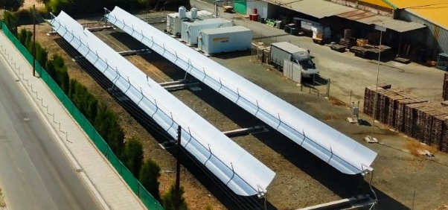 | 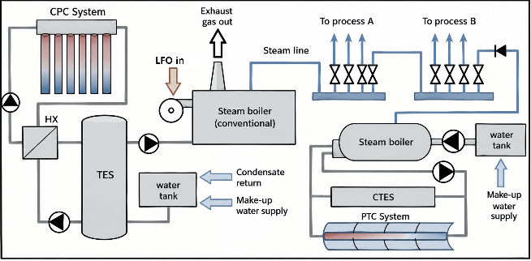
Figure 2: Left: Photograph of the Protarget parabolic trough plant in Limassol, Cyprus, showing the two collector rows. Right: Schematic diagram of the plant hydraulics showing the primary silicone oil loop, the steam boiler, and the concrete thermal energy storage. Source: Protarget AG
- Sensors and Measurement Uncertainties
5.1 Instrumentation Overview
The demonstration plant was not specifically instrumented for the purposes of this research project. Rather, monitoring data from the year 2024 was provided by the plant operator, recorded using sensors installed by the manufacturer during construction. The installed measurement setup is given in Table 1. This represents a typical measurement setup for industrial process heat applications and reflects the intended use case of ISO/FDIS 24194 (ISO/FDIS 24194:2026(en)) performance verification using existing plant instrumentation without the need for research-grade measurement equipment.
Table 1: Sensors installed by the manufacturer during construction.
Measurement | Sensor type | Specification
Direct and diffuse irradiance | Rotating shadowband irradiometer (RSI) | CSP Services Twin-RSI
Fluid temperature (inlet/outlet) | Pt100 resistance thermometer | Two-wire connection, immersion sleeve
Volume flow rate | Orifice plate | Manufacturer calibration
Ambient air temperature | Pt100 resistance thermometer | Shaded, ventilated housing
Tracking angle | Inclinometer (integrated in control system) | -
5.2 Measurement Uncertainty Analysis
A measurement uncertainty analysis was carried out for the installed instrumentation to determine the achievable accuracy level according to ISO/FDIS 24194 (ISO/FDIS 24194:2026(en)). The standard defines three levels of accuracy (Table 2).
Table 2: Accuracy levels according to ISO/FDIS 24194 (ISO/FDIS 24194:2026(en)).
Level | Solar radiation | Power output | Comment
I | ±3 % | ±2 % | High accuracy, expensive equipment, frequent maintenance
II | ±5 % | ±3 % | Moderate accuracy
III | ±5 % | ±5 % | Basic accuracy, allows modelled radiation data

The uncertainty analysis identified two particularly unfavorable factors in the measurement chain of the demonstration plant:
- Two-wire Pt100 cabling: The PT100 temperature sensors are connected using a two-wire configuration rather than the preferred three-wire or four-wire connection. In a two-wire configuration, the resistance of the connecting cables is added to the sensor resistance and cannot be compensated, introducing a systematic positive temperature offset.
- Rotating shadowband irradiometer (RSI): While the RSI provides simultaneous measurement of global, direct, and diffuse irradiance components — which is essential for concentrating collectors with an incidence angle modifier for diffuse solar radiation K_{d} < 0.8 — it is susceptible to soiling in the coastal environment. Salt spray and dust deposits on the sensor dome and accumulate between cleaning intervals, causing measurement to drift. The RSI requires regular cleaning and recalibration to maintain the ±5 % accuracy required for Level II/III.
5.3 Uncertainty Propagation
For the specific instrumentation at the demonstration plant, the individual uncertainty contributions were estimated as follows (Table 3).
Table 3: Estimated standard uncertainties of individual measurement quantities at the demonstration plant.
Quantity | Source of uncertainty | Estimated standard uncertainty
Volume flow rate V̇ | Orifice plate calibration, Reynolds number dependency | ±3 %
Temperature difference ΔT | Two-wire Pt100, immersion sleeve thermal contact, cable resistance | ±2.5 K (combined for ΔT)
Fluid density ρ | Temperature-dependent correlation for silicone oil | ±1 %
Specific heat capacity c_{f} | Temperature-dependent correlation for silicone oil | ±2 %
Direct irradiance G_{b} | RSI measurement, soiling, spectral response | ±5–8 % (depending on cleaning interval)
Diffuse irradiance G_{d} | RSI measurement, shadowband correction | ±10–15 %

The combined standard uncertainty of the thermal power is propagated from the individual measurement uncertainties using the law of propagation of uncertainties according to GUM [ISO/IEC Guide 98-3:2008-09]. Under these conditions, the total combined uncertainty of the measured thermal power output is estimated at approximately ±11 % of the measured value. This places the measurement setup at the boundary between Level II and Level III according to ISO/FDIS 24194 (ISO/FDIS 24194:2026(en)). It should be noted that the reason for the conservative estimate of measurement uncertainty is largely due to the lack of sufficient information regarding the maintenance and calibration of the irradiance measurement equipment.
5.4 Implications for the Performance Factor
Measuring uncertainty directly influences the choice of the safety factor f_{U} within the combined performance factor f_{perf}. Given the estimated total uncertainty of ±11 %, a safety factor of f_{U} = 0.89 was adopted for the demonstration plant, corresponding to Level III. This conservative choice ensures that the verification criterion remains meaningful despite the elevated measurement uncertainty.
5.5 Recommendations for Improved Instrumentation
The uncertainty analysis demonstrates that the safety margins for guaranteed field yields depend significantly on the measurement technology applied and its installation conditions. For the specific case of the demonstration plant, there is room for improvement through the following measures:
- Upgrading the Pt100 cabling from two-wire to at least three-wire configuration, which eliminates the cable resistance error and reduces the temperature measurement uncertainty to the Class A limit of ± 0.35 K.
- Implementing a regular cleaning and calibration/correction schedule for the RSI, ideally weekly in the coastal environment, to maintain the direct irradiance measurement within ± 5 %.
These improvements would allow the measurement setup to achieve Level II accuracy, enabling the use of a higher safety factor (f_U ≈ 0.93) and thereby increasing the sensitivity of the yield assessment methods to detect actual performance deficiencies.
- Method Validation and Monitoring Results
This section presents the results of applying the three yield assessment methods — PC, DYC, AYC — to the 2024 monitoring dataset of the Protarget demonstration plant. The available dataset covers 12 consecutive months (January–December 2024) in a resolution of 5 seconds. The validation process served a dual purpose: first, to verify the correctness and applicability of the methods to concentrating tracking collectors, and second, to identify methodological deviations and feed improvements back into the ISO standardization process. To validate the methods two entities, Fraunhofer ISE and Solar Experience GmbH, apply the principles of the methods within their in-house tools and compare the results. Additionally, the results out of these evaluations were compared to a TRNSYS-Simulation by Solites.
6.1 Power Check
Figure 3 presents an intercomparison of the results of the PC conducted by ISE and SE, using July 1, 2024, as an example. Under the assumptions a performance factor f_perf = 0.82 and a cleanliness factor f_c = 0.96, seven valid 1-hour intervals can be identified in each case. The different positions of the data points result from differing definitions of the averaging period for the 1-hour intervals. SE centered the 1-hour averaging intervals around fixed hourly values while the starting point of each 1-hour averaging intervals from ISE result from the analysis of the boundary conditions specified for the PC in ISO/FDIS 24194 (ISO/FDIS 24194:2026(en)) and therefore do not have a fixed timestamp. Despite this difference in approach—the standard permits both—the number of data points correspond and their position above the bisectors confirms that the system performs as expected under the steady-state conditions used as the basis for the power check.
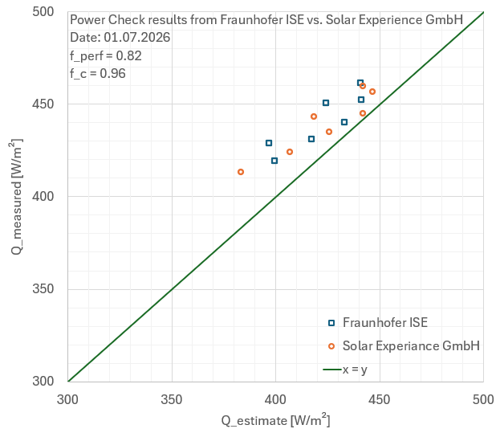
Figure 3: Intercomparison of the results of the PC conducted by Fraunhofer ISE and Solar Experience GmbH, using July 1, 2024, as an example (Source: Fraunhofer ISE)
The application of the PC revealed the following operational and methodological issues that reduce the number of valid hourly intervals below the theoretically achievable value:
- A dynamic acceptance criterion for the collector mean temperature variation, replacing the previous fixed ±5 K criterion with temperature-dependent limits that scale with the outlet-inlet temperature difference has been introduced. This modification is essential for high-temperature concentrating collectors. Without this revision, fewer than 10 valid data points would have been available within the summer half-year 2024, rendering the Power Check infeasible for this plant.
- Azimuth deviation: A misalignment of 0.85° was identified between the actual North–South orientation of the collector rows and the orientation stored in the tracking control system. This deviation causes yield losses primarily during the morning hours (09:00–14:00) and is more pronounced in spring and autumn when the longitudinal incidence angle is higher.
- Irregular mirror cleaning: The coastal location promotes rapid soiling of the reflector surfaces. Data analysis indicates that cleaning is carried out at irregular intervals rather than on a fixed schedule. At the same time the monitoring data clearly demonstrate the strong dependence of the collector performance on the cleanliness state of the parabolic trough mirrors. Analysis reveals a recurring pattern: after each cleaning event, the performance reaches its maximum, followed by a progressive decline at a rate of approximately 1 % per day until the next cleaning intervention. This observation motivated the introduction of a dynamic cleanliness performance factor into ISO/FDIS 24194 described by:
$$f_C= max⁡(1 - r∙d, f_(C,min)) (eq. 1)$$
with r=0.01/d and d being the number of days since the last cleaning. The minimum cleanliness factor f_{C,min} represents the asymptotic soiling level at which further degradation saturates.
These findings demonstrate that the PC not only serve the purpose of performance verification but also provide diagnostic capability for identifying and quantifying operational deficiencies that can be addressed through simple corrective measures. Under consideration of the identified operational and methodological issues and considering a combined performance factor of:
$$f_{\text{perf}}=f_{C}⋅f_{P}⋅f_{U}⋅f_{O} (eq. 2)$$
where f_{c} accounts for the dynamic cleanliness degradation, f_{P} for pipe heat losses in the primary loop, f_{U}=0.89 corresponds to Level III measurement accuracy, and f_{O} accounts for the identified azimuth deviation and other non-ideal effects, the results confirm that the PC is verified for the demonstration plant. A number of 230 valid hourly intervals could be found within the summer half year 2024 fulfilling the methodological requirements.
6.2 Daily Yield Check
Figure 4 presents an intercomparison of the results of the DYC conducted by ISE and SE, using the data of the summer half year 2024 (21.03.2024 – 21.09.2024). While ISE has implemented the DYC methodology within a Python routine, SE uses Excel to evaluate the measurement data. Under consideration of pipe losses calculated by the empiric equation:
$${\dot{Q}}_{pipe,d}=0.61⋅{\left(\frac{V_{\text{pipe}}}{L_{\text{pipe}}}\right)}^{0.22}⋅L_{\text{pipe}}⋅\left(\overline{ϑ_{m}}-\overline{ϑ_{a}}\right) (eq. 3)$$
and the assumptions f_{O} * f_{U} = 0.75 as well as a variable f_{C} in the range of 0.85 to 1.0, both evaluations are showing nearly the same overall result. In total, 70 days were identified that met the requirements for minimum total irradiance and thus allowed for a DYC evaluation. Of these 70 days, 65 days confirmed — according to the evaluation by SE — and 66 days — according to the evaluation by ISE — that the system generated the expected daily yield. The compliance rate is thus 92.9% (SE) and 94.3% (ISE), respectively.
Non-significant deviations between the results of the ISE and the SE arise, for example, from minor differences in how pipe-losses are accounted for or from a minimally different stop time in the evaluation, which is attributable to a different interpretation of the methodological requirements.

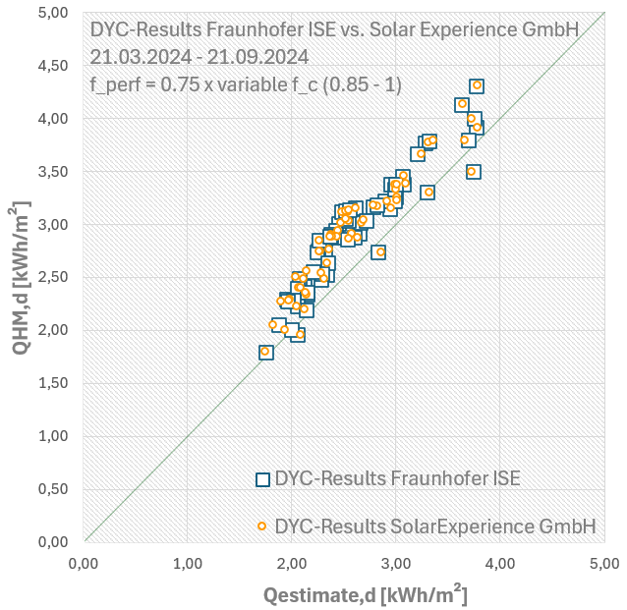
Figure 4: Intercomparison of the results of the DYC conducted by Fraunhofer ISE and Solar Experience GmbH (Source: Fraunhofer ISE)
Table 4 compares, as an example for two days in March 21, 2024, and July 1, 2024, the daily measured yields Q_{HM,d} and Q_{estimate,d} determined using the DYC analysis of ISE and SE with the results of a TRNSYS simulation study conducted by Solites in Tamm et al. (2026). Although the TRNSYS simulation was performed with a time step of one minute, the result files are limited to 0.1-hour steps (6 minutes) due to the large volume of data. The calculated yield is therefore based on 0.1-hour intervals and was linearly interpolated for the desired period. Nevertheless, this comparison confirms both the consistency of the DYC methodology’s results — despite differences in implementation and approach — and its general accuracy regarding the calculated daily yields.

Table 4: Comparison of the results from the DYC methodology and a TRNSYS simulation, using March 21, 2024, and July 1, 2024, as examples.
Date | Fraunhofer ISE |  | Solar Experience GmbH |  | Solites
Date | Q_{HM,d}  [kW/md] | Q_{estimate,d} [kW/md] | Q_{HM,d}  [kW/md] | Q_{estimate,d} [kW/md] | Simulated Q_{HM,d}  [kW/md]
21.03.2024 | 2.91 | 2.65 | 2.91 | 2.58 | 3.04
01.07.2024 | 4.31 | 3.77 | 4.31 | 3.79 | 4.54

The low performance factor f_{perf} results, on the one hand, from the irregular cleaning intervals of the mirrors and the described azimuth deviation of the collector’s tracking axis. However, application of the methodology also shows that part of the low f_{perf} is attributable to the method itself. For systems operating according to an operational schedule, the start and end times — from which the contributions to the daily irradiance sum are accumulated to calculate the estimated daily yield Q_{estimate,d} — are defined by the start and end times of that operational schedule. The impact is illustrated in Figure 5, showing the daily curve for 2024-07-01. If the start and end times of the collector tracking are used to define the operating schedule, the calculation of Q_{estimate,d} also considers periods during which the linear model does not accurately represent the transient behaviour of the system. Furthermore, this definition neglects the minimum temperature required at which heat is transferred to the secondary circuit. This is leading to an overestimated Q_{estimate,d} that is artificially compensated by a reduced f_{perf} = 0.82. By limiting the observation period to a time span with a temperature level suitable for the process, the overestimation is eliminated, causing f_{perf} to increase to 0.87, as summarized in Table 5. For CST-Systems, it is proposed that the observation period be coupled to the target temperature T_{set} as a practical means of defining steady-state conditions.
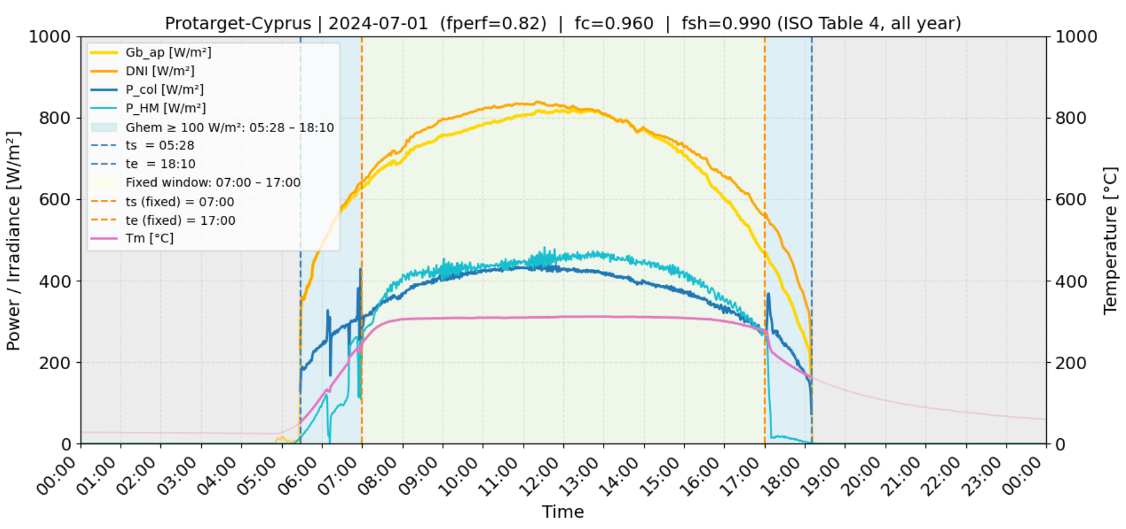
Figure 5:Daily curve for 2024-07-01, illustrating the effect of the operating time restriction on DYC.
Table 5: Effect of Operating Time Restriction on DYC Results (2024-07-01)
Operation time (h) | 12 | 10
Q_{HM,d} [kWh/m²] | 4,31 | 4,26
Q_{estimate,d} [kWh/m²] | 4.26 | 4.23
Performace Factor f_{perf} | 0.82 | 0.87

6.3 Annual Yield Check
The Annual Yield Check was applied to the complete 2024 dataset (12 consecutive months, 365 days). The key parameters and results are summarized in Table 6.
Table 6: Key parameters and results of the Annual Yield Check for the Protarget demonstration plant (2024).
Parameter | Value | Unit
Production days | 190 | d/a
Effective irradiation on collector plane (operating hours) 𝐻_{𝑜𝑝,a} | 868 | kWh/m²
Direct normal irradiation H_{bn} | 1,949 | kWh/m²
Fictitious constant heat loss coefficient 𝑈_{𝑠𝑦𝑠} | 0.263 | kWh/(m²K)
Performance factor f_{𝑝𝑒𝑟𝑓} | 0.70 | —
Max. Performance factor 𝑓𝑝𝑒𝑟𝑓,max | 0,76 | —
Estimated system efficiency 𝜂_{𝑒𝑠𝑡𝑖𝑚𝑎𝑡𝑒,𝑜𝑝} | 0.394 | —
Measured system efficiency 𝜂_{𝑚,𝑜𝑝} | 0.426 | —
Measured annual specific yield Q_{HM,a} | 370 | kWh/m²
Verification result | Verified (𝜂_{𝑚,𝑜𝑝} > η_{𝑒𝑠𝑡𝑖𝑚𝑎𝑡𝑒,𝑜𝑝}) | —

The measured annual system efficiency of 42.6 % exceeds the estimated system efficiency of 39.4 %, thereby verifying the field performance according to ISO/FDIS 24194. The relatively low-performance factor of f_{perf} = 0.76 reflects the combined effect of the identified azimuth deviation (reducing the effective optical efficiency), the irregular cleaning intervals (reducing the average mirror reflectance) and the operation time (overestimation of Q_{estimate,d}). The analysis further indicates that with correction of the azimuth deviation in the control system and implementation of a regular cleaning schedule (every 10 days), the annual yield could increase to approximately 420 kWh/m² and the system efficiency to 48.4 %. Under these improved conditions, a higher performance factor of approximately f_{perf} = 0.85 would be justified.
- Conclusion and Outlook
7.1 Summary
This paper presented the development, validation, and application of standardized yield assessment methods for large-scale solar thermal plants equipped with concentrating and tracking collectors. Three complementary procedures were described: the Power Check (PC) for instantaneous thermal power verification, the Daily Yield Check (DYC) for daily energy output assessment, and the newly developed Annual Yield Check (AYC) for verifying predicted annual system yields. All three methods build upon collector characterization according to ISO 9806 (ISO 9806:2025) and are implemented in the revised ISO/FDIS 24194 ISO/FDIS 24194:2026(en), which extends the scope of the standard from non-concentrating stationary collectors to tracking concentrating collectors such as parabolic trough collectors and linear Fresnel collectors.
The methods were validated using one year (2024) of operational monitoring data from a parabolic trough collector plant (Protarget PT950, 278 m² aperture area) located in Limassol, Cyprus. The validation demonstrated that:
- All three methods — PC, DYC, and AYC — are applicable to parabolic trough collectors and produce valid, consistent results.
- The methods provide diagnostic capability beyond simple pass/fail verification: a systematic azimuth deviation of 0.85° and the impact of irregular mirror cleaning were identified and quantified.
7.2 Key Contributions to the ISO Standardization Process
The validation process revealed several methodological gaps that were addressed and incorporated into the ISO/FDIS 24194 revision:
- Alignment of the formulas with the general collector model of ISO 9806:2025, eliminating the previously incomplete and inconsistent formulations within ISO 24194 (ISO 24194:2022) and enables the application to tracking and concentrating collectors, due to differentiation between direct and diffuse irradiance.
- Introduction of a dynamic acceptance criterion for the collector mean temperature variation, replacing the previous fixed ±5 K criterion with temperature-dependent limits that scale with the outlet-inlet temperature difference enables the application to high temperature collectors.
- Introduction of a dynamic cleanliness factor f_{C} for systems cleaned according to a cleaning schedule enables the application of the PC, the DYC and the AYC to collector plants which are sensitive to soiling.
- The introduction of operating schedule provisions includes a minimum effective daily operating irradiation criterion for the DYC and reduced effective reference irradiation for the AYC, enabling the application to process heat plants that operate according to production schedules.
Other methodological aspects, such as how to account for an operating schedule for concentrating and tracking collectors, are to be discussed as part of the revision process for ISO/FDIS 24194 ISO/FDIS 24194:2026(en).
7.3 Implications for Market Deployment
The availability of standardized, internationally recognized yield assessment methods has significant implications for the market deployment of large-scale solar thermal plants:
- Risk mitigation for investors: Standardized performance verification provides an objective basis for performance guarantees, reducing investment risk and improving bankability of solar thermal projects.
- Quality assurance: The methods enable continuous monitoring over the entire service lifetime (typically > 25 years), allowing early detection of performance degradation due to soiling, ageing, or component failures.
- Comparability: Standardized methods ensure that yield statements from different systems and suppliers can be compared on a common basis, fostering healthy competition and trust among market participants.
- Operational optimization: As demonstrated in this paper, the methods provide diagnostic information that enables operators to identify and address operational deficiencies through simple corrective measures.
7.4 Outlook
The methods developed as part of the ProSolNetz project are being further utilized in an ongoing CETP project (SolarOpt) as follows:
- Software tool development: The python-based evaluation routine developed at Fraunhofer ISE will be further refined and potentially made available as a publicly accessible tool to facilitate broad application of the standardized methods by plant operators and third-party evaluators.
- Integration with digital monitoring platforms: The methods are well-suited for integration into SCADA systems and digital twin platforms, enabling automated, continuous yield verification without manual intervention.
- Extension to further collector technologies: While this paper focused on parabolic trough collectors, the revised ISO 24194 ISO/FDIS 24194:2026(en) is applicable to all liquid heating collector types. Future work will include validation with several other collector technologies.
- Next revision cycle: Experiences gained from broad application of the revised standard will be collected and evaluated for the next revision cycle, with particular attention to shading provisions for the Power Check, refinement of the daily observation period for systems which are operating according to an operation schedule and the definition of satellite-based irradiation data requirements.

Competing Interests
The authors declare that they have no competing interests.

Funding
This work was funded by the German Federal Ministry for Economic Affairs and Energy (BMWE) within the project ProSolNetz – Prozess- und Fernwärme mit konzentrierenden Solarkollektoren (Grant No. 03EN603F). The authors of this publication are responsible for its contents.
Acknowledgements
The authors gratefully acknowledge the contributions of the ProSolNetz project partners: Solar Experience GmbH (Stefan Abrecht) for independent method cross-verification, Protarget AG (Martin Scheuerer and Johannes Werner) for providing the demonstration plant and monitoring data, and Deutsches Zentrum für Luft- und Raumfahrt DLR (Dirk Krüger, Navina Konz, Eckhard Lüpfert) for scientific exchange and support. The authors further acknowledge the IEA Solar Heating and Cooling Technology Collaboration Programme (IEA SHC), in particular Task 68 – Efficient Solar District Heating, for facilitating international collaboration and dissemination of results. The project is accompanied by an advisory board comprising AGFW (Energieeffizienzverband für Wärme, Kälte und KWK e.V.), dena (Deutsche Energie-Agentur), and BSW (Bundesverband Solarwirtschaft).
References
ISO/FDIS 24194:2026(en) Solar energy — Collector fields — Check of performance
ISO 9806:2025, Solar energy — Solar thermal collectors — Test methods.
IEA SHC Task 45, Fact Sheet 45.A.3.2, "Performance guarantee for large collector fields."
L. Feierl, S. Putz, V. Unterberger et al., "Efficient Data Management and Validation," IEA SHC Task 68, Report RB1, 2024.
S. Mehnert, S. Abrecht, "Annual Yield Check of Large Scale Solar Thermal Systems," IEA SHC Task 68, Report RA3, 2025.
D. Tschopp, P. Ohnewein, S. Mehnert et al., "Guide to ISO 24194:2022 Power Check," IEA SHC Task 68, Report RB2, 2024.
ColSim (Fraunhofer ISE, https://colsim.org/)
ISO/IEC Guide 98-3:2008-09 Measurement uncertainty –Teil 3: Guidance on Specifying Uncertainty in Measurements
S. Tamm, M. Berberich, D. Krüger, 2026. Parabolic Trough Collectors for Existing District Heating Networks, in: Proceedings of ISEC 2026, Graz, Austria. https://doi.org/10.52825/isec.v2i.3374

