**Optimization of Tow-Steered Perforated Variable Stiffness Composite Laminates for Vibration Tailoring using IGA**

V. Khalafi, J. Fazilati

Aerospace Research Institute, Tehran, Iran

Thin-walled structures are the most utilized structural elements in case of aerial, marine, space and even land transport systems including airplanes, ships, launchers and automobiles. In order to lighten the structure, to provide venting or accessibility to other sides and also to meet mechanical design considerations, the thin-walled structures with internal perforations are broadly employed in inner parts of those structural systems. In the other hand, to design thin-walled elements with the most stiffness to weight ratio that is a very important efficiency factor especially in case of aerial and marine structures, laminated composite materials are now an accepted solution. Nowadays, With the automated fiber placement technology and tow-steering machines, it is possible to fabricate composite plies with variable orientation fibers within their geometrical domain. As a result of changed fiber orientation, it is possible to gain variable stiffnesses through the laminate geometry. The subject of the present research is to optimize the laminate layup to get to a more dynamically stable panel from the natural frequencies point of view. The isogeometric analysis is a recently developing technology in computational mechanics that benefitted the integration of numerical analysis and the computer aided design system into a single and unified process. The isogeometric formulation (IGA) based on non-uniform rational B-spline (NURBS) is developed based on the first order shear deformation plate theory (FST). An IGA tool and the Nitche technique is then developed in order to extract the panel behavior while a genetic algorithm is applied to find the best design choices including the ply layups. The effects of change in the mechanical properties of tow steered laminates throughout the geometry due to fibers following prescribed curvilinear paths are taken into account in the integration procedures. The accuracy and reliability of the IGA tool is shown and some representative problems are solved and their corresponding results are exhibited. Figure 1 depicts a typical perforated panel geometry. Table 1 given below presents the results for the first ten natural frequencies of 3-layered VSCL plate containing central cutouts of different sizes in case of various end constraints sets.

It is also to be noted that the developed formulation is the first implementation of IGA method in analyzing the tow steered plates with cutouts.

|  |  |  |  |  |  |
| --- | --- | --- | --- | --- | --- |
| [<30, 0>,<45,90>,<30,0>] | | | | | |
|  | Mode | FFFF | SSSS | CCCC | CSCS |
| c/a=0.2 | 1 | 3.479 | 8.602 | 21.71 | 20.949 |
|  | 2 | 5.578 | 15.902 | 27.336 | 24.74 |
|  | 3 | 8.647 | 27.427 | 40.904 | 34.941 |
|  | 4 | 14.236 | 30.098 | 43.779 | 43.307 |
|  | 5 | 14.806 | 40.166 | 55.024 | 47.376 |
|  | 6 | 17.598 | 40.862 | 59.151 | 57.573 |
|  | 7 | 21.104 | 51.484 | 69.466 | 65.016 |
|  | 8 | 24.352 | 56.161 | 74.282 | 65.628 |
|  | 9 | 27.091 | 73.096 | 89.614 | 81.667 |
|  | 10 | 34.783 | 73.365 | 93.262 | 82.908 |
| c/a=0.4 | 1 | 3.165 | 8.116 | 27.766 | 24.645 |
|  | 2 | 5.17 | 13.976 | 27.942 | 24.681 |
|  | 3 | 8.363 | 18.439 | 42.642 | 42.062 |
|  | 4 | 11.763 | 27.295 | 46.63 | 43.816 |
|  | 5 | 13.711 | 32.386 | 50.802 | 49.029 |
|  | 6 | 18.135 | 40.466 | 58.693 | 52.175 |
|  | 7 | 18.663 | 50.035 | 68.449 | 63.824 |
|  | 8 | 23.897 | 54.926 | 75.816 | 66.544 |
|  | 9 | 25.42 | 66.276 | 87.534 | 77.205 |
|  | 10 | 26.771 | 67.735 | 87.614 | 79.286 |

**Table 1.** Non-dimensional frequency parameters (**)of VSCL plate with central squarecutout (*a/b=1, h/a=0.01*, *E1* =173e9, *E2*=7.2e9, *G12* =3.76e9, *v*12=0.29, *ρ*=1560)

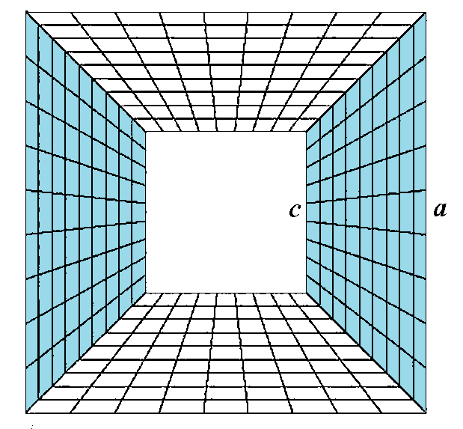

**Figure 1.** Square plate of length *a* with cutouts edge *c* and four non-conforming patch parts