EuroSun2026
BEYOND THE FOCAL LINE: RE-DESIGNING PARABOLIC TROUGHS FOR RECEIVER LONGEVITY

Sainath A. Waghmare¹ (corresponding author), Gabriel Cardona², Ramón Pujol-Nadal¹
¹Departament d'Enginyeria Industrial i Construcció, Universitat de les Illes Balears, Palma, 07122, Spain
²Departament de Ciències Matemàtiques i Informàtica, Universitat de les Illes Balears, Palma, 07122, Spain
sainath-arjun.waghmare@uib.es, gabriel.cardona@uib.es, ramon.pujol@uib.es
Summary
This research aims to improve receiver-tube reliability in the LS-III Parabolic Trough Collector (PTC) through a primary-mirror design that splits the common focal line into two laterally displaced foci, combined with a corresponding shift of the receiver toward the reflector. A Monte Carlo Ray Tracing (MCRT)-based Optical Design Optimization (ODO) statistically evaluates 328 geometries across nine incidence angles (2952 cases) for optical efficiency, flux uniformity, and peak flux metrics. At its core, this study shows that focal splitting trades a minor drop in perfect-alignment performance for major gains in the field. Under real-world tracking errors, replacing a single focus with two aim points reduces peak flux by 20–45% and restores thermal efficiency. Combining a reduced receiver height with a moderate focal split identifies a single geometry that outperforms the conventional single-focus design under both ideal and realistic tracking conditions. The only trade-off is a bounded loss in optical efficiency, accepted in exchange for improved flux uniformity and, by extension, anticipated gains in receiver life. The design is expected to reduce the thermal cycling implicated in receiver degradation, offering a retrofit-compatible route to longer receiver life and lower maintenance costs.
Keywords: Flux distribution, MCRT, Optical design optimization, parabolic trough collector, receiver tube.
Field of application for the findings: Concentrating Solar Power (CSP) and Solar Thermal Power Plants
Addressed audience: Solar engineers, researchers, and plant operators interested in component reliability.
- Introduction
Parabolic trough collectors (PTCs) remain the most widely deployed line-focus technology in concentrating solar power (CSP), owing to their manufacturing maturity and compatibility with thermal storage. Their principal optical limitation, however, is intrinsic to the single-focus geometry itself. Because the reflected ray bundle converges onto a narrow band along the lower half of the receiver, the resulting flux distribution is highly non-uniform around the tube circumference, and this non-uniformity has been identified as a persistent threat to receiver reliability (Wang et al., 2015; Shimada et al., 2025).
Circumferential flux non-uniformity translates directly into circumferential temperature non-uniformity, since the tube wall at the irradiated face absorbs substantially more heat than the shaded face. The differential thermal expansion this produces induced bending stress in the receiver, concentrated at the glass-to-metal transition where the ductile absorber tube and the more brittle glass envelope are joined (Wu et al., 2014a; Natraj & Reddy, 2023). Repeated thermal cycling at this junction is understood to promote fatigue and progressive seal degradation, and field data report receiver failure rates on the order of a few percent annually, with receiver-related issues ranked among the more significant contributors to solar-field maintenance risk (Wu et al., 2014b; Mehos et al., 2020). The economic consequence follows directly, since receivers are a comparatively costly recurring component, and any mechanism that reduces this circumferential gradient without materially compromising optical performance is therefore of practical interest (Stettenheim et al., 2013).
Two broad mitigation strategies have been examined previously. Shifting the receiver away from the geometric focus reduces flux concentration by utilizing exposed receiver surface area (Waghmare & Gulhane, 2016). However, it does so at the cost of the intercept factor, since a growing fraction of the reflected bundle passes outside the receiver's cross-section as the shift increases (Agagna et al., 2022). Secondary reflectors positioned near the receiver redistribute a portion of the incident flux but introduce an additional optical surface, with associated alignment sensitivity, soiling exposure (Heimsath et al., 2020), and a documented tendency to attenuate rays arriving at low angles (Sallaberry et al., 2018; Shyam et al., 2024). Neither strategy has seen widespread adoption at utility scale, suggesting that the balance between added complexity and demonstrated benefit has not, to date, favored either approach.
This study examines a modification to the primary mirror itself rather than to the receiver or a secondary optic. The parabolic aperture is divided into two symmetric segments whose focal points are laterally displaced from the collector axis, splitting the single focal line into two spatially separated lines. This is combined with a corresponding vertical shift of the receiver toward the reflector. Together, these two changes are intended to distribute concentrated flux across a wider arc of the receiver circumference, reducing the peak-to-average flux ratio that drives the thermal gradient described above.
The resulting design space, defined jointly by receiver height, focal offset, and incidence angle, is evaluated through a two-stage Monte Carlo ray-tracing (MCRT) optical design optimization. The first stage screens the full parametric set on optical efficiency; the second resolves the circumferential flux distribution for the efficiency-competitive subset. Following the second stage, flux uniformity and peak-flux metrics are derived and used to rank candidate geometries under both normal-incidence and off-tracking conditions. To the author's knowledge, no established method exists to convert a given flux profile directly into a quantified receiver lifetime, and this study does not attempt to supply one. Instead, based on the uniformity and peak-flux improvements reported here, and consistent with the thermal-cycling mechanism outlined above, we anticipate that this geometry may extend receiver service life, a projection left for future thermomechanical validation. The results show that a modest change in the mounting geometry of the primary mirrors can meaningfully lower peak flux and improve flux uniformity, offering a practical path toward longer receiver lifetime and reduced operating cost in commercial CSP plants.
- PTC Geometry and Materials
2.1. Geometric details
Fig. 1 contrasts the baseline LS-III parabolic trough collector geometry (Zou et al., 2019) (Fig. 1a) with the modified split-focus, shifted-receiver configuration studied here (Fig. 1b). Both configurations share a fixed clear aperture width, W = 5760 mm, and a receiver tube of diameter D_{R} = 70 mm enclosed in an evacuated glass envelope of inner diameter D_{i} = 108 mm and outer diameter D_{o} = 115 mm. In the baseline design, the reflector is a single continuous parabolic profile with its focus, F, coincident with the receiver centerline at the nominal height H_{R} = 1740 mm above the reflector vertex.
The modified design divides the aperture into two symmetric parabolic segments (Reflector 1 and Reflector 2 in Fig. 1b), each retaining the same aperture width and rim-angle envelope as the corresponding half of the baseline profile, but with their focal points F₁ and F₂ laterally displaced from the collector's vertical axis by a horizontal offset dx. The receiver, an unmodified circular absorber tube, retained at the same D_{R}, D_{i}, and D_{o} as the baseline, is repositioned at height H_{R} below the geometric focus, straddling the midpoint between F₁ and F₂.
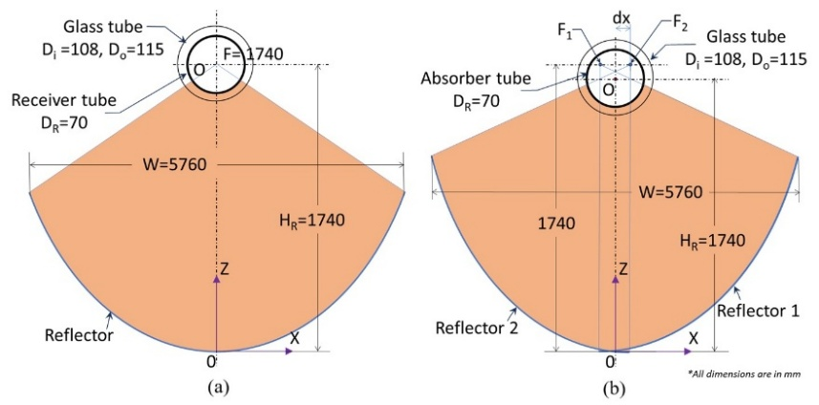
Fig. 1: Geometry of PTC: (a) base LS-III design, (b) concept of horizontal split-focus with receiver vertical-shift
2.2. Optical materials
Tab. 1 lists the wavelength-dependent optical properties assigned to each optical surface, representative of materials used in next-generation solar collectors (Leal et al., 2024). The reflector (both segments in the modified design) is modeled as 4 mm water-white glass with a silver reflective layer, including scattering error from specular reflectance. The absorber is modeled as a TiAlN–TiAlON–Si₃N₄ thin-film selective coating on a metallic substrate. The glass envelope is modeled as 3.5-mm-thick SiO₂ tubing with an MgF₂ anti-reflective coating applied to both the inner and outer surfaces. These wavelength-dependent properties yield realistic, higher normal-incidence optical efficiency.
Tab. 1: Wavelength-dependent optical materials used for simulation, Leal et al. (2024)
Part | Material name | Description
Reflector (collector) | Silver-Glass (Ag) | 4 mm water-white glass with silver layer (scattering error due to the specular reflectance is considered)
Absorber (receiver) | TiAlN-TiAlON-Si₃N₄ | Thin-film on metallic absorber
Glass tube | SiO₂ | 3.5 mm thick glass tube
Anti-reflective coating | MgF₂ | Thin film on inner and outer surfaces of glass tube

- Methodology
This section describes the ray-tracing formulation, the two-stage MCRT-ODO parametric workflow, and the statistical metrics used to evaluate flux quality and rank candidate geometries.
3.1. Ray tracing
Optical simulation is performed using OTSunApp (Cardona et al., 2020), an open-source Python library for Monte Carlo ray tracing. Spectral weighting of the incident beam uses the ASTM G173-03 (ASTM International, 2003) direct-normal reference spectrum, allowing the simulation to resolve wavelength-dependent optical behavior rather than treating incident radiation as monochromatic. OTSun's spectral mode treats incident irradiance as wavelength-dependent, so the energy carried by an individual ray must be derived from the source spectrum rather than assumed uniform. Writing the ASTM G173-03 spectral irradiance as f₀(λ) (W/m²/nm), the direct normal irradiance (DNI) is its integral over the simulated spectral range:
$$DNI=\int_{280}^{3990}{f_{o}\left(λ\right)dλ}$$ | (eq. 1)
Rays are launched in discrete wavelength bins; for a bin spanning [λᵢ, λₒ], the energy contained in that band is
$$ε_{o}=\int_{λ_{i}}^{λ_{o}}{f_{o}\left(λ\right)dλ}$$ | (eq. 2)
Furthermore, this band energy is divided evenly among the rays launched for it:
$$E_{ray, λ}=\frac{ε_{o}A_{so}}{N_{λ}}$$ | (eq. 3)
with A_{so} the source-plane area and N_{λ} the ray count assigned to that wavelength bin. Every ray begins with unit energy and is attenuated as it interacts with each surface it strikes, mirror reflectance, envelope transmission, absorber-coating absorptance, so that only a fraction of its original energy, E_{OTSun,j} ∈ [0, 1], survives to the point of final absorption.
Summing surviving ray energies over a small patch of the receiver surface gives the local flux at circumferential position φ:
$$q(φ)=\frac{1}{A_{r}}\sum_{j∈A_{r}}{E_{ray, λ}∙E_{OTSun,j}}$$ | (eq. 4)
where A_{r} is the area of that receiver patch and the sum runs over every ray absorbed within it. Normalizing by the incident DNI gives the local concentration ratio used throughout the flux-distribution analysis (Section 4.2, Fig. 4):
$$LCR (φ)=\frac{q(φ)}{DNI}$$ | (eq. 5)
Aggregating absorbed ray energy over the entire receiver, rather than a single patch, and normalizing by the total power incident on the aperture, gives the overall optical efficiency reported in Section 4.1:
$$η_{o}=\frac{\sum_{λ}{\sum_{j}{E_{ray, λ}∙E_{OTSun,j}}}}{DNI∙A_{so}}$$ | (eq. 6)
3.2. MCRT-ODO Workflow
The optical design space defined by H_{R} and dx is explored using a two-stage Monte Carlo ray-tracing–based optical design optimization (MCRT-ODO) procedure, illustrated schematically in Fig. 2. Stage 1 uses OTSunApp's Total analysis module to compute the aperture-integrated optical efficiency, η₀ (eq. 6), for every candidate geometry across the full incidence-angle range. Stage 2 uses the Spectral analysis module to resolve the full circumferential flux distribution on the receiver, which is substantially more computationally challenging per case than Stage 1. Running Stage 2 across the entire parameter space would be computationally excessive, so Stage 1 is used first to identify, at each incidence angle, the geometries whose efficiency falls within 5% of that angle's peak value. Only this qualifying subset proceeds to Stage 2.
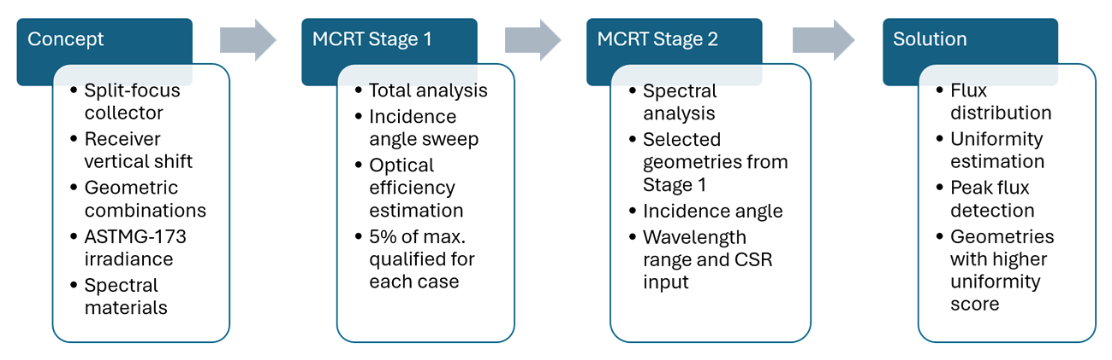
Fig. 2: Workflow of the two-stage MCRT-ODO adopted in the study
This staged filter is important for making the joint reliability analysis meaningful rather than merely affordable. Restricting Stage 2 to efficiency-competitive candidates ensures that the uniformity and peak-flux comparisons in Section 4 are made among geometries a plant would consider adopting, rather than against efficiency-poor cases that would be rejected on efficiency grounds regardless of their flux quality. The 5% qualification threshold is applied independently at each incidence angle, so a geometry can qualify at one angle without qualifying at another, which is itself part of what the angle-dependent results in Section 4.1 capture. Stage 2 results are reported at a normal-incidence angle and a representative off-tracking angle, since evaluating flux quality only under idealized, error-free tracking would not reveal whether a candidate's uniformity benefit survives the tracking conditions a field operates under.
Flux-quality metrics are computed from the Stage-2 circumferential LCR(φ) profile for each qualifying case. The coefficient of variation is defined with the mean and standard deviation of LCR values, given by
$$CV=\frac{σ_{LCR}}{μ_{LCR}}$$ | (eq. 7)
The uniformity index, U_{LCR}, is defined as,
$$U_{LCR}=\frac{1}{1+CV}$$ | (eq. 8)
so that U_{LCR} increases monotonically as the flux distribution becomes more uniform (CV → 0 gives U_{LCR} → 1). The flux uniformity increase, ΔU_{LCR}, expresses the percentage change in U_{LCR} for a given case relative to a fixed baseline case:
$${∆U}_{\text{LCR}}=\left(\frac{U_{\text{LCR, new}}-U_{\text{LCR, baseline}}}{U_{\text{LCR, baseline}}}\right)×100$$ | (eq. 9)
Moreover, the peak flux reduction, ΔR_{peak}, expresses the percentage change in the peak (maximum) LCR value around the receiver circumference relative to the same baseline:
$${∆R}_{\text{peak}}=\left(\frac{{LCR}_{\text{peak, baseline}}-{LCR}_{\text{peak, new}}}{{LCR}_{\text{peak, baseline}}}\right)×100$$ | (eq. 10)
For both eq. 9 and eq. 10, the baseline case is the unmodified LS-III geometry (H_{R} = 1740 mm, dx = 0 mm) evaluated at the same incidence angle θ as the case being scored, i.e., a separate baseline is used for each θ, rather than a single baseline across all angles. This convention means ΔU_{LCR} and ΔR_{peak}, and hence S, measure improvement or degradation relative to what the unmodified single-focus design achieves at that specific incidence angle, not relative to its normal-incidence performance.
Finally, the two metrics are combined into a single weighted composite score,
$$S=w_{1}⋅{∆U}_{\text{LCR}}+w_{2}⋅{∆R}_{\text{peak}}$$ | (eq. 11)
with weights w₁ = 0.7 and w₂ = 0.3, giving flux uniformity precedence over peak-flux reduction as the primary reliability-relevant criterion, consistent with the receiver-degradation motivation in Section 1 (non-uniform circumferential temperature distribution, rather than peak flux alone, is the more direct driver of the thermal-cycling stress implicated in coating and glass-envelope degradation). S is used throughout Section 4.3 to rank candidate (H_{R}, dx) combinations at each incidence angle and is reported as a signed quantity; positive values indicate net improvement over the unmodified baseline at that angle; negative values indicate net degradation.
- Results and Discussion
The 328 geometric combinations defined in Tab. 2 were constructed in FreeCAD following the modified split-focus configuration (Section 2.1) and evaluated in OTSunApp using the two-stage MCRT-ODO procedure described in Section 3.2. All simulations use a circumsolar ratio (CSR) of 0.05 with the Buie sunshape model (Buie et al., 2003), and each geometry was evaluated at nine incidence angles, θ = 0° to 2° in steps of 0.25°, giving 328 × 9 = 2952 total optical cases. This section follows the paper's core objectives in sequence. Section 4.1 establishes how efficiency depends on H_{R}, dx, and θ, and defines two operating zones, precision-tracked and tolerance-favoring, that anchor the rest of the analysis. Section 4.2 examines the circumferential flux distribution directly, since avoiding localized flux concentration, not efficiency, is this design's primary target. Section 4.3 quantifies uniformity and peak-flux behavior through a single weighted score. Section 4.4 draws these together around receiver longevity, the paper's central motivation, and positions dx as the specific contribution responsible for it.
Tab. 2: Variable parameters, range, and step for FreeCAD geometry construction.
Parameters | Base values of LS-III | Range for modification (from-to) | Step
Receiver Height (H_{R}) | 1740 mm | 1600 to 1800 mm | 5 mm
Focal shift distance (dx) | 0 mm | 0 to 35 mm | 5 mm

4.1. Sensitivity of Optical Efficiency to H_{R}, dx, and θ
Fig. 3 shows the effect of H_{R}, dx, and θ on optical efficiency. At normal incidence, the unmodified baseline (H_{R} = 1740 mm, dx = 0) reaches η_{o} = 85.3%, falling to 67.4% at dx = 35 mm (Fig. 3a), an 18-point efficiency cost from the focal split alone at θ = 0°, since a growing fraction of reflected rays fall outside the receiver before any tracking error is introduced. This cost, however, is angle-dependent: split-focus geometries increasingly outperform the unmodified baseline as θ grows, with the crossover occurring earlier (θ ≈ 0.75–1.0°) for larger shifts and later (θ ≈ 1.0 – 1.25°) for smaller ones. By θ = 1.25°, every dx > 0 case exceeds the dx = 0 baseline. This occurs because tracking error displaces a single-focus ray bundle as one unit, causing efficiency to collapse sharply. In contrast, the split-focus geometry's two off-center foci partly compensate for each other as θ increases.
In Fig. 3b, the receiver height that maximizes θ = 0° efficiency also shifts with dx, from H_{R} = 1740 mm (dx = 0) down to H_{R} ≈ 1710 mm (dx = 35), reflecting the two foci converging progressively closer to the mirror. This motivates the three representative heights carried into Sections 4.2–4.3 (1740, 1725, 1705 mm), which trace this trend rather than sampling arbitrarily.
Two operating zones emerge from the full H_{R} – θ sweep (Fig. 3b). A High-Precision Zone (H_{R} = 1725–1740 mm) remains within 5% of peak efficiency simultaneously across θ = 0–0.75°, favors dx up to 20 mm, however, requires tracking accuracy better than ~0.75°. A High-Tolerance Zone exists for θ ≥ 1.0°, but it is not a fixed band; it drifts from H_{R} ≈ 1660–1715 mm at θ = 1.0° down to 1620–1650 mm at θ = 2.0°, so no single geometry stays optimal across the full tolerance range. The choice between these zones is a choice between two tracking-accuracy assumptions, not a single global optimum. Still, higher dx (25-35 mm) shows better performance than the baseline LS-III case at every θ ≥ 1.0°.
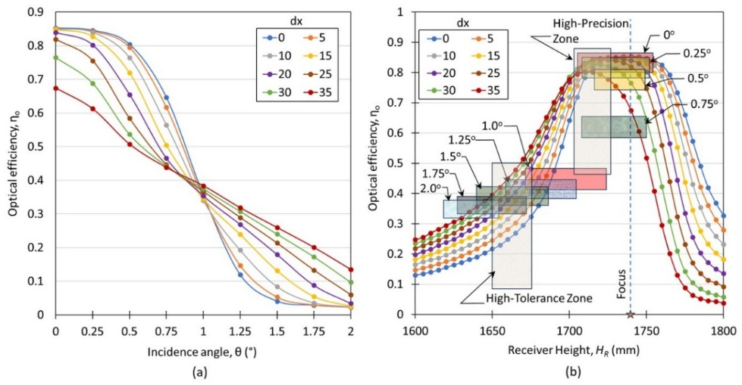
Fig. 3: Effect of split-focus geometry of optical efficiency with varying incidence angle: (a) H_{R} =focus, (b) variable H_{R}
4.2. Effect on Circumferential Flux Distribution
The split-focus design aims to homogenize the circumferential flux distribution and suppress localized hotspots. Fig. 4 shows the circumferential LCR profile at normal incidence for the three representative receiver heights.
At the nominal focus (H_{R} = 1740 mm), the conventional case is compact and moderately peaked, and a lateral shift does not resolve into two separate hotspots at small dx, since the two focal images are close enough to overlap and reinforce each other rather than separate, sharpening the peak instead of flattening it. The moderately lowered height (H_{R} = 1725 mm) tells a more instructive story. With no lateral shift, defocus alone leaves an asymmetric, front-loaded profile, strongly peaked at the shoulders near ±80–90° but markedly deficient at the tube's lowest point, an imbalance vertical defocus by itself does not correct. A small lateral shift closes this gap directly, lifting the deficient bottom toward the shoulder level and, over this narrow window, holding peak flux essentially flat or marginally improved. Pushed further, the same mechanism overcorrects, and the two focal images separate enough to reconcentrate flux into a sharp central peak, driving both peak flux and dispersion back up. At the lowest height tested (H_{R} = 1705 mm), vertical defocus alone already produces a shallow, well-balanced saddle between the bottom and the shoulders, so this deficiency does not appear, and the same moderate-shift correction is unnecessary. Taken together, these three heights show that receiver height and focal split are not independent levers even at normal incidence. Height alone can leave a real asymmetry uncorrected, a bounded lateral shift can resolve it, and only an excessive shift works against uniformity.
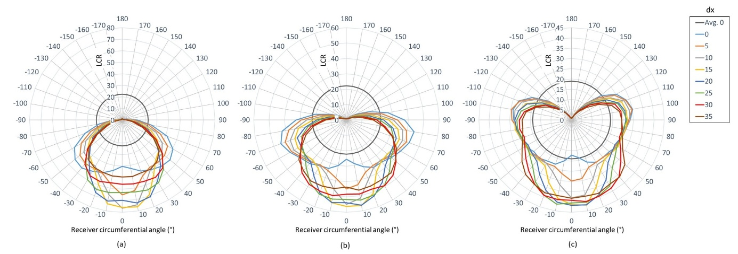
Fig. 4: Flux distribution profile on the receiver circumference at θ = 0° for (a) H_{R} = 1740, (b) H_{R} = 1725, (c) H_{R} = 1705
Tracking error is unavoidable in operating CSP fields, and Fig. 5 shows how the same three geometries respond to a representative 0.75° off-axis condition. In the conventional baseline, tilting the incident beam breaks circumferential symmetry outright. The reflected bundle drifts as a single unit, and at H_{R} = 1705 mm the broad shoulders seen at normal incidence collapse into one asymmetric peak, nearly doubling peak flux and roughly doubling flux non-uniformity relative to perfect tracking.
A lateral focal split directly counteracts this. Because the ray bundle now has two aim points rather than one, part of what a single-focus receiver would lose to the tilt is recaptured through the second focus, spreading the drifted beam back across a wider arc instead of concentrating it on one side. At H_{R} = 1705 and 1725 mm, widening the dx to 25–30 mm lowers the peak flux by 24–31% relative to the untilted-focus case at the same height, with flux uniformity recovering substantially over the same range. This is the design's central function under realistic operating conditions, not a general-purpose uniformity improvement, but a specific safeguard against the flux collapse that a single-focus receiver suffers the moment tracking is imperfect, which is expected to limit the asymmetric thermal loading associated with bowing and seal fatigue.

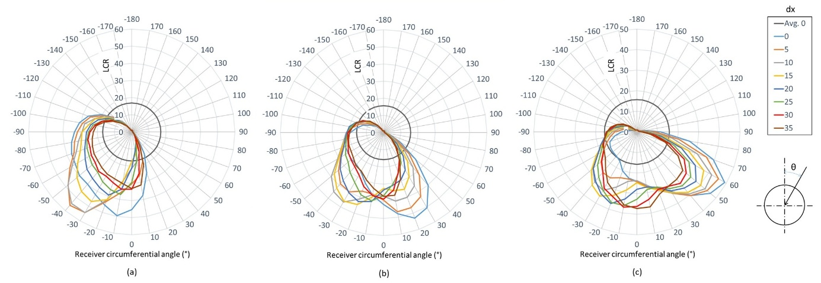
Fig. 5: Flux distribution profile on the receiver circumference at θ = 0.75° for (a) H_{R} = 1740, (b) H_{R} = 1725, (c) H_{R} = 1705
4.3. Weighted Score Analysis
Fig. 6 reports the composite score S (eq. 11) for every combination of receiver height and focal shift, at normal incidence and under a representative 0.75° tracking error, with color indicating relative performance on a shared scale. The pattern revealed by Fig. 6 is that receiver height and focal shift are not substitutes; they are complementary, and a design that combines a lowered receiver with a moderate focal shift outperforms the traditional single-focus geometry under both ideal and realistic tracking conditions.
Reducing receiver height alone accounts for most of the gain achievable at normal incidence, reaching S = 35.7 at H_{R} = 1705 mm with no lateral shift. However, this height alone is not sufficient once tracking error is introduced; in that case, the same geometry yields S = −0.7, which is barely distinguishable from the traditional design. Adding a moderate focal shift, dx = 25 to 30 mm, at this same reduced height keeps the normal-incidence score strongly positive at S ≈ 23 while raising the off-tracking score to S ≈ 11.6 to 11.8, its best value anywhere in the table. This single geometry, H_{R} = 1705 mm with dx around 25 to 30 mm, is therefore a robust improvement over the conventional PTC regardless of tracking accuracy, rather than a compromise that wins only under one condition.
The only cost is a bounded reduction in optical efficiency (Section 4.1), traded for a substantially more uniform flux distribution and a lower peak concentration. Because circumferential thermal cycling is the mechanism understood to drive receiver bending and seal fatigue, a higher, more consistently positive S across both tracking conditions represents a design with a better chance of extended operational life, and this is the balance a plant can weigh when selecting between energy yield and receiver longevity.

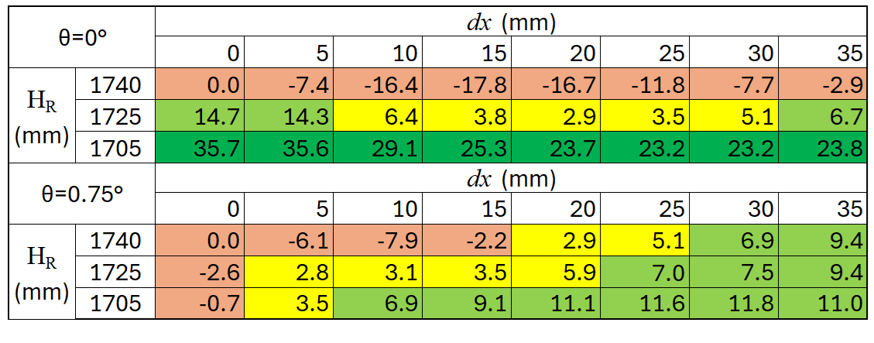
Fig. 6: Weighted score, S, for adopted configurations at θ = 0° and θ = 0.75°
4.4. Receiver Longevity via dx as the Novel Design Contribution
Receiver defocus is well established in the literature. Prior studies combining ray tracing with thermal-stress analysis report the same efficiency-for-uniformity trade-off found in Sections 4.1–4.3, and link non-uniform flux directly to receiver fracture, confirming flux uniformity as a meaningful reliability metric. This study builds on that foundation, and its real contribution is the lateral focal split. Its defining advantage is one that a single receiver-height adjustment alone cannot provide. By splitting the primary mirror into two laterally displaced focal points, the design gives the reflected ray bundle two aim points instead of one, recovering rays that a single-focus receiver would otherwise lose outright once tracking error appears. Because the modification is limited to the primary mirror, it requires no redesign of the secondary optical surface or receiver, thereby avoiding the alignment, soiling, and low-angle ray-blocking costs associated with secondary-reflector approaches.
This is why the combined geometry identified in Section 4.3, a lowered receiver paired with a moderate focal split, outperforms the traditional design under both ideal and realistic tracking conditions, rather than only under one. Its efficiency and flux-quality cost are paid under a continuously perfect-tracking condition, which real fields rarely sustain, while its benefit, a lower peak flux and a more uniform distribution, accrue under the imperfect-tracking condition that a field spends most of its operating life in. The practical outcome is a single design direction, a reduced receiver height combined with a moderate focal split, with the trade-off against optical efficiency the only cost a designer needs to weigh.
- Conclusion
This study evaluated a split-focus, shifted-receiver modification to the LS-III parabolic trough collector using a two-stage MCRT-ODO campaign spanning 2952 optical cases. A reduced receiver height combined with a moderate lateral focal split outperforms the conventional single-focus geometry under both ideal and realistic tracking conditions, at the cost of a bounded reduction in optical efficiency. Because circumferential thermal cycling, rather than average flux level, is understood to drive receiver bending and seal fatigue, this efficiency-for-uniformity trade-off is expected to improve the receiver's chances of a longer operational life.
This benefit to receiver lifetime remains plausible rather than proven, since flux non-uniformity is a documented contributor to seal fatigue but not yet a directly quantified predictor of service life. Confirming this link requires coupling these optical results with a thermomechanical fatigue model, quantifying the associated maintenance-cost savings, and validating the design through prototype testing. These steps are left for future work.
CRediT authorship contribution statement
Sainath A. Waghmare: Conceptualization, Methodology, Investigation, Formal analysis, Validation, Data curation, Writing - original draft, Writing - review and editing. Gabriel Cardona: Software, Investigation, Formal analysis, Writing - review and editing. Ramón Pujol-Nadal: Supervision, Resources, Project administration, Funding acquisition, Writing - review and editing.
Funding
This work is part of the project PID2024-160780OB-I00 funded by MICIU/AEI/10.13039/501100011033 and by the European Union through the European Regional Development Fund (ERDF/FEDER). Reference contract PD-016-2023, within the framework of grants to incorporate research personnel into the science system of the Balearic Islands (postdoc contracts 2023), financed by the Government of the Balearic Islands (CAIB) and the European Social Fund Plus (ESF+).
Declaration of Competing Interest
The authors declare that they have no known competing financial interests or personal relationships that could have appeared to influence the work reported in this paper.
Data Availability
The data that support the findings of this study are available from the corresponding author upon request.
Declaration of AI-assisted technologies in the writing process
As non-native English speakers, the authors used Grammarly and Anthropic's Claude to correct grammatical errors and improve sentence structure for clarity while preparing this manuscript.
References
Agagna, B., Behar, O., Smaili, A., 2022. Performance analysis of parabolic trough solar collector under varying optical errors. Energy Sources, Part A: Recovery, Utilization, and Environmental Effects. 44(1), 1189-1207. Doi: 10.1080/15567036.2022.2052385
ASTM International, 2003. Standard tables for reference solar spectral irradiances: Direct normal and hemispherical on 37° tilted surface (ASTM G173-03). url: https://store.astm.org/g0173-03.html
Buie, D., Monger, A.G., Dey, C.J., 2003. Sunshape distributions for terrestrial solar simulations. Solar energy. 74(2), 113-122. doi: 10.1016/S0038-092X(03)00125-7
Cardona, G., Pujol-Nadal, R., 2020. OTSun, a Python package for the optical analysis of solar-thermal collectors and photovoltaic cells with arbitrary geometry. Plos one. 15(10), 0240735. doi: 10.1371/journal.pone.0240735
Heimsath, A., Sutardhio, C., Schöttl, P., Nitz, P., 2020. Soiling of solar mirrors-impact of incidence angles on CSP plant performance. In AIP Conference Proceedings (Vol. 2303, No. 1, p. 210003). AIP Publishing LLC. doi: 10.1063/5.0029067
Leal, M., Pujol-Nadal, R., Domingo Álvarez, J., del Mar Castilla, M., Torres, J. L., Cardona, G., Pérez, M., 2024. Optical performance analysis of a hybrid parabolic trough collector with photovoltaic slats. Applied Optics. 63(34), 8878-8889. doi: 10.1364/AO.537784
Mehos, M., Price, H., Cable, R., Kearney, D., Kelly, B., Kolb, G., Morse, F., 2020. Concentrating solar power best practices study (No. NREL/TP--5500-75763). National Renewable Energy Laboratory (NREL), Golden, CO (United States); Solar Dynamics, LLC, Denver, CO (United States). url: http://en.cnste.org/uploads/soft/200703/1_1416292091.pdf
Natraj, Reddy, K.S., 2023. Investigations of thermo-structural instability on the performance of solar parabolic trough collectors. Renewable Energy. 202, 381-393. doi: 10.1016/j.renene.2022.11.068
Sallaberry, F., Tian, Z., Jauregi, O.G., Furbo, S., Perers, B., Zourellis, A., Rothmann, J.H., 2018. Evaluation of the tracking accuracy of parabolic-trough collectors in a solar plant for district heating. In AIP Conference Proceedings (Vol. 2033, No. 1, p. 030015). AIP Publishing LLC. doi: 10.1063/1.5067031
Shimada, D., Iwamoto, T., Maruhashi, A., Kitagawa, K., Shimizu, R., Ijitsu, A., Ueta, M., Yoshida, J., Inoue, S., Minamizawa, Y., Tamamura, T., 2025. Experimental and numerical investigation of receiver tube fracture of parabolic trough solar thermal collectors. Renewable Energy. 259, 125022. doi: 10.1016/j.renene.2025.125022
Shyam, A., Ahmed, K.R.A., Christopher, S.S., Iniyan, S., 2024. Thermal performance enhancement in a solar parabolic trough collector with optimized secondary optics. Clean Technologies and Environmental Policy. 26(3), 771-784. doi: 10.1007/s10098-023-02649-2
Stettenheim, J., McBride, T., Brambles, O., Magari, P., Davis, B., Iveson, M., Chen, W., Kaszeta, R., Kattamis, N., Cheng, C., 2013. Advanced Low-Cost Receivers for Parabolic Troughs. CONCENTRATING SOLAR POWER PROGRAM REVIEW 2013, p.21. url: https://docs.nlr.gov/docs/fy13osti/58484.pdf#page=26
Waghmare, S.A., Gulhane, N.P., 2016. Design and ray tracing of a compound parabolic collector with tubular receiver. Solar Energy. 137, 165-172. doi: 10.1016/j.solener.2016.08.009
Wang, Y., Liu, Q., Lei, J., Jin, H., 2015. Performance analysis of a parabolic trough solar collector with non-uniform solar flux conditions. International Journal of Heat and Mass Transfer. 82, 236-249. doi: 10.1016/j.ijheatmasstransfer.2014.11.055
Wu, Z., Lei, D., Yuan, G., Shao, J., Zhang, Y., Wang, Z., 2014a. Structural reliability analysis of parabolic trough receivers. Applied energy. 123, 232-241. doi: 10.1016/j.apenergy.2014.02.068
Wu, Z., Li, S., Yuan, G., Lei, D., Wang, Z., 2014b. Three-dimensional numerical study of heat transfer characteristics of parabolic trough receiver. Applied energy. 113, 902-911. doi:10.1016/j.apenergy.2013.07.050
Zou, B., Jiang, Y., Yao, Y., Yang, H., 2019. Optical performance of parabolic trough solar collectors under condition of multiple optical factors. Applied Thermal Engineering. 160, 114070. doi: 10.1016/j.applthermaleng.2019.114070

