EuroSun2026
PASSIVE INTELLIGENT RADIANT COOLING AND HEATING FOR ZERO-ENERGY HOUSES
S.H.Yoo^{1,*}, H.F.CARLAK², F.Bagheri ³, S.Kim¹
¹ Nearly Zero Energy Concepts for Solar Apartment Consortium/Yonsei University, Seoul, Republic of Korea
²Akdeniz University, Department of Electrical-Electronics Engineering,²Elektromed Ar-Ge Ltd, Antalya, Türkiye
³Antalya Bilim University, Department of Electrical & Electronics Engineering, ³INELSO Energy Company, Antalya, Türkiye
^{1,*} mryooo@naver.com , ²fezacarlak@akdeniz.edu.tr , ³farzaneh.bagheri@antalya.edu.tr
Summary
This study investigates a passive intelligent radiant cooling (PIRC) and heating concept for nearly zero-energy residential buildings. The system reuses an existing hydronic radiant-heating network for summer cooling using low-temperature water and can be combined with source-flow ventilation or a downstream fan-coil unit (FCU). A full-scale residential experiment in South Korea evaluated cooling capacity, intermittent water-flow behavior, and vertical thermal conditions. During two laundry-driven water-use periods, the radiant component provided 55.2–57.9 W/m² of cooling, while the combined PIRC-FCU thermal output reached 101.7–115.4 W/m². Water-side enthalpy and DIN EN 14240-based radiant-capacity estimates differed by approximately 5–7% across the two test periods. A parallel pilot in Antalya, Türkiye, integrates groundwater-based radiant heating and cooling with photovoltaic generation, battery storage, and intelligent energy management. A cradle-to-grave LCA framework using openLCA and Ecoinvent has also been established to compare PIRC with conventional compressor-based radiant cooling over a 25-year service life.
Keywords: passive intelligent radiant cooling, radiant floor cooling, source-flow ventilation, water enthalpy, nearly zero-energy building, thermal comfort
Field of application for the findings: Low-energy radiant cooling and heating for nearly zero-energy and off-grid buildings, including renewable-energy integration and life-cycle environmental assessment.
Addressed audience: Researchers and practitioners in solar buildings, building energy, HVAC and radiant systems, sustainable architecture, and low-carbon building technologies.
1. Introduction
The increasing cooling demand of buildings has intensified the need for thermal-conditioning strategies that reduce operational energy use and peak electricity demand while maintaining indoor comfort. Radiant cooling is attractive in this context because a large fraction of human thermal exchange occurs radiatively and because water can transport sensible heat with much lower distribution energy than all-air systems. Previous work on passive intelligent radiant cooling showed that an existing floor-heating network can be repurposed for cooling by circulating naturally cool water through the embedded pipes, thereby reducing surrounding surface temperatures and improving the operative thermal environment (Yoo, 2022).
The PIRC concept examined here extends this principle. The embedded hydronic floor network is used as the primary radiant heat exchanger, and an FCU is connected downstream when additional air-side cooling and air movement are required. This arrangement differs from a conventional vapour-compression cooling system: the principal cooling source is the temperature difference between the supplied water and the indoor environment, while the existing floor structure provides thermal storage and a large radiant exchange area. Earlier measurements of a related system reported an average operative temperature of 25.69 °C and a maximum radiant asymmetry of 1.88 °C under hot summer conditions, indicating that low-temperature floor cooling can provide acceptable thermal conditions when surface temperatures and humidity are appropriately controlled (Yoo, 2022; ANSI/ASHRAE, 2004).
Beyond cooling capacity and thermal comfort, the environmental benefit of low-energy cooling systems should be evaluated over their full life cycle. Recent building and air-conditioning LCA reviews show that environmental performance depends not only on operational electricity, but also on equipment manufacturing, refrigerant-related emissions, system boundaries, and service-life assumptions (Hansen et al., 2023; Litardo et al., 2023). Related reviews have also highlighted techno-environmental and life-cycle considerations for building cooling technologies (Pirvaram et al., 2022). For radiant cooling, life-cycle and whole-life-carbon comparisons have reported lower impacts than conventional all-air alternatives under specific building and operating conditions, while also showing that embodied impacts become increasingly important as operational energy demand decreases (Pieskä et al., 2023; Shindo et al., 2023). Recent experimental work in a zero-energy office further showed that radiant cooling can provide comparable thermal comfort with lower energy use than air-based cooling under controlled conditions (Li et al., 2024). These findings motivate evaluating PIRC through both measured thermal performance and a cradle-to-grave LCA framework.
The present paper extends the earlier PIRC work by focusing on the 2026 South Korean full-scale experiment and by quantifying the cooling contribution of the radiant floor and the connected FCU under two water-use periods. Particular attention is given to cooling capacity, intermittent water flow, vertical temperature distribution, and the consistency between direct enthalpy-based capacity and the DIN EN 14240-based radiant-capacity estimate. A separate pilot implementation is also being developed in Antalya, Türkiye, within an off-grid-oriented building concept integrating groundwater-based radiant heating and cooling with photovoltaic generation and battery storage. This parallel implementation extends the investigation toward different climatic and building conditions and provides a basis for evaluating the broader applicability of the PIRC concept. Together with the LCA framework described in Section 2.4, these activities provide the basis for cross-climate evaluation and environmental assessment.
2. Methodology
2.1. Passive Intelligent Radiant Cooling (PIRC) System
The PIRC system was tested in a residential building in South Korea. The system reuses the pipe network originally installed for radiant floor heating. During cooling operation, low-temperature water passes through the embedded floor pipes and absorbs sensible heat from the floor structure and the room. The concept is compatible with source-flow ventilation, in which a water-to-air heat exchanger can pre-cool incoming ventilation air. In the present full-scale experiment, an FCU connected to the downstream water line was used to quantify the additional air-side cooling potential. The radiant component therefore represents the passive/low-energy heat-exchange mechanism, whereas the experimental FCU fan and groundwater pump are auxiliary electrical components that must be included in any net-energy assessment.
Figure 1 shows the test-room section and the existing radiant-heating pipe layout reused for cooling.
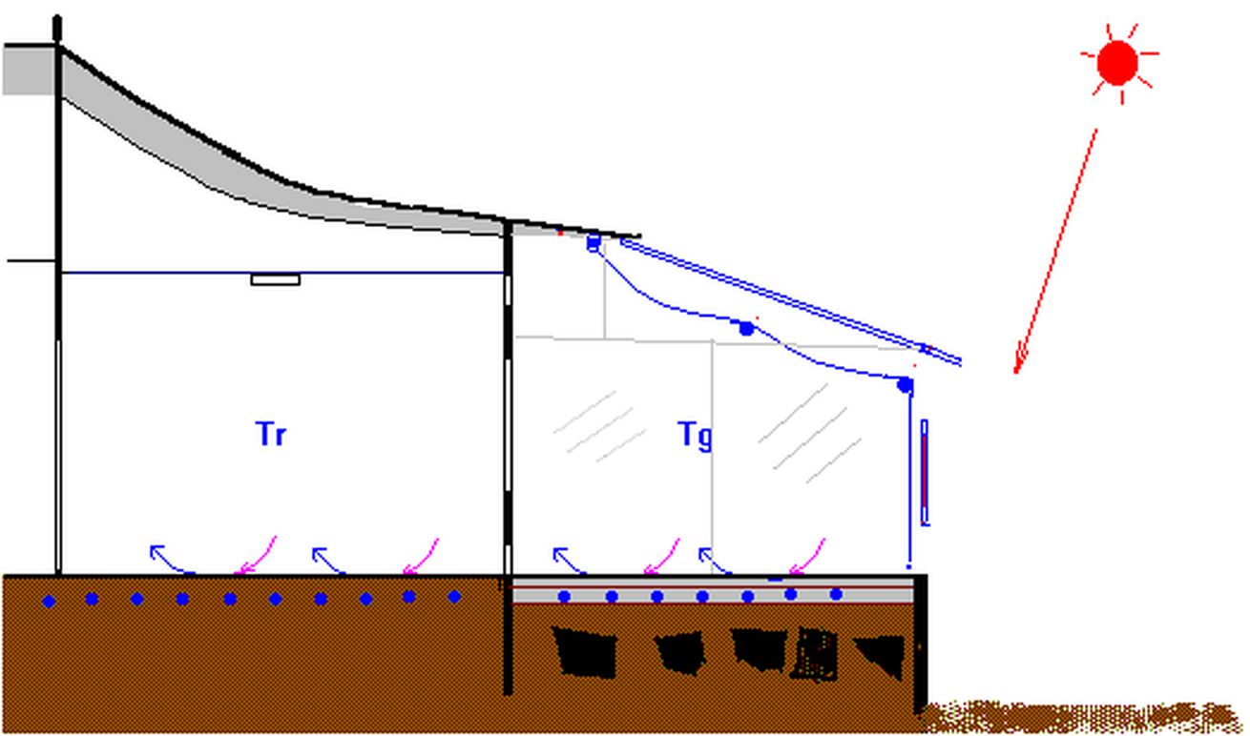
(a) Section of the test room (Yoo, 2022)
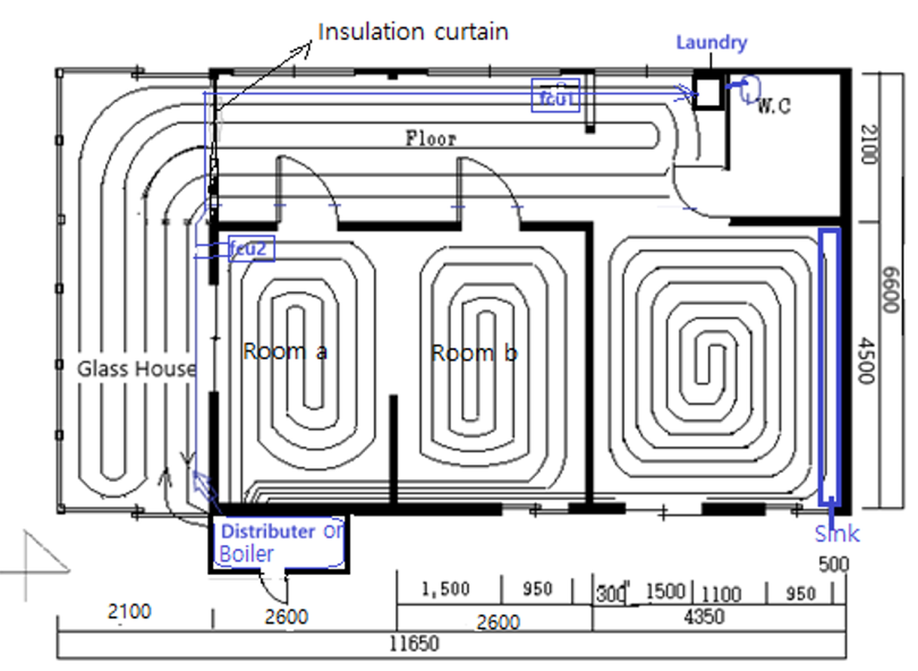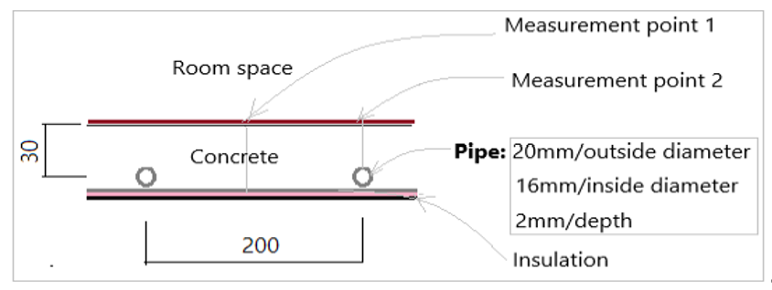
(b) Cooling-pipe plan (left: floor plan; right: section)
Fig. 1: Test-room configuration and radiant cooling/heating pipe layout
The house dimensions are approximately 11.7 m × 6.6 m × 2.5 m (length × width × height), including the attached glass house. The active floor area of Room a (Tr in (a)) is 10.3 m² and the ceiling height is 2.1 m. The glass house uses vacuum glazing. The exterior wall was retrofitted with a 5 cm sandwich panel, whereas the interior wall retains the original 10 cm traditional earthen construction. The glass window between the glass house and Room a is 3 mm thick.
The radiant-cooling pipe is polyethylene, with a pipe spacing of 200 mm and approximately 30 mm of concrete above the pipe to the floor surface. Fifty one measurement points were monitored. Measurements included solar irradiance, outdoor air temperature, vertical room-air temperature, floor and enclosure surface temperatures, glass-house temperatures, inlet and outlet water temperatures, water flow rate, globe temperature, indoor air velocity, relative humidity, and dew-point temperature. This expanded measurement set follows the thermal-behavior approach used in the earlier PIRC study, while adding variables needed to assess air movement and condensation risk.
Table 1 summarizes the measured variables and instruments.
Tab. 1: Measurement variables and instrumentation
Measurement factor (Position) | Method
Solar irradiance (2.3 m) | Pyranometer
Outdoor air temperature (1.5 m) | K-type thermocouple + data logger
Vertical room temperature (floor surface, 0.1 m, 0.8 m, 1.1 m, 1.7 m, 2.0 m, 2.1 m [ceiling surface]) | K-type thermocouple + data logger
Vertical floor temperature (floor surface, 0.1 m, 0.8 m) | K-type thermocouple + data logger
Inside surface temperature (walls/window at 1.1 m; ceiling; floor surfaces 1–3) | K-type thermocouple + data logger
Glass-house surface and vertical-air temperatures (0.1 m, 0.8 m, 2.3 m) | K-type thermocouple + data logger
Inlet/outlet water and pipe-surface temperatures | K-type thermocouple + data logger
Water flow rate | Electromagnetic flow meter (M-1500 DA)
Globe temperature (room and glass house, 0.8 m) | Globe thermometer
Air velocity, room relative humidity, and dew-point temperature (floor) | TES 1341N Hot-Wire Anemometer
2.2. Experimental Procedure and Cooling-Capacity Evaluation
The instantaneous cooling rates of the water-side PIRC and the air-side FCU were calculated from the measured mass flow rate and inlet–outlet enthalpy difference according to Eq. (1):
Q = m × (h₂ − h₁) (1)
where Q is the thermal cooling rate (W), m is the mass flow rate (kg/s), and h₁ and h₂ are the inlet and outlet specific enthalpies. For sensible heat, h₂ − h₁ = Cₚ(t₂ − t₁), with Cₚ = 4.186 kJ/(kg·K) for water and approximately 1.02 kJ/(kg·K) for air. The reported capacities in W/m² were obtained by normalizing the corresponding thermal cooling rates to the active floor area represented in each calculation. The radiant-floor capacity was also compared with the DIN EN 14240 correlation for a comparable radiant cooling geometry (DIN EN 14240, 2004).
In the 2026 experiment, groundwater pumped from an underground well directly in front of the building was used as the cooling medium. Water passed through Rooms a and b before reaching the downstream FCU. Cooling capacity was evaluated only during periods of measurable water flow. The FCU fan was operated electrically to enhance air-side heat transfer. Therefore, the reported PIRC and FCU values represent thermal cooling output rather than net electrical or primary-energy performance.
Figure 2 shows the cooling capacities of the PIRC and FCU during the morning laundry period on 15 July 2026.

Fig. 2: Cooling capacity of the PIRC and FCU during the morning laundry period
Water was supplied through Rooms a and b during the laundry cycle. Total water use was 232 L and the average water mass flow rate during operation was 0.05 kg/s. The average FCU air velocity was 3.42 m/s and the measured relative humidity averaged 79.3%. During active-flow intervals within the 140 min observation period, the combined thermal cooling capacity of the PIRC and FCU was 101.7 W/m². The water-side enthalpy calculation gave a radiant PIRC capacity of 57.9 W/m², while the DIN EN 14240-based estimate was 54.8 W/m², a difference of approximately 5%. The close agreement supports the internal consistency of the two capacity-estimation approaches for this test condition.
Figure 3 shows the time-resolved vertical temperature distribution in Room a during the morning laundry period.

Fig. 3: Time-resolved vertical temperature distribution in Room a
During the morning test, the indoor air and surface temperatures remained substantially more stable than the water temperature, reflecting the thermal inertia of the floor construction.
Figure 4 compares the period-average vertical temperature profile with the profile measured at 10:00, when water was flowing for the laundry cycle.

Fig. 4: Period-average temperatures, 10:00 temperatures, and corresponding differences in Room a
The blue bars represent the average temperatures over the full laundry period, the red bars represent the 10:00 temperatures during active water use, and the green line indicates the corresponding temperature differences. Groundwater temperature was 16.84 °C at 10:00 and averaged 17.65 °C over the measurement period. The corresponding pipe-surface temperatures were 21.13 and 22.35 °C, and the average floor-surface temperatures were 24.16 and 24.91 °C. Air temperature increased with height from the near-floor zone toward the ceiling, but the vertical differences remained modest. The largest difference occurred at 0.1 m, where air movement from the FCU affected the local temperature field. This indicates that the measured vertical profile reflects the combined effects of floor radiation, buoyancy, and fan-induced mixing rather than radiant cooling alone.
Figure 5 shows the intermittent water-flow pattern during the morning laundry cycle.

Fig. 5: PIRC water-flow rate during the morning laundry cycle (total water use: 232 L)
The water flow was strongly intermittent, following the operating sequence of the washing machine. Flow occurred during several discrete intervals rather than continuously, with an average measured rate of 0.05 kg/s during the test. Despite this intermittent input, the room air and globe temperatures remained approximately 26.9 and 27.1 °C, respectively. This behavior is consistent with the high thermal capacity of the concrete floor reported in the earlier PIRC study, which damped short-term variations in water flow (Yoo, 2022).
Figure 6 shows the cooling capacities of the PIRC and FCU during the afternoon laundry period on 15 July 2026.

Fig. 6: Cooling capacity of the PIRC and FCU during the afternoon laundry period
During the afternoon test, total water use was 227 L and the average water mass flow rate was 0.033 kg/s. During active-flow intervals within the 130 min observation period, the combined thermal cooling capacity of the PIRC and FCU reached 115.4 W/m². The water-side enthalpy method gave a radiant PIRC capacity of 55.2 W/m², whereas the DIN EN 14240-based estimate was 59.8 W/m², a difference of approximately 7%. Although the ordering of the two estimates reversed relative to the morning test, their agreement remained within 7%, suggesting that both methods describe a similar magnitude of radiant cooling under the tested conditions.
Figure 7 shows the time-resolved vertical temperature distribution during the afternoon test.

Fig. 7: Time-resolved vertical temperature distribution in Room a during the afternoon test
The afternoon boundary conditions were more severe than in the morning, with higher outdoor and glass-house temperatures and substantially higher solar irradiance.
Figure 8 summarizes the average vertical temperature profile during the afternoon laundry period.

Fig. 8: Average vertical temperature profile during the afternoon
The afternoon profile had a shape similar to the morning profile but was shifted to higher temperatures. The measured groundwater temperature averaged about 18.3 °C, the pipe surface about 23.1 °C, and the average floor surface about 25.5 °C, while indoor air temperatures were approximately 26.6–28.2 °C across the measured heights. This temperature hierarchy is physically consistent with heat transfer from the room to the cooled floor structure. Because relative humidity was high during operation, however, condensation safety should be assessed using the measured dew-point temperature and the minimum floor/pipe-surface temperature rather than inferred from air temperature alone.
2.3. Türkiye Pilot Implementation
A parallel radiant heating and passive cooling implementation is being developed in Antalya, Türkiye, as part of an off-grid-oriented building concept integrating radiant thermal systems with local building characteristics and renewable-energy generation. The pilot building is located in Alanya, Antalya, at an altitude of approximately 400 m and has been designed to operate independently of the conventional electricity and water grids. The climatic conditions of the region, characterized by high summer temperatures, high solar energy potential, and a comparatively moderate heating demand during winter, provide a suitable environment for investigating renewable-energy-based heating and cooling solutions.
The proposed energy infrastructure consists primarily of photovoltaic (PV) generation, battery energy storage, a water-source heat pump (WSHP), and a hydronic underfloor heating/cooling system. Two PV systems have been designed for the pilot site. The first system is dedicated to water supply and consists of 32 monocrystalline PV modules rated at 550 W each, corresponding to an installed capacity of approximately 17.6 kWp. An 11 kVA motor drive is integrated to operate the borehole pumping system, while the PV modules are installed at an inclination of approximately 7°. The second system is a 45 kWp rooftop PV installation using 615 W monocrystalline modules with TOPCon cells. A 30 kW hybrid inverter and a 30 kWh LiFePO4 battery energy storage system are integrated into this system. This configuration provides the infrastructure for off-grid electricity generation, energy storage, and coordinated load management.
For thermal conditioning, a water-source heat pump is integrated with a hydronic underfloor heating and cooling system. Groundwater provides a relatively stable thermal source compared with outdoor air, allowing the heat pump to operate under favorable conditions throughout the year. During heating operation, thermal energy extracted from the groundwater is transferred through an intermediate plate heat exchanger to the heat pump evaporator. The refrigerant subsequently undergoes the conventional vapor-compression cycle, and the resulting thermal energy is transferred to the hydronic underfloor heating circuit. The heated water circulates through the floor pipes and transfers heat to the indoor environment until the required thermal conditions are achieved.
The system is also designed to exploit passive or natural cooling. In passive cooling mode, the relatively low temperature of the groundwater can be transferred directly to the building-side hydronic circuit through an intermediate heat exchanger, while the heat-pump compressor remains inactive. Only the circulation pumps are required, substantially reducing electrical consumption compared with active mechanical cooling. Passive cooling can therefore be used during low and moderate cooling loads, while active cooling can be activated when the cooling demand exceeds the capacity of the passive mode. An intelligent control strategy can select between these operating modes according to indoor temperature, thermal demand, water temperature, and overall system conditions. Appropriate control of the floor surface temperature is also required to prevent condensation when underfloor cooling is applied.
The Turkish implementation represents a new-build pilot case, whereas the corresponding South Korean implementation is based on a retrofit approach in which an existing radiant-heating network is reused. This distinction is important when comparing the two implementations because building characteristics, system configuration, and installation constraints can differ substantially between new-build and retrofit applications. At the current stage, the Turkish installation is considered a pilot implementation framework, and validated operational performance data are not yet available. Therefore, direct quantitative cross-country performance comparisons should not be made until comparable experimental data have been obtained from both sites.
The integration of PV generation, battery storage, groundwater-based thermal energy, and radiant heating and cooling provides an opportunity to investigate the interaction between renewable electricity production and building thermal demand. PV electricity can be used to supply the heat pump, circulation pumps, borehole pump, and other building loads, while excess generation can be stored in the battery. Intelligent energy management can subsequently coordinate PV generation, battery state of charge, thermal demand, and the operating modes of the heating and cooling systems. Such an approach can increase renewable-energy utilization, reduce peak electrical demand, and improve the energy autonomy of the off-grid building.
Overall, the Antalya pilot combines water-source heat pump technology, radiant heating and passive cooling, photovoltaic generation, battery storage, and intelligent energy management within an integrated off-grid-oriented building concept. The combination of stable groundwater temperatures, high solar availability, and low-energy radiant distribution provides a suitable platform for investigating energy-efficient thermal conditioning and for future optimization and validation of the proposed system.
Figure 9 shows an architectural layout plan of the Antalya pilot implementation building.
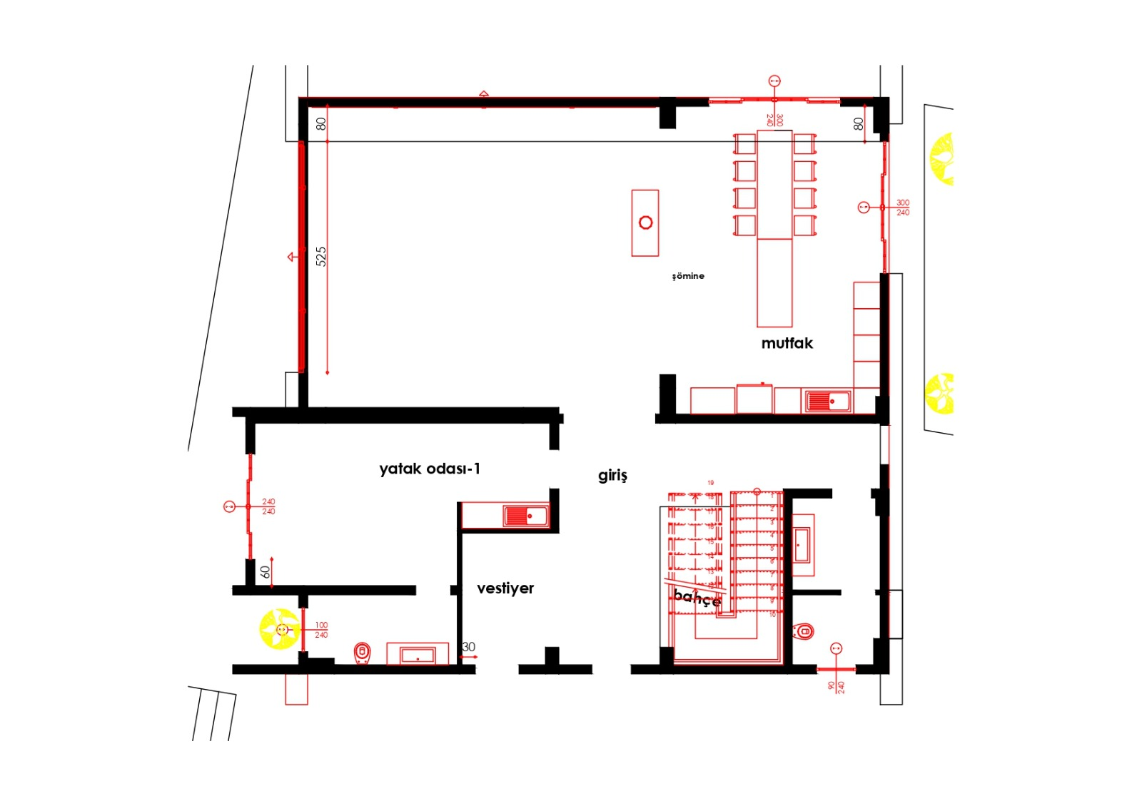
Fig. 9: Architectural layout plan of the Antalya pilot implementation building

2.4. Life-Cycle Assessment (LCA) Methodology
2.4.1. Goal, Scope, and System Boundaries
A cradle-to-grave Life-Cycle Assessment (LCA) framework is being established using openLCA to evaluate and compare the environmental performance of a conventional compressor-based radiant cooling (RC) system against the Passive Intelligent Radiant Cooling (PIRC) system. The Life-Cycle Inventory (LCI) is developed by integrating project-specific foreground data with representative background processes from the Ecoinvent database. This approach enables the environmental burdens associated with material manufacturing, installation, operational use, maintenance, and end-of-life management to be assessed within a consistent framework.
For the LCA comparison case, the functional unit is defined as the provision of cooling service to a 78 m² conditioned office area over a 25-year service life. This LCA comparison case is treated separately from the South Korean residential experiment. The system boundary follows a cradle-to-grave approach, encompassing raw material extraction and production (A1–A3), transportation and installation (A4–A5), the operational use phase (B1–B7), and end-of-life processes (C1–C4). “A, B, and C” refer to the different stages of a building/product life cycle. This classification is commonly used within the framework of EN 15804 and EN 15978. Stage A covers the product and construction process stages, Stage B corresponds to the use stage, and Stage C represents the end-of-life stage.
For the operational phase, annual electricity consumption data derived from TRNSYS simulations are integrated into the model, distinguishing the energy demand of the chiller/heat pump from the circulation pumps. In the PIRC system, the reduced mechanical cooling load is reflected through the lower electricity demand. In addition, refrigerant leakage is modeled as a direct elementary emission to air, allowing both direct fugitive emissions and indirect grid-related emissions to be accounted for.
2.4.2. Life-Cycle Inventory (LCI) and Ecoinvent Mapping
Foreground inventory parameters are derived from the technical specifications of both cooling systems and linked to representative Ecoinvent background processes. Turkish-specific electricity datasets ({TR}) are prioritized for operational energy, while European ({RER}), Swiss ({CH}), and global ({GLO}) datasets are utilized where representative local processes are unavailable. Tab. 2 summarizes the comparative inventory parameters and the corresponding Ecoinvent process mapping.
Tab. 2: Comparative Life-Cycle Inventory Parameters and Ecoinvent Mapping for the Radiant Cooling Systems
Component / Flow | Standard RC System | PIRC System | Corresponding Ecoinvent Background Process
Radiant Panel (Aluminium) | 4.80 kg | 4.80 kg | Aluminium, wrought alloy {RER} | production
PEX Piping | 47.58 kg | 47.58 kg | Polyethylene, linear low density (LLDPE) {RER} | production
Thermal Mass (Concrete/Screed) | 8580 kg | 8580 kg | Concrete, sole plate and foundation {CH} | production
Chiller / Heat Pump | 1.0 unit | 0.5 unit | Heat pump, brine-water, 15 kW {RER} | production
Refrigerant Charge (R410A) | 2.0 kg | 1.0 kg | Refrigerant R410A {GLO} | market for
Annual Chiller Electricity | 2005 kWh | 500 kWh | Electricity, low voltage {TR} | market for electricity
Annual Circulation Pump Electricity | 234 kWh | 117 kWh | Electricity, low voltage {TR} | market for electricity
Refrigerant Leakage (R410A) | 0.08 kg/year | 0.04 kg/year | Air emission / halogenated hydrocarbons
Product systems and process interconnections are structured within openLCA, with connection consistency verified via the openLCA Model Graph.
2.4.3. Life-Cycle Impact Assessment and Modeling Assumptions
Upon completion of inventory modeling, Life-Cycle Impact Assessment (LCIA) will be performed to evaluate key environmental indicators, including:
• Global Warming Potential (GWP, kg CO₂-eq)
• Cumulative / Primary Energy Demand (CED / PED)
• Acidification Potential (AP)
• Eutrophication Potential (EP)
• Photochemical Ozone Creation Potential (POCP)
• Abiotic Depletion Potential (ADP)
EF 3.1 and CML-IA Baseline methods are selected as candidate characterization models. For end-of-life modeling, a 90% recycling rate is assumed for structural metal and glass components, evaluating both Cut-off and System Expansion approaches. Furthermore, Energy Payback Time (EPBT) and Carbon Payback Time (CPBT) will be calculated separately as system-level performance metrics.
At the current stage, the methodological framework and product systems have been structured; full quantitative impact results and comparative analyses will be reported in subsequent work.

3. Conclusions
This study demonstrates the technical feasibility of a passive intelligent radiant cooling concept that reuses existing radiant-heating infrastructure and exploits the thermal potential of low-temperature water. In the 2026 South Korean full-scale tests, the radiant PIRC component delivered 55.2–57.9 W/m², and the combined PIRC-FCU thermal output reached 101.7–115.4 W/m². Across the two test periods, the radiant-capacity estimates obtained from the measured water-side enthalpy change and the DIN EN 14240-based relation differed by approximately 5–7%.
The results also indicate that the thermal mass of the floor can buffer intermittent household water use, while the vertical temperature field remains physically consistent with a cooled floor and a warmer upper room zone. The concept is therefore promising as a building-integrated strategy for reducing conventional cooling demand. However, thermal cooling output alone does not establish net energy or carbon benefits because pumping and fan electricity, condensation control, and climate-dependent operating conditions must also be considered. To complement the thermal-performance analysis, a cradle-to-grave LCA framework has been established in openLCA to compare PIRC with conventional compressor-based radiant cooling over a 25-year service life, including material production, operational electricity, refrigerant leakage, and end-of-life processes.
The planned LCA will quantify global warming potential, primary energy demand, and other environmental indicators. Future work will combine the LCA results with long-term monitoring and the Antalya pilot implementation to assess net energy and carbon benefits, renewable-energy integration, and the applicability of the PIRC concept under different climatic and building conditions.
4. Acknowledgments
This research was financially supported by the Ministry of Trade, Industry and Energy (MOTIE) and the Korea Institute for Advancement of Technology (KIAT) under Project No. P0026322, and by The Scientific and Technological Research Council of Türkiye (TÜBİTAK) under Project No. 9220035 through the International Cooperative R&D program EUREKA.
5. References
ANSI/ASHRAE Standard 55-2004, 2004. Thermal Environmental Conditions for Human Occupancy.
DIN EN 14240, 2004. Ventilation for buildings – Chilled ceilings – Testing and rating.
Hansen, R.N. et al., 2023. A systematic review of consequential LCA on buildings: the perspectives and challenges of applications and inventory modelling. International Journal of Life Cycle Assessment.
Li, J. et al., 2024. Comparison of the environmental, energy, and thermal comfort performance of air and radiant cooling systems in a zero-energy office building in Singapore. Energy and Buildings 318, 114487.
Litardo, J. et al., 2023. Air-conditioning life cycle assessment research: A review of the methodology, environmental impacts, and areas of future improvement. Energy and Buildings 296, 113415.
Pieskä, H., Ploskić, A., Wang, Q., 2023. Life-cycle assessment of a radiant high-temperature cooling system in the Mediterranean climate. Building and Environment 245, 110847.
Pirvaram, A., Talebzadeh, N., Leung, S.N., O'Brien, P.G., 2022. Radiative cooling for buildings: A review of techno-enviro-economics and life-cycle assessment methods. Renewable and Sustainable Energy Reviews 162, 112415.
Shindo, K. et al., 2023. A comparative study of the whole life carbon of a radiant system and an all-air system in a non-residential building. Energy and Buildings 300, 113668.
Yoo, S.-H., 2022. Thermal Behavior of Passive Intelligent Radiant Cooling Systems. Processes 10.

