EuroSun2026
PERFORMANCE MODEL FOR PHASE-CHANGE MATERIAL THERMAL STORAGES
Anh Kiet Nguyen¹, Phoebe Chalmers², Stephen Harrison²
1 QSBR Innovations, Kingston (Canada)
2 Queen’s University, Mechanical and Materials Engineering, Kingston (Canada)

Summary
Thermal energy storage has been used in domestic hot water systems for many years. Virtually all these systems have been based on sensible heating of potable water that is available on demand to meet the needs of consumers. The use of phase-change materials for thermal storage has been investigated by many researchers in the past. They have the potential to provide a high-energy density storage of thermal energy that can be delivered at a nearly constant temperature. The recent advent of commercial products using phase-change materials has incentivized the development and refinement of test methods and standard procedures for evaluating the performance of these devices under repeatable conditions. In this study, two commercially available, latent heat storages were tested according to a pre-existing test method, designed to evaluate similar products. The test data were then analyzed to create performance models for these phase-change material thermal storages.
Keywords: Phase-change material, latent heat thermal storage, thermal performance, modelling
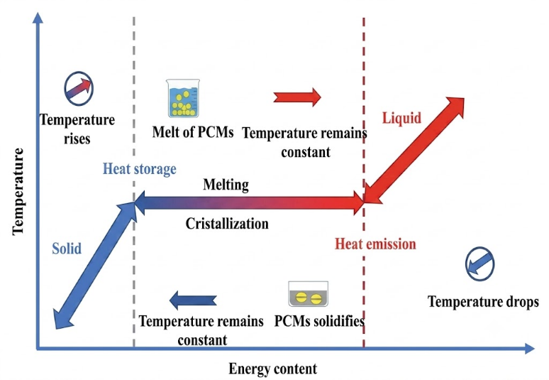
- Introduction
The physics of phase-change material (PCM) storage has been studied by many researchers (Ahmed et al., 2022, Hassan et al., 2016, Radouane, 2022, Teggar et al., 2021). The process involves the latent “heat of fusion” associated with a phase change between a liquid and a solid that occurs without a change in temperature, as demonstrated in Fig. 1. In a recent study, two commercially available phase-change thermal storages were tested in a laboratory environment according to the general requirements of ASHRAE 94.1-2010 (ASHRAE Standards Committee., 2010), to characterize their operations and quantify their overall capacities. Each unit consists of a leakproof container, filled with a salt hydrate with a nominal phase-change temperature of 58°C. Therefore, the storage system requires hot water between 65-80°C to achieve a full charge. Each storage is charged by circulating hot liquid through its integral tube and sheet heat exchanger and discharged by circulating cool liquid through a separate discharge flow loop. The only difference was the capacity of the two units: one weighed 176 kg (unit 1) and the other weighed 129 kg (unit 2).
Fig 1: Charging of an ideal Phase-change substance (Radouane, 2022)

- A Generalized Test Method and Performance Model for Phase-change Storages
Tests were conducted according to the general requirements of ASHRAE Standard 94.1-2010 for phase-change storages. In addition, constant temperature charge tests were also performed to further understand the relation between the energy stored and the fluid charge temperature (Harrison et al., 2024). An instrumented calorimeter rig was used to function as a controlled heat source for the thermal storages. The calorimeter rig comprised two temperature-controlled heaters, speed-controlled pumps, an expansion tank, a pressure relief valve, air eliminators, a magnetic flowmeter, and temperature sensors. The thermal storages were charged at constant power by running hot water from the calorimeter through the charge loop of the storage. The storages were discharged by running cold “mains” water from the calorimeter through the discharge loop to the drain.
Due to the nature of phase-change material, supercooling was observed in all discharge tests. Actual power input or output from the storage was calculated from the product of the water mass flow rate, specific heat, and the temperature difference across the inlets and outlets of the storage.
In terms of modelling the performance of the PCM storages, the concept is to develop a simple “black box” test method and characterization of the storages, which is illustrated with various steps in Fig. 2 below.
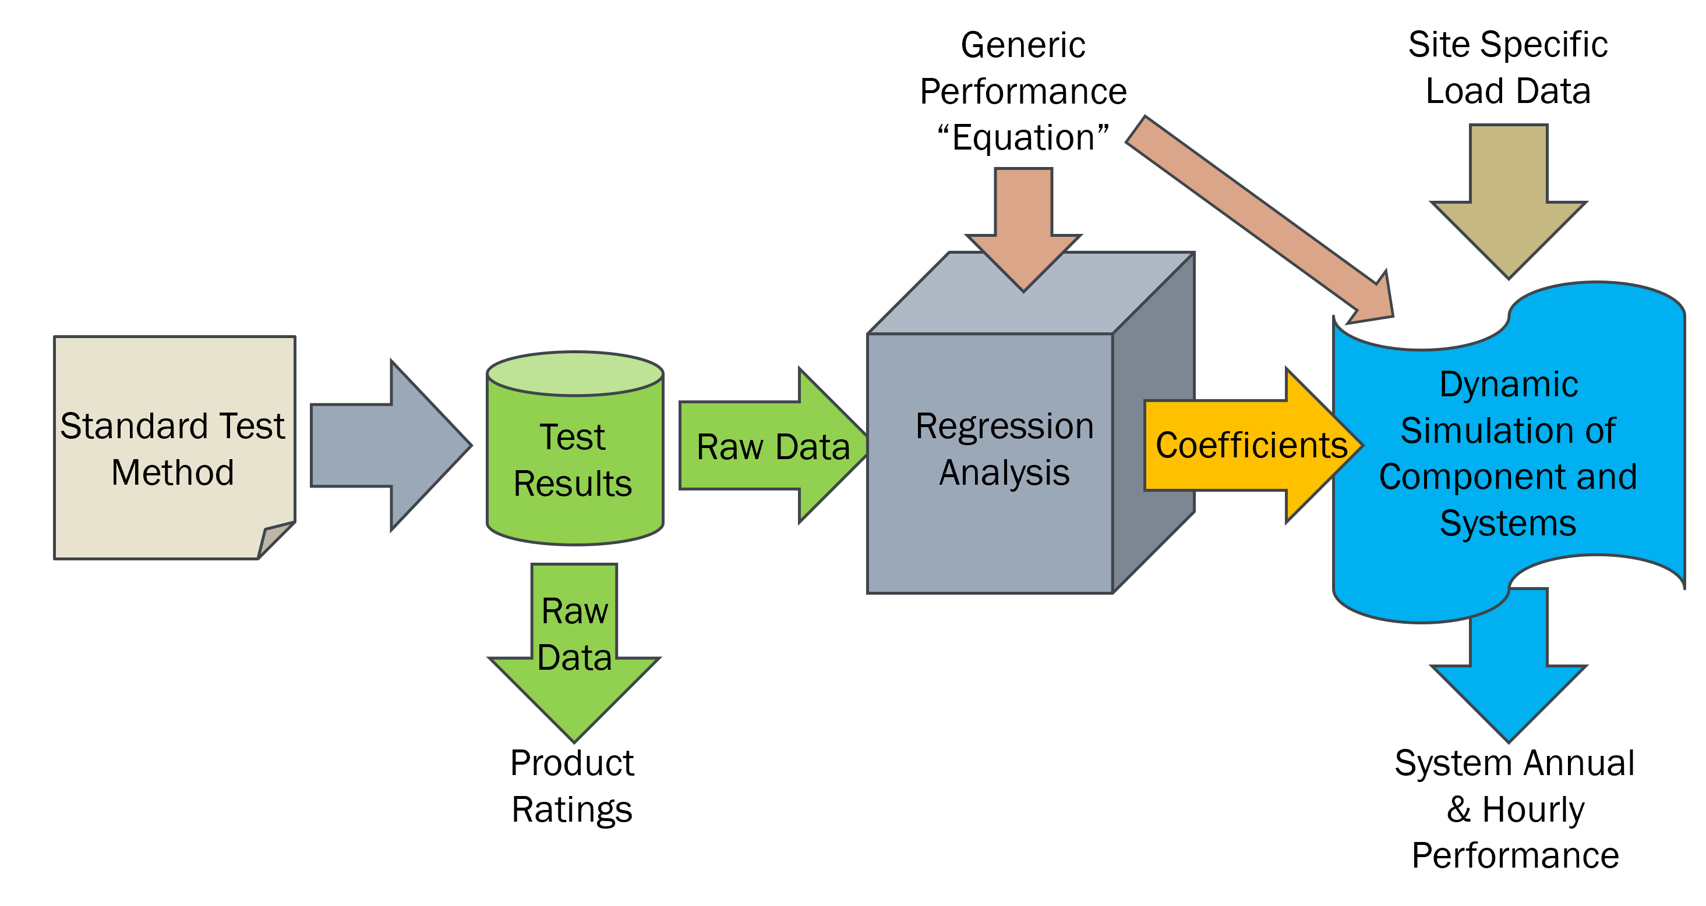
Fig. 2: Flowchart of Model Development
The proposed scheme is to construct a model from experimental testing during typical heating and cooling tests that indicate the energy storage rates and temperature with respect to time. Initially, a PCM storage would undergo sensible heating during the “solid” portion of the heating curve. This is followed by the phase-change portion of the test that proceeds at a relatively constant temperature. During the testing, the energy delivered to the storage will be recorded along with the temperature history, allowing the latent heat of fusion associated with melting of the phase-change material to be estimated. Heating would continue until the outlet temperature of the storage increases indicating the unit is transitioning to the sensible heating of the liquid phase of the PCM material. The effective specific heats occurring during the initial and final stages of the charge cycle would be determined and reported, along with the transition temperature associated with the phase-change. The charge test would be followed with a similar discharge cycle to the same temperatures; the integrated charge and discharge values will define the effectiveness of the storage.
This sequence will be repeated at a range of inlet fluid temperatures both above and below the transition temperature and the net energy stored recorded. It is advantageous to conduct tests in which the supply temperature would be reduced in increments until no latent heating is observed, thereby obtaining a single-phase specific heat value. With this data, it would be possible to construct a general model that will predict the performance of the storage at a range of operational conditions without knowing the details of the storage construction or materials, as depicted in Fig. 3.
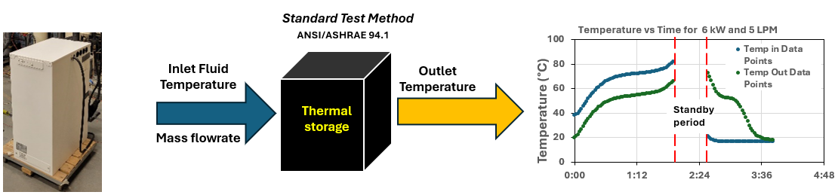
Fig. 3: General Model predicting the performance of the storage based on data from non-intrusive “black box” test method
- Modelling Thermal Storage Performance based on the Energy Stored – Fluid Outlet Temperature Relation
3.1. Developing Curve Fit Equation for Charge Test
Fig. 4 below shows experimental values of energy stored versus the outlet temperature of the charge/discharge fluid.

Fig. 4. Energy Stored vs Fluid Outlet Temperature for Unit 1 Charge Tests
Since with different water flow rates and charge powers, the Energy Stored – Outlet Temperature curves are still in a relatively close position to one another, it can be assumed that this relation is not significantly affected by the flow rate and power. Therefore, it is possible to fit a curve fit through these curves, which will represent the relationship between the outlet temperature and the energy stored. In addition, with the formation of this relationship, the fluid outlet temperature can be considered as the effective temperature that represents the temperature of the storage.
As described, it is desirable to have a general “black box” model that can describe the performance of a PCM storage based on experimental data. The model should be general and applicable to a wide range of PCM materials and operational modes. In analyzing the data measured for the PCM storage, it became apparent that a higher-order mathematical equation was required to ensure that it would apply to a wide range of operational conditions and to other PCM storages. The Generic Performance Equation for Solar Collector (Hottel & Whillier, 1958, Bliss, 1959) and the PCM Storage Capacity Equation (Lane, 1983) were the inspiration to form a general equation in the first place.
Hottel-Whillier-Bliss Equation for Solar Collector:
$\dot{Q}=F_{R}A_{c}\left[\left(τα\right)G_{i}-{U_{L}\left(T_{i}-T_{a}\right)}\right]$ or $\dot{Q}=F^{'}A_{c}\left[\left(τα\right)G_{i}-{U_{L}\left(T_{mean}-T_{a}\right)}\right]$
and G. A. Lane Equation for PCM Storage Capacity:
$$E_{s}=m\left[C_{sp}\left(T_{m}-T_{i}\right)+ a_{m}∆h_{m}+ C_{lp}\left(T_{f}-T_{m}\right)\right]$$
After considerable analysis, a flexible performance equation was identified. The coefficients for the general equation could be identified through a non-linear regression technique. The following equation was found to best fit the complex shape of the PCM heating/cooling experimental data, Fig. 5.
$E= E_{0}+c∙T_{out}+\frac{a}{1+e^{b\left(T_{PC}-T_{out}\right)}}+\left[∆c\left(T_{out}-T_{liq}\right)\right]∙I\left(T_{out}>T_{liq}\right)$ (eq. 1)
This equation can be broken down into four terms:
- $E_{0}$: the energy stored at 0°C in theory.
- $c∙T_{out}$: describe the curve in the solid sensible heating section (before phase change).
- $\frac{a}{1+e^{b(T_{PC}-T_{out})}}$: responsible for the S-shape curvature, or the phase change (latent heating) section
- $[∆c\left(T_{out}-T_{liq}\right)]∙I(T_{out}>T_{liq})$: added in after the material finishes its phase change to describe the curve in the liquid sensible heating section. $I\left(T_{out}>T_{liq}\right)$ is an indicator function with $I=1 if\left(T_{out}>T_{liq}\right)$ and $I=0 if \left(T_{out}<T_{liq}\right)$
With:
$E$: energy stored by the storage
$T_{PC}$: representative temperature at phase change
$T_{liq}$: temperature at the end of phase change, or at the start of the liquid phase
$a,b,c,∆c$: fitting constants

Fig. 5. Proposed Curve Fit Equation and how its individual term corresponds to the curve shape
Based on the tests conducted on the PCM storage, a value of T_{liq} = 60°C was identified, which represents the neck of the curve for the transition from the phase change region to the liquid region curve. The remaining terms of the general equation were then identified by regression analysis on the measured data for the 4 constant power charge tests of Unit 1 and 3 charge tests of Unit 2 using eq. 1. Since the proposed equation contains both the linear functions (for the sensible heating section) and the logistic function (for the phase changing section), a non-linear regression analysis is used. Specifically, the Excel add-in, “Solver”, is used to find the 6 unknown parameters (E₀, T_{PC}, a, b, c, ∆c) that will minimize the sum of squares of the energy residuals, i.e. ${\sum{(Calculated Values-Measured Data)}}^{2}$.
The final result for each parameter is the average of the regression results calculated from the four tests. The finalized equations for the curve fit are as follows:
Unit 1 – charge:
$$E= -1.98+0.103T_{out}+\frac{5.91}{1+e^{0.85(55.38-T_{out})}}+[0.036\left(T_{out}-60\right)]∙I(T_{out}>60)$$
Unit 2 – charge:
$$E= -1.36+0.067T_{out}+\frac{3.22}{1+e^{0.6(56.8-T_{out})}}+[0.065\left(T_{out}-60\right)]∙I(T_{out}>60)$$
Fig. 6 shows the curve fit, as a continuous black line, relative to the real test data points.

Fig. 6. Curve Fit versus Data Points for Unit 1 Charge Tests
Fig. 7 compares Unit 2 curve fit with Unit 1, and Fig. 8 normalizes the two curves by their total energy capacity.
Fig. 8. Unit 1 & Unit 2 Normalized Charge Curve Fit
Fig. 7. Unit 1 & Unit 2 Charge Curve Fit
3.2. Proposed Equation for Discharge Test
Based on the discharge data graphs, the water temperature at the end of phase change (T_{liq}) was approximated to be 54°C for Unit 1 and 53°C for Unit 2.
The same form of equation is applied to the discharge test to describe the relationship between Energy Stored and fluid Outlet Temperature. Using the same non-linear regression method, the parameters for the discharge curve fit equation can be found. The finalized equations for the curve fits are as follow:
Unit 1 – discharge:
$$E= -1.33+0.081T_{out}+\frac{4.8}{1+e^{1.09(52.04-T_{out})}}+[0.106\left(T_{out}-54\right)]∙I(T_{out}>54)$$
Unit 2 – discharge:
$$E= -1.37+0.064T_{out}+\frac{2.97}{1+e^{0.86(50.22-T_{out})}}+[0.045\left(T_{out}-53\right)]∙I(T_{out}>53)$$
Due to the fact that the fluid inlet temperature is now on the cold side, as well as the effect of supercooling, it is expected that the Energy Stored – Outlet Temperature curve fit for the Discharge will be off to the left of the Charge curve fit, which is demonstrated below in Fig. 9 and Fig. 10.
Fig. 10. Charge & Discharge Curve Fits for Unit 2
Fig. 9. Charge & Discharge Curve Fits for Unit 1
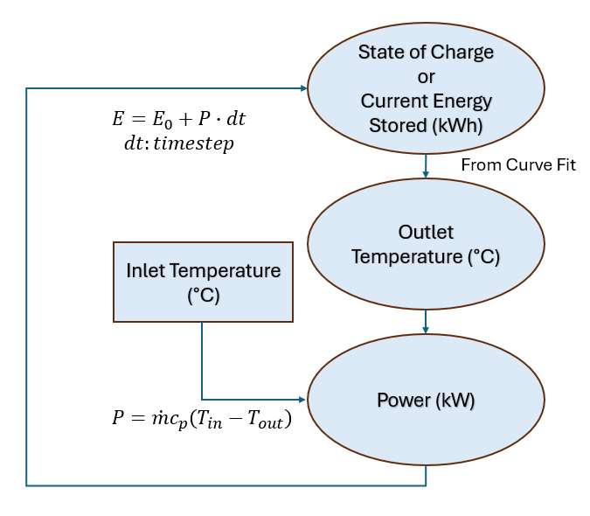
3.3. Predicting Performance Data using Proposed Curve Fit Equation
An algorithm has been developed to use the curve fit equation in predicting test data. This algorithm will take the initial state of charge, or the initial energy stored in the storage, the fluid inlet temperature, and the fluid flow rate, to predict the fluid outlet temperature, charge/discharge power as well as the state of charge (energy stored) after a certain time period.
Fig. 11 describes the algorithm. By knowing the initial state of charge (current energy stored), the outlet temperature can be figured out by using the correlation of the curve fit equation, Fig. 12. Knowing the outlet temperature and along with the provided inlet temperature, the power delivered by the fluid to the PCM storage can be calculated with the heat transfer equation. With a pre-specified time step, the calculated power is then used to find the energy added to the storage, which ultimately leads to the total energy (state of charge) of the storage for the next time step. It should be noted that the shorter the timestep chosen, the more accurate the prediction will be.
Fig. 12. Finding T_{out} from state of charge
Fig. 11. Algorithm used to predict Test Data from the Curve Fit
- Alternative Approach to Calculate the Storage Temperature
4.1. Using Fluid Inlet Temperature for Modelling
In the previous sections, the storage temperature is represented by the fluid outlet temperature, which is also used in the Energy Stored – Temperature curve fit. However, the fluid inlet temperature could also be used for the modelling if a Flow Factor is added.

Fig. 13. Energy Stored vs Fluid Inlet Temperature for Unit 1 Charge Tests
Fig. 13 above shows the fluid inlet temperature of the same 4 constant power charge tests of Unit 1. Because of the spread-out of the 4 curves due to different charge powers and fluid flow rates, it is not possible to achieve a single performance graph for different flow rates and powers if data is only plotted against the inlet temperature.
To minimize this effect, a set of modified temperatures, $T^{*}$, was introduced to better represent the effective storage temperature. The descriptive equation is shown below in (eq. 2), with the unit of $P$ is kW and the unit of $\dot{m}$ is (kg s⁻¹).
$T^{*}=T_{inlet}-T_{corr}=T_{inlet}-F_{f}∙\frac{P}{\dot{m}}$ (charge)
or $T^{*}=T_{inlet}+T_{corr}=T_{inlet}+F_{f}∙\frac{P}{\dot{m}}$ (discharge) (eq. 2)
$T_{corr}$ is a Correction Temperature and is the difference between the inlet temperature ($T_{inlet}$) and the effective storage temperature ($T^{*}$). $F_{f}$ is a Flow Factor with the unit of (kg K kJ⁻¹) and will be responsible for how the $\frac{Power}{Flow Rate}$ ratio affects the Correction Temperature. The values of $F_{f}$ is different for charge and discharge process, and also different for different storages. By performing extrapolation on the effective phase-change temperature $T_{PC}^{*}$ of the different tests (or visually the middle point of each S-curve), with respect to the $\frac{Power}{Flow Rate}$ fraction, the phase-change temperature at $\frac{Power}{Flow Rate}=0$ can be determined. Physically, this is when the inlet and outlet are at the same temperature, and essentially this is also the storage temperature. Fig. 14 and 15 below show how the Correction Temperature $T_{corr}$ and Flow Factor $F_{f}$ is related to the $\frac{Power}{Flow Rate}$ fraction. Each point on the trendline represents the extrapolation result of one experimental test data.

Fig. 15. Correction Temperature versus (Power/Flow Rate) Fraction for Unit 1 Discharge Test
Fig. 14. Correction Temperature versus (Power/Flow Rate) Fraction for Unit 1 Charge Test
After replacing $T_{inlet}$ with $T^{*}$, the gaps mentioned above are reduced significantly, which is shown below in Fig. 16 for Unit 1 PCM storage.

Fig. 16. Energy Stored vs Effective Temperature T* for Unit 1 Charge Tests
4.2. Curve Fit Equation for T*
With the effective temperature T* representing the temperature of the storage, it is now possible to fit a single Energy Stored – Effective Storage Temperature curve for different flow rates and powers. The same equation form (eq. 1) was used for the regression. The results are shown below.
Finalized equations for the curve fit:
Unit 1:
Charge $E= -2.79+0.119T^{*}+$ $\frac{5.65}{1+e^{0.96(56.76-T^{*})}}$ $+[0.028\left(T^{*}-60\right)]∙I(T_{out}>60)$
With: $T^{*}=T_{in}-0.219\frac{P}{\dot{m}}$

Discharge: $E= -1.81+0.095∙T^{*}+\frac{4.43}{1+e^{1.021\left(50.06-T^{*}\right)}}+\left[0.082\left(T^{*}-54\right)\right]∙I\left(T^{*}>54\right)$
With: $T^{*}=T_{in}+0.225\frac{P}{\dot{m}}$
Unit 2:
Charge: $E= -2.20+0.079T^{*}+\frac{3.20}{1+e^{0.73(57.95-T^{*})}}+[0.070\left(T^{*}-60\right)]∙I(T_{out}>60)$
With: $T^{*}=T_{in}-0.207\frac{P}{\dot{m}}$

Discharge: $E= -1.45+0.067∙T^{*}+\frac{2.74}{1+e^{0.878\left(52.30-T^{*}\right)}}+\left[0.034\left(T^{*}-54\right)\right]∙I\left(T^{*}>54\right)$
With: $T^{*}=T_{in}+0.249\frac{P}{\dot{m}}$

4.3. Predicting Performance Data
An update in the algorithm used to predict test data is necessary since the Energy Stored – Outlet Temperature relation is now replaced by Energy Stored – Effective Storage Temperature (which derives from fluid inlet temperature, flow rate, and power). The algorithm is shown below in Fig. 17 (the two equations used to calculate $P$ and $T_{out}$ are specifically for charge test).
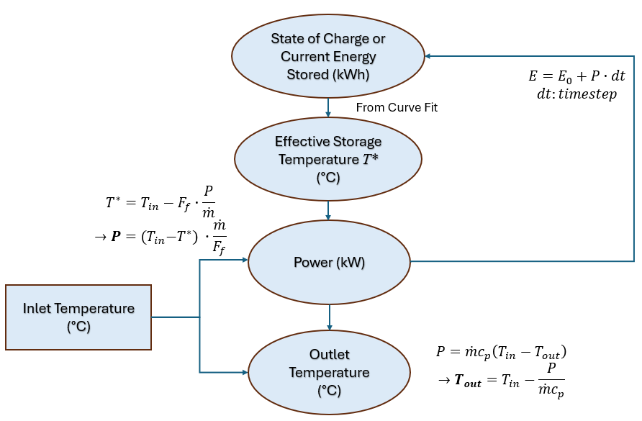
Fig. 17. Updated Algorithm used to Predict Test Data if $T_{in}$ is used for modelling
4.4. Comparison between the two Approaches
Fig. 18 to Fig. 23 compare the data prediction coefficients between the Outlet Temperature approach and the Inlet Temperature approach. The Constant Temperature Charge Test at 75°C Inlet and 3 LPM of Unit 1 was chosen as the example to illustrate this comparison.
Fig. 18. Outlet Temperature Correlation (Outlet Temperature approach)
Fig. 19. Outlet Temperature Correlation (Inlet Temperature approach)
Fig. 22. Power Correlation (Outlet Temperature approach)
Fig. 23. Power Correlation (Inlet Temperature approach)
Fig. 20. Energy Correlation (Outlet Temperature approach)
Fig. 21. Energy Correlation (Inlet Temperature approach)
- Conclusion
A generalized “black-box” model of the phase-change material (PCM) thermal storage has been derived such that the performance (energy storage capacity versus charge-loop temperature) can be determined at a range of charge-circuit liquid flow rates and power levels. Two approaches have been proposed for the model i.e.,
- Using the fluid outlet temperature to form a relation with the energy stored, then use this relation to predict the system’s performance, or
- Using an effective storage temperature $T^{*}$, which is derived from the inlet temperature based on different flow rates and power, to form a relation with the energy stored, then use this relation to predict the system’s performance.
The second approach may be preferable since the fluid inlet temperature is used to derive the model, but it is also more complicated since it requires an additional step of calculating the effective storage temperature. This latter approach is similar to that used to characterize solar collectors, where a general relationship is derived from tests for a specific flow rate, incidence angle of the incident solar radiation, and sky condition, e.g., overcast, cloudy, etc. Operations during real conditions are determined from a repeatable standard test result and then modified by factors determined by individual tests of the parameter, e.g., heat transfer fluid flow rate. The coefficients from a specific test (e.g., flow rate) are then used with the appropriate modifying factors to determine the performance of the device at a specified operational condition.
The results of this study indicate that a non-intrusive “black-box” model is possible for use in characterizing and describing the characteristics of a wide range of PCM storage systems and the development of numerical models for use in full system simulations. In addition, this study and its results may significantly guide the development of standard testing procedures and protocols for product ratings. To achieve this, further testing and analysis for a variety of PCM storage devices, utilizing different PCM formulations, sizing, and design features is recommended.
- Recommendations for Future Work
Although these approaches on the modelling of PCM thermal storage may be universal, they have only been developed and verified on one type of PCM storage. As a result, future work on PCM modelling should investigate its application on a range of commercial products with different phase-change materials and configurations. This includes conducting tests and analysis for a variety of PCM storage devices with different PCM formulations, storage sizes and design features
Finally, many modern appliances contain electronic controls that adjust operations based on internal algorithms. The implication of these internal controls may introduce an additional level of characterization required in performance simulations. This is an area for further analysis and is not currently addressed in this study.
- Acknowledgement
Support for this study was provided by CanmetENERGY-Ottawa / Energy Efficiency and Technology Sector / Natural Resources Canada. In particular, the contribution and guidance of Dr. Reda Djebbar throughout this study is appreciated.
- References
ASHRAE 94.1-2010, 2010. Method Of Testing Active Latent-Heat Storage Devices Based on Thermal Performance. 1791 Tullie Circle NE, Atlanta, GA 30329.
G.A. Lane, 1983. Solar Heat Storage: Latent Heat Materials, Vol. I: Background and Scientific Principles. CRC Press, Boca Raton, Florida.
Hassan, Laghari, Rashid, 2016. Micro-Encapsulated Phase Change Materials: A Review of Encapsulation, Safety and Thermal Characteristics. MDPI, Sustainability, Volume 8.
H.C. Hottel, A.F. Whillier, 1958. Evaluation of Flat-Plate Solar Collector Performance. In J. H. Boer (Ed.), Transactions of the Conference on the Use of Solar Energy: The Scientific Basis (Vol. 2, Part 1). University of Arizona Press
Radouane, 2022. A Comprehensive Review of Composite Phase Change Materials (cPCMs) for Thermal Management Applications, Including Manufacturing Processes, Performance, and Applications. MDPI, Energies, Volume 15.
R.W. Bliss, 1959. The Derivations of Several "Plate-Efficiency Factors" Useful in the Design of Flat-Plate Solar-Heat Collectors. Solar Energy. 3(4), 55–64.
S. Harrison, R. Indranil, A.K. Nguyen, 2024. Experimental Evaluation of a Phase-change Thermal Storage. Enerstock 2024, the 16th IAE EST CP International Conference on Energy Storage.
S.F. Ahmed, Rafa, Mehnaz, B. Ahmed, 2022. Integration of phase change materials in improving the performance of heating, cooling, and clean energy storage systems: An overview. Journal of Cleaner Production 364:132639.
Teggar, Arıcı, Mert, Ajarostaghi, 2021. A comprehensive review of micro/nano enhanced phase change materials. Journal of Thermal Analysis and Calorimetry, Springer Science, p. 3989-4016.

