Structural evolutions of fully dense amorphous polymer-derived silicon carbonitride ceramics
Jiahong Niu, Songhe Meng*, Jinping Li, Gaoming Zhang
Center for Composite Materials and Structures, Harbin Institute of Technology, Harbin, 150001, China

Abstract
Polymer-derived ceramics (PDCs) are one kind of structure controlled composite by molecular design which are obtained by the thermal decomposition of organic polymers. PDCs have attracted extensive attention for years due to a variety of unique and superior properties, including excellent thermal stability, great creep resistance, as well as unusual electric behavior. The amorphous structural evolution (<1450 ºC) is rather worth studying since many of the functional properties are related to this unique nanodomain structure. In this work, the liquid-phase polysilazane (PSN2) with a low viscosity (15-80 cP at 25 ºC) was selected as the original polymer. The crack-free, fully dense SiCN ceramics were prepared by a simple liquid forming route and subsequent pyrolysis. The pyrolysis temperature ranged from 1000 ºC to 1400 ºC. The ²⁹Si solid-state NMR study indicated that the nanostructures in the Si-containing area mainly contained SiCN₃ unit, SiC₄ unit and SiN₄ unit. And with the pyrolysis temperature increasing, SiCN₃ unit concentrations decreased, the SiC₄ unit and SiN₄ unit increased. This tendency is well agree with the subsequent crystallization of SiC and Si₃N₄ at higher temperature. In addition, the structural evolution within the free carbon area was studied by Raman spectrum, which revealed the graphitization of amorphous carbon and the lateral growth of nanographite, as the pyrolysis temperature increased.
Keywords: Polymer derived ceramics; SiCN; structural evolutions; Nanostructure
Corresponding author: Songhe Meng
E-mail: mengsh@hit.edu.cn
Tel/Fax: +86-451-86417560

References
- P Colombo, G Mera, R Riedel, et al. Polymer-derived ceramics: 40 years of research and innovation in advanced ceramics [J]. Journal of the American Ceramic Society, 2010, 93(7): 1805-1837.
- E. Ionescu, H. J. Kleebeb, R. Riedel, Silicon-containing polymer-derived ceramic nanocomposites (PDC-NCs): preparative approaches and properties [J]. Chemical Society Reviews, 2012, 41(15): 5032-5052.
- L H Hu, R Raj. Semi-conductive Behavior of Polymer-Derived SiCN Ceramics for Hydrogen Sensing [J]. Journal of the American Ceramic Society, 2015, 98(4): 1052-1055.
- G Mera, A Navrotsky, S Sen, et al. Polymer-derived SiCN and SiOC ceramics structure and energetics at the nanoscale [J]. Journal of Materials Chemistry A, 2013, 1(12): 3826-3836.
- L David, S Bernard, C Gervais, et al. Facile synthesis and high rate capability of silicon carbonitride/boron nitride composite with a sheet-like morphology [J]. The Journal of Physical Chemistry C, 2015, 119(5): 2783-2791.
- Y Gao, G Mera, H Nguyen, et al. Processing route dramatically influencing the nanostructure of carbon-rich SiCN and SiBCN polymer-derived ceramics. Part I: Low temperature thermal transformation [J]. Journal of the European Ceramic Society, 2012, 32(9): 1857-1866.
- S Kaur, R Riedel, E Ionescu, Pressureless fabrication of dense monolithic SiC ceramics from a polycarbosilane [J]. Journal of the European Ceramic Society, 2014, 34(15): 3571-3578.
- Y. H. Chen, X. P. Yang, Y. J. Cao, Z. H. Gan, L. N. An, Quantitative study on structural evolutions and associated energetics in polysilazane-derived amorphous silicon carbonitride ceramics [J]. Acta Materialia, 2014, 72: 22-31.
- S. Sarkar, Z.H. Gan, L.N, An and L. Zhai, Structural evolution of polymer-derived amorphous SiBCN ceramics at high temperature [J]. The Journal of Physical Chemistry C, 2011, 115(50): 24993-25000.
- K.W. Wang, B.S. Ma, X.Q. Li, Y.G. Wang and L.N. An, Structural Evolutions in Polymer-Derived Carbon-Rich Amorphous Silicon Carbide [J]. The Journal of Physical Chemistry A, 2015, 119(4): 552-558.
Figure captions:
Fig.1 A fully dense specimen cross-linked at 200 ºC (left), and pyrolyzed at 1100 ºC (right).
Fig.2 (a) ²⁹Si solid-state NMR spectra of the SiCN pyrolyzed at different temperatures; and (b) curve fitting of ²⁹Si NMR for the SiCN ceramic pyrolyzed at 1100 ºC.
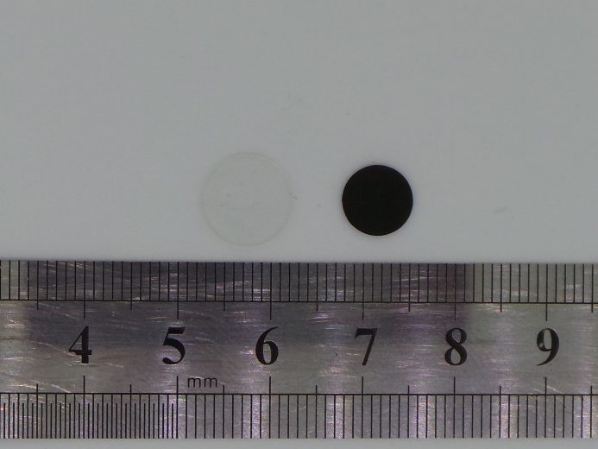
Fig.1 A fully dense specimen cross-linked at 200 ºC (left), and pyrolyzed at 1100 ºC (right).
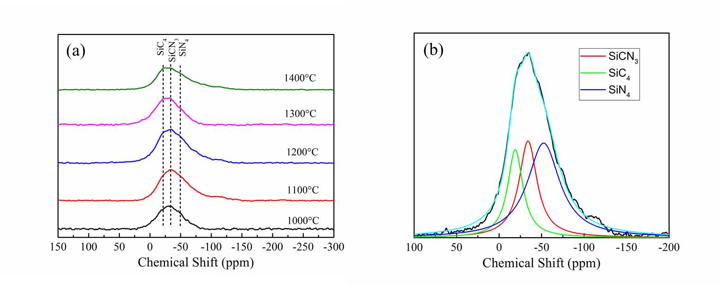
Fig.2 (a) ²⁹Si solid-state NMR spectra of the SiCN pyrolyzed at different temperatures; and (b) curve fitting of ²⁹Si NMR for the SiCN ceramic pyrolyzed at 1100 ºC.

