**MULTI-SCALES ANALYSIS OF THE DAMAGE INDUCED DURING ONE-SHOT DRILLING OF CFRP/TITANIUM ALLOY**

M. F. Ameur1,2, R. Zitoune3, M. Habak4, M. Kenane2

1 Ecole Nationale Supérieure de Technologie Algiers, Algeria

E-mail: faycalameur@gmail.com

2Laboratoire de mécanique Appliquée, Faculté de Génie Mécanique et Génie des Procédés Université USTHB, USTHB, BP 32, El-Allia, Bab Ezzouar Algeria

3Université de Toulouse, INSA, UPS, Mines d’Albi, ISAE, ICA (Institut Clément Ader) - UMR, CNRS - 5312, IUT-A GMP Toulouse, France

4Laboratoire des Technologies Innovantes (LTI), IUT d’Amiens, Dépt GMP, Université de Picardie Jules Verne, Avenue Facultés Bailly 80001 Amiens, French

**Keywords:**Drilling, Multi-stacks, Damage, FEM, Delamination

**Abstract**

One-shot drilling of multi-stacks made carbon fibers reinforced polymer (CFRP) and titanium alloy is a challenging machining process. In fact, due to the difference in the mechanical properties of both materials combined with the anisotropy of the composite, the mechanisms of material removal are accompanied by several damages. In fact, the continous chips of the isotropic part and the high level of the thrust force are the main factors responsible of damage of the composite part.

In this paper, a 3D Finite Elements Method model is proposed to predict the impact of the machining parameters on the thrust force, the interface behavior (CFRP/Ti) as well as the damage generated in the composite. The validation of this model is conducted by performing drilling tests using a dynamometer. The obtained results have shown that, at the macro scale, the thrust forces predicted by the numerical model are in good agreement with those measured in the CFRP and in the Ti. In addition, at the meso scale the cartographies of the damage predicted by the model using Hashin cretiria reveal that, the damage observed at the hole entry is due to the matrix fracture by compressive and tensile modes.

**1. Introduction**

The aviation industry is widely known for the diversity of manufacturing techniques and materials that it employs. For many years, intensive use of composite materials made of carbon fiber reinforced polymer and aluminum alloy has been integrated into the aeronautical industry. The use of hybrid CFRP/Aluminium stacks provides the best combination of mechanical properties including low density, high strength/weight ratio and high corrosion resistance which result in energy and cost saving [1-4]. For example, the Boeing 787 aircraft consists of 50% composite, 20% aluminum, 15% titanium, 10% steel, and 5% other materials [2]. In the aircraft industry, thousands of holes required for the assemblies of hybrid structures are needed to be drilled and drilling them is a challenging task due to the desperate mechanical properties of each material. The accuracy of assembly of these hybrid structures depends mainly on the hole quality, dimensional and geometric tolerances [3]. However, in order to obtain high hole quality, Zitoune et al. [4] have proposed a to investigate the influence of the double cone drill geometry on the machining quality during drilling in one-shot operation of multi-stack made of CFRP/Al. single-shot drilling process as a solution instead of drilling each constituent separately. In fact, the obtained results shown that the double cone drill generate a less thrust force compared to the twist drill. In the aeronautical field, it was mentioned that, about 60% of rejected parts is due to the presence of defects in the drilled hole [5]. Among these defects, we can distinguish the appearance of delamination, matrix degradation, poor diameter tolerance and fiber burrs [6]. These hole quality problems were due to inappropriate use of machining conditions and an incorrect application of the cutting tool [7]. For these reasons, different researchers have studied the defects associated with drilling using analytical and numerical methods and approaches with the aim of specify the factors responsible for the appearance of these defects [8-13]. Krishanaraj et al. [9] mentioned that the cutting parameters directly influence the mechanical behavior of composites. Amrinder et al. [10] explained that delamination around the drilled hole depends on the cutting forces exerted during drilling. On the other hand, Zitoune et al. [11] have noted that whenever the composite is stacked with aluminium or titanium, composite should be placed on top most of the time in order to avoid the risks of delamination. Davim et al. [12], observed that the feed rate is a significant parameter which has a very important influence on fiber-matrix interface decohesion. The appearance of burr defect depends on the thrust force and the temperature of the material [14]. Singh et al. [15] have shown that the point angle and feed rate are the most influential factors on the thrust force. Moreover, the drilling at a high feed rate and low spindle speed increases the circularity defects [1].Therefore, the cutting parameters such as feed rate and spindle speed must be optimized in order to improve the machinability of the hybrid materials [1-4]. However, the experimental method may still be too time-consuming and cost prohibitive. On the other hand, the FE model should be a qualified tool to model the mechanical behavior and damage formation when machining of hybrid materials. Furthermore, FE analysis of machining processes can provide a good understanding of the underlying mechanical behavior of materials and challenging problems. Though several investigations have been addressed with single composite CFRP modeling and single titanium modeling [13, 16], comprehensive FE investigations concerning hybrid CFRP/Aluminium and CFRP/Ti drilling still have not been clearly reported.

In this paper, an experimental and numerical studies is proposed during drilling of multistack made of CFRP/Ti. The 3D numerical model was developed to predict the machining behavior when dry drilling of stacked carbon fiber reinforced epoxy (carbon T700 / epoxy M21) / Titanium alloy using the ABAQUS/EXPLICIT solver.

**2. Experimental procedure**

**2.1. Material preparation**

The composite material used for this study is made of carbon fiber and epoxy matrix. This material is manufactured by Hexcel Composite Company and referenced under T700-M21. The lay-up sequence is ${[{(90/45/0/-45)}_{3}]}_{s}$, which means total 24 layers, each layer has 15 mm×15 mm×0.25 mm dimensions of length, width and thickness, respectively, with a final thickness of 6 mm.The composite specimens were manufactured with the autoclave process.The mechanical properties of the unidirectionnel ply used are summarized in the Table 1.

Titanium alloy was used to form the stack. The mechanical properties of Titanium alloy are listed in Table 2. This alloy has a high fatigue strength and average machinability with excellent corrosion resistance, which is widely used in the aircraft industry. The properties of Titanium alloy(Ti6Al4V)are (Al 6.13%, V 4.2% , Fe 0.19%, C0.03%, N 0.01%, H0.001%, Ti rest%).

**Table 1.**Mechanical properties of the carbon/epoxy unidirectionnel ply.

|  |  |  |  |  |  |  |  |
| --- | --- | --- | --- | --- | --- | --- | --- |
| ***E1***(Mpa) | ***E2***(Mpa) | ***E3***(Mpa) | ***G12***(Mpa) | ***G13***(Mpa) | ***G23***(Mpa) |  |  |
| 127000 | 8625 | 8600 | 6000 | 3000 | 4500 | 0.3 | 0.02 |
| Xt (Mpa) | Xc (Mpa) | Yt (Mpa) | Yc(Mpa) | Sl (Mpa) | St (Mpa) |  |  |
| 1900 | 1000 | 84 | 250 | 60 | 110 |

**Table 2.** Mechanical properties of Titanium alloy Ti6Al4V

|  |  |
| --- | --- |
| Density (p) | 4.43 g/cm³ |
| Young’s modulus (E) | 110000MPa |
| Poisson’s ration (v) | 0.34 |

**2.2 Drilling tests**

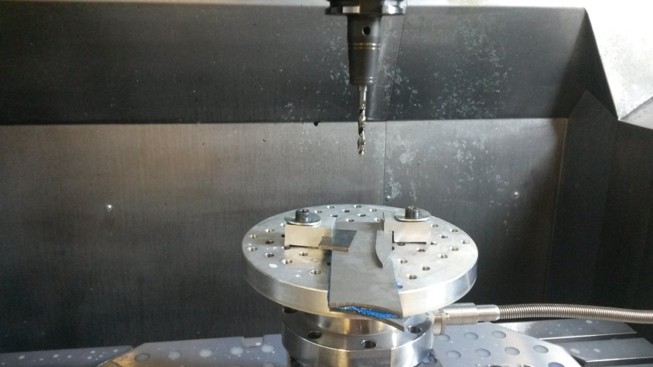The drilling tests have been conducted using CNC machine and twist drill made of tungsten carbide with the grade K20 (cf. table 3). The experimental device used for the drilling tests is shown in Figure1. The thrust force was measured using four-component piezo-electric dynamometer (Kistler Type: 9257B). An amplifier system was used to convert the charge signals from the dynamometer into output voltages using a multi-core high-insulation connecting cable, the output voltage is proportional to the force. The force signals were recorded using Dynoware software. The experiments were conducted at various combinations of spindle speeds (800, and 2000 rpm) and feed rates (0.05, 0.1 and 0.15 mm/rev). These cutting conditions are selected based on the requirements of the aeronautical industry. Each experimental test was performed using a new cutting tool to avoid the effects of the tool wear.

**Twist drill**

**Multi-stacks**

**Figure 1.** Experimental setup for dry drilling of multi-stack made of CFRP/Titanium alloy Ti6Al4V

**Table 3.**Geometry of the cutting tool.

|  |
| --- |
| Tool Materiel Tungsten carbide Wc with grade K20 |
| Diametre φ 6 mm |
| Point angle  =118° |
| Helix angle θ=30° |
| Rake angle    |
| Clearance angle = 6° |
| Web thickness e = 0.8 mm |

**3. Numerical model**

**3.1 Mesh and Boundary conditions**

The numerical model proposed is developed using the commercially available software ‘Abaqus’ explicit. The mesh and the boundary conditions used in this model are represented in the Fig 2. The CFRP and the Titanium alloy Ti6Al4V parts are defined with the dimensions of 15 mm×15 mm. The thickness of CFRP and the Titanium alloy parts are 6.2 mm and 6 mm respectively. All degrees of freedom were constrained for the composite laminate and Titanium plates along the perimiter (cf. figure 2-a). The spindle speed and feed rate were applied to the drill body in z-direction using a reference point, and it was constrained in x and y directions as shown in Fig 2-a.

Due to the desperate mechanical properties and machinability behaviors of each material constituent, the machining process was modeled using shell, solid elements geometry and rigid body elements (for the drill) with different mesh densities (cf. figure 2-b), taking into account the interactions of different damage modes and failure criteria. More precisely, the aluminium part is modeled using a 3D 8-node linear iso-parametric element with the reduced integration of the type C3D8R; while each layer composite lamina was modeled using 8-node quadrilateral continuum shell, reduced integration with hourglass control of type SC8R; while the drill was modeled using 3D 10-node modified tetrahedral element of type C3D10M.

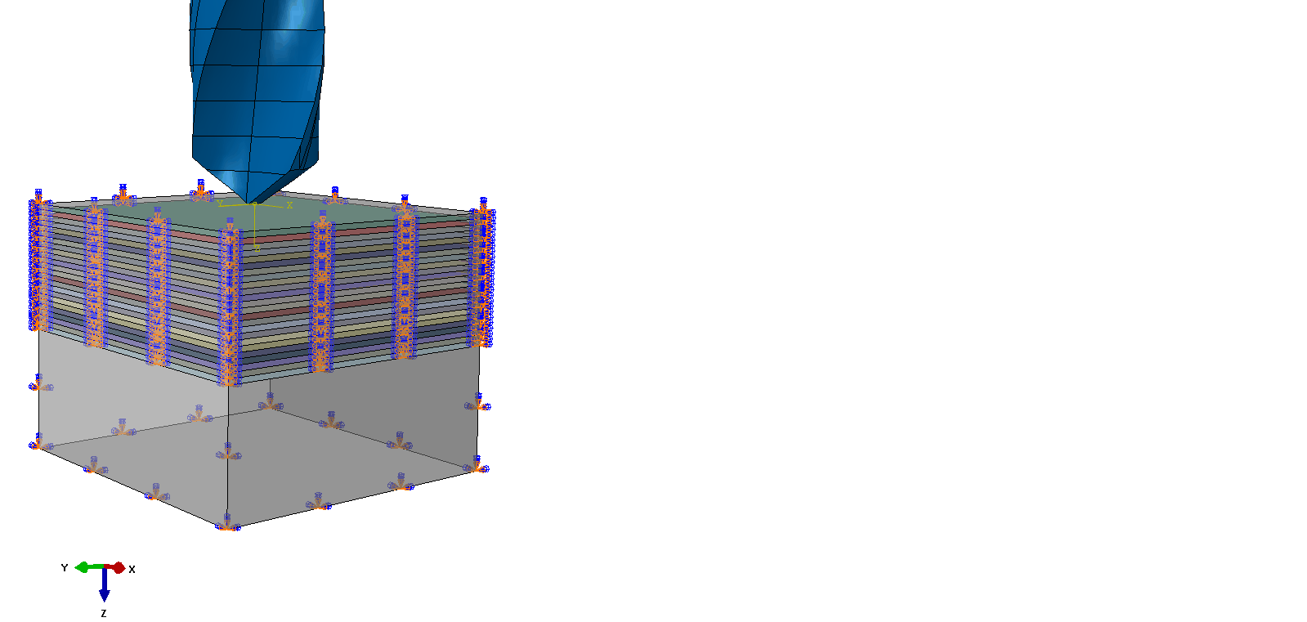

**U=V=W=0**

**Feed direction**

**Rotation motion**

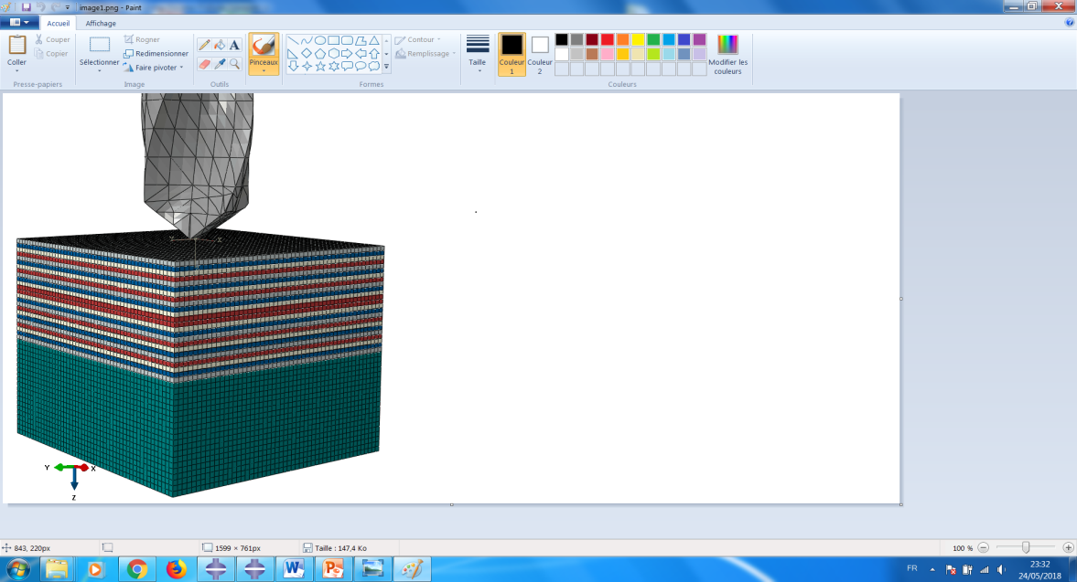

**Composite CRFP**

$${[{(90/45/0/-45)}_{3}]}_{s}$$

**Titanium alloy**

**(Ti6Al4V**)

**Tungsten carbide Wc K20**

**φ 6 mm =118°θ=30°**

**feed rates**

**(mm/rev)**

**spindle speed**

**(rpm)**

1. (b)

**Figure 2.** Numerical model proposed. With: (a) geometry and the boundary conditions, (b): mesh characteristic.

## 3.2 Modeling of workpieces materials

The behavior law of the CFRP plate is considered as orthotropic linear elastic with damage. In fact, orthotropic linear elastic material properties were assigned to each individual unidirectional (UD) composite ply.The influence of micro cracking on the performance of composite structures requires more extensive work so as to properly understand and correctly predict changes in properties of composite structures. The most used failure criteria to model composite layers is based on Hashin's theory [17]. For the interface between the composite layers, the Surface-based Cohesive Behavior and Benzeggagh-Kenane (BK) criterion are used [18]. The properties of the interface are given in the table 4.

|  |  |  |  |  |  |
| --- | --- | --- | --- | --- | --- |
| $t_{n}^{0}$ (MPa) | $t_{s}^{0}$ (MPa) | $t_{t}^{0}$ (MPa) | $G_{I}^{c}$ (J/mm²) | $G_{II}^{c}$ (J/mm²) | $G_{III}^{c}$ (J/mm²) |
| 60 | 85 | 85 | 0.33 | 1.22 | 1.22 |

**Table 4.** Critical values of the interface.

For the titanium material, the Johnson-Cook (J-C) law damage model is considered [19]. The Johnson Cook damage model is based on the value of the equivalent plastic deformation of an element. Damage occurs when the damage parameter reaches value 1.This parameter increases monotonically with plastic deformation. In fact; Johnson-Cook constitutive model is one of the most commonly used semi-empirical phenomenological model for describing the plastic deformation behavior at high strain, high strain rate and high temperature, especially suitable for the simulation of machining processes for the isotropic material. The mechanical properties which characterize this damage model are those proposed in the literature by DR. Lesuer [16].

**4. Results and discussion**

Figure 3 shows the evolution of thrust force and the torque as a function of drilling time measured by the dynamometer when the machining is conducted with a feed rate of 0.05 mm/rev and a spindle speed of 800 rpm. Due to the different nature of materials used, different peak thrust and torque magnitudes can be observed. From this figure, two main zones can be observed and are characterized by the quasistability of the signal of the thrust force in the CFRP and in the titanium. These two zones are highlighted on the graph. The first zone (N°1 on the figure) appears when the point of the tool is totally in the CFRP. However, the second zone is observed when the point of the tool starts to machine the titanium. In addition, it is clear that, the thrust force predicted during drilling of titanium was found to be around three times higher than the one predicted during drilling of CFRP.

**Mz [N.cm]**

**Fz [N]**

Zone N°2: Ti

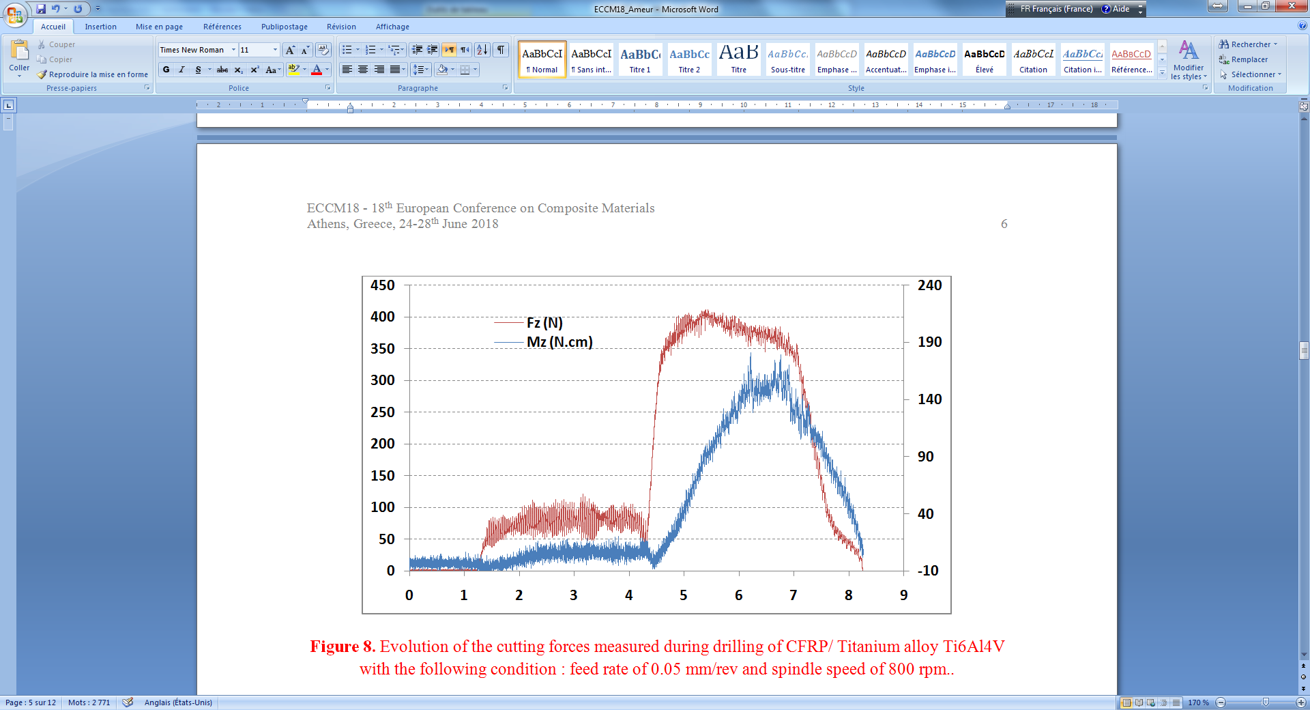

Zone N°1: CFRP

**Time of drilling (s)**

**Figure 3.**Evolution of the thrust force and the torque measured during drilling of CFRP/ Titanium alloy Ti6Al4V with the following condition: Feed rate of 0.05 mm/rev and spindle speed of 800 rpm.

It is important to notice that, for all the conditions tested the form of the signal is similar to the one observed in the figure 3; however, the level of the force is strongly influence by the feed rate and few impacted by the spindle speed. Several works in the literature have used the ANOVA analysis and concluded that, the thrust force is impacted by the tool geometry and the feed speed [6-7]. For this reason we will focused on the parameter thrust force generated during drilling.

In fact, the average values of the thrust forces measured in the two zones mentioned above in function of the position of the drill in the material are correlated to those predicted by the numerical model and are presented in the figure 4. From this figure 4, it is clear that a good correlation of the average values of the thurst force is observed. In fact, the maximum deviation between the numerical values and the experimental values of the thrust force in the CFRP it is around 15 % (cf. figure 4-a). Simlar results have been obtained for the thrust force in the titanium, with a maximum deviation around 5 %.

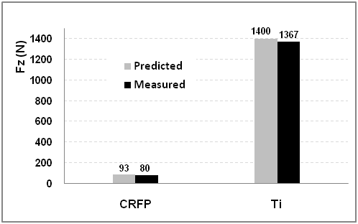

**Figure 4.** Comparaison between the thrust force measured and predicted in function of the position of the tool in the material, when drilling is conducted with a feed rate of 0.15 mm/rev and a spindle speed of 2000 rpm.

In the figure 5 and figure 6 we represent the cartographies of damage in the composite predicted by the model when drilling is conducted with a feed speed of 0.15 mm/rev and a spindle speed of 2000 rpm. These damages which concerns the fibers and the matrix are calculated based on Hashin failure cretiria which is implimented in Abaqus. It is clear that, the fracture of the fiber by compresion or by tensile is located mainly in the vicinity of the nominal diameter of the drilled hole. However, the carthographies of fracture of the matrix by tensile or by compressive modes, reveal that, the extent of the damage at the hole entry of the CFRP plate is two times higher compared to the nominal diameter.

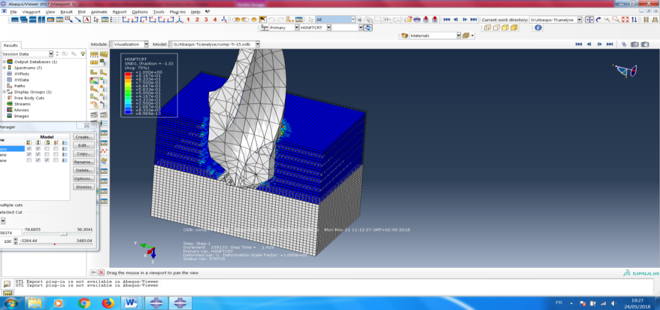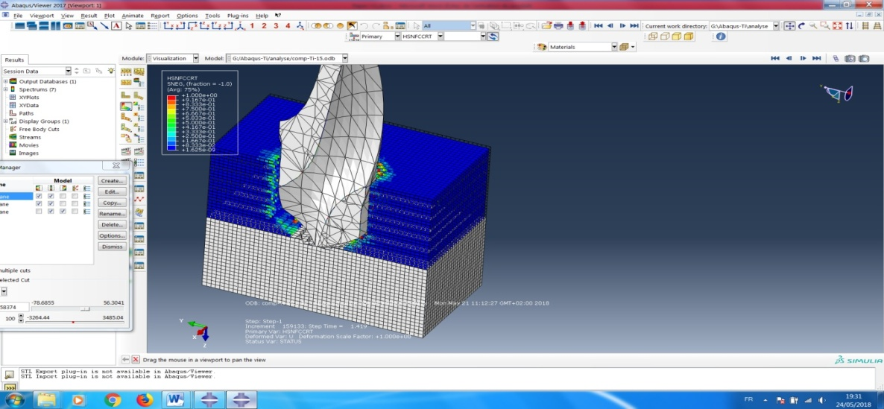

**(a)**

**(b)**

**Figure 5.** Cartographies showing the damage in fibers based on Hashin criterion when drilling is conducted with a feed rate of 0.15 mm/rev and a spindle speed of 2000 rpm. With: (a) Damage by tensile mode, (b): damage by compression mode.

Unlike at the hole entry, the extent of the damage located at the hole exit is less. In fact, this difference can be certainly attributed the presence of the titanium plate which can prevent the deflection of the CFRP plate.

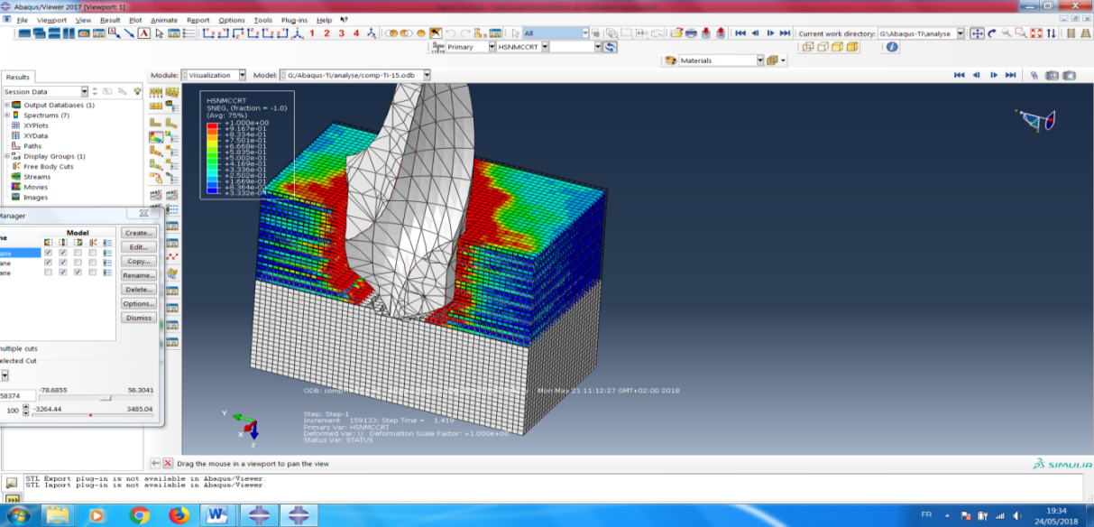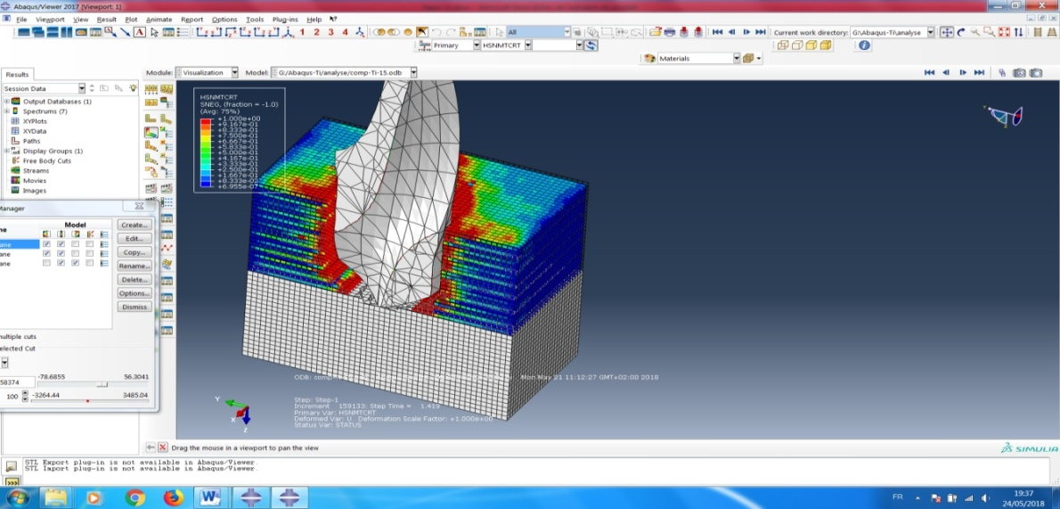

**(a)**

**(b)**

**Figure 6.** Cartographies showing the damage in matrix, based on Hashin criterion when drilling is conducted with a feed rate of 0.15 mm/rev and a spindle speed of 2000 rpm. With: (a) Damage by tensile mode, (b): damage by compression mode.

Figure 7. shows the flow of Titanium chip removed by the drilling tool, it can be observed that the chip flow advances towards the wall of the hole. This flow of hard and hot Titanium chips can potentially increase the damage at the wall of the hole. Infact, drilling with broken chips favours the reduction of the damage generated by the effect of erosion between Ti chip and the wall of the CFRP hole.

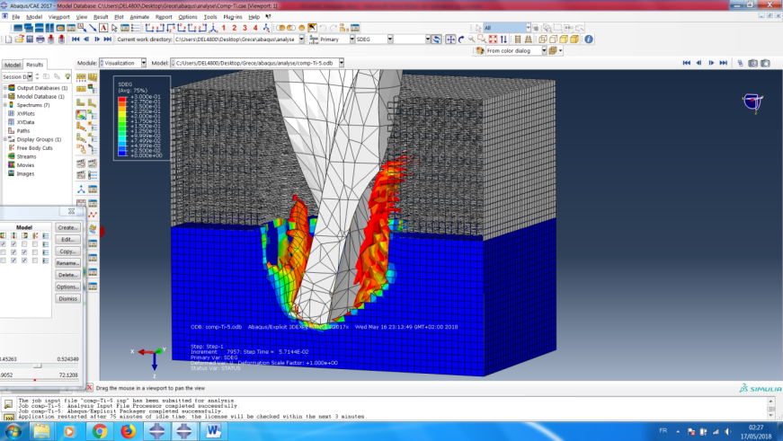

**Figure 7.**Cartography showing chip formation and burring during drilling the Titanium alloy Ti6Al4V with a feed rate of 0.15 mm/rev and a spindle speed of 2000 rpm.

5. Conclusions

From the experimental and numerical study on the drilling of multi-stacks made of CFRP and titanium alloy, the following conclusions can be drawn:

* For all feed rates tested, it was observed that, the thrust forces generated in the composite part are much lower compared to those generated when drilling the titanium alloy. For example, when drilling is conducted with a feed rate of 0.05 mm/rev and spindle speed of 2000rpm, the recoreded thrust force in the CFRP and the Ti are 70 N and 380 N respectively.
* The proposed model for drilling of multi-stacks made of CFRP/Ti, leads to reliable prediction of the key parameter responsible of the major defects in the composites, which is the thrust forces. In fact, with this model, the maximum deviation observed between the measured and the predicted thrust force it is around 15 %.
* Thanks to the proposed FEM model, it was clearly observed that, the main defect observed at the hole entry is due the fracture by compressive and tensile modes of the matrix. In addition, during the formation of the titanium chip, its flow can causes some damages on the wall of the CFRP hole.

References

[1] R. Zitoune, V. Krishnaraj, S. Almabouacif, F. Collombet, M. Sima and A. Jolin."Influence of

machining parameters and new nano-coated tool on drilling performance of CFRP/Aluminium

sandwich". *Composites Part B*, 43(3), pp. 1480-1488, 2012.

[2] Chang-Ying Wang, Yu-Han Chen, Qing-Long An, Xiao-Jiang Cai, Wei-Wei Ming and Ming Chen. “Drilling Temperature and Hole Quality in Drilling of CFRP/Aluminum Stacks Using Diamond Coated Drill”. *International journal of precision engineering and manufacturing* ,Vol. 16, No. 8, pp. 1689-1697, July 2015.

[3] M. Ramulu, T. Branson, and D. Kim, “study on the drilling of composite and titanium stacks” .*Composite Structures*, vol. 54, pp. 67-77, 2001.

[4] R. Zitoune, K. Vijayan, F. Collombet and S. Le Roux. Experimental and numerical analysis on drilling of carbon fibre reinforced plastic and aluminium stacks. *Composite Structures*, 146 (20)148-158, 2016.

[5] Konig W, Cronjager L, Spur G, Tonshoff HK. Machining of new materials. *Ann CIRP*; 39 (2):673–80.579–593,1990.

[6] Davim JP, Pedro Reis, Conceicao Antonia. Experimental study of drilling glass ﬁber reinforced (GFRP) manufactured by hand lay-up. *ComputSciTechnol*, 64:289–97, 2004.

[7] M. F. Ameur, M. Habak, M. Kenane, H.Aouici, M. Cheikh : Machinability analysis of dry drilling of carbon/epoxy composites: cases of exit delamination and cylindricity error. *Advanced Manufacturing Technology*, 10.1007/s00170-016-8967-8, 2016.

[8] J. Saoudi, R. Zitoune, S. Gururaja, S. Mezlini and P. Seitier . Critical thrust force predictions during drilling: analytical modeling and X-ray tomography quantification.*Composite Structures*, 153 (1) 886-894. 2016.

[9] Krishnaraj V, Vijayarangan S, Rameshkumar A: Effect of drilling parameters on mechanical strength in drilling GFRP. *Int J ComputApplTechnol*, 28 (1):87–93,2007.

[10] Amrrinder Pal Singh, Dr. Manu Sharma: Modelling of Thrust Force during Drilling of Fibre Reinforced Plastic Composites. *Chemical, Civil and Mechanical Engineering Tracks of 3rd Nirma University International Conference*.Procedia engineering 51 , 630 – 636, 2013.

[11] R. Zitoune, V. Krishnaraj, and F. Collombet: Study of drilling of composite material and aluminium stack, *Composite Structures*, vol. 92, pp. 1246-1255, 2010.

[12] Davim JP, Reis P. Damage and dimensional precision on milling carbon ﬁberreinforced plastics using design experiments. *J Mater ProcessTechnol*, 160(2):160–7, 2005.

[13] Zitoune R and Collombet F. Numerical prediction of the thrust force responsible of delamination during the drilling of the long-fibre composite structures. *Compos Part A: ApplSciManufac*, 38(3): 858–866, 2007.

[14] D.A. Dornfeldl L.J.Chen J.S.Kim H.Dechowet J. H EWSON: Drilling burr formation in titanium alloy, ti-6ai-4v. *CIRP Annals -Manufacturing Technology*, vol. 48, no. 1, pages 73–76, 1999.

[15] Singh I, Bhatnagar N, Viswanath P. Drilling of uni-directional glass ﬁber reinforced plastics: experimental and ﬁnite element study. *Mater Des*;29: 546-53,2008.

[16] Lesuer DR. Experiment investigations of material models for Ti-6Al-4V titanium and 2024-T3 Aluminium, *Technical report*, 2000.

[17] Abaqus Version 6.14. Abaqus Theory Manuals. Available online: http://abaqus.software.polimi.it /v2017/books/usb/default.htm?startat=pt03ch06s03abo07.html

[18] Benzeggagh M., Kenane M. Measurement of mixed-Mode delamination fracture toughness of unidirectional glass/epoxy Composites with mixed-mode bending apparatus. *Composite Science and Technology*, 56: 439-44,1996.

[19] Johnson, G. R., and W. H. Cook.Fracture Characteristics of Three Metals Subjected to VarisSoutrains, Strain Rates Temperatures and Pressures. *Engineering Fracture Mechanics.*21. 31–48,1985.