EuroSun2026
MODEL BASED ANALYSIS OF MONITORING DATA FOR PERFORMANCE OPTIMIZATION IN LARGE MULTI APARTMENT BUILDINGS
Samuel Breuss¹ (corresponding author), Elisa Venturi¹, William Monteleone¹, Fabian Ochs¹
¹ Unit of Energy Efficient Building, University of Innsbruck, Technikerstraße 13, A-6020, Innsbruck, Austria
samuel.breuss@uibk.ac.at
Summary
In a block of four large multi-apartment buildings (MAB) with 307 apartments, a high-resolution monitoring system was implemented consisting of heat meters in the technical room, distribution network, and apartment-level fresh water stations (FWS). Monitored losses proved to be higher than pre-design expectations. The main driver was drifting FWS bypass setpoints, visible as increasing return temperature and flow. Adjusting one remaining station lowered the investigated riser return temperature by 8.3 K. A constrained grey-box model was developed and calibrated with the monitoring data to merge measured and expected performance, enabling attribution of losses to distribution pipes inside and outside the thermal envelope and FWS standby while quantifying the impact of elevated return temperatures. Hypothetical scenarios indicate 23–30 % annual loss reduction for a correctly commissioned 30 °C bypass return at 54 °C flow, while 55–58 % of losses occur outside the thermal envelope. The results support monitoring-based fault detection and planning guidance for DHW systems in large MAB
Keywords: HVAC, Monitoring, Domestic Hot Water, Multi Apartment Building, Heat Pump, District Heating
Field of application for the findings: Monitoring, Fault Detection and Diagnosis
Addressed audience: Scientists, Planners
- Introduction
In the context of highly energy-efficient buildings, such as passive houses, distribution losses are of particular significance. In these buildings, they serve as a substantial uncontrolled heat source (Hamburg et al., 2021). During the summer months distribution losses from domestic hot water (DHW) can lead to overheating or an increased cooling demand. In conventional DHW systems with circulation pipes, it is necessary to maintain temperatures in the flow and return pipes above 55 °C to meet hygienic requirements, particularly with regard to the prevention of legionella (e.g. in accordance with ÖNORM B 2531:2024-10). With the increasing integration of heat pumps (HP) for low-temperature supply, reducing system temperatures becomes essential (Kropp et al., 2025). Decentral DHW preparation via fresh water stations (FWS) allows lower supply temperatures, provided the apartment-wise distribution volume is below three litres. These systems often have a thermal bypass function, i.e., a thermostatic valve controlling a predefined standby temperature to be set for quick heating-up times. However, the energetic benefit of FWS depends strongly on the correct operation of the thermal bypass, since the bypass setpoint determines the standby return temperature and the circulation flow required to compensate distribution losses. At a central measurement point, drifting or incorrectly commissioned bypass valves may appear only as a gradual increase in return temperature and circulation flow, while the responsible FWS cannot be localised without more detailed metering. The problem is not only that DHW distribution losses occur, but that they can increase unnoticed due to bypass drift and are difficult to localise with central metering alone. Energy metering for DHW allows costs to be allocated accurately to individual users and reveals distribution and storage losses that often go unnoticed with central-only metering. As these losses cannot be observed without user-level data, the implementation of energy metering is generally recommended to support transparent operations and promote energy-efficient DHW preparation (Pomianowski et al., 2020), but currently limited to few research projects. A remaining challenge is therefore not only to measure total DHW distribution losses, but to attribute them to physically meaningful loss paths and to quantify how operational deviations, such as elevated bypass return temperatures, affect the overall performance.
This paper analyses long-term monitoring data from the DHW distribution system of a block of large MABs and develops a constrained grey-box model for one well-instrumented riser group. The objective is to quantify measured distribution losses, attribute them to loss paths inside and outside the thermal envelope, and assess the impact of elevated bypass return temperatures on annual losses.
- Case Study
A comprehensive monitoring system was installed in a block of four large MABs (buildings A, B, C and D, see Fig. 1) to record both space heating (SH) and DHW demand as well as the supplied energy. The buildings are characterized by their highly efficient thermal envelopes: two of the buildings have been certified according to the Passive House (PH) standard, the other two have components in PH quality (Ochs et al., 2025). In this contribution we focus on the DHW distribution. DHW is supplied by the city district heating network through heat exchangers and storages located in the central technical room. From there, heat is distributed to the buildings, where apartment-wise FWS prepare DHW on demand.
The distribution pipes pass through three thermally distinct zones, a distinction that is decisive for the attribution of losses. Leaving the technical room, the main distribution pipes first run through the basement of Building C, where the first three riser shafts (C1–C3) branch off. It then enters a bicycle storage room on the ground floor of Building C. This room is enclosed by concrete walls, but its openings are unglazed grilles, so it is naturally ventilated, and its air temperature follows ambient conditions closely. A dedicated sensor recorded a mean excess of about 2.5 K over the nearby weather stations (Data source: (GeoSphere Austria, 2026) - https://data.hub.geosphere.at“), with the largest deviation in winter. The remaining seven riser shafts (C4–C10) branch off within this storage room before the main line continues to building D. From the branch-off points, the risers run vertically inside the thermal envelope across five storeys. The FWS are mounted directly at the shafts, so that horizontal distribution inside the apartments is negligible, whereas the FWS themselves are uninsulated. The shafts are sealed with fire barriers at every floor, which prevents direct verification of the associated thermal bridges.
Heat meters were placed at selected points throughout the distribution system to monitor energy flows at technical room-, riser-, and apartment-levels. In Fig. 1, the DHW distribution system and the technical room, including the monitoring concept, is presented. Building C is monitored in greater detail, with apartment temperature sensors and heat meters installed at every apartment’s FWS. This configuration allowed an exact determination of user DHW demand, internal apartment temperatures and, together with the heat meters in the main distribution pipes, enabled detailed analysis of distribution losses along the network. To better capture transient behaviour and bypass operation, high-resolution temperature sensors were added (see yellow points in Fig. 1)
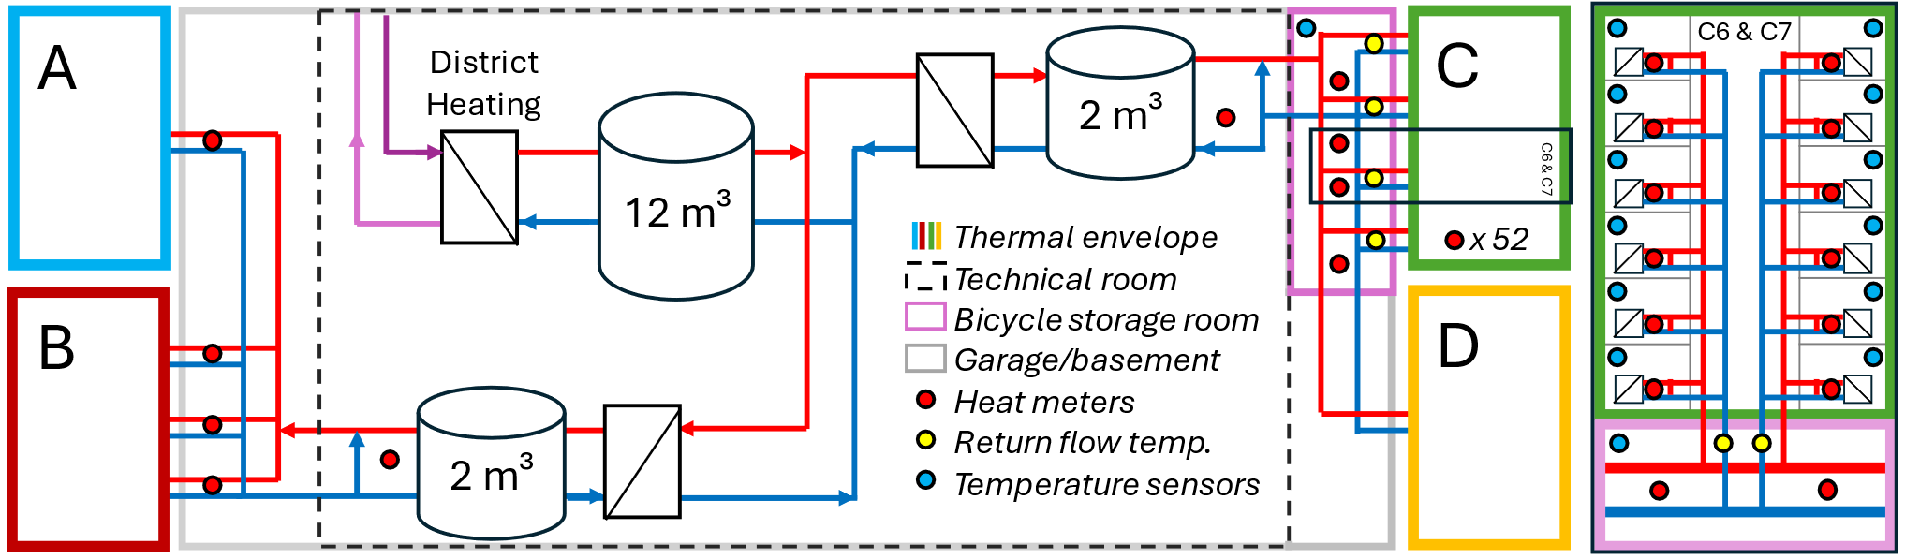
a) | b)
Fig. 1(a): Scheme of the monitoring of the central technical room and the DHW distribution system supplying buildings A, B, C and D; (b): detailed view on riser shaft group C6 & C7 in Building C
Tab.1 summarises the metering equipment, its logging intervals, resolutions and accuracy classes. Two characteristics of the installation are relevant for the analysis presented below. First, the heat meters log cumulative energy in whole kilowatt-hours only. For an individual apartment meter this quantisation is of the same order as the energy recorded during a single tapping event, so short-interval evaluations at apartment level are inherently coarse; the resulting uncertainty is limited to ±1 kWh per meter and reading, however, and therefore becomes negligible when energy is evaluated as the difference between two counter readings over longer periods. Second, the meters are not synchronised with each other, and their logging intervals differ between measurement points. All timeseries were therefore harmonised to a common time base before any difference between meters was formed, as described in Section 3.
Tab.1: Metering equipment in the DHW distribution system of Building C: logging intervals, accuracy and resolution. Heat meter accuracy classes refer to EN 1434
 | Logging intervals  [mm:ss] | Accuracy | Resolution(s)
Distribution HM | 15:00 | class 2 | 10 W; 1 kWh; 0.1 K; 0.01 m³ h⁻¹
FWS HM | 0:46 -1:28 (C7)  - 2:24 (C6) | class 2 | 10 W; 1 kWh; 0.1 K; 0.01 m³ h⁻¹
temperature sensors room | 14:23 – 14:50 | ±0.2 K (10 °C < ϑ < 30 °C) | 0.1 K
temperature sensors storage room | 1:00 | class B  ±0.4 K (ϑ = 20 °C) | 0.1 K
return temperature sensors | 1:00 | class B  ±0.55 K (ϑ = 50 °C) | 0.1 K

The distribution pump maintains a constant differential pressure, and each FWS is equipped with a thermostatic bypass valve throttling to a preset return temperature. In this configuration the temperature is the controlled variable and the volume flow is the process variable. The bypass flow self-adjusts to whatever is required to sustain the distribution losses. A drift of the valve setting is therefore not visible as a temperature anomaly at system level but manifests itself as a gradual increase in both circulation flow rate and return temperature. Two consequences follow. First, the thermal losses of a riser cannot be inferred from temperature measurements alone, since the temperature difference is imposed by the control loop; the volume flow carries the loss information. Second, elevated return temperatures propagate back to the heat supply, reducing the temperature spread available to the district heating network and increasing pumping energy while the distribution losses themselves grow.
- Methodology
The methodology includes five steps. First, the monitoring data are harmonised and filtered to isolate quasi-steady bypass operation, which is the state in which distribution losses can be observed without influence from tapping. Second, the measured losses of the investigated riser group are determined from an energy balance across the heat meters enclosing it, using cumulative readings only. Third, a grey-box model of the same riser group is set up, in which the losses are split into thermal zones and each pipe conductance is derived from documented geometry, insulation and material properties. Fourth, the model is calibrated against the measured losses. All pipe conductances remain fixed, so that only two quantities are inferred from the measurements: an ambient-coupled conductance outside the thermal envelope and a residual conductance inside it. Fifth, the calibrated model is applied to hypothetical operating scenarios in order to quantify the savings that a correctly set bypass would have achieved. The deliberate consequence of this design is that any discrepancy between model and measurement is forced into a small number of physically interpretable quantities instead of being absorbed by regression freedom. The plausibility of the calibrated values, rather than the goodness of fit, therefore becomes the relevant validation criterion.
Data preparation
All measurements were referred to a common local time base and, where meters with differing logging intervals had to be combined, resampled to the 15-minute grid of the distribution heat meters using time-weighted averaging over the respective interval. Gaps exceeding 30 minutes were excluded rather than interpolated. Since the cumulated energy is the primary quantity recorded by the heat meters, all energies were evaluated as the difference between two counter readings taken at the boundaries of the evaluation period, rather than as a sum of shorter increments. In this way the quantisation error remains bounded at ±1 kWh per meter and reading, independent of the length of the period considered.
A second filter addresses the operating state itself. Because the bypass flow and the tapping flow cannot be separated at the distribution heat meters, the analysis of quasi-steady bypass operation is restricted to a nightly window between 01:00 and 04:00, during which tapping is rare. Within this window, individual intervals still affected by tapping were removed using a median-absolute-deviation criterion applied on a daily basis.
Measured losses
The riser shaft group C6 & C7 was selected for detailed investigation because it has the shortest distribution pipe sections outside the thermal envelope and the lowest uncertainty in determining pipe lengths, and because two heat meters enclose it directly. As seen in Fig. 1(b), the riser group is enclosed by two heat meters in the main distribution line, HM6 upstream and HM7 downstream of the branch-off. Every apartment supplied by it is equipped with a heat meter on the primary side of its FWS. The heat entering the riser group is therefore the difference between the two distribution meters, while the heat leaving it as useful energy is the sum of the apartment meters. Their difference is the loss of the riser group (see equation (1), (2)), including the pipe sections in the storage room, the risers inside the thermal envelope and the standby losses of the FWS. Since the apartment meters register energy only while tapping, the bypass flow sustaining these losses is not part of the demand term and the balance is closed without further assumptions.
$$Q_{\text{loss},i}^{\text{meas}}=\underset{Q_{\text{supply},k}}{\underbrace{ΔE_{\text{HM6},k}-ΔE_{HM7,k}}} - \underset{Q_{\text{demand},k}}{\underbrace{\sum_{j∈C}{ΔE_{j,k}}}}$$ |  | (1)
$ΔE_{j,k}=E_{j}\left(t_{k}\right)-E_{j}\left(t_{k-1}\right)$ |  | (2)
Because the useful energy is subtracted through the apartment meters, this balance holds over any evaluation period and is not restricted to bypass conditions. The balance is evaluated over daily, weekly and monthly periods, with all heat meter readings taken at the period boundaries. Dividing by the period duration yields the mean loss power, which is the quantity the model is calibrated and validated against. All temperature differences entering the model are averaged over exactly the same periods. The nightly window is therefore not used for the calibration itself, but for the analysis of bypass operation and for the independent cross-check described at the end of this section.
$\overline{P_{\text{loss},k}^{\text{meas}}}=\frac{Q_{\text{loss},k}^{\text{meas}}}{t_{k}-t_{k-1}}$ | (3)
Model structure
The losses of the riser group are attributed to two thermal zones. The first includes the main distribution pipes between HM6 and HM7 and the branch connecting it to the riser shafts. Both pipe segments are located in the unheated bicycle storage room (pink frame in Fig. 1(b)) hanging from the ceiling. The second zone includes the vertical risers inside the thermal envelope (green frame in Fig. 1(b)) together with the FWS. Since the volume flow in the main distribution pipes exceeds the bypass flow of the riser group by a factor of eleven to fourteen (see Fig. 2), its water temperature is barely affected by the state of the riser group and is taken directly from the flow and return temperatures measured at HM6 and HM7.
$ϑ_{main}=\frac{1}{2}\left(\frac{ϑ_{f,HM6}+ϑ_{f,HM7}}{2}+\frac{ϑ_{r,HM6}+ϑ_{r,HM7}}{2}\right)$ |  | (4)
$ϑ_{riser}=\frac{1}{2}\left(ϑ_{f,HM6}+ϑ_{r,C6/C7}\right)$ |  | (5)
$ΔT_{main}=ϑ_{main}-ϑ_{storage}$ |  | (6)
${ΔT}_{branch}=ϑ_{riser}-ϑ_{storage}$ |  | (7)
$ΔT_{riser}=ϑ_{riser}-{\overline{ϑ}}_{flat}$ |  | (8)
$ΔT_{FWS}=ϑ_{r,C6/C7}-{\overline{ϑ}}_{flat}$ |  | (9)
Here ϑ_{f} and ϑ_{r} denote flow and return temperatures at the indicated measurement points, ϑ_{storage} the air temperature in the bicycle storage room, and ϑ̄_{flat} the mean indoor temperature of the twelve apartments supplied by the riser group. All quantities entering the model are evaluated as means over the respective evaluation period. The pipe conductances Λ_{z} are parameterized according to the design plans and are fixed throughout the analysis.
$$Λ_{z}=\sum_{n∈z}{ψ_{n}L_{n}}$$ | (10)
The linear thermal transmittance ψ_{n} of pipe section n follows from the series connection of the internal heat transfer, the insulation and the external surface resistance. The resistance of the pipe wall is three orders of magnitude smaller and is neglected.
$$ψ_{n}=1/{(R_{si}+ln\left(\frac{r_{n}+s_{n}}{r_{n}}\right)∙{\left(2πk_{\text{ins}}\right)}^{-1}+R_{se})}$$ | (11)
Pipe lengths, diameters and insulation thicknesses were taken from the design plans and verified on site. Both the supply and the return pipes of each section are accounted for. The insulation conductivity was taken as k_{ins} = 0.04 W m⁻¹ K⁻¹ for the installed mineral wool shells. The internal heat transfer coefficient is derived from the Nusselt number for fully developed laminar flow at constant wall temperature (Nu = 3.66), since the risers operate under bypass conditions for more than 98 % of the time. Only the main distribution pipe, which carries the flow of the remaining risers of Building C and of Building D, is treated as turbulent. The external surface resistance was accounted for using a constant surface coefficient of h_{se} = 10 W m⁻² K⁻¹. It contributes between 2 % and 10 % of the total resistance, depending on insulation thickness, so this simplification has only a minor effect.
Calibration
An initial comparison between expected performance and monitoring data revealed substantially higher distribution losses in operation than anticipated. In a first calibration step, all pipe conductance’s and all thermal bridges according to PHPP (Passive House Planning Package) were fixed, and only the conductance of the FWS was assumed from the measurements. This one-parameter model reproduced the total annual loss but left a systematic seasonal residual: the losses were underestimated in winter and overestimated in summer, and the residual correlated with the air temperature of the storage room with a slope of about 12 W K⁻¹. Since the modelled FWS conductance acts on a temperature difference that is nearly constant throughout the year, it cannot compensate such a residual, regardless of its magnitude.
The model was therefore extended by one degree of freedom, and the thermal bridges were removed from the fixed part. Two conductances are calibrated simultaneously. The first, χ_{amb}, acts in addition to the documented pipes outside the thermal envelope and is driven by the storage room temperature. The second, χ_{int}, acts in addition to the documented riser pipes and is driven by the indoor temperature. The two are identifiable because their driving temperature differences behave differently over the year: ΔT_{amb} varies by more than a factor of two between summer and winter, whereas ΔT_{riser} is nearly constant. For the branch and the risers, the mean of the flow temperature at HM6 and the measured riser return temperature is used.
${\dot{Q}}_{loss}=\left(Λ_{main}+Λ_{branch}+χ_{amb} \right)∙ΔT_{amb}+\left(Λ_{riser}+χ_{int} \right)∙ΔT_{riser}$ | (12)
The two pipe sections outside the envelope share the same ambient temperature but differ slightly in water temperature. They are combined into a single driving temperature difference, weighted by their documented conductances, so that χ_{amb} is a total conductance and the decomposition remains consistent with the fit.
$$ΔT_{amb}=\frac{Λ_{main} ∙ΔT_{main}+Λ_{branch}∙ΔT_{branch}}{Λ_{main}+Λ_{branch}}$$ | (13)
The problem is linear in two unknowns and constrained to non-negative values. It is solved directly by bounded linear least squares. No iterative optimisation or initial estimate is involved. Neither the thermal bridge assumptions nor the FWS enter this step, so the resulting fit quality is independent of them.
$$\left(χ_{amb}^{*},χ_{int}^{*}\right)=argmin_{χ_{amb},χ_{int}≥0} \sum_{k}{{\left({\overline{P}}_{loss,k}^{meas}-\left(Λ_{main}+Λ_{branch}+χ_{amb}\right)∙Δ{\overline{T}}_{amb,k}-\left(Λ_{riser}+χ_{int}\right)∙Δ{\overline{T}}_{riser,k}\right)}^{2}}$$ | (14)
The residual conductance inside the thermal envelope lumps two contributions that the measurements cannot separate: the thermal bridges of the riser shafts and the standby losses of the FWS. Both are driven by temperature differences that remain nearly constant throughout the year, so no seasonal signature distinguishes them. Their attribution therefore relies on the thermal bridge assumptions and is reported as a range rather than as a single value. Two bounding scenarios are evaluated: point thermal transmittances χ_{riser} characteristic of "good" and of "moderate" execution quality according to PHPP. Because the FWS absorb whatever the thermal bridges do not explain, the moderate scenario yields the lower and the good scenario the upper bound of the FWS standby loss. The two scenarios bracket the attribution while leaving the calibrated total unchanged.
Since the two contributions act on different temperature differences, the conversion is performed on an energy-equivalent basis over all evaluation periods.
$$ΔUA_{FWS}=\left(χ_{int}^{*}-χ_{riser}^{PHPP}\right)\frac{\sum_{k}{Δ{\overline{T}}_{riser,k}∙Δ{\overline{T}}_{FWS,k}}}{\sum_{k}{Δ{\overline{T}}_{FWS,k}^{2}}}$$ | (15)
The calibrated model was applied to hypothetical operating scenarios for the years 2024 and 2025. Three constant operating points were evaluated, combining flow temperatures of 57, 54 and 50 °C with a return temperature of 30 °C, the latter representing a correctly commissioned bypass setpoint. The same temperatures were assumed for the main distribution line. All other boundary conditions were taken from the measurements at monthly resolution. Where the air temperature of the storage room was not measured, it was reconstructed from two nearby weather stations with a seasonal bias correction derived from the overlapping measurement period, reaching about 2.8 K on 1st January and vanishing in early June. Missing monthly indoor temperatures were replaced by the value of the same month of the adjacent year. The reference losses were obtained from the same energy balance, where a logging gap crossed a month boundary, the heat meter reading was interpolated linearly, which distributes the recorded energy across the adjacent months without discarding them.
- Results
Fig. 2 shows the flow and return temperatures, and the volume flow measured at HM6 and HM7 in the main distribution line supplying Buildings C and D over the monitored period. Dashed lines represent daily means over the full day, solid lines the corresponding means restricted to the nightly window between 01:00 and 04:00, which is dominated by bypass operation.
The supply temperature remained largely constant at about 57 °C and was lowered to 54 °C between 12.2025 and 02.2026. Between 07.2023 and 07.2025 the return temperature rose from about 43.5 °C to 46.6 °C, and the volume flow increased from 0.74 to 0.98 m³ h⁻¹ (HM6), with a superimposed seasonal variation showing maxima in winter and minima in summer. The difference between the filtered and unfiltered series is about 4 K for the return temperatures and about 0.3 m³ h⁻¹ for the volume flow, confirming that the nightly window isolates bypass operation. As the measured losses for the entire building were significantly higher than predicted, and the return temperatures had increased by approximately 9 K since commissioning, an intervention was conducted to adjust the settings.

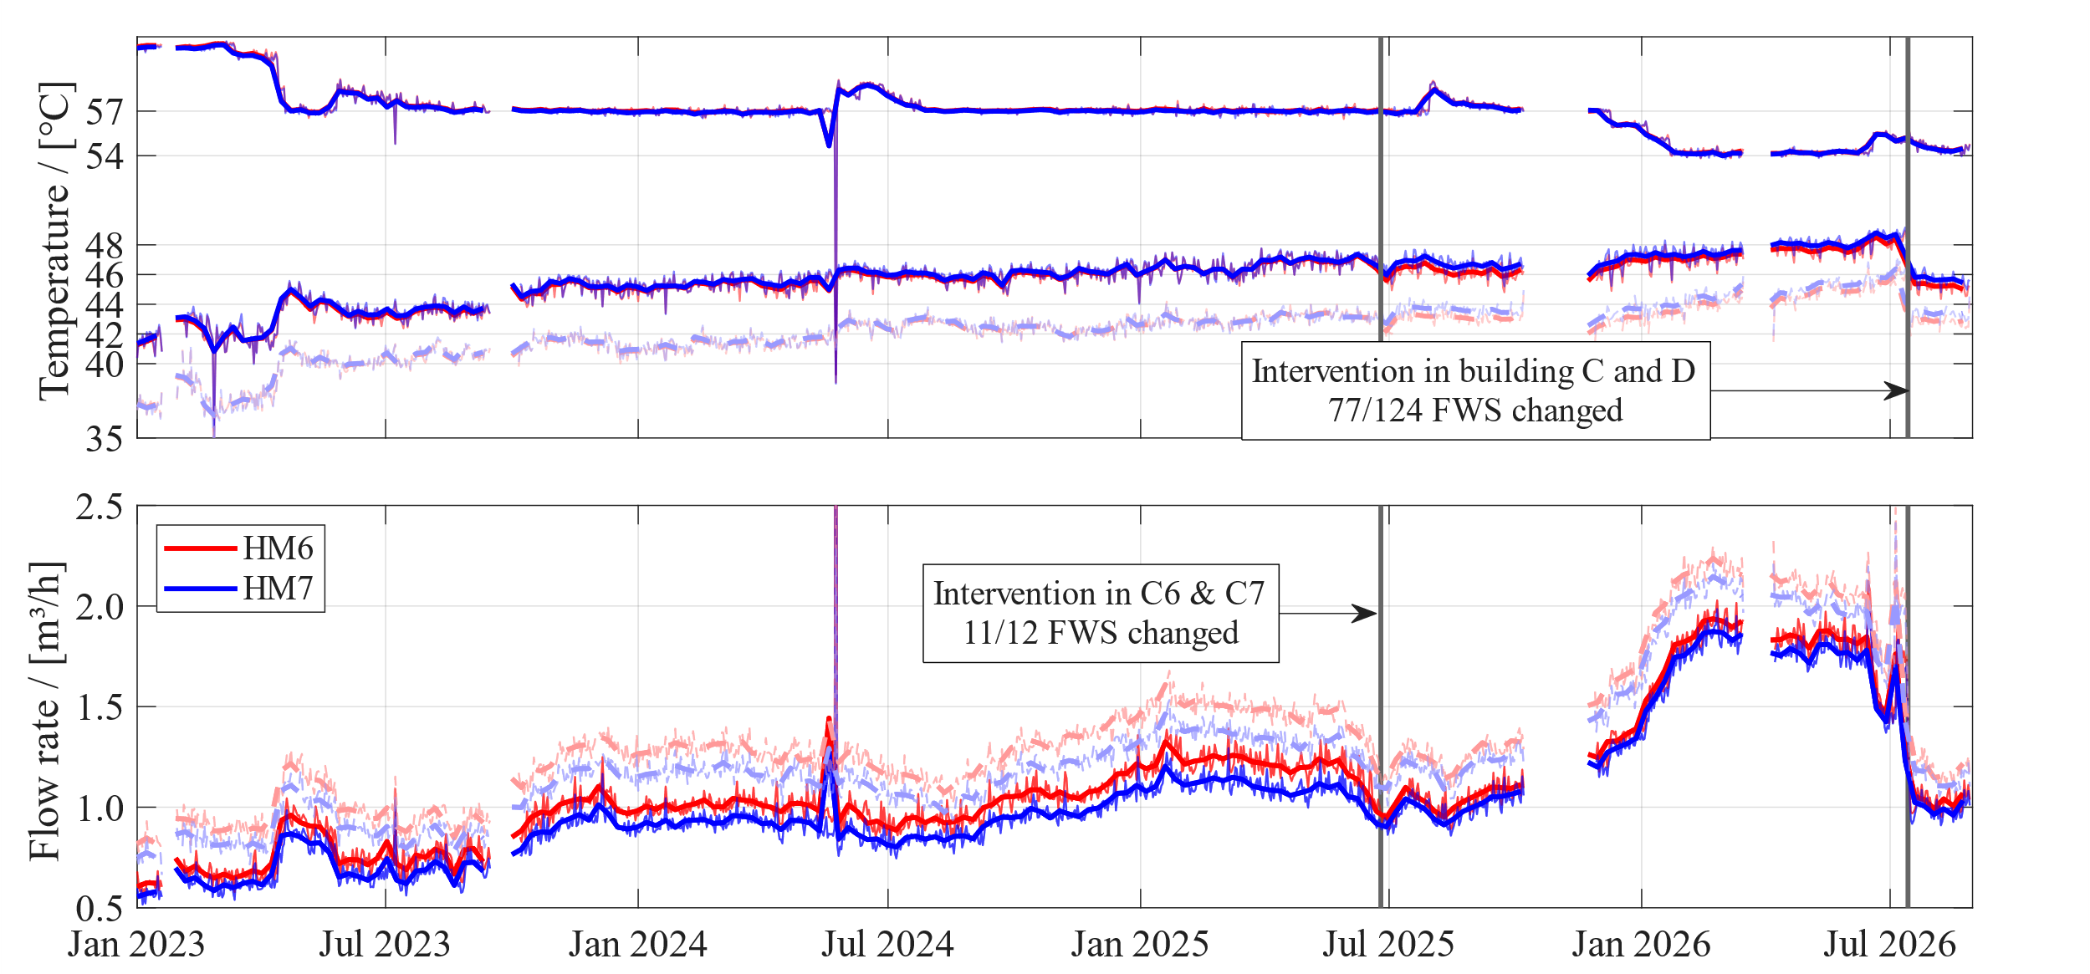
Fig. 2 Monitored flow and return temperature and flowrate at HM6 & HM7 as daily and weekly mean for nightly window (solid) and whole day (dashed)
Direct return temperature measurements at the riser shafts C6 and C7 were installed after the first intervention, so Fig. 3 covers the second intervention only. Markers represent hourly means within the nightly window, thin lines weekly means, and the thick horizontal segments the means of the sub-periods (30 days) before and after the intervention. During the first intervention on 25.06.2025, the bypass setpoint had been reduced in eleven of the twelve apartments supplied by the two risers. The remaining station on riser C6 was adjusted between 13.07 and 15.07.2026. Comparing the sub-period means, the return temperature at C6 decreased by 8.3 K, while at C7 it increased by 1.1 K over the same period. Settings in other risers of Buildings C and D were adapted during the same visit, so the observed change at C7 reflects the response to the modified hydraulic conditions in the network rather than to the single station on C6 alone.
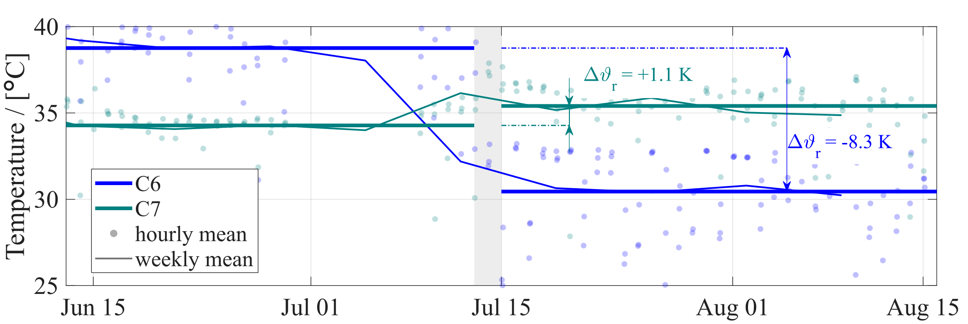
Fig. 3 Monitored return temperature at C6 & C7 as hourly, weekly and monthly mean for nightly bypass period.
Fig. 4 shows the flow and return temperatures measured on the primary side of each FWS in risers C6 and C7 to the corresponding measured thermal power. The eight panels correspond to the sub-periods before and after each of the two interventions, shown separately for the two risers.
Two effects are visible. First, the flow temperature clouds shift downwards, reflecting the reduction of the central supply temperature setpoint. In the first sub-period they form a narrow band between about 50 °C and 57 °C with a slight upward tendency towards higher tapping power. After the interventions the same clouds scatter considerably more, while the upward tendency is retained. The behaviour is similar for both risers. Second, the return temperature clouds differ noticeably between the two risers. At C6 the return temperature scatters over a wide range at all power levels. In the first sub-period it varies between about 15 and 40 °C at a tapping power of 20 kW, whereas the corresponding flow temperature varies by about 5 K only. At C7 the scatter is considerably smaller, with return temperatures between about 15 and 30 °C at the same power level. In all sub-periods the lower envelope of the C7 return temperature cloud follows a parabolic shape, with its minimum shifting from approximately 12 kW and 12 °C in the first sub-period to about 10 kW and 15 °C in the most recent one. The logging intervals of the FWS heat meters differ between the two risers (Tab. 1), therefore the number of captured operating states is not identical.
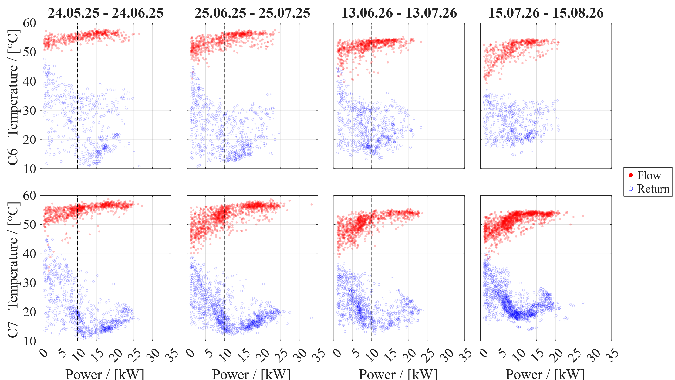
Fig. 4 Monitored flow (red) and return (blue) temperature at every FWS HM in C6 & C7 vs. thermal power
Comparing the 30 days before and after each intervention, the measured distribution losses of the riser group decreased by 26.2 % after the first and by 13 % after the second intervention. For the entire building C, the corresponding reductions were 9.8 % and 18 %. Since a substantial share of the losses is driven by the ambient temperature of the storage room, and the comparison windows fall in different parts of the season, part of the apparent reduction reflects the change in boundary conditions rather than the intervention itself.
Tab. 2 Measured and modelled distribution losses of riser shafts C6 & C7 at three aggregation levels, mean per period.
δ_{rel} = (model − measured) / measured
 | $$n_{periods}$$[-] | $$Q_{\text{loss}}^{\text{meas}}$$[kWh] | $Q_{\text{loss}}^{\text{model}}$  [kWh] | $δ_{rel}$  [%] | R²  [-]
Daily | 245 | 25.2 | 25.2 | -0.2 | 0.310
Weekly | 32 | 175.3 | 176.1 | 0.4 | 0.900
Monthly | 6 | 768.8 | 770.7 | 0.2 | 0.969

The calibrated model reproduces the measured losses at all three aggregation levels with a mean deviation below 0.5 %. The coefficient of determination increases from 0.31 for daily to 0.97 for monthly periods. This is a consequence of the metering resolution rather than of model quality. The heat meters record cumulative energy in whole kilowatt-hours, so the quantisation uncertainty of a daily balance is of the same order as the daily loss variation, whereas it becomes negligible over a month. The calibration itself is unaffected, since the quantisation error is zero-mean and does not bias the least-squares estimate.
The calibration yields an ambient-coupled conductance of χ_{amb} = 15.32 W K⁻¹ in addition to the 2.65 W K⁻¹ of the documented pipes outside the thermal envelope, and a residual conductance inside the envelope of χ_{int} = 8.73 W K⁻¹ in addition to the 16.45 W K⁻¹ of the documented riser pipes. Attributing the internal residual according to the two thermal bridge scenarios yields FWS standby conductances between 7.99 and 17.83 W K⁻¹ per station.
Fig. 5 shows the breakdown of the modelled losses for three winter and three summer months of 2026, at weekly and monthly resolution, together with the measured values. The contributions inside the thermal envelope are nearly constant throughout the year, whereas the ambient-coupled contribution varies by roughly a factor of 1.9 between summer and winter. Averaged over the evaluation period, 54 % of the losses occur outside the thermal envelope.
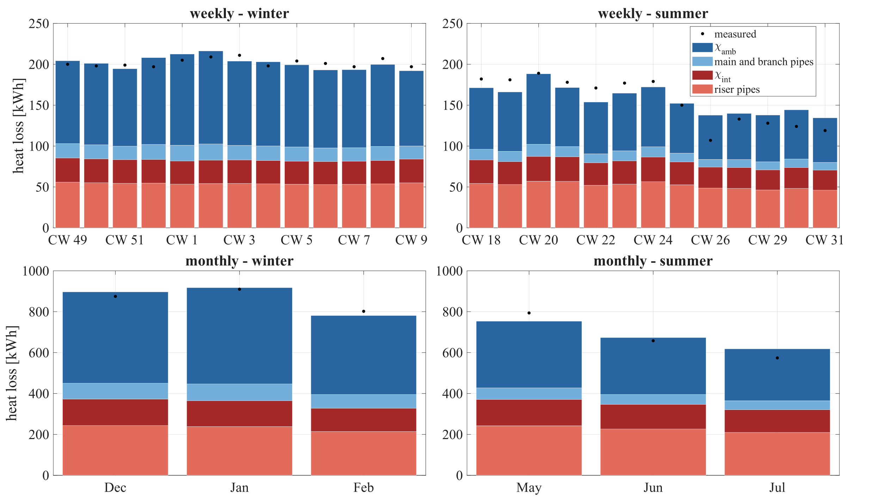
Fig. 5 Breakdown of the modelled distribution losses of riser shafts C6 & C7 into the fixed pipe conductances and the two calibrated residual conductances, for weekly and monthly periods in winter and summer. Markers show the measured losses from the energy balance.
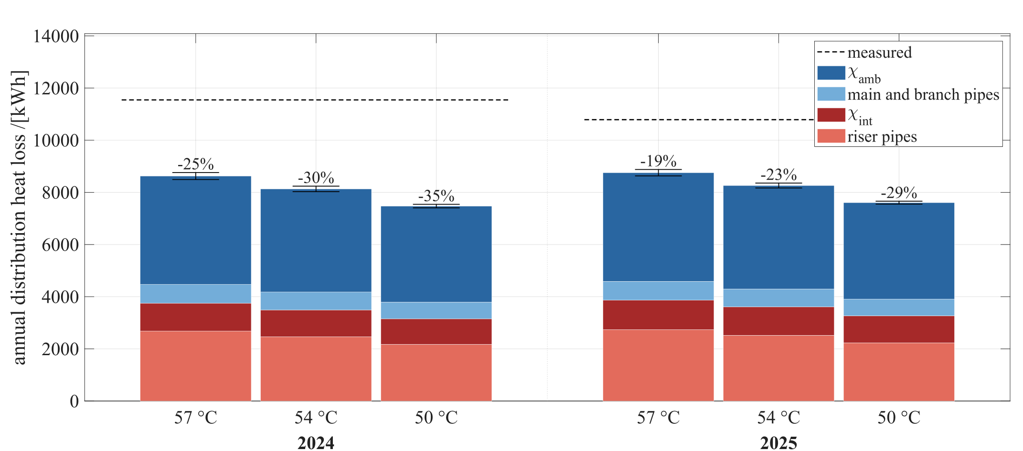
Fig. 6 Predicted annual distribution losses for the operating scenarios. The data labels show the relative saving to the measured loss of the respective year, for the intermediate thermal bridge scenario.
Fig. 6 shows the annual distribution losses that the calibrated model predicts for the three hypothetical operating scenarios, together with the measured losses of the same years. A bypass return temperature of 30 °C at the unchanged flow temperature of 57 °C would have reduced the annual losses by 19 to 25 %. Lowering the flow temperature in addition increases the saving to 23 to 30 % at 54 °C and 29 to 35 % at 50 °C. In accordance with VDI 6003, a minimum outlet temperature of 50 °C is recommended for the design of FWS, therefore the 50 °C scenario is included to illustrate the sensitivity of the losses rather than as a feasible operating point, since the flow temperature has to exceed the required outlet temperature by the driving temperature difference of the heat exchanger. Across all scenarios, between 55 % and 58 % of the losses occur outside the thermal envelope and the share attributable to the FWS ranges from 4 to 11 % depending on the thermal bridge scenario. Both shares are largely insensitive to the supply temperature.
Tab. 3 Annual distribution losses under three hypothetical operating scenarios, averaged over 2024 and 2025. Ranges indicate the span across the two bounding thermal bridge scenarios. δ_{rel} = (measured - model) / measured
$$ϑ_{f}/ϑ_{r}$$ [°C] | annual $Q_{\text{loss}}^{\text{model}}$  [kWh] | $δ_{rel}$  [%] | $Q_{amb}/Q_{loss}$  [%] | $Q_{FWS}/Q_{loss}$  [%]
57 / 30 | 8691 | 20.9 to 23.2 | 55.4 to 57.0 | 4.2 to 9.6
54 / 30 | 8198 | 25.6 to 27.4 | 56.0 to 57.4 | 4.4 to 10.2
50 / 30 | 7540 | 31.9 to 32.9 | 57.0 to 58.0 | 4.8 to 11.0

The losses occurring inside the thermal envelope act as an internal gain. During the cooling season (June to September) they accounted to 1.75 – 2.05 kWh m⁻² over the reference area of 618.9 m² of the twelve apartments (54 – 57°C scenario).
- Discussion
The monitoring results show that the DHW distribution losses were strongly influenced by the bypass operation of the FWS. While the supply temperature remained largely constant at about 57 °C and was later reduced to 54 °C, the return temperature and the circulation volume flow increased over time. As seen in Fig. 2, at HM6, the return temperature rose from about 43.5 °C to 46.6 °C and the volume flow from 0.74 to 0.98 m³ h⁻¹ between 07.2023 and 07.2025. The comparison between full-day and nightly filtered data confirms that the selected nightly window isolates bypass-dominated operation sufficiently well for this interpretation. This behaviour is consistent with the hydraulic configuration of the system. Under constant differential pressure, the thermostatic bypass valves regulate towards a preset return temperature by adjusting the bypass flow. Consequently, a drift of bypass settings is not necessarily visible as a distinct local temperature anomaly but manifests itself as a gradual increase in both circulation flow and return temperature. This also shows that temperature measurements alone are insufficient to infer riser-level losses, since the volume flow carries essential information on the heat losses sustained by the bypass operation.
The interventions support this interpretation and demonstrate the relevance of local FWS settings for system-level performance. During the first intervention, the bypass setpoint had been reduced in eleven of the twelve apartments supplied by risers C6 and C7. The remaining station on C6 was adjusted later. Comparing the sub-period means before and after this second intervention, the return temperature at C6 decreased by 8.3 K, while C7 increased by 1.1 K over the same period (Fig. 3). Since settings in other risers of Buildings C and D were adapted during the same visit, the response at C7 must be interpreted as part of the modified hydraulic conditions of the wider network rather than as an isolated effect of the single station on C6. Overall, the measurements indicate that a small number of incorrectly commissioned or drifting bypass valves can be sufficient to affect the performance of an entire riser group. This has direct implications for fault detection. A central measurement point can indicate that the system is drifting, but it cannot localise the responsible FWS or distinguish whether all valves drift gradually or only a few valves fail substantially.
The grey-box model provides a structured way to connect these operational observations with the measured energy losses. The measured losses of the riser group were obtained from an energy balance across HM6 and HM7 and the apartment-level FWS meters, so the total loss determination is independent of the model assumptions. In contrast to a purely empirical fit, the model keeps the documented pipe geometry and pipe conductances fixed and calibrates only two physically interpretable residual conductances. One coupled to the storage-room temperature outside the thermal envelope, and one coupled to the indoor temperature inside the thermal envelope. This limits regression freedom and makes the plausibility of the calibrated conductances more important than the fit alone. The calibrated model reproduced the measured losses with a mean deviation below 0.5 % across the evaluated aggregation levels. At monthly resolution, the coefficient of determination reached 0.969 (Tab. 2). The lower coefficient of determination at daily resolution should therefore not be overinterpreted as a model deficiency, since it is mainly caused by the heat meter resolution and the resulting quantisation uncertainty.
The attribution of losses to individual components is more uncertain than the total measured loss. The calibrated ambient-coupled conductance exceeds the value expected from the documented pipe geometry, which suggests additional heat losses or thermal bridges in the storage-room zone. Plausible contributions include the uninsulated heat meters, shut-off valves and fittings, as well as thermal coupling at the base of the riser shafts, where the shaft construction may connect parts of the nominally internal system to the storage-room air. Inside the thermal envelope, the residual conductance combines two contributions that cannot be separated directly by the available measurements, thermal bridges of the riser shafts and standby losses of the FWS. Since both contributions are driven by temperature differences that remain nearly constant over the year, their separation depends on the assumed thermal bridge scenarios and should be interpreted as a plausible attribution range rather than as measurement uncertainty. This also confirms the practical limitation of applying simplified PHPP-based thermal bridge estimates to extended DHW distribution networks in multi-apartment buildings, where the present results suggest that such approaches may underestimate the actual thermal bridge contribution considerably.
From an operational perspective, the hypothetical scenarios show that correcting the bypass return temperature is a relevant optimisation measure even without changes to the heat supply. A bypass return temperature of 30 °C at an unchanged flow temperature of 57 °C would have reduced the annual distribution losses by 19 to 25 % in the analysed years. Combining the same return temperature with a lower flow temperature further increases the predicted savings to 23 to 30 % at 54 °C and 29 to 35 % at 50 °C. The 50 °C scenario should, however, be read primarily as a sensitivity case, since a minimum outlet temperature of 50 °C is recommended for the design of FWS and the supply temperature must exceed this value by the driving temperature difference of the heat exchanger. Across the hypothetical scenarios, 55 to 58 % of the losses occur outside the thermal envelope, while the share attributed to the FWS ranges from 4 to 11 %, depending on the thermal bridge scenario. This underlines that both the ambient-coupled distribution sections and the local FWS/bypass operation have to be considered when assessing the efficiency of DHW distribution systems.
The changes in tapping behaviour after the interventions do not indicate a clear comfort problem, but the available data only allow a limited assessment of transient effects. The wider scatter of the flow temperature after the interventions occurs mainly at low thermal power, i.e. during short draw-offs and heat-up phases, where the temperature level is less critical than during longer draw-offs such as showering. In addition, no complaints were reported since the interventions, including the period with a flow temperature of 54 °C. Nevertheless, the temporal resolution of the apartment heat meters limits any quantitative assessment of heat-up times and short tapping events. Therefore, the results support the feasibility of lowering bypass return temperatures, but they do not replace a dedicated transient comfort analysis.
Several limitations should be considered when interpreting the results. First, the detailed model calibration and validation focus on riser group C6 & C7, which was selected because it has short distribution pipe sections outside the thermal envelope, comparatively low uncertainty in pipe lengths and two heat meters directly enclosing the investigated branch. This strengthens the internal consistency of the case study, but limits the direct transferability of the calibrated conductances to risers or buildings with different layouts. Second, the apartment heat meters record cumulative energy in whole kilowatt-hours and are not synchronised with the distribution meters. Although the data were harmonised and evaluated over longer periods to limit quantisation effects, short-interval apartment-level analyses remain inherently coarse. Third, the model cannot directly separate riser-shaft thermal bridges from FWS standby losses, because both are associated with nearly constant temperature differences over the year. Finally, while the monitoring clearly identifies bypass drift as the main operational driver of elevated return temperatures and volume flows, the physical origin of the valve drift remains unresolved.
Future work should therefore apply the monitoring and modelling approach to additional riser groups and buildings in order to test the transferability of the calibrated residual conductances and the robustness of the fault-detection logic. More detailed component-level measurements would be useful to separate losses from uninsulated fittings, heat meters, riser-shaft thermal bridges and FWS standby more clearly. A dedicated investigation of the long-term stability and failure mechanisms of thermostatic bypass valves would also be necessary to distinguish gradual drift from isolated defective or incorrectly commissioned valves. Finally, higher temporal resolution and better synchronisation of apartment-level metering would allow a more robust assessment of transient tapping behaviour and DHW comfort after bypass optimisation. (Bagge and Johansson, 2011) showed, that the maximum DHW flow was 40% higher at a 6 s resolution compared to 60 s. These extensions would support the development of more reliable planning guidelines and monitoring-based fault detection methods for DHW systems in large multi-apartment buildings.
- Conclusion
This study demonstrates how detailed monitoring and a constrained grey-box model can be combined to diagnose and quantify DHW distribution losses in a highly efficient large MAB. The long-term monitoring revealed a gradual increase in return temperature and circulation flow, which was traced to drifting or incorrectly set FWS bypass settings. The interventions showed that even a small number of faulty stations can affect the performance of an entire riser group, while central measurements alone are not sufficient to localise the fault. This confirms the value of distributed metering for operational diagnosis and for making otherwise hidden distribution losses visible.
The calibrated model links the measured losses to physically meaningful loss paths while keeping the documented pipe geometry fixed and limiting the calibration to two residual conductances. It reproduced the measured losses with a mean deviation below 0.5 %, and the monthly evaluation reached a coefficient of determination of 0.969. The analysis further shows that a substantial share of the losses is coupled to the bicycle storage-room zone outside the thermal envelope, while the remaining internal residual must be attributed to riser-shaft thermal bridges and FWS standby losses within a plausible range. The results therefore highlight the need to account for thermal bridges, uninsulated components and FWS standby behaviour more explicitly when estimating DHW distribution losses in extended multi-apartment networks.
The hypothetical analysis shows that correctly commissioned bypass settings can provide substantial savings without intervention in the heat supply. A return temperature of 30 °C would have reduced annual distribution losses by 23 to 30 % at 54 °C flow temperature. No relevant comfort impairment was indicated by the available operational data, although a detailed assessment of transient tapping behaviour is limited by the temporal resolution of the apartment meters. Overall, the paper contributes a monitoring-based methodology for identifying DHW distribution faults, quantifying their energy impact and translating operational data into planning-relevant information for large MABs.
- Acknowledgements
Project 101166831 - LIFE23-CET-KnowHowHP, Co-funded by the European Union. Views and opinions expressed are however those of the authors only and do not necessarily reflect those of the European Union or CINEA. Neither the European Union nor CINEA can be held responsible for them.
- References
Bagge, H., Johansson, D., 2011. Measurements of household electricity and domestic hot water use in dwellings and the effect of different monitoring time resolution. Energy 36, 2943–2951. https://doi.org/10.1016/J.ENERGY.2011.02.037
GeoSphere Austria, 2026. historical station data [WWW Document]. URL https://dataset.api.hub.geosphere.at/app/frontend/station/historical/klima-v2-10min (accessed 8.25.26).
Hamburg, A., Mikola, A., Parts, T.M., Kalamees, T., 2021. Heat Loss Due to Domestic Hot Water Pipes. Energies 2021, Vol. 14, Page 6446 14, 6446. https://doi.org/10.3390/EN14206446
Kropp, M., Lämmle, M., Herkel, S., Henning, H.M., Velte-Schäfer, A., 2025. Enhancing heat pump performance for domestic hot water preparation: A comparative analysis in existing multi-family houses. Energy Build. 328, 115155. https://doi.org/10.1016/j.enbuild.2024.115155
Ochs, F., Tosatto, A., Venturi, E., Breuss, S., Magni, M., Dermentzis, G., Wemhoener, C., 2025. Characteristic load curves of positive energy districts. Solar Energy Advances 5, 100081. https://doi.org/10.1016/j.seja.2024.100081
Pomianowski, M.Z., Johra, H., Marszal-Pomianowska, A., Zhang, C., 2020. Sustainable and energy-efficient domestic hot water systems: A review. Renewable and Sustainable Energy Reviews 128, 115155. https://doi.org/10.1016/j.rser.2020.109900

