EuroSun2026
Retrofit application and validation of a building-integrated photovoltaic-thermal system

Min-Hwi Kim, Heon-Min Lee, Youngsub An, Hong-Jin Joo, Jongkyu Kim
Renewable Energy System Laboratory, Korea Institute of Energy Research, Republic of Korea

mhkim001@kier.re.kr

Summary
This paper investigates the retrofit application and performance validation of a building-integrated photovoltaic-thermal (BIPVT) system for building thermal energy serving system. The system was developed to overcome the leakage risk and limited façade applicability of conventional photovoltaic-thermal systems by reducing the number of hydraulic joints. A 1.472 kW capacity of BIPVT system composed of eight 184 W electric capacity modules was installed in a renovated building and operated as a heat source of a water-to-water heat pump system. And the heat source of heat pump uses BIPVT and ground heat exchagner. The surplus thermal energy duriong the day-time was stored into the ground. To validate its thermal behavior, a Hottel-whillier model was adopted using a 23.5% of optical efficiency and first-order heat loss coefficient of -5.795 W/m²K. The simulation outputs were validated against measured performance data, it was found that a installed BIPVT showed 7.2% of CV(RMSE) and 91.8% of an R² value. These results show that the BIPVT system can be practically applied to retrofit buildings and that its actual performance can be reliably predicted through a simulation model.
Keywords: Building-integrated photovoltaic-thermal, building retrofit, experimental validation
Field of application for the findings: Retrofit building energy systems, solar-assisted heat pump systems, building-integrated renewable energy technologies
Addressed audience: Researchers and engineers in solar thermal systems, building façade design, heat pump applications, building retrofits

- Introduction
Interest is increasing in photovoltaic-thermal (PVT) systems that can simultaneously utilize photovoltaic and solar thermal energy in order to enhance the applicability of renewable energy in the building sector. In particular, building-integrated photovoltaic-thermal (BIPVT) systems are advantageous for application to retrofit and net zero-energy buildings in that they can efficiently utilize limited installation area through integration with the building envelope. However, conventional PVT or building-attached PVT (BAPVT) systems have a risk of leakage due to the large number of connecting components between modules, which may limit their reliability and constructability as exterior materials.
In this study, to improve these limitations, a BIPVT system with reduced number of connecting components was applied to a retrofitted building, and both the system performance and the validity of the analytical model were examined through comparison of measured data and simulation results. In particular, this system has significant practical implications not only because of the structural improvement in enhancing building applicability, but also because under actual operation it serves as a heat source for a heat pump and excess heat is stored in the ground heat exchanger.
The objectives of this paper can be summarized in three parts. First, it presents the applicability of a BIPVT system with reduced connections, compared to conventional PVT systems, to retrofitted buildings. Second, it evaluates the thermal utilization potential of the system through actual installation and operation. Third, it verifies the applicability of the analytical model by comparing simulation results with measured values.

- System description and methodology
2.1. Overview of BIPVT system
The proposed BIPVT system installed on a retrofitted building, with a total installed capacity of 1.472 kWp, consisting of eight 184 W modules. The overall construction period was from June 26 to August 11, 2025, and the BIPVT installation itself required a total of 6 days. Specifically, 2 days were installed for the modules, 1 day for insulation, 2 days for piping, and 1 day for the inverter. This shows that, in terms of constructability, the system has a relatively short installation period when applied to retrofitted buildings.
Conventional PVT systems have a high possibility of leakage because they contain module connection parts, and this structure acts unfavorably for application as a building exterior material. The BIPVT system examined in this study was designed to allow the use of original 6 m copper tubes, thereby reducing the number of separate connection parts. As a result, the number of joints was reduced from 24 to 6, a reduction of about 75%. Such a structural improvement can be regarded as a key strategy for reducing the possibility of leakage and enhancing system reliability in terms of long-term operation and integration with the building envelope.
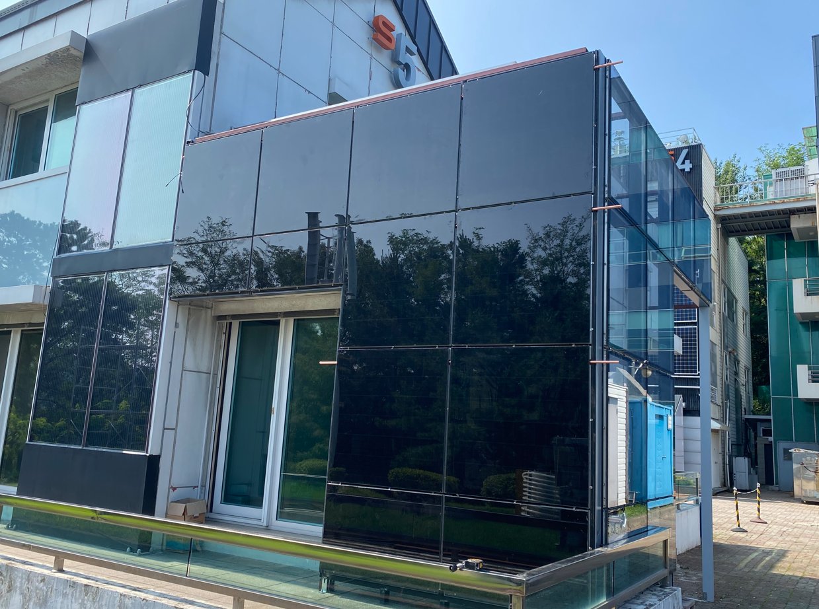
Fig. 1: Overview of BIPVT system
2.2. Operation conditions
This BIPVT system was operated not as a electricity generation system, but as a heat source generation device linked with the building thermal energy services system. The heat recovered from the BIPVT was used as a heat source for the heat pump and was utilized to produce thermal energy for heating and hot water supply, while excess heat during daytime operation was stored into the ground heat exchanger. This operating method takes into account both the direct usability of the recovered solar thermal energy and the possibility of seasonal or hourly-shifted utilization.
2.3. Performance evaluation methods
The Hottel–Whillier model was applied for thermal performance analysis. In this study, the useful heat gain of the BIPVT system was calculated based on the optical efficiency and the heat loss coefficient, with the optical efficiency set at 23.5% and the first-order heat loss coefficient set at 5.795 W/m²K. This model is widely used for evaluating the steady-state or quasi-steady-state performance of solar thermal collectors, and it has also been extended to the analysis of PVT and BIPVT systems. Relevant previous literature (An et al. 2025) nd the collector performance characterization approach of the ISO 9806 series provide the background for this coefficient-based analysis. The power generation model was applied to NOCT cell temperature model.
In this study, the suitability of the model was examined by comparing the simulation results with measured data. The measured-based comparison item was the thermal performance obtained from the system operating data, and CV(RMSE) and the coefficient of determination R² were used as quantitative comparison indicators. This comparison was intended to determine how accurately the analytical model reproduces the trend and level under actual operating conditions.

- Results and validation
3.1. Thermal and electrical performance evaluation
From the operation results of the proposed BIPVT system during the two months after installation (September to October 2025), it was confirmed that the total power generation over the two-month period was 17.97 kWh and the heat collection amount was 37.37 kWh. During the heat collection period, the inlet water temperature of the BIPVT ranged from 21.7°C to 41.2°C, and the outlet water temperature ranged from 22.6°C to 41.7°C, with the average inlet-outlet temperature difference operated at 0.6 °C. During the measurement period, for most of the time, the collected heat was stored in the ground-source heat pump, and during some daytime hours, it was operated as a heat source for the heat pump.
3.2. Performance validation
The comparison between the simulation results and the measured data for solar thermal performance showed that the CV(RMSE) was 7.2% and the coefficient of determination R² was 91.8%. In general, a low CV(RMSE) and a high R² indicate that the model estimates the measured data with high accuracy, and the results of this study show that the simple model can sufficiently reproduce the thermal performance trend of the actual BIPVT system. An actual building-applied system involves various non-ideal factors such as installation conditions, operation control, outdoor conditions, piping, and storage conditions, it still showed a relatively high level of agreement, indicating high practical applicability.
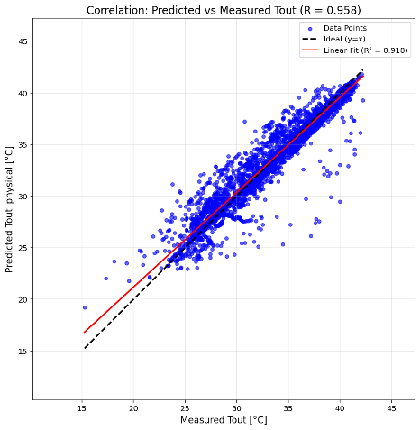
Fig. 2: Comparison of measured and predicted outlet temperature of BIPVT
- Conclusions
In this study, the applicability and performance verification results of a building-integrated photovoltaic-thermal (BIPVT) system applied to a remodeled building were presented. To alleviate the leakage risk at connection parts inherent in conventional PVT systems, a structure with a greatly reduced number of connecting components was applied, and as a result, the number of joints was reduced from 24 to 6. In addition, by installing and operating a 1.472 kWp system on an actual building, the possibility of real-scale application of the improved BIPVT system was confirmed.
For thermal performance analysis, simulations were performed based on the measured zero-loss maximum efficiency of 23.5% and the first-order heat loss coefficient of 5.795 W/m²K. As a result, comparison with the measured data showed a CV(RMSE) of 7.2% and an R² of 91.8%, securing a high level of agreement between the model predictions and the measured values. This means that the simple physics-based model applied in this study can be used as a reliable performance prediction tool even under actual operating conditions.
Acknowledgement
This work was conducted under the framework of the Research and Development Program of the Korea Institute of Energy Research (C6-2410-32) and was supported by the Korea Agency for Infrastructure Technology Advancement (KAIA) grant funded by the Ministry of Land, Infrastructure and Transport (Grant RS-2025-02316198).
References
An Y., Lee W., Joo H.J., Kim D.W., Kim J., Kim M.H., 2025. Effects of heat collection methods on the electrical and thermal efficiencies of building-integrated photovoltaic thermal modules. Applied Thermal Engineering. 277, 127067.

