EuroSun2026
TECHNO-ECONOMIC ANALYSIS FOR THE DECARBONIZATION OF AN INDUSTRIAL MINERAL DRYING PROCESS IN SOUTHERN FRANCE

Margherita Bonizzato, Simon Caron, Valéry Vuillerme
CEA, LITEN, Grenoble, France
Margherita.BONIZZATO@cea.fr, Valery.VUILLERME@cea.fr
Summary
The SHIP4D project explores the integration of solar heat for the decarbonization of industrial process heat in the medium temperature range (100–400 °C). A hybrid energy system is modelled, including photovoltaics (PV), concentrated solar thermal (CST), electrical or thermal storage and power to heat (electric heater or heat pump). The CAIRN open-source optimization software minimizes Net Present Value (NPV) and Greenhouse Warming Potential (GWP) of the hybrid energy system. The analysis focuses on an industrial case study for a site producing industrial minerals in Southern France. The industrial process consists in grinding and drying calcium carbonate. Process heat is currently provided by a gas burner as a hot air stream. The analysis shows how this industrial process can be decarbonized by a combination of process electrification, demand response and hybridization with solar energy, including thermal energy storage.
Keywords: Solar energy, Hybrid energy system, Industrial Process Heat, Decarbonization
Field of application for the findings: Sustainable Heat for Industrial Process (SHIP)
Addressed audience: Industrial energy managers, renewable energy planners, research institutions
- Introduction
According to the IEA (IEA,2026), the industrial sector represents 19% of France total final energy consumption and generates 15% of its CO2 emissions. More than 70% of this energy is consumed in the form of heat, while 50% of this heat requires a temperature below 400°C. Today, this thermal energy is mainly supplied by fossil fuels, particularly natural gas. Several decarbonization pathways are considered in the sectoral transition plans presented by the French energy agency ADEME for 2050 (ADEME, 2026): i) energy efficiency and conservation, ii) process electrification, iii) smart integration of renewable energies and energy storage.
The SHIP4D project (SHIP4D, 2026), as part of the French research program for industry decarbonization (PEPR SPLEEN, 2026), studies the contribution of solar energy to the decarbonization of industrial processes, in particular for the medium temperature range (100-400°C). Preliminary results for a generic case study have been published in a project deliverable (Caron and Vuillerme, 2025). This paper follows a similar methodological approach tailored to a real industrial case study.
- Case study
The industrial partner is an international producer of industrial minerals, mainly fillers and pigments derived from calcium carbonate and a worldwide distributor of speciality chemicals. The industrial site, located in Southern France, is ISO 50001 certified since 2018. The activities are mainly pre-grinding and drying of calcium carbonate, which requires a significant amount of heat. The industrial partner aims to achieve net zero greenhouse gases (GHG) emissions and has already implemented several energy efficiency measures, such as waste heat recovery (WHR). These actions are in line with the objectives of the French Low Carbon Strategy (SNBC, 2025) and Energy and Climate Plan (NECP) (EU commission, 2024).
The industrial partner has evaluated different options for this site, such as the integration of a hybrid gas-electric heater, process electrification and demand response, local production of renewable energy (solar PV, concentrated solar thermal CST).
This case study focuses on the decarbonization of one particular drying process requiring a temperature between 150 and 400 °C, which represents approximately 30% of the site’s natural gas consumption. Heat demand is supplied by two direct firing gas burners (4.6 MW each) and the global energy efficiency of the process is around 80-90 %. In 2025, the annual CaCO₃ demand was around 180000 t, corresponding to a natural gas consumption of 16000 MWh, approximately $1.5 x {10}^{6}$Nm³. The electricity consumption required to operate the auxiliary equipment was 2500 MWh. The objective of this case study is to optimize the energy infrastructure sizing and operation for this process, aiming at a hybrid system minimizing both Net Present Value (NPV) and the Greenhouse Warming Potential (GWP).
Weather data
Following the description of the case study, the main meteorological conditions at the investigated site are presented to characterize the available solar resource and provide the environmental inputs for the subsequent analysis. The meteorological dataset was generated using Meteonorm v8 (Meteonorm, Version 8, 2026) to obtain a synthetic Typical Meteorological Year (TMY), while the U.S. National Renewable Energy Laboratory System Advisor Model (SAM, version 2025.4.16; SAM™ 2025.4.16) was used to derive the solar energy yield time series. The dataset includes solar radiation parameters (Global Horizontal Irradiance GHI and Direct Normal Irradiance DNI), solar position, ambient temperature, relative humidity, and atmospheric pressure. GHI is considered for PV systems, while DNI is the main solar resource parameter for one-axis tracking CST systems.
In the figures below (figure 1 and figure 2), the main meteorological parameters for the site are presented (year 2005). The ambient temperature ranges from -5 °C to 37 °C, with an annual average value of 15°C. The Global Horizontal Irradiance reaches a maximum value of 1092 W m⁻² with an annual irradiation of 1583 kWh m⁻², while the DNI reaches a maximum value of 1012 W m⁻², with an annual irradiation of 1854 kWh m^{-2.}

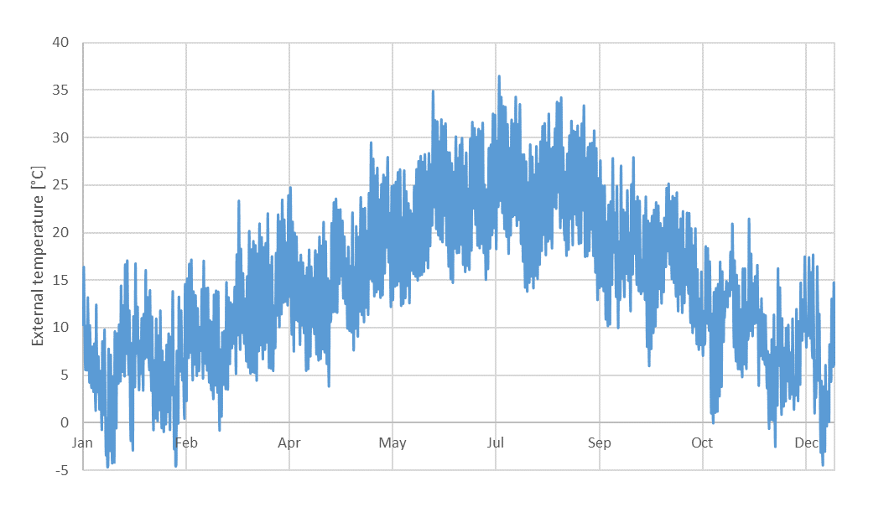
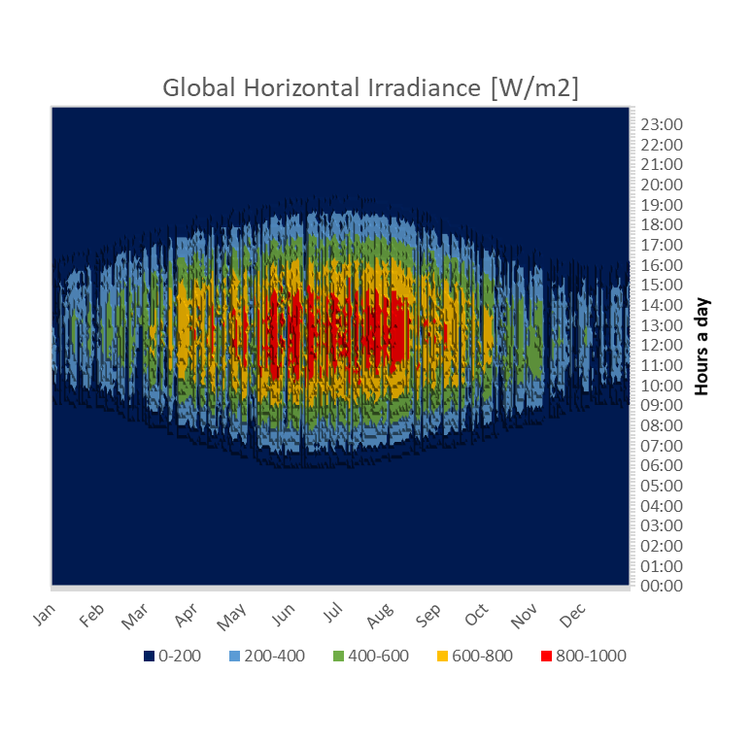
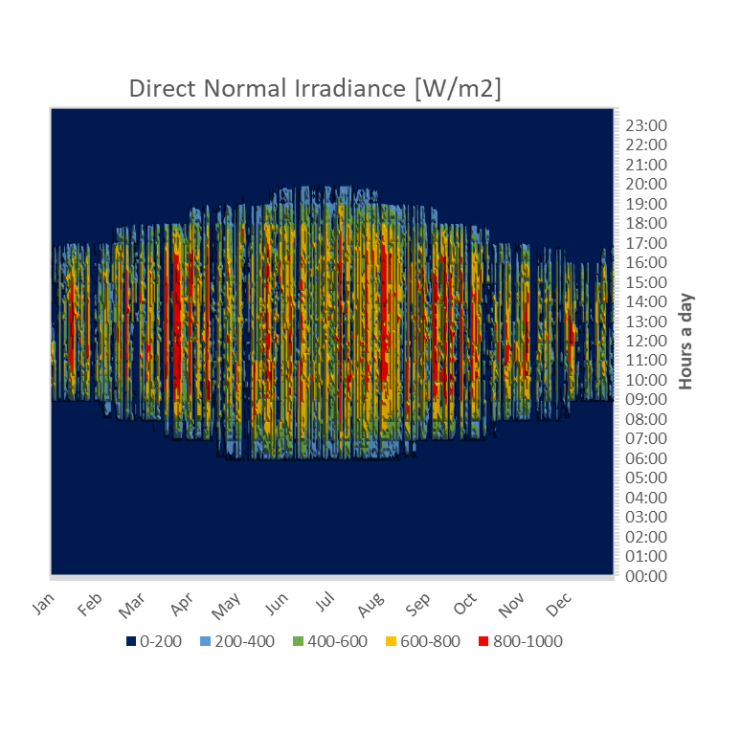
Fig. 1: Site annual temperature profile (2005)
Fig. 2: Site annual solar irradiance shown as heat maps throughout the year
- Methodology
CAIRN is an optimization software for energy system management developed by CEA (Commissariat à l’énergie atomique et aux énergies alternatives) since 2019. CAIRN is an object-oriented modelling and optimization software for the techno-economic and environmental analysis of multi-carrier energy systems. It uses a Mixed-Integer Linear Programming (MILP) formulation and a dynamic temporal optimization approach to simultaneously optimize system sizing and operation. Energy systems are modelled by assembling modular technological components that exchange energy and state variables, such as electricity, heat, and fuel. The optimization problem is solved using IBM CPLEX, while Key Performance Indicators (KPIs) can be calculated and post-processed using Python or Excel.
In this study, the optimization objective is to minimize the Net Present Value (NPV) while satisfying specific decarbonization targets defined relative to the current emissions baseline.
Technological Scope
According to partner’s priorities, the analysis considers multiple technologies for both electricity and heat generation solutions:
- Air heaters
  - Natural gas direct firing heater (already present on site)
  - Electric heater (to be sized)
  - Hybrid heater (Natural gas and electricity – to be sized)
- Solar energy:
- PT CST, Parabolic Trough Concentrated Solar Thermal technology (to be sized)
- LF CST, Linear Fresnel Concentrated Solar Thermal technology (to be sized)
- PV, Photovoltaics, more specifically crystalline silicon (to be sized)
- Energy storage
  - EES, Electrical Energy Storage, in particular Lithium iron phosphate (to be sized)
  - TES, Thermal Energy Storage (to be sized)
- Energy efficiency
  - HP, Heat Pump to recover waste heat (to be sized)

System architecture
The CAIRN energy system model (shown in figure 3) includes both existing on-site components and additional components to be sized and operated, with the aim of identifying the optimal system configuration under the imposed constraints.

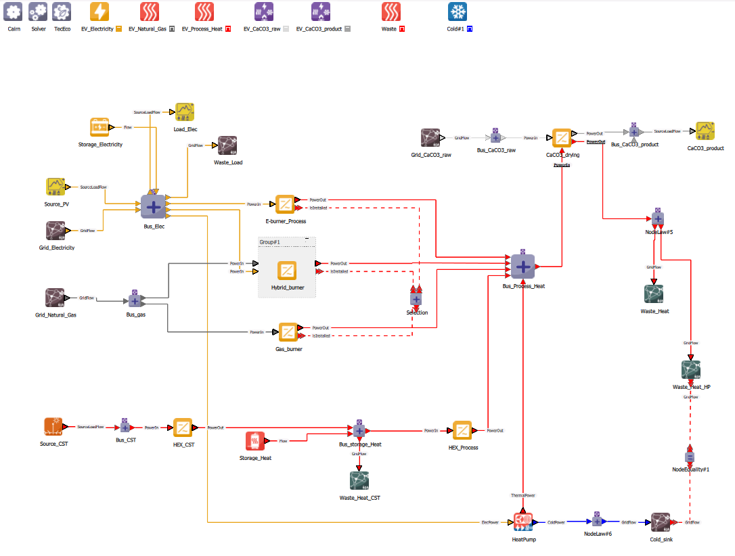
Fig. 3: CAIRN energy system model
This model includes:
- Seven energy carriers: electricity (230 V, AC), natural gas (NG), process heat, waste heat (equal to cold power for the HP), CaCO₃.
- CaCO₃ drying system.
- Six energy sources: electricity, natural gas, PV installation and CST installation.
- Two energy storages: EES, TES (strictly connected to PV and CST power installations, respectively).
- Three heaters: electric, hybrid, gas direct firing.
- One waste heat recovery heat pump, to heat up the residual process heat.
- Three sinks for curtailed electricity and non-recoverable waste.
- Assumptions and scenarios
Parameter input
The following section presents the main techno-economic parameters used as inputs. The project lifetime is set to 25 years, while the discount rate is 5% for Net Present Cost (NPC) and Levelized Cost of Heat (LCOH) calculations. Inflation is not considered in the energy carrier costs over the analysis period.
Other assumptions include that excess electricity and heat cannot be sold. CAPEX is available “Overnight” and there is also no lead time between project funding and commissioning.

Tab. 1: Technologies included in the analysis, including CAPEX, OPEX, efficiency, carbon footprint and data sources.
Technology | CAPEX | OPEX | Efficiency | Carbon Footprint | Data Source
Direct firing gas heater (4.6 MW) | 0 €/kW_{t} | 213 €/MW | 100% | N.A. | Danish Energy Agency
Electric heater | 850 €/kW_{e} (*) | 0.5% | 100% | N.A. | Danish Energy Agency / Provided by the partner (*)
Hybrid heater | 1140 €/kW (*) | 1.5% | 100% | N.A. | Danish Energy Agency / Provided by the partner (*)
PV (+ inverter) | 900 €/kW_{p}  (incl. inverter) | 3.3% | Timeseries  No degradation | 1050 kg CO_{2,eq}/kW_{p} installed | ABTEC database
PT CST | 500 €/m² | 1.5% | Timeseries  No degradation | 5 g CO_{2,eq}/kWh | Provided by actual industrial supplier / U.S. NREL
LF CST | 320 €/m² | 1. 5% | Timeseries  No degradation | 5 g CO_{2,eq}/kWh (*) | Provided by actual industrial supplier / U.S. NREL (*)
EES | 300 €/kWh  (incl. BMS) | 2.5% | 85% (round trip) | 300 kCO_{2,eq}/kWh capacity | ABTEC database
TES | 150 €/kWh  (incl. HEX) | 2.5% | 80% | N.A. | WBCSD technology briefs
HP | 1550 €/kW_{t} | 0.161% | COP = 2.7 | N.A. | Danish Energy Agency

For environmental analyses, the focus is set exclusively on the Greenhouse Warming Potential (GWP), i.e. the equivalent emissions of CO₂ or carbon footprint expressed in kgCO_{2,eq}. One can distinguish between embodied grey emissions for a given technology due to manufacturing and direct emissions during usage. A detailed lifecycle
analysis (LCA) or “cradle-to-grave” (including dismantling) is out of scope for this case study. A “cradle-to-gate”
approach is preferred, using available literature. The carbon footprint of electricity extracted from the grid is assumed to be constant over the project’s lifetime, ignoring future decarbonization of the power sector. Grey emissions are available for PV, CST and EES technologies. No data is yet available for TES and boiler technologies.
For energy storage (EES and TES), the initial State of Charge (SOC) is set to 0% (empty storage on January 1st).
Technology specific parameter inputs, i.e. CAPEX, OPEX, lifetime, efficiency and carbon footprint, are aggregated from different references. Relevant values and sources are listed in table 1. OPEX costs are given as a percentage of CAPEX.
For the space constraints, values of 60000 m² are assumed for CST.
As a disclaimer, all mentioned cost figures have to be cautiously scrutinized, as they are regarded as generic technology costs. Potential economies of scale are not directly taken into account in CAIRN.
The electricity and natural gas prices were derived from the industrial partner’s 2025 utility bills, resulting in monthly energy price values that account for variations throughout the year. The annual market mean priced for natural gas and electricity are 50 €/MWh and 80 €/MWh, respectively.
The carbon footprint factors for natural gas and electricity were obtained from the ADEME Base Empreinte database for mainland France. The latest available values were considered, corresponding to 240 kCO_{2,eq}/MWh for natural gas and 46.1 kCO_{2,eq}/MWh for electricity.

Estimated Solar Energy Yield
The weather data presented in Section 2 were used to generate the solar energy production time series required by CAIRN.
For PV systems, the SAM generic PVWatts model was adopted for preliminary assessment, using the default assumptions for module and inverter characteristics and system losses. Two configurations were considered: south-facing with a 30° tilt (S30) and east–west with a 15° tilt (EW15).
For CST systems, two collector technologies were considered: Parabolic Trough (PT) and Linear Fresnel (LF), each with north–south and east–west orientations. The thermal energy yield was calculated using manufacturer-provided optical and thermal performance data. The thermal power delivered to the heat transfer fluid was determined from the absorbed solar radiation, accounting for direct and diffuse components through the collector optical efficiency and incidence angle modifier (IAM), and subtracting thermal losses as a function of the mean fluid and ambient temperatures.
The resulting PV and CST production time series are presented in the following figures.

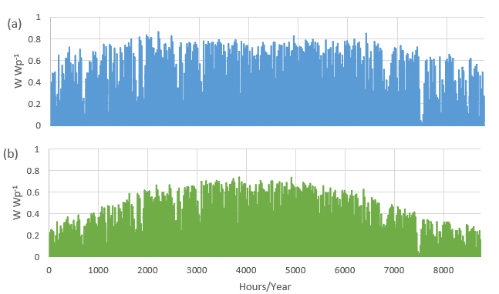
Fig. 4: Specific PV production time series per unit of installed peak capacity for a) south facing 30° tilt PV and b) eat-west facing 15° tilt

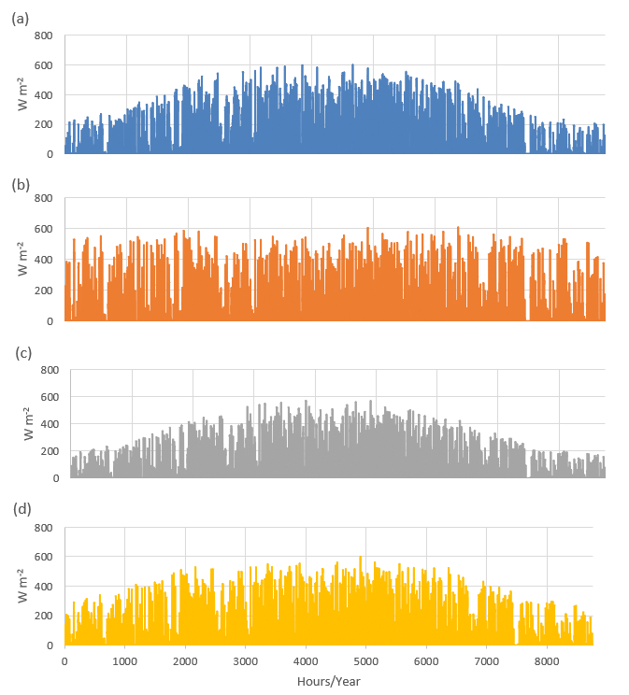

Fig. 5: Specific CST production time series per unit area for a) NS oriented PT CST, b) EW oriented PT CST, c) NS oriented LF CST, d) EW oriented LF CST
Key performance indicators
Main key performance indicators analysed in this study are:

- CAPEX value represents the initial investment required, per technology and per scenario.
- OPEX includes the operating and maintenance costs. In this paper, OPEX values are calculated over the 25-years evaluation period, considering the discount factor to account for the time value of money.
- NPV (Net Present Value) sums initial CAPEX with discounted OPEX. It corresponds to the optimization cost function to be minimized for each scenario.
- Decarbonization Level is the percentage reduction in CO2 emissions achieved by a given scenario compared with the reference scenario (current system configuration).
- LCOH (Levelized Cost of Heat) corresponds to the NPV divided by the useful thermal energy generated and it is expressed in €/MWh.
- Marginal Abatement Cost is the additional cost required to achieve one additional unit of CO2 emissions reduction, expressed in €/kgCO₂.
- ROI (Return of Investment) is calculated as the net profit divided by the initial investment cost, expressed as a percentage.
- Design Solar Fraction is the ratio between the heat produced by solar energy (coming from solar PV and CST) and the annual heat demand, expressed in %.
- Solar Utilization Factor is the fraction of the available solar energy effectively utilized by the system.
- Solar Multiple is the ratio between the solar field size and the nominal heat power demand.

Scenarios
A set of scenarios is defined for the case study, as listed in table 2.

Tab. 2: Benchmark of scenarios analysed in this study
ID | Scenario label | NG | Electricity | CST PT NS | CST PT EW | CST LF NS | CST LF EW | TES | PV | EES | WHR HP
1 | NG  Reference Scenario | x | o | o | o | o | o | o | o | o | o
2 | Elec heater | o | x | o | o | o | o | o | o | o | o
3 * | Hybrid heater | x | x | o | o | o | o | o | o | o | o
6.a * | NG+CST PT | x | o | x | x | o | o | o | o | o | o
6.b * | NG+CST PT+TES | o | o | x | x | o | o | x | o | o | o
7.a * | NG+CST LF | x | o | o | o | x | x | o | o | o | o
7.b * | NG+CST LF+TES | o | o | o | o | x | x | x | o | o | o
8 | NG+PV+ EES | x | o | o | o | o | o | o | x | x | o
9 * | WHR HP | x | o | o | o | o | o | o | o | o | x
10.a * | All technologies (CST PT NS) | x | x | x | o | o | o | x | x | x | x
10.b * | All technologies (CST PT EW) | x | x | o | x | o | o | x | x | x | x
10.c * | All technologies (CST LF NS) | x | x | o | o | x | o | x | x | x | x
10.d * | All technologies (CST LF EW) | x | x | o | o | o | x | x | x | x | x
11.a * | All technologies  +- 50% gas price | x | x | The best optimum according to scenarios 10 |  |  |  | x | x | x | x
11.b * | All technologies  +- 50% electricity price | x | x | The best optimum according to scenarios 10 |  |  |  | x | x | x | x
11.c * | All technologies  - 50% CST price | x | x | The best optimum according to scenarios 10 |  |  |  | x | x | x | x
11.d * | All technologies  discount rate [0.03 – 0.07] | x | x | The best optimum according to scenarios 10 |  |  |  | x | x | x | x

Scenario 1 represents the reference case, describing the current state of the plant. The associated emissions are used as the baseline against which all other scenarios are evaluated.
Scenarios 2 to 9 focus on the assessment of the individual proposed technologies: the electric and hybrid heaters have been studied as replacement for the existing gas heater, while CST, TES, PV, EES and WHR HP were included as complementary options to the gas heater.
Scenarios 10 consider the integration of all proposed solutions within the same system.
The last batch of scenarios (n°11) investigates the sensitivity of the results to some uncertain parameters that may significantly affect the study conclusions, such as electricity and natural gas prices, discount rate and the CST investment price.
Scenarios marked with an asterisk (*) were tested for multiple decarbonization targets (from 10% to 100% in 10-percentage-point-increments, relative to the reference scenario).
- Results and discussion
The starting point of the study is the assessment of the reference scenario (Scenario 1), in which the thermal demand is entirely supplied by the gas burner. The annual heat production is approximately 15,548.5 MWh, corresponding to around 3,850 tCO₂/year. The resulting LCOH is 61.8 €/MWh.
Replacing the gas heater with an electric system allows to achieve 78% of carbon footprint reduction: it requires an initial investment of about 3M€ for a 3.5 MW electric heater.
The hybrid gas-electric solution combines the two energy carriers, with their respective contributions adjusted according to the desired level of decarbonization. The configuration ranges from 0% decarbonization, corresponding to the reference current system, up to 78% decarbonization, corresponding to full electrification. Across the considered configurations, the required investment is approximately €4 million.
The HP sizing is limited by the amount of waste heat: solutions with levels of decarbonization up to 14% were found for a 0.44 MW heat pump which capex is around 683000 €.
The electricity demand is relatively small compared with the thermal demand. Therefore, integrating PV as a complement to the natural gas solution would have a limited impact on the overall environmental performance and would not significantly contribute to decarbonization. Nevertheless, in Scenario 10, both options will be investigated to assess their potential contribution: S30 and EW15.
The four solar thermal configurations were investigated as a complement to the natural gas heater, both with and without TES, in order to assess their performance and identify the main limitations.
Figure 6 and figure 7 show the Design Solar Fraction, the LCOH and the Solar Utilization Factor for the four configurations without TES (on the left) and with TES (on the right). Without TES, PT NS collectors are the least suited for the system’s demand profile. On the other hand, LF NS concentrators are the ones with the lower LCOH for a same design solar fraction value. 34% of decarbonization is reached but with a significant Solar Utilization Factor drop. PT EW option seems to be the least suitable one: the maximum possible decarbonization level is around 22% and no other investments could lead to a better solution.
Including TES, LF concentrators are confirmed as the less expensive choice, while PT EW can reach almost 80% of carbon footprint reduction, with 33.4 MW of CST installed, 54836 m2 of needed surface and 180.5 MWh of thermal storage. Thanks to the TES, Solar Utilization Factor is increased, keeping values between 0.35 and 0.6.
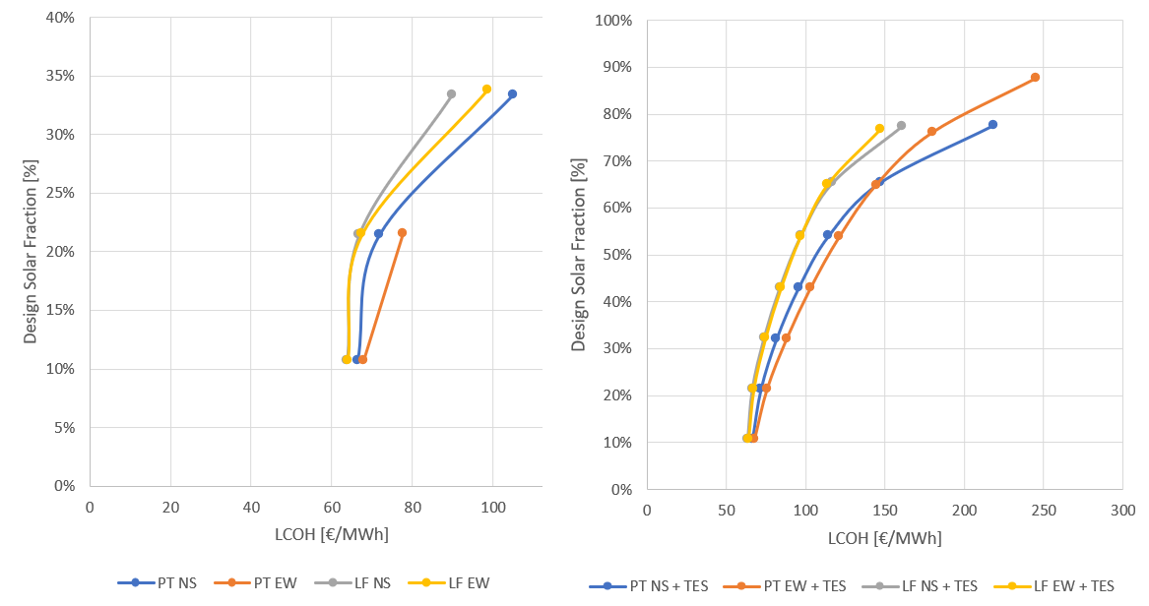
Fig. 6: LCOH as a function of the Design Solar Fraction for CST options without TES (on the right) and with TES (on the left)
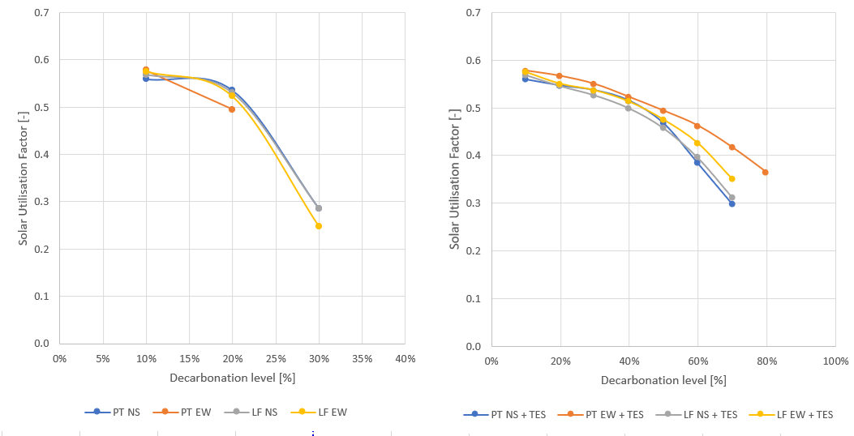
Fig. 7: Solar Utilization Factor as a function of the decarbonization level for CST options without TES (on the right) and with TES (on the left)
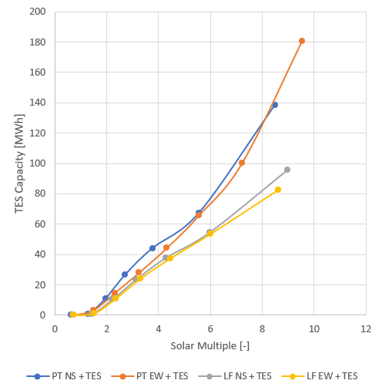
Fig. 8: Solar multiple as a TES capacity function for the CST options with TES
Figure 9 summarizes the main results for scenarios 10, which include all the studied technologies. The results of the simulations performed with PV EW15 are not shown, as this technology proved to be less suited to the system’s energy demand profile. For decarbonization levels of up to approximately 80%, the required investment and NPV remain limited to 10 M€. However, approaching the maximum achievable decarbonization level of 89%, costs increase significantly (over 20 M€). This trend reflects that higher levels of decarbonization require increasingly higher investments, as the remaining emissions are more difficult and costly to reduce. Details of 89% decarbonization level scenarios are shown in table 3. Depending on the level of decarbonization, all the technologies included can be deployed, except for EES, whose investment was never economically attractive.

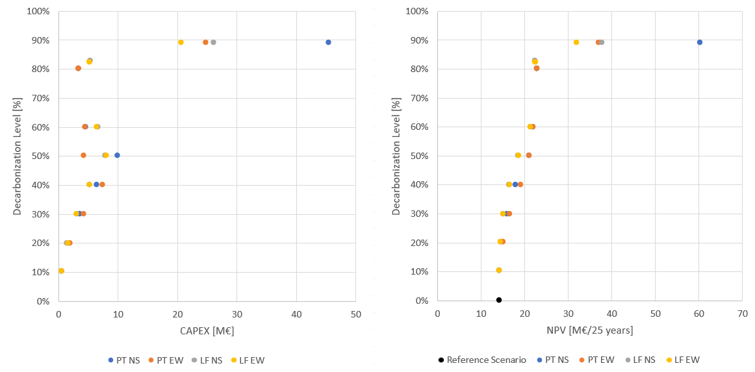
Fig. 9: CAPEX (on the right) and NPV (on the left) as a function of the decarbonization level for the scenarios 11 (all technologies included)

Tab. 3: Main results for 89% decarbonization level scenarios
89% Scenarios | 1 – Ref. | 10.a | 10.b | 10.c | 10.d
CST | - | PT NS | PT EW | LF NS | LF EW
PV | - | S30 | S30 | S30 | S30
CAPEX [M€] | 0 | 45.4 | 24.8 | 26 | 20.7
Discounted OPEX [M€] | 14.2 | 14.8 | 12.3 | 11.6 | 11.2
NPV [M€] | 14.2 | 60.3 | 37.1 | 37.6 | 31.8
Max decarbonatization achievable [%] | 0 | 89% | 89% | 89% | 89%
LCOH [€/MWh] | 61.8 | 262.1 | 99.3 | 163.5 | 138.5
Marginal Abatement Cost [€/kgCO2] | - | 0.54 | 0.27 | 0.27 | 0.21
ROI [%] | - | - 1% | 8% | 10% | 15%

The optimum scenario for a maximum decarbonization level is the 10.d, with CST LF EW and PV S30. The investment is 20.7 M€, for an NPV of 31.8 M€ on 25 years and the lowest Marginal Abatement Cost is equal to 0.21 €/kgCO2. The configuration includes a 2.3 MW electric heater, 0.6 MW of PV (without EES) and a 0.5 MW of HP. CST system is sized at 20.6 MW, corresponding to approximately 34400 m² of surface (out of the 60000 m² available), and it is coupled with 85.7 MWh of TES. CST and TES investments amount to 11 M€ and 6 M€ respectively, and account for 80% of the total CAPEX. Figure 10 shows the contribution of each technology to the total energy production. The CST covers 67% of the total demand, while the HP covers 10%. The remaining 22% is supplied by the electric heater.
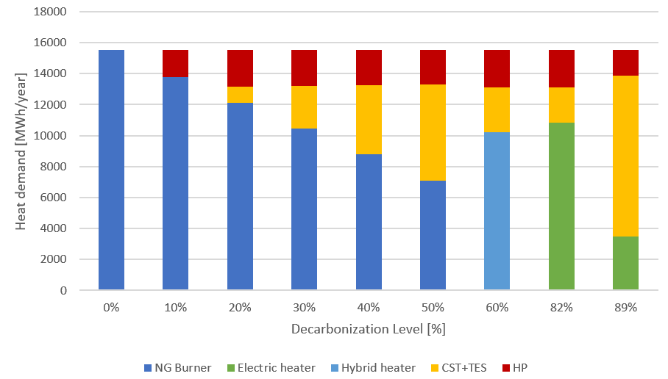
Fig. 10: Distribution of the total thermal power demand by technology at different levels of decarbonization.
A sensitivity study was performed on the optimum scenario, as specified in table 2. The discount rate (0.03–0.07) mainly affects the NPV, ranging from €30 to €34 M, while technology sizing remains unchanged. A 50% reduction in CST CAPEX increases the optimal CST capacity by 2 MW, reducing CAPEX and NPV to €15 M and €25 M, respectively. Electricity price variations (40–120 €/MWh, ±50%) do not affect technology sizing but lead to an NPV range of €28–35 M. Natural gas price has no significant impact, as the gas heater is completely replaced by an electric solution.
- Conclusion
In this paper, a hybrid energy system architecture was laid out to provide heat and power to an industrial site producing calcium carbonate products in Southern France. This case study focuses on a specific calcium carbonate drying process, which heat demand is supplied by direct firing natural gas burners. Different technologies were analysed, and optimal scenarios were identified to determine the maximum achievable level of decarbonization while minimizing NPV. Included technologies were: electric heaters or hybrid heaters as a replacement for the current gas heater, solar Photovoltaics (PV), Concentrated Solar Thermal (CST), Electrical Energy Storage (EES), Thermal Energy Storage (TES) and Waste Heat Recovery Heat Pump (WHR HP) as complementary options. A mixed integer linear programming (MILP) formalism was applied and solved with CEA-Liten open-source software CAIRN. For CST, two different technologies were considered: Parabolic Trough (PT) and Linear Fresnel (LF), each with two possible orientations: North–South (NS) and East–West (EW). For PV, two configurations were considered: South-facing at 30° (S30) and East–West at 15° (EW15). Applied optimization criteria was to minimize NPV while achieving the maximum possible decarbonization level, relative to the current environmental impact (reference scenario).
As the decarbonization level increases, the first technologies selected are the WHR HP and the CST. At higher targets, the hybrid heater is introduced and replaced by a full electric heater to achieve deeper reductions. Solar PV was deployed only at very high decarbonization levels, while EES investments were never economically attractive.
Solutions up to 89% of decarbonization level were identified: optimal results were found with CST LF EW and PV S30. The investment is 20.7 M€, for an NPV of 31.8 M€ on 25 years and the lowest Marginal Abatement Cost is equal to 0.21 €/kgCO2. The configuration includes a 2.3 MW electric heater, 0.6 MW of PV (without EES) and a 0.5 MW of WHR HP. CST system is sized at 20.6 MW, corresponding to approximately 34400 m2 of surface, and it is coupled with 85.7 MWh of TES. CST and TES represent the main contributors to the overall CAPEX, with investments of 11 M€ and 6 M€, respectively, accounting for 80% of the total investment. 0.6 MW of PV were installed to lower the NPV. Comparing to other CST options, CST LF EW is the one that, coupled to a TES, allows a lower LCOH for a same Designed Solar Fraction.
Moreover, the optimal scenario was examined by varying selected uncertain economic parameters, such as: electricity and natural gas price, CST needed investment, discount rate. As expected, lower CST CAPEX makes this solution more competitive. Electricity price, natural gas price and the discount rate do not affect technology sizing, although they have a significant impact on the overall NPV, which varies between 28 and 35 M€ over the 25-years period.
- Acknowledgements
This work received support from the French government managed by the National Research Agency (ANR) under the France 2030 program, reference ANR-22-PESP-0005. We kindly acknowledge the participation of our industrial partner for providing data for their industrial site.
- References
Caron, S., Vuillerme, V., SHIP4D – Solar Heat for Decarbonization of Industrial Processes, Deliverable D1.1, [3] Solar process architecture and initial sizing, (2025). https://cea.hal.science/cea-05457602

ADEME Base Empreinte, https://base-empreinte.ademe.fr/, last accessed on 25/08/2025
ADEME, Methodological guide to drafting a sectoral transition plan for the decarbonization of industry, 88 p., 2024. https://librairie.ademe.fr/industrie-et-production-durable/7014-methodological-guide-to-drafting-a-sectoral-transition-plan-for-the-decarbonisation-of-industry-9791029722769.html, last accessed 25/02/2026.

CEA, ABTEC, Agrégateur de base de données tech-éco sur l’énergie, last accessed on 10/09/2025.
CEA Liten, CAIRN Open, Github repository, 2025. https://github.com/CEA-Liten/CairnOpen, last accessed 25/02/2026.

Danish Energy Agency, Technology Data for Industrial Process Heat. https://ens.dk/en/analyses-and-statistics/technology-data-industrial-process-heat, last accessed 25/08/2026

EU Commission, France - Final updated NECP 2021-2030, 2024. https://commission.europa.eu/publications/
france-final-updated-necp-2021-2030-submitted-2024_en, last accessed 25/02/2026.

International Energy Agency (IEA), Energy System of France, 2026. https://www.iea.org/countries/france, last accessed 25/02/2026.

Meteonorm, Version 8, 2026. https://mn8.meteonorm.com/en/meteonorm-version-8, last accessed 25/02/2026.

PEPR SPLEEN program, 2026. https://www.pepr-spleen.fr/en/the-pepr-spleen/, last accessed 25/02/2026.

SHIP4D project, 2026. https://www.pepr-spleen.fr/en/projet/ship4d-project/, last accessed 25/02/2026.

Stratégie Nationale Bas Carbone (SNBC), https://www.ecologie.gouv.fr/politiques-publiques/strategie-nationale-bas-carbone-snbc, last accessed 25/02/2026.

System Advisor Model (SAM), version 2025.4.16 (SAM™ 2025.4.16). National Laboratory of the Rockies. Golden, CO, 2025. https://sam.nlr.gov/, last accessed 25/02/2026.

U.S. National Renewable Energy Laboratory (NREL); Life Cycle Greenhouse Gas Emissions from Electricity
Generation: Update, (2021). https://docs.nrel.gov/docs/fy21osti/80580.pdf
World Business Council for Sustainable Development (WBCSD), Renewable industrial heat navigator brief: Thermal energy storage, February 2025. https://www.wbcsd.org/resources/renewable-industrial-heat-navigatorbrief- thermal-energy-storage/, last accessed on 10/09/2025.

