BRIDGING CLIMATE SERVICES AND SOLAR ENERGY TRANSITION: INSIGHTS FROM C3S NCP GREECE AND REENERGY-MED PROJECTS
C. Giannakopoulos¹, V. Amiridis², I. Fountoulakis³, M. Gratsea¹, S. Kartsios², S. Misios³, N. Papadimitriou^{3,4}
¹ Institute for Environmental Research and Sustainable Development (IERSD), National Observatory of Athens, Athens, Greece
² Institute for Astronomy, Astrophysics, Space Applications and Remote Sensing, National Observatory of Athens, Greece
³ Research Centre for Atmospheric Physics and Climatology, Academy of Athens, Athens, Greece
⁴ Department of Physics, University of Patras, Patras, Greece
cgiannak@noa.gr, vamoir@noa.gr, ifountoulakis@academyofathens.gr, npapadimitriou@academyofathens.gr, kartsios@noa.gr, missios@academyofathens.gr
Keywords: solar energy, wind energy, Copernicus data, Mediterranean Region

Abstract
The Mediterranean region possesses exceptional solar and wind resources, making it one of Europe's most promising regions for renewable-energy deployment. However, maximizing the potential of these resources requires not only expanded renewable-energy infrastructure but also the effective integration of climate information into energy planning and operation. Renewable-energy production is inherently sensitive to weather and climate variability across timescales ranging from seasons to decades, while long-term climate change is expected to influence both energy generation and electricity demand. Consequently, climate services have become increasingly important for supporting climate-informed decision-making in the energy sector.
The Copernicus Climate Change Service (C3S) and the Copernicus Atmosphere Monitoring Service (CAMS) provide high-quality climate and atmospheric datasets that enable the development of operational services for renewable-energy applications. This paper presents the complementary roles of the C3S National Collaboration Programme (C3S NCP Greece) and the ReEnergy-MED project in transforming these datasets into decision-support tools for the Mediterranean region. ClimateHub, developed within C3S NCP Greece, provides operational seasonal and decadal predictions of renewable-energy production and electricity demand for Greece, while ReEnergy-MED combines C3S and CAMS products with statistical downscaling, bias correction and photovoltaic energy modelling to deliver site-specific climate services for demonstration cases in Greece and Morocco. Together, the two initiatives illustrate a transferable framework for integrating Copernicus climate information into renewable-energy planning, operational management and long-term investment decisions across the Mediterranean.

1. Introduction
The transition towards a low-carbon energy system has become a central pillar of European climate and energy policy, driven by the urgent need to mitigate climate change, enhance energy security, and reduce dependence on fossil fuels (European Commission, 2019; IPCC, 2023). Within this framework, renewable energy sources (RES), particularly solar and wind power, are expected to play a central role in achieving the European Union's climate-neutrality objectives. The Mediterranean region is particularly well suited to this transition owing to its abundant solar resources, favourable wind conditions, and rapidly expanding renewable-energy infrastructure (Pfenninger et al., 2014; Jerez et al., 2015). Nevertheless, the full exploitation of these resources remains constrained by weather and climate variability, as well as by the limited integration of climate information into energy planning and operational decision-making.
Renewable-energy production and electricity demand are strongly influenced by atmospheric conditions across timescales ranging from days to decades. Short-term weather variability affects electricity generation and grid stability, seasonal fluctuations influence energy availability, maintenance planning and demand, while long-term climate change is expected to alter renewable-energy resources through changes in temperature, cloudiness, wind regimes and the frequency of extreme events (Craig et al., 2019; IPCC, 2023). Consequently, reliable climate information—from seasonal forecasts and decadal predictions to long-term climate projections—is increasingly required to support renewable-energy planning, system operation and infrastructure investment.
The growing need for climate-informed decision-making has led to the development of climate services, which transform scientific knowledge into actionable information tailored to the needs of specific sectors (Vaughan and Dessai, 2014; Hewitt et al., 2020). By translating complex climate datasets into user-oriented products and indicators, climate services support evidence-based decisions related to renewable-energy production, electricity demand, infrastructure design, system operation and climate-change adaptation.
The European Copernicus Programme provides one of the world's most comprehensive operational frameworks for environmental information through a suite of thematic services. Among these, the Copernicus Climate Change Service (C3S) delivers freely accessible climate observations, reanalysis datasets, seasonal forecasts and climate projections, together with tools that facilitate their application across a broad range of socio-economic sectors (Buontempo et al., 2022). These products underpin numerous applications, including climate adaptation, risk assessment and renewable-energy planning.
Complementing C3S, the Copernicus Atmosphere Monitoring Service (CAMS) provides operational information on atmospheric composition and surface solar radiation, both of which directly influence photovoltaic performance (Antonanzas-Torres et al., 2019; CAMS, 2020). The combination of C3S climate products with CAMS atmospheric information enables more realistic estimates of renewable-energy production by accounting for the effects of aerosols, clouds and other atmospheric constituents on solar-energy yield.
Despite the availability of these high-quality datasets, transforming climate and atmospheric information into operational decision-support tools remains a significant challenge. Energy companies, system operators, investors, regional authorities and policy makers require climate information translated into sector-specific indicators at appropriate spatial and temporal scales. Bridging the gap between advanced Earth-system datasets and practical energy applications therefore requires climate services that combine scientific expertise with stakeholder needs and application-oriented methodologies (Bruno Soares et al., 2018).
In Greece, the Copernicus Climate Change Service National Collaboration Programme (C3S NCP Greece) addresses this challenge by promoting the uptake of Copernicus climate information through the development of operational climate services tailored to national stakeholders. One of its principal outcomes is ClimateHub, an online platform that provides seasonal and decadal predictions of renewable-energy production and electricity demand, facilitating access to climate intelligence for decision-makers and supporting climate-informed energy planning at the national scale. Building upon this operational framework, the ReEnergy-MED project extends the use of Copernicus climate and atmospheric products to site-specific renewable-energy applications across the Mediterranean.
This paper presents the complementary roles of C3S NCP Greece and ReEnergy-MED in advancing climate-informed renewable-energy services. While C3S NCP Greece provides operational climate services and facilitates user access to Copernicus climate information at the national level, ReEnergy-MED extends these capabilities through regional downscaling, atmospheric information and photovoltaic modelling for site-specific applications. Together, the two initiatives demonstrate a coherent and transferable framework that transforms Copernicus climate and atmospheric data into operational decision-support tools, supporting renewable-energy planning, strengthening climate resilience and accelerating the clean-energy transition across the Mediterranean region.

2. Data and methods
2.1. Climate information for renewable energy
2.1.1. Climate and atmospheric variables relevant to renewable energy
Renewable-energy production is strongly influenced by meteorological and atmospheric conditions across a wide range of temporal and spatial scales. The key variables controlling photovoltaic (PV) energy generation include surface solar radiation, air temperature, cloud cover and atmospheric aerosols, while wind speed is the primary driver of wind-power production. Air temperature also plays a major role in determining electricity demand through heating and cooling requirements, making it an essential variable for both energy production and consumption analyses.
Surface solar radiation determines the amount of energy available for electricity generation and therefore represents the principal input to PV performance models. Air temperature affects photovoltaic conversion efficiency, with increasing module temperatures generally reducing electricity production. Cloud cover modifies incoming solar radiation through absorption and scattering processes, whereas atmospheric aerosols further influence solar irradiance by attenuating and redistributing solar radiation. These atmospheric effects are particularly important in the Mediterranean region, where aerosol concentrations frequently vary due to desert dust transport, biomass burning and anthropogenic emissions (Gutiérrez et al., 2018). For wind-energy applications, near-surface wind speed remains the dominant meteorological variable controlling power production.
Given the strong dependence of renewable-energy systems on climate variability, reliable information is required over timescales ranging from seasonal forecasts to multi-decadal climate projections. Consequently, the climate services presented in this study combine observations, reanalyses, seasonal prediction systems and climate projections to support operational energy management, infrastructure planning and long-term investment decisions.
2.1.2. Copernicus datasets and ancillary data
The climate services developed within the C3S National Collaboration Programme (C3S NCP Greece) and the ReEnergy-MED project are primarily based on datasets provided by the Copernicus Climate Change Service (C3S) and the Copernicus Atmosphere Monitoring Service (CAMS), complemented by electricity-demand records and ground-based observations.
Historical climate conditions are represented using the ERA5 and ERA5-Land reanalysis datasets, which provide spatially and temporally consistent meteorological variables for climatological analyses, model calibration and bias adjustment. Seasonal predictions are obtained from the ECMWF SEAS5 forecasting system, while future climate conditions are assessed using CMIP6 global climate model projections under multiple Shared Socioeconomic Pathways (SSPs). For applications requiring enhanced spatial detail, particularly over the complex terrain and small islands of the Mediterranean, ReEnergy-MED additionally employs the high-resolution CERRA regional reanalysis.
Unlike ClimateHub, ReEnergy-MED also incorporates atmospheric information from CAMS, including surface solar radiation and aerosol products, allowing the explicit representation of atmospheric effects on photovoltaic performance. Electricity-demand analyses in both projects make use of ENTSO-E datasets, while ReEnergy-MED further exploits ground-based solar radiation and photovoltaic production measurements for model calibration and validation.
Although both initiatives rely on a common Copernicus framework, they differ in their scope and implementation. ClimateHub focuses on the operational delivery of climate services at the national scale using harmonised Copernicus datasets, whereas ReEnergy-MED extends these capabilities through higher-resolution products, atmospheric information and site-specific validation to support renewable-energy applications across the Mediterranean.
Table 1. Main datasets used by the C3S NCP Greece ClimateHub and ReEnergy-MED climate services.
Dataset | ClimateHub (C3S NCP Greece) | ReEnergy-MED | Purpose
ERA5 | ✓ | ✓ | Historical climatology, model evaluation and validation
ERA5-Land | ✓ | ✓ | Land-surface meteorological variables, climatology and bias correction
CERRA | – | ✓ | High-resolution regional reference dataset, particularly for Mediterranean islands
ECMWF SEAS5 | ✓ | ✓ | Seasonal climate predictions
CMIP6 climate projections | ✓ | ✓ | Long-term climate projections under multiple Shared Socioeconomic Pathways (SSPs)
CAMS surface solar radiation | – | ✓ | Solar resource assessment and photovoltaic energy simulations
CAMS aerosol products | – | ✓ | Quantification of aerosol effects on photovoltaic performance
ENTSO-E electricity data | ✓ | ✓ | Electricity-demand analysis, model development and evaluation
Ground-based meteorological observations | – | ✓ | Validation of downscaled climate variables
Ground-based solar radiation observations | – | ✓ | Validation of solar radiation products
Ground-based PV production measurements | – | ✓ | Calibration and validation of GSEE photovoltaic simulations

2.2. From Copernicus data to climate services
Climate services transform large volumes of climate and environmental data into tailored information that supports evidence-based decision-making (Vaughan and Dessai, 2014; Palutikof et al., 2019). Rather than simply providing access to climate datasets, they combine observations, model output, scientific expertise and user requirements to produce application-specific indicators, forecasts and decision-support products (Goodess et al., 2019; Dubus et al., 2023).
The development of a climate service typically involves a sequence of processing steps that convert raw climate information into products suitable for end users. These include data acquisition from operational services such as C3S and CAMS, quality control, statistical post-processing, spatial downscaling, bias adjustment, derivation of sector-specific indicators and visualization through interactive platforms. Continuous interaction with stakeholders is an equally important component, ensuring that the resulting products address operational needs and can be effectively integrated into planning and decision-making processes.
The climate services presented in this study follow this general framework but target different user communities and spatial scales. Within C3S NCP Greece, ClimateHub focuses on transforming Copernicus datasets into operational national-scale products, including seasonal forecasts and decadal outlooks of renewable-energy production and electricity demand. In contrast, ReEnergy-MED extends this workflow by incorporating higher-resolution regional datasets, atmospheric information from CAMS, statistical downscaling, bias correction and photovoltaic energy modelling to generate site-specific climate services for demonstration cases across the Mediterranean.
Together, these complementary approaches illustrate how Copernicus data can be translated into operational decision-support tools, providing stakeholders with scientifically robust, user-oriented information for renewable-energy planning, system operation and long-term investment.
2.3. Photovoltaic energy modelling using GSEE
To translate climate information into estimates of photovoltaic (PV) electricity production, this study employs the Global Solar Energy Estimator (GSEE), an open-source photovoltaic performance model specifically designed for applications based on meteorological and climate datasets (Pfenninger and Staffell, 2016). GSEE has been widely used to simulate PV energy production across temporal scales ranging from individual days to multi-decadal climate projections (e.g., Papadimitriou et al., 2026).
GSEE estimates the electricity production of grid-connected PV systems using surface solar radiation and near-surface air temperature together with user-defined system characteristics, including installed capacity, module technology, panel orientation, tilt angle, tracking configuration and system losses. When direct and diffuse irradiance measurements are unavailable, the model derives the diffuse component from global solar radiation using physically based parameterizations, enabling robust simulations under a wide range of atmospheric conditions.
Within the present study, GSEE constitutes the common modelling framework used to transform Copernicus climate information into photovoltaic energy estimates. In ClimateHub, the model is driven by seasonal forecasts and climate projections to generate national-scale outlooks of photovoltaic energy production. In ReEnergy-MED, GSEE is coupled with statistically downscaled and bias-adjusted climate datasets and high-resolution regional products to produce site-specific simulations for the demonstration sites in Greece and Morocco.
Model performance is evaluated through comparisons with ground-based measurements of solar radiation and photovoltaic electricity production available at the demonstration sites. This validation strategy enables the quantification of modelling uncertainties and provides confidence in the operational application of the developed climate services. The validation methodology and preliminary results are presented in Section 3.3.

3. Services and preliminary results
3.1. From Climate Data to Climate Services: C3S NCP Greece
The ClimateHub platform, developed within the Copernicus Climate Change Service National Collaboration Programme (C3S NCP Greece), provides operational climate services that translate Copernicus climate information into decision-support products for the Greek energy sector (Kartsios et al., 2025). Building upon C3S datasets and prediction systems, the platform delivers user-oriented products that support renewable-energy management and climate-informed planning through an interactive web portal (https://portal.climatehub.gr).
ClimateHub currently provides seasonal forecasts (up to three months ahead) and decadal outlooks of renewable-energy production and electricity demand at the national and regional scales. The services are based on ECMWF SEAS5 seasonal forecasts, CMIP6 decadal climate predictions, ERA5 reanalysis and ENTSO-E electricity-demand data, which are combined with the Global Solar Energy Estimator (GSEE) model and wind-power conversion algorithms to derive energy-specific indicators. The resulting products include probabilistic forecasts of photovoltaic and wind energy production, as well as climate-informed estimates of electricity demand, enabling users to assess both expected conditions and forecast uncertainty.
A key characteristic of ClimateHub is the transformation of complex climate datasets into intuitive products that are directly relevant to stakeholders. Forecasts are presented through interactive maps, regional time series, ensemble box plots and downloadable graphics, allowing users to explore both spatial variability and prediction uncertainty. The platform therefore provides information that is readily applicable by public authorities, energy companies, system operators and researchers involved in renewable-energy planning and climate adaptation.
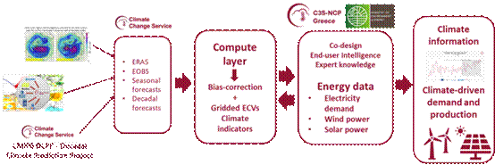
Figure 1. Workflow of the C3S-NCP Climatehub energy prediction system.
Figure 1 illustrates the overall workflow of the ClimateHub energy prediction system, from the acquisition of Copernicus climate information to the generation of renewable-energy indicators. An example of the operational products is presented in Figure 2, which shows the probabilistic forecast of the wind capacity factor for March 2026 over the Greek regions based on the ECMWF SEAS5 ensemble prediction system. In addition to the spatial distribution of the predicted capacity factor, the platform provides regional time series together with the full ensemble spread, enabling users to assess both the expected renewable-energy production and the associated forecast uncertainty.
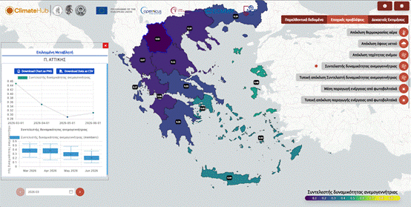
Figure 2. Wind capacity factor in March 2026 based on ECMWF/SEAS5 seasonal forecasts (initialization 01 March 2026) for each Region in Greece. The pop-up window on the left depicts the timeseries of the average wind capacity factor for the period March-June 2026 (top) for the Region of Attica, while the box-plot time series (bottom) presents the spread of the ensemble members.

3.2. From Climate Services to Energy Applications: ReEnergy-MED
Building upon the operational climate services developed through ClimateHub, the ReEnergy-MED project extends the application of Copernicus climate information to site-specific solar-energy assessments across the Eastern and Southern Mediterranean. The project develops climate services tailored to the operational needs of renewable-energy stakeholders by combining products from the Copernicus Climate Change Service (C3S) and the Copernicus Atmosphere Monitoring Service (CAMS) with high-resolution regional modelling, statistical downscaling and photovoltaic energy simulations. The primary objective is to provide reliable seasonal forecasts and long-term climate projections of solar-energy production that support operational management, infrastructure planning and investment decisions in the renewable-energy sector.
While ClimateHub provides national-scale seasonal forecasts and decadal outlooks for Greece, ReEnergy-MED advances this approach by delivering site-specific climate services for selected photovoltaic installations in Greece and Morocco. The project employs the same photovoltaic modelling framework (GSEE) but complements it with bias-adjusted climate datasets, higher-resolution regional products (ERA5-Land and CERRA where appropriate), CAMS atmospheric information and local observations. This integrated approach enables a more accurate representation of the local climatic and atmospheric conditions affecting photovoltaic performance and allows the development of customized products for individual renewable-energy operators.
Three demonstration cases have been selected to represent different climatic, geographical and operational conditions across the Mediterranean (Figure 3). The first demonstration case focuses on photovoltaic parks operated by Zephiros S.A. in the Evros region of northern Greece, where seasonal climate information can support energy production forecasting and operational planning. The second demonstration case investigates three Greek islands that exhibit contrasting climatic conditions and rapidly increasing summer electricity demand driven by tourism. These islands provide an ideal environment for assessing the contribution of climate-informed solar-energy forecasts to future energy autonomy and adaptation planning. The third demonstration case focuses on Morocco, where climate services are developed in collaboration with MASEN for both utility-scale photovoltaic installations and earthquake-affected regions. In addition to supporting solar-energy planning and plant operation, the developed products are designed to quantify the local photovoltaic generation potential and future electricity demand, providing information that can support the deployment of resilient energy systems. This is particularly relevant for regions vulnerable to seismic hazards, where decentralized renewable-energy generation can contribute to maintaining electricity supply and improving energy autonomy in the event of damage to the transmission network.
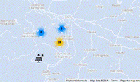 | 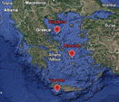 | 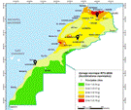
Figure 3. Demonstration cases in Greece and Morocco: (a) three Greek islands with different climatic conditions and touristic growth, (b) solar parks at Evros region in Northern Greece, and (c) three regions in Morocco.
An important component of ReEnergy-MED is the active involvement of end users throughout the development process. Renewable-energy companies, regional authorities and scientific institutions participate in defining user requirements, evaluating prototype products and assessing their operational value. Dedicated workshops, training activities and dissemination events promote the uptake of Copernicus climate services, particularly in the Southern Mediterranean, ensuring that the developed products address real operational needs and can be transferred to similar renewable-energy applications across the Mediterranean region.

3.3. Preliminary results from ReEnergy-MED
The ReEnergy-MED energy prediction system combines Copernicus climate and atmospheric information with high-resolution regional datasets and photovoltaic modelling to produce seasonal forecasts and long-term projections of solar-energy production for the selected demonstration sites. Seasonal predictions are based on the ECMWF SEAS5 forecasting system, whereas long-term assessments employ statistically downscaled and bias-adjusted CMIP6 climate projections. ERA5-Land is used as the reference dataset for continental regions, while the higher-resolution CERRA reanalysis is employed for the Greek islands to better resolve local topographic features. Photovoltaic energy production is simulated using the Global Solar Energy Estimator (GSEE), driven by the processed climate datasets and validated against in situ observations available at the demonstration sites.
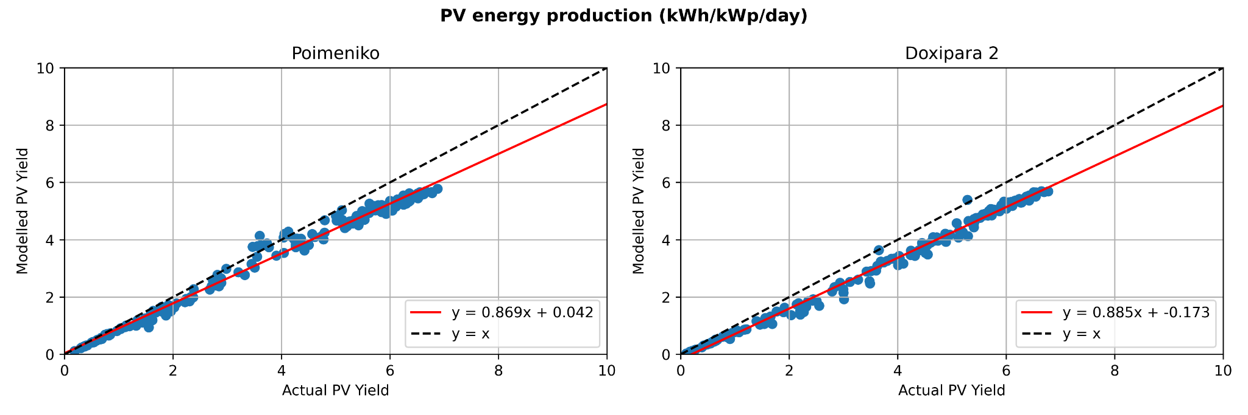
Figure 4. Measured versus simulated daily PV energy production at the Poimeniko (a) and Doxipara 2 (b) photovoltaic parks in Evros, Greece, using co-located ground-based solar radiation measurements

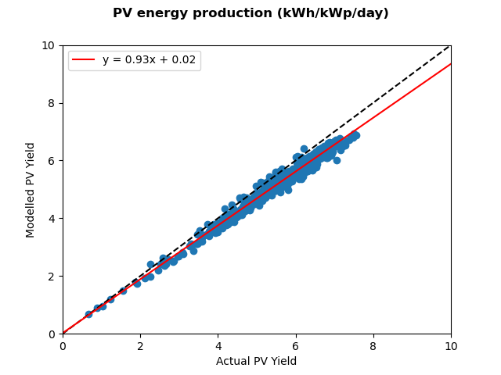
Figure 5. Measured versus simulated daily PV energy production at the SiPV facility in Ouarzazate, Morocco, using co-located ground-based solar radiation measurements.
The first step in the evaluation of the modelling framework is the reproduction of the observed photovoltaic electricity production using co-located measurements of solar irradiance and air temperature as model input. Figures 4 and 5 compare measured and simulated daily PV energy production for two photovoltaic parks in Evros, Greece (Poimeniko and Doxipara 2), and the SiPV facility in Ouarzazate, Morocco. In all cases, the simulations successfully reproduce the observed temporal variability, demonstrating that GSEE captures the day-to-day fluctuations in photovoltaic production under diverse climatic conditions.
Although the correlation between modelled and observed PV production is high, a systematic bias remains, with the model consistently underestimating the measured energy yield. Ongoing investigations indicate that this offset is primarily associated with assumptions regarding photovoltaic system and inverter losses rather than deficiencies in the representation of the available solar resource. Future work will refine these parameterizations and quantify the associated modelling uncertainties, including the effects of aerosols, clouds and diffuse radiation on photovoltaic performance.
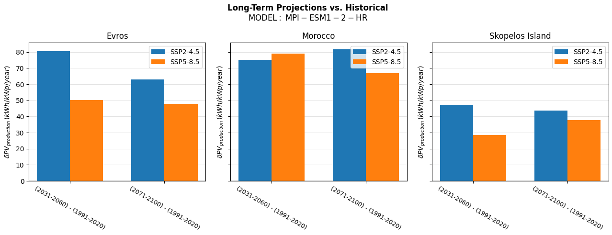
Figure 6. Difference in the annually averaged PV energy production between the future (2080 - 2100) and the past (1980 - 2000), for three different sites and two different scenarios (SSP2-4.5 and SSP5-8.5)
Long-term climate projections were subsequently used to assess future changes in photovoltaic energy production under the SSP2-4.5 and SSP5-8.5 emission scenarios. Figure 6 presents the projected difference in mean annual PV production between the late twenty-first century (2080–2100) and the historical reference period (1980–2000) for the MPI-ESM1-2-HR climate model. Both scenarios indicate an increase in annual photovoltaic production, with projected gains ranging from approximately 30 to 80 kWh kWp⁻¹ yr⁻¹ across the demonstration sites. The largest increases are found in Morocco, reflecting the region's high solar resource and favourable future climatic conditions. These preliminary results demonstrate the potential of climate-informed energy services to support long-term renewable-energy planning and investment decisions by providing quantitative estimates of future photovoltaic productivity under different climate scenarios.
4. Summary and Conclusions
The increasing penetration of renewable energy sources requires climate information to become an integral component of energy-system planning and operation. Seasonal climate predictions and long-term climate projections provide valuable information for anticipating fluctuations in renewable-energy production and electricity demand, thereby supporting more resilient and informed decision-making. The Copernicus Climate Change Service (C3S) and the Copernicus Atmosphere Monitoring Service (CAMS) offer a comprehensive and consistent suite of climate and atmospheric datasets that can be translated into operational climate services for the energy sector.
This paper presented the complementary roles of the C3S NCP Greece (ClimateHub) and ReEnergy-MED initiatives in advancing climate-informed renewable-energy services. ClimateHub demonstrates how Copernicus datasets can be transformed into operational national-scale services, providing seasonal forecasts and decadal outlooks of photovoltaic and wind energy production together with electricity-demand indicators through an accessible web platform. ReEnergy-MED builds upon this foundation by integrating higher-resolution climate datasets, atmospheric information from CAMS, statistical downscaling and site-specific photovoltaic simulations to deliver tailored climate services for demonstration cases in Greece and Morocco.
The preliminary results demonstrate the ability of the developed framework to reproduce observed photovoltaic production with high temporal consistency and to quantify potential future changes in solar-energy production under different climate scenarios. Beyond supporting photovoltaic plant operation and renewable-energy investments, the developed services address broader societal challenges, including energy security, climate adaptation and infrastructure resilience. In particular, the Moroccan demonstration case illustrates how climate-informed assessments of photovoltaic generation potential can contribute to improving energy autonomy in regions where natural hazards, such as earthquakes, may disrupt the electricity transmission network.
Together, the two initiatives illustrate a coherent pathway from climate observations and predictions to user-oriented decision-support tools. ClimateHub provides the operational national framework for delivering climate services, whereas ReEnergy-MED demonstrates how these services can be adapted to local conditions and stakeholder requirements through higher-resolution modelling and application-specific methodologies. Their complementary nature provides a transferable approach that can be replicated across the Mediterranean and other climate-sensitive regions.
Future work will focus on expanding the range of climate-informed energy indicators, improving the representation of photovoltaic-system performance through enhanced atmospheric information and additional validation datasets, and strengthening user engagement to ensure that climate services continue to evolve according to operational needs. As renewable-energy systems become increasingly climate-dependent, integrating Copernicus climate services into energy planning will be essential for supporting a resilient, secure and sustainable energy transition.

References
Antonanzas-Torres, F., Urraca, R., Polo, J., Perpiñán-Lamigueiro, O., Escobar, R., 2019. Clear sky solar irradiance models: A review of seventy models. Renewable and Sustainable Energy Reviews 107, 374–387. https://doi.org/10.1016/j.rser.2019.02.032
Bruno Soares, M., Daly, M., Dessai, S., 2018. Assessing the value of seasonal climate forecasts for decision-making. Climatic Change 149, 151–164. https://doi.org/10.1007/s10584-018-2165-7
Buontempo, C., Hutjes, R., Beavis, P., et al., 2020. Fostering the development of climate services through Copernicus Climate Change Service (C3S) for agriculture applications. Weather and Climate Extremes 27, 100226. https://doi.org/10.1016/j.wace.2019.100226
Copernicus Atmosphere Monitoring Service (CAMS), 2020. CAMS Solar Radiation Time Series. https://doi.org/10.24381/5cab0912
Craig, M.T., Cohen, S., Macknick, J., Draxl, C., Guerra, O.J., Sengupta, M., Haupt, S.E., Hodge, B.-M., Brancucci Martinez-Anido, C., Hamann, H.F., 2019. A review of the potential impacts of climate change on bulk power system planning and operations in the United States. Renewable and Sustainable Energy Reviews 98, 255–267. https://doi.org/10.1016/j.rser.2018.09.022
Dubus, L., Troccoli, A., et al., 2023. Climate services for the energy sector: Recent developments and future perspectives. Meteorological Applications 30, e2145. https://doi.org/10.1002/met.2145
European Commission, 2019. The European Green Deal. COM(2019) 640 final.
Goodess, C.M., et al., 2019. Advancing climate services for the energy sector. Climate Services 16, 100139. https://doi.org/10.1016/j.cliser.2019.100139
Gutiérrez, C., Somot, S., Nabat, P., Mallet, M., Gaertner, M.Á., Perpiñán, O., Khvorostyanov, D., 2018. Impact of aerosols on the spatiotemporal variability of photovoltaic energy production in the Euro-Mediterranean area. Solar Energy 174, 1142–1152. https://doi.org/10.1016/j.solener.2018.09.085
Hewitt, C.D., Stone, R.C., 2021. Climate services for managing societal risks and opportunities. Climate Services 23, 100240. https://doi.org/10.1016/j.cliser.2021.100240
IPCC, 2023. Climate Change 2023: Synthesis Report. Intergovernmental Panel on Climate Change.
Jerez, S., Tobin, I., Vautard, R., et al., 2015. The impact of climate change on photovoltaic power generation in Europe. Nature Communications 6, 10014. https://doi.org/10.1038/ncomms10014
Kartsios, S., Giannakopoulos, C., Gratsea, M., et al., 2025. ClimateHub: A national climate service for renewable energy and climate adaptation in Greece. Environmental Earth Sciences Proceedings 35, 28. https://doi.org/10.3390/eesp2025035028
Palutikof, J.P., Street, R.B., Gardiner, E.P., et al., 2019. Making climate services fit for purpose. Climatic Change 157, 527–543. https://doi.org/10.1007/s10584-019-02445-2
Papadimitriou, N., Fountoulakis, I., Gkikas, A., Papachristopoulou, K., Kazantzidis, A., Kazadzis, S., Pfenninger, S., Kapsomenakis, J., Eleftheratos, K., Argiriou, A.A., Doppler, L., Zerefos, C.S., 2026. PV power modelling using solar radiation from ground-based measurements and CAMS: Assessing the diffuse component related uncertainties leveraging the Global Solar Energy Estimator (GSEE). Atmospheric Measurement Techniques 19, 1227–1244. https://doi.org/10.5194/amt-19-1227-2026
Pfenninger, S., Hawkes, A., Keirstead, J., 2014. Energy systems modeling for twenty-first century energy challenges. Renewable and Sustainable Energy Reviews 33, 74–86. https://doi.org/10.1016/j.rser.2014.02.003
Pfenninger, S., Staffell, I., 2016. Long-term patterns of European PV output using 30 years of validated hourly reanalysis and satellite data. Energy 114, 1251–1265. https://doi.org/10.1016/j.energy.2016.08.060
Vaughan, C., Dessai, S., 2014. Climate services for society: Origins, institutional arrangements, and design elements for an evaluation framework. WIREs Climate Change 5, 587–603. https://doi.org/10.1002/wcc.290

