EuroSun2026
EXPERIMENTAL PERFORMANCE STUDY OF WATER PVT COLLECTORS FOR INTEGRATION WITH SEASONAL STORAGE

Author: Lucía Cano¹, Raquel Simón-Allué¹, Yolanda Lara¹, Raúl Villén¹, Isabel Guedea¹
Affiliation: ENDEF, c/P-B 20, Polígono Ciudad del Transporte, 50820, Zaragoza (Spain)
Email: lucia.cano@endef.com
Summary
Photovoltaic (PV) systems have grown rapidly, though solar thermal technologies still offer higher efficiencies.
Hybrid PVT systems combine both approaches, providing improved overall energy performance. However, challenges remain in performance and system integration. This work presents three novel PVT prototypes using TOPCon N-type silicon technology where different heat exchanger geometries are evaluated to assess thermal behaviour. The system targets low-temperature applications with seasonal thermal storage integration, and the selected PVT panels are planned to be installed in a demo site in The Netherlands. A dedicated test bench has been built, enabling the performance analysis of the prototypes under real environmental conditions. Experimental results allow to compare and select the most promising configuration, while demonstrate the potential of the proposed PVT configurations for low-temperature heat recovery and seasonal thermal storage applications.
Keywords: Water PVT; experimental; energy performance; solar energy; seasonal storage
Field of application for the findings: PVT solar technology (photovoltaic-thermal)
Addressed audience: Energy Researchers; Engineers, Solar planners, Public Administrations
- Introduction
Photovoltaic (PV) systems have considerably grown in residential and industrial markets due to their cost decrease and ease of installation (Bórawski et al., 2023). However, solar thermal technologies still achieve higher energy conversion efficiencies in comparison with photovoltaic technologies. In this context, hybrid photovoltaic-thermal systems (PVT), which combine solar thermal and photovoltaic technologies on the same panel, emerges as a promising solution.
As highlighted by the IEA Solar Heating and Cooling Programme through the Task 73 (IEA SHC, 2025), PVT technology shows considerable potential. Recent research advances include modifications related to the internal design of these PVT collectors, such as optimized geometries (Das et al., 2021), new components (Joshi and Dhoble, 2018), advances in PV cell technologies (Al-Ali et al., 2025) or new integration strategies; including coupling with heat pumps (Coca-Ortegón et al., 2023) or seasonal storage (Chen et al., 2025). However, experts point out that barriers to market adoption are more closely linked to standardization and technological maturity than to the development of sophisticated collectors.
According to 2024 data, a total of 72,544 m² of new PVT collector area was installed that year (AEE INTEC, 2025), while approximately 12,157 PVT-related research articles were published. This yields a ratio of 1 published research article for every 6 m² installed, signalling a clear bottleneck in the real-world deployment of this technology. Based on these results, it is evident that research must pivot toward practical feasibility, incorporating factors beyond thermal efficiency into the development phase, such as installation complexity, scalability for mass production, and manufacturing costs.
Regarding system integration, recent research has focused on combining PVT collectors with complementary technologies, predominantly heat pumps (Arnesson et al., 2025; Wang et al., 2017) -in direct (Liu et al., 2023) or indirect expansion (Junjorn et al., 2025; Ma et al., 2026)-, geothermal systems (Cao et al., 2025), or seasonal thermal energy storage (STES). These integrated configurations aim to maximize low-temperature PVT heat yield, either by elevating evaporator inlet temperatures to enhance the seasonal performance factor (SPF) or by thermal regeneration of boreholes in mild to cold climates (Miglioli et al., 2023). Seasonal thermal storage represents a particularly promising approach, allowing peak summer generation to be shifted to meet peak winter demand, maximizing PVT output through the reduction on the operation temperature and the enhancement of the heat pump performance (Del Amo et al., 2020). However, the insufficient operational performance (Nahar et al., 2017) and lack of reference cases (particularly in the case of ATES, aquifer thermal energy storage) hinders the integration of these technologies (Pellegrini et al., 2019).
This work presents the operational performance of three novel PVT prototypes incorporating cutting-edge PV technologies. Beyond energy performance, the design of these prototypes explicitly incorporates considerations of feasibility and straightforward downstream installation. These prototypes have been specifically designed for low-temperature operation and for their integration with a high-efficiency heat pump and a seasonal thermal energy storage. Their installation on the selected site is planned by the end of the current year, demonstrating their integration potential for high-efficiency renewable energy systems. This work is part of the research European project USES4HEAT - Underground Large Scale Seasonal Energy Storage for Decarbonized and Reliable Heat.
- Material & Methods
2.1. Description of the PVT components
The objective of this work is to develop and experimentally assess water-based PVT prototypes that combine a high-efficiency PV module with compact heat exchangers (HXs) suitable for low-temperature operation. The selected photovoltaic technology is based on tunnel oxide passivated contact (TOPCon) N-type silicon cells, which reduce recombination losses, improve conversion efficiency, and provide enhanced thermal and operational stability compared with conventional silicon technologies such as Passivated Emitter and Rear Cell (PERC). The selected module has a rated peak power of 620 W, an aperture area of approximately 2.7 m², and a large-format geometry that is considerably larger than many commercial PVT collectors. Tab. 1 summarises the main mechanical and electrical parameters of the PV panel selected for the prototypes.
Tab. 1: Technical PV panel parameters from datasheet.
Description |  | Unit | Value
General characteristics PV | Length x Width x Height | [mm] | 2382x1134x30
General characteristics PV | Gross area | [m²] | 2.7
General characteristics PV | PV Weight | [kg] | 33.1
Main electrical characteristics STC | Cell type | [-] | N-type i-TOPCon
Main electrical characteristics STC | Module Efficiency STC ⁽¹⁾ | [%] | 23.0
Main electrical characteristics STC | Rated Maximum Power (Pmax) | [W] | 620
Main electrical characteristics STC | Temperature NOCT ⁽²⁾ | [°C] | 45±2
Main electrical characteristics STC | Temperature Coefficient of Pmax | [%/ºC] | -0.290
⁽¹⁾ STC: Standard Testing Conditions; ⁽²⁾ NOCT: Normal Operation Cell Temperature
The use of this large-format PV module defines the boundary conditions for the thermal design. The heat exchanger (HX) must be integrated within the 30 mm frame thickness while maintaining good thermal contact with the PV laminate, without increasing the overall panel thickness or introducing bulges. Further constraints arise from the rear electrical layout, which includes central junction boxes, cable outlets, and fixing elements that restrict the routing of the hydraulic circuits. These module-specific features limit the applicability of bulky HX solutions and require compact geometries that can be integrated without interfering with the electrical and mechanical components of the module.
Accordingly, the design prioritised the preservation of the electrical performance of the high-efficiency PV module while enabling useful low-temperature heat recovery. Three HX configurations based on conventional water heat exchanger concepts were therefore developed and experimentally assessed: a harp exchanger, a meander exchanger, and a double-meander arrangement. The configurations were selected to investigate the trade-offs between thermal performance, hydraulic resistance, manufacturability, and compatibility with the available rear-side space. These constraints were considered throughout the adaptation of the three concepts and their subsequent experimental and performance analysis.
The first prototype uses an exchanger with a harp configuration, with several parallel tubes connected to common inlet and outlet manifolds. This layout is expected to reduce pressure losses and distribute the flow over the HX surface, although the short parallel flow paths may limit the fluid temperature increase. However, the harp configuration requires a relatively large number of welded joints, increasing the manufacturing time and the number of potential leakage points.
The second prototype contains an exchanger with a meander configuration, based on a single continuous tube routed across the rear side of the module. This option increases the flow path and can promote higher temperature gradients, but it also introduces higher hydraulic resistance/pressure drops.
The third prototype’s exchanger adopts a double-meander configuration, consisting of two meander circuits connected in parallel with two inlets and outlets connected to the common manifolds. This arrangement aims to retain part of the temperature-lift potential of the meander design while reducing pressure drop compared with a single long meander path. Fig. 1 shows the three HX concepts considered in the experimental campaign.
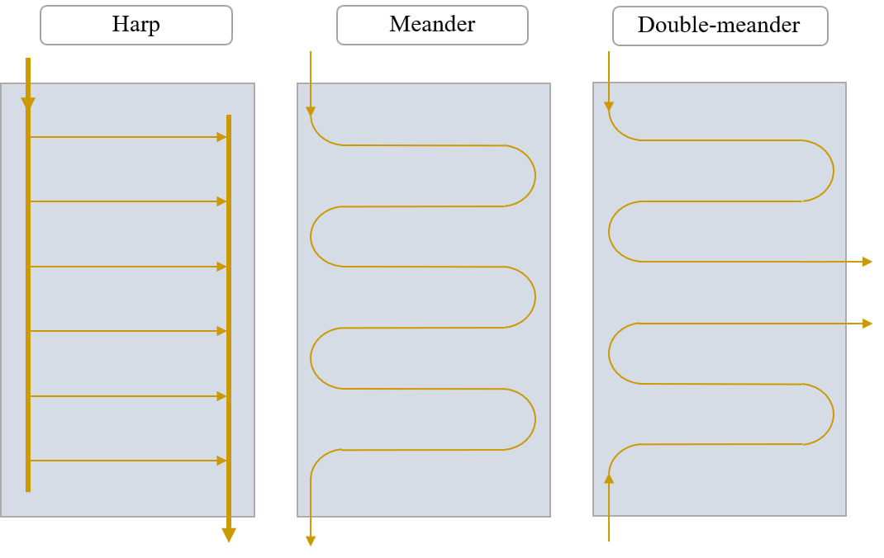
Fig. 1: Schematic description of the three PVT heat exchangers configurations.
Tab. 2 summarises the main characteristics of the PVT prototypes, focusing on thermal configurations.
Tab. 2: PVT prototypes description and characteristics.
PVT prototype | HX design | HX volume (litre) | No. of inlets & outlets | Pressure drop
Prototype 1 | Harp configuration | 2.3 | 1 inlet, 1 outlet | Low
Prototype 2 | Meander configuration | 1.5 | 1 inlet, 1 outlet | High
Prototype 3 | Double-meander configuration | 1.5 | 2 inlets, 2 outlets | Medium
Note: At a flow rate of 0.05 litre s⁻¹, the measured pressure drops were 850 Pa, 8000 Pa, and 3400 Pa for Prototypes 1, 2, and 3, respectively.
2.2. Description of the testing installation
The experimental campaign is conducted in a test bench with capacity for three panels, designed to assess the performance of each prototype simultaneously under comparable operating conditions. PVT panels are installed on a fixed outdoor structure (see Fig. 2) at a 41.65°N latitude, with a tilt angle of 30°, and azimuth angle of 10° west from south. The photovoltaic side of the panels is connected to a Huawei SUN2000-2KTL-L1 inverter.
Besides, PVT panels are hydraulically connected in parallel to a closed solar loop coupled to a 260-litre storage tank, which enables long-term monitoring of the prototypes under natural weather exposure. The storage tank includes an internal coil through which the PVT loop circulates, as well as an electrical resistance used to adjust the inlet temperature when required. A heat dissipater with a maximum power of 10 kW, supplied by Aula Solar, is installed downstream of the panels to reject excess heat and avoid excessive tank temperature during prolonged operation or high-irradiance periods. The hydraulic layout also allows the flow rate and inlet temperature of each prototype to be adjusted, supporting comparative testing under defined operating conditions. The overall hydraulic layout, including the main equipment, auxiliary components and measurement points used for monitoring the system, is shown in Fig. 3.
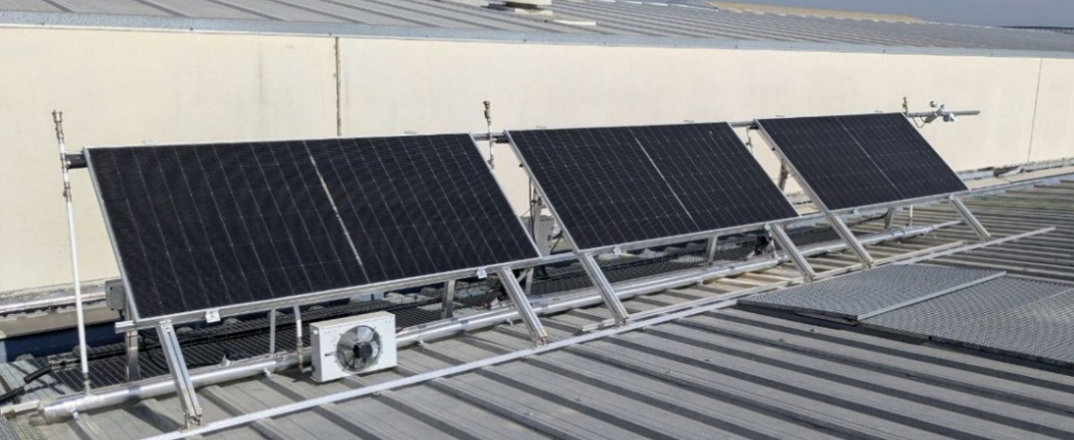
Fig. 2: Frontal side of the test bench, with the three prototypes installed.
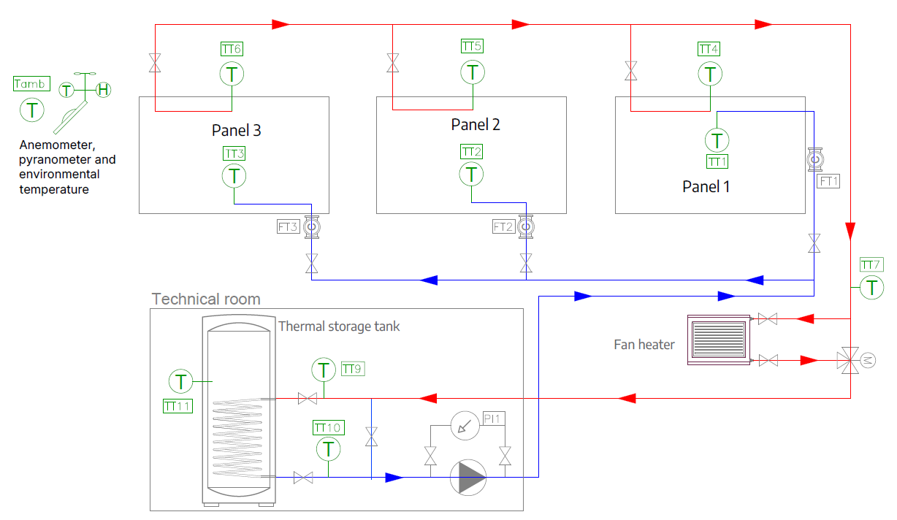
Fig. 3: Test bench hydraulic diagram with sensors and auxiliary equipment.
To characterise the thermal, hydraulic and environmental behaviour of the prototypes, the test bench is equipped with eleven temperature sensors, three flow meters and a weather station composed of an anemometer, a pyranometer and an ambient temperature sensor. These sensors are summarised in Tab. 3.
All measurements are registered in a Modicon M241 PLC from Schneider Electric and transferred through the Modbus TCP protocol at one-minute intervals, enabling detailed analysis of the prototypes’ performance under real outdoor conditions. The electrical parameters, including current, voltage and generated power, are registered directly through the commercial inverter monitoring platform.
Tab. 3: Test bench sensor description
Physical property | Qty. | Sensor model | Range | Precision
Temperature | 11 | Pt100, TCDirect | -50-400 ºC | ± 0.05 °C
Irradiance | 1 | Pyranometer, LP-PYRA-03 AC | 0-2000 W m⁻² | ± 0.025 W m⁻²
Wind velocity | 1 | 4.3303.22.007, Thies Clima | 0-50 m s⁻¹ | ± 0.3 m s⁻¹
Flow rate | 3 | V40 - RESOL GmbH | 0.008-0.833 litre s⁻¹ | 2.7 x 10⁻⁵ litre s⁻¹
2.3. Experimental test procedure
The experimental campaign reported in this work was conducted from November to April, covering a range of outdoor operating conditions during the heating season. The three PVT prototypes were monitored at defined flow rates and under the prevailing outdoor operating conditions. Flow rates and testing periods for each prototype are summarised in Tab. 4. The experimental analysis evaluates electrical and useful thermal output, fluid temperature rise, sensitivity to solar irradiance and wind speed, pressure drop, and thermal-to-electrical energy ratios, as well as the implications of each design for manufacturing and integration with seasonal thermal storage.
Tab. 4: Experimental testing conditions for the PVT prototypes
PVT prototype | Flow rates (litre s⁻¹) | Testing season
Prototype 1 | Medium (0.055-0.062) | Winter
Prototype 2 | Low (0.025-0.040) | Winter and Spring
Prototype 3 | Low (0.029-0.043) | Winter and Spring

For each operating condition, the thermal output was calculated from the measured mass flow rate, specific heat capacity of the working fluid, and inlet and outlet temperatures. The specific heat capacity was evaluated as a function of the fluid temperature and composition. The resulting performance indicators were compared with the incident solar irradiance and outdoor conditions to assess the thermal, electrical, and hydraulic behaviour of the three HX configurations.
To ensure the reliability of the comparison, data affected by start-up periods, transient operating conditions, sensor anomalies, or incomplete measurements were excluded from the analysis. The remaining measurements were processed at one-minute intervals, consistent with the acquisition system, and used to evaluate the performance of each prototype under stable operating conditions.
2.4. Integration at the demonstration site
The development of these PVT prototypes is part of the USES4HEAT project (USES4HEAT project, 2026), a European research project that involves its installation in a greenhouse use case in the Netherlands. The project plans the integration of the PVT system with an Aquifer Thermal Energy Storage (ATES) and groundwater heat pumps (GWHPs) to support decarbonization and increase the share of renewables and waste heat utilization. In this context, a solar field of 126 PVT panels (78.12 kW of peak electrical power) is planned to be installed by the end of 2026 on the south-facing side of the building.
The demonstration site is conceived as a coupled renewable energy system in which the PVT field supplies electricity and low-temperature heat. The collected heat will be used together with ATES and GWHPs, allowing part of the solar thermal production to be shifted in time and used according to the greenhouse energy demand. In the planned operation, the PVT inlet temperature is expected to vary between approximately 4 and 20 °C depending on the season and system operating conditions. The ATES charging strategy aims to reach fluid temperatures close to 50 °C through the combined contribution of the PVT field and the heat pump. Therefore, maximising the temperature increase provided by the PVT collectors is a key performance criterion.
Within this framework, the prototypes tested in this study support the selection of the PVT configuration to be deployed at the demonstration site, which will allow the selected PVT concept to be assessed at field scale.
- Results
This section presents the experimental performance of the three PVT prototypes under real outdoor operating conditions, following the HX concepts and design criteria introduced in Sections 2.1 and 2.3. The analysis focuses on electrical and thermal output, fluid temperature rise, thermal-to-electrical energy ratio, and the response of the prototypes to variations in solar irradiance and wind speed. Particular attention is paid to the trade-off between temperature lift, thermal output, and hydraulic operating conditions, which is central to the assessment of the different thermal configurations.
The results are first analysed during the winter testing period to provide a basis for screening the three prototypes. Representative operating days are used to illustrate the response of each configuration under different weather conditions, while the complete experimental dataset is considered for the quantitative comparison. The analysis is subsequently extended to the two selected configurations during spring operation and, finally, to the estimation of annual energy production for the demonstration site.
3.1. Winter performance of the three PVT prototypes
The winter campaign provides the first experimental comparison of the three PVT prototypes under low-temperature outdoor operation.
Across the tested conditions, the three prototypes exhibited broadly similar electrical and thermal power levels, whereas more pronounced differences were observed in fluid temperature rise. The harp configuration generally produced the lowest temperature increase, while the meander and double-meander configurations achieved higher temperature lifts. These differences must be interpreted together with the different flow rates and hydraulic resistance associated with each HX geometry.
The harp configuration (Prototype 1) was considered the baseline HX-concept. Its parallel hydraulic layout was expected to provide low pressure losses and a relatively uniform flow distribution over the rear surface of the module. The average peak solar irradiance during the testing period was approximately 900 W m⁻², with maximum values below 1000 W m⁻². The measured fluid temperature increase, defined as T_{outlet} - T_{inlet}, remained relatively limited, typically between 2 and 3 K, operating at medium flow level (see Tab. 4). During the highest-irradiance hours, Prototype 1 reached average peak thermal and electrical powers of approximately 607 W and 467 W, respectively. The thermal-to-electrical daily energy ratio remained close to 1:1, due to the shorter generation time of the thermal circuit compared with the electrical circuit.
The meander configuration (Prototype 2) reached average peak thermal and electrical powers of approximately 542 W and 418 W, respectively. The thermal-to-electrical energy ratio remained close to 1:1 over the representative winter days. The average peak solar irradiance during its testing period was approximately 850 W m⁻², slightly lower than that recorded for Prototype 1. This prototype exhibited a higher fluid temperature increase, typically between 4 and 6 K, operating at low flow level (see Tab. 4). Although the absolute thermal power was lower than that of Prototype 1, the higher temperature lift indicates a different thermal response associated with the longer flow path and lower flow rate.
The double-meander configuration (Prototype 3) reached average peak thermal and electrical power values of approximately 534 W and 418 W, respectively, during the highest-irradiance hours, with a thermal-to-electrical energy ratio close to 1:1. The average peak solar irradiance during its testing period was approximately 850 W m⁻², similar to Prototype 2 conditions. This configuration produced fluid temperature increases of around 5 K under outdoor conditions comparable to those of the other prototypes.
Particular days:
To illustrate the response of the prototypes to different outdoor conditions, representative operating days were selected from the experimental dataset. The selected cases cover three characteristic conditions: sunny and low-wind, sunny and windy, and cloudy days. For each case, the figures show the main environmental variables (Tamb, Wind) together with the electrical (We) and thermal (Qx) power output, the temperature at which the PVT panel is operating (Tx_{op}) and the fluid temperature difference between the inlet and outlet (dTx), being x the number of the prototype tested (1 to 3). This representation allows to visually assess the influence of solar irradiance and wind speed on the thermal and electrical response of the different HX configurations.
Under these lines, Fig. 4 shows the results obtained for Prototype 1 under the selected winter representative days, while Fig. 5 refers to Prototype 2 and Fig. 6 to Prototype 3.

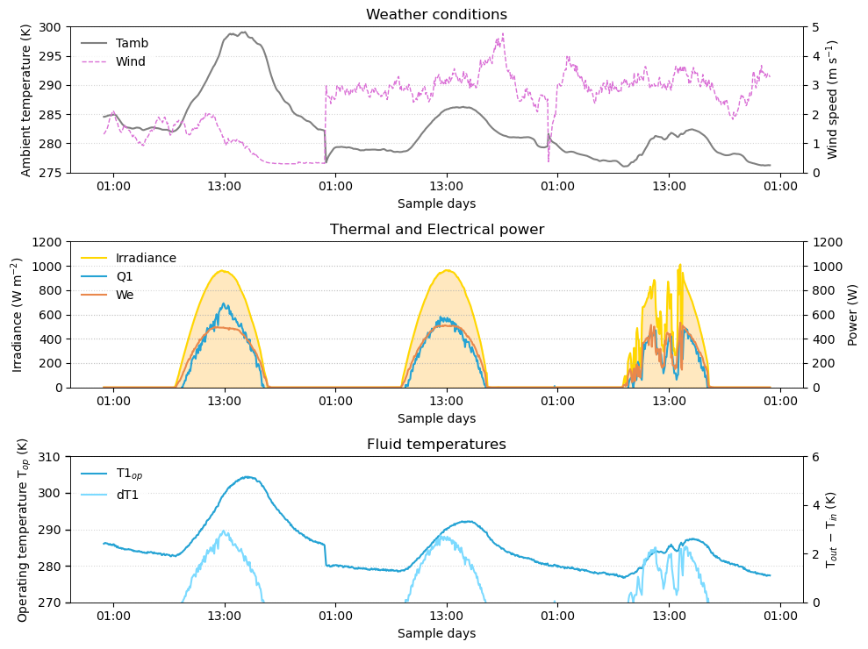
Fig. 4: Prototype 1 results, harp configuration. Winter representative days: sunny and low-wind, sunny and windy, and cloudy
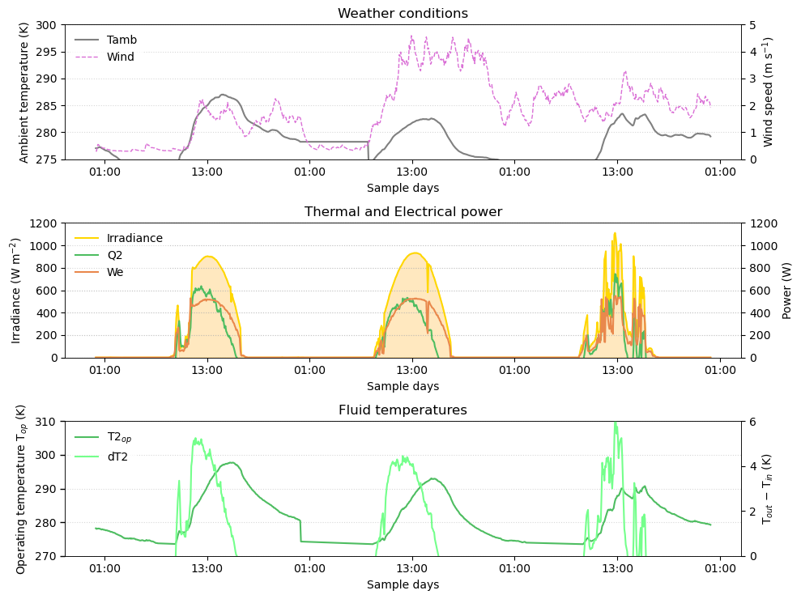
Fig. 5: Prototype 2 results, meander configuration. Winter representative days: sunny and low-wind, sunny and windy, and cloudy.
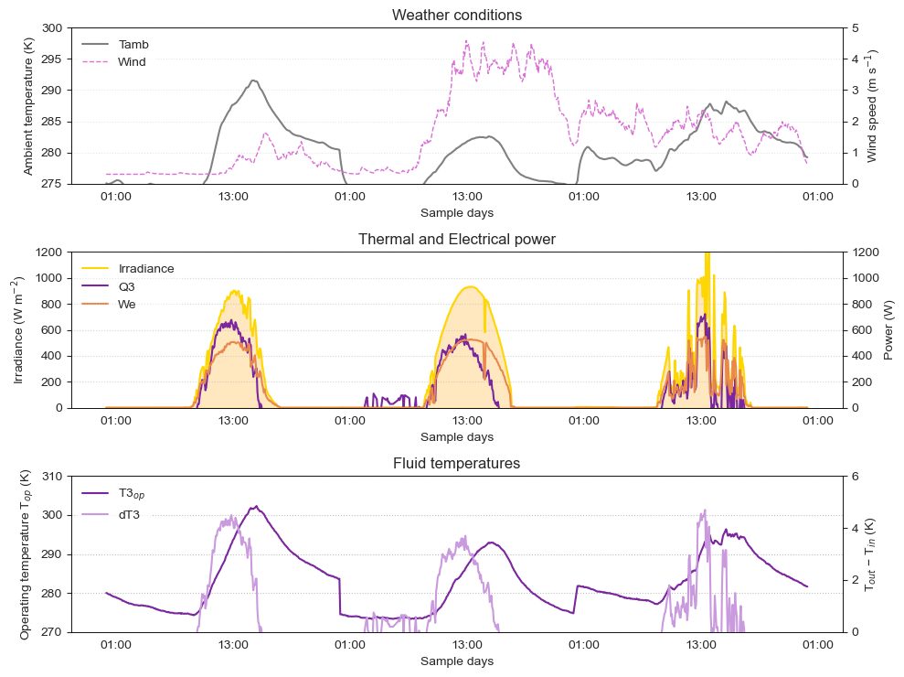
Fig. 6: Prototype 3 results, double-meander configuration. Winter representative days: sunny and low-wind, sunny and windy, and cloudy.
In the three cases, the thermal output shows a consistent reduction under sunny high-wind conditions, suggesting a sensitivity of the thermal subsystem to convective disturbances. In contrast, the electrical output exhibits a slight increase at elevated wind speeds, due to the increase in convective heat losses and the subsequent reduction on the cell temperature.
As shown in the figures, the thermal generation period is shorter than the electrical generation period, particularly under low ambient temperatures and windy conditions. Under these conditions, which penalize thermal power generation, the system is unable to heat the storage tank during the early afternoon despite ongoing solar radiation. In such cases, the daily thermal operating period could be extended by reducing the use temperature.
3.2. Comparative assessment of the three PVT designs
The winter results indicate that the main distinction between the three HX geometries is not their electrical or absolute thermal power output, but the combination of fluid temperature lift and hydraulic resistance, as well as the mechanical compatibility of the HX design with the PV module and the entire PVT panel design.
For a summarised comparison between the three prototypes, Fig. 7 shows daily electrical and thermal energy outputs, homogenized to the same daily solar radiation level. The figure distinguishes between low-wind (plain bar) and high-wind days (with a diagonal hatch pattern). Results support the wind speed effect reported in in the previous section, showing how electrical output slightly increases with high-wind conditions, while thermal generation considerably decreases. Thermal-to-electrical energy ratios remain close to 1:1 for the three prototypes during low-wind sunny days, while the difference between both outputs becomes more noticeable on windy days.

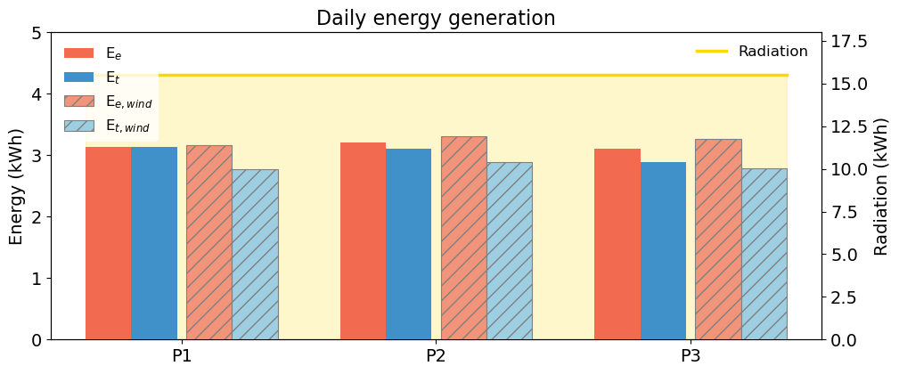
Fig. 7: Daily electrical and thermal energy production comparison of prototypes, distinguishing between calm and windy days.
The three prototypes exhibited similar power outputs, but differences in the temperature lift are observed, driven by both variations in the circulating flow rate and the absorber geometry. The higher temperature lift observed for Prototypes 2 and 3 cannot be interpreted independently of their hydraulic operating conditions. The greater pressure drops associated to the meander-based configurations are not limiting but need to be taken into account in the further installations.
Regarding practical design aspects, the harp configuration provides the simplest parallel flow arrangement, but the meander-based configurations provided higher temperature lifts. The winter results therefore identified the meander and double-meander configurations as the most promising candidates for the intended PVT application, as higher temperature level is desired for the ATES charging strategy. Between the two meander-based prototypes, similar results were observed in terms of power, energy, and temperature rise. However, the double-meander configuration (Prototype 3) exhibits a lower pressure drop, suggesting that this layout provides a better compromise between thermal performance and hydraulic resistance.
3.3. Spring performance and of selected prototypes
To enable a more detailed comparison of the two most promising configurations, Prototypes 2 and 3 were subsequently tested under spring conditions, characterised by higher ambient temperatures and solar irradiance levels above 1000 W m⁻². Both prototypes were operated at comparable flow rates, allowing their thermal response to be assessed under more similar hydraulic conditions (0.030-0.035 s⁻¹). Fig. 8 presents the results of both prototypes for three representative spring days.
Under these conditions, both selected prototypes achieved higher thermal performance than during the winter campaign. During sunny and low-wind conditions, thermal production exceeded electrical production, whereas under windy and cloudy conditions, thermal production remained slightly below electrical production. The effect of wind speed was particularly relevant to the thermal response, following the same trend as in winter.
During the highest-irradiance hours, both prototypes reached an average peak electrical power of approximately 508 W, while the corresponding average peak thermal powers were approximately 852 W for Prototype 2 and 854 W for Prototype 3. The average daily electrical production was 3.31 kWh for both panels, while the corresponding thermal production was 3.60 kWh for Prototype 2 and 3.57 kWh for Prototype 3. Both configurations produced fluid temperature increases in the range of 5 to 7 K.
The comparison between Prototypes 2 and 3 showed very similar thermal production and fluid temperature rise when operated at comparable flow rates, confirming that the double-meander configuration can achieve a thermal response comparable to that of the single meander configuration under favorable outdoor conditions. However, considering that its parallel arrangement results in a lower pressure drop, this prototype was selected for integration with the ATES.
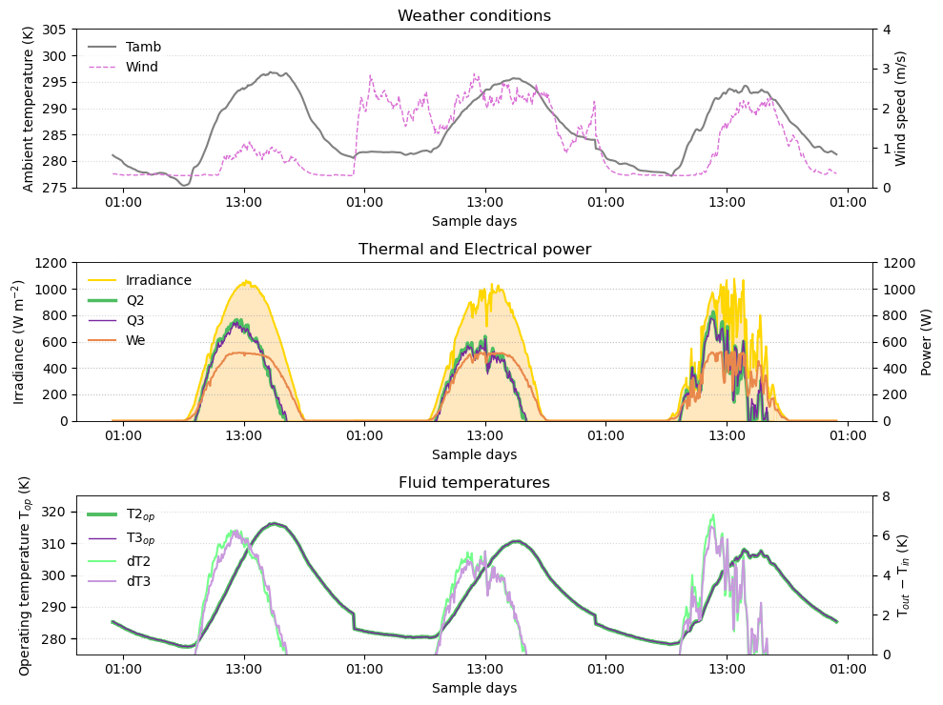
Fig. 8: Results from prototype 2 and 3: meander and double-meander configuration. Spring representative days.
3.4. Production estimation for the demonstration site
The experimental results obtained during the campaign were used to estimate the annual electrical and thermal energy production expected at the demonstration site. The PVT field is planned to be installed on the roof of the greenhouse technical building in the Netherlands, with an 11° tilt angle (coplanar to the roof) and south-oriented with a 10° deviation to the west. The estimation considers a planned field of 126 PVT panels, equivalent to 78.12 kWp of peak electrical power, and an annual in-plane irradiation of approximately 1050 kWh m⁻².
The estimation was first performed for a single panel and subsequently scaled to the planned 126-panel field. This approach links the experimentally measured prototype performance with the expected contribution of the full installation, where the PVT field is intended to provide useful heat and reduce the temperature lift required from the heat pump during ATES charging. The thermal production estimate assumes PVT inlet temperatures in the range of approximately 4-20 °C, depending on the season and system operating conditions. The estimation is based on the results obtained with Prototype 3
Tab. 5: Estimated annual electrical and thermal production for the demonstration site.
Scenario | Electrical production | Thermal production
Per panel | 495 kWh/year | 542 kWh/year
Full PVT field | 62.4 MWh/year | 68.3 MWh/year

As summarised in Tab. 5, the estimated annual production is approximately 495 kWh of electricity and 542 kWh of useful thermal energy per panel, corresponding to approximately 62.4 MWh of electricity and 68.3 MWh of thermal energy per year for the complete PVT field. Approximately 80% of the estimated thermal production is expected during the summer period, when the ATES is charged, while the remaining thermal production can support additional greenhouse loads or auxiliary demands during the winter season.
These preliminary estimates indicate that the proposed PVT field could provide relevant annual electrical and useful thermal contributions while supporting the ATES charging strategy. However, the annual production values remain indicative and require validation at the demonstration site once the PVT panels have been installed, the final hydraulic layout has been implemented, and the system is operating under real conditions with the ATES/GWHP configuration.
- Conclusions
The experimental assessment of three PVT prototypes with different HX configurations under outdoor operating conditions has been developed and explained in the present work. Overall, the results demonstrate the potential of the proposed PVT configurations for low-temperature heat recovery and seasonal thermal storage applications; leading to the following main conclusions:
- The three prototypes showed broadly comparable electrical and thermal power outputs, while the main differences were observed in the fluid temperature rise. The harp configuration provided the lowest temperature lift, typically 2–3 K in winter, compared with approximately 4–6 K for the meander and double-meander configurations.
- Wind speed had a noticeable effect on thermal performance, with higher wind conditions generally reducing thermal output and fluid temperature rise. In contrast, electrical output showed a slight increase under higher wind speeds. The magnitude of these effects varied between testing periods and should therefore be interpreted considering the prevailing outdoor conditions, especially irradiance and ambient temperature.
- The higher temperature lift achieved by the meander-based configurations was linked to lower operating flow rates and longer tubbing paths. However, it brings associated higher hydraulic resistance. Consequently, thermal performance cannot be assessed independently of the hydraulic characteristics of the HX, highlighting the importance of considering practical aspects besides the power performance in the selection of PVT configurations.
- The winter results identified the meander and double-meander configurations as the most promising designs for applications requiring higher fluid temperature levels. Both configurations achieved similar thermal responses during the subsequent spring campaign, with temperature increases of approximately 5 to 7 K and peak thermal powers of around 850 W.
- The comparable thermal performance of the two meander-based configurations indicates that the double-meander design can provide a competitive alternative to the single meander, potentially offering a more favourable balance between thermal performance and hydraulic resistance. Based on this, the double-meander configuration has been selected for future installation and integration with seasonal thermal storage.
- The experimental results indicate an estimated annual production of approximately 495 kWh of electricity and 542 kWh of useful thermal energy per panel. For the planned 126-panel PVT field, this corresponds to approximately 62.4 MWh of electricity and 68.3 MWh of thermal energy per year. These values are preliminary estimates based on the experimental results and are subject to validation under the final operating conditions of the demonstration site.
- Acknowledges
This work was supported by the European Union’s Horizon Europe research and innovation programme under grant agreement No 101136136 (Project USES4HEAT - Underground Large Scale Seasonal Energy Storage for Decarbonized and Reliable Heat).
- References
AEE INTEC, 2025. Solar Heat Worldwide - Global Market Development and Trends 2024. https://doi.org/10.18777/ieashc-shww-2025-0001
Al-Ali, S., Olabi, A.G., Mahmoud, M., 2025. A review of solar photovoltaic technologies: developments, challenges, and future perspectives. Energy Conversion and Management: X. https://doi.org/10.1016/j.ecmx.2025.101057
Arnesson, H., Olympios, A. V., Harraz, A.A., Xu, J., 2025. Comprehensive energy, economic, and environmental analysis of a hybrid photovoltaic–thermal (PVT) heat pump system. Energy 331, 136563. https://doi.org/10.1016/j.energy.2025.136563
Bórawski, P., Holden, L., Bełdycka-Bórawska, A., 2023. Perspectives of photovoltaic energy market development in the european union. Energy 270, 126804. https://doi.org/10.1016/j.energy.2023.126804
Cao, H., Liu, X., Feng, G., Huang, K., Zhang, L., Sun, Q., Wang, X., 2025. Performance analysis and optimisation of solar hybrid ground source heat pump system for nearly zero-energy building in severely cold regions. Journal of Building Engineering 113, 113763. https://doi.org/10.1016/j.jobe.2025.113763
Chen, J., Chen, K., Zhao, B., Yu, J., Hu, M., Pei, G., 2025. Numerical analysis of spectrally selective photovoltaic-thermal collectors coupled with pit thermal energy storage in solar district heating systems. Appl. Therm. Eng. 262, 125239. https://doi.org/10.1016/j.applthermaleng.2024.125239
Coca-Ortegón, A., Simón-Allué, R., Guedea, I., Brun, G., Villén, R., 2023. Operational performance of trigeneration PVT-assisted HP system. Energy Build. 296. https://doi.org/10.1016/j.enbuild.2023.113383
Das, D., Bordoloi, U., Kamble, A.D., Muigai, H.H., Pai, R.K., Kalita, P., 2021. Performance investigation of a rectangular spiral flow PV/T collector with a novel form-stable composite material. Appl. Therm. Eng. 182, 116035. https://doi.org/10.1016/j.applthermaleng.2020.116035
Del Amo, A., Martínez-Gracia, A., Pintanel, T., Bayod-Rújula, A.A., Torné, S., 2020. Analysis and optimization of a heat pump system coupled to an installation of PVT panels and a seasonal storage tank on an educational building. Energy Build. 226, 110373. https://doi.org/10.1016/j.enbuild.2020.110373
IEA SHC, 2025. Task 73 - PVT Heating Systems [WWW Document]. URL https://task73.iea-shc.org/ (accessed 3.13.26).
Joshi, S.S., Dhoble, A.S., 2018. Photovoltaic -Thermal systems (PVT): Technology review and future trends. Renewable and Sustainable Energy Reviews. https://doi.org/10.1016/j.rser.2018.04.067
Junjorn, T., Deethayat, T., Asanakham, A., Kiatsiriroat, T., 2025. Evaluation of cold water temperature and tank size impacts on a PVT-assisted heat pump system performance for hot water applications. Case Studies in Thermal Engineering 76, 107496. https://doi.org/10.1016/j.csite.2025.107496
Liu, W., Yao, J., Jia, T., Zhao, Y., Dai, Y., Zhu, J., Novakovic, V., 2023. The performance optimization of DX-PVT heat pump system for residential heating. Renew. Energy 206, 1106–1119. https://doi.org/10.1016/j.renene.2023.02.089
Ma, J., Zhang, H., Ding, S., Su, J., Xie, L., Bai, J., Zhang, Z., 2026. Experimental study of photovoltaic thermal control in an indirect expansion heat pump. Appl. Therm. Eng. 284. https://doi.org/10.1016/j.applthermaleng.2025.128980
Miglioli, A., Aste, N., Del Pero, C., Leonforte, F., 2023. Photovoltaic-thermal solar-assisted heat pump systems for building applications: Integration and design methods. Energy and Built Environment 4, 39–56. https://doi.org/10.1016/j.enbenv.2021.07.002
Nahar, A., Hasanuzzaman, M., Rahim, N.A., 2017. Numerical and experimental investigation on the performance of a photovoltaic thermal collector with parallel plate flow channel under different operating conditions in Malaysia. Solar Energy 144, 517–528. https://doi.org/10.1016/j.solener.2017.01.041
Pellegrini, M., Bloemendal, M., Hoekstra, N., Spaak, G., Andreu Gallego, A., Rodriguez Comins, J., Grotenhuis, T., Picone, S., Murrell, A.J., Steeman, H.J., 2019. Low carbon heating and cooling by combining various technologies with Aquifer Thermal Energy Storage. Science of the Total Environment 665, 1–10. https://doi.org/10.1016/j.scitotenv.2019.01.135
USES4HEAT project [WWW Document], 2026. URL https://www.uses4heat.eu/ (accessed 7.3.26).
Wang, Z., Guo, P., Zhang, H., Yang, W., Mei, S., 2017. Comprehensive review on the development of SAHP for domestic hot water. Renewable and Sustainable Energy Reviews 72, 871–881. https://doi.org/10.1016/j.rser.2017.01.127

Source: ScienceDirect, find articles with words “solar photovoltaic-thermal”

