EuroSun2026
SOLAR THERMAL ASSISTED AIR DEHUMIDIFICATION IN WATERWORKS
Lisa Völker¹, Felix Micus¹, Daniel Fleig¹, Ulrike Jordan¹
¹University of Kassel, Institute of Thermal Engineering, Kassel (Germany), solar@uni-kassel.de
Summary
Dehumidification is essential in waterworks to prevent condensation and corrosion on cold pipe surfaces, but its energy demand has received little attention so far. Field measurements in three waterworks showed both insufficient dehumidification under critical summer conditions and over-dehumidification during low-load periods, the latter caused by control based on relative humidity rather than on the dew point. The results highlight considerable potential for improving control strategies and reducing electricity consumption. For one elevated tank, a solar-thermal-assisted desiccant wheel system was therefore designed and installed as a demonstration plant, combining a commercially available desiccant wheel with evacuated tube collectors and a buffer storage tank to preheat the regeneration air. First results from two months of operation show that condensation is reliably prevented and that about 68 % of the regeneration heat is covered by solar energy. At the same time, the coupling of the two established technologies revealed unexpected challenges, in particular in the internal control of the desiccant wheel and in the performance of the air-to-water heat exchanger. Further work will focus on resolving these issues and on quantifying the achievable energy savings.
Keywords: Dehumidification, desiccant wheel, solar thermal system
Field of application for the findings: Solar cooling (dehumidification), condensation prevention
Addressed audience: Researchers and engineers in solar thermal energy and solar-assisted air conditioning, planners and manufacturers of desiccant dehumidification systems
- Introduction
Water supply is a widespread infrastructure task: in Germany alone, around 5,600 public water suppliers operate roughly 15,200 water extraction plants, supplying about 4.67 billion m³ of water to end consumers in 2022 (UBA, 2024). In many of these waterworks, air dehumidification is required to prevent condensation on cold pipe and tank surfaces and the resulting corrosion. Dehumidification loads are mainly caused by infiltration through the building envelope and, in some cases, by internal moisture sources such as backwashing processes. While the energy demand of water supply systems is generally dominated by pumping (Grzegorzek et al., 2023), the energy demand for dehumidification in waterworks has hardly been investigated so far.
Depending on the required indoor dew point, either condensation dehumidifiers or desiccant wheels (DW) are applied. Condensation dehumidification becomes critical when very low dew points are required, whereas desiccant wheels can operate effectively under such conditions. Most commercially available small desiccant wheel units for waterworks use electric heating for regeneration. Since in Central Europe the highest dehumidification loads occur in summer, when solar irradiation is also highest, solar thermal regeneration appears promising.
Solar-assisted desiccant wheels for air dehumidification have been studied both experimentally and in simulation studies. In contrast to laboratory studies, evaluations of field test applications are rather rare and have been conducted e.g. by Baniyounes et al. (2013)., Comino et al. (2020) or Qadar Chaudhary et al.(2018). Qadar Chaudhary et al. (2018) investigated a system in Pakistan from May to July, operating daily between 10:00 and 16:00. Their system uses an electric water heater as back-up heater when the supply water temperature from the buffer storage for the regeneration air stream falls below 74 °C, and they report a mean solar fraction of 70 %. Baniyounes et al. (2013) investigated a system in Queensland (Australia), also with an electric back-up heater, and report an annual solar fraction of 25 % with peak values of up to 55 %. In a case study by Lai et al. (2022), two climatic zones in Australia were investigated, resulting in solar fractions on typical summer days of 36 % in Melbourne and more than 75 % in tropical Darwin. Lin et al. (2025). performed a TRNSYS simulation study for various climatic zones in China, concluding that on sunny days the solar fraction can reach up to 84 %, while on cloudy days the system has to be run solely on auxiliary energy. (Comino et al., 2020) used a solar-assisted desiccant wheel to condition a research laboratory in Spain for six weeks during spring. When the solely solar-heated desiccant wheel could not meet the room requirements, an auxiliary system was activated to remove the remaining latent and sensible loads. In contrast to all other presented systems, their system operated without a buffer storage, leading the authors to conclude that a thermal buffer storage should always be applied.
This overview shows that solar-assisted desiccant wheel systems have mainly been studied for comfort air conditioning, and hardly for waterworks applications. Waterworks differ from comfort air conditioning in three relevant aspects: they often require lower dew point temperatures, the dehumidification load also occurs during the night and no set room air temperatures are given and therefore no additional sensible cooling of dehumidified air is needed. Against this background, the present study integrates a commercially available desiccant wheel, which uses electrical air heating and a dew point control, with a solar thermal system.
The aim of this study is to provide insight into current dehumidification practice of three different waterworks, to identify efficiency potentials, and to investigate the reduction in electrical energy demand achieved by integrating solar thermal heat into a commercially available desiccant wheel system, implemented and evaluated in a demonstration plant.
- Assessment of dehumidification in existing waterworks
Measurement campaign and results
To investigate dehumidification under practical operating conditions, measurements were carried out in three waterworks of different sizes, namely two elevated tanks and one pumping station (Tab. 1). At all sites, air temperature and relative humidity were measured at different positions, and the surface temperatures of selected pipelines were monitored over periods of one to two years. Two of the sites use condensation dehumidifiers, while one site is equipped with desiccant wheels.
Tab. 1: Overview of measured waterworks
Name | Room volume | Dehumidification Technology | Annual electricity consumption | Measurement period
Pumping station | 5000 m³ | 1 x air handling unit (condensation dehumidification) | no data | 31.03.23-04.11.25
Elevated tank A | 690 m³ | 5 x mobile condensation dehumidifier | 3.6 MWh/a | 03.02.23-16.04.24
Elevated tank B | 2500 m³ | 3 x stand-alone desiccant wheel | 72 MWh/a | 25.04.24-04.11.25

Based on the measured air temperature and relative humidity, the dew point temperature was calculated and compared with the measured pipe surface temperature in order to evaluate whether the installed dehumidification systems reliably prevent condensation.
Fig. 1 to Fig. 2 show measurement results for the three investigated waterworks. For the pumping station, the annual mean value of the pipe surface temperature is 7.8 °C. Outliers represent periods where water volume flow rate is decreased. With the given pipe surface temperature, the room dew point temperature should be around 5 °C all year long to prevent condensation. However, Fig. 1 shows that the room dewpoint temperature significantly exceeds the pipe surface temperature during the period from May to November, leading to condensation, while during the winter months it is undershot. The measured pumping station uses a central air conditioning unit with a high amount of fresh air supply. During winter months (November to April) nearly no dehumidification is needed because the outdoor air dewpoint is mostly already lower than 5 °C. Based on the measured data during summer months the relative humidity of the room air is on average 55 % RH, suggesting that the central air conditioning unit is regulated to this setpoint. However, a constant setpoint of 55 % RH is evidently not sufficient to prevent condensation. Further, it might be that the installed system is already at its limits.
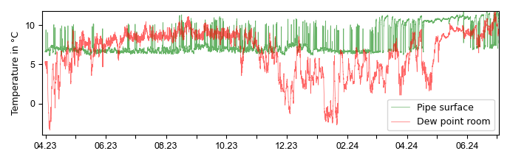
Fig. 1: Excerpt of measured dew point and pipe surface temperature from April 2023 to July 2024 in pumping station
In contrast, no critical condensation risk was observed in elevated tanks A and B. Elevated tank A is dehumidified by five mobile condensation dehumidifier which also only offer the possibility to choose a relative humidity as set point. The setpoint is about 55 % RH. The average pipe surface temperature is 11.8 °C (see Fig. 2). Except for some hours during summer months, the room air dew point in elevated tank A is below the pipe surface temperature and especially during the winter months undershot it significantly.
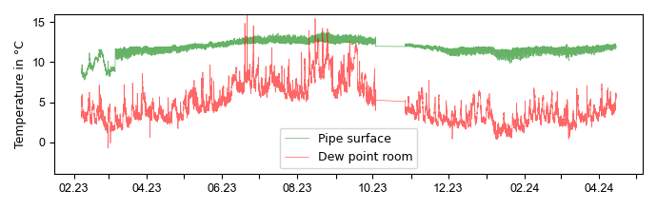
Fig. 2: Excerpt of measured dew point and pipe surface temperature from February 2023 to April 2024 in elevated tank A
In elevated tank B, dehumidified by three DW-units of various sizes, the average pipe surface temperature is 7.6 °C (see Fig. 3) resulting in lower room air dew points compared to elevated tank a to fulfill the requirements to prevent condensation. Here, too, a set point for the relative humidity of about 40 % RH was set, resulting in unnecessarily high dehumidification from October to July and thus in an annual electricity consumption of 72 MWh which is about 20 times higher compared to elevated tank A.
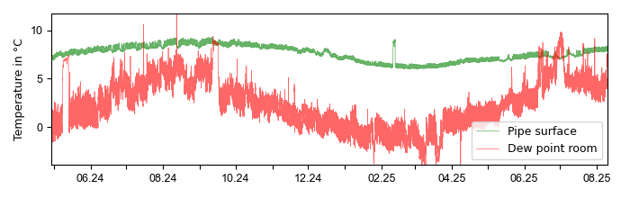
Fig. 3: Excerpt of measured dew point and pipe surface temperature from May 2024 to August 2025 in elevated tank B
Identified efficiency potentials in waterworks
The measurement campaign highlights that existing dehumidification systems in waterworks may suffer both from insufficient performance under critical conditions and from inefficient controlling based on relative humidity instead of dew point controlling. While older DW-unit might have no option for dew point control special sensors which still measure the relative humidity but are installed on the cold pipeline surface and thus correspond to a dew point control can be retrofitted.
Further, as in the example of the pumping station, fresh air supply should be reduced to a minimum to reduce moisture input during summer months. Usually, fresh air supply is only needed to fulfill health and safety regulations for employees. However, there are usually no permanent workplaces in the areas of waterworks where the cold pipelines are located.
For waterworks with rather low raw water temperatures (e.g. elevated tank B), this cold water could also be used to pre-dehumidify the air by condensation, provided this complies with existing regulations.
- Solar-thermal-assisted desiccant wheel demonstration plant
Experimental setup
Elevated tank A was selected for the implementation of the solar-thermal-assisted adsorption dehumidification system, primarily for practical reasons, as the local municipality agreed to host the demonstration plant. The elevated tank has three levels: a ground level and two basement levels. While most of the cold pipes are installed on the second basement level, the highest dehumidification load was identified on the ground level due to infiltration through the building envelope. No DW unit existed yet at the chosen elevated tank, and therefore a new DW unit had to be installed. Since a commercially available DW unit was installed, the setup is nevertheless representative of retrofitting a solar thermal system to an existing DW unit in waterworks.
Fig. 4 shows the integration of the DW unit and the solar thermal system including all measurement points. The DW unit is positioned on the ground level in the elevated tank and draws the process air, which is recirculated room air. The dehumidified air is led by an air channel to the second basement level. The solid desiccant of the rotor, which is silica gel, adsorbs the water molecules in the process air section. Afterwards, the desiccant enters the regeneration section, where the water molecules are desorbed by hot air. Ambient air is used as regeneration air. The nominal air volume flow rate is 99 m³/h for the regeneration air and 270 m³/h for the process air. The maximal power of the electrical heater is 2.7 kW. The sensor for controlling the room dew point is also installed close to the unit on the ground level.
On the solar charging side, the installed system consists of a 13 m² (gross area) evacuated tube collector, an 800 l buffer storage tank and external heat exchanger. Discharging of the storage is realised by an air-to-water heat exchanger for preheating the regeneration air. Fig. 5 and Fig. 6 show pictures of the installed pilot plant at elevated tank A.
The system is supposed to control the room dew point temperature to a given setpoint with a hysteresis. The DW unit has its own internal control to set the necessary regeneration temperature depending on the actual and setpoint dew point values. The solar system is integrated such that once the dehumidifier switches on, the discharging pump starts first. If the solar preheating is not sufficient to fulfil the regeneration air temperature required by the internal control, the electric air heater is activated additionally. In contrast to normal DW operation, the maximal regeneration temperature for this DW unit is set to 85 °C.
The system has been operating since the middle of June 2026, but full data acquisition could only be realised since 06.07.26. Data are logged every 10 seconds and averaged to one minute for evaluations.

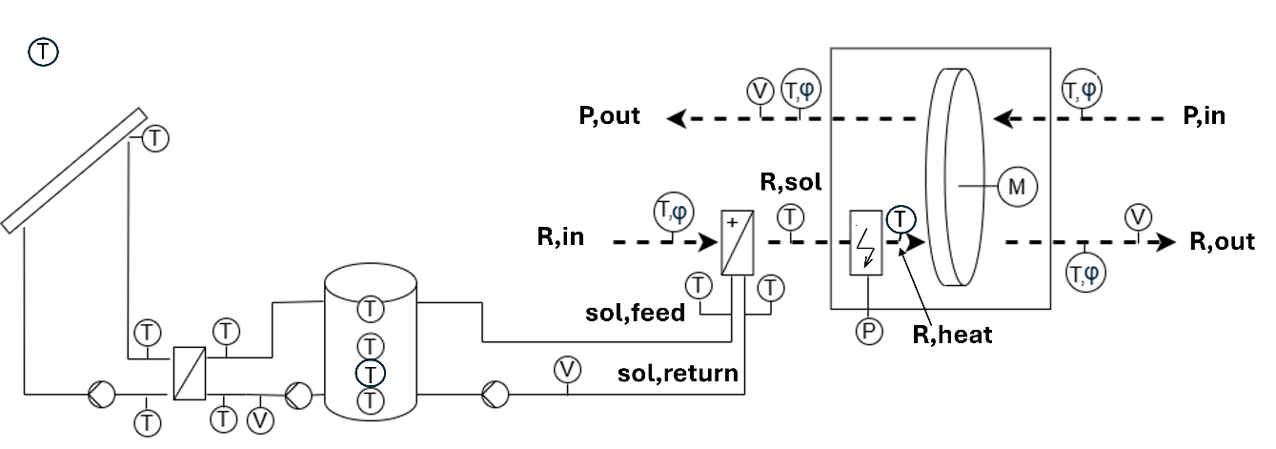

Fig. 4: Scheme of demonstration plant including all measurement points

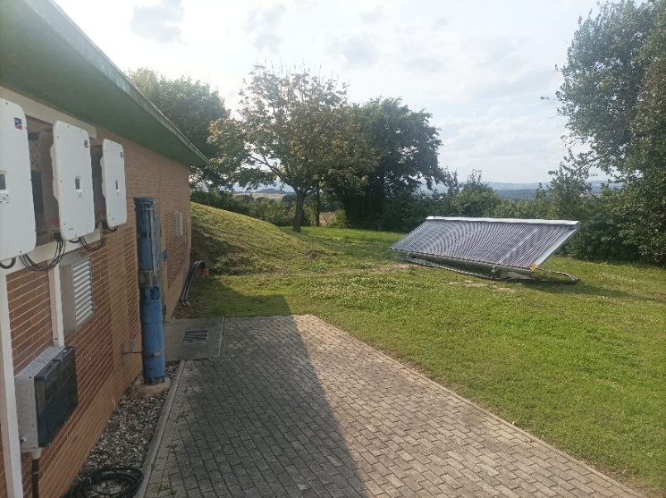 | 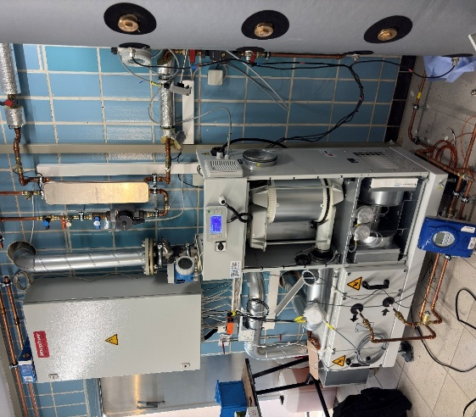
Fig. 5: Vacuum tube collector in front of elevated tank A | Fig. 6: Desiccant wheel unit including air-to-water heat exchanger and buffer storage inside of elevated tank A
Energy evaluation methodology
For the energy evaluation, the regeneration heat flow rate is calculated for every time step and integrated over time to obtain the corresponding energy, see eq. 1.
$${\dot{Q}}_{reg,tot}={\dot{V}}_{reg}⋅ρ_{air}⋅c_{p,air}⋅\left(T_{R,heat}-T_{R,in}\right)$$ | eq. 1
The solar-covered regeneration heat flow rate is calculated analogously according to eq. 2 from the temperature increase across the air-to-water heat exchanger:
$${\dot{Q}}_{reg,sol}={\dot{V}}_{reg}⋅ρ_{air}⋅c_{p,air}⋅\left(T_{R,sol}-T_{R,in}\right)$$ | eq. 2
${\dot{V}}_{reg}$ is the measured volume flow rate of the regeneration air, $ρ_{air}$ the air density, $c_{p,air}$the specific heat capacity of air (mean value of inlet and outlet), and $T_{R,in}$, $T_{R,sol}$and $T_{R,heat}$ the regeneration air temperatures at the inlet, after solar preheating and after the electric heater, respectively (see Fig. 4). Both power values are integrated over time to obtain the total regeneration energy $Q_{reg,tot}$ and the solar-covered regeneration energy $Q_{reg,sol}$. Since the direct electricity measurement is not yet operational, the electrical regeneration energy is obtained as the difference $Q_{reg,el}=Q_{reg,tot}-Q_{reg,sol}$, assuming an electrical efficiency of approximately one for the resistance heater. The solar fraction of the regeneration heat is defined as:
$f_{sol}=Q_{reg,sol}/Q_{reg,tot}$. | eq. 3
Since the electricity consumption of the fans is not measured directly either, it is estimated using the nominal fan power of 0.36 kW, which is assumed whenever a regeneration air volume flow is measured. As the fans frequently continue running after the heater and the pump have switched off, their operating time — and thus $E_{fan,el}$— is somewhat longer than that of the heater and the pump.
- Results and discussion
Dehumidification performance
Fig. 7 shows the measured dew point temperature on the ground level ($T_{DP,Room}$) of the elevated tank from 06.07-07.09.2026 and the pipe surface temperature ($T_{pipe,surf}$) from 13.07.-25.08.26. The room sensors were installed on 13.07., but in contrast to the system’s data logging, they have to be read out on site, and therefore the data since 25.08.2026 could not be updated to date. For this two-month period, the average pipe surface temperature is 12.4 °C. The room dew point temperature setpoint was varied several times during this period (between 6.5 °C and 8.5 °C, each with ± 1 K hysteresis) in order to investigate the system's behaviour. To sum up, over the two-month period the room air dew point temperature did not exceed the upper hysteresis level, and since it remains constantly 3 to 4 K below the pipe surface temperature, no condensation occurs.
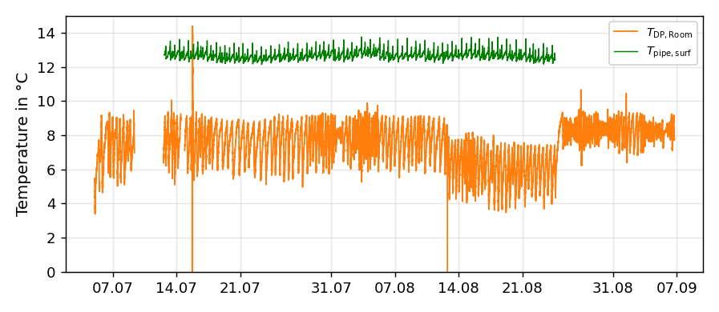
Fig. 7: Dew point temperature in elevated tank A (ground level) and pipe surface temperature from 06.07.-07.09.26
On 25.08., the air outlet on the second basement level was changed such that part of the air is blown more towards the top instead of vertically into the room. As can be seen in Fig. 7, the oscillations around the setpoint are notably smaller after this change than before, showing that the outlet position of the dry air has a direct impact on the dew point control of the DW unit. A further effect can be observed throughout the measurement period: once the lower hysteresis limit is reached, the system, in particular the electric heater, does not switch off immediately but ramps down gradually. As a consequence, dehumidification continues for some time, and the room dew point temperature frequently undershoots the lower hysteresis limit.
Interaction between solar system and desiccant wheel
Fig. 8 gives an overview of the operating behaviour of the system for a five-day excerpt. The DW switches on every time the measured dew point temperature on the ground level reaches the upper hysteresis limit. The measured dew point temperature on the second basement level (2B) also approaches this value. Once the DW switches on, the discharging pump also starts running, and the water from the buffer storage (sol,feed) heats the regeneration air inlet (R,in) as much as possible (R,sol). For the given excerpt, every time the DW is on, electrical reheating is needed to fulfil the requirements for the regeneration temperature (R,heat) according to the internal control of the DW unit. Once the wheel switches on, the dew point on all levels starts to decrease, with lower values in the second basement. It can be observed that the dew point of the process outlet (P,out) is very low (< 0 °C). Further Fig. 8 underlines that dehumidification load occurs during nighttime.
Two effects can be further observed. First, the solar feed temperature to the air-to-water heat exchanger (sol,feed) during DW operation changes between 60 and 80 °C, depending on the solar heat input and thus on the upper buffer storage temperature. Second, the actually required regeneration temperature (R,sol) varies from 62 °C to 83 °C for the given excerpt. As a result, on sunny days with solar feed temperatures of 80 °C and rather low dehumidification load, the regeneration heat can be almost fully supplied by solar preheating for some DW operating hours (29.07. and 30.07. in the afternoon), while for other operating hours not even half of the regeneration heat can be covered by solar preheating.
The measurement results show that the effectiveness of the air-to-water heat exchanger is only 0.62, although it was designed as a counter-flow heat exchanger with an effectiveness of 0.9. The approach temperature at the air outlet is up to 20 K. An incorrect installation of the heat exchanger might be the reason for this, but this has to be clarified. If the heat exchanger operated at its design effectiveness, the solar-covered regeneration heat could be increased further.
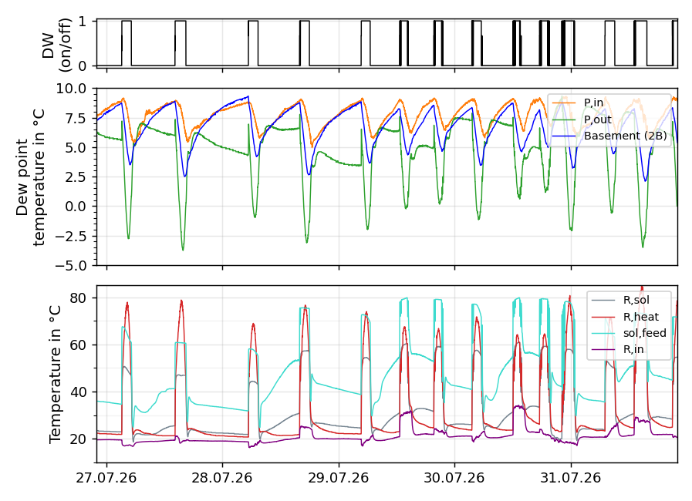
Fig. 8: Desiccant wheel mode (on/off), measured dew point temperatures of process air inlet and outlet and in the second basement as well as measured temperatures on regeneration side. The set room air dew point in this period is 8 °C ± 1 K.
Even when the solar feed temperature is sufficient to fully heat the regeneration air (despite the reduced heat exchanger effectiveness), the internal control of the DW currently cannot handle this, resulting in frequent switching of the DW. This behaviour could not yet be clarified and will be a focus of further research on the system's control. Over the two-month period, 321 kg of water were removed by the DW. Fig. 9 shows the cumulative removed water. Short periods with steeper gradients can be observed, which correspond to days with high outdoor air dew points (up to 20 °C).
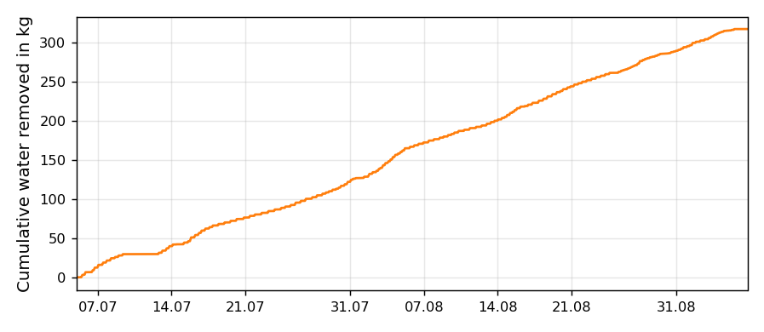
Fig. 9: Cumulative water removed from the desiccant wheel in the period from 06.07.-07.09.2026
Energy Evaluations
For the investigated two-month period, the total regeneration heat (${\dot{Q}}_{reg,tot}$) is 390 kWh, of which 68 % could be covered by solar heat. Fig. 10 shows the cumulative regeneration heat, split into the solar covered (${\dot{Q}}_{reg,sol}$) and the electrically supplied share (${\dot{Q}}_{reg,el}$), together with the electrical energy consumption of the fans ($E_{fan,el}$). The resulting total electricity consumption, including electrical regeneration heat and fans, is 363 kWh.
As can be seen in Fig. 10, the electricity consumption of the fans even exceeds that of the electrical heater over the investigated period. The reason becomes apparent from the slope of $E_{fan,el}$. as already mentioned, the air outlet on the second basement level was adjusted on 25.08.2026. For reasons not yet identified, this resulted in nearly continuous fan operation of the DW unit from that date onwards, although the discharging pump and the heater continued to switch on and off. Consequently, the slope of $E_{fan,el}$ increases markedly from that date, while ${\dot{Q}}_{reg,el}$, continues to rise more gradually. The reason for this behaviour still needs to be specified, but it might be related to the internal control of the DW unit. A meaningful energy comparison with the previously installed condensation dehumidifiers is not yet possible at this stage and requires a longer monitoring period, in particular once the described control issues have been resolved.
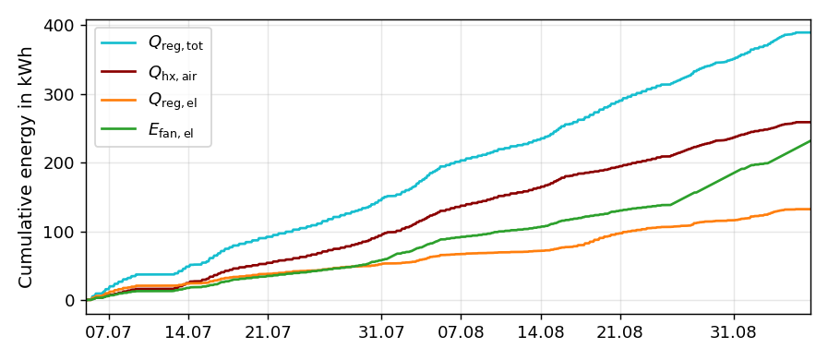
Fig. 10: Cumulated regeneration heat and electrical energy
- Conclusion
Dehumidification in waterworks has so far received little attention regarding its energy demand. Measurements in three waterworks showed that the installed systems are commonly controlled based on relative humidity rather than on the dew point, which leads either to insufficient dehumidification under critical summer conditions or to unnecessarily high dehumidification and thus electricity consumption during the rest of the year. Retrofitting dew point-based control and reducing fresh air supply were identified as efficiency potentials that can be realised with little effort.
The measurement results of the demonstration plant demonstrate that the main challenge of solar-assisted dehumidification in waterworks does not lie in the individual components, but in their coupling. Both the desiccant wheel and the solar thermal plant are established technologies, yet their interaction gave rise to effects that were not anticipated in the design: the internal control of the desiccant wheel causes frequent switching and, after a minor change to the air outlet, nearly continuous fan operation, while the air-to-water heat exchanger reached only 0.62 of its intended effectiveness. These findings suggest that, for such retrofits, the control strategy and the integration of the two subsystems deserve at least as much attention as the sizing of the components themselves.
Despite these unresolved issues, the demonstration plant already prevents condensation reliably and covers about 68 % of the regeneration heat with solar energy over the first two months of operation. This indicates that the concept is technically feasible and that a substantial reduction of the electrical energy demand for regeneration is within reach once the system operates as intended.
A conclusive assessment of the actual electricity savings compared to the previously installed condensation dehumidifiers is not yet possible and requires a longer monitoring period. Ongoing work therefore focuses on adapting the control parameters and improving the heat exchanger performance.
- Acknowledgements
The authors are thankful to the Federal Ministry for Economic Affairs and Climate Action (BMWK) for funding the research project dx-Wasser (grant number: 03EN6019A).
- References

Baniyounes, A.M., Rasul, M.G., Khan, M., 2013. Experimental assessment of a solar desiccant cooling system for an institutional building in subtropical Queensland, Australia. Energy and Buildings 62, 78–86.
Comino, F., Castillo González, J., Navas-Martos, F.J., Ruiz de Adana, M., 2020. Experimental energy performance assessment of a solar desiccant cooling system in Southern Europe climates. Applied Thermal Engineering 165, 114579.
Grzegorzek, M., Wartalska, K., Kaźmierczak, B., 2023. Review of water treatment methods with a focus on energy consumption. International Communications in Heat and Mass Transfer 143, 106674.
Lai, L., Wang, X., Kefayati, G., Hu, E., 2022. Performance evaluation of a solar powered solid desiccant evaporative cooling system with different recirculation air ratios. Energy and Buildings 270, 112273.
Lin, S., Tao, Z., Jiang, M., Deng, L., Li, J., Huang, H., 2025. Applicability of solar assisted desiccant wheel and adsorption cooling system in different climate zones: A study based on TRNSYS. Energy 341, 139540.
Qadar Chaudhary, G., Ali, M., Sheikh, N.A., Gilani, S.I.u.H., Khushnood, S., 2018. Integration of solar assisted solid desiccant cooling system with efficient evaporative cooling technique for separate load handling. Applied Thermal Engineering 140, 696–706.
UBA, 2024. Öffentliche Wasserversorgung. https://www.uba.de/n11076de. Accessed 7 September 2026.

