EuroSun2026
LATITUDINAL ASSESSMENT OF ROOFTOP BIFACIAL PV IRRADIANCE ACROSS MEXICO USING BIFACIAL RADIANCE
Rodolfo Rentería Ramírez¹ (corresponding author), Guillermo Barrios del Valle², Carlos Álvarez Macías¹, Francisco Jurado¹
¹ Instituto Tecnológico de la Laguna, Tecnológico Nacional de México, Torreón, Coahuila (Mexico)
² Instituto de Energías Renovables, Universidad Nacional Autónoma de México, Temixco, Morelos (Mexico)

hon.rerenteriar@lalaguna.tecnm.mx¹, gbv@ier.unam.mx², calvarezm@correo.itlalaguna.edu.mx¹, fjuradoz@lalaguna.tecnm.mx¹
Summary
Bifacial photovoltaic technology has been assessed mainly in utility scale plants, whereas its behaviour on rooftops under distributed generation has received far less attention. A campaign of 110 ray tracing simulations carried out with bifacial radiance is presented, covering five Mexican cities between 16.8° and 29.1° N, which span the latitudinal range of the country, eleven tilt angles between 0° and 45°, and two roof albedos representative of national construction practice: 0.25, typical of grey waterproofing, and 0.70, corresponding to a reflective cool roof coating. Each case resolves the full year with a cumulative sky over an array of four modules in a single row, the usual configuration in Mexican housing. From the energy optimum a single tilt rule is derived, 30° over grey and 40° over cool roof, valid for the five locations. The inherited criterion of setting tilt equal to latitude remains acceptable over a grey roof, at a cost below 1.1 %, but not over a cool roof, where it reaches 3.9 %: it is roof reflectance, and not latitude, the variable that invalidates it. Against an equivalent monofacial system, bifaciality contributes between 13.4 % and 15.7 % over grey and between 35.4 % and 40.4 % over cool roof. The results support improved installation practice and provide a starting point for extending tilt control algorithms to distributed generation.
Keywords:
bifacial, monofacial, distributed generation, rooftop, albedo, cool roof, ray tracing, latitude
Field of application for the findings: rooftop photovoltaic system design in distributed generation; bifacial irradiance assessment across the latitudinal range of Mexico.
Addressed audience: researchers and practitioners in photovoltaic modelling, rooftop system design and solar resource assessment.
1. Introduction
According to NASA, the average insolation in Mexico is 5.56 kWh/m² per day, which places the country in favourable conditions for the installation of photovoltaic systems, particularly in the residential sector. That resource is, however, far from being exploited (Rosas-Flores et al., 2019). The distributed generation scheme has driven much of the recent growth in capacity installed on residential rooftops.
Bifacial photovoltaic technology collects radiation on both the front and the rear side, which allows it to make use of the diffuse component and of the fraction reflected by the surroundings. Gains of up to 50 % of power with respect to monofacial modules of identical orientation have been reported (Cuevas et al., 1982) and, in more recent studies, of the order of 13 % to 35 % under clear-sky conditions and 40 % to 70 % under overcast conditions, depending on mounting height (Valdivia et al., 2017). This gain is not a fixed value: it depends on mounting height, tilt angle, surface reflectance, array geometry, solar elevation and the diffuse fraction of the resource (Sun et al., 2018; Bhayat et al., 2023).
Consequently, design practices inherited from monofacial systems, in particular the rule of setting tilt equal to latitude, do not necessarily lead to optimal performance in bifacial configurations (Corso et al., 2023; McIntosh et al., 2022). The problem is aggravated on Mexican rooftops, where the reflectance of the mounting surface varies widely between the grey or terracotta waterproofing in general use and the reflective coatings of high solar reflectance whose adoption national regulation promotes for thermal comfort reasons (Lucero-Álvarez and Martín-Domínguez, 2019).
This work quantifies, by means of ray-tracing radiative simulation, how latitude, tilt angle and roof reflectance interact in the irradiance available to a rooftop array, and derives from that quantification an explicit design criterion. Since the simulation resolves both sides separately, the same set of results also describes the performance of a monofacial system, which allows the two technologies to be compared without introducing additional assumptions. The central contribution is twofold: the demonstration that bifacial gain and collected energy become dissociated, and the identification of an interaction between technology and roof reflectance that conventional design does not contemplate.
2. Background
2.1 Rooftop surfaces in Mexico and their reflectance
Mexico has a predominantly warm climate and high solar radiation on dwelling surfaces, which are generally built with concrete roofs. The optical properties of these materials condition both the heat flux towards the interior and the radiation available to the rear side of a bifacial module mounted on them. Grey and terracotta materials are the most widely used for roof waterproofing in the country (Lucero-Álvarez and Martín-Domínguez, 2019).
Roof whitening and the use of reflective coatings have been promoted as a thermal conditioning strategy. The Mexican standard NMX-U-125-SCFI-2016 establishes the use of these coatings as a measure to improve thermal comfort. The coexistence of two construction practices of very different reflectance directly motivates the two albedo levels evaluated in this study.
2.2 Representative residential array
The simulated array consists of four modules arranged in a single portrait-oriented row. This configuration was selected as a representative minimal unit of Mexican residential distributed generation for three converging reasons. First, it reflects the prevailing residential market: the average distributed generation interconnection request in Mexico reached 8.64 kW at the end of 2025 (Comisión Nacional de Energía CNE, 2025), and systems below 50 kW account for 98.23% of all requests; typical residential installations comprise between four and twelve modules, so a four module block (≈2.6 kWp with 650 W modules) represents the lower, entry level segment that predominates among tariff 1 households and modular installations. Second, a four module unit is an established simulation array in the bifacial modeling literature: Ernst et al. (2021) explicitly 'define a PV system with four modules as [their] unit system' and, using periodic boundary conditions, show it can reproduce the illumination of an arbitrarily large field. Third, the single row portrait layout is the dominant residential practice on the flat concrete roofs common in Latin America (Solar Power World, 2024), where obstructions (water tanks, air-conditioning units, access paths) reduce usable roof area to roughly half of the gross area, and where portrait racking minimizes rail length and ballast. We acknowledge that a small finite array exhibits edge effects on rear side irradiance that a large-field 'infinite-array' assumption would smooth out (IEA-PVPS Task 13, 2021; Ayala Pelaez et al., 2019); however, because these effects are physically real in small rooftop systems, modeling an explicit single row of four modules yields a more faithful representation of an actual Mexican residential installation than an infinite array idealization."
2.3 Bifacial irradiance modelling methods
The techniques reported in the literature fall into three categories: empirical models, view factor models and ray tracing models (Louw and Rix, 2020). The first are fast but difficult to extrapolate; the second resolve the geometry analytically but require restrictive assumptions about surface uniformity; the third resolve radiative transport explicitly and admit arbitrary geometries and optical properties, at the cost of greater computational effort. This work adopts ray tracing as the only approach that simultaneously resolves the self-shading of the array on the roof itself and the non-uniform distribution of irradiance over the rear side.
2.4 Structural constraint on the tilt angle
The operating angle cannot grow indefinitely: the greater the tilt, the larger the surface exposed to wind and the greater the uplift force on the structure. The Manual de Diseño de Obras Civiles por Viento of the Comisión Federal de Electricidad (CFE, 2020) devotes a section to wind loads on solar panels, and the ASCE/SEI 7-16 standard (ASCE, 2016) establishes that above approximately 45° the module ceases to behave aerodynamically as a roof and starts to behave as a solid vertical surface. For this reason, the sweep is bounded at 45°, a value to be interpreted as the upper limit admissible for structural safety and not as a constraint of the radiative model.
3. Methodology
3.1 Tool and sky mode
The simulations were run with bifacial_radiance (Ayala Pelaez and Deline, 2020), an open source library of the National Renewable Energy Laboratory that automates the modelling of bifacial photovoltaic systems on top of the Radiance ray tracing engine (Ward, 1994). The ground is modelled as a physical polygon of Lambertian reflectance, appropriate to represent a rooftop surface of known reflectance.
The cumulative sky mode (gencumulativesky) was used, which integrates the annual distribution of sky radiance into a single model. Verification was carried out on a horizontal surface against the global horizontal irradiation of the weather file itself, with a deviation of −4.0 % for the Torreón case, considered acceptable for the comparative purpose of the campaign.
3.2 Locations and weather files
Five cities covering the latitudinal and climatic range of the country were selected. Torreón and Monterrey constitute a deliberate control pair: they share latitude, with a difference of 0.165°, but differ appreciably in diffuse fraction, which allows the geometric effect to be separated from the climatic one. All files belong to the TMYx 2004–2018 family and their provenance, including the cryptographic hash of each file, was recorded.
Tab. 1: Locations evaluated and characterisation of the annual solar resource kWh/m²/year according to the TMYx 2004–2018 weather files used.
City | State | WMO | Latitude (°N) | Longitude (°) | Altitude (m) | GHI (kWh/m²) | DHI/GHI (–)
Hermosillo | Sonora | 761600 | 29.096 | −111.048 | 191 | 2196 | 0.222
Monterrey | Nuevo León | 763930 | 25.733 | −100.300 | 515 | 2003 | 0.306
Torreón | Coahuila | 763820 | 25.568 | −103.411 | 1124 | 2284 | 0.230
Mexico City | CDMX | 766793 | 19.433 | −99.133 | 2235 | 2175 | 0.306
Tuxtla Gutiérrez | Chiapas | 768430 | 16.770 | −93.341 | 1052 | 2004 | 0.388

3.3 Geometry and fixed parameters
A single row of four modules in portrait arrangement facing south was modelled, on an extensive ground plane of uniform Lambertian reflectance. The single row avoids inter-row shading by construction and isolates the effect of the tilt angle. The extensive plane represents a large rooftop or the interior area of ​​a slab far from its edges; for an arrangement close to the parapet, the available reflected component would be smaller, and the magnitudes reported here should be interpreted as an upper limit. Results were computed on the two interior modules of the block, each sampled with nine sensors per side, which discards the edge effects of the outermost modules as documented (Ayala Pelaez and Deline, 2020). The dimensions and bifaciality factor of a commercial module model, the Trina Vertex S+, were adopted. No perimeter parapet was included. Table 2 lists the parameters considered.
Tab. 2: Geometric and optical parameters held constant across the 110 cases.
Parameter | Value
Azimuth | 180° (south)
Clearance to the lower edge | 1.00 m
Module dimensions | 1.134 m × 2.384 m, portrait arrangement
Array | 4 modules × 1 row
Gap between modules | 0.02 m
Bifaciality factor | 0.85
Sensors per side and module | 9
Modules analysed | 2 and 3 (interior), averaged
Parapet | Not modelled
Sky | gencumulativesky, full year
Ray-tracing parameters | −ab 2 −aa 0.1 −ar 256 −ad 2048 −as 256

3.4 Study variables and case matrix
The variables were city, tilt angle and roof reflectance. Eleven tilts were evaluated per city: ten absolute values from 0° to 45° in steps of 5°, plus the angle equal to the exact latitude of each location. The choice of absolute angles, rather than angles relative to latitude, allows the cities to be compared at identical geometry and isolates latitude as an independent variable. The two reflectances evaluated were 0.25, representative of grey waterproofing, and 0.70, representative of a reflective coating. The combination produced 110 cases.
The modelled configuration corresponds to the usual practice of residential distributed generation in Mexico (Fig. 1): a small block of modules arranged in a single row on the flat rooftop slab, mounted on a fixed structure of low tilt and without immediate obstructions.

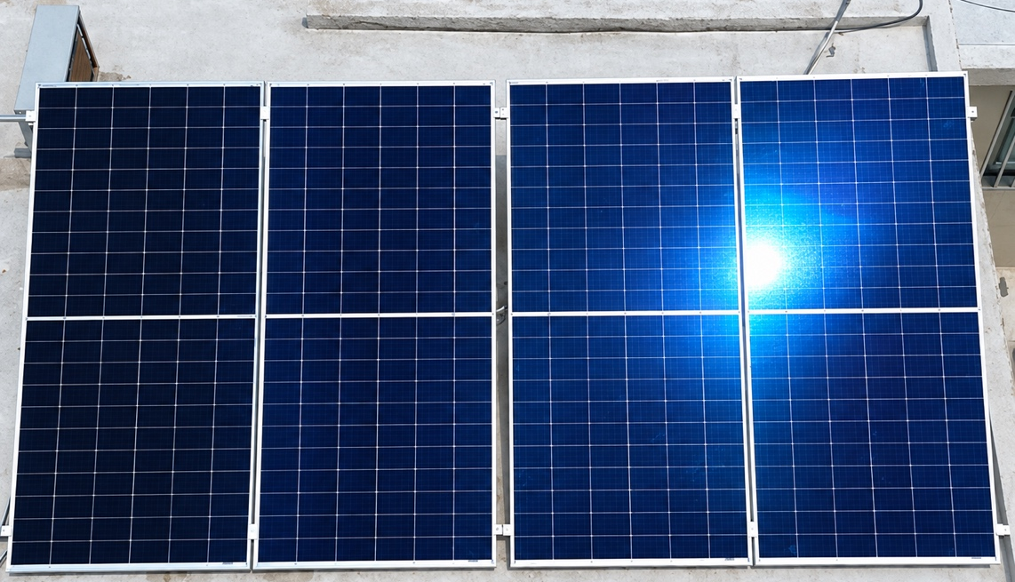
Fig. 1: Residential rooftop photovoltaic installation in Mexico, with four modules in a single row on a flat slab.
The simulated scene reproduces that arrangement and is shown (Fig. 2) for three of the eleven tilts evaluated, 0°, 25° and 45°, the two ends of the range and an intermediate value, across the five locations. The geometry of the array is identical in all of them: the scene files generated for a given tilt match byte for byte between cities. What varies is the solar position, computed with the coordinates of the corresponding weather file; at solar noon on the winter solstice the elevation ranges from 37.5° in Hermosillo to 49.8° in Tuxtla Gutiérrez, and with it changes the shadow the array casts on the roof, which conditions the irradiance available to the rear side.
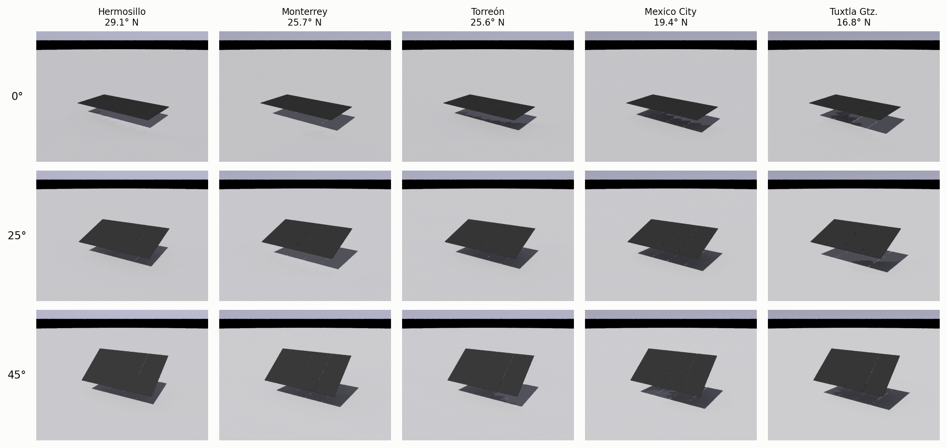
Fig. 2: Simulated scene, five locations and three of the eleven tilts evaluated. Solar noon on the winter solstice.

3.5 Metrics
From each case the annual irradiation on the front side, $G_{front}$, and on the rear side, $G_{back}$, was extracted, both in kWh/m². From them the bifacial gain is defined as

$BG = φ · \frac{G_{back}}{G_{front}}$ (eq. 1)

where φ = 0.85 is the bifaciality factor, and the effective bifacial irradiance

${G_{ef}=G}_{front}+ φ {·G}_{back}$ (eq. 2)

which represents the total usable irradiance and constitutes the indicator proportional to the energy generated. The distinction between the two is central: BG is a ratio and increases with tilt partly because its denominator decreases, which does not constitute energy; $G_{ef}$ is the quantity that must be maximised. In addition, $G_{front}$ on its own describes the performance of a monofacial module of identical geometry and siting, which allows both technologies to be compared over exactly the same set of simulations without additional assumptions.
The annual diffuse fraction $F_{d}$ used as a climatic descriptor is obtained by dividing the annual totals of the diffuse and global horizontal irradiance columns of the weather file itself, summed over the 8760 hours. It is worth noting that this is not the average of the hourly fractions: being the ratio of the totals, it weights each hour by its energy, so that clear midday weighs far more than an overcast dawn. A value of $F_{d}$ = 0.23 indicates that 77 % of the annual horizontal energy arrives by the direct path.

3.6 Verification and reproducibility
Each case was run in isolation, with prior recording of all its parameters, the versions of the tools and the cryptographic hash of the weather file. Results were read by explicit location of the generated files and not by reconstruction of the expected name. It was verified that the 110 cases retained the nine valid sensors per side and module, with none of them intersecting the ground or the sky.
The dispersion between identical runs, measured over five repetitions of representative cases, amounted to between 0.2 % and 1.3 % in coefficient of variation for $G_{back}$ and BG, with occasional outliers of the order of 3 % to 5 %. This tolerance is inherent to the sampling of the Radiance ambient calculation and must be borne in mind when interpreting differences smaller than 1 % between individual cases.
4. Results and discussion
4.1 Bifacial gain: range and dependence on tilt
The 110 cases completed without incident. With an albedo of 0.25 the bifacial gain lies between 10.4 % and 20.3 %, and with an albedo of 0.70 between 29.2 % and 41.8 %. Across the ten series evaluated, five cities by two albedos, the gain increases monotonically with tilt, with no decreasing stretch in the range from 0° to 45° (Fig. 3). Both panels of that figure share the vertical scale and their ranges are disjoint: roof albedo shifts the bifacial gain by an order of magnitude more than any other factor evaluated.
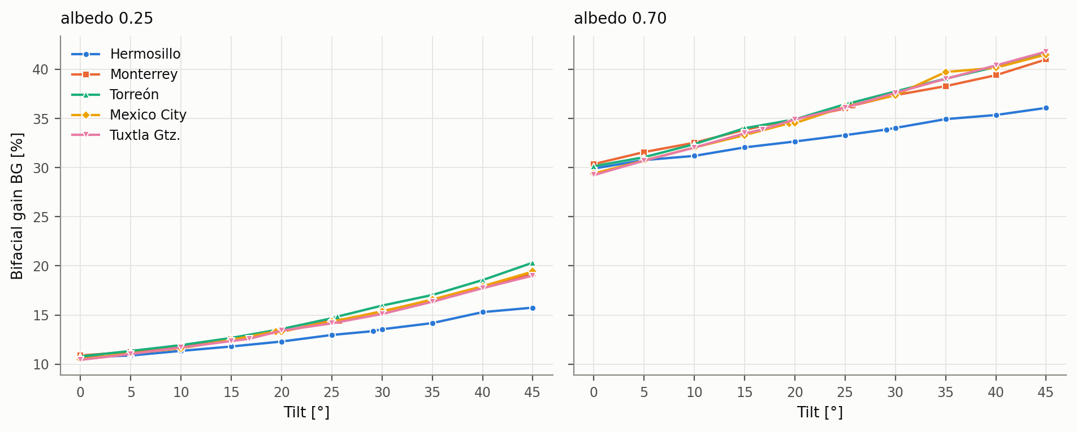
Fig. 3: Bifacial gain as a function of tilt angle, with roof reflectance of 0.25 (left) and 0.70 (right).
The median increase in bifacial gain when moving from 0.25 to 0.70 is 21.3 percentage points, whereas the full sweep of tilt, from 0° to 45°, contributes of the order of 9 to 11 points depending on the city.
The dependence on latitude, though secondary, is neither negligible nor explained by climate. Hermosillo shows the lowest gain over the whole range evaluated, 15.8 % at 45° and an albedo of 0.25, against 20.3 % for Torreón. Both cities have practically identical diffuse fractions, 0.222 and 0.230, so the difference cannot be attributed to the proportion of diffuse radiation. The mechanism is geometric and operates on the denominator of equation 1: at higher latitude the sun stays lower and further south, so that a south-facing surface receives more front-side irradiance, Hermosillo reaching the highest $G_{front}$ of the set, 2315 kWh/m², and the relative gain decreases. The Torreón–Monterrey control pair reinforces this reading: with the same latitude and diffuse fractions of 0.230 and 0.306, their curves separate by little more than one percentage point even at 45°.
The sign of that small difference is moreover contrary to what the climatic descriptor would suggest: despite its higher diffuse fraction, Monterrey obtains less bifacial gain than Torreón. The reason is that $F_{d}$ is a ratio whereas what reaches the rear side are absolute values. At 45° and an albedo of 0.25, Monterrey has 90 kWh/m² of sky diffuse on the rear side against 77 for Torreón, but only 427 kWh/m² of reflected ground against 487, because its annual global irradiation is 12 % lower. The ground term weighs about five times more than the sky term at that tilt, so that the balance is unfavourable. Therefore, diffuse fraction alone cannot explain the rear-side irradiance; absolute irradiance and ground-reflected irradiance must also be considered.
4.2 Shift of the front side optimum tilt
The angle that maximises front-side irradiation shifts systematically as roof reflectance increases. The front side of a surface tilted at θ sees the ground with a view factor (1 − cos θ)/2, zero when horizontal and 0.146 at 45°, so that over a reflective roof it receives an additional contribution that grows with the angle and offsets the loss of direct collection. Measured for Torreón, that contribution amounts to +144 kWh/m² at 45° against +150 kWh/m² from the isotropic calculation, and vanishes when horizontal as the geometry requires. Consequently, at low reflectance tilting the module only costs direct collection and the optimum lies close to latitude, whereas at high reflectance tilting additionally gains radiation reflected by the roof and the maximum shifts between 4° and 11° towards larger angles across the five locations (Fig. 4).
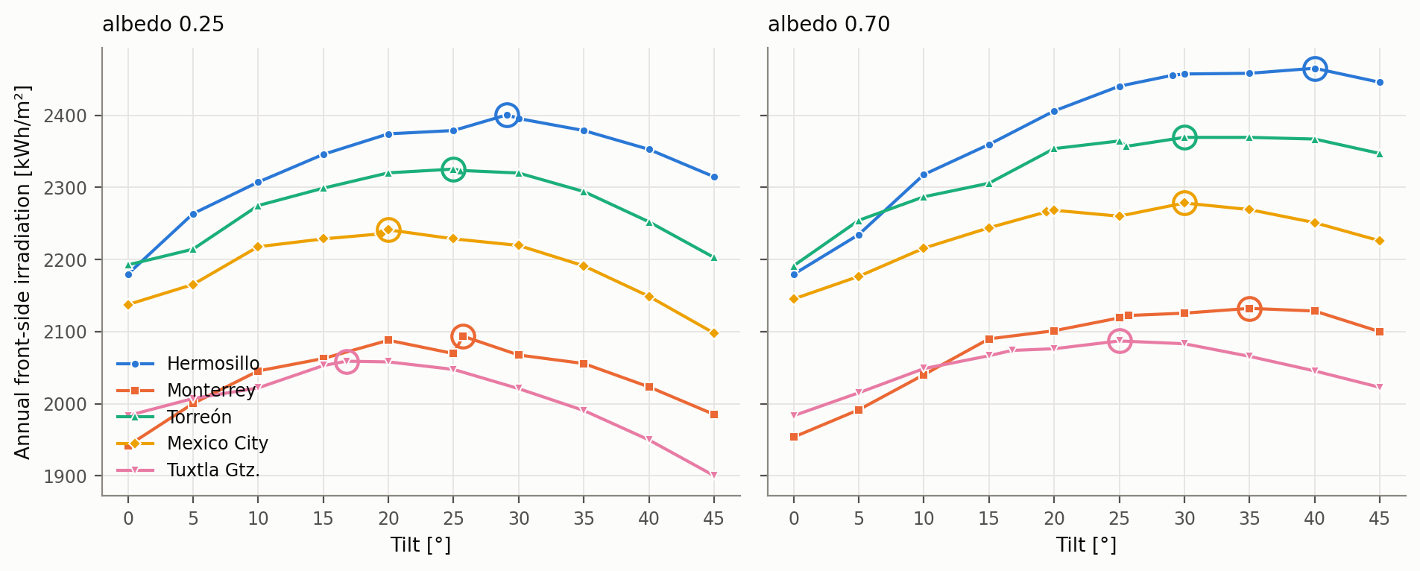
Fig. 4: Annual front-side irradiation as a function of tilt. The circle marks the maximum of each series.
4.3 Comparison of radiation collection between a monofacial and a bifacial system
Since the simulation resolves both sides separately, $G_{front}$ on its own describes the performance of a monofacial module of identical geometry, orientation and siting. The comparison between technologies therefore requires neither additional assumptions nor a second campaign: it is the same simulation read in two ways. Each technology is evaluated at its own optimum tilt.
Tab. 3: Annual usable irradiance for each technology at its own optimum tilt, and advantage of the bifacial over the monofacial system, for the two reflectance levels.
City | Monofacial ρ=0.25 | Bifacial ρ=0.25 | Bifacial advantage vs  monofacial (%) | Monofacial ρ=0.7 | Bifacial ρ=0.7 | Bifacial advantage vs. monofacial  (%)
Hermosillo | 2401 @ 29.1° | 2721 @ 29.1° | +13.4 | 2465 @ 40° | 3337 @ 40° | +35.4
Monterrey | 2094 @ 25.73° | 2395 @ 25.73° | +14.4 | 2132 @ 35° | 2967 @ 40° | +39.2
Torreón | 2325 @ 25° | 2690 @ 30° | +15.7 | 2369 @ 30° | 3326 @ 45° | +40.4
Mexico City | 2241 @ 20° | 2560 @ 30° | +14.2 | 2278 @ 30° | 3171 @ 35° | +39.2
Tuxtla Gutiérrez | 2059 @ 16.77° | 2337 @ 25° | +13.5 | 2087 @ 25° | 2872 @ 35° | +37.6

Over a grey roof the bifacial system provides between 13.4 % and 15.7 % more usable irradiance than the monofacial one. Over a reflective coating the advantage rises to between 35.4 % and 40.4 %. The cumulative step from the most common configuration in Mexico, a monofacial module over grey waterproofing, to a bifacial module over a cool roof ranges from 39.0 % to 43.0 % (Fig. 5). In the left panel of that figure the four combinations are shown as a function of tilt for Torreón, with the optimum of each curve marked and colour distinguishing the technology; in the right panel the five locations appear with each technology evaluated at its own optimum tilt.
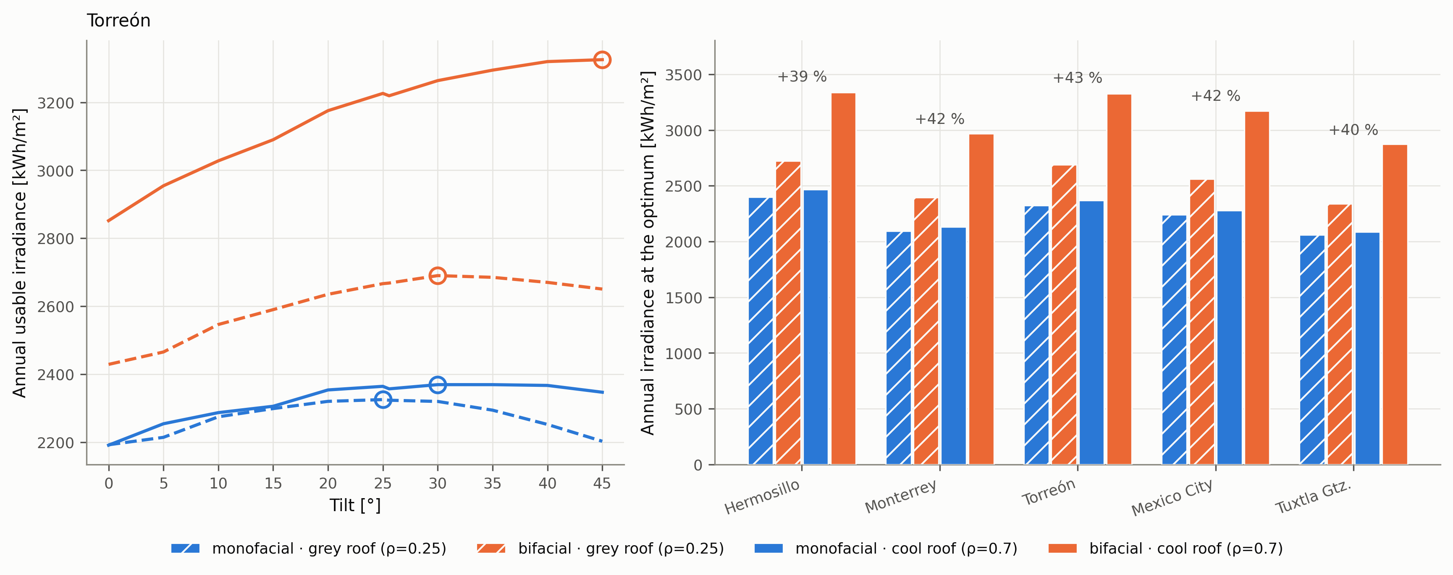
Fig. 5: Annual usable irradiance of a monofacial and a bifacial system, for the two roof reflectance levels.
The result of greatest interest is the interaction between technology and reflectance. Replacing grey waterproofing with a reflective coating provides a monofacial system with only between 1.4 % and 2.7 %, whereas it provides the bifacial one with between 22.6 % and 23.9 %, an order of magnitude more. The reason is geometric: at its optimum a monofacial module is tilted only slightly, between 16.8° and 29.1° depending on the city, and at those angles its view factor towards the roof barely reaches 0.02 to 0.06, so that almost none of the reflected radiation reaches it. The bifacial module, by contrast, has a side oriented precisely towards the roof.
The design consequence is direct: improving the rooftop surface and adopting bifacial technology are not independent measures that can be evaluated separately and added. Investing in a reflective coating beneath a monofacial array is, from the standpoint of electricity generation, an intervention of marginal return; the same investment beneath a bifacial array yield. The increase obtained with a bifacial array is approximately 8–17 times larger. Economic analyses that treat these two interventions independently may underestimate their potential interaction.
4.4 Effect of albedo on the collected energy
Evaluated on the effective bifacial irradiance, replacing grey waterproofing with a reflective coating produces a remarkably uniform increase across cities, from 22.6 % to 23.9 % if the array is re-tilted to its new optimum. The increase is almost entirely preserved, between 20.8 % and 22.2 %, when the array keeps its previous tilt, which implies that the intervention on the roof is usable in existing installations without modifying the support structure.
Tab. 4: Annual effective bifacial irradiance at the optimum of each case and increase associated with replacing grey waterproofing with a reflective coating.
City | Optimum θ at ρ=0.25 (°) | $G_{ef}$ (kWh/m²) | Optimum θ at ρ=0.7 (°) | $G_{ef}$ (kWh/m²) | Increase (%) | Increase without re-tilting (%)
Hermosillo | 29.1 | 2721 | 40 | 3337 | +22.6 | +20.8
Monterrey | 25.73 | 2395 | 40 | 2967 | +23.9 | +20.8
Torreón | 30 | 2690 | 45 | 3326 | +23.6 | +21.3
Mexico City | 30 | 2560 | 35 | 3171 | +23.8 | +22.2
Tuxtla Gutiérrez | 25 | 2337 | 35 | 2872 | +22.9 | +21.5

4.5 Dissociation between bifacial gain and collected energy
The bifacial gain of equation 1 is a ratio, and it increases with tilt both because its numerator grows and because its denominator falls. The second mechanism has no energy value. Tuxtla Gutiérrez with an albedo of 0.25 illustrates this: moving from 25° to 45° the rear-side contribution increases by 71.6 kWh/m², but the front-side one decreases by 147.4 kWh/m², so that the effective irradiance falls by 75.8 kWh/m², a drop of 3.2 %. The bifacial gain, by contrast, rises from 14.1 % to 19.0 %, which would wrongly suggest an improvement of 34 %. Maximizing bifacial gain does not necessarily maximize annual energy yield.
Both quantities are contrasted by indexing each curve to its own maximum (Fig. 6), so that the two reach 100 % at their respective optimum and become comparable in shape but not in value; a dual axis is thereby avoided, in which the choice of ranges would arbitrarily determine where the curves cross. The shaded band delimits the tilts whose energy remains within 1 % of its maximum, the dashed line marks the energy optimum and the grey dotted line the latitude of each location.
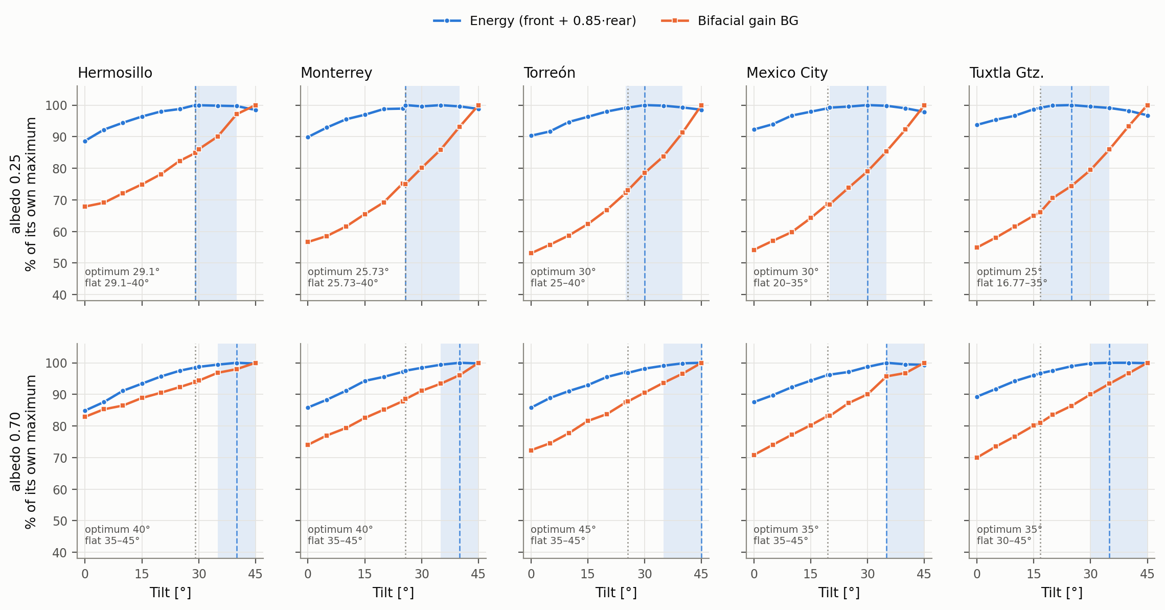
Fig. 6: Effective bifacial irradiance and bifacial gain as a function of tilt, each indexed to its own maximum.
The two follow different trajectories: energy presents an interior maximum and then decays, whereas gain increases up to the end of the range. Maximising bifacial gain costs between 1.2 % and 3.2 % of the annual energy at an albedo of 0.25. At an albedo of 0.70 the conflict practically disappears, with costs from 0.0 % to 0.7 %, because the increase in front-side collection with tilt shifts the energy optimum towards high angles. It follows that bifacial gain must be interpreted as an indicator of the split between sides and not as a design objective function.
4.6 Design criterion and practical rule
The energy optimum is not a point but a plateau, and expressing it as a band is more useful than as a single angle. A tolerance of 1 % on the energy maximum is adopted because it corresponds to the order of magnitude of the dispersion between identical runs reported in section 3.6: below that threshold the simulation does not distinguish between two tilts. For reference, in Torreón with an albedo of 0.25 a tolerance of 0.5 % would produce a band from 30° to 35°, that of 1 % produces it from 25° to 40°, and that of 5 % from 15° to 45°, at which point it would no longer discriminate.
Admitting the 1 % tolerance with respect to the maximum, the intersection of the five locations runs from 29.1° to 35° at an albedo of 0.25 and from 35° to 45° at an albedo of 0.70. This allows a single rule to be formulated: mount at 30° over a grey roof and at 40° over a cool roof, angles for which the worst case cost is 0.48 % and 0.49 % respectively, for latitudes between 16.8° and 29.1°.

Tab. 5: Energy optimum tilt, range within 1 % of the maximum and cost of applying the rule of tilt equal to latitude.
City | ρ | Optimum θ (°) | Range within 1 % (°) | Latitude within range | Cost of θ = (%)
Hermosillo | 0.25 | 29.1 | 29.1 – 40 | Yes | 0.00
Hermosillo | 0.70 | 40 | 35 – 45 | No | -1.48
Monterrey | 0.25 | 25.73 | 25.73 – 40 | Yes | 0.00
Monterrey | 0.70 | 40 | 35 – 45 | No | -2.51
Torreón | 0.25 | 30 | 25 – 40 | Yes | -0.81
Torreón | 0.70 | 45 | 35 – 45 | No | -3.20
Mexico City | 0.25 | 30 | 20 – 35 | No | -1.04
Mexico City | 0.70 | 35 | 35 – 45 | No | -3.86
Tuxtla Gutiérrez | 0.25 | 25 | 16.77 – 35 | Yes | -0.84
Tuxtla Gutiérrez | 0.70 | 35 | 30 – 45 | No | -3.33

Over a grey roof the classical rule remains acceptable: its cost does not exceed 1.04 % and in Hermosillo and Monterrey the optimum coincides exactly with latitude. Over a cool roof, by contrast, latitude falls outside the tolerance range in all five cities, with a cost of between 1.48 % and 3.86 %. Roof reflectance, and not latitude, is the variable that determines whether the criterion inherited from monofacial systems remains applicable. That trade-off can be expressed from the installer's standpoint by taking the latitude rule itself as reference (Fig. 7), which occupies the last row with a null value while the black box marks the energy optimum; the diverging scale is symmetric, so that the sparse use of the gain half-plane does not stem from the representation but from the result itself.
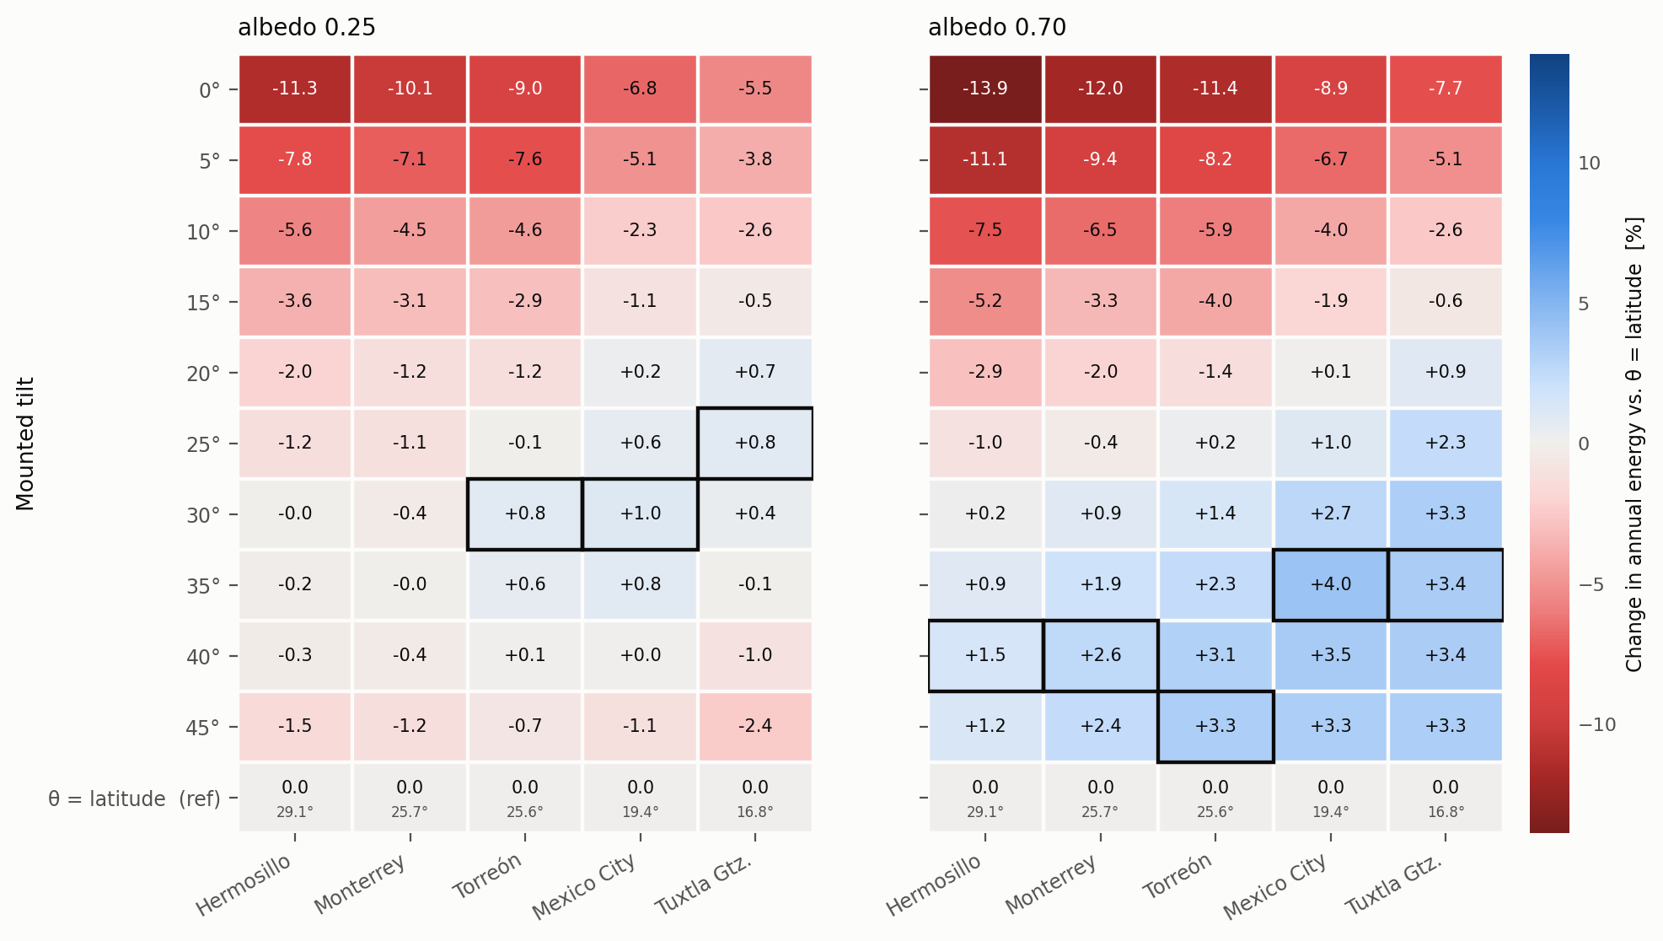
Fig. 7: Change in annual effective bifacial irradiance, front plus rear, when mounting the array at each tilt, with respect to the tilt equal to latitude.
The reading is asymmetric: the maximum improvement attainable with respect to the latitude rule is 4.0 %, whereas the maximum loss from an unsuitable tilt reaches 13.9 %. Getting the exact angle right contributes little; getting it wrong on the low side penalises considerably.

5. Conclusions
A campaign of 110 ray tracing simulations was carried out, characterising the bifacial irradiance available on Mexican rooftops across 12.3 degrees of latitude, eleven tilts and two roof reflectances representative of national construction practice. By resolving both sides separately, the same set of results also describes monofacial performance. The main conclusions are the following.
The advantage of bifacial over monofacial technology depends strongly on the mounting surface: between 13.4 % and 15.7 % over grey waterproofing, and between 35.4 % and 40.4 % over a reflective coating.
The type of technology and the type of surface are not independent measures, but rather reinforce one another in synergy. The reflective coating provides a monofacial system with between 1.4 % and 2.7 %, against 22.6 % to 23.9 % in a bifacial one: the benefit of increased roof reflectance is substantially enhanced when a rear irradiance collection surface is present. Any economic analysis treating both decisions as additive will underestimate the synergy.
Bifacial gain and collected energy become dissociated. The gain increases monotonically with tilt across the ten series evaluated, whereas energy presents an interior maximum; maximising the former costs up to 3.2 % of the latter over a grey roof. Bifacial gain must be used as an indicator of the split between sides and not as an objective function.
The energy optimum is a wide plateau, which allows a single design rule to be formulated: 30° over a grey roof and 40° over a reflective coating, valid for the five cities at a maximum cost of 0.49 % with respect to the individual optimum of each.
The standard rule for monofacial systems, tilt equal to latitude, remains valid over a grey roof, where its cost does not exceed 1.04 %, but ceases to be acceptable over a cool roof, with a cost of up to 3.86 % and latitude outside the tolerance range in all five cities.
The latitudinal dependence of bifacial gain exists but operates through the front side and not through the diffuse fraction of the resource, as evidenced by the comparison between Hermosillo and Torreón, of practically identical diffuse fraction and gains separated by more than four percentage points.
The results obtained in this research provide a better understanding of the behaviour of bifacial technology in distributed generation buildings, which can be used both for the implementation of improved installation strategies and practices and for the application of control systems and algorithms able to further optimise those results. Future work is directed towards incorporating a more complete characterisation of climate than the annual diffuse fraction, capable of removing the systematic structure observed in the residuals, and towards extending the campaign to multi-row configurations, where mutual shading introduces an interior optimum additional to the one analysed here.
6. Acknowledgment
To SECIHTI for the doctoral scholarship (CVU 1155773) that made this research possible, to the Instituto de Energías Renovables of UNAM for the research stay in which the methodological tools used here were acquired, and to the Instituto Tecnológico de La Laguna for the facilities provided for its development. We also gratefully acknowledge Green Power Solutions for their sponsorship and support.

7. References
ASCE, 2016. Minimum Design Loads and Associated Criteria for Buildings and Other Structures, ASCE/SEI 7-16. American Society of Civil Engineers, Reston, VA.
Ayala Pelaez, S., Deline, C., 2020. bifacial_radiance: a python package for modeling bifacial solar photovoltaic systems. Journal of Open Source Software 5, 1865. https://doi.org/10.21105/joss.01865
Ayala Pelaez, S., Deline, C., MacAlpine, S.M., Marion, B., Stein, J.S., Kostuk, R.K., 2019. Comparison of bifacial solar irradiance model predictions with field validation. IEEE Journal of Photovoltaics 9, 82–88. https://doi.org/10.1109/JPHOTOV.2018.2877000
Bhayat, M.H., Vaithilingam, C.A., Oruganti, K.S.P., Sivasubramanian, R., Ardhanari, J., 2023. Monofacial and bifacial photovoltaics systems with uniaxial solar tracking. Journal of Physics: Conference Series 2523, 012024. https://doi.org/10.1088/1742-6596/2523/1/012024
CFE, 2020. Manual de Diseño de Obras Civiles: Diseño por Viento. Comisión Federal de Electricidad, México.
Climate.OneBuilding.org, 2024. Repository of free climate data for building performance simulation. https://climate.onebuilding.org (accessed 18 August 2026).
Corso, R., Matera, F., Lombardo, S.A., 2023. Numerical evaluation of optimal tilt angle for energy production and minimum shadowing for bifacial solar modules, in: Conference Record of the IEEE Photovoltaic Specialists Conference. https://doi.org/10.1109/PVSC48320.2023.10359728
Cuevas, A., Luque, A., Eguren, J., del Alamo, J., 1982. 50 per cent more output power from an albedo-collecting flat panel using bifacial solar cells. Solar Energy 29, 419–420.
Comisión Nacional de Energía, 2025. Reporte semestral de generación distribuida, segundo semestre 2025. CNE, Ciudad de México.
Ernst, M., Conechado, G.E.J., Asselineau, C.-A., 2021. Accelerating the simulation of annual bifacial illumination of real photovoltaic systems with ray tracing. iScience 25, 103698. https://doi.org/10.1016/j.isci.2021.103698

Louw, J., Rix, A.J., 2020. Modelling and simulation of bifacial PV modules by implementing the ray tracing technique. Stellenbosch University.
Lucero-Álvarez, J., Martín-Domínguez, I.R., 2019. The effect of solar reflectance, infrared emissivity and thermal insulation of roofs on the annual energy consumption of single-family households in México. Indoor and Built Environment 28, 17–33. https://doi.org/10.1177/1420326X17729194
McIntosh, K.R., Abbott, M.D., Sudbury, B.A., 2022. The optimal tilt angle of monofacial and bifacial modules on single-axis trackers. IEEE Journal of Photovoltaics 12, 397–405. https://doi.org/10.1109/JPHOTOV.2021.3126115
Rosas-Flores, J.A., Zenón-Olvera, E., Gálvez, D.M., 2019. Potential energy saving in urban and rural households of Mexico with solar photovoltaic systems using geographical information system. Renewable and Sustainable Energy Reviews 116, 109412. https://doi.org/10.1016/j.rser.2019.109412
Stein, J.S., Riley, D., Lave, M., Hansen, C., Deline, C., Toor, F., 2021. Bifacial Photovoltaic Modules and Systems: Experience and Results from International Research and Pilot Applications. IEA-PVPS Task 13, Report T13-14:2021. International Energy Agency, Paris.
Sun, X., Khan, M.R., Deline, C., Alam, M.A., 2018. Optimization and performance of bifacial solar modules: A global perspective. Applied Energy 212, 1601–1610. https://doi.org/10.1016/j.apenergy.2017.12.041
Valdivia, C.E., Li, C.T., Russell, A., Haysom, J.E., Li, R., Lekx, D., Sepeher, M.M., Henes, K., Hinzer, K., Schriemer, H., 2017. Bifacial photovoltaic module energy yield calculation and analysis, in: IEEE Photovoltaic Specialists Conference.
Ward, G.J., 1994. The RADIANCE lighting simulation and rendering system, in: Proceedings of SIGGRAPH ’94, pp. 459–472. https://doi.org/10.1145/192161.192286

