Development of mesh-free simulation tool for the optimization of microscopic composite structure

Ryo Higuchi¹, Tomohiro Yokozeki², Tomonaga Okabe³, Toshio Nagashima⁴ and Takahira Aoki⁵

¹Department of Aeronautics and Astronautics, The University of Tokyo, 7-3-1 Hongo, Bunkyo-ku, Tokyo, 113-8656 Japan, Email: higuchi@aastr.t.u-tokyo.ac.jp
²Department of Aeronautics and Astronautics, The University of Tokyo, 7-3-1 Hongo, Bunkyo-ku, Tokyo, 113-8656 Japan, Email: yokozeki@aastr.t.u-tokyo.ac.jp
³ Department of Aerospace Engineering, Tohoku University, 6-6-01, Aoba-yama, Aoba-ku, Sendai, Miyagi, 980-8579 Japan, Email: okabe@plum.mech.tohoku.ac.jp
⁴ Department of Engineering and Applied Sciences, Faculty of Science and Technology, Sophia University, 7-1, Kioicho, Chiyoda-ku, Tokyo, 102-8554 Japan, Email: nagashim@sophia.ac.jp
⁵Department of Aeronautics and Astronautics, The University of Tokyo, 7-3-1 Hongo, Bunkyo-ku, Tokyo, 113-8656 Japan, Email: aoki@aastr.t.u-tokyo.ac.jp

Keywords: Composite, Fiber shape, XFEM, Homogenization method

Abstract
Recently, freedom in design of composite microstructure has been improved due to the development of the manufacturing technology of various shapes and diameters of carbon fibers. In other words, numerous candidates of composite microstructure should be considered toward a microscopic optimization of composite. To this end, two kinds of computational techniques were introduced in this study; homogenization method using key degree of freedom (DoF), and extended finite element method (XFEM). In order to evaluate an effect of microstructure on the macroscopic mechanical and fracture properties, homogenization method was introduced. Here, the key DoF method was utilized to simply handle the periodic boundary conditions. Additionally, the composite microstructure (fiber/ matrix interface) can be modeled independently of the mesh by the XFEM. This makes it possible to conduct comprehensive numerical investigation into various microstructures without remeshing.

1. Introduction

In recent years, the application range of carbon fiber reinforced plastic (CFRP) in the aerospace field is expanding since they are lightweight and have excellent mechanical properties. However, improvement of the transverse mechanical and fracture characteristics of CFRP is still challenging problem. Although the failure strain under longitudinal tension has been increasing in recent decades, the failure strain under transverse tension hasn't been improved. As a result, even in a laminate which is commonly used in the airplane structure, matrix cracking in the off-axis layers is the initial damage. This triggers following damages such as delamination and fiber breakage and finally contributes to ultimate failure of the whole laminate. Therefore, an improvement of the transverse performance of each ply is required to increase the overall performance of laminates.

CFRP is a microscopic heterogeneous material composed of fibers and matrix. For this reason, it is well known that the transverse strength depends not only on the matrix properties but also on the microscopic structure characterized by fiber cross-sectional shape, fiber volume fraction, and so on. The essential question in this study is whether or not the existing fiber shape (i.e., circular) is optimal from the aspect of mechanical and fracture properties of composite. Thus, the authors believe that microscopic optimization of composite is going to be required in near future.
In recent 30 years, the manufacturing technology of carbon fibers has been developed. Nowadays, carbon fibers of various cross-sectional shapes can be manufactured [1]. From the 2000s, a lot of authors have revealed that fiber shape (C-shaped [2], kidney [3], triangle [4]) affects the mechanical and fracture properties of composite from the experimental approach.

More recently, a few numerical studies have been conducted on the effects of fiber cross section on the composite performance by using computational micromechanics [5]. This method combines the finite element method (FEM) with the homogenization method [6] and performs the numerical simulation of representative volume element of composite microstructure. This is the powerful tool to numerically investigate the composite performance from the micromechanical characteristics. However, this method still needs an improvement of computational efficiency for the microscopic optimization of composite where various composite microstructures need to be investigated comprehensively. The problem is the difficulty to treat the discontinuous field (fiber/matrix interface, crack, and void) in the numerical model. In FEM model, the edge of discontinuous field needs to be aligned with element edge since the discontinuity is not able to be defined within one element. Therefore, remeshing and redefinition of boundary conditions are essential when the composite microstructure is changed.

This study establishes the mesh-free microscopic simulation tool based on the extended finite element method (XFEM) [7, 8] for the improvement of efficiency of the conventional computational micromechanics. In the XFEM, discontinuity is able to be handle within one element by an enrichment of conventional shape function and the introduction of additional degree of freedoms (DoFs). These additional DoFs are introduced to construct enrichment function and are called as enriched DoFs. Although the XFEM was firstly proposed for the strong (displacement) discontinuity problem regarding cracks, this method can be applied to the weak (strain) discontinuity problem such as material interface [9-11]. To model the material interface independently of the element makes us possible to conduct the comprehensive numerical investigation of various kinds of composite microstructure without the remeshing and redefinition of the boundary conditions.

In this paper, the details of the proposed tool are described in Section 2. The proposed tool is verified in Section 3 by comparing results with FEM and experiment. In Section 4, the effect of fiber shape on macroscopic mechanical property is numerically investigated. Finally, the conclusions are presented in Section 5.

2. Numerical method

2.1. Quasi-three-dimensional XFEM for weak discontinuity

The proposed simulation tool is based on the quasi-3D XFEM developed by Nagashima and Sawada [12]. Figure 1 presents schematic diagrams of quasi-3D interface modeling. The base surface is divided using a three-node triangular element. An arbitrarily shaped interface on the base surface is defined using multiple line segments and is implicitly modeled by the level-set method. The level-set method utilizes the sign distance function (SDF) $φ$. The SDF $φ$ is defined as follows:
$φ\left(x\right)=\underset{\bar{x}∈Γ}{\text{min}}\left\|x−\bar{x}\right\|\text{sign}\left(n^{+}\left(\bar{x}\right)⋅\left(x−\bar{x}\right)\right)$, | (1)
where $n^{+}$ is the normal vector upward from the interface line $Γ$. Based on the SDF, all elements are then classified into normal and cut elements. The detailed classification procedure is given in Ref. [12]. Extruding these triangular elements in the fiber direction produces two kinds of six-node pentahedral elements, as depicted in Fig. 1.

In the cut element, the approximated displacement field $u^{h}$ at arbitrary position $x$, $r_{3}$ near the 3D interface is expressed as
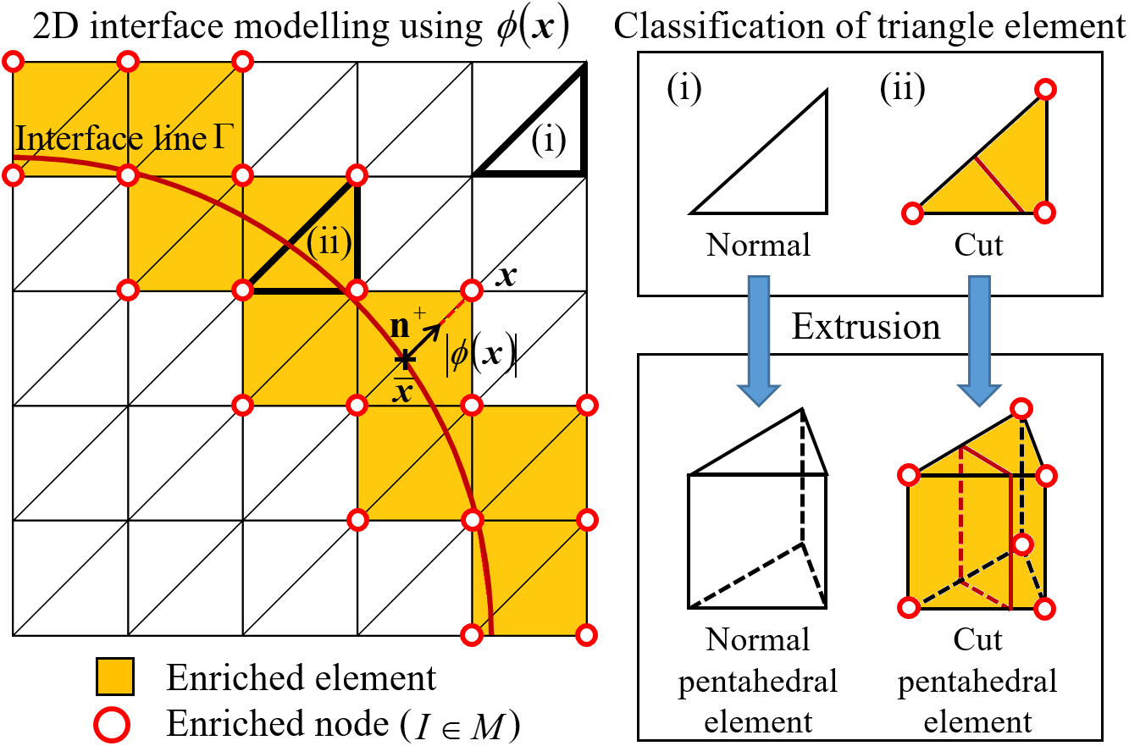

Figure 1. Interface modelling by quasi-3D XFEM.

$$u^{h}\left(x,r_{3}\right)=\sum_{I=1}^{3}{L_{I}\left(x\right)\left(N_{B}\left(r_{3}\right)u_{I}+N_{T}\left(r_{3}\right)u_{I+3}\right)}+\sum_{I=1}^{3}{L_{I}}\left(x\right)f\left(x\right)\left(N_{B}\left(r_{3}\right)a_{I}+N_{T}\left(r_{3}\right)a_{I+3}\right)$$  with: $\bar{φ}\left(x\right)=\sum_{I=1}^{3}{L_{I}φ_{I}}$, $N_{B}\left(r_{3}\right)=\frac{1−r_{3}}{2}$, $N_{T}\left(r_{3}\right)=\frac{1+r_{3}}{2}$, | (2)
where, $L_{I}$ is the area coordinate of the triangle, $u^{I}$ and $a^{I}$ are nodal degrees of freedom assigned to each node, and $F\left(x\right)$ is the ramp function, defined as follows [11].
$F\left(x\right)=\sum_{I=1}^{3}{\left|φ_{I}\right|L_{I}\left(x\right)}−\left|\sum_{I=1}^{3}{φ_{I}L_{I}\left(x\right)}\right|$. | (3)

2.2. Homogenization method using key degree of freedom

This study considers the periodic unit cell (PUC) with single fiber. For the convenience of explanation of the periodic boundary conditions imposed on the PUC, the faces, edges, and vertices having periodicity are named as Faces (X1)-(Z2), Edges (x1)-(z4), Vertices (A)-(H) as shown in Fig. 2. In order to avoid overlapping of periodic boundary conditions, Vertices (A)-(H) are not included in Edges (x1)-(z4), and Edges (x1)-(z4), Vertices (A)-(H) are not included in the Faces (X1)-(Z2).

The displacement $u_{i}$ at the arbitrary point $x_{i}$ in the PUC is expressed by using macroscopic strain $E_{\text{ij}}^{\left(\text{macro}\right)}$ and microscopic perturbed displacement $u_{i}^{\left(\text{per}\right)}$ as follows:
$u_{i}\left(x_{i}\right)=E_{\text{ij}}^{\left(\text{macro}\right)}x_{j}+u_{i}^{\left(\text{per}\right)}\left(x_{i}\right)$. | (4)
Here, let us consider the periodic boundary condition between the Faces (X1)-(X2) as an example. Between the corresponding nodes on the Faces (X1) and (X2), the microscopic perturbed displacements satisfy the following periodic condition.
$u_{i}^{\left(\text{per}\right)}|_{\text{X1}}=u_{i}^{\left(\text{per}\right)}|_{\text{X2}}$. | (5)
By substituting Eq. (5) into Eq. (4), the following periodic boundary conditions are obtained.
$u_{1}|_{\text{X1}}−u_{1}|_{\text{X2}}=2{\text{aE}}_{\text{11}}^{\left(\text{macro}\right)}, u_{2}|_{\text{X1}}−u_{2}|_{\text{X2}}=2{\text{aE}}_{\text{12}}^{\left(\text{macro}\right)}, u_{3}|_{\text{X1}}−u_{3}|_{\text{X2}}=2{\text{aE}}_{\text{13}}^{\left(\text{macro}\right)}$. | (6)
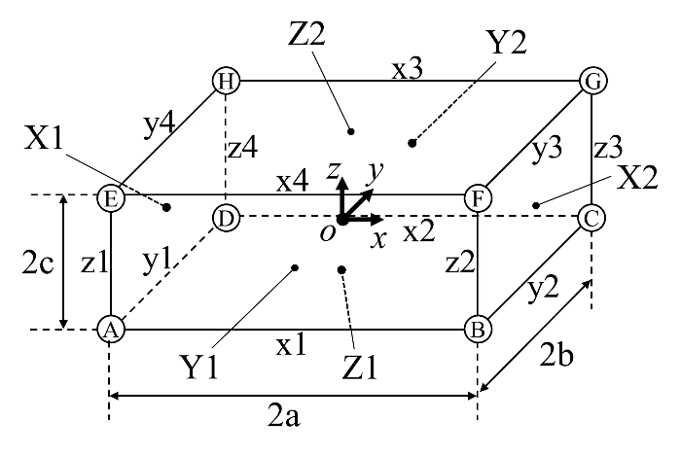

Figure 2. Definition of faces, edges and corners of unit cell.

It should be noted that the following periodic boundary conditions need to be imposed between enriched DoFs when the enriched node is included in the Faces (X1) and (X2).
$a_{1}|_{\text{X1}}−a_{1}|_{\text{X2}}=0, a_{2}|_{\text{X1}}−a_{2}|_{\text{X2}}=0, a_{3}|_{\text{X1}}−a_{3}|_{\text{X2}}=0$. | (7)
The other periodic boundary conditions can be obtained by the similar way.

Then, we introduce the key DoF method [13] to impose the periodic boundary conditions. In addition to the DoFs belonging to the mesh of simulation model, another independent DoFs are introduced in the model. These DoFs are called as key DoFs and are regarded to be equivalent to macroscopic strain components as follows:
$d_{1}^{\text{key}}=E_{\text{11}}^{\left(\text{macro}\right)}, d_{2}^{\text{key}}=E_{\text{22}}^{\left(\text{macro}\right)}, d_{3}^{\text{key}}=E_{\text{33}}^{\left(\text{macro}\right)}, d_{4}^{\text{key}}=2E_{\text{12}}^{\left(\text{macro}\right)}, d_{5}^{\text{key}}=2E_{\text{23}}^{\left(\text{macro}\right)}, d_{6}^{\text{key}}=2E_{\text{13}}^{\left(\text{macro}\right)}$. | (8)
By introducing Eq. (8) to the multi-point constraint (MPC) equations (Eqs. (6) and (7)), the period boundary conditions are controlled by using these key DoFs. For instance, MPC in 1-direction between the Faces (X1) and (X2) is as follows.
$u_{1}|_{A}−u_{1}|_{G}=2{\text{ad}}_{1}^{\text{key}}$. | (9)
The relations between the nodal forces $f_{i}^{\text{key}}$ at the key DoF and the macroscopic stress components $Σ_{\text{ij}}$ are given by the following equations.
$f_{1}^{\text{key}}=\left|A\right|Σ_{\text{11}}, f_{2}^{\text{key}}=\left|A\right|Σ_{\text{22}}, f_{3}^{\text{key}}=\left|A\right|Σ_{\text{33}}, f_{4}^{\text{key}}=\left|A\right|Σ_{\text{12}}, f_{5}^{\text{key}}=\left|A\right|Σ_{\text{23}}, f_{6}^{\text{key}}=\left|A\right|Σ_{\text{13}}$. | (10)
where, A is the area where the loading is subjected.

3. Verification - PUC analysis of CFRP with single circular fiber

To verify the methodologies of PUC simulation using XFEM (hereinafter XFEM-PUC), the homogenized analysis is conducted on the PUC of CFRP with single circular fiber. The material of T800S/3900-2B (Toray), the volume fraction of 55% [14], and the diameter of 5μm [15] are used. The mechanical properties of fiber and resin used in the simulation are summarized in Table 1 [15-17].

In order to examine the mesh dependency of the XFEM-PUC simulation, four kinds of meshes are prepared by dividing edge of PUC into 10, 50, 100, 500. For comparison, the FEM-PUC model is also prepared by dividing edge of PUC into 500. And the predicted homogenized elastic moduluses from XFEM-PUC are compared with both of FEM-PUC and experiment.
Table 1. Mechanical properties of T800S/3900-2B used in PUC analysis [15-17].

Fiber longitudinal Young's modulus $E_{L}^{f}$ | 294 GPa [15]
Fiber transverse Young's modulus $E_{T}^{f}$ | 19.5 GPa [16]
Fiber longitudinal Poisson's ratio $ν_{L}^{f}$ | 0.17 [16]
Fiber transverse Poisson's ratio $ν_{T}^{f}$ | 0.46 [16]
Fiber longitudinal shear modulus $G_{L}^{f}$ | 27 GPa [17]
Fiber transverse shear modulus $G_{T}^{f}$ | 27 GPa*
Matrix Young's modulus $E^{m}$ | 3.2 GPa [16]
Matrix Poisson's ratio $ν^{m}$ | 0.38 [16]
* Assumed as $G_{T}^{f}=G_{L}^{f}$.

The results of mesh convergence study of homogenized elastic modulus are summarized in Fig 3. In this figure, the vertical axis indicates the error between XFEM-PUC and FEM-PUC, and the horizontal axis indicates non-dimensional number defined as mesh size divided by fiber diameter. As shown in Fig. 3, in the case of a coarse mesh, the error of Young's modulus and Poisson's ratio in the transverse direction are particularly large. This is caused by approximation error of the cross-sectional shape of fiber. Although the XFEM can model the material interface independent of the mesh, the shape of interface is modelled as plane in one element. In other words, circular fibers are approximated by polygonal column. Therefore, if the elements are large, the approximation accuracy of the shape and the prediction accuracy of the elastic modulus in the transverse direction deteriorates. On the other hand, when the element length was set to 2% or less of the fiber diameter, the error converged to less than 0.1% in all elastic constants.

Based on the convergence study, the results obtained by XFEM-PUC (100×100) are compared with experiment [14] in Table 2. As shown in Table 2, the predicted values roughly match the experimental values. One reason of this error is volume fraction. The interface between each layer of T800S/3900-2B is toughened by thermoplastic particles. Due to these thermoplastic particles, fiber volume fraction around the interface is lower than the other region. As a result, the fiber volume fraction of whole of laminate becomes lower than the measured value. In fact, XFEM-PUC analysis with $V_{f}=\text{52}\text{\%}$ resulted in more accurate prediction in terms of longitudinal Young's modulus (see Table 2). On the other hand, the Poisson's ratio and the shear modulus in the longitudinal direction deviate from the experiment even in the case of $V_{f}=\text{52}\text{\%}$. This is probably because the measured values $ν_{L}^{f}$ and $G_{L}^{f}$ include measurement error since difficulty of measurement.

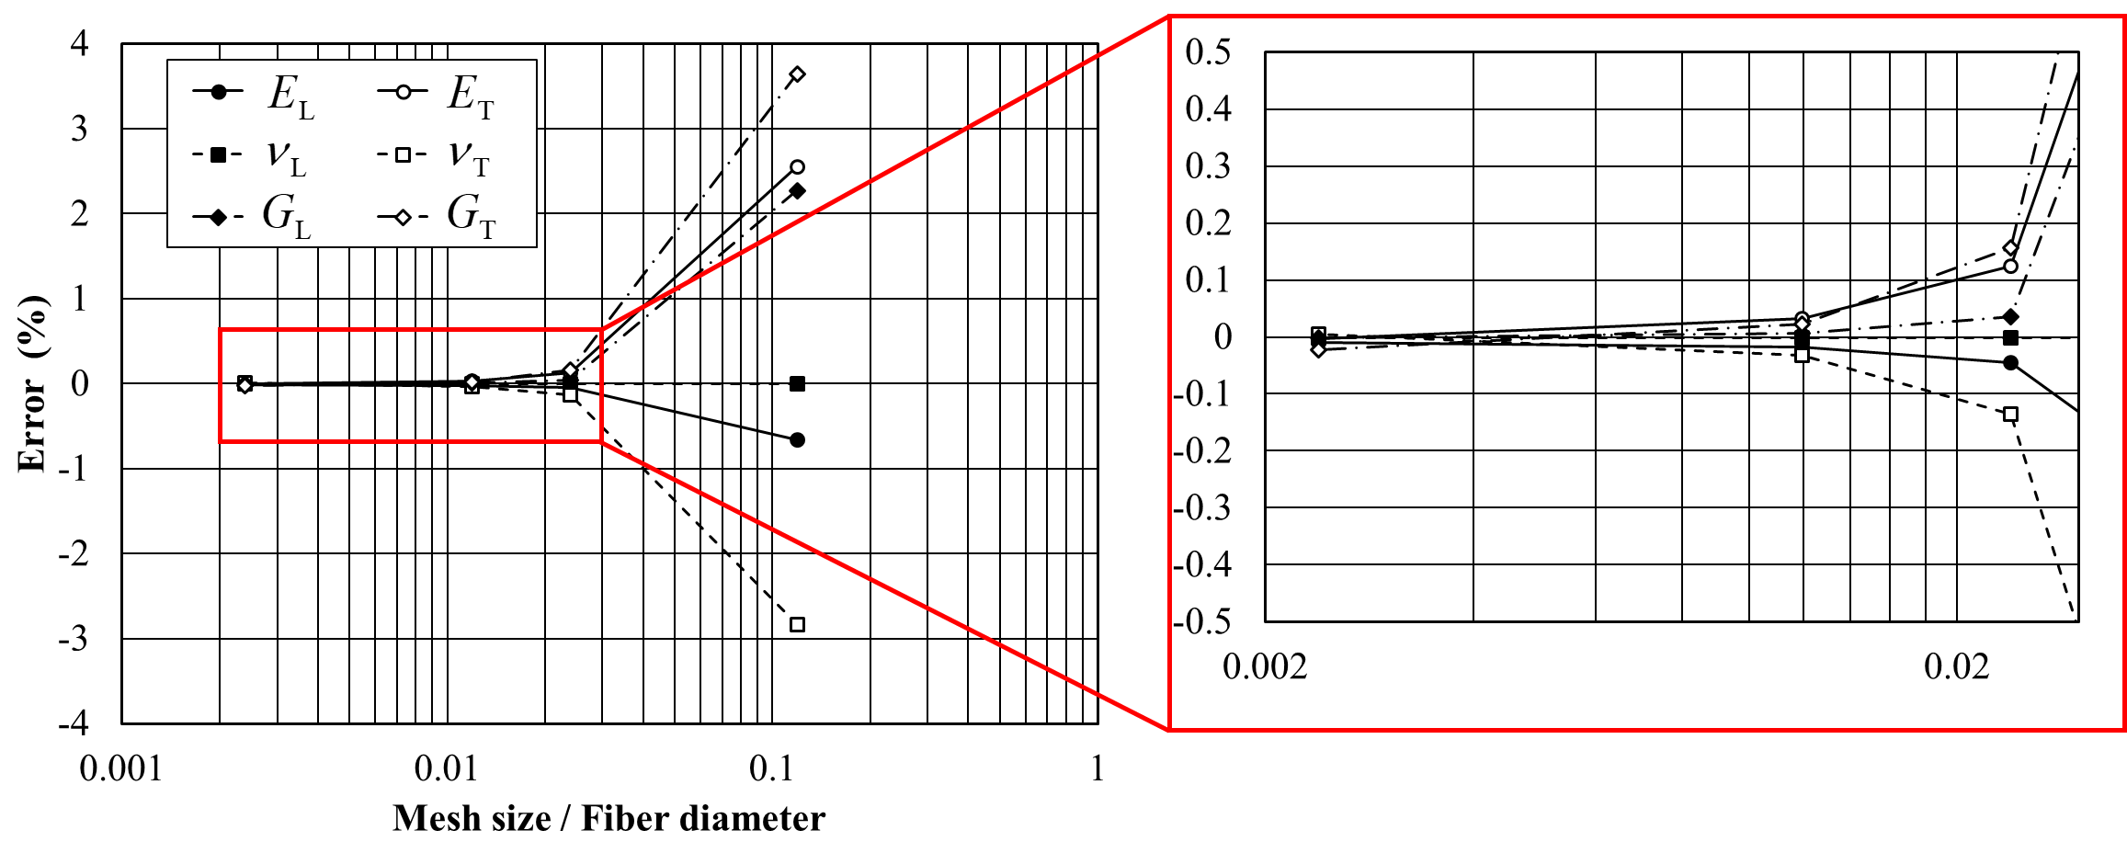

Figure 3. Mesh convergence study of homogenized elastic modulus.
Table 2. Comparison of macroscopic mechanical properties between experiment and 3D PUC simulations.

 | Experiment [14] | Simulation$V_{f}=\text{55}\text{\%}$ | Simulation $V_{f}=\text{52}\text{\%}$
$E_{L}$(GPa) | 153 | 163 (6.47) | 154 (0.65)
$E_{T}$(GPa) | 8.00 | 8.82 (10.3) | 8.39 (4.82)
$$ν_{L}$$ | 0.34 | 0.256 (-24.7) | 0.262 (-22.8)
$$ν_{T}$$ | 0.45-0.5* | 0.475 (---) | 0.482 (---)
$G_{L}$(GPa) | 4.03 | 3.17 (-21.4) | 3.12 (-22.7)
$G_{T}$(GPa) | 2.67-2.76** | 3.09 (---) | 3.04 (---)
* Typical value of CFRP.
** Calculated by$G_{T}=E_{T}/\left\{2\left(1+ν_{T}\right)\right\}$.

4. Application - PUC analysis of CFRP with single non-circular fiber

In this section, the PUC simulations of CFRP consisting of carbon fibers with various cross-sectional shapes (circular, elliptical, and 2-lobed) are conducted to investigate their effect on the macroscopic mechanical properties. The PUCs of each cross-sectional shape are shown in Fig. 4. Here, volume fraction of 40% is assumed.

Homogenized mechanical properties of CFEPs with different fiber shapes were compared with Mori-Tanaka theory [18] in Table 3. As seen in Table 3, elliptical and 2-lobed CFRPs resulted in fully orthotropic while circular CFRP resulted in transverse isotropic. In the former cases, Young's modulus and shear modulus in the major radius direction are larger than the latter case. However, Poisson's ratio in the major radius direction became smaller. These tendencies are similar with the results from Mori-Tanaka theory.

Analytical model including MT theory is not able to be applied to complicated fiber shape such as 2-lobed shape. Although conventional FEM has the capability to treat complicated fiber shape, element edge should be aligned with fiber shape. On the other hand, fiber shape can be modeled independently of the element in the proposed XFEM-based simulation tool. In fact, all calculations listed in Table 3 were conducted by using the same mesh. Consequently, we can conclude that the proposed tool has enough prediction accuracy and is more versatile than analytical model and conventional FEM.

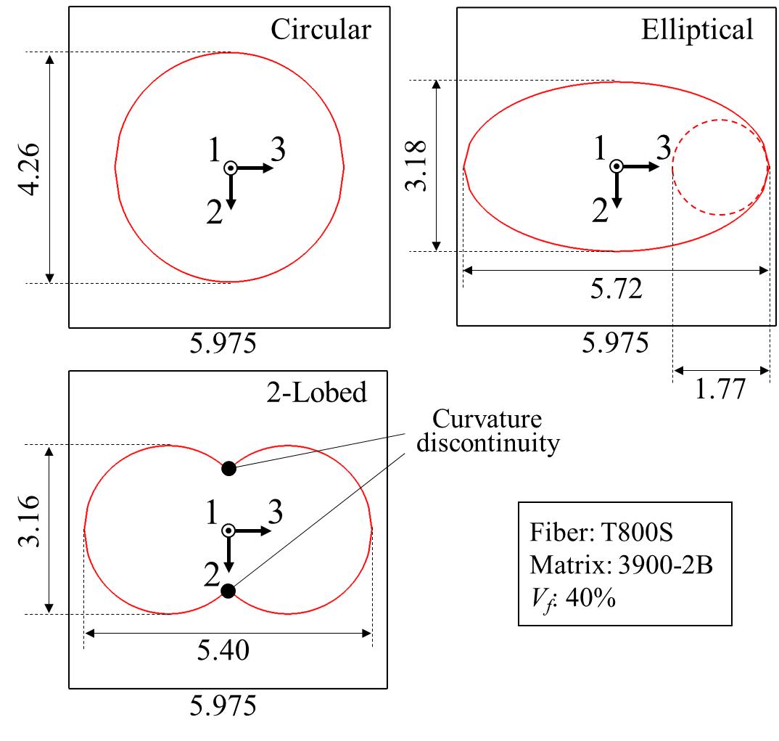

Figure 4. Schematics of PUCs with different fiber shape.
Table 3. Comparison of macroscopic mechanical properties of CFRP with different fiber shapes between 3D PUC simulation and MT theory.

 | Circular |  | Elliptical |  | 2-Lobed
 | 3D PUC | MT theory | 3D PUC | MT theory | 3D PUC
Longitudinal Young's modulus $E_{\text{11}}$ | 119 GPa | 120 GPa | 119 GPa | 120 GPa | 119 GPa
Transverse Young's modulus $E_{\text{22}}$ | 6.76 GPa | 6.16 GPa | 6.60 GPa | 6.06 GPa | 6.63 GPa
Transverse Young's modulus $E_{\text{33}}$ | 6.76 GPa | 6.16 GPa | 8.18 GPa | 6.44 GPa | 7.90 GPa
Longitudinal Poisson's ratio $ν_{\text{12}}$ | 0.288 | 0.288 | 0.325 | 0.301 | 0.319
Transverse Poisson's ratio $ν_{\text{23}}$ | 0.515 | 0.559 | 0.437 | 0.537 | 0.449
Longitudinal Poisson's ratio $ν_{\text{13}}$ | 0.288 | 0.288 | 0.246 | 0.274 | 0.253
Longitudinal shear modulus $G_{\text{12}}$ | 2.91 GPa | 1.45 GPa | 2.84 GPa | 1.44 GPa | 2.85 GPa
Transverse Poisson's ratio $G_{\text{23}}$ | 2.84 GPa | 1.45 GPa | 2.83 GPa | 1.47 GPa | 2.83 GPa
Longitudinal shear modulus $G_{\text{13}}$ | 2.91 GPa | 1.45 GPa | 2.99 GPa | 1.44 GPa | 2.98 GPa

5. Conclusions

This study developed a mesh-free microscopic simulation tool toward the optimization of composite microstructure considering the enormous candidates of microstructure. The proposed tool combines XFEM and homogenization method for the improvement of versatility and efficiency of computational micromechanics. The prediction capability regarding mechanical properties were examined through comparison with FEM and experimental results. As an application example, the PUC analysis of CFRPs with different cross-sectional shapes of carbon fibers was carried out. All calculations PUC analysis of CFRPs with different fiber shapes were conducted by using the same mesh. In the elliptical shape and the two-lobed shape, the mechanical properties in the direction of major radius are improved with respect to that of circular shape. These results are consistent with the Mori-Tanaka theory. Consequently, the proposed tool was successfully verified in terms of prediction accuracy and versatility. In this paper, only the mechanical properties were investigated. In the future work, it is necessary to verify the fracture properties considering the plasticity and damage in the resin.

Acknowledgments

This study was partially supported by the Japan Society for the Promotion of Science (JSPS) KAKENHI (Grant Number 18K13921).

References

- Y. Liu, and S. Kumar. Recent progress in fabrication, structure, and properties of carbon fibers. Polymer Reviews, 52 (3): 234-258, 2012.
- S.-J. Park, M.-K. Seo, and H.-B. Shim. Effect of fiber shapes on physical characteristics of non-circular carbon fibers-reinforced composites. Materials Science and Engineering: A, 352 (1-2): 34-39, 2003.
- Z. Xu, J. Li, X. Wu, Y. Huang, L. Chen, and G. Zhang. Effect of kidney type and circular cross sections on carbon fiber surface and composite interface. Composites Part A: Applied Science and Manufacturing, 39 (2): 301-307, 2008.
- X. Liu, R. Wang, Z. Wu, and W. Liu. The eﬀect of triangle-shape carbon ﬁber on the ﬂexural properties of the carbon ﬁber reinforced plastics. Materials Letters, 73: 21–23, 2012.
- M. Herráez, C. González, C. Lopes, R. G. de Villoria, J. LLorca, T. Varela, and J. Sánchez. Computational micromechanics evaluation of the eﬀect of ﬁbre shape on the transverse strength of unidirectional composites: An approach to virtual materials design. Composites Part A: Applied Science and Manufacturing, 91: 484–492, 2016.
- E. Sánchez-Palencia. Non-homogeneous media and vibration theory. Lecture notes in physics 127, 1980.
- T. Belytschko, and T. Black. Elastic crack growth in ﬁnite elements with minimal remeshing. International Journal for Numerical Methods in Engineering, 45 (5): 605–620, 1999.
- N. Moës, J. Dolbow, and T. Belytschko. A ﬁnite element method for crack growth without remeshing. International Journal for Numerical Methods in Engineering, 46 (1): 131–150, 1999.
- N. Sukumar, D. Chopp, N. Moës, and T. Belytschko. Modeling holes and inclusions by level sets in the extended ﬁnite-element method. Computer Methods in Applied Mechanics and Engineering, 190 (46-47): 6183–6200, 2001.
- T. Belytschko, C. Parimi, N. Moës, N. Sukumar, and S. Usui, Structured extended ﬁnite element methods for solids deﬁned by implicit surfaces. International Journal for Numerical Methods in Engineering, 56 (4): 609–635, 2002.
- N. Moës, M. Cloirec, P. Cartraud, and J.-F. Remacle. A computational approach to handle complex microstructure geometries. Computer Methods in Applied Mechanics and Engineering, 192 (28-30): 3163–3177, 2003.
- T. Nagashima, and M. Sawada. Development of a damage propagation analysis system based on level set XFEM using the cohesive zone model. Computers & Structures, 174: 42–53, 2016.
- S. Li, N. Warrior, Z. Zou, and F. Almaskari. A unit cell for FE analysis of materials with the microstructure of a staggered pattern. Composites Part A: Applied Science and Manufacturing, 42 (7): 801–811, 2011.
- T. Morimoto, S. Sugimoto, H. Katoh, E. Hara, T. Yasuoka, Y. Iwahori, T. Ogasawara, and S. Ito. JAXA advanced composites database, JAXA research and development memorandum, Technical report, JAXA-RM-14-004, ISSN 1349-1121, 2015 (in Japanese).
- Toray Carbon Fibers America, T800S Data Sheet, 2003.
- K. Yoshioka, Y. Kumagai, R. Higuchi, D. Lee, and T. Okabe. Multiscale modeling of failure strain in oﬀ-axis tensile testing of UD-CFRP, Material System, 34: 7–13, 2016 (in Japanese).
- F. Tanaka. The Effect of Nanostructure upon the Mechanical Properties of Carbon Fibres. Ph. D. thesis, Tohoku University, 2014.
- T. Mori, and K. Tanaka. Average stress in matrix and average elastic energy of materials with misﬁtting inclusions. Acta Metallurgica, 21 (5): 571–574, 1973.

