EuroSun2026
FULL-SPECTRUM SOLAR ENERGY UTILIZATION FOR HIGH-EFFICIENCY HYDROGEN PRODUCTION

Yu Tian (corresponding author), Gan Huang
Affiliations: Institute of Microstructure Technology, Karlsruhe Institute of Technology, Hermann-von-Helmholtz-Platz 1, 76344 Eggenstein-Leopoldshafen, Germany.
Email(s): yu.tian@kit.edu
Summary
This study evaluates the technical and economic performance of a spectral-splitting photovoltaic-thermal hydrogen (SSPVTH) system across ten European cities: Helsinki, Copenhagen, London, Paris, Vienna, Bucharest, Lisbon, Madrid, Rome, and Athens. Hourly typical meteorological year (TMY) data from the PVGIS-ERA5 database were used to represent the direct normal irradiance and ambient temperature at each location. Dual axis and single axis tracking configurations were compared using a coupled optical, thermal, electrical, and electrochemical model. Annual hydrogen production, solar-to-hydrogen efficiency, levelized cost of hydrogen, and discounted payback time were evaluated. Under dual axis tracking, annual normalized hydrogen production ranged from 5.0 kg H₂ m⁻² year⁻¹ in London to 11.2 kg H₂ m⁻² year⁻¹ in Madrid. The corresponding annual HHV-based solar-to-hydrogen efficiency ranged from 18.1% to 19.5%. Dual axis tracking increased annual hydrogen production by 31.3–45.0% relative to single axis tracking and achieved a lower levelized cost of hydrogen in every city. The lowest levelized cost was 6.9 EUR kg⁻¹ H₂ in Madrid, where the hydrogen-sales-only payback time was 6.6 years. Including oxygen-sales revenue further reduced the payback time to 5.8 years. The results identify high-DNI southern European locations combined with dual axis tracking as the most favourable conditions for efficient and economically competitive solar hydrogen production.
Keywords: solar hydrogen, spectral splitting, photovoltaic–thermal system, levelized cost of hydrogen
Field of application for the findings: Electrical Energy Storage & Hydrogen
Addressed audience: Researchers and engineers in solar energy systems and techno-economic assessment of renewable hydrogen technologies
- Introduction
The Hydrogen produced using renewable electricity is expected to play an important role in the decarbonisation of hard-to-electrify industrial sectors and long-duration energy storage (Li et al., 2023). Solar-driven hydrogen production is particularly attractive because solar energy is abundant, broadly distributed, and can be converted directly into electricity and heat (Herrando et al., 2023; Huang et al., 2021). Conventional photovoltaic-electrolysis (PV-EC) systems, however, do not fully utilise the incident solar spectrum. Photons with energies below the photovoltaic bandgap cannot be converted into electricity and are mainly dissipated as heat, while excess energy of above-bandgap photons is lost through thermalisation (Huang et al., 2021a, 2021b, Polito et al., 2025). These spectral losses limit the solar-to-hydrogen (STH) efficiency and motivate integrated approaches that utilise both electrical and thermal solar energy (Curcio, 2025; Grube et al., 2020).
Spectral-splitting photovoltaic-thermal hydrogen (SSPVTH) systems provide one such full-spectrum solar-energy-utilisation pathway (Tian et al., 2025). In this configuration, a concentrating optical system directs solar radiation to a spectral-selective filter. The short-wavelength portion of the spectrum is transmitted to a photovoltaic-thermal (PVT) receiver to generate electricity, whereas the long-wavelength portion is directed to a thermal absorber. The electrical output supplies the electrolyzer, while the recovered thermal energy raises the electrolyte temperature and thereby reduces electrochemical losses (Hadikhani et al., 2021; Hashemi et al., 2019). By thermally decoupling the photovoltaic and electrolyzer subsystems, the PV receiver can remain within a favourable operating-temperature range while the electrolyzer benefits from elevated-temperature operation. This combined optical, thermal, electrical, and electrochemical integration offers a route towards higher STH efficiency than conventional PV-EC systems. The concept and integrated energy-flow pathway of the SSPVTH system are illustrated in Fig. 1.
The performance of concentrating solar hydrogen systems is intrinsically location dependent. Direct normal irradiance (DNI), ambient temperature, seasonal daylight duration, and solar geometry influence the available solar energy, photovoltaic operating conditions, thermal output, and tracking losses (Mostafaeipour et al., 2020; Peacock et al., 2022). These factors can alter not only annual hydrogen yield but also its seasonal distribution, which subsequently affects the economic feasibility of a project. In particular, the benefit of dual axis tracking relative to single axis tracking depends on the local solar path and the corresponding incidence-angle losses. Although dual axis tracking generally increases the capital cost, its enhanced collection of direct irradiance may increase annual hydrogen production sufficiently to reduce the levelized cost of hydrogen (LCOH) and shorten the discounted payback time (PBT).
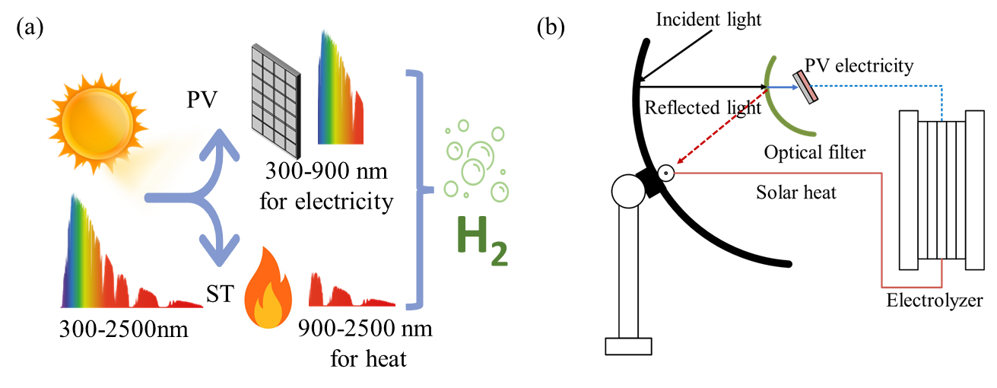
Fig. 1: Concept of full-spectrum solar energy utilization in the SSPVTH system. (a) Spectral-splitting configuration, in which short-wavelength photons are directed to the photovoltaic receiver and long-wavelength photons to the thermal absorber for high-temperature electrolysis. (b) Integrated SSPVTH system layout.
Previous work by the authors established and validated the coupled modelling framework for the SSPVTH concept, including the spectral-splitting optical configuration, thermal management, high-temperature membrane-less alkaline electrolysis (Tian et al., 2025). The present study extends this system-level analysis from a small number of representative climate zones to a Europe-wide comparison based on hourly typical meteorological year (TMY) data. Rather than reproducing the component-level physical model, the objective here is to investigate how the same SSPVTH system performs across the substantial solar-resource gradient within Europe.
Accordingly, annual simulations are performed for ten European cities spanning northern, central, western, southern, and southeastern climatic regions: Helsinki, Copenhagen, London, Paris, Vienna, Bucharest, Lisbon, Madrid, Rome, and Athens. For each city, 8760-hour DNI and ambient-temperature profiles from the PVGIS-ERA5 database are applied to evaluate dual axis and single axis tracking configurations. The resulting annual normalized hydrogen production and STH efficiency are compared, followed by an economic assessment based on LCOH and discounted PBT under hydrogen-only and hydrogen-plus-oxygen revenue scenarios. The analysis identifies the climatic conditions under which full-spectrum SSPVTH systems can provide the greatest technical and economic value in the European context.
- Methodology
This study combines hourly climate-resolved performance simulations with a discounted-cash-flow assessment to evaluate the technical and economic potential of the SSPVTH system across ten European cities. The validated coupled system model was driven by 8760-hour PVGIS-ERA5 TMY data (European Commission Joint Research Centre, 2026) to calculate annual hydrogen production and STH efficiency for dual axis and single axis tracking configurations. The resulting annual hydrogen yields were subsequently used to determine the LCOH and discounted PBT under two revenue scenarios.
2.1 System configuration and annual performance simulation
The full-spectrum solar energy utilization concept and the integrated SSPVTH configuration are shown in Fig. 1. The system combines a parabolic concentrator, a spectral-splitting filter, a GaAs photovoltaic-thermal receiver, a solar thermal absorber, and a membrane-less alkaline electrolyzer. The short-wavelength portion of the concentrated solar spectrum is directed to the photovoltaic receiver to generate electricity, while the long-wavelength portion is utilised for thermal assistance of the electrolyzer.
The coupled optical, thermal, electrical, and electrochemical model used in this work follows the framework established in our previous study. Therefore, the component-level governing equations and validation are not repeated here. The present study focuses on the annual climate-dependent performance of the validated system across Europe.
Hourly TMY data for Helsinki, Copenhagen, London, Paris, Vienna, Bucharest, Lisbon, Madrid, Rome, and Athens were obtained from the PVGIS-ERA5 database. Their codes, geographical coordinates, and regional classifications are listed in Table 1. The input data comprise DNI and ambient temperature for 8760 hourly time steps. Two tracking configurations were evaluated. For the dual axis configuration, the DNI was directly applied to the optical model. For the single axis configuration, the DNI was projected onto the instantaneous tracking geometry, thereby accounting for the time-dependent incidence-angle loss. The system was considered inactive when the relevant irradiance input was below 45 W m⁻². For each hour, the coupled model calculates the hydrogen production rate $\dot{m}$_{H2}(t) in g h⁻¹. The annual hydrogen production is obtained by summing all hourly values:
 | $$Y_{H_{2,year}}=\frac{{10}^{-3}}{A_{ap}}\sum_{t=1}^{8760}{{\dot{m}}_{H_{2}}(t)∆t}$$ | (eq.1)
where Δt=1 h. All hydrogen-production results were normalized using the solar-energy receiving aperture area, A_{ap}=5.04 m². The annual STH efficiency is reported on a hydrogen higher-heating-value (HHV) basis (Holmes-Gentle et al., 2023):

 | $$η_{STH}=\frac{Y_{H_{2},year}HHV_{H_{2}}}{{10}^{-3}\sum_{t=1}^{8760}{ }G_{b}(t)Δt}$$ | (eq.2)
where G_{b} is the original DNI from the TMY dataset and HHV_{H2} is the higher heating value of hydrogen. For both tracking configurations, the denominator uses the full annual unprojected DNI, including hours below the operating threshold, to provide a consistent solar-resource basis for comparison.
Tab. 1: European cities included in the TMY-based screening.
Code | City | Country | Latitude | Longitude | Region
HEL | Helsinki | Finland | 60.17 | 24.94 | Northern Europe
CPH | Copenhagen | Denmark | 55.68 | 12.57 | Northern Europe
LON | London | United Kingdom | 51.51 | -0.13 | Atlantic Europe
PAR | Paris | France | 48.86 | 2.35 | Atlantic Europe
VIE | Vienna | Austria | 48.21 | 16.37 | Central Europe
BUC | Bucharest | Romania | 44.43 | 26.10 | Eastern Europe
LIS | Lisbon | Portugal | 38.72 | -9.14 | Atlantic Europe
MAD | Madrid | Spain | 40.42 | -3.70 | Mediterranean Europe
ROM | Rome | Italy | 41.90 | 12.50 | Mediterranean Europe
ATH | Athens | Greece | 37.98 | 23.73 | Mediterranean Europe
2.2 Techno-economic assessment
A nominal discounting approach is adopted to ensure consistency between cost escalation and discounting. The LCOH (in €/kg) is then defined as (Grimm et al., 2020):
 | $$LCOH=\frac{I_{0}+\sum_{t=1}^{N}{ }\frac{OPEX_{0}(1+i)^{t-1}}{\left(1 + r_{nom})^{t}\right.}+\sum_{k}{ }\frac{C_{k,0}(1+i)^{t_{k}-1}}{\left(1 + r_{nom})^{t_{k}}\right.}}{\sum_{t=1}^{N}{ }\frac{Y_{H_{2,year}} A_{ap}}{\left(1 + r_{nom})^{t}\right.}}$$ | (eq.3)
where I₀ is the initial investment CAPEX, t represents the year index. The design lifetime for the whole system is 25 years. The annual operating expenditure is represented by a single equivalent operating cost term, OPEX₀. This term is modelled as a fixed percentage of the total CAPEX to capture all recurring costs associated with normal system operation, including auxiliary electricity consumption, insurance, and routine maintenance. Specifically, OPEX₀ is set to 1.5% of I₀ for the single axis tracking system. For the dual axis configuration, this rate is increased to 2.0% to account for the higher complexity and maintenance requirements of the dual axis tracking mechanism. For each investigated site, the annual hydrogen production Y_{H2,year} is obtained from the system-performance model outputs and used as the basis for the economic calculations. r_{nom} is the nominal discount rate, C_{k,0} is the base-year cost, k is the identical number of a replacement event, t_{k} is the replacement year, and i is the annual inflation rate. Component replacement costs are modelled as discrete expenditures occurring at specific intervals. In this study, a scheduled system overhaul is assumed to occur every 10 years of operation (Li et al., 2022). Each replacement event k is defined by its base-year cost C_{k,0} and also the replacement year t_{k}. The overhaul strategy involves a partial replacement (50%) of the electrolyzer stack and spectral-splitting filters to account for performance degradation, along with a general system refurbishment cost estimated at 5% of the total direct capital cost to cover balance-of-plant maintenance. The nominal discount rate r_{nom} is defined with the Fisher equation (Short et al., 1995):
 | $$r_{nom}=\left(1+r_{real}\right)\left(1+i\right)-1$$ | (eq.4)
where r_{real} is the real discount rate, and i is the annual inflation rate. The total CAPEX I₀ is calculated as:
 | $$I_{0}=C_{direct}+C_{add}$$ | (eq.5)
where C_{direct} is the total direct component costs, and C_{add} is a cost adder. The CAPEX I₀ is incurred at the beginning of the project (t = 0) and comprises the total direct component costs C_{direct}, including PV modules, optical concentrators, spectral filters, absorbers, electrolyzers, power electronics, and tracking structures. To account for balance-of-system expenses, a cost adder C_{add} covering installation, commissioning, and contingency is applied as a fixed fraction of the direct costs. In this study, C_{add} is set to 10% of C_{direct}.
Tab. 2: Key component-cost and economic assumptions used in the techno-economic assessment.
Category | Parameter | Assumption (unit cost; basis quantity) | Unit | Ref.
Solar collection and conversion | Concentrated PV module cost | 1200; 0.24 | EUR m⁻²; m² | (Lee et al., 2020)
Solar collection and conversion | Parabolic reflector cost | 100; 5.04 | EUR m⁻²; m² | (Peacock et al., 2022)
Solar collection and conversion | Spectral-splitting filter cost | 800; 0.32 | EUR m⁻²; m² | (Peacock et al., 2022)
Solar collection and conversion | Evacuated-tube absorber cost | 100; 0.24 | EUR m⁻²; m² | (Peacock et al., 2022)
Electrolysis | Electrolyzer stack cost | 350; 1.0 | EUR kW⁻¹; kW | (Esposito, 2017)
Tracking | Single axis tracker cost | 40; 5.04 | EUR m⁻²; m² | (Ramasamy et al., 2023)
Tracking | Dual axis tracker cost | 100; 5.04 | EUR m⁻²; m² | (Ramasamy et al., 2023)
CAPEX | Installation, integration, commissioning, and contingency adder | 10 | % of direct CAPEX | (Peacock et al., 2022)
OPEX | Single axis configuration | 1.5 | % of CAPEX year⁻¹ | Assumption
OPEX | Dual axis configuration | 2.0 | % of CAPEX year⁻¹ | Assumption
Replacement | Replacement interval | 10 | years | (Li et al., 2022)
Replacement | Scheduled overhaul | 50% electrolyzer stack + 50% filter + 5% direct CAPEX for refurbishment | — | Assumption
Financial parameters | Project lifetime | 25 | years | Assumption
Financial parameters | Real discount rate | 4.0 | % | (Peacock et al., 2022)
Financial parameters | Inflation rate | 2.0 | % | (Peacock et al., 2022)
Financial parameters | Nominal discount rate | 6.08 | %
The discounted PBT was evaluated:
 | $$PBT=min\left\{τ∈\{1,…,N_{search}\}∣\sum_{t=1}^{τ}{ }\frac{R_{t}-(OPEX_{t}+C_{rep,t})}{\left(1 + r_{nom})^{t}\right.}≥I_{0}\right\}$$ | (eq.6)
The discounted PBT was calculated as the earliest year at which the cumulative discounted net cash flow equalled or exceeded the initial investment, as expressed in Eq. (6). Here, R_{t} is the revenue in year t, OPEX_{t} is the annual operating expenditure, and C_{rep,t} is the scheduled replacement expenditure. Two revenue scenarios were considered: hydrogen sales only and combined hydrogen and oxygen sales. The base-year selling prices were 12.0 EUR kg⁻¹ H₂ and 0.15 EUR kg⁻¹ O₂, respectively, with an oxygen-to-hydrogen mass ratio of 8:1. The project lifetime was N=25 years. Thus, PBT values exceeding 25 years indicate that the system does not achieve capital recovery within its assumed project lifetime. Linear interpolation was applied within the year in which the cumulative discounted cash flow crossed the initial investment. The principal component-cost and economic assumptions used in the techno-economic assessment are summarized in Table 2. All costs are expressed in base-year values and are applied consistently to every location. The table distinguishes the two tracking configurations through their respective tracker costs and annual operating-expenditure rates, while the remaining component and financial assumptions are identical.
- Results and discussion
This section compares the hourly operation, annual technical performance, and economic feasibility of the SSPVTH system across the ten selected European cities. Fig. 2 illustrates the hourly meteorological input and hydrogen-production behaviour at two representative locations, Vienna and Athens. 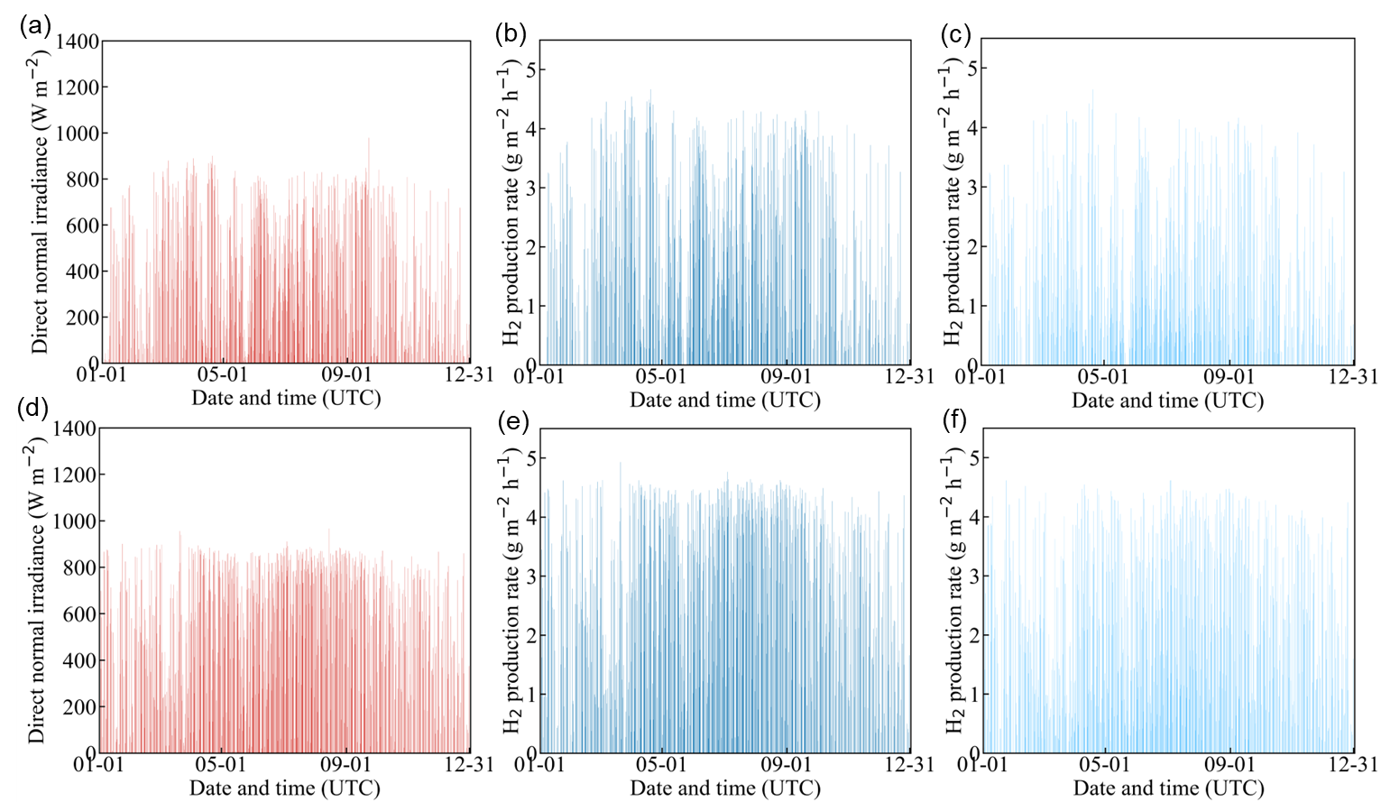
Fig. 2: Hourly TMY direct normal irradiance and corresponding normalized hydrogen production rates in Vienna and Athens: (a) DNI in Vienna, (b) dual axis hydrogen production in Vienna, (c) single axis hydrogen production in Vienna, (d) DNI in Athens, (e) dual axis hydrogen production in Athens, and (f) single axis hydrogen production in Athens.
Fig. 2 shows clear differences between the hourly DNI characteristics of Vienna and Athens. Vienna exhibits considerable irradiance intermittency and a pronounced seasonal variation, with lower and less frequent DNI events during the winter months. Athens presents a stronger and more regular solar resource throughout the year, with frequent high-DNI periods extending beyond the summer season. These contrasting profiles illustrate the geographical variation in the direct solar resource available to a concentrating solar-hydrogen system.
The hourly hydrogen-production profiles closely follow the corresponding DNI patterns because the system operates without importing electricity from the utility grid. Hours with insufficient irradiance result in zero hydrogen production, while fluctuations in DNI lead directly to part-load operation of the PV receiver and electrolyzer. Consequently, Vienna exhibits more frequent interruptions and lower hourly production during winter, whereas Athens maintains a longer and more consistent production window over the year. Nevertheless, the hourly results also demonstrate that high instantaneous production rates can occur at both locations when sufficiently strong DNI is available. The principal geographical difference therefore lies not only in the maximum production rate but also in the frequency and duration of productive operating periods.
Under both climatic conditions, the dual axis configuration produces more hydrogen than the single axis configuration. Dual axis tracking continuously aligns the concentrator with the solar beam and therefore minimizes incidence-angle losses. In contrast, the projected irradiance available to the single axis system is reduced during periods of optical misalignment, particularly in the morning and afternoon. This effect narrows the productive operating window and decreases the hydrogen-production rate at many hourly time steps. The difference between the two configurations is therefore accumulated throughout the year and becomes substantial in the annual yield.
Fig. 3(a) compares the annual normalized hydrogen production across the ten cities. A clear geographical gradient is observed, although the ranking is governed by the local DNI resource rather than latitude alone. Under dual axis tracking, annual hydrogen production ranges from 5.0 kg H₂ m⁻² year⁻¹ in London to 11.2 kg H₂ m⁻² year⁻¹ in Madrid. Athens provides a similarly high yield of 11.1 kg H₂ m⁻² year⁻¹, followed by Lisbon and Rome at 10.3 and 9.9 kg H₂ m⁻² year⁻¹, respectively. Bucharest reaches 8.8 kg H₂ m⁻² year⁻¹, while Vienna, Helsinki, Copenhagen, and Paris produce between 5.9 and 7.2 kg H₂ m⁻² year⁻¹. These results confirm the strong advantage of southern European locations with abundant direct solar irradiation.
The same geographical tendency is retained under single axis tracking, but the annual yields are consistently lower. The single axis production ranges from 3.6 kg H₂ m⁻² year⁻¹ in London to 8.5 kg H₂ m⁻² year⁻¹ in Madrid. Athens and Lisbon achieve 8.2 and 7.9 kg H₂ m⁻² year⁻¹, respectively. Depending on location, dual axis tracking increases annual hydrogen production by approximately 31.3–45.0% relative to single axis tracking. The largest relative improvement occurs in Helsinki, whereas the smallest occurs in Lisbon. The results indicate that the additional degree of tracking remains beneficial throughout the investigated European climatic range and is particularly valuable where the usable DNI resource is already limited.
The annual HHV-based STH efficiencies are presented in Fig. 3(b). Under dual axis tracking, the efficiency varies from 18.1% in London to 19.5% in Athens. The relatively narrow range indicates that the coupled SSPVTH system maintains comparable energy-conversion performance under different European climates, while the absolute hydrogen yield is primarily determined by the amount and temporal distribution of the available DNI. Under single axis tracking, the annual STH efficiency decreases to between 12.9% and 14.4%. In this calculation, the solar-energy denominator is based on the original DNI before single axis projection and includes irradiance below the 45 W m⁻² operating threshold. Consequently, the single axis STH values account for incidence-angle losses and unavailable low-irradiance energy at the overall system level. The consistently lower single axis efficiency therefore directly quantifies the annual energetic penalty associated with the reduced tracking capability.
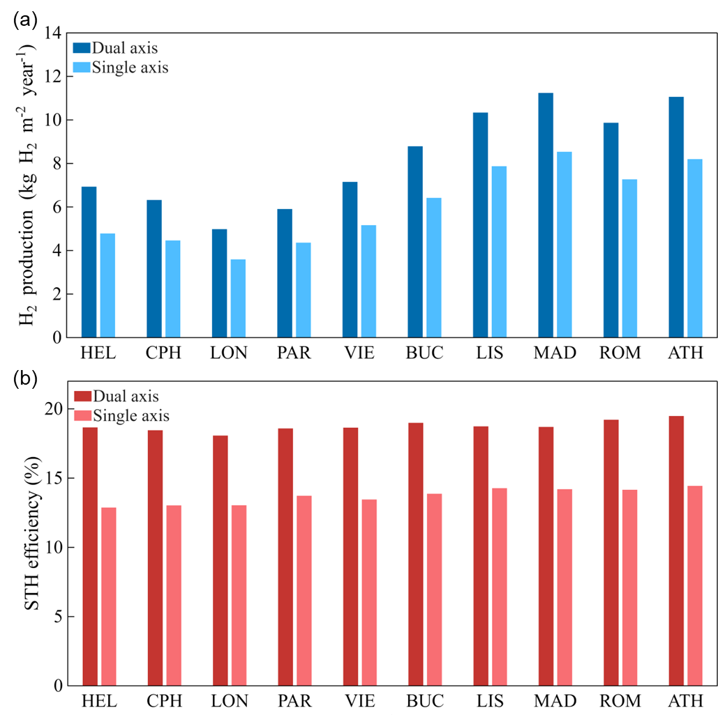
Fig. 3. Annual technical performance of the SSPVTH system across ten European cities under dual axis and single axis tracking configurations: (a) normalized hydrogen production and (b) annual HHV-based STH efficiency. HEL: Helsinki; CPH: Copenhagen; LON: London; PAR: Paris; VIE: Vienna; BUC: Bucharest; LIS: Lisbon; MAD: Madrid; ROM: Rome; ATH: Athens.
The technical advantages of dual axis tracking must be assessed against its higher initial and operating costs. Fig. 4 presents the resulting LCOH for the ten cities. A strong inverse relationship between annual hydrogen yield and LCOH is evident. Under dual axis tracking, the LCOH decreases from 15.6 EUR kg⁻¹ H₂ in London to 6.9 EUR kg⁻¹ H₂ in Madrid. Athens, Lisbon, and Rome achieve values of 7.0, 7.5, and 7.9 EUR kg⁻¹ H₂, respectively. By comparison, the corresponding single axis LCOH ranges from 18.6 EUR kg⁻¹ H₂ in London to 7.8 EUR kg⁻¹ H₂ in Madrid.
Despite its higher tracker cost and OPEX assumption, the dual axis configuration achieves a lower LCOH in every investigated city. Relative to single axis tracking, the reduction ranges from approximately 11.6% in Lisbon to 19.9% in Helsinki. The higher investment associated with dual axis tracking is therefore more than compensated for by the increase in lifetime hydrogen production. This result is especially relevant for a concentrating system because the optical losses caused by incomplete solar alignment reduce not only the electricity supplied to the electrolyzer but also the effective utilization of the remaining system components.

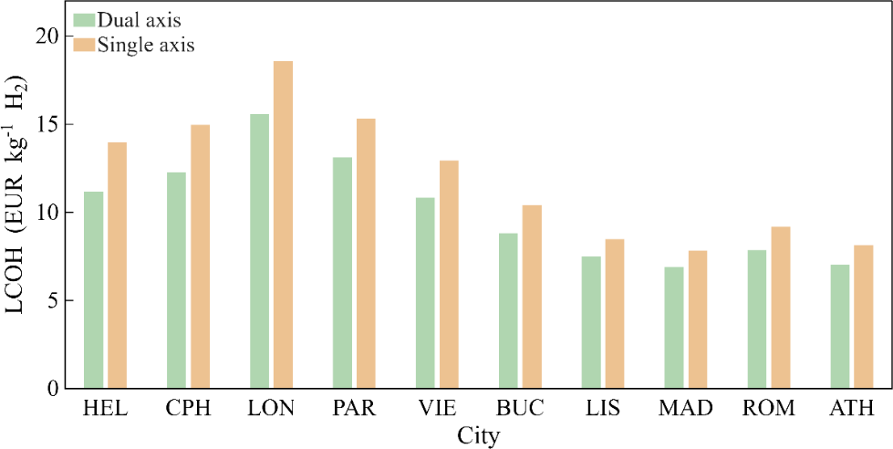
Fig. 4. LCOH of the SSPVTH system across ten European cities under dual axis and single axis tracking configurations. HEL: Helsinki; CPH: Copenhagen; LON: London; PAR: Paris; VIE: Vienna; BUC: Bucharest; LIS: Lisbon; MAD: Madrid; ROM: Rome; ATH: Athens.
Fig. 5 compares the discounted PBT under two revenue scenarios. In the hydrogen-sales-only scenario shown in Fig. 5(a), Madrid achieves the shortest PBT, at 6.6 years for dual axis tracking and 7.9 years for single axis tracking. Athens follows closely, with corresponding values of 6.7 and 8.3 years. Lisbon, Rome, and Bucharest also exhibit substantially shorter recovery periods than the northern and western European cities because their higher annual yields generate greater hydrogen-sales revenue from the same installed collection area.
The economic limitations of low-DNI locations are particularly evident in London. Its PBT reaches 31.5 years under dual axis tracking and 66.7 years under single axis tracking, both exceeding the assumed 25-year project lifetime. The values shown beyond 25 years represent the extrapolated time required for the cumulative discounted cash flow to become positive and indicate that the corresponding configuration does not recover its initial investment within the project lifetime. Under the same hydrogen-only scenario, the single axis configuration in Copenhagen also slightly exceeds the project lifetime, with a PBT of 26.7 years. These findings demonstrate that tracking selection alone cannot completely overcome an insufficient local direct solar resource.
Fig. 5(b) includes revenue from both hydrogen and the stoichiometrically produced oxygen. Oxygen valorization shortens the PBT in every city and tracking configuration. For example, the dual axis PBT decreases from 6.6 to 5.8 years in Madrid and from 6.7 to 6.0 years in Athens. In London, it decreases from 31.5 to 23.8 years for dual axis tracking, bringing capital recovery within the assumed project lifetime, whereas the single axis PBT remains longer than the project lifetime at 38.8 years. The magnitude of the improvement depends on the initial production level and cash-flow trajectory. These results represent the potential economic benefit of oxygen utilization under the assumed selling price and full byproduct offtake; practical benefits would additionally depend on local demand and any required oxygen conditioning, storage, and delivery costs.
Across both revenue scenarios, dual axis tracking consistently produces a shorter PBT than single axis tracking. This agrees with the LCOH results and confirms that maximizing annual solar-energy capture is more economically important than minimizing tracker cost for the investigated SSPVTH system. Overall, Madrid and Athens provide the strongest combination of hydrogen yield, STH efficiency, LCOH, and PBT among the selected cities, while London presents the least favourable conditions. The comparison demonstrates that both geographical site selection and tracking strategy are decisive for SSPVTH deployment: high-DNI southern European locations combined with dual axis tracking offer the greatest potential for technically productive and economically competitive solar hydrogen generation.
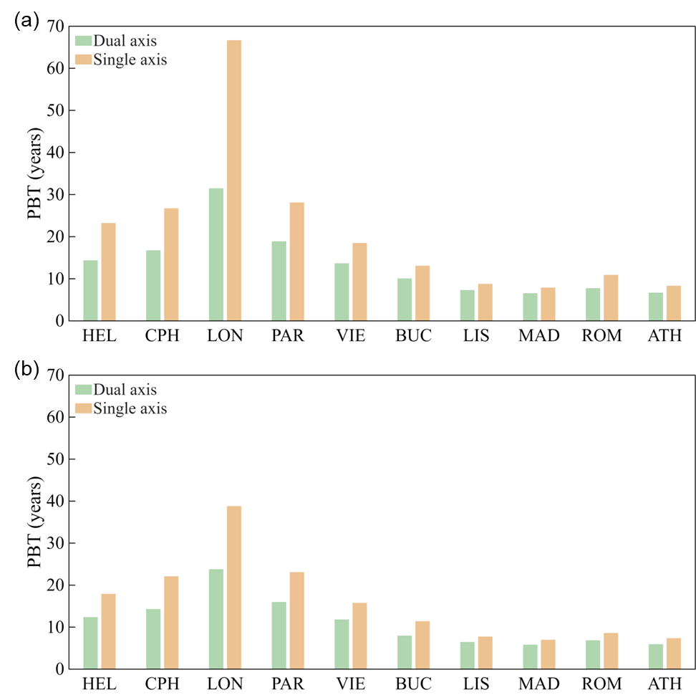
Fig. 5. PBT of the SSPVTH system across ten European cities under two revenue scenarios: (a) hydrogen sales only and (b) combined hydrogen and oxygen sales. HEL: Helsinki; CPH: Copenhagen; LON: London; PAR: Paris; VIE: Vienna; BUC: Bucharest; LIS: Lisbon; MAD: Madrid; ROM: Rome; ATH: Athens.
- Conclusion
This study evaluated the technical and economic performance of a solar-driven SSPVTH system in ten European cities using hourly TMY data. The results demonstrate that geographical DNI availability and tracking strategy are the principal factors governing annual hydrogen production. Under dual axis tracking, the annual normalized hydrogen yield ranged from 5.0 kg H₂ m⁻² year⁻¹ in London to 11.2 kg H₂ m⁻² year⁻¹ in Madrid, while the corresponding single axis values ranged from 3.6 to 8.5 kg H₂ m⁻² year⁻¹. Dual axis tracking increased annual hydrogen production by 31.3–45.0% relative to single axis tracking across the investigated locations.
The annual HHV-based STH efficiency reached 18.1–19.5% under dual axis tracking, compared with 12.9–14.4% under single axis tracking. The relatively narrow variation in efficiency within each tracking configuration indicates that the system retains stable conversion performance across different European climates, whereas the absolute hydrogen yield is primarily controlled by the magnitude and temporal distribution of DNI. Among the selected cities, Madrid and Athens offered the most favourable technical performance, while London presented the lowest annual yield because of its limited direct solar resource.
The higher yield obtained using dual axis tracking also outweighed its additional capital and operating costs. The dual axis LCOH ranged from 6.9 to 15.6 EUR kg⁻¹ H₂, remaining below the corresponding single axis range of 7.8–18.6 EUR kg⁻¹ H₂ in every city. Under the hydrogen-sales-only scenario, the shortest dual axis PBT values were obtained in Madrid and Athens at 6.6 and 6.7 years, respectively. In contrast, the PBT in London exceeded the assumed 25-year project lifetime. Including oxygen-sales revenue shortened the PBT across all cities and reduced it to 5.8 years in Madrid and 6.0 years in Athens under dual axis tracking. However, this improvement depends on sufficient local oxygen demand and does not include additional downstream conditioning, storage, or delivery costs.
Overall, high-DNI southern European locations combined with dual axis tracking provide the strongest prospects for efficient and economically competitive solar hydrogen production. The findings demonstrate the importance of considering local hourly solar conditions rather than relying solely on latitude or annual average irradiation when selecting deployment sites. Future work should extend the assessment to include site-specific installation costs, long-term component degradation, water availability, hydrogen and oxygen handling infrastructure, and local market conditions.
- References
Curcio, E., 2025. Techno-economic analysis of hydrogen production: Costs, policies, and scalability in the transition to net-zero. International Journal of Hydrogen Energy 128, 473–487. https://doi.org/10.1016/j.ijhydene.2025.04.013.
Esposito, D.V., 2017. Membraneless electrolyzers for low-cost hydrogen production in a renewable energy future. Joule 1, 651–658. https://doi.org/10.1016/j.joule.2017.07.003.
European Commission Joint Research Centre (JRC), 2026. PVGIS: Photovoltaic Geographical Information System. https://re.jrc.ec.europa.eu/pvg_tools/en/#MR (accessed 6 February 2026).
Grimm, A., de Jong, W.A., Kramer, G.J., 2020. Renewable hydrogen production: A techno-economic comparison of photoelectrochemical cells and photovoltaic-electrolysis. International Journal of Hydrogen Energy 45, 22545–22555. https://doi.org/10.1016/j.ijhydene.2020.06.092.
Grube, T., Reul, J., Reuß, M., Calnan, S., Monnerie, N., Schlatmann, R., et al., 2020. A techno-economic perspective on solar-to-hydrogen concepts through 2025. Sustainable Energy & Fuels 4, 5818–5834. https://doi.org/10.1039/D0SE00896F.
Hadikhani, P., Hashemi, S.M.H., Schenk, S.A., Psaltis, D., 2021. A membrane-less electrolyzer with porous walls for high throughput and pure hydrogen production. Sustainable Energy & Fuels 5, 2419–2432. https://doi.org/10.1039/D1SE00255D.
Hashemi, S.M.H., Karnakov, P., Hadikhani, P., Chinello, E., Litvinov, S., Moser, C., et al., 2019. A versatile and membrane-less electrochemical reactor for the electrolysis of water and brine. Energy & Environmental Science 12, 1592–1604. https://doi.org/10.1039/C9EE00219G.
Herrando, M., Wang, K., Huang, G., Otanicar, T., Mousa, O.B., Agathokleous, R.A., et al., 2023. A review of solar hybrid photovoltaic-thermal (PV-T) collectors and systems. Progress in Energy and Combustion Science 97, 101072. https://doi.org/10.1016/j.pecs.2023.101072.
Holmes-Gentle, I., Tembhurne, S., Suter, C., Haussener, S., 2023. Kilowatt-scale solar hydrogen production system using a concentrated integrated photoelectrochemical device. Nature Energy 8, 586–596. https://doi.org/10.1038/s41560-023-01247-2.
Huang, G., Wang, K., Curt, S.R., Franchetti, B., Pesmazoglou, I., Markides, C.N., 2021a. On the performance of concentrating fluid-based spectral-splitting hybrid PV-thermal (PV-T) solar collectors. Renewable Energy 174, 590–605. https://doi.org/10.1016/j.renene.2021.04.070.
Huang, G., Wang, K., Markides, C.N., 2021. Efficiency limits of concentrating spectral-splitting hybrid photovoltaic-thermal (PV-T) solar collectors and systems. Light: Science & Applications 10, 28. https://doi.org/10.1038/s41377-021-00465-1.
Lee, B., Fan, D., Forrest, S.R., 2020. A high throughput, linear molecular beam epitaxy system for reduced cost manufacturing of GaAs photovoltaic cells: Will GaAs ever be inexpensive enough? Sustainable Energy & Fuels 4, 2035–2042. https://doi.org/10.1039/C9SE01255A.
Li, W., Tian, H., Ma, L., Wang, Y., Liu, X., Gao, X., 2022. Low-temperature water electrolysis: Fundamentals, progress, and new strategies. Materials Advances 3, 5598–5644. https://doi.org/10.1039/D2MA00185C.
Li, Z., Fang, S., Sun, H., Chung, R.J., Fang, X., He, J.H., 2023. Solar hydrogen. Advanced Energy Materials 13, 2203019. https://doi.org/10.1002/aenm.202203019.
Mostafaeipour, A., Rezayat, H., Rezaei, M., 2020. A thorough investigation of solar-powered hydrogen potential and accurate location planning for big cities: A case study. International Journal of Hydrogen Energy 45, 31599–31611. https://doi.org/10.1016/j.ijhydene.2020.08.211.
Park, J., Ryu, K.H., Kim, C.H., Cho, W.C., Kim, M., Lee, J.H., et al., 2023. Green hydrogen to tackle the power curtailment: Meteorological data-based capacity factor and techno-economic analysis. Applied Energy 340, 121016. https://doi.org/10.1016/j.apenergy.2023.121016.
Peacock, J., Huang, G., Song, J., Markides, C.N., 2022. Techno-economic assessment of integrated spectral-beam-splitting photovoltaic-thermal (PV-T) and organic Rankine cycle (ORC) systems. Energy Conversion and Management 269, 116071. https://doi.org/10.1016/j.enconman.2022.116071.
Polito, F., Huang, G., Markides, C.N., 2025. A building-integrated hybrid photovoltaic-thermal (PV-T) window for synergistic light management, electricity and heat generation. Advanced Science 12, 2408057. https://doi.org/10.1002/advs.202408057.
Ramasamy, V., Zuboy, J., Woodhouse, M., O'Shaughnessy, E., Feldman, D., Desai, J., et al., 2023. U.S. solar photovoltaic system and energy storage cost benchmarks, with minimum sustainable price analysis: Q1 2023. National Renewable Energy Laboratory, Golden, CO. Report No. NREL/TP-7A40-87303. https://doi.org/10.2172/2005540.
Short, W., Packey, D.J., Holt, T., 1995. A manual for the economic evaluation of energy efficiency and renewable energy technologies. National Renewable Energy Laboratory, Golden, CO. Report No. NREL/TP-462-5173. https://doi.org/10.2172/35391.
Tian, Y., Hadikhani, P., Alati, N., Richards, B.S., Huang, G., 2025. Hybrid solar spectral-splitting photovoltaic-thermal hydrogen production systems. Advanced Science 12, 2503205. https://doi.org/10.1002/advs.202503205.

