**Abstract**

This work concerns a detailed microstructure investigations of aluminum based composite strengthened with the TiC particles being in nanometer size. The composites were fabricated by the casting method combined with in-situ formation of TiC particles. Applying a suitable composition of components and moderators of SHS reaction which occur during casting, it was possible to cast the samples with TiC particles below 100 nm in size. Detailed microstructure investigations using scanning and transmission electron microscopy (SEM and TEM) allowed to identified the distribution of TiC particles and their preferred location in the microstructure of composites. Also the additional precipitates with different size and shape were identified in investigated samples. In order to confirm the crystal structure of TiC nanoparticles as well as additional phases the detailed microstructure investigations were performed by TEM. Thin foil for TEM observations was prepared by Focused Ion Beam (FIB) method. The EDS elemental mapping and point chemical analyses were performed and at least three different phases were identified, an example in presented in Fig. 1. The TiC particle are in size of about 100 nm and they have tendency for agglomeration. The elongated precipitate represents phase from Fe-Al-Si system and additionally Si enriched phase can be recognized.

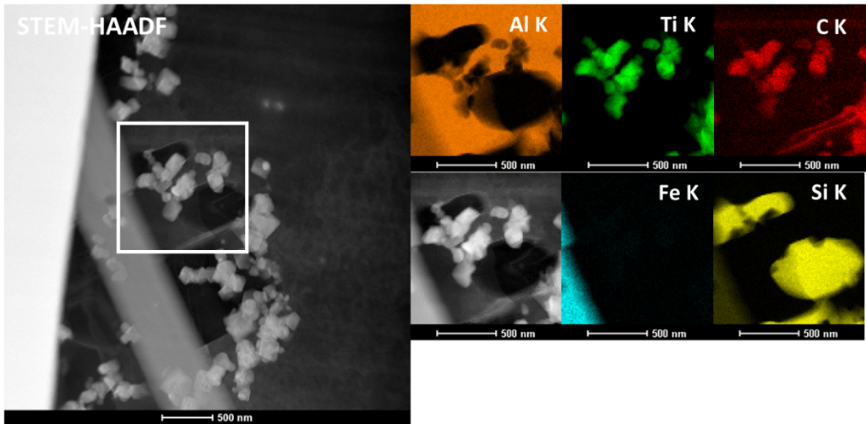

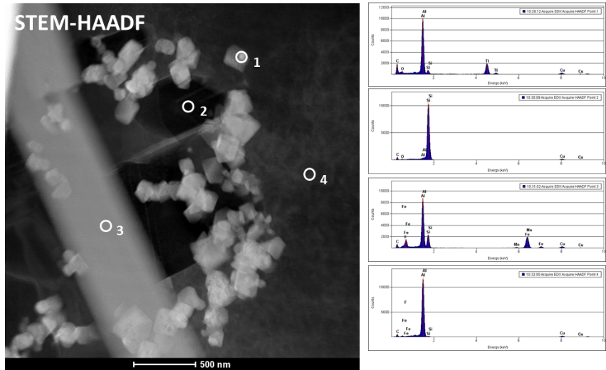

Fig. 1. Set of TEM result showing elemental mapping and chemical point analyses of different phases in in-situ cast composite.

Selected area diffraction technique allowed to identified the crystal structure of TiC particles as cubic fcc structure with space group Fm-3m and lattice parameter a = b = c= 0.4327 nm.

**Acknowledgements**

This work was performed in the frame of NCN Research Project no. 2016/21/B/ST8/01181