EuroSun2026
ENVIRONMENTAL PERFORMANCE OF RESIDENTIAL HEATING SYSTEMS: A COMPARATIVE CROSS-TECHNOLOGY LCA
Marie Fischer¹, Sina Herceg¹, Karl-Anders Weiß¹
¹Fraunhofer Institute for Solar Energy Systems ISE
marie.fischer@ise.fraunhofer.de
Summary
This paper presents a harmonized framework for life cycle assessment (LCA) to compare the environmental impacts of heating systems for single-family house. The analysis is conducted using the functional unit of 1 kWh of heat supplied to the building. The technologies examined include air source heat pumps with and without solar thermal collectors, brine-water heat pumps with geothermal probes or PVT collectors, and a hybrid system combining an air source heat pump with a gas boiler for peak loads. A gas condensing boiler serves as a reference system. The results show that all investigated heat pump systems significantly reduce climate change impacts compared to the gas boiler with impacts ranging from 0.031 to 0.078 kg CO₂ eq./kWh_{th}, compared to 0.277 kg CO₂ eq./kWh_{th} for the reference system. Differences between future electricity scenarios remain limited in the climate change category, as all pathways assume a transition towards climate neutrality. At the same time, heat pump systems show higher impacts than the gas boiler in the category resource use, minerals and metals, reflecting their higher material intensity and more complex material composition. The results highlight a trade-off between carbon reduction and material demand, demonstrating the need to consider resource-related burdens and circular economy strategies.
Keywords: Life cycle assessment, heat pump, solar thermal, PVT, decarbonization potential
Field of application for the findings: investment decisions for residential heat supply, strategic planning and policy design for decarbonizing residential heating
Addressed audience: investors, policy makers, energy planners and consultants, LCA practitioners
- Introduction
In Germany, the heat demand in the residential sector is 586 TWh, which represents 47 % of the total national heat demand (Umweltbundesamt, 2025). The energy required for space heating contributes the largest share at almost 71%, while the energy required to cover the hot water demand accounts for an additional 17% (Umweltbundesamt, 2025). Since about 78 % of residential heating systems are still fossil-based (Becker et al., 2023), this is a key area of action to achieve climate neutrality by 2045. To reach this goal, the transition to a renewable energy system is essential, requiring a broad variety of private actors to participate and replace their fossil-fueled heating systems with renewable energy technologies. The German building energy act from 2024 (Gebäudeenergiegesetz, GEG), aimed to further accelerate this transition in the heating sector. It required heating systems to be fueled by at least 65 % of renewable energy sources, while defining exceptions and transition periods (Bundestag, 2020). In July 2026, the GEG was renamed into the Building Modernization Act (GModG), introducing new requirements for heating systems. The previous 65% renewable energy requirement was replaced by a broader set of technology options and a phased approach to achieving climate-neutral building stock, including a stepwise increase in the required share of biogenic fuels (Bundesinstitut für Bau-, Stadt- und Raumforschung, 2026).
Especially heat pumps have experienced an accelerated deployment in the recent years (Bundesverband Wärmepumpe e.V., 2023). The vast majority of renewable heat, however, is still provided by biomass (Umweltbundesamt, 2025). Solar thermal collectors covered less than 5% of the heat demand in Germany in 2024 (Umweltbundesamt, 2025). All of these technologies have an impact on the environment during their production and disposal phases. However, the impact during the usage phase can vary greatly. While the operational environmental impact of a heat pump is mainly due to electricity consumption, the combustion of biomass produces direct emissions. Emissions originating from the combustions of biomass are classified as biogenic (non-fossil) emissions. They are by definition climate-neutral and are not counted towards the climate change impacts. Solar thermal collectors do not cause any direct emissions during their operation.
The market for residential heating systems is highly heterogeneous and, depending on the building specifications, characterized by varying requirements. Investors face a large number of alternatives, not only in terms of the heating technology itself, but also regarding the energy carriers or fuels as well as the system configuration and sizing, while a comprehensive comparison is missing.
The conducted research project aims to fill this gap and provides both a methodological guideline on how to conduct a cross-technology comparison of heating systems as well as calculated results on the economic and ecological sustainability of selected heating systems under pre-defined conditions. In the project four different reference buildings were defined, and a heating load profile was generated (Chaigneau, 2025a; Chaigneau, 2025b). The investigated heating systems have been dimensioned accordingly, and their operation phase was simulated in PolySun. Based on this data, an economic and ecological evaluation of all systems was conducted. Selected systems were then linked in a comprehensive comparative analysis.
This contribution focuses on the ecological assessment and comparison of selected heating systems, with particular emphasis on how different electricity mix scenarios affect the associated environmental impacts during the use-phase. Previous studies have shown that the electricity mix during the operation of heat pumps has a significant impact on their environmental performance (Chaigneau et al., 2025; Fischer et al., 2025; Fischer et al., 2026). Whereas earlier assessments mainly compared the current status quo with a single potential decarbonization pathway, this analysis focuses on comparing the effects of different decarbonization pathways.
- Methodology
Life Cycle Assessment (LCA) is the method of choice to assess environmental impacts of products or services. The two norms DIN EN ISO 14040 and 14044 (Deutsches Institut für Normung e.V., 2006; Deutsches Institut für Normung e.V., 2009) define the basic structure and minimum requirements for this methodology, while allowing for flexibility. This enables practitioners to make individual methodological choices to assess the product or service of their choice. However, it makes the comparison of results of different studies difficult or even impossible. To ensure fair and comprehensive comparability, especially across several different technologies, the harmonization of system boundaries, functional units and impact assessment methods is essential.
System Boundaries
In order to achieve comprehensive and therefore meaningful results, the entire life cycle of the heating system is considered. To create the greatest possible added value for users, only the heating system and its components are assessed. Potential renovations of buildings (e.g., additional insulation) and the distribution system (radiators) are not within the scope of this analysis. To further increase the comparability of the results, the consumption side is standardized using representative standard load profiles. All heating technologies considered are designed to meet the heat demand of the reference buildings at all times. Existing single-family houses are assessed in this contribution. The functional unit is set at 1 kWh of heat supplied to the building. The uniform choice of evaluation method is also crucial for the comparability of LCA results. In line with ecological assessment approaches in the building sector, modeling and evaluation are carried out in accordance with EN15804+A2.The chosen system model is “cut-off”. The investigated time horizon is 25 years. Any necessary component replacements during that time are included in the assessment. The roof area is covered by PV modules, PVT modules, solar thermal collectors or a combination of those, depending on the system configuration. During periods of simultaneous electricity generation and demand, the electricity produced by the PV system is used directly to operate the heat pump. Surplus electricity is exported to the grid, whereas additional electricity demand is supplied by grid electricity.
Life Cycle Inventory
The data requirements are largely covered by primary data collection from project partners, with the life cycle inventory database ecoinvent (Wernet et al., 2016) and literature data (Kägi et al., 2021; Khan et al., 2024) being used to fill in any data gaps. In addition to methodological aspects, technological parameters must also be standardized to ensure a comprehensive and fair comparison. These include, for example, the service life of heating systems and individual components, efficiency, degradation, installation location, disposal scenarios, and the electricity mix used.
The investigated heating technologies are designed to be GEG-compliant and selected according to their market relevance. These include an air-source heat pump (ASHP) with and without additional solar thermal collectors (ST), or a peak-load gas boiler (Gas), as well as a brine water heat pump using a ground probe (GSHP) as a source or a PVT-collector (BWHP+PVT). A gas condensing boiler is included as a reference system. An overview on the sizing of the technology components is given in Table 1. Additionally, the heating systems include further auxiliary components such as pipes, hot water storage tanks, or additional pumps. These components are standardized for all systems and only varied in size, where applicable.
Table 1: Overview of system configuration and sizing.
Name | Description | Size
ASHP+Gas | Air source heat pump with gas condensing boiler | HP: 4.8 kW, Gas: 15.9kW
ASHP | Air source heat pump | 8.9 kW
ASHP+ST | Air source heat pump with solar thermal collectors | HP: 8.9 kW, ST: 6 m²
BWHP+PVT | Brine water heat pump with PVT collectors as a source | HP: 8.9 kW,  PVT: 21.8 m² [4.8 kWpel]
GSHP | Ground source heat pump | HP: 8.9 kW, Ground probe: 180 m
Investigated Scenarios
Since the assessment covers a 25-year time horizon, applying the current electricity mix as a static input over the entire use phase could overestimate the environmental impacts of electricity-based heating systems, particularly their climate change impacts. To address this, electricity mix projections from the literature are incorporated into the LCA.
In previous publications (Fischer et al., 2024; Fischer et al., 2025; Fischer et al., 2026), the reference scenario from the study by Brandes et al. (2021) was considered. To test the influence of different decarbonization pathways on the environmental performance of heat pump systems, additional scenarios are investigated in this contribution. The analysis is expanded to include the remaining three scenarios from this study as well: persistence, non-acceptance, and sufficiency. Furthermore, four scenarios from the updated study by Thelen et al. (2024) are included: technology-open, efficiency, persistence, and robust. This newer study is built on the same methodological basis but updates the target framework to climate neutrality by 2045. It reflects more recent assumptions on electrification, infrastructure development, and geopolitical robustness. These scenarios are therefore well suited as they provide consistent and methodologically comparable pathways for the future decarbonization of the German electricity system.
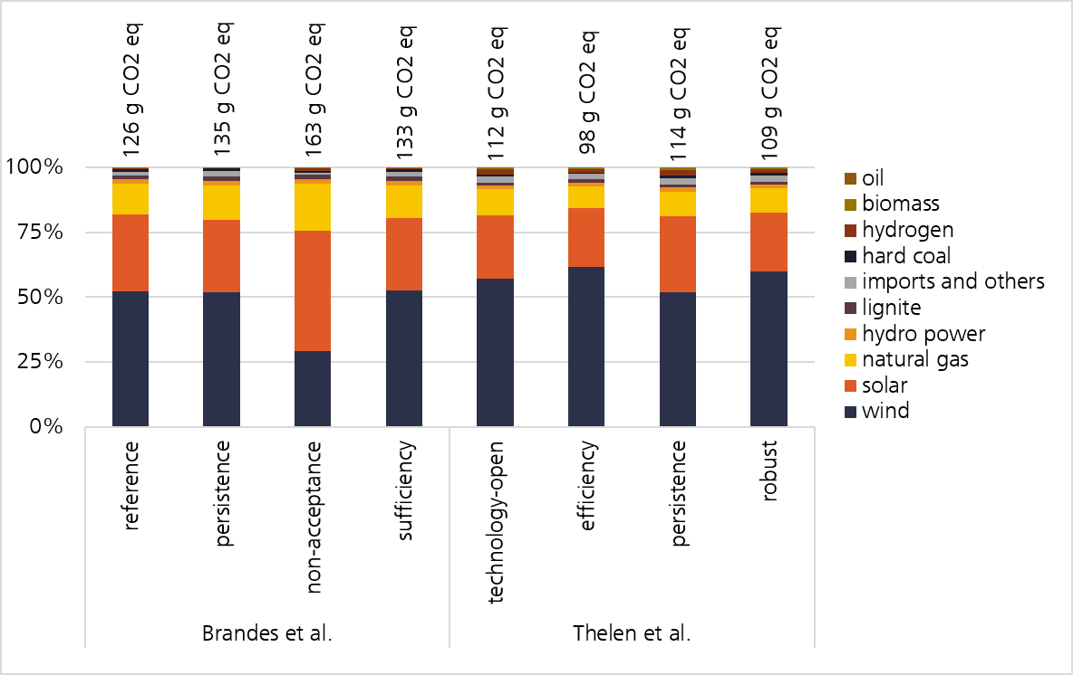
Figure 1: Calculated average electricity mixes over a 25-year time horizon (2026-2050) based on the scenarios and data provided by Brandes et al. (2021) and Thelen et al. (2024). The carbon footprint is given per kWh of electricity.
Impact assessment methodology: EN15804+A2, Software: SimaPro, background database: ecoinvent.
Based on these scenarios, virtual average electricity mixes over the next 25 years (2026 to 2050) are calculated and implemented in the model. Figure 1 shows these calculated averages along with the associated carbon footprint per kWh of electricity. It can be seen that since all scenarios are founded on the principle of climate neutrality by the mid of the century, the share of electricity from wind and solar in the virtual mix over the next 25 years exceeds 75% in all scenarios. Together with natural gas, these three technologies provide more than 90% of the electricity mix over the 25-year timeframe. The carbon footprint of the electricity mixes varies between 98 g CO₂ eq./kWh for the efficiency scenario in Thelen et al. (2024) to 163 g CO₂ eq./kWh for the non-acceptance scenario in Brandes et al. (2021).
- Results and Discussion
All investigated systems were assessed under each of the electricity scenarios described above, resulting in eight impact values per system and impact category. The impact values are reported per functional unit of 1 kWh of thermal energy supplied to the building. The gas boiler system is included as a reference. However, because its electricity demand during the use phase is negligible, the choice of electricity scenario does not lead to any relevant variation in its impact results. The results for the impact categories climate change and resource use, minerals and metals are presented in detail in the following sub-sections.
Climate Change
All investigated heat pump systems show a significant decarbonization potential in comparison to the gas condensing boiler which shows a carbon footprint of 0.277 kg CO₂ eq./kWh_{th}. Depending on the system and the electricity mix, the carbon footprint of the heat supplied by any of the heat pump systems ranges from 0.031 to 0.078 kg CO₂ eq./kWh_{th} (see Figure 2).
The combination of the ASHP with gas leads to the highest climate change impacts among the heat pump systems in this comparison. In the use-phase of this system not only indirect emissions from electricity consumption must be considered but also direct emissions from natural gas combustion. Depending on the system and the electricity scenario, the overall climate change impacts of the ASHP+Gas system are between 0.027 and 0.039 kg CO₂ eq./kWh_{th} higher than those of the other heat pump systems. For the systems ASHP and ASHP+ST the carbon footprint of the provided heat ranges between 0.031 kg CO₂ eq./kWh_{th} for the efficiency scenario by Thelen et al. (2024) and 0.048 kg CO₂ eq./kWh_{th} for the non-acceptance scenario by Brandes et al. (2021). The systems BWHP+PVT and GSHP show carbon footprints of 0.034 to 0.051 kg CO₂ eq./kWh_{th} and 0.032 to 0.047 kg CO₂ eq./kWh_{th}, respectively.
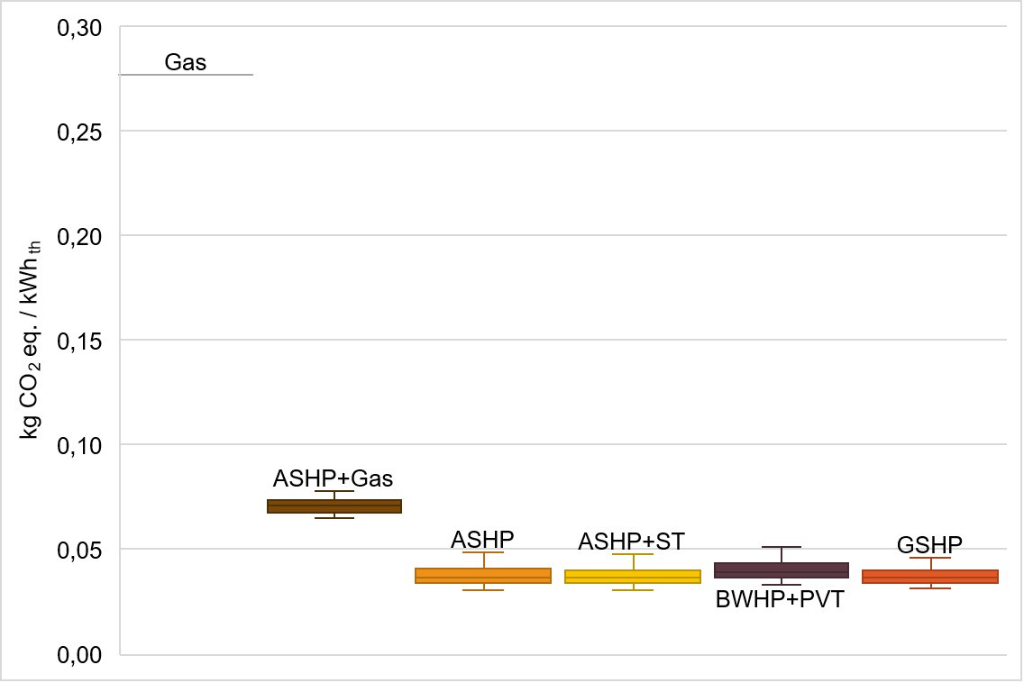
Figure 2: Overview of impacts in the category climate change per system across all investigated scenarios.
Functional unit: 1 kWh of heat supplied to the building, impact assessment methodology: EN15804+A2.
When the electricity scenarios are analyzed individually, marginal but consistent shifts in the ranking of the heat pump systems can be observed. For the scenarios taken from Thelen et al. (2024) as well as the reference scenario from Brandes et al. (2021) the ASHP+ST system shows the lowest carbon footprint. For the three remaining scenarios the GSHP shows a lower carbon footprint. Although these differences are only marginal (< 1 g CO₂ eq./kWh_{th}), they still indicate a tendency. This pattern can be explained by the balance between operational efficiency and installation-related burdens. In scenarios with a higher electricity carbon footprint the higher use-phase efficiency of the GSHP reduces electricity consumption and thereby results in slightly lower climate change impacts. In scenarios with a lower electricity carbon footprint on the other hand the relevance of operational electricity demand decreases, and the additional burdens associated with diesel combustion for the borehole drilling lead to slightly higher impacts for the GSHP compared to the ASHP and ASHP+ST system.
In this comparison the carbon footprint for the BWHP+PVT system is slightly higher than for the GSHP, ASHP and ASHP+ST systems. This can partially be explained by the material intensity of the PVT collector and associated supply chain burdens. However, because the PVT collector simultaneously generates heat and electricity, an energetic allocation approach was taken. Although this allows for a more balanced comparison with the other technologies than a non-allocation approach, it also introduces an additional source of uncertainty that should be considered when interpreting the results.
Overall, the results show a strong decarbonization potential when a gas boiler is replaced by any of the investigated heat pump systems. Even the combination of an ASHP with a gas boiler for peak loads can be rather beneficial, reducing the climate change impact significantly. Overall, the entirely renewable systems (ASHP, ASHP+ST, BWHP+PVT, GSHP) show nearly the same climate change impacts.
Resource Use, minerals and metals
The impact values reported for the category resource use, minerals and metals indicate the material intensity of a given system. The impacts are expressed in kg Sb eq. and are calculated based on the abundance or scarcity of minerals and metals in the Earth’s crust. A high impact value in this category indicates the use of scarce minerals or metals and/or a generally high demand for mineral and metal resources in the analyzed supply chain. Consequently, this impact category only refers to the installed infrastructure and does not account for example for natural gas consumed during the use phase.

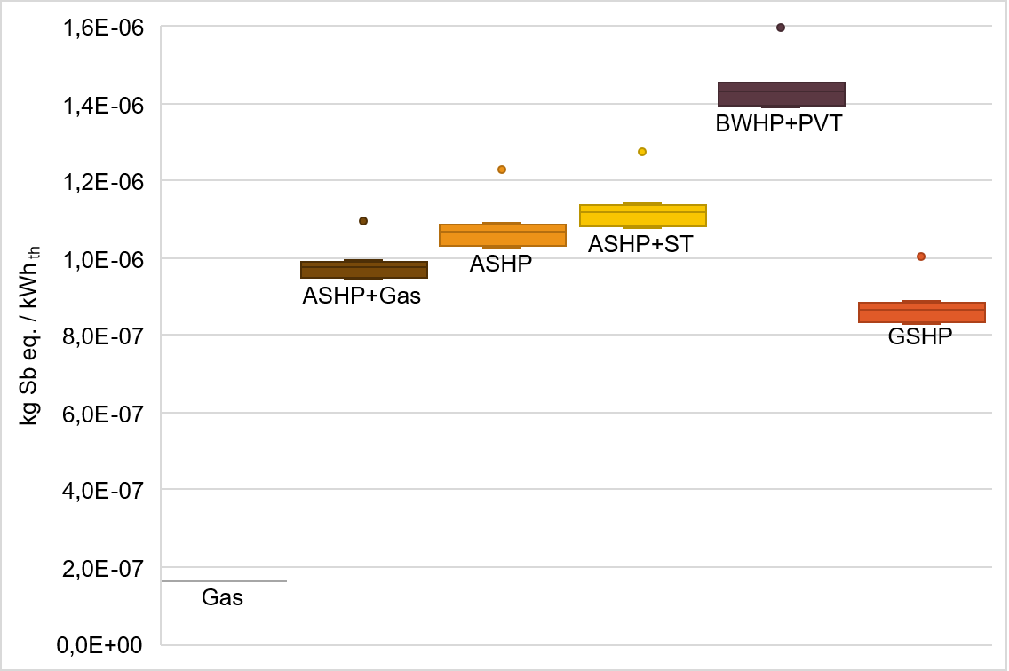
Figure 3: Overview of impacts in the category resource use, minerals and metals, per system across all investigated scenarios.
Functional unit: 1 kWh of heat supplied to the building, impact assessment methodology: EN15804+A2.

The results show that heat pump systems have higher impact values in this category than the reference gas boiler system (see Figure 3). This indicates the lower material intensity of gas boiler infrastructure compared to heat pumps. Additionally, heat pumps require a more complex material mix, including scarce minerals and metals, resulting in higher impact values in this category.
Among the heat pump systems, the GSHP exhibits the lowest impact, indicating comparatively low material demand combined with high operational efficiency. The ASHP and ASHP+ST systems show similar impacts. However, the addition of solar thermal collectors in the ASHP+ST system leads to a slightly higher material demand. The ASHP+Gas system shows a lower impact than the standalone ASHP. This is explained by the smaller heat pump capacity required in the hybrid configuration. The results suggest that the reduction in heat pump size outweighs the additional material demand associated with the gas boiler. The BWHP+PVT system shows the highest demand for minerals and metals in this comparison, mainly due to the material-intensive PVT collectors. As noted above, energetic allocation was applied to distribute impacts between heat and electricity. However, because of the integrated nature of this technology, a clear separation is not fully possible. The values for this system should therefore be interpreted with some caution, as they are subject to greater uncertainty.
When assessing the scenarios individually, the order of the systems remains unchanged regardless of the scenario considered. This suggests that variations in the electricity mix influence all systems in a similar manner, with no visible offsetting effects. However, the non-acceptance scenario has a strong influence on the results and appears as an outlier in the statistical assessment for each of the systems. Especially, the high share of solar electricity in this scenario increases the demand for minerals and metals along the supply chain.
- Conclusion and Outlook
This contribution presents a harmonized cross-technology LCA of residential heating systems under different future electricity mix scenarios. All investigated heat pump systems show substantially lower climate change impacts than the reference gas condensing boiler. Depending on the system configuration and scenario, impacts range from 0.031 to 0.051 kg CO₂ eq./kWh_{th}. Even the hybrid ASHP+Gas system performs significantly better (up to 0.078 kg CO₂ eq./kWh_{th}) than the reference system. Overall, the variation between scenarios is limited, since all pathways assume a transition towards climate neutrality and therefore relatively low average grid carbon intensities over the assessment period. Nevertheless, differences remain visible: the non-acceptance scenario results in the highest carbon footprint, while the efficiency scenario shows the lowest values.
At the same time, the results reveal clear trade-offs between impact categories. While heat pump systems perform better in the climate change category, their higher material intensity and more complex composition lead to higher impacts than the gas boiler in the resource use, minerals and metals category. Among the heat pump systems, the GSHP shows the lowest resource use impacts, whereas the BWHP+PVT system shows the highest impacts due to the material-intensive PVT collectors. Scenario effects are also visible in this category: the non-acceptance scenario has by far the highest resource demand, while the robust scenario has the lowest. More generally, the scenario ranking differs between climate change and resource use, highlighting a central trade-off of the energy transition. Renewable energies show lower carbon footprints while often requiring higher material inputs and more complex material mixes.
The results further indicate that higher installation-related burdens can be offset in the climate change category by better operational efficiency, as seen for example for GSHP systems. In the resource use category, such compensation is not visible, showing that manufacturing and infrastructure burdens are more influential than differences in operational electricity demand. At the same time, the outlier position of the non-acceptance scenario shows that the material profile of future electricity supply chains can still strongly affect the overall impacts.
Overall, the findings underline that environmental assessments of heating systems should not focus on climate change alone. A broader life cycle perspective is needed to capture trade-offs between impact categories and to support robust technology and policy decisions. The results must be interpreted in the context of the underlying assumptions, including the selected building characteristics, system configurations, lifetimes, and assumed electricity mix scenarios. The presented results provide orientation for typical applications in the residential building stock and illustrate how different electricity mix scenarios affect the environmental performance of heat pump systems. Differences in energy performance as well as structural and technical boundary conditions could change the relative advantages and disadvantages of the systems.
Finally, within the investigated framework, renewable heating systems offer clear advantages over the gas reference system in the climate change category and contribute substantially to reducing greenhouse gas emissions in the building sector. However, these advantages are accompanied by higher impacts in the category resource use, minerals and metals, reflecting the greater material intensity and technical complexity of heat pump systems compared to fossil technologies. The results therefore demonstrate that the transition to renewable heating needs to be accompanied by strategies aimed at improving material efficiency, extending product lifetimes, increasing recycling and secondary material use, and embedding heating system deployment in broader circular economy concepts.
References
Becker, S., Hagen, J., Joshi, S., Krüger, R., and La Serna, S. de, 2023. DENA-Gebäudereport 2024: Zahlen, Daten, Fakten zum Klimaschutz im Gebäudebestand, 84 p.
Brandes, J., Haun, M., Wrede, D., Jürgens, P., Kost, C., and Henning, H.-M., 2021. Wege zu einem klimaneutralen Energiesystem: Die deutsche Energiewende im Kontext gesellschaftlicher Verhaltensweisen, 47 p.
Bundesinstitut für Bau-, Stadt- und Raumforschung, 2026. Neuregelungen mit dem Gebäudemodernisierungsgesetz (GModG): Aus GEG wird GModG. Available at: https://www.gmodg.bund.de/GEGPortal/DE/GEGRegelungen/GModG_neu/GModG_neu-node.html. Accessed 4 August 2026.
Bundesverband Wärmepumpe e.V. (BWP), 2023. Branchenstudie 2023: Marktentwicklung - Prognose - Handlungsempfehlungen.
Chaigneau, M., 2025a. Gebäudetyp – Einfamilienhaus (EFH): Factsheet. Available at: https://www.effizientes-heizen.de/documents/Effizientes-Heizen_Infosheet_Gebaeude_EFH_final.pdf. Accessed 1 April 2025.
Chaigneau, M., 2025b. Gebäudetyp – Mehrfamilienhaus (MFH): Factsheet. Available at: https://www.effizientes-heizen.de/documents/Effizientes-Heizen_Infosheet_Gebaeude_MFH_final.pdf. Accessed 1 April 2025.
Chaigneau, M., Häußler, S. and Nienborg, B., 2025. Umweltauswirkungen von Wärmepumpen mit dynamischem Emissionsfaktor. In: Symposium Zukunft Wärme. Symposium Zukunft Wärme. May 20 - May 22 2025, Bad Staffelstein, Germany. Conexio, pp. 308–327.
Deutsches Institut für Normung e.V. (DIN), 2006. Umweltmanagement – Ökobilanz – Anforderungen und Anleitungen: Deutsche und Englische Fassung. Beuth Verlag, Berlin, Germany.
Deutsches Institut für Normung e.V. (DIN), 2009. Umweltmanagement – Ökobilanz – Grundsätze und Rahmenbedingungen: Deutsche und Englische Fassung. Beuth Verlag, Berlin, Germany.
Fischer, M., Chaigneau, M., Herceg, S. and Weiß, K.-A., 2026. Comparative Life Cycle Assessment of Residential Heating Systems in existing Single-Family Homes. In: 4th International Sustainable Energy Conference (ISEC). 14.-16.04.2026, Graz, Austria.
Fischer, M., Herceg, S., Lenz, K., Fischer, S. and Weiß, K.-A., 2025. Ganzheitliche Nachhaltigkeitsbewertung von Heizungssystemen in Wohngebäuden: ökologischer Vergleich innovativer Systeme. In: Symposium Zukunft Wärme. Symposium Zukunft Wärme. May 20 - May 22 2025, Bad Staffelstein, Germany. Conexio.
Fischer, M., Herceg, S. and Weiß, K.-A., 2024. Ganzheitliche Nachhaltigkeitsbewertung von Heizungssystemen in Wohngebäuden: Ansatz, Datenbedarf und Einbindung einer dynamischen Strommixentwicklung. In: 34. Symposium Solarthermie und innovative Wärmesysteme 2024. Symposium Solarthermie und Innovative Wärmesysteme 2024. May 14 - May 16 2024, Bad Staffelstein, Germany. Conexio.
2020. Gesetz zur Einsparung von Energie und zur Nutzung erneuerbarer Energien zur Wärme- und Kälteerzeugung in Gebäuden: Gebäudeenergiegesetz (GEG). In: Bundesgesetzblatt, pp. 1728–1794.
Kägi, T., Waldburger, L., Kern, C., Roberts, G., Zschokke, M., Conte, F., and Weber, L., 2021. Life Cycle Inventories of Heating Systems: Heat from natural gas, biomethane, district heating, electric heating, heat pumps, PVT, wood, cogeneration, 177 p.
Khan, A.A., Reichel, C., Molina, P., Friedrich, L., Subasi, D.M., Neuhaus, H. and Nold, S., 2024. Global warming potential of photovoltaics with state-of-the art silicon solar cells: Influence of electricity mix, installation location and lifetime. Solar Energy Materials and Solar Cells 269, 112724. DOI: http://dx.doi.org/10.1016/j.solmat.2024.112724.
Thelen, C., Nolte, H., Kaiser, M., Jürgens, P., Müller, P., Senkpiel, C., and Kost, C., 2024. Wege zu einem Klimaneutralen Energiesystem: Bundesländer im Transformationsprozess.
Umweltbundesamt (UBA), 2025. Energieverbrauch für fossile und erneuerbare Wärme. Available at: https://www.umweltbundesamt.de/daten/energie/energieverbrauch-fuer-fossile-erneuerbare-waerme. Accessed 25 August 2025.
Wernet, G., Bauer, C., Steubing, B., Reinhard, J., Moreno-Ruiz, E. and Weidema, B.P., 2016. The ecoinvent database version 3 (part I): overview and methodology. The International Journal of Life Cycle Assessment 21, 1218–1230. DOI: http://dx.doi.org/10.1007/s11367-016-1087-8.

