EuroSun2026
MULTIFUNCTIONAL BIFACIAL BUILDING-INTEGRATED PHOTOVOLTAIC SHADING FOR ZERO ENERGY SOLAR HOUSE

S.H.Yoo^{1,}*, S.Chung¹, S.Kim¹
¹ Nearly Zero Energy Concepts for Solar Apartment Consortium/Yonsei University
^{1,*} mryooo@naver.com
Summary
This study investigates the optimal application of a multifunctional bifacial building-integrated photovoltaic shading system (MB-BIPVS) for nearly zero-energy apartment buildings. The system is designed to function simultaneously as a facade-integrated electricity generator and as an architectural overhang that reduces solar heat gains. A 22-story residential building near Seoul, Republic of Korea, was analyzed using the SolCel simulation tool. The effects of PV module width, cell ratio, adjacent-building geometry, ground albedo, and building latitude were evaluated through annual power-generation simulations. For module widths of 0.8, 1.0, 1.2, and 1.4 m, annual generation increased from 49,430 to 68,406 kWh, while the system usage rate (SUR) decreased from 13.31% to 10.52%. Reducing the cell ratio from 0.85 to 0.60 increased annual generation from 55,928 to 97,069 kWh and SUR from 12.04% to 20.9%. The adjacent building reduced annual output by up to 1.11%, whereas the tested albedo and latitude variations changed output by only 0.21% and 0.64%, respectively. Considering architectural compatibility, the intended shading function, and electricity generation together, a 1.0 m projection is proposed as a practical design reference for the studied facade. The MB-BIPVS can also be integrated with passive intelligent radiant cooling to form a multi-functional strategy for nearly zero-energy apartments.
Keywords: multifunctional BIPV, bifacial photovoltaic, solar shading, nearly zero-energy apartment, system usage rate, passive intelligent radiant cooling
Field of application for the findings: High-rise residential buildings, building-integrated photovoltaics, nearly zero-energy buildings, solar facade design
Addressed audience: Solar-energy researchers, architects, building-energy engineers, BIPV designers, and nearly zero-energy building practitioners
1. Introduction
Buildings are central to the transition toward a low-carbon energy system because they account for a substantial share of global final energy use and greenhouse-gas emissions. At the same time, space-cooling demand is increasing rapidly, which makes the integration of renewable electricity generation and passive load reduction particularly important for nearly zero-energy buildings (IEA, 2021). Photovoltaic systems integrated into the building envelope can contribute to both objectives when they replace or complement conventional facade components rather than functioning only as add-on electricity generators.
Bifacial photovoltaic modules are especially relevant to facade applications because electricity can be generated from both front-side direct and diffuse irradiance and rear-side radiation reflected from surrounding surfaces. Previous studies have emphasized the importance of facade geometry, shading, urban obstructions, and regional climate for the performance of BIPV and bifacial PV systems (Brito et al., 2017; Chen et al., 2021; Ghosh, 2020; Skandalos et al., 2022; Tina et al., 2020). When a BIPV module is configured as an overhang, it can also reduce direct solar gains and therefore contribute to lower cooling loads, linking active solar harvesting with passive architectural design (Mandalaki et al., 2014; Paydar, 2020; Yoo et al., 2025).
This paper evaluates a multifunctional bifacial BIPV shading system (MB-BIPVS) for a planned 22-story apartment building near Seoul. The study examines five design and boundary-condition variables: PV-module projection width, cell ratio within the module, adjacent-building geometry, ground albedo, and building latitude. The objective is not to maximize annual electricity production alone, but to identify design tendencies that can support a practical nearly zero-energy apartment concept while preserving shading, daylight access, architectural integration, and compatibility with passive cooling strategies.
2. Methodology
2.1. Target Apartment and MB-BIPVS Concept
The target building is a planned 22-story apartment building located near Seoul at approximately 37.5°N, 126.6°E. The principal facade faces south (180°). The BIPV shading system is applied from the 4th to the 22nd floor, corresponding to 19 facade levels. The floor area per story is approximately 852.3 m². The site contains several neighboring apartment blocks, allowing the influence of surrounding buildings on reflected irradiance and power generation to be evaluated. Figure 1 shows the perspective view and site plan.
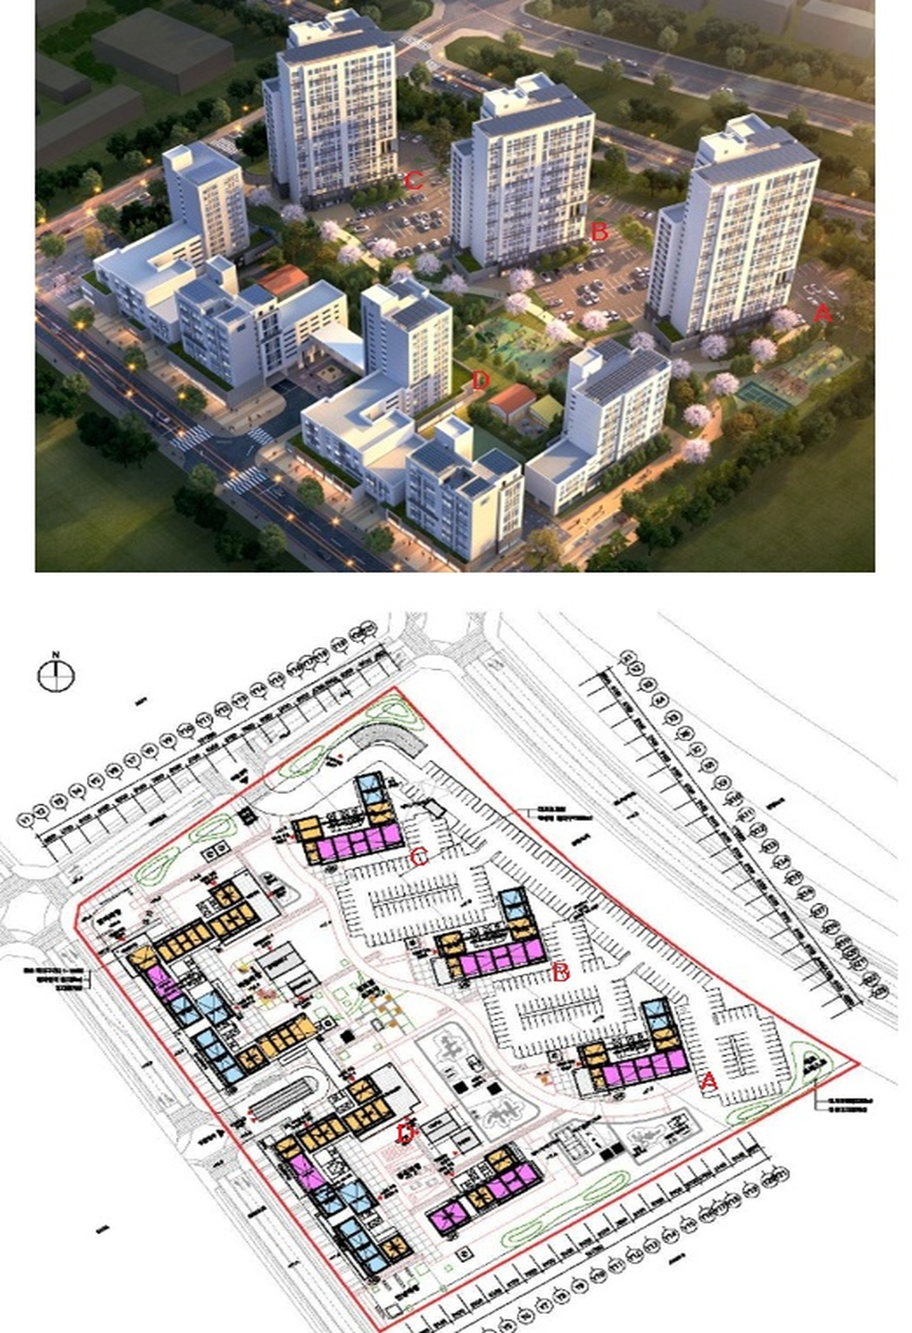
Fig. 1: Perspective view and site plan of the target apartment complex
The architectural concept is derived from the overhang function of traditional Korean buildings. The overhang reduces high-angle summer solar gains while allowing lower-angle winter radiation to reach the facade. In the proposed system, a bifacial PV module occupies this overhang position so that the same element provides shading and solar-electricity generation. The target apartment section also allows integration with a hydronic radiant heating and cooling system, creating a combined envelope-and-conditioning concept for nearly zero-energy housing.
Figure 2 shows the concept of traditional architecture and Figure 3 illustrates the section of the target apartment.
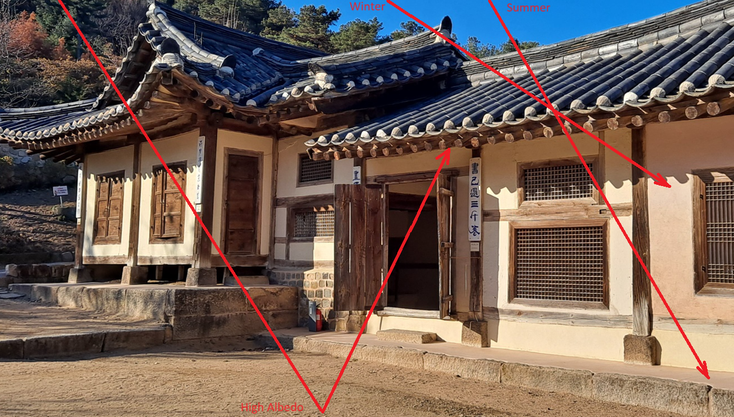
Fig. 2: Concept of traditional architecture
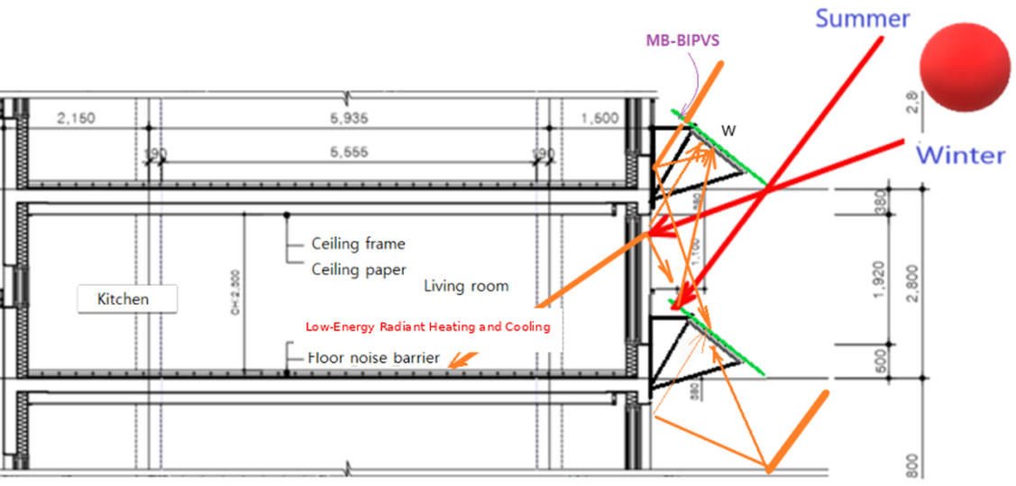
Fig. 3: Section of the target apartment
The passive intelligent radiant cooling concept considered for integration with the MB-BIPVS reuses embedded hydronic floor pipes for summer cooling. Low-temperature water can absorb heat from the floor structure before being used for normal non-potable household purposes. In the present BIPV study, this cooling concept is treated as a complementary system rather than as part of the PV simulation itself. The shading function of the MB-BIPVS can reduce the cooling load and may therefore reduce the cooling duty imposed on the radiant system.
2.2. Solar Simulation Method
The MB-BIPVS was simulated using the SolCel program, which calculates solar position, diffuse irradiance, shading, surface view factors, total solar radiation, cell temperature, and PV power output. The simulation was adapted to account for bifacial radiation exchange from walls, windows, the ground, the PV surfaces, and adjacent buildings. The reflected-radiation component is determined through view-factor calculations, enabling the influence of urban surroundings on the rear side of the bifacial module to be represented.
Figure 4 shows the calculation structure of the SolCel simulation program.
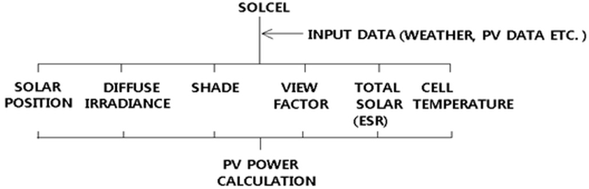
Fig. 4: Calculation structure of the SolCel simulation program
Figure 5 illustrates the geometric variables used to calculate direct, diffuse, reflected, and obstructed solar radiation (Yoo, 2019). The ray paths represent the principal radiation components that can reach the front and rear sides of the bifacial module. The model therefore captures both the shading function of the projection and the energy-harvesting potential of reflected radiation.
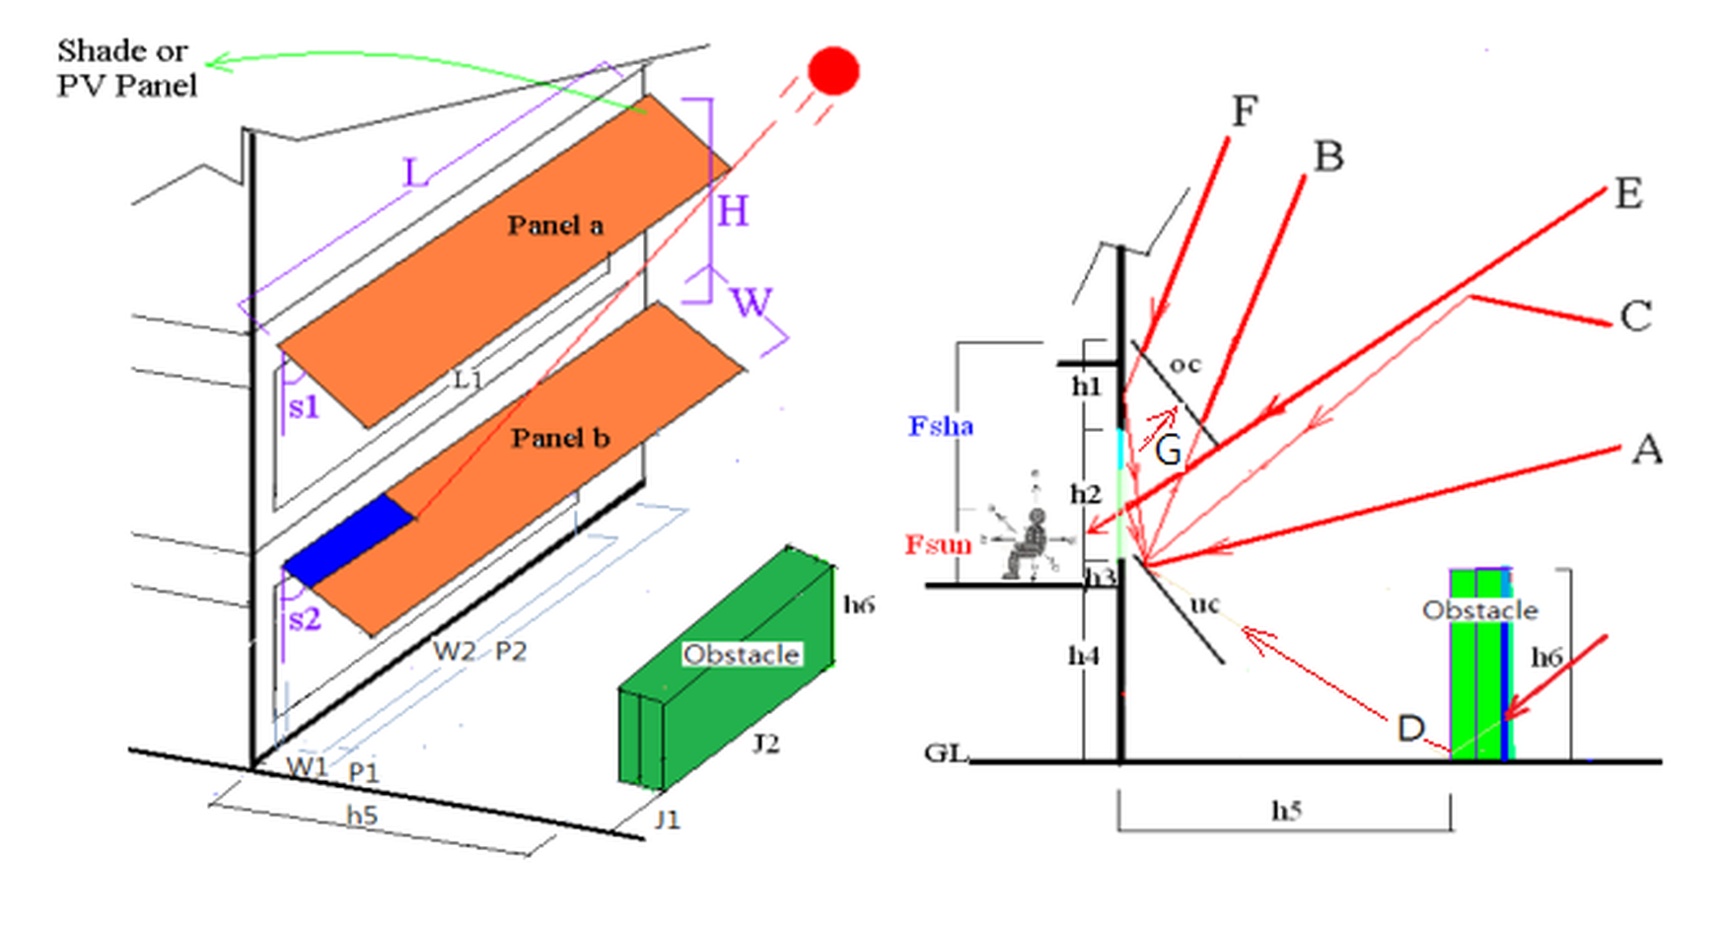
Fig. 5: Geometric representation of shading, obstacles, and reflected solar radiation for the MB-BIPVS
Figure 6 shows the perspective view of the MB-BIPVS.

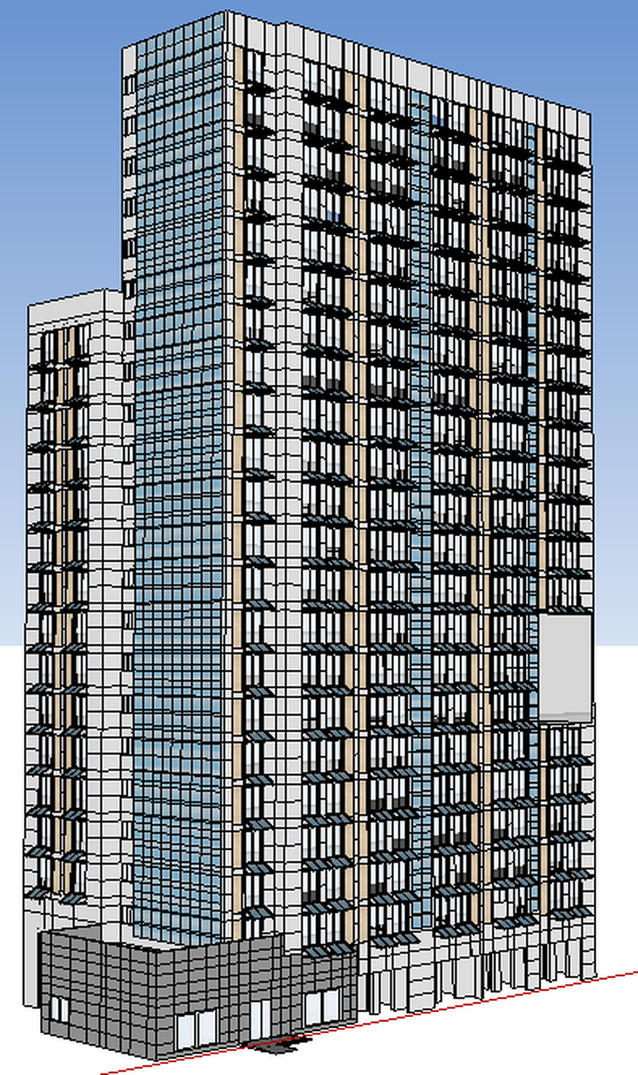
Fig. 6: Perspective view of the MB-BIPVS
Table 1 summarizes the principal input variables used in the target apartment simulations.
Tab. 1: Principal simulation inputs for the target apartment
Parameter | Value | Remarks
Building latitude | 37.5°N (comparison: 34.0°N) | Seoul-region base case
Facade azimuth | 180° | South-facing
Adjacent-building height | 63 m | Obstacle apartment A
Distance between buildings | 40 m | Right-angle distance
PV module angle | 23.5° | Relative to horizontal
Cell type | Monocrystalline | Bifacial module
Nominal module efficiency | 16.44% | Reference input
Module size | 1643 × 981 × 40 mm | Unit area ≈ 1.6 m²
Module projection width | 0.8, 1.0, 1.2, 1.4 m | Sensitivity analysis
Cell ratio | 0.85, 0.75, 0.60 | Sensitivity analysis
Ground albedo | 0.2/0.3 and 0.3/0.4 | Summer/Winter cases
Wall / window reflectance | 0.4 / 0.2 | Base case
Annual system performance is summarized using the system usage rate (SUR), defined as:
SUR = 100 × Annual electricity generation / (Total PV area × Annual global irradiation) (1)
Hourly weather data for the Seoul region were used for the base simulation. The original dataset gives annual global solar irradiation values of approximately 1,106 kWh/m²·yr for the northern reference region and 1,137 kWh/m²·yr for the southern reference region. Unless a parameter is varied explicitly, the remaining inputs are held at the base-case values shown in Table 1. The cell-ratio sensitivity (0.85, 0.75, and 0.60) is used to examine active cell area, transmission, and rear-side irradiation effects.
3. Results and Discussion
3.1. Influence of PV Module Width
Increasing the projection width from 0.8 to 1.4 m increases the total installed PV area and therefore increases annual electricity generation. Annual generation rises from 49,430 kWh at 0.8 m to 55,928 kWh at 1.0 m, 60,573 kWh at 1.2 m, and 68,406 kWh at 1.4 m. In contrast, SUR decreases from 13.31% to 12.04%, 10.87%, and 10.52%, respectively. Thus, a larger projection produces more total electricity but uses the available PV area less efficiently according to the SUR metric.
Figure 7 shows monthly power generation for four MB-BIPVS projection widths.

Fig. 7: Monthly power generation for four MB-BIPVS projection widths
The preferred projection cannot be selected from annual electricity generation alone because the overhang also affects shading, daylight, facade appearance, and cooling-load reduction. Within the studied design concept, a 1.0 m projection is retained as a practical reference because it is compatible with the intended traditional overhang proportion while maintaining substantial annual generation.
3.2. Influence of Cell Ratio
The cell ratio has a strong influence on annual electricity generation in the simulated geometry. With a cell ratio of 0.85, annual generation is 55,928 kWh and SUR is 12.04%. Reducing the ratio to 0.75 increases these values to 74,580 kWh and 16.06%, while a ratio of 0.60 produces 97,069 kWh and an SUR of 20.9%. These results show that the cell ratio changes the balance between active cell area, transmission, rear-side irradiation, and the total reference PV area used in the SUR definition. Figure 8 shows the influence of PV cell ratio on monthly MB-BIPVS electricity generation.

Fig. 8: Influence of PV cell ratio on monthly MB-BIPVS electricity generation
The highest SUR does not automatically define the preferred facade design. A lower cell ratio also changes daylight transmission and the amount of solar radiation entering the apartment. Therefore, the final cell ratio should be selected by considering power output, daylight availability, glare/visual comfort, and cooling-load reduction together.
3.3. Influence of an Adjacent Building
The influence of the neighboring apartment is comparatively small but measurable even when the PV modules are not directly shaded. The reference apartment A produces 55,928 kWh annually. The corresponding outputs for apartments B and B1 are 55,605 and 55,295 kWh, equivalent to reductions of approximately 0.58% and 1.11%, respectively. The difference results from changes in reflected and obstructed radiation associated with relative building position. Figure 9 shows the influence of adjacent-building position on monthly MB-BIPVS electricity generation.

Fig. 9: Influence of adjacent-building position on monthly MB-BIPVS electricity generation
3.4. Influence of Ground Albedo
Changing the assumed ground albedo from 0.2 in summer and 0.3 in winter to 0.3 in summer and 0.4 in winter produces only a 0.21% increase in annual electricity generation for the studied high-rise inland configuration. This limited sensitivity reflects both the moderate albedo range and the geometry of the facade system. Although bifacial modules can benefit from reflected irradiance, the magnitude of this benefit depends strongly on surface visibility and urban geometry.
Figure 10 shows the influence of seasonal ground albedo on monthly MB-BIPVS electricity generation.

Fig. 10: Influence of seasonal ground albedo on monthly MB-BIPVS electricity generation
3.5. Influence of Building Latitude
The same building and MB-BIPVS geometry were compared at 37.5°N and 34.0°N. Annual generation changes from approximately 55,928 to 55,572 kWh, a difference of about 0.64%, while the respective SUR values are 12.04% and 11.89%. Within this limited 3.5° latitude range and at the same module inclination, the annual output is therefore relatively insensitive to latitude, although the monthly distribution changes more visibly.
Figure 11 shows the influence of building latitude on monthly MB-BIPVS power generation.

Fig. 11: Influence of building latitude on monthly MB-BIPVS power generation
3.6. Integrated Interpretation for Nearly Zero-Energy Apartments
The parameter study shows that the MB-BIPVS should be optimized as a building component rather than as an isolated PV generator. Projection width and cell ratio have the largest influence on the simulated performance, whereas the tested variations in neighboring-building position, ground albedo, and latitude are comparatively modest. The overhang function can additionally reduce direct summer solar gains; earlier work on the same shading concept reported a cooling-load reduction of approximately 27.5-34% depending on conditions (Yoo et al., 2025). This passive contribution is important because it can reduce the cooling demand that must be met by mechanical or radiant systems.
A further system-level opportunity is the integration of the MB-BIPVS with passive intelligent radiant cooling. In this configuration, the facade reduces solar gains and generates electricity, while the radiant system uses low-temperature water and the thermal mass of the floor to remove sensible heat. The present paper does not quantify a complete energy balance for the combined system; therefore, this integration is presented as a design strategy to be validated experimentally rather than as a quantified zero-energy result.
Table 2 summarizes the principal MB-BIPVS sensitivity results.
Tab. 2: Summary of the principal MB-BIPVS sensitivity results
Variable | Cases | Main result | Design implication
Projection width | 0.8-1.4 m | 49,430-68,406 kWh; SUR 13.31-10.52% | 1.0 m retained as practical reference
Cell ratio | 0.85 / 0.75 / 0.60 | SUR 12.04 / 16.06 / 20.9% | Balance power, daylight and shading
Adjacent building | A / B / B1 | Maximum reduction ≈ 1.11% | Account for reflected/obstructed radiation
Ground albedo | 0.2/0.3 → 0.3/0.4 | Annual increase ≈ 0.21% | Minor effect for tested inland case
Latitude | 37.5°N vs 34.0°N | Annual difference ≈ 0.64% | Small within tested range
4. Implications for Practitioners and Policy Makers
The results support three practical points. First, facade PV should be evaluated as both an architectural and energy component: a design that maximizes installed PV area is not necessarily the design that best balances electricity generation, shading, daylight, and appearance. Second, urban surroundings should be represented in bifacial BIPV assessment even when direct shading is absent, because reflected radiation can alter annual output. Third, nearly zero-energy housing strategies can benefit from combining passive load reduction with on-site renewable generation and low-energy conditioning rather than relying on a single technology.
For practitioners, the simulation workflow provides a way to screen module geometry and site conditions before detailed facade engineering. For policy makers and demonstration projects, performance assessment should consider multiple functions of BIPV, including renewable generation, solar control, material substitution, and potential interaction with cooling systems, so that incentives do not reward electricity yield alone.
5. Conclusions
A multifunctional bifacial BIPV shading system was evaluated for a 22-story nearly zero-energy apartment concept. The simulation quantified the influence of PV projection width, cell ratio, adjacent-building geometry, albedo, and latitude. Increasing projection width raised total annual generation but reduced SUR, while reducing the cell ratio produced a substantial increase in both annual generation and SUR. The adjacent-building effect reached approximately 1.11%, whereas the tested albedo and latitude variations changed annual output by only about 0.21% and 0.64%, respectively.
The findings indicate that MB-BIPVS optimization should be based on a multi-objective design criterion rather than electricity production alone. For the studied facade, a 1.0 m projection is proposed as a practical reference because it combines meaningful power generation with the intended architectural overhang function.
The cell ratio should be selected by jointly assessing PV output, daylight, and shading. Integration with passive intelligent radiant cooling is a promising system-level extension, but a complete energy balance of the combined system remains to be experimentally validated. Future work should therefore evaluate full-scale BIPV performance, apartment cooling/heating demand, thermal comfort, and system-level energy self-reliance under different climates and urban configurations.
6. Acknowledgments
This research was financially supported by the Ministry of Trade, Industry and Energy (MOTIE) and the Korea Institute for Advancement of Technology (KIAT) under Project No. P0026322 through the International Cooperative R&D program EUREKA.
7. References
Brito, M.C., Gomes, N., Santos, T., Tenedorio, J.A., 2017. The importance of facades for the solar PV potential of a Mediterranean city using LiDAR data. Renewable Energy 111, 85-94.
Chen, M. et al., 2021. Improvement of the electricity performance of bifacial PV module applied on the building envelope. Energy and Buildings 238, 110849.
Ghosh, A., 2020. Potential of building integrated and attached/applied photovoltaic (BIPV/BAPV) for adaptive less energy-hungry building skin: A comprehensive review. Journal of Cleaner Production 276, 123343.
IEA, 2021. The Role of Energy Efficient Buildings on the Path to Net-Zero - Strategies for Policymakers. International Energy Agency, Paris.
Mandalaki, M. et al., 2014. Integrated PV in shading systems for Mediterranean countries: Balance between energy production and visual comfort. Energy and Buildings 77, 445-456.
Paydar, M.A., 2020. Optimum design of building integrated PV module as a movable shading device. Sustainable Cities and Society 62.
Skandalos, N. et al., 2022. Building PV integration according to regional climate conditions: BIPV regional adaptability extending Koppen-Geiger climate classification against urban and climate-related temperature increases. Renewable and Sustainable Energy Reviews 169.
Tina, G.M. et al., 2020. A novel building ventilated facade with integrated bifacial photovoltaic modules: Analysis of the electrical and thermal performances. SpliTech 2020.
Yoo, S.-H., 2019. Optimization of a BIPV system to mitigate greenhouse gas and indoor environment. Solar Energy 188, 875-882.
Yoo, S.-H., et al., 2025. Ecological guidelines of plus-energy solar house elements for the climate resilient village model, ISES Solar World Congress 2025, Fortaleza, Brazil.

