Virtual testing of composite sandwich structures in aircraft interior – an industrial case study
Ralf Seemann¹ and Hermann Hübner¹

¹DIEHL Aviation, Hein-Saß-Weg 41, 21129 Hamburg, Germany
Email: ralf.seemann@diehl.com, Web Page: http://www.diehl.com/aviation

Keywords: Nomex honeycomb, partially potted insert, explicit FEA, virtual testing

Abstract
The present contribution presents a comparative study where two state-of-the art finite element modelling approaches for virtual testing of honeycomb sandwich panel joints are compared. This is done using the example of partially potted inserts under out-of-plane loading. The two compared approaches differ in the implemented core models while both, a 3D-continuum and a detailed meso-scale model were implemented. It could be demonstrated that the 3D-continuum approach yields to similar results if compared to the detailed meso-scale model, at considerably less computational and modelling effort. It is therefore recommended for typical industrial engineering applications.

1. Introduction

Aircraft interior monuments have to comply with strict legal airworthiness requirements not only in terms of flammability but also mechanical strength. Acceptable means of compliance include engineering evaluation for instance through calculation or testing. Furthermore, in order to ensure that compliance can be substantiated, concurrent determination of the mechanical product properties is required throughout the product development phase. Due to the complicated failure behavior of composite sandwich panels in particular in the vicinity of attachments and joints, the determination of the structural strength largely relies on real world testing. This is a major cost driver in the development process of aircraft cabin monuments. The implementation of virtual test methods based on FE-simulations can be a significant contributor to reducing the development cost.

In the recent past several studies have emerged where non-linear FE-simulations were successfully implemented in order to predict the strength of composite sandwich panel components. Notable works include Bunyawanichakul et al. [1], who tested countersunk titanium fasteners bonded in honeycomb sandwich panels on a test rig, which allows to apply pre-stress to the fastener. In addition, they developed a FE-model supported by constituent tests on the potting material and the honeycomb core, while the honeycomb core was modelled using 3D-continuum elements. Nguyen et al. [2], developed a FE-model for various configurations of composite foam sandwich panel joints, while comparing different failure modeling methods. Heimbs and Pein [3] derived 3D-continuum models of sandwich corner joint and inserts. These models were based on spotweld elements and they were intended for an implementation in a global non-linear model of aircraft interior components. They also implemented a detailed FE-model of a honeycomb sandwich insert, where the hexagon core geometry is modeled accurately. Such detailed meso-scale models of sandwich panels with structured cores have seen increasing applications, in particular for impact and crushing analyses of sandwich panels [4–9]. However, there are additional applications for sandwich panel inserts evident. Bianchi et al. [10], investigated hot and cold bonded procedures of honeycomb sandwich insert manufacturing. They implemented a linear detailed FE-model and concluded that the stiffness of the potting material strongly influences the insert joint strength. Roy et al. [11] conducted experimental studies on honeycomb sandwich panel inserts and derived the orthotropic material properties of the Nomex cell wall material using a detailed meso-model of the joint. The reviewed literature can be sub-divided in 3D-continuum models, where the honeycomb core is modelled using 8-node brick elements and detailed models where the actual cellular core is modelling using shell or brick elements. This contribution presents a case study, where these two state of the art modelling approaches are benchmarked. The objective was to evaluate what modelling approach is more suitable for industrial engineering applications. This was done based on the example of the out-of-plane loading of sandwich panel inserts. This example was chosen, since it represents a standard fastening element in sandwich construction and it is known to exhibit a complicated failure behaviour. In the following, the investigated materials are introduced before, the experimental study as foundation of the benchmark is described. Subsequently the implemented numerical models are described and the results are presented and briefly discussed.

2. Materials

The investigated materials represent a typical insert configuration in aircraft interior applications. The face sheets comprised a single layer of glass fiber fabric reinforced phenolic resin prepreg (according to Airbus standard ABS5047-07). The core was a Nomex honeycomb core with 3.2 mm cell width and a density of 48 kg/m³. The base panel had a nominal thickness of 26 mm and was manufactured industrially using co-curing flat press moulding. A light weight plastic insert with metallic thread of the type ABS1005-08078T was cold bonded in the panel using a two-component epoxy adhesive. The investigated material configuration is illustrated in Figure 1
Figure 1 Materials of investigated insert configuration

3. Experimental study

The experimental study comprised 12 specimens, which were tested until catastrophic failure using a typical insert pull-out fixture as suggested by the Insert Design Handbook [12]. The circular cut-out of the fixture had a diameter of 80 mm and the specimens had a cross section of 100 mm x 100 mm. The universal testing machine was equipped with a HBM S9M-10 kN load cell. The displacement was recorded directly from the crosshead of the machine. The experimental results for all specimens are given in terms of force-displacement relationship in Figure 2 a). The pull-out strength in terms of peak force ranged between 1600 N and 1300 N, which corresponds to a scatter of about 20%. It is assumed that this considerable scatter largely originates from the varying effective potting radius in the specimens, which has significant impact on the pull-out strength of sandwich inserts [12]. The varying potting radius is a result of the random number of honeycomb cells being opened by the borehole during insert manufacturing. The curve progression of all specimens was characterized by three stages, linear elastic deformation followed by quadratic curve flattening from about 1000 N and rapid stiffness degradation shortly after the peak force. The governing damage mechanisms were investigated based on external inspection during and after the tests as well as based on cut section of the specimens. The four identified damage mechanisms are depicted in Figure 2 b). Shear buckling of the cell walls at the interface between potting and core, is well known as first damage mechanism for typical honeycomb sandwich insert configurations [11,13] and this was also confirmed in the present study. The rapid stiffness degradation is initiated by tensile failure of the core beneath the potting. Face sheet failure and debonding of core and face only occurred well beyond the peak force.
a)  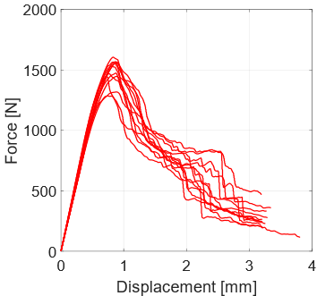 | b)  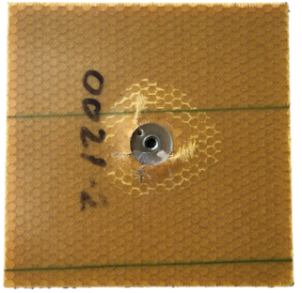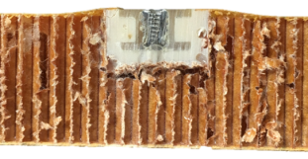  Debonding of core and face sheet  Tensile failure of core  Face sheet failure  Shear buckling of cell walls
Figure 2 Experimental results, a) force-displacement relationship and b) observed damage mechanisms

4. Numerical models

The investigated insert configuration consists of four constituents. The modelling approach for each constituent is described, in the following. All simulations were performed using ABAQUS/Explicit 6.14. An explicit solver was selected to account for the multitude of damage mechanisms to be considered.
The insert was made of plastic body with a metallic threaded bushing. The experimental study did not indicate any damage of the insert. Therefore, an isotropic elastic material model with an estimated Young’s modulus of E = 5000 MPa was implemented. The threaded bushing was modelled as rigid element, which also served as load introduction point. The elastic-plastic material parameters of the used adhesive after curing, were characterized in tension and compression tests based on ASTM D638 and ASTM D695 respectively. A suitable material model was derived and calibrated, using the experimentally determined stress-strain behavior. The core was implemented using both of the previously introduced modelling approaches, 3D-continuum and detailed meso scale. The detailed model was implemented based on the recommendation given in a previous work of Seemann and Krause [8], where the same Nomex material was investigated in experiments and numerical studies. They recommended a single layer orthotropic plastic material model for the cell wall material. For the 3D-continuum modelling approach, a homogenized orthotropic plastic material model was implemented and calibrated with the same experimental results. The faces were implemented using an orthotropic material model based on the continuum damage mechanics model of Johnson [14]. This material model is available in ABAQUS/Explicit as pre-compiled user subroutine (VUMAT). It enables to input compressive and tensile strengths in the two material directions independently. In addition, it is capable to represent the shear plasticity of fabric reinforced composites. The unidirectional material properties were determined in coupon tests of the fabric as well as based on four-point bending tests of the base panel. The shear properties were determined from picture frame shear tests of the base panel.
The previously described constituent models were incorporated in two overall models for insert pull-out. The only difference between the two models is the core modelling approach, while both introduced core models, meso scale and 3D-continuum, were implemented. The models feature an irregular potting-to-core interface accounting for the hexagon grid which leads to varying potting geometries. This interface was modelled as tied contact, since no debonding was evident in the experimental study. The same applied for the face-to-potting interface. In contrast, there was debonding of the face sheet and core visible during post-test inspection. However, this only occurred well beyond the peak force in the post failure regime. Therefore, this effect was neglected and the core-to-face interface was modelled as tied contact as well. The fixture was modelled using 8-node continuum elements and an elastic isotropic material model with a Young’s modulus of 210000 MPa. The interface between fixture and top face was modelled as penalty contact. This allowed the panel to separate from the fixture due to bending. Similar to previous publications [1,3,11], the model was implemented as quarter model in order to utilize the symmetry of the specimen and loading condition, thus reducing the computational cost. The simulations were carried out using mass scaling and increased displacement rate. Both numerical parameters were set based on convergence studies. The same applied for the eventually implemented mesh sizes of the different constituents. The overall model is illustrated in Figure 3. The computational time for the 3D-continuum model was about 7 min, while the detailed meso model required 87 min to run. The simulations were run using four cores on a state of the art Intel® Core™ i7 workstation.

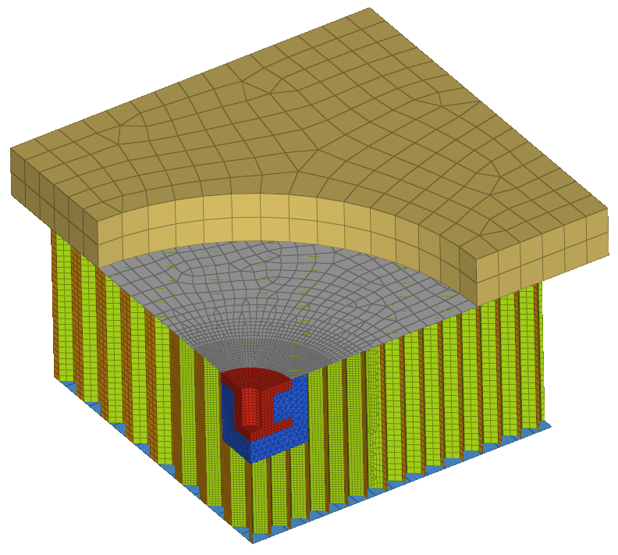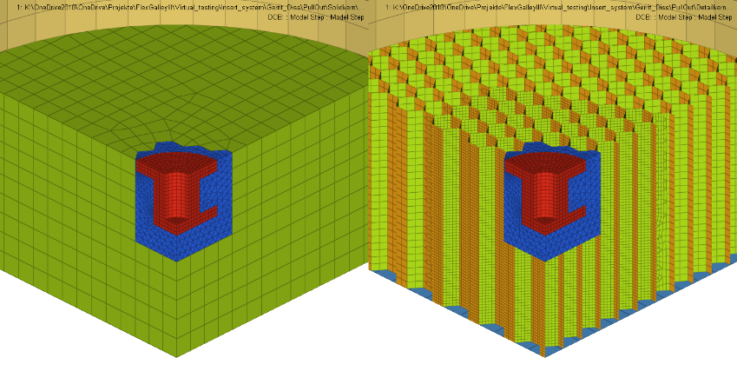
Insert
C3D8R | Elastic
0.5mm elemsize
symmetry
symmetry
Face-core bond
Tied contact
Penalty contact
Honeycomb
S4R | Orth. plastic
0.4/1.5mm elemsize
C3D8R | Orth. plastic
2mm elem size
Fixture
C3D8R | Isotr. elastic
5mm elemsize
Potting
C3D10M | Isotr. bi-plastic
0.8mm elemsize
S4R | Orth. fabric (VUMAT) 0.4-2mm elemsize
Tx,Ty,Tz = 0
Rx,Ry,Rz = 0
Tz = v
Tx,Ty = 0
Potting-core bond
Tied contact
Face
Face-fixture interface
3D-continuum core
Meso scale core
y
x
z
Figure 3 Implemented numerical models

4. Results and conclusion

The simulation results of both models in comparison to the experimental results are given in terms of force-displacement relationship in Figure 4. The experimental results are plotted in the background, while also the scatter is indicated by light grey lines. Macroscopically, both simulation models yield similar results with regards to initial stiffness, peak force and stiffness degradation. Both models match the initial stiffness of the experiments well, while the simulated strength lies in the scatter of the experiments. The curve progression in the following stiffness degradation phase is not matched as accurately by the simulation models. However, overall both models agree well with the experimental results. The detailed meso-scale model performs slightly better in particular when it comes to reproducing the quadratic curve flattening due to core shear failure. The same applies for the stiffness degradation after peak force. The simulation results in terms of visual damage patterns are illustrated in Figure 5. It can be seen, that both simulations also reflect all damage mechanisms, which were observed during post-test inspection of the experimental samples (Figure 2 b).
Considering these results, it can be concluded, that the 3D-continuum modelling approach is sufficient for typical industrial virtual testing applications. The more complicated meso-scale model is recommended only for detailed academic studies, which require more accuracy.
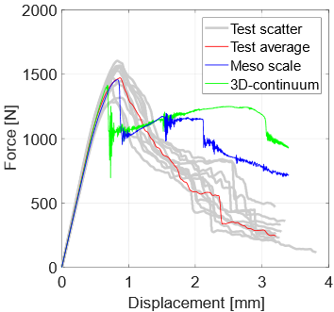
Figure 4 Comparison of numerical and experimental results in terms of force-displacement curves

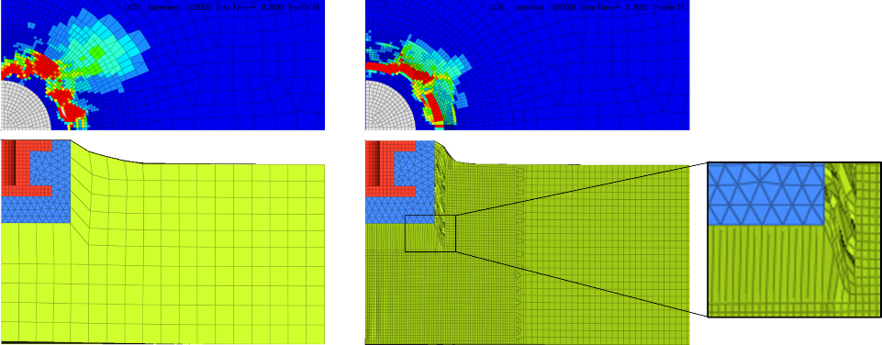
Figure 5 Comparison of the damage mechanisms indicated by both simulation models

Acknowledgments

The presented work was partially funded by the German Federal Ministry for Economic Affairs and Energy, in the framework of LuFo V-2.

References
[1] Bunyawanichakul P, Castanié B, Barrau J-J. Non-linear finite element analysis of inserts in composite sandwich structures. Composites Part B: Engineering 2008;39(7-8):1077–92.
[2] Nguyen K-H, Park Y-B, Kweon J-H, Choi J-H. Failure behaviour of foam-based sandwich joints under pull-out testing. Composite Structures 2012;94(2):617–24.
[3] Heimbs S, Pein M. Failure behaviour of honeycomb sandwich corner joints and inserts. Composite Structures 2009;89(4):575–88.
[4] Castanié B, Aminanda Y, Barrau J-J, Thevenet P. Discrete Modeling of the Crushing of Nomex Honeycomb Core and Application to Impact and Post-impact Behavior of Sandwich Structures. In: Abrate S, Castanié B, Rajapakse YDS, editors. Dynamic Failure of Composite and Sandwich Structures. Dordrecht: Springer Netherlands; 2013, p. 427–89.
[5] Asprone D, Auricchio F, Menna C, Morganti S, Prota A, Reali A. Statistical finite element analysis of the buckling behavior of honeycomb structures. Composite Structures 2013;105:240–55.
[6] Fischer S, Drechsler K, Kilchert S, Johnson A. Mechanical tests for foldcore base material properties. Composites Part A: Applied Science and Manufacturing 2009;40(12):1941–52.
[7] Foo C, Chai G, Seah L. A model to predict low-velocity impact response and damage in sandwich composites. Composites Science and Technology 2008;68(6):1348–56.
[8] Seemann R, Krause D. Numerical modelling of Nomex honeycomb sandwich cores at meso-scale level. Composite Structures 2017;159:702–18.
[9] Giglio M, Manes A, Gilioli A. Investigations on sandwich core properties through an experimental–numerical approach. Composites Part B: Engineering 2012;43(2):361–74.
[10] Bianchi G, Aglietti GS, Richardson G. Static Performance of Hot Bonded and Cold Bonded Inserts in Honeycomb Panels. Journal of Sandwich Structures and Materials 2011;13(1):59–82.
[11] Roy R, Nguyen KH, Park YB, Kweon JH, Choi JH. Testing and modeling of Nomex™ honeycomb sandwich Panels with bolt insert. Composites Part B: Engineering 2014;56:762–9.
[12] ESA. Space engineering Insert Design Handbook; 2011.
[13] Song K-I, Choi J-Y, Kweon J-H, Choi J-H, Kim K-S. An experimental study of the insert joint strength of composite sandwich structures. Composite Structures 2008;86(1-3):107–13.
[14] Johnson AF. Modelling fabric reinforced composites under impact loads. Composites Part A: Applied Science and Manufacturing 2001;32(9):1197–206.

