EuroSun2026
AN ENERGY MODELLING TOOL FOR MUNICIPAL NET-ZERO PLANNING
Santhosh Iyyakkunnel 1 (corresponding author), Pascal M. Vecsei 1, Ueli Schilt 1,2, Sarah Schneeberger 1, Philipp Schuetz 1
1 Hochschule Luzern - Technik & Architektur, Technikumstrasse 21, CH-6048 Horw, Switzerland
2 School of Architecture, Civil and Environmental Engineering (ENAC), École Polytechnique Fédérale de
Lausanne (EPFL), Lausanne, Switzerland
santhosh.iyyakkunnel@hslu.ch
Summary
Municipalities play a key role in achieving Switzerland’s net-zero target by 2050, while local energy planning is becoming increasingly challenging as it is shaped by electrification, sector coupling, and the integration of renewable energy sources. This study demonstrates how a publicly available online tool and its underlying hourly energy system model can be used to explore municipality-specific transition pathways across the heating, electricity, and mobility sectors. Based largely on publicly available data, the model enables the estimation of the impact of parametric variation of measures like heat pump deployment, passenger car electrification, rooftop PV and wind power expansion, and thermal energy storage on emissions and renewable energy consumption. Three contrasting municipalities (Basel, Sirnach, and Lauterbrunnen) are used as illustrative case studies. The results show that the mitigation effect of individual measures depends strongly on local energy system conditions and on cross-effects between measures. Electrification substantially reduces direct heating and mobility emissions but simultaneously increases electricity demand. Depending on the status quo technology mix and the availability of renewable resources, the same measures resulted in markedly different cumulative emission reductions across the three municipalities. The study demonstrates how systematic scenario exploration can complement technical-potential assessments and provide an accessible basis for integrated municipal energy planning.
Keywords: Municipal energy system planning, Net-zero districts
Field of application for the findings: Municipal energy planning
Addressed audience: Energy planners, Municipal officers, Utilities, Researchers, Energy consultants
- Introduction
Switzerland has pledged to reach net-zero greenhouse gas emissions by 2050 (Swiss Federal Office of Energy, 2025a). This requires substantial reductions in emissions from heating, electricity supply and mobility. To achieve this goal, municipalities play an important role in implementing this transition because the majority of relevant measures are dependent on local conditions, including building retrofits, heating-system replacement, renewable-energy deployment, district-heating development, and charging infrastructure for electric mobility. At the same time, the available transition options differ considerably between municipalities as a result of differences in building stock, settlement structure, existing energy infrastructure, mobility patterns, and locally available renewable resources.
This heterogeneity is increasingly important as the heat, electricity, and mobility sectors become more strongly intertwined. Replacing fossil heating systems with heat pumps and combustion engine vehicles with electric vehicles can substantially reduce direct fossil fuel use, but both measures increase electricity demand. The resulting mitigation effect therefore depends not only on the technology being introduced, but also on the status quo energy system configuration, electricity supply, the availability and temporal profile of local renewable generation, and the presence of flexibility options such as energy storage. Assessing transition measures independently can consequently overlook interactions between sectors and lead to different conclusions than an integrated system assessment.
For municipalities, performing such integrated assessments can nevertheless be challenging. Detailed energy-system studies require access to substantial amounts of data, modelling expertise, and typically substantial effort, and are therefore often carried out through dedicated planning studies or external consultancy. In particular smaller municipalities may have limited resources for repeatedly evaluating alternative technology configurations. Decision-support tools that combine openly available data with energy-system modelling can help make such analyses more accessible, while also providing a consistent basis for comparing alternative measures.
To address this need, the Recommender Tool (Gökgöl et al., 2025; HSLU, 2026; Meyer et al., 2026, 2023) was developed within the Swiss Energy Research for the Energy Transition (SWEET) EDGE project (“Sweet EDGE,” 2026). The tool combines municipality-specific energy system data derived from openly available sources with simulations carried out by the in-house developed District Energy Model (DEM). The DEM models hourly energy balances across the heating and electricity sectors and allows the parametrization of various energy technologies. Within the Recommender Tool, users can inspect municipality-specific data related to energy and modify a selected set of transition measures such as replacement of fossil heaters with heat pumps, electrification of passenger cars, rooftop PV expansion, wind power deployment, and thermal energy storage usage. The tool does not prescribe a predefined transition pathway but rather provides a platform on which the key performance factors of potential configurations can be compared with the current setup.
In this study, we demonstrate how the Recommender Tool can be used systematically to investigate these interactions for three Swiss municipalities in different regions: Sirnach (Swiss plateau), Basel (city), and Lauterbrunnen (alpine). We first characterize their status quo emissions distribution and modeled renewable energy generation potentials. We then quantify how heating and mobility electrification alter electricity demand and compare the estimated CO₂ reduction to increasing rooftop PV and wind power deployment. Finally, the measures are combined sequentially to construct an illustrative cumulative transition pathway. The objective is to demonstrate how municipality-specific scenario exploration can reveal differences in mitigation potential and the cumulative effect of transition measures.
- Methods
2.1 Recommender Tool and District Energy Model
This study is based on the Recommender Tool (Gökgöl et al., 2025; HSLU, 2026; Meyer et al., 2026, 2023) and its underlying District Energy Model (DEM) (Schilt et al., 2026a, 2023). The DEM is a municipal-scale multi-energy system model based on an hourly resolution using Calliope (Pfenninger and Pickering, 2018) as an optimization backend. It is openly available as a Python package (Schilt, 2026) or via GitHub (Schilt et al., 2026b). This study uses the DEM version 0.1.0-rc (Schilt et al., 2025a) along with the provided input dataset for Switzerland (Schilt et al., 2025b). Detailed information about the DEM and references to the modeling framework and datasets can be found in the official documentation (Schilt and Vecsei, 2025).
The graphs and diagrams presented in this study were adapted from the Recommender Tool visualizations. While the underlying data and scenario functionality are available in the openly accessible tool, some of the analyses and visualizations shown here are not yet directly implemented in the front end and are planned for future integration.
2.2 Electricity
The municipal electricity demand is estimated using a combination of top-down and bottom-up approaches. Total annual municipal demand is obtained from a top-down electricity-demand model based on measured national consumption, while residential demand is estimated bottom-up using building-stock information from the Swiss Federal Register of Buildings and Dwellings (RBD) (Federal Statistical Office, 2025a) and representative consumption values. The difference is attributed to industry and services. Cantonal electricity consumption data from Swissgrid are used to derive representative hourly profiles for industry and services demand while standard hourly load profiles are used for residential buildings (Rinaldi et al., 2022). Local electricity generation from rooftop PV, wind, biomass, and small-scale hydropower is explicitly represented in the model. Residual demand that cannot be met by local generation is supplied through grid imports, representing electricity from the Swiss electricity system and cross-border exchanges.

2.3 Heat
The municipal heat demand is estimated bottom-up from building characteristics reported in the Swiss Federal Register of Buildings and Dwellings (RBD) (Federal Statistical Office, 2025a). Annual space heating demand is derived from local weather conditions and building characteristics such as construction period, building type, and floor area (Schneeberger et al., 2025). Domestic hot water demand is estimated using SIA reference values (SIA, 2025) and the estimated number of occupants per building. Hourly space-heating profiles are generated using a heating-degree-hour approach, while a standardized load profile is applied to domestic hot-water demand. Information on the installed heating systems is obtained from the RBD and used to assign the calculated heat demand to the respective heat-supply technologies. Heat pumps are modeled using a dynamic coefficient of performance (COP) that varies with local ambient temperature. If thermal energy storage (TES) is deployed in the simulation, it is coupled to the heat pump and charged exclusively during periods with available excess local renewable electricity. The TES is modeled as a simple thermal battery and represents a thermal flexibility potential.
2.4 Mobility
Municipality-specific vehicle shares by fuel type are derived from the Swiss Federal Statistical Office (Federal Statistical Office, 2025b), while EV charging profiles follow the methodology described in (Herrera and Hug, 2025). In consultation with the authors, we used simulated values for the overall distance travelled on a municipal level and combined them with available vehicle stock data to estimate the carbon emissions.
In the DEM, additional EV electricity demand is represented separately. However, existing EV charging in the status quo is assumed to be included in the empirical baseline electricity demand. For reporting, this contribution is estimated by scaling the electricity demand of a 100% EV reference simulation by the observed EV share in the respective status quo year. The EV expansion scenario is then applied to the remaining non-electric passenger-car fleet.
2.5 Renewable potentials
Municipality-specific modeled potentials for rooftop PV (Frischholz, 2025; Swiss Federal Office of Energy, 2023) and wind power (Dujardin and Lehning, 2022) were received from the authors and are used to define the maximum deployment levels. Existing installations are accounted for separately (Swiss Federal Office of Energy, 2025b), such that scenario deployment refers to the remaining modeled potential.
2.6 Emissions
Operational CO₂-equivalent emissions are calculated from the hourly energy supplied by each technology using fixed technology-specific emission factors. Local renewables like PV and wind are given zero operational emissions, while imported grid electricity and fossil-based heating technologies are assigned corresponding CO₂-equivalent intensities. The factors are assumed to be constant over the simulation period. Direct mobility emissions are limited to registered passenger cars and are calculated from travelled distance, fuel shares, and fuel-specific CO₂-equivalent emission factors. Fully electric vehicles are excluded from direct mobility emissions because their emissions are accounted for in the electricity sector. The CO₂ emission factors for the relevant technologies and car fuels (Federal Statistical Office, 2025b) are compiled in Table 1.
2.7 Scenario analysis
In this study, DEM is operated in deterministic, hourly resolved simulation mode. Transformation measures can be parameterized independently, allowing different technology combinations to be evaluated. The investigated measures are: (i) heat pump retrofit (100%), replacing all oil and gas boilers with heat pumps; (ii) EV electrification (100%), electrifying the entire remaining non-electric passenger-car fleet., (iii) PV rooftop deployment (100%), exploiting all remaining suitable rooftop potential; (iv) wind power deployment(100%), utilizing the remaining technically available wind potential; and (v) thermal energy storage (TES), installing a maximum storage capacity equivalent to 20% of annual municipal heat demand, representing an upper-bound thermal flexibility scenario. The TES is solely charged using heat pumps whenever excess renewable electricity is available. Although DEM includes an optimization module, it is not applied here; the focus is on pathway-based scenario evaluation.
The measures are evaluated in different combinations depending on the analysis. For the renewable deployment analysis, rooftop PV and wind deployment are varied between 0 and 100% of the remaining modeled potential under the four electricity-demand configurations: status quo, full heat-pump deployment, full passenger-car electrification, and combined heat-pump and passenger-car electrification. For the cumulative pathway analysis, the above-mentioned measures are added sequentially in that order, with each step retaining the measures implemented previously. Finally, an illustrative cumulative pathway is constructed by sequentially applying heat-pump electrification, passenger-car electrification, rooftop PV, wind power, and finally TES.
2.8 Case study municipalities
Three municipalities were selected to cover contrasting geographical and settlement contexts as well as different local energy systems and renewable resource conditions in Switzerland: Sirnach (TG) as a municipality on the Swiss plateau, Basel (BS) as a city, and Lauterbrunnen (BE) as an alpine case. Their populations at the end of 2024 are approximately 177’571, 8’200, and 2’331, respectively. The selection is illustrative rather than statistically representative and is intended to demonstrate how the same modeling framework responds to different local energy-system conditions.
Tab. 1: CO₂ intensities of heating technologies and grid supply in the DEM, as well as fuel types of passenger cars, used to estimate total municipal emissions.
Sector | Technology | CO₂ Intensity  [kg CO₂/kWh]
heat | oil boiler | 0.301
heat | gas boiler | 0.228
heat | wood boiler | 0.027
heat | district heating | 0.108
electricity | grid supply | 0.128
 | Fuel type | CO₂ Intensity  [kg CO₂/km]
mobility | petrol (gasoline) | 0.2976
mobility | diesel | 0.3024
mobility | petrol–electric: normal hybrid | 0.2857
mobility | petrol–electric: plug-in-hybrid | 0.2749
mobility | diesel-electric: normal hybrid | 0.2477
mobility | diesel-electric: plug-in-hybrid | 0.2509
mobility | electric | 0.1437
mobility | hydrogen | 0.1893
mobility | gas (mono- und bivalent) | 0.2445
mobility | Other | 0.2983
- Results
The Recommender Tool allows users to explore municipality-specific energy indicators and simulate alternative technology configurations. Here, these capabilities are used systematically to compare the current emissions structure, renewable-generation potential, the effect of sector electrification on electricity demand, the CO₂ response to increasing renewable deployment, and finally cumulative transition pathways for Sirnach, Basel, and Lauterbrunnen.
The Recommender Tool provides municipality-specific information on current CO₂ emissions from sectors, electricity consumption, heating, and mobility. Exploring these indicators gives an initial picture of the sectors that dominate the local carbon footprint and may therefore be particularly relevant when evaluating measures. Fig. 1 shows the status quo emissions structure for Sirnach, Basel, and Lauterbrunnen. In addition to the sectoral shares, total annual emissions and per-capita emissions are reported in the center of each donut chart.
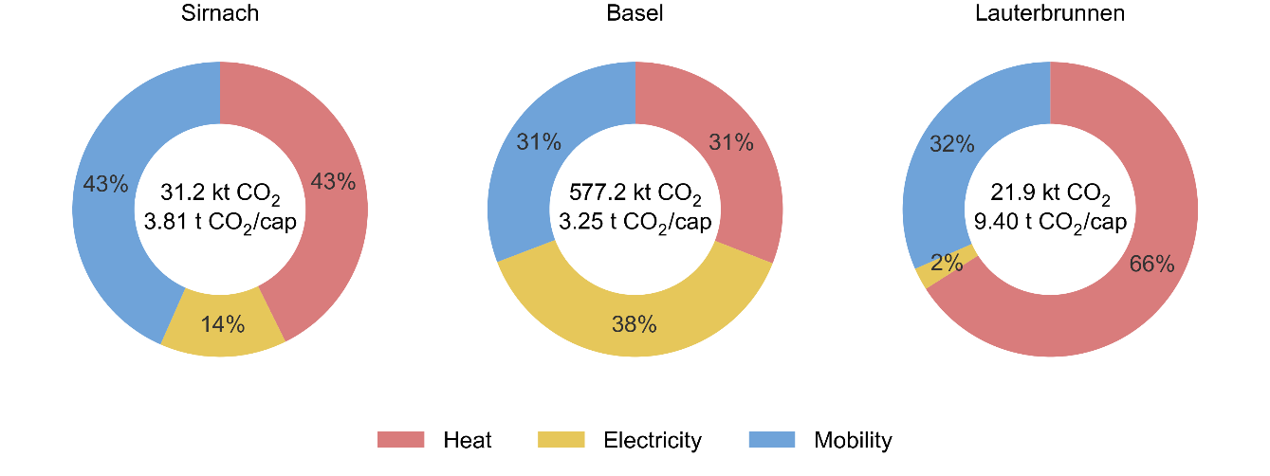
Fig. 1: Annual CO₂ emissions by sectors for the three municipalities Sirnach, Basel and Lauterbrunnen.
The three municipalities differ substantially in their baseline emissions structure. Basel exhibits a comparatively balanced distribution across the three sectors. In Sirnach, heating and mobility together account for more than 85% of status quo emissions, while electricity contributes only a small share. Lauterbrunnen is strongly dominated by heating-related emissions, which account for approximately two-thirds of its total emissions.
The sectoral composition indicates where emissions currently arise and where mitigation potential most likely lies. The following analyses investigate which local renewable resources are available and how strongly different deployment measures can reduce these emissions.
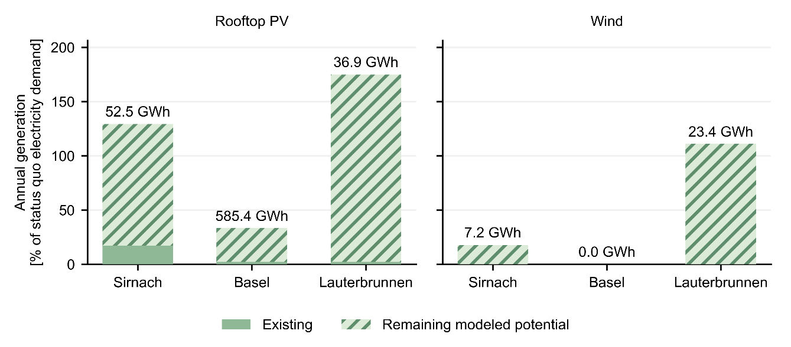
Fig. 1: Existing and remaining modeled potential annual energy generation of rooftop PV (left) and wind power (right) relative to the status quo electricity demand for Sirnach, Basel and Lauterbrunnen.
The Recommender Tool also provides estimates of existing renewable electricity generation and the remaining modeled generation potential for technologies such as rooftop PV systems and wind power. Fig. 2 compares these quantities for the three municipalities. To facilitate comparison between municipalities of very different sizes, annual generation is normalized by status quo electricity demand, while the labels above the bars report the corresponding annual generation at full modeled deployment.
Rooftop PV represents a substantial resource in all three municipalities, although its importance relative to local electricity demand varies considerably. In Sirnach, full modeled rooftop-PV generation corresponds to approximately 130% of current annual electricity demand, while in Lauterbrunnen it reaches roughly 175%. Basel has by far the largest absolute rooftop-PV generation potential, approximately 585 GWh per year, but this corresponds to only about one-third of its substantially larger electricity demand. Existing PV generation represents only a small fraction of the modeled potential in all three municipalities.
Wind potential is considerably more heterogeneous. Sirnach has a comparatively modest, modeled annual wind resource of about 7.2 GWh, whereas no additional wind potential is identified for Basel. Lauterbrunnen shows a much larger wind resource relative to its electricity demand as a modeled annual wind generation of approximately 23.4 GWh corresponds to more than the municipality's current annual electricity consumption.
Both, absolute renewable potential and its magnitude relative to local demand, are relevant indicators for municipalities and their transition planning.
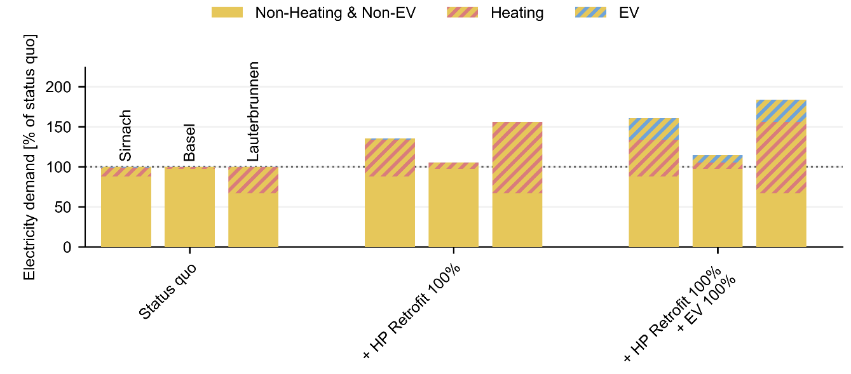
Fig. 3: Relative change in electricity demand in the three municipalities following the full retrofit of fossil heaters to heat pumps and the electrification of passenger cars. Electricity demand for heating is shown in red hatching, while EV charging is shown in blue hatching.
Measures such as replacing fossil-fuel heating systems with heat pumps and electrifying passenger cars reduce direct fossil energy use but simultaneously increase electricity consumption. The scenario simulation feature of the Recommender Tool can therefore be used to quantify how these measures change the municipal electricity demand. Fig. 3 compares the status quo with full replacement of fossil heating systems by heat pumps and with the subsequent electrification of the remaining passenger car fleet. For more clarity, electricity demand is separated here into heating, EV charging, and all remaining electricity demand. It is normalized by the status quo electricity demand of each municipality.
The results reveal a clear sector-coupling effect. Heat pump deployment transfers part of the energy demand previously supplied by fossil fuels into the electricity sector, while EV deployment creates an additional electricity load associated with motorized mobility. The magnitude of these changes differs across the municipalities because their initial heating and mobility structures are different. Consequently, measures that reduce direct emissions in heating and mobility simultaneously increase the importance of the electricity sector in the municipal energy balance. Following full heat pump deployment and mobility electrification, electricity demand increases by ca. 60 % in Sirnach and over 80 % in Lauterbrunnen but only by ca. 14 % in Basel.
The renewable-generation potentials shown in Fig. 2 do not translate directly into equivalent CO₂ reductions. Their mitigation effect depends on the electricity demand configuration in which additional renewable generation is introduced. To investigate this interaction, rooftop PV and wind deployment were varied from 0 to 100% of the modeled additional potential under four configurations: the status quo, full heat pump deployment, full passenger car electrification, and combined heat pump deployment and mobility electrification. Fig. 4 reports the resulting additional CO₂ reduction relative to the original municipal status quo.
In Sirnach, rooftop PV provides a progressively increasing CO₂ reduction, but the magnitude depends strongly on the electrification configuration. At full PV deployment, the reduction is approximately 3.5% of status quo emissions under current demand and increases to more than 5% following combined heat pump and EV deployment. Wind deployment produces a smaller overall CO₂ reduction of approximately 2.5–3%, and the differences between demand configurations are less pronounced than for PV.
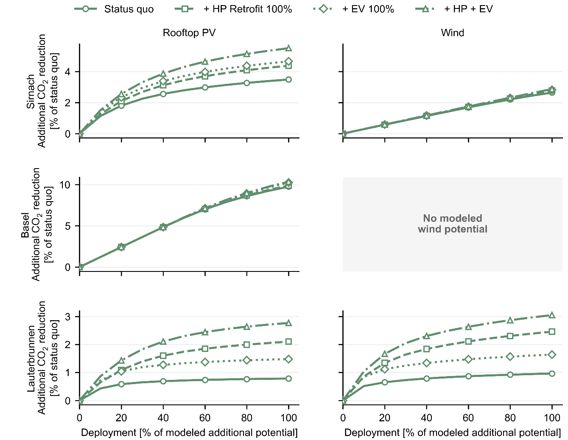
Fig. 4: Additional CO₂ emission reductions from the deployment of local renewable energy sources, such as rooftop solar and wind power, under four scenarios: status quo, full heat pump retrofit, full electrification of passenger cars, and both measures combined. Results are shown for the three municipalities (rows).
Basel shows a substantially larger absolute CO₂ response to rooftop-PV deployment. At full modeled deployment, PV reduces emissions by approximately 10% of the municipal status quo across all four configurations. As no additional modeled wind potential is available for Basel, no additional CO₂ reduction from wind deployment is evaluated.
Lauterbrunnen displays the strongest dependence on the electrification configuration. Under status quo demand, full deployment of either PV or wind produces a reduction of only around 1% of baseline emissions. Following electrification, however, the mitigation benefit increases substantially. Combined heat pump and EV deployment raises the reduction from full rooftop PV deployment to almost 3%, while full wind deployment achieves slightly more than 3%. The response curves also become progressively flatter with increasing deployment, particularly under the status quo configuration, indicating diminishing additional CO₂ reductions at higher deployment levels.
Across the three municipalities, the results demonstrate that the CO₂ benefit of renewable deployment is not determined solely by the size of the technical resource but also by the municipal electricity demand structure and which electrification measures have already been implemented.
To examine how individual measures interact when combined, illustrative cumulative transition pathways are constructed using the results of the Recommender Tool. Starting from the status quo, fossil heating systems are replaced by heat pumps, the remaining passenger car fleet is electrified, the modeled rooftop PV and wind potentials are deployed, and thermal energy storage is added. The pathways are constructed for analytical purposes and do not represent a fixed sequence prescribed by the Recommender Tool. Fig. 5 separates changes in heating, mobility, and electricity related emissions, thereby showing both the direct mitigation effect of each intervention and the electricity sector effects induced through sector coupling.
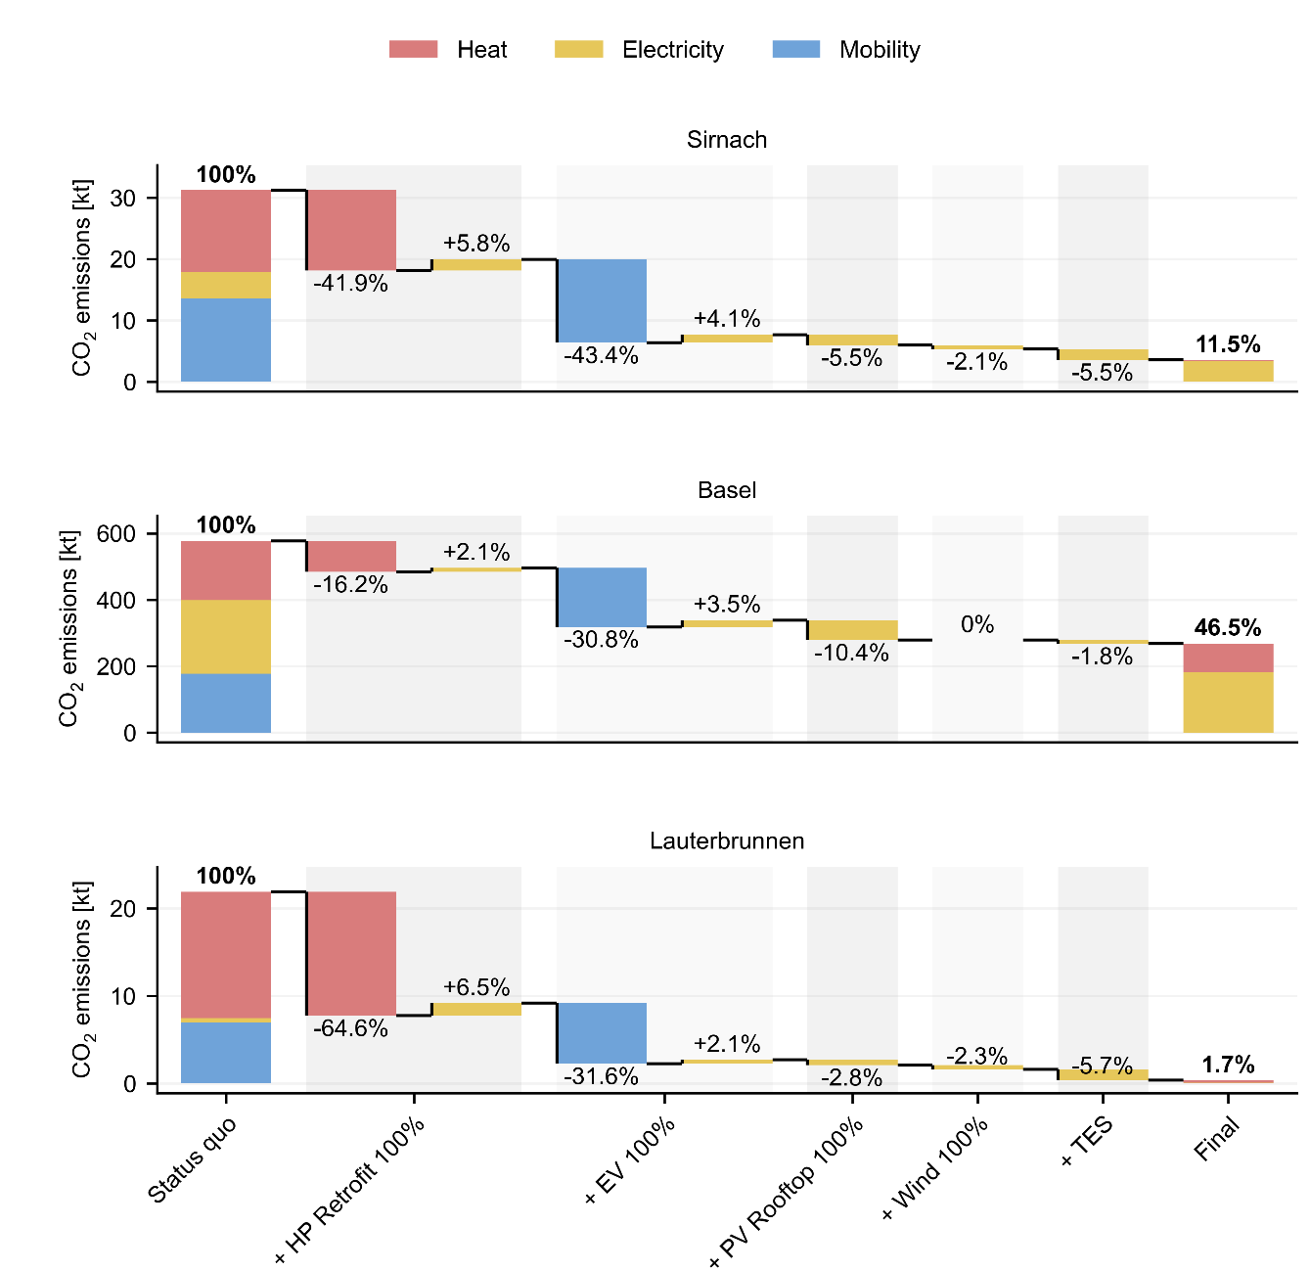
Fig. 5: Impact of pathway-based scenarios on the carbon emissions of three Swiss municipalities. The scenarios include the replacement of fossil-fuel heating systems with heat pumps (+HP Retrofit 100%), expansion of electric vehicles (+EV 100%), expansion of rooftop photovoltaic (PV) systems (+PV Rooftop 100%), expansion of wind power (+Wind 100%), and implementation of thermal energy storage (TES).
In Sirnach, after all measures, 11.5% of status quo emissions remain, corresponding to an overall reduction of 88.5%. Basel exhibits a different transition structure as the final configuration retains 46.5% of status quo emissions, corresponding to an overall reduction of 53.5%.
In Lauterbrunnen, heating system electrification dominates the pathway. After all measures are implemented, only 1.7% of the initial emissions remain, corresponding to a modeled reduction of 98.3%.
The three pathways illustrate the importance of the initial municipal energy-system structure. The results also demonstrate a common sector-coupling mechanism: reductions in direct heating and mobility emissions are partly offset by increased electricity-related emissions. Subsequent renewable and flexibility measures can reduce this transferred burden, but the magnitude of their contribution depends strongly on local renewable resources and electricity demand.
- Discussion
The three municipalities demonstrate that transitions to lower emissions are strongly dependent by configurations of the local energy system and by interactions between the energy sectors. Although the same set of measures was evaluated in all three municipalities, Sirnach, Basel, and Lauterbrunnen, the resulting mitigation pathways differ substantially. This shows that the impact of individual measures cannot be inferred from technical potential alone, but depends also strongly on starting conditions, local renewable resources, and the way in which measures impact one another.
The status quo analysis already reveals markedly different transition challenges. Sirnach is characterized by high contributions from both heating and mobility, whereas Lauterbrunnen is dominated by heating related emissions. Basel exhibits a more balanced sectoral distribution and a substantially different potential of renewables. These differences are subsequently reflected in the mitigation effects of the simulated measures. In municipalities with a large share of fossil heating, heat pump deployment can deliver directly substantial emission reductions. Similarly, where mobility contributes strongly to the baseline carbon footprint, electrification of private transport provides significant mitigation potential.
At the same time, the analysis highlights the importance of sector coupling. Electrification of heating and mobility may reduce direct fossil-fuel emissions but adds demand to the electricity sector. This effect is visible both in the electricity demand analysis in Fig. 3 and in the waterfall plots in Fig. 5, where reductions in heating and mobility emissions are partly offset by increases in electricity-related emissions. Their system-wide effect also depends strongly on how the additional electricity is supplied.
This interaction is particularly relevant when evaluating renewable-generation measures. The comparison between technical generation potential and the CO₂ response to increasing PV and wind deployment shows that renewable generation potential and emission mitigation potential are not equivalent. A municipality may possess a large technical resource, but the carbon benefit of deploying that resource depends on the local temporal demand and existing generation structure. Conversely, electrification can increase the usefulness of locally generated renewable electricity by creating additional demand that can be supplied by PV or wind. The deployment-response curves therefore reveal information that is not apparent from potential estimates alone.
The response curves in Fig. 4 also show that the mitigation benefit of renewable deployment is not necessarily proportional to the degree of deployment. In several cases, the curves flatten at higher deployment levels, indicating declining marginal CO₂ reductions from additional renewable generation. This behavior is consistent with the increasing importance of temporal matching between local generation and electricity demand. Once renewable generation increasingly exceeds simultaneous local demand, additional deployment may displace less grid electricity and therefore deliver a smaller emission reduction.
The contrast between the municipalities is especially visible in the cumulative pathways. The same modeled sequence reduces residual emissions to approximately 11.5% of the status quo in Sirnach and 1.7% in Lauterbrunnen, whereas 46.5% remain in Basel. Many buildings in Basel are connected to a district heating network which is exempt from the heat pump deployment. This limits the potential for emission reductions, as emissions from the heating sector depend on the emission intensity of the district heating supply, e.g., the central plant serving the district heating network. In the DEM, a CO₂ intensity factor of 0.108 kg CO₂/kWh is assumed generally for district heating without specified heat generator. The three municipalities demonstrate that a similar technology mix encounters different opportunities and constraints in different local energy systems. In some municipalities, electrification combined with local renewable generation can address a large share of current operational emissions, whereas others require additional measures beyond the technology set considered here.
The Recommender Tool in its current state does not prescribe or suggest a fixed transition pathway. Instead, users can inspect municipality-specific information and explore alternative technology configurations. By systematically varying these configurations, the analysis presented here shows how the tool can be used to identify dependencies between measures, compare local renewable resources, and investigate cumulative transition effects. The value of the tool lies not only in compiling and displaying individual indicators, but also in enabling exploration of how local energy systems respond to alternative configurations.
A current limitation of the Recommender Tool, however, may concern the range of transition measures represented. The present implementation focuses on five broadly applicable measures such as heat pump deployment, passenger car electrification, rooftop PV, wind power deployment, and installing thermal energy storage. These measures were selected because they are relevant to many Swiss municipalities and allow a manageable set of parameters to be exposed to users. However, the most relevant transition options can differ considerably between municipalities. Local systems may depend on technologies or infrastructures that are not represented by these five parameters, such as district heating expansion, biomass, hydropower, alpine PV, other storage technologies, or changes in building demand. The underlying DEM allows a much more detailed representation of municipality-specific energy systems than is presented through the simplified Recommender Tool. Battery electricity storage is one example of an additional option that can be investigated in the DEM but is not yet included as a configurable measure in the Recommender Tool as the current version does not allow simultaneous enabling of thermal and electrical storage in non-optimized scenarios. Future versions of the tool could therefore provide a broader or municipality-dependent set of transition parameters while retaining an interface that remains understandable and intuitive also to non-expert users.
The study primarily evaluates operational CO₂ effects, does not consider embodied emissions and does not constitute a full assessment of broader transition performance. Alternate indicators of interest are, among others, local self-consumption, energy self-sufficiency, and costs. These can all affect the attractiveness of a simulated scenario. A configuration that performs well in terms of annual operational CO₂ emissions may nevertheless create challenges elsewhere in the energy system. Extending the Recommender Tool with additional indicators could therefore provide a more balanced basis for municipal decision support.
The simulated scenarios should also not be mistaken as forecasts. The analysis estimates the effect that could be achieved if specified fractions of the modeled technology potential were deployed. Scenarios as we demonstrated here are used to characterize the response of the municipal energy system. They do not imply that these deployment levels are technically, economically, politically, or socially achievable within a particular time horizon. Nor does the model simulate the temporal evolution from the present system toward the final configuration.
A further source of uncertainty is the input data. The Recommender Tool and the underlying DEM rely substantially on openly available datasets and on modeled estimates, as municipality-level measurements are typically unavailable. These approaches are necessary to provide comparable estimates for all municipalities, but they do not guarantee that the modeled status quo reproduces the present local energy system exactly. Errors or differences in modeled building data, demand estimates, and actual local conditions can consequently propagate into the calculated emissions and scenario responses. Where more recent local measurements are available, they should be used to validate or replace generic input assumptions. Regularly updated datasets could substantially improve the representation of the local energy system.
The modeled renewable potentials themselves are also subject to uncertainty. A technical rooftop-PV or wind potential does not necessarily correspond to the practically deployable potential. Factors such as cantonal or municipal planning restrictions or landscape protection, technical feasibility, social acceptance and unfavorable cost structures can reduce the share that can realistically be implemented. The deployment levels evaluated here should therefore be understood as scenario parameters based on modeled potentials rather than predictions of future installed capacity.
Finally, the three municipalities were selected to demonstrate different system settings and characteristics rather than to represent a sample of Swiss municipalities. The differences observed between Sirnach, Basel, and Lauterbrunnen should illustrate the importance of local context, but they should not be generalized quantitatively to municipalities with similar geographic labels or settlement types without further analysis.
Despite these limitations, the results demonstrate the usefulness of combining municipality-specific baseline information with configurable energy-system simulations. Rather than producing a single prescriptive pathway, the Recommender Tool enables users to investigate how different interventions alter the municipal system and how their effectiveness changes when measures are combined. The case studies show that such interactions can materially affect the resulting CO₂ reduction and that the same technology configurations and measures can lead to very different outcomes across municipalities. Improving local input data, expanding the range of configurable measures, and incorporating implementation constraints and costs could therefore be features of the tool’s next version that facilitate municipal energy transition even further.
- Conclusion
This study demonstrates the capability of the Recommender Tool and its underlying District Energy Model to support municipal energy planning toward Switzerland’s net-zero target. By integrating local demand, renewable potentials, and sector coupling, the tool enables transparent evaluation of transformation measures and their system-wide carbon emission impacts. The pathway-based representation facilitates identification of high-impact interventions under conditions relevant for the considered community.
The quantitative results depend on the quality and resolution of the underlying public datasets and assumptions. Therefore, incorporation of locally measured data and increased and refined parameterization can further improve accuracy. Overall, the approach offers an accessible and intuitive basis for informed decision-making in municipal energy transition planning.
- Acknowledgements
This research study was supported by the Swiss Federal Office of Energy as part of the SWEET consortium EDGE. The authors bear sole responsibility for the conclusions and the results presented in this publication. We are grateful for the contributions and collaborations within the SWEET EDGE consortium.
- References
Dujardin, J., Lehning, M., 2022. Wind-Topo: Downscaling near-surface wind fields to high-resolution topography in highly complex terrain with deep learning. Q. J. R. Meteorol. Soc. 148, 1368–1388. https://doi.org/10.1002/qj.4265
Federal Statistical Office, 2025a. Federal Register of Buildings and Dwellings.
Federal Statistical Office, 2025b. Bestand der Strassenfahrzeuge nach Gemeinde, ab 2010 - 2010-2024 [WWW Document]. Bundesamt Stat. Fed. Stat. Off. URL https://www.bfs.admin.ch/asset/de/33827764 (accessed 8.26.26).
Frischholz, Y., 2025. CH-POA300 -- Hourly Plane-of-Array Solar Irradiance at High Resolution for Switzerland. Int. J. Retina Vitr. 11. https://doi.org/10.16904/envidat.632
Gökgöl, E.K., Linder, E., Schuetz, P., 2025. A community-based decision support map for building retrofit towards a more sustainable future. Energy Build. 335, 115554. https://doi.org/10.1016/j.enbuild.2025.115554
Herrera, M.P., Hug, G., 2025. Modeling Charging Demand and Quantifying Flexibility Bounds for Large-Scale BEV Fleets, in: 2025 IEEE Kiel PowerTech. Presented at the 2025 IEEE Kiel PowerTech, pp. 1–6. https://doi.org/10.1109/PowerTech59965.2025.11180551
HSLU, C.S., 2026. Recommender Tool [WWW Document]. URL prototype.recommendertool.ch
Meyer, M., Iyyakkunnel, S., Schilt, U., Schneeberger, S., Linder, E., Vijayananda, S., Schuetz, P., 2026. Supporting the Integration of Renewable Energy in Communities and Districts by Automated, Online Impact Assessment, in: Zilio, C., Busato, F., Mazzarella, L., Noro, M. (Eds.), Proceedings of the 15th REHVA HVAC World Congress - CLIMA 2025. Springer Nature Switzerland, Cham, pp. 940–949. https://doi.org/10.1007/978-3-032-10546-2_88
Meyer, M., Linder, E., Schilt, U., Schneeberger, S., Melillo, A., Gökgöl, E.K., Schuetz, P., 2023. Tool for evaluation of energy system options for municipalities. J. Phys. Conf. Ser. 2600, 022010. https://doi.org/10.1088/1742-6596/2600/2/022010
Pfenninger, S., Pickering, B., 2018. Calliope: a multi-scale energy systems modelling framework. J. Open Source Softw. 3, 825. https://doi.org/10.21105/joss.00825
Rinaldi, A., Ramirez, H., Schroeteler, B., Meier, M., 2022. The role of energy storage technologies in the context of the Swiss energy transition (SwissStore). https://doi.org/10.5281/zenodo.6782179
Schilt, U., 2026. District Energy Model - Python package. Python package index (PyPI).
Schilt, U., Meyer, M., Schneeberger, S., Schuetz, P., 2023. Impact Analysis of Solar PV Integration and Heating System Retrofit: a District-Level Energy System Model, in: Proceedings of Solar World Congress 2023. Presented at the SWC 2023 - ISES Solar World Congress 2023, International Solar Energy Society, New Delhi, India, pp. 1–8. https://doi.org/10.18086/swc.2023.08.06
Schilt, U., Vecsei, P.M., 2025. District Energy Model (DEM) Documentation [WWW Document]. URL https://demdocumentation.readthedocs.io/
Schilt, U., Vecsei, P.M., Vijayananda, S., Schneeberger, S., Iyyakkunnel, S., Schütz, P., 2025a. District Energy Model (DEM): Version 0.1.0-rc2. https://doi.org/10.5281/zenodo.18154581
Schilt, U., Vecsei, P.M., Vijayananda, S., Schneeberger, S., Iyyakkunnel, S., Schütz, P., 2025b. District Energy Model (DEM) Input Data for Switzerland. https://doi.org/10.5281/zenodo.17603139
Schilt, U., Vecsei, P.M., Vijayananda, S., Schuetz, P., 2026a. District Energy Model (DEM): A Python framework for modelling renewable energy integration and flexibility at district scale. https://doi.org/10.2139/ssrn.6679309
Schilt, U., Vecsei, P.M., Zurbriggen, T., 2026b. District_Energy_Model (DEM) [Github].
Schneeberger, S., Meister, C., Schuetz, P., 2025. Estimating the heating energy demand of residential buildings in Switzerland using only public data. Energy Build. 347, 116371. https://doi.org/10.1016/j.enbuild.2025.116371
SIA, 2025. SIA 385/2, Anlagen für Trinkwarmwasser in Gebäuden - Warmwasserbedarf, Gesamtan-forderungen und Auslegung (Schweizer Ingenieur- und Architektenverein).
Sweet EDGE [WWW Document], 2026. URL https://www.sweet-edge.ch/
Swiss Federal Office of Energy, 2025a. Langfristige Klimastrategie 2050 [WWW Document]. Langfristige Klimastrategie 2050. URL https://www.bafu.admin.ch/de/klimastrategie-2050 (accessed 8.26.26).
Swiss Federal Office of Energy, 2025b. Elektrizitätsproduktionsanlagen in der Schweiz [WWW Document]. Elektrizitätsproduktionsanlagen Schweiz. URL https://www.uvek-gis.admin.ch/BFE/storymaps/EE_Elektrizitaetsproduktionsanlagen/ (accessed 2.25.26).
Swiss Federal Office of Energy, 2023. Dokumentation Geodatenmodell Solarenergie: Eignung Dächer (Sonnendach.ch) Solarenergie: Eignung Fassaden (Sonnenfassade.ch).

