EuroSun2026
ENERGY AND COST PERFORMANCE MODELLING OF A REFERENCE COASTAL HOUSE TOWARD NEARLY ZERO ENERGY STANDARDS

Ugo Gruden (corresponding author), Boris Delač, Branimir Pavković, Anica Trp
University of Rijeka, Faculty of Engineering, Vukovarska 58, 51000 Rijeka
ugo.gruden@riteh.uniri.hr, boris.delac@riteh.uniri.hr, pavkovic.branimir@gmail.com, anica.trp@riteh.uniri.hr

Summary

This study presents an annual thermal performance and cost analysis of a reference single family building, representative of typical residential construction in coastal Croatia during the second half of the 20th century. The objective of this study was to evaluate the energy performance under various renovation scenarios, aiming to reduce annual energy consumption through improved building envelope and HVAC systems in order to move the building toward nearly zero energy standards. A number of cases were simulated, varying in HVAC configurations, including both traditional and renewable energy systems. Although the initial building exhibited poor thermal efficiency and high energy consumption, results showed that strategic upgrades could significantly reduce energy demand, confirming that even outdated, energy-inefficient buildings can be transformed into low-energy homes through targeted renovations.
Keywords: Dynamic modelling, HVAC, Nearly zero energy building, renewables, TRNSYS.
Field of application for the findings: Energy Efficient Buildings
Addressed audience: Researchers and HVAC experts

1. Introduction
Improving energy efficiency is a key strategy to reduce primary energy consumption in the European Union (EU). Buildings in the EU account for over 40% of final energy use and about 35% of total CO₂ emissions, with heating and cooling systems responsible for roughly half of this consumption. Since the majority of existing buildings show poor energy performance, renovating existing buildings is essential for the transition to a low-carbon energy sector. According to the Energy Performance of Buildings Directive (EPBD) EU/31/2010 (revised in 2018), all new buildings and those undergoing major renovations must meet nearly zero energy building (nZEB) standards. To be cost-effective, renovations should reach a cost optimal level that minimizes total annual costs over the system’s lifetime. Nearly zero energy buildings (nZEBs) are highly energy-efficient buildings that cover most of their energy needs from renewable sources. This transition is directly aligned with the United Nations Sustainable Development Goals, in particular SDG 7 (Affordable and Clean Energy), which aims to ensure universal access to affordable, reliable, sustainable and modern energy services, while promoting an increased share of renewable energy and improved energy efficiency performance as core mechanisms for the decarbonization of the global energy system. Various studies have been conducted in order to evaluate the energy performance and environmental impacts of HVAC systems under different building configurations. Hamdy et al. (2013) showed that cost-optimal nearly zero energy buildings can be achieved through optimization balancing technical, economic, and environmental aspects. For a single-family house in Finland, they found that ground source heat pumps and solar systems are the key for reducing costs and emissions. Barthelmes et al. (2015) investigated the replicability of nZEBs in Mediterranean countries, analysing HVAC configurations for a reference building in Piedmont, Italy. Different HVAC systems were combined with an optimized building envelope to evaluate energy performance, indoor comfort, and economic feasibility. Baglivo et al. (2015) showed that identifying cost-optimal solutions for nearly zero energy buildings in warm climates requires balancing energy performance and investment costs. Using reference residential buildings, they tested envelope and system efficiency measures to find configurations that minimize primary energy use and CO₂ emissions. Ascione et al. (2019) investigated a single family nZEB building in southern Italy, designed for a Mediterranean climate. A real house was monitored to assess energy demand, renewable energy generation, storage, and indoor environmental quality during summer. Monitoring data were used to validate a numerical model. Slijepčević et al. (2019) analysed the cost-effectiveness of installing heat-cost allocators in multifamily residential buildings in Croatia. Using a cost–benefit approach with a 4% discount rate, the study assessed investment, maintenance, and energy savings over the systems’ lifetime. Keček (2023) analysed the effects of the 2021–2022 global energy crisis on the Croatian economy using an input-output price model. Eksi and Ozcan (2025) showed that retrofitting a residential building in Izmir Mediterranean climate into a nearly zero energy building (nZEB) using active and passive measures can greatly enhance efficiency. Through simulations, they found that the optimal scenario reduced net primary energy use and CO₂ emissions by around 80%, demonstrating that nZEB retrofits in Mediterranean climates can cut heating and cooling demands by more than half. Zhen et al. (2025) investigated the impact of different building envelope configurations on energy consumption and indoor comfort in nZEB building in northwest China through experimental measurements and TRNSYS/CFD simulation analysis.
The objective of this study is to define, for a given building, the appropriate systems for heating, cooling, ventilation, and domestic hot water production, and to perform annual simulations in order to calculate costs, CO₂ emissions and energy consumption up to the level of primary energy. The building under study is a single-family house with a basement, ground floor, and first floor, designed in the second half of the 20th century, a type that exists in large numbers along the Croatian coast in a similar form and size. For this reason, the analyses and results obtained can be considered representative for a wide range of comparable buildings.

2. Building 3D model

The building under consideration consists of three floors, which can be considered as three separate apartments and auxiliary spaces on the ground floor. The building model was created in Google SketchUp with the TRNSYS3D plug-in to ensure compatibility for subsequent thermal property calculations. In the development of the thermal model, the building was divided into nine thermal zones, three of which are heated. The heated zones of the building include the occupied areas located in the basement, ground floor, and first floor, whereas the unheated zones comprise the garage, three storage rooms, the porches on the ground and first floors, and the attic. The storage rooms are auxiliary spaces located at the basement level, partially embedded into the ground. The porches are situated within the open stairwell areas in front of the apartment entrances and serve as protection against wind and other weather conditions. The attic thermal zone corresponds to the space beneath the roof structure, which is also unheated. The graphical representation of the building model is shown in Fig. 1.

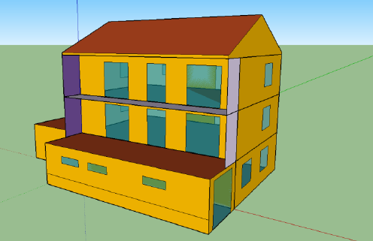
Fig. 1: 3D multizone model of the reference building designed in Google SketchUp
The building is oriented so that the larger windows and balconies face south, a common practice in most buildings along the coast, especially in the area around the city of Rijeka, for which this study was conducted. For the purpose of the simulation, six different wall types were defined. The thermal resistances of the external walls, the walls between heated and auxiliary unheated rooms, the walls and floor adjacent to the ground, the floors between the apartments and the roof construction were defined according to a real building with values representative for buildings built in the 1970s in the coastal area of Croatia. The values of the overall heat transfer coefficients of the building elements in the original state and after applying insulation (k_{ins} = 0.04 W/mK), are presented in Tab. 1. To meet the criteria of U_{max} specified in Tab. 1, additional thermal insulation was applied as follows: 3 cm between the floors of adjacent apartments, 10 cm above the ceiling below the unheated attic, and 8 cm on the façade, on walls and floors in contact with the ground, and on walls adjoining other unheated auxiliary spaces.

Tab. 1: Overall heat transfer coefficients for building elements in original state
No. | Building element | U_{original} [W/m²K] | U_{insul.} [W/m²K] | U_{max} [W/m²K]
1 | External walls and roofs | 0.97 | 0.3 (8 cm) | 0.45
2 | Walls to unheated rooms | 0.73 | 0.27 (8 cm) | 0.45
3 | Ceilings to unheated rooms | 1.90 | 0.29 (10 cm) | 0.30
4 | Walls to ground | 0.81 | 0.30 (8 cm) | 0.60
5 | Floors to ground | 2.01 | 0.46 (8 cm) | 0.60
6 | Ceilings between heated rooms | 1.55 | 0.34 (3 cm) | 0.80

The external air temperature was simulated using real data available for the location of the city of Rijeka using the representative year approach. This approach is common in meteorology and building energy simulations, in which the representative year refers to a synthesized dataset of climatic conditions (typically hourly values of temperature, humidity, solar radiation, etc.) that reproduces the long-term average weather patterns for a given location. The values of the ambient air temperature for the location of the city of Rijeka (Meteonorm, 2012), that was used in the simulation for the whole representative year are shown in Fig. 2.

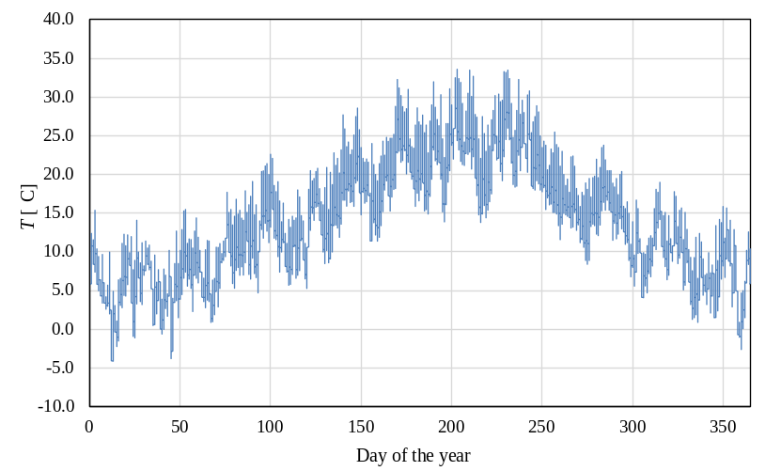
Fig. 2: Ambient air temperature during the representative year

For the windows, a double glass type of windows was chosen for the simulation with the overall heat transfer coefficient of U_{glass} = 1.4 W/m²K. The external doors were modelled as windows with a frame that occupies 80% of the whole aperture area. In order to maximize solar gains in winter and minimize them in summer, shading is also applied in the simulation. The windows have a visible light transmittance factor of 0.8, the external shading has a solar radiation transmittance factor of 0.2, and the internal shading a factor of 0.8. Shading is considered in the simulation when incident solar radiation exceeds 140 W/m² and is deactivated below 120 W/m². The garage and the external staircase windows are not equipped with external shading.
Apart from external heat gains, internal gains were also included in the model. For the purpose of the simulation, it is assumed that the building consists of three residential units, each occupied by four persons. Using the Schedule Type Manager in TRNBuild, an occupancy profile was created to differentiate between weekday and weekend operation. The schedule, shown in Tab. 2, defines occupancy coefficients ranging from 0 to 1, representing the ratio between the instantaneous and maximum number of occupants in each apartment (maximum of four). The internal heat gain per person was selected for the case of light activity and seated occupants, with a total value of 150 W per person, consisting of 75 W sensible and 75 W latent heat.

Tab. 2: Weekly occupancy schedule
Hours | Weekdays | Weekend
0 - 8 | 1 | 1
8 -16 | 0 | 0.5
16 -24 | 1 | 1

Lighting heat gains are included in the model, with LED fixtures providing 1.424 W/m² of internal heat gain and operating according to solar radiation thresholds (off above 200 W/m², on below 120 W/m²) and a scheduled control using Type 516 Hourly Schedule (weekdays 06:00–00:00, weekends 08:00–00:00). In addition to these sources, other internal heat gains are considered, consisting of both constant and variable components dependent on occupancy. These gains are estimated at 1 W/m² for both types. In the heated zones, where occupants are present, all aforementioned types of internal gains are included.

3. Systems design

3.1. Heating and Cooling Design Loads

The required heating and cooling design loads were determined under project design conditions. The calculation of the heating design load was done in accordance with EN 12831. The reference outdoor air temperature for the winter period for the location of the city of Rijeka is T_{ext} = −8 °C. The indoor temperature was defined as T_{int} = 20 °C. In the calculation of the heating design load, solar gains are neglected. For the cooling design load, both solar gains and internal heat gains are considered. The calculation of the cooling design load was done in accordance with VDI 2078. The summer reference outdoor conditions were taken as T_{ext} = 32 °C with a relative humidity of ϕ = 40%. The indoor temperature was defined as T_{int} = 26 °C. Under design conditions, the building in insulated state requires a heating load of Q_{h,design} = 9.8 kW, while for the cooling during the summer period, the cooling load Q_{c,design} = 6.6 kW is required. These calculated design loads served as the basis for designing all HVAC systems for the subsequent evaluation of energy performance and economic feasibility.

3.2. HVAC systems description

After determining the design heating and cooling loads, different HVAC system variants were designed for space heating, cooling, and domestic hot water (DHW) production in order to compare them, and identify the solution that best meets the building’s needs while minimizing energy consumption and overall cost. For this analysis, nine system variants were considered:
S1) Existing Base System: The existing system uses an oil-fired 30 kW boiler operating at a constant supply water temperature of 90 °C, delivering hot water to radiators operating in a 90/70 °C regime. The same boiler also provides domestic hot water (DHW) through an 800 l storage tank equipped with an internal helical heat exchanger. No mechanical ventilation is installed. Air exchange occurs through natural infiltration at a rate of 0.5 air changes per hour. Cooling is provided by two split-type air conditioning units per floor, each with a cooling capacity of 2.2 kW.
S2) Insulated Building with Condensing Gas Boiler: In this configuration, the building envelope is insulated with 80 mm of mineral wool on external walls, 100 mm of expanded polystyrene (EPS) above the ceiling slab, 80 mm EPS under the basement floor slab, and 80 mm of mineral wool with 10 mm gypsum board cladding on basement walls adjacent to unheated spaces. Inter-floor ceilings are insulated with 30 mm of mineral wool. The heating system retains the existing radiators and 800 l DHW tank but replaces the oil-fired boiler with a 12 kW condensing natural gas boiler to improve efficiency. The supply water temperature is reduced to 60 °C at the design outdoor temperature of −8 °C and regulated linearly according to the outdoor temperature (down to 20 °C supply at +20 °C outdoor temperature). Cooling is provided by two split-type air conditioning units per floor, each with a cooling capacity of 2.2 kW.
S3) Insulated Building with Condensing Gas Boiler and Heat Recovery Ventilation: This configuration builds upon S2 by introducing a mechanical ventilation system with heat recovery, which significantly improves indoor air quality and reduces ventilation heat losses. The heating and DHW systems remain identical to S2 (condensing gas boiler, 800 l tank, and regulated supply temperature curve). Cooling is provided by two split-type air conditioning units per floor, each with a cooling capacity of 2.2 kW.
S4) Insulated Building with Condensing Gas Boiler, Heat Recovery Ventilation, and Solar DHW System: This configuration further enhances S3 by integrating flat-plate solar collectors for DHW production. Instead of one 800 l tank, two 300 l tanks connected in series are used. The first tank is heated by solar energy, while the second tank is connected to the central heating circuit for auxiliary heating when solar input is insufficient. A mixing valve regulates DHW temperature to maintain 40 °C at the outlet by blending hot water from the tank (which may exceed 40 °C during summer) with 10 °C mains water. The space heating and ventilation systems are the same as in S3. Cooling is provided by two split-type air conditioning units per floor, each with a cooling capacity of 2.2 kW.
S5) Insulated Building with Heat Pump and Fan Coil Units (No Heat Recovery Ventilation): In this configuration, the traditional boiler system and radiators are completely replaced by a heat pump system supplying fan coil units (FCUs) for both heating and cooling. The heat pump is connected to a 200 l buffer tank, from which water is circulated to FCUs and to the DHW tank via a dedicated pump. During winter, the heat pump provides both space heating and DHW. During summer, DHW is supplied by an electric heater. No mechanical ventilation with heat recovery is included in this configuration.
S6) Insulated Building with Heat Pump and Fan Coil Units and Heat Recovery Ventilation: This case builds on S5 by adding a mechanical ventilation system with heat recovery. The heat pump again serves both heating and cooling via fan coil units and provides DHW during winter. In the summer period, DHW is heated by an electric heater.
S7) Insulated Building with Heat Pump and Fan Coil Units, Heat Recovery Ventilation, and Nighttime DHW Heating: This configuration is similar to S6 but features optimized operation of the heat pump. In winter, the heat pump provides both heating and DHW. In summer, it operates in cooling mode during the day and switches to nighttime DHW heating mode, raising the tank temperature to 55 °C to ensure that the temperature does not drop below 40 °C during daily use, accounting for cold water inflow and tank heat losses. The system includes a 200 l buffer tank, thermostatic controls for both heating and cooling, and fan coil units replacing the original radiators.
S8) Insulated Building with Electric Heating and Photovoltaic System (No Heat Recovery Ventilation): In this configuration, the thermally improved building envelope is retained, corresponding to the insulated case described in S2. Space heating is provided by electric heaters, while cooling is supplied by two split-type air conditioning units per floor, each with a cooling capacity of 2.2 kW. DHW is also generated using an electric heater. A photovoltaic (PV) system with an area of 35 m² is integrated to offset part of the building’s electricity demand. No mechanical ventilation system is installed in this configuration.
S9) Insulated Building with Electric Heating, Photovoltaic System, and Heat Recovery Ventilation: This configuration builds upon S8 by introducing a mechanical ventilation system with heat recovery, which significantly reduces ventilation heat losses. The building envelope remains identical to that of S8. Space heating is provided by electric heaters, while cooling is supplied by two split-type air conditioning units per floor, each with a cooling capacity of 2.2 kW. DHW is generated using an electric heater. A photovoltaic (PV) system an area of 22 m² is included to offset part of the building’s electricity demand.

In order to have a more comprehensive comparison of the analysed system variants, a summary of all considered HVAC systems is presented in Tab. 3.

Tab. 3: System variants component summary
Syst. |  | Envelope | Heating | Cooling | DHW | Ventilation
S1 | Original uninsulated |  | Oil boiler, radiators | Split system | Oil boiler | Natural
S2 | Insulated |  | Gas boiler, radiators | Split system | Gas boiler | Natural
S3 | Insulated |  | Gas boiler, radiators | Split system | Gas boiler | Heat recovery
S4 | Insulated |  | Gas boiler, radiators | Split system | Solar, gas boiler | Heat recovery
S5 | Insulated |  | Heat pump, FCUs | Heat pump | Electric heater | Natural
S6 | Insulated |  | Heat pump, FCUs | Heat pump | Electric heater | Heat recovery
S7 | Insulated |  | Heat pump, FCUs | Heat pump | Heat pump | Heat recovery
S8 | Insulated |  | Electric heater + PV | Split system | Electric heater | Natural
S9 | Insulated |  | Electric heater + PV | Split system | Electric heater |  | Heat recovery

After defining the system variants to be analyzed, each configuration was developed in TRNSYS as a dynamic simulation model. The simulations were carried out over a one-year period to evaluate the energy performance, economic feasibility, and emission characteristics of each system variant.
A summary of the principal system components used in the simulations, along with their corresponding TRNSYS Types and TESS library components, is presented in Tab. 4.

Tab. 4: System component summary with corresponding TRNSYS Type
System component |  |  |  |  | TRNSYS/TESS Type
Oil-fired boiler |  |  |  |  | Type 700
Condensing gas boiler |  |  |  |  | Type 751
Heat pump |  |  |  |  | Type 941
Solar collectors |  |  |  |  | Type 1
Photovoltaic array |  |  |  |  | Type 103
Air handling unit |  |  |  |  | Type 335
DHW tank |  |  |  |  | TESS Type 534

4. Energy and economic analysis

After defining all system configurations, annual dynamic simulations were conducted to determine the delivered energy demand of each HVAC system for the same thermally insulated building. The results of the annual simulations are shown in Fig. 3, with different patterns distinguishing between electricity, fuel, and solar energy contributions. Fig. 3 presents the delivered energy of each analysed HVAC system variant, categorized according to the energy source used. The results show a clear trend of decreasing total delivered energy as the systems become more advanced and energy-efficient. System variant S1, representing the base case with an oil-fired boiler and no insulation, exhibits the highest delivered energy consumption, entirely supplied by fuel. In system variant S2, the introduction of thermal insulation and a condensing gas boiler significantly reduces the annual delivered energy and fuel use of the heating system. System variant S3, which includes a mechanical ventilation unit with heat recovery, shows an additional reduction in total energy demand compared to S2.
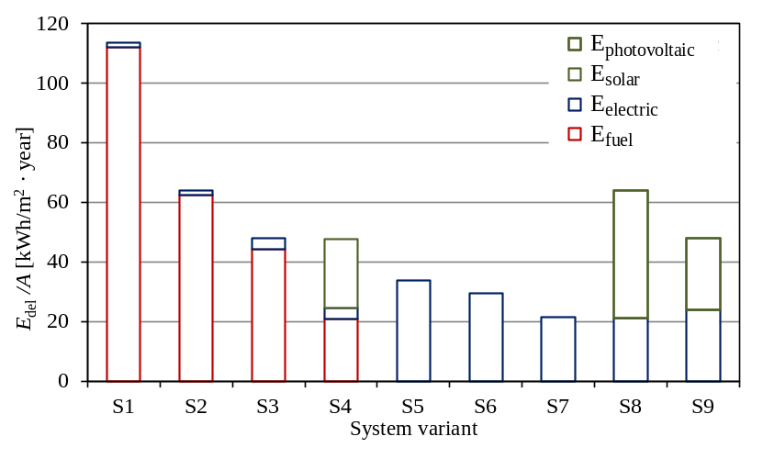
Fig. 3: Annual delivered energy from different sources

In system variant S4, the integration of solar thermal collectors for domestic hot water production adds a renewable energy contribution, as indicated by the green portion of the bar, and further reduces fuel consumption. System variants S5 to S7, which employ air-to-water heat pumps and fan coil units, rely entirely on electricity, leading to a complete transition from fuel to electrical energy and a further decrease in total delivered energy. Among these configurations, system variant S7 achieves the lowest overall delivered energy consumption, an improvement of 80% in relation to the base system variant S1, demonstrating the highest level of efficiency due to the combined effects of heat recovery ventilation and optimized operation of the heat pump for both heating and domestic hot water production. System variants S8 and S9, which use electric resistance heating for space heating and domestic hot water preparation in combination with a photovoltaic system, also show a transition from fossil fuels to electricity-based operation. In these cases, the photovoltaic system contributes renewable energy in order to achieve at least a 30% renewable energy share and to comply with primary energy regulations. Owing to the addition of heat recovery ventilation, system variant S9 exhibits a lower total delivered energy demand than S8.
In order to enable a consistent and objective comparison of the performance of the analysed HVAC system variants, the delivered energy of each system variant is converted to the level of primary energy. Primary energy represents the total amount of raw energy resources required to provide heating, cooling, ventilation, and domestic hot water (DHW), including all extraction, conversion, and transmission losses. The conversion from the delivered energy E_{del} to primary energy E_{prim} was done with current conversion factors valid in Croatia (Primary energy factors and CO₂ emission factors, n.d.), which are presented in Tab. 5.

Tab. 5: Primary energy conversion factors
Energy source |  | Primary energy factor
Fuel oil |  | 1.130
Natural gas |  | 1.160
Electric energy |  | 1.614
Solar energy |  | 0.000

Fig. 4 shows the annual primary energy demand per square meter for the analysed HVAC systems (S1–S9). The red dashed line represents the maximum allowable value of 35 kWh/m² annually for single-family houses in the coastal climate zone according to national building energy efficiency requirements (Technical Regulation on Rational Use of Energy and Thermal Protection in Buildings, 2020). The highest primary energy demand is recorded for the baseline system S1, which uses a heating oil boiler and lacks thermal insulation or mechanical ventilation with heat recovery. Progressive improvements such as thermal insulation, condensing gas boilers, ventilation with heat recovery, solar collectors, and heat pumps significantly reduce primary energy use.
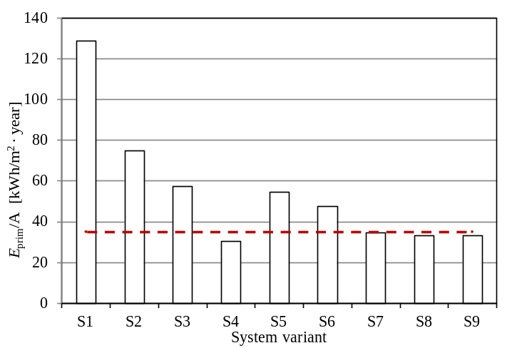
Fig. 4: Annual primary energy

The transition from S1 to S2 leads to a significant reduction in primary energy demand due to the addition of thermal insulation to the building envelope and the replacement of the oil-fired boiler with a condensing gas boiler operating at lower water temperatures. The improvement from S2 to S3 is mainly attributed to the introduction of a mechanical ventilation system with heat recovery, which reduces ventilation heat losses. The further reduction observed in S4 results from the integration of flat-plate solar collectors for domestic hot water (DHW) production, which partially replace fossil fuel consumption with renewable solar energy. The reduction in primary energy consumption from S5 to S6 results from the integration of mechanical ventilation with heat recovery and the use of nighttime ventilation for passive cooling during the summer. The further reduction from S6 to S7 is achieved by assigning domestic hot water (DHW) production to the heat pump instead of electric heaters, taking advantage of the heat pump’s higher coefficient of performance (COP). Systems S8 and S9, which rely on electric resistance heating and domestic hot water preparation in combination with a photovoltaic system, also achieve relatively low primary energy demand. In these cases, the photovoltaic system was introduced to ensure a renewable energy share of at least 30% and compliance with primary energy regulations. The inclusion of heat recovery ventilation in S9 further reduces primary energy demand compared to S8. Among all configurations, only system variants S4, S7, S8 and S9 satisfy the regulatory limit for nearly zero energy buildings (nZEB) of 35 kWh/m² annually for single family homes, achieving the lowest primary energy consumption and demonstrating the best overall energy performance and compliance with national standards.
In this study, CO₂ emissions were also calculated for each HVAC configuration, using delivered energy and national emission factors (Primary energy factors and CO₂ emission factors, n.d.), to quantify the operational climate impact of each solution beyond primary energy demand alone. This indicator is important for evaluating the decarbonisation potential of different renovation strategies and is directly aligned with UN SDG 7, which aims to achieve affordable, reliable and clean energy systems while reducing energy-related greenhouse gas emissions globally. The factors used in this study are presented in Tab. 6.

Tab. 6: Carbon dioxide emission factors
Energy source |  | CO₂ emission factor [kg/MWh]
Fuel oil |  | 310.31
Natural gas |  | 220.20
Electric energy |  | 234.81
Solar energy |  | 0.0000

The calculated annual CO₂ emissions for each considered case are presented in Fig. 5. From the results presented in Fig. 5, it is clear that the improvement of the building envelope (insulation) provides the largest contribution to CO₂ emission reduction. In addition, system variants employing renewable energy sources, such as S4, and system variants based on heat pump technology exhibit the lowest CO₂ emission values.
This outcome is particularly relevant for the Croatian context, where electricity generation already includes a significant share of hydropower (approximately 30%), further improving the environmental performance of electrified HVAC solutions. Overall, system variants S4, S7 and S8 demonstrate the most favourable results, achieving reductions in CO₂ emissions of approximately 85%, relative to the uninsulated starting configuration S1. System variant S9 exhibits a slightly higher value owing to the electricity demand of the heat recovery ventilation system.

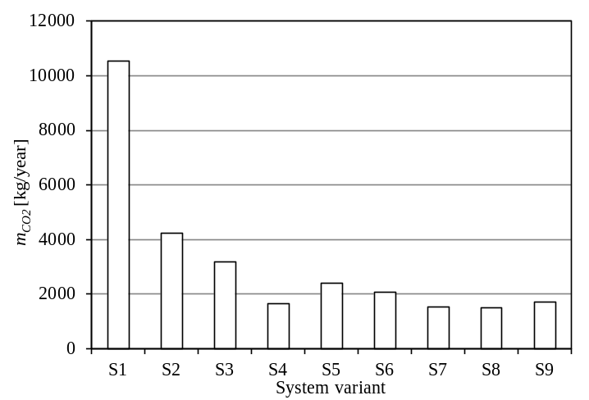
Fig. 5: Annual CO₂ emissions for each HVAC system

In order to provide a fair comparison of different HVAC systems, both investment and operating costs were evaluated using the global cost (G_{g}) approach, representing the total expenditure over a 20-year period. Since the investment cost represents a one-time expenditure for equipment with an extended service life, the global cost G_{g} combines the initial capital investment with the discounted operating and maintenance costs over 20 years, providing a comprehensive measure of the system’s economic performance. A 20-year evaluation period was applied consistently to all components, including HVAC equipment and construction elements such as facade insulation, ensuring a uniform basis for comparison across different system configurations. The global cost of each system is defined according to the following expression:
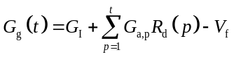 (eq. 1)

where G_{I} is the initial investment cost, G_{a,p} is the annual operating cost in the year p, V_{f} is the residual value at the end of the period, and R_{d} is the discount factor, defined as:

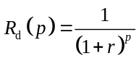 (eq. 2)

with r being the real discount rate and t the analysis period in years. In the present study, all costs were calculated per net floor area. The global cost per unit area, or cost indicator C_{I}, is defined as:

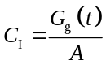 (eq. 3)

where A is the net usable building area. The investment C_{I,inv} and operating C_{I,op} components of the cost indicator, were calculated separately to allow a clear assessment of their relative contributions to the total life-time cost.
The investment component C_{I,inv} is defined as the initial capital cost divided by the building area:

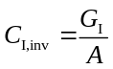 (eq. 4)
The operating component, C_{I,op} represents the discounted sum of annual operating costs per unit area:

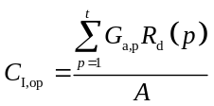 (eq. 5)

In this study, calculations were performed over a 20-year period using a real discount rate of 4%, and the residual value V_{f} is assumed to be zero, as the HVAC system is considered to have no remaining value at the end of its service life. A real discount rate of 4% was applied following standard building life-cycle cost analysis guidelines (e.g., EN 15459), consistent with values determined and used for the Croatian region in previous studies (Slijepčević et al., 2019; Keček, 2023). Investment costs for HVAC equipment were based on moderately priced units available in the Croatian market at the time of this study. The cost of associated works, including the installation, connection, and commissioning of HVAC equipment, was estimated at 30% of the equipment value, in accordance with established engineering design guidelines and professional practice standards. All prices in this study are inclusive of value-added tax (VAT). The bar chart in Fig. 6 presents the global cost per unit floor area or cost indicator C_{I}, for nine HVAC system configurations (S1–S9), distinguishing investment cost (blue hatched) and operating cost (red hatched) for a period of 20 years.

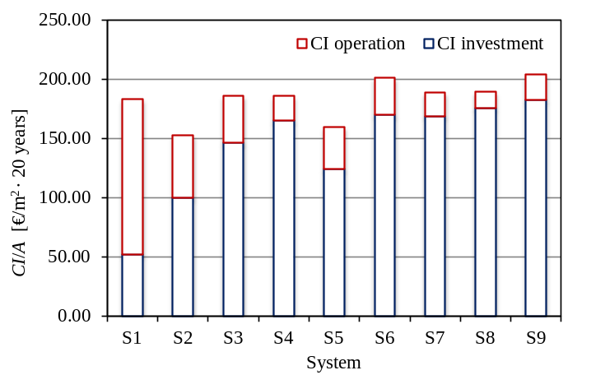
Fig. 6: Cost indicators for investment and operation over a 20-year period

The analysis indicates that the investment cost generally increases with system complexity (S4, S6, S7, S8, S9), whereas simpler systems (S1, S2, S5) require lower initial investments. In contrast, operating costs decrease with increasing system complexity. High-performance system variants, such as S4, S7 and S8 demonstrate the lowest operating costs, reflecting improved energy efficiency, while basic systems require higher energy related expenses. This illustrates a classic trade-off between capital and operational expenditures, where increased investment partially offsets energy costs. System variants S4, S7 and S8 achieve a good balance with moderate total costs, while S2 and S5 keep total costs low through moderate investment and operating expenses. System variants S6 and S9 demonstrate that higher investment does not always guarantee the best overall savings.
Fig. 7 illustrates the relationship between the cost indicator C_{I} calculated for a period of 20 years and the annual primary energy consumption (E_{prim}/A) for the evaluated HVAC system configurations (S1–S9). The results indicate that only system variants S4, S7, S8 and S9 comply with the 35 kWh/m² primary energy requirement (Technical Regulation on Rational Use of Energy and Thermal Protection in Buildings, 2020). These systems exhibit superior energy performance, resulting in a significant reduction in annual operating costs, even though their investment costs are comparatively higher.

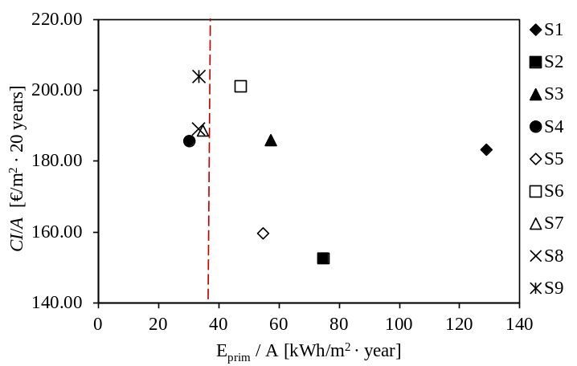
Fig. 7: Cost indicator for a period of 20 years in relation to annual system primary energy requirements

The remaining configurations show increased primary energy consumption, primarily because they lack heat recovery or renewable energy sources, or because DHW production is not covered by the heat pump, even though their total costs are comparable or slightly lower. Consequently, S4, S7 and S8 can be identified as the most energy-efficient solutions, providing an optimal balance between economic performance and energy demand over the system’s operational lifetime.

5. Conclusion

This study investigated the impact of various HVAC system configurations on the energy and economic performance of a typical single-family residential building representative of the Croatian coastal region. The simulations were conducted using TRNSYS Simulation Studio to evaluate both envelope and system-level improvements in accordance with current national energy efficiency regulations. Several HVAC system variants were simulated to identify the most energy-efficient and cost-effective configurations. The analysed system variants included oil and gas boilers, condensing gas boilers combined with solar domestic hot water (DHW) production, mechanical ventilation with heat recovery, heat pumps with auxiliary electric heating, and fully electric heating systems coupled with photovoltaic panels. From an energy and economic perspective, the condensing gas boiler system with solar collectors (S4), the heat pump system (S7) and systems with electric heating with photovoltaics (S8 and S9) demonstrated the lowest primary energy consumption satisfying the maximum allowable primary energy condition of 35 kWh/m² annually for family homes in coastal Croatia, maintaining moderate overall costs. Since other system variants do not comply with national regulations, only S4, S7, S8 and S9 should be considered for retrofitting projects. System variants S4, S7, S8, and S9 meet the nZEB requirement that at least 30% of the annual delivered energy must originate from renewable sources. The analysis demonstrates that existing coastal residential buildings can achieve high energy performance with moderate wall insulation thicknesses (8 cm), combined either with an efficient condensing boiler, a solar thermal system, and heat recovery ventilation, or with an efficient heat pump system. A further alternative is fully electric heating coupled with photovoltaics, which has become increasingly popular in recent years, especially in mild climates. The findings also indicate that domestic hot water (DHW) production should be covered by either a heat pump or a solar thermal system in order to satisfy the maximum primary energy requirements. From a CO₂ emissions perspective, system variants S4, S7 and S8 are the most favourable, achieving reductions of approximately 85%, compared to the uninsulated baseline system S1.
The presented methodology and results may serve as a guideline for similar retrofit projects aimed at achieving cost optimal and regulation compliant energy performance levels in the residential building sector, especially in Mediterranean areas with comparable climate to the one considered in this study.
Acknowledgment: This work has been funded by the European Union – NextGenerationEU – HEEGES – uniri-mzi-25-33.

6. References

Ascione, F., Borrelli, M., De Masi, R.F., de Rossi, F., Vanoli, G.P., 2019. A framework for NZEB design in Mediterranean climate: Design, building and set-up monitoring of a lab-small villa. Solar Energy 184, 11–29.
Baglivo, C., Congedo, P.M., D’Agostino, D., Zacà, I., 2015. Cost-optimal analysis and technical comparison between standard and high efficient mono-residential buildings in a warm climate. Energy 83, 560–575.
Barthelmes, V.M., Becchio, C., Corgnati, S.P., Guala, C., Lequio, M., 2015. Replicability of nZEBs on real estate market in Mediterranean countries. Energy Procedia 82, 452–457.
Eksi, M., Ozcan, M., 2025. Towards nearly zero energy buildings: Energy and environmental analysis of retrofit scenarios for a residential building in Izmir. Engineering Research Express 7 (2), 025339.
European Parliament, Council of the European Union, 2010. Energy Performance of Buildings Directive (EPBD) 2010/31/EU of the European Parliament and of the Council of 19 May 2010 on the energy performance of buildings (recast). Official Journal of the European Union, Brussels, Belgium. Revised 2018.
Hamdy, M., Hasan, A., Siren, K., 2013. A multi-stage optimization method for cost-optimal and nearly-zero-energy building solutions in line with the EPBD-recast 2010. Energy and Buildings 56, 189–203.
Keček, D., 2023. The effects of rising energy prices on inflation in Croatia. Energies 16 (4), 1583.
Meteonorm, 2012. Meteonorm—Global Meteorological Database. Meteotest, Bern, Switzerland.
Primary energy factors and CO₂ emission factors [Faktori primarne energije i emisija CO₂], n.d. Available online: https://mpgi.gov.hr/UserDocsImages/dokumenti/EnergetskaUcinkovitost/meteoroloski_podaci/
FAKTORI_primarne_energije.pdf (accessed 12 May 2026).
Recknagel, E., Sprenger, H., Schramek, E.-R., 2007. Taschenbuch für Heizung und Klimatechnik. Oldenbourg Industrieverlag, München, Germany.
Slijepčević, S., Mikulić, D., Horvat, K., 2019. Evaluation of the cost-effectiveness of the installation of heat-cost allocators in multifamily buildings in Croatia. Energies 12 (3), 507.
Technical Regulation on the Rational Use of Energy and Thermal Insulation in Buildings [Tehnički propis o racionalnoj uporabi energije i toplinskoj zaštiti u zgradama], 2020. Narodne novine 128/15, 70/18, 73/18, 86/18, 102/20.
United Nations, 2015. Transforming our world: The 2030 Agenda for Sustainable Development (A/RES/70/1). United Nations General Assembly, New York.
United Nations Department of Economic and Social Affairs, n.d. Sustainable Development Goal 7: Affordable and clean energy. Available online: https://sdgs.un.org/goals/goal7 (accessed 12 May 2026).
Zhen, X., Jiao, R., Li, S., Wu, W., Peng, J., 2025. Analysis of building envelope for energy consumption and indoor comfort in a near-zero-energy building in Northwest China. Results in Engineering 104243. https://doi.org/10.1016/j.rineng.2025.104243

