Synthesis and Characterization of Intrinsic Superhydrophobic Polyimide Aerogels

Yibo Zhao and Jingjing Ma

Aerospace Research Institute of Materials and Processing Technology, Beijing, 100076, P. R. China
E-mail: 66201769@qq.com or majingjingbh@126.com

Keywords: aerogel, polyimide, thermal insulation, porous materials, superhydrophobic

Abstract
Aerogels are a kind of nanoporous materials with unique properties such as extremely low density, high specific surface areas, high porosity, and high pore volume, and are widely used in thermal insulation, catalyst support, drug carriers, oil adsorption, etc. However, aerogels face two serious general problems: they are normally very fragile and brittle; and the moisture in air or water may be absorbed by the aerogels, which result in the failure of aerogels. In the present work, mechanically strong polyimide aerogels were prepared via the sol-gel transformation of p-phenylene diamine (PPDA) and 4,4’-(4,4’-isopropylidenediphenoxy)bis(phthalic anhydride) (BPADA), followed by supercritical CO₂ drying. Interestingly, the PI aerogel is white and it shows superhydrophobic property. To the best of our acknowledge, this is the first time to prepare polyimide aerogel with an intrinsic superhydrophobicity. The mechanical property of the PI aerogels will be reported, and the reason for its superhydrophobicity will also systematically investigated. In sum, the present work opened a new strategy to synthesis superhydrophobic polyimide aerogel, which may be used for high temperature (500ºC) thermal insulation and extra low temperature (liquid N₂) thermal insulation due to their resistance to both high temperature and low temperature.

1. Introduction

Aerogel is a type of porous materials with low density, low thermal conductivity, and large specific surface area, etc., and are widely used as thermal and acoustic insulator, catalyst support, and drug carrier, etc[1-4]. Recently, a variety of new aerogels, such as carbon aerogels, graphene aerogels, and polymer aerogels[5-9], have been synthesized. However, the aerogels face two serious general problems due to their porous character. Aerogels are fragile and brittle, and lake of water resistance capacity. Methods to increase their mechanical strength, such as modification of silica aerogels with polymers, composition aerogel, and increase of the precursor concentration, have been proposed[10-19]. But they are inevitably resulted in significant increment of density. While the hydrophobic modification method of silica could not be directly applied to polymeric aerogels[20-22].
To solve these problems, polyimide (PI) aerogels made from aromatic dianhydrides and diamines have been synthesized. These PI aerogels exhibit excellent mechanical properties (e.g. Young’s modulus over 100 MPa) and high temperature stability (up to 600 ºC)[23-26]. Therefore, the synthesis and application of PI aerogels has attracted increasing interests recently. However, PI aerogels are hydrophilic and could absorb a large amount of water, which results in the change of microstructure and poor performances. In order to improve the hydrophobicity of PI aerogels and their moisture resistance, great efforts have been tried, such as the introduction of hydrophobic chemical structures , e.g. PPG, -CH₃[27-30]. In this work, we reported a simple and straightforward methods to synthesize fluorine-free, superhydrophobic PI aerogels with low density and high mechanical strength. The porous structure, micro-morphology, and superhydrophobicity of the PI aerogels will be investigated.

2. Experiments

2.1. Materials

P-phenylene diamine (PPDA) was purchased from Sinopharm Chemical Reagent Co., Ltd. 4,4’-(4,4’-isopropylidenediphenoxy)bis(phthalic anhydride) (BPADA) was purchased from Damas Reagent Co., Ltd. Anhydrous N-methylpyrrolidinone (NMP), acetic anhydride, and pyridine were purchased from Aladdin. 1,3,5-Tris(4’-aminophenyl)benzene (TAPB) was purchased from Shanghai UCHEM Inc. Dianhydrides were dried at 125℃ in vacuum for 12 h before use. All other reagents were used without further purification.

2.2. Synthesis of PI aerogels

PI aerogels synthesized from PPDA and BPADA were prepared by the following process: BPADA (1.04 mmol) was slowly added to a solution of PPDA (1 mmol) in 3.67 ml NMP. The mixture was stirred for 2h to form polyamide acid (PAA) oligomer solution. Then, a solution of TAPB (0.02 mmol) in 0.46 ml of NMP was added under stirring. After stirring for 10 min, acetic anhydride (8.32 mmol,) and pyridine (8.32 mmol) were added to the solution and stirring for another 10 min. Then the solution was poured into a mold and put into an oven of 60 ºC. The solution was gelled in 1 h. The gels were aged for 48 h at 60 ºC. Following that, the gels were soaked in a solution of 75 % NMP in acetone overnight. Subsequently, the solvent was exchange in 12 h intervals with 50 %, 25 % NMP in acetone, and finally 100 % acetone. PI aerogels were obtained by supercritical CO₂ extraction.The chemical reaction which might occur during the preparation was shown in Figure 1.
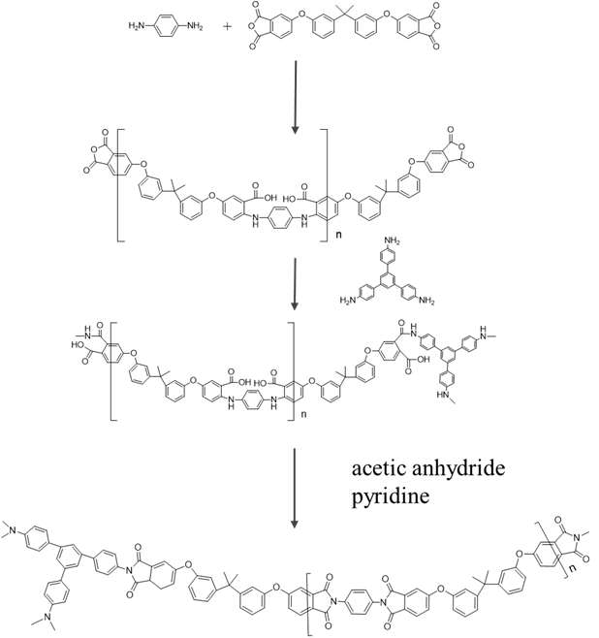
Figure 1. Schematic illustration of the synthesis of PPDA-BPADA PI aerogel

2.3. Characterization

The samples were imaged by scanning electron microscope (SEM) (Hitachi S-4800) with the acceleration voltage of 5-15 KV. The samples were coated with Au nano-powder under current of 20 mA for 1 min. The pore size distribution and average pore diameter of the aerogels were analyzed by the Barret-Joyner-Halenda (BJH) nitrogen adsorption and desorption method (ASAP 2020, Micromeritics, USA). The specific surface area of the aerogels was determined by the Brunauer-Emmett-Teller (BET) method, based on the amount of N₂ adsorbed at pressures 0.05 < P/P₀ < 0.3. Compression tests were run on a tensile testing machine (Instron 3365). The densities of the aerogels were calculated from the volume and weight of the aerogel monoliths. The hydrophobicity of the aerogels was characterized using an optical angle meter system (Dataphysics Inc. OCA20, Germany).

3. Results and discussion

Photo images of the PI aerogel and the low density PI aerogel supported with small flowers were shown in Figure 2. Interestingly, the PI aerogel is white in appearance, which is different from the yellow-coloured aerogels in the past. The white-colour advantage makes the aerogel to be candidates for some specific applications. Moreover, the PI aerogel shows low density of 0.1g/cm³ and high specific surface area of 247m²/g. Importantly, it displays high CA up to 157º, indicating superhydrophobic property. To the best of our acknowledge, this is the first time to prepare polyimide aerogel with an intrinsic superhydrophobicity. Due to the hydrophobic nature, these PI aerogels exhibit good water resistance.

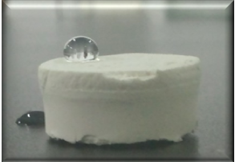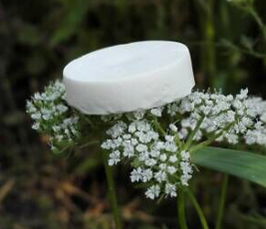

Figure 2. Optical images of the PI aerogel

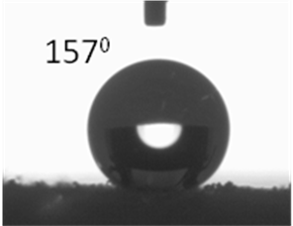

Figure 3. Photo images of the contact angle measurement for the PI aerogel

Representative sample was imaged by SEM to characterize the microstructure. SEM images of the sample are shown in Figure 4. As indicated in Figure 4a with magnification of ×7000, the samples do not look like conventionnal aerogels, with the typical bundles of polymer fibers tangled together with fiber diameters. Rather, the polyimide aerogel morphology dispalys strings of particles with particl diameters in the range of 5-10μm. A higher magnification of ×100000 (Figure 4b) shows that the particles exhibit a structure where the typical bundles of polymer fibers tangled together with fiber diameters in the range of 10-45nm.

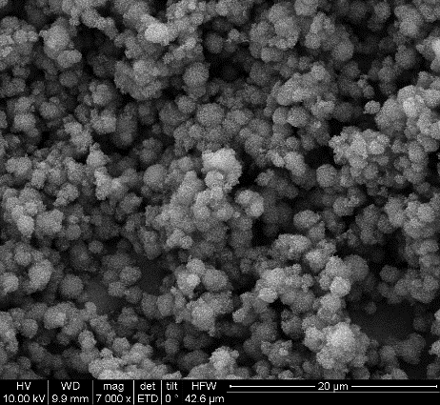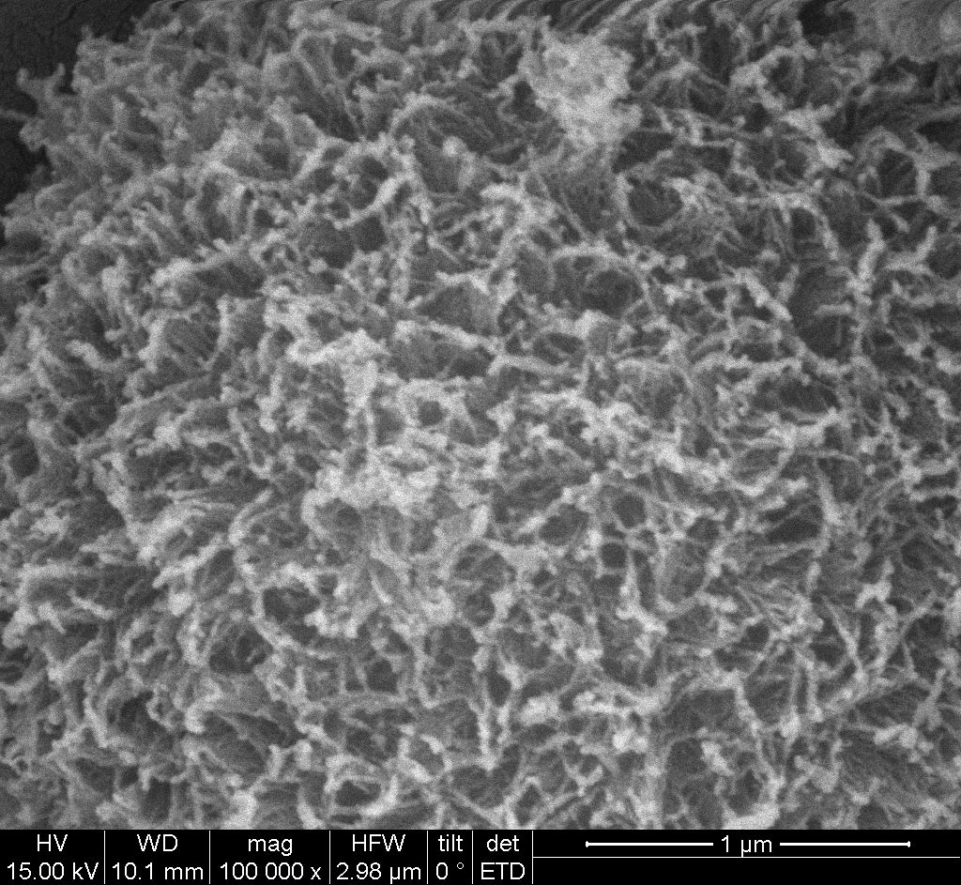
a
b

Figure 4. SEM images of the PI aerogel at different magnificant scales.

Based on the Brunauer–Emmett–Teller (BET) method, the N₂ adsorption–desorption isotherms of the aerogels are presented in Figure 5. According to the picture, all the adsorption and desorption curves are type IV isotherms with a H1 hysteresis loop, which indicates that the PI aerogels are still mesoporous materials. The loop is associated with the occurrence of capillary condensation, while the plateau at the range of high relative pressure indicates complete pore filling.

Figure 5. N₂ adsorption-desorption isotherm of the aerogels.

Compression tests for the obtained aerogels were performed and the stress-strain curves are shown in Figure 6. The sample did not break during compression, and the radial dimension remained unchanged. Actually, all the composite aerogels acted in the same way, indicating good toughness. All the stress- strain curves present three stages: (1)linear stage, in which the reversible deformation occurred and the slope of the curve was considered as Young's modulus, (2) yield stage, in which the framework of the aerogel began to collapse and irreversible deformation occurred, and (3) dense stage, in which the structure of the aerogel became dense and the stress increased sharply with the developing of strain. From this picture, the aerogel dispalys Modulus of 1.7MPa.

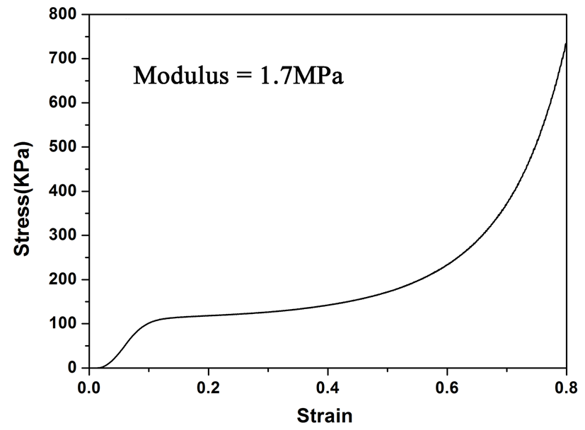

Figure 6. Compressive strain-stress curves of the PI aerogel.

4. Conclusions

A novel superhydrophobic PI aerogel based on PPDA-BPADA was synthesized. The aerogel is with white color, low density ca. 0.1g/cm³, high specific surface area (247m²/g), high CA up to 157º. Due to the hydrophobic nature, these PI aerogels exhibit good water resistance. These findings in the present work may guide to synthesize fluorine-free and hydrophobic (or superhydrophobic) PI aerogels, while it still keeps a high thermal stability and a low thermal conductivity. The resulting PI aerogels might find various application for thermal insulation in both high temperature and low temperature environment, and even for underwater thermal insulations due to their water resistance.

References

[1] Pierre, A. C.; Pajonk, G. M. Chemistry of Aerogels and Their Applications. Chem. Rev. 2002, 102, 4243-4266.
[2] Hüsing, N.; Schubert, U. Aerogels—Airy Materials: Chemistry, Structure, and Properties. Angew. Chem. Int. Ed. 1998, 37, 22-45.
[3] Randall, J. P.; Meador, M. A. B.; Jana, S. C. Tailoring Mechanical Properties of Aerogels for Aerospace Applications. ACS Appl. Mater. Interfaces 2011, 3, 613-626.
[4] Kistler, S. Coherent Expanded Aerogels and Jellies. Nature 1931, 127, 741.
[5] Wang, J.; Du, R.; Zhang, X. Thermoresponsive Polyrotaxane Aerogels: Converting Molecular Necklaces into Tough Porous Monoliths. ACS Appl. Mater. Interfaces 2018, 10, 1468-1473.
[6] Saeed, A. M.; Rewatkar, P. M.; Majedi Far, H.; Taghvaee, T.; Donthula, S.; Mandal, C.; Sotiriou-Leventis, C.; Leventis, N. Selective CO2 Sequestration with Monolithic Bimodal Micro/Macroporous Carbon Aerogels Derived from Stepwise Pyrolytic Decomposition of Polyamide-Polyimide-Polyurea Random Copolymers. ACS Appl. Mater. Interfaces 2017, 9, 13520-13536.
[7] Wang, J.; Wang, X.; Zhang, X. Cyclic molecule aerogels: a robust cyclodextrin monolith with hierarchically porous structures for removal of micropollutants from water. J. Mater. Chem. A 2017, 5, 4308-4313.
[8] Chen, L.; Wei, B.; Zhang, X.; Li, C. Bifunctional Graphene/γ-Fe2O3 Hybrid Aerogels with Double Nanocrystalline Networks for Enzyme Immobilization. Small 2013, 9, 2331-2340.
[9] Wang, J.; Zhang, X. Binary Crystallized Supramolecular Aerogels Derived from Host–Guest Inclusion Complexes. ACS Nano 2015, 9, 11389-11397.
[10] Meador, M. A. B.; Weber, A. S.; Hindi, A.; Naumenko, M.; McCorkle, L.; Quade, D.; Vivod, S. L.; Gould, G. L.; White, S.; Deshpande, K. Structure−Property Relationships in Porous 3D Nanostructures: Epoxy-Cross-Linked Silica Aerogels Produced Using Ethanol as the Solvent. ACS Appl. Mater. Interfaces 2009, 1, 894-906.
[11] Nguyen, B. N.; Meador, M. A. B.; Medoro, A.; Arendt, V.; Randall, J.; McCorkle, L.; Shonkwiler, B. Elastic Behavior of Methyltrimethoxysilane Based Aerogels Reinforced with Tri-Isocyanate. ACS Appl. Mater. Interfaces 2010, 2, 1430-1443.
[12] Fricke, J. Aerogels — highly tenuous solids with fascinating properties. J. Non-Cryst. Solids 1988, 100, 169-173.
[13] Li, L.; Yalcin, B.; Nguyen, B. N.; Meador, M. A. B.; Cakmak, M. Flexible Nanofiber-Reinforced Aerogel (Xerogel) Synthesis, Manufacture, and Characterization. ACS Appl. Mater. Interfaces 2009, 1, 2491-2501.
[14] Han, Z.; Tang, Z.; Li, P.; Yang, G.; Zheng, Q.; Yang, J. Ammonia solution strengthened three-dimensional macro-porous graphene aerogel. Nanoscale 2013, 5, 5462-5467.
[15] Arndt, E. M.; Gawryla, M. D.; Schiraldi, D. A. Elastic, low density epoxy/clay aerogel composites. J. Mater. Chem. 2007, 17, 3525-3529.
[16] Woignier, T.; Reynes, J.; Hafidi Alaoui, A.; Beurroies, I.; Phalippou, J. Different kinds of structure in aerogels: relationships with the mechanical properties1Presented at the 7th International Conference on Non-Crystalline Materials, Cagliari, Italy, 15–19 September 1997.1. J. Non-Cryst. Solids 1998, 241, 45-52.
[17] Groβ, J.; Fricke, J. Scaling of elastic properties in highly porous nanostructured aerogels. Nanostruct. Mater. 1995, 6, 905-908.
[18] Paakko, M.; Vapaavuori, J.; Silvennoinen, R.; Kosonen, H.; Ankerfors, M.; Lindstrom, T.; Berglund, L. A.; Ikkala, O. Long and entangled native cellulose I nanofibers allow flexible aerogels and hierarchically porous templates for functionalities. Soft Matt. 2008, 4, 2492-2499.
[19] Gawryla, M. D.; van den Berg, O.; Weder, C.; Schiraldi, D. A. Clay aerogel/cellulose whisker nanocomposites: a nanoscale wattle and daub. J. Mater. Chem. 2009, 19, 2118-2124.
[20] Prakash, S. S.; Brinker, C. J.; Hurd, A. J.; Rao, S. M. Silica aerogel films prepared at ambient pressure by using surface derivatization to induce reversible drying shrinkage. Nature 1995, 374, 439-443.
[21] Wang, J.; Zhang, Y.; Zhang, X. Reversible superhydrophobic coatings on lifeless and biotic surfaces via dry-painting of aerogel microparticles. J. Mater.Chem. A 2016, 4, 11408-11415.
[22] Wang, J.; Zhang, Y.; Wei, Y.; Zhang, X. Fast and one-pot synthesis of silica aerogels via a quasi-solvent-exchange-free ambient pressure drying process. Micropor. Mesopor. Mater. 2015, 218, 192-198.
[23] Qian, Z.; Wang, Z.; Chen, Y.; Tong, S.; Ge, M.; Zhao, N.; Xu, J. Superelastic and ultralight polyimide aerogels as thermal insulators and particulate air filters. J. Mater.Chem. A 2018, 6 (3), 828-832.
[24] Guo, H.; Meador, M. A. B.; McCorkle, L.; Quade, D. J.; Guo, J.; Hamilton, B.; Cakmak, M.; Sprowl, G. Polyimide Aerogels Cross-Linked through Amine Functionalized Polyoligomeric Silsesquioxane. ACS Appl. Mater. Interfaces 2011, 3, 546-552.
[25] Meador, M. A. B.; Alemán, C. R.; Hanson, K.; Ramirez, N.; Vivod, S. L.; Wilmoth, N.; McCorkle, L. Polyimide Aerogels with Amide Cross-Links: A Low Cost Alternative for Mechanically Strong Polymer Aerogels. ACS Appl. Mater. Interfaces 2015, 7, 1240-1249.
[26] Meador, M. A. B.; Malow, E. J.; Silva, R.; Wright, S.; Quade, D.; Vivod, S. L.; Guo, H.; Guo, J.; Cakmak, M. Mechanically Strong, Flexible Polyimide Aerogels Cross-Linked with Aromatic Triamine. ACS Appl. Mater. Interfaces 2012, 4, 536-544.
[27] He, X.; Zhang, L.; Meng, D.; Wu, J. From hydrogel to aerogel: A green fabrication of multifunctional polyimide absorbents. Eur. Polym. J. 2017, 89, 461-467.
[28] Meador, M. A. B.; Wright, S.; Sandberg, A.; Nguyen, B. N.; Van Keuls, F. W.; Mueller, C. H.; Rodríguez-Solís, R.; Miranda, F. A. Low Dielectric Polyimide Aerogels As Substrates for Lightweight Patch Antennas. ACS Appl. Mater. Interfaces 2012, 4 (11), 6346-6353.
[29] Wu, S.; Du, A.; Huang, S.; Sun, W.; Xiang, Y.; Zhou, B. Solution-processable polyimide aerogels with high hydrophobicity. Mater. Lett. 2016, 176, 118-121.
[30] Guo, H.; Meador, M. A. B.; McCorkle, L.; Quade, D. J.; Guo, J.; Hamilton, B.; Cakmak, M. Tailoring Properties of Cross-Linked Polyimide Aerogels for Better Moisture Resistance, Flexibility, and Strength. ACS Appl. Mater. Interfaces 2012, 4, 5422-5429.

