EuroSun2026
ACTIVATING FLEXIBILITY OF THE HEAT SUPPLY SYSTEMS AT THE LAGARDE-CAMPUS IN BAMBERG: EVALUATION OF THE CONTROL SYSTEM

Krause, M.¹, Langemeyer, S. ², Loskarn, S. ³, Kalysh, I. ², Meyer, T. ³, Dittmer, H. ¹, Otte, R. ¹
¹ Fraunhofer Institute for Energy Economics and Energy System Technology IEE, Joseph-Beuys-Str. 8, 34117 Kassel, Germany, e-mail: michael.krause@iee.fraunhofer.de
² Siemens AG, Sustainable Energy & Infrastructure, Schuckertstr. 2, 91058 Erlangen, Germany
³ STWB Stadtwerke Bamberg GmbH, Margaretendamm 28, 96052 Bamberg
Summary
Within the last years, the Lagarde Campus in Bamberg (Germany) has been transformed into an energy efficient campus for living and commercial use. To implement flexible operations of installed heat pumps (HP) and combined heat and power (CHP) units, an information and communication system (ICT) for the complete interaction of sensors, components, forecasting systems, and interfaces to the grid operator, energy supplier, and a trading platform has been included. A monitoring system enables the evaluation of the energy supply system regarding key performance indicators, like energy efficiency, prices and CO₂. Energy-market oriented flexible operation of HP and CHP units has been implemented and evaluated for the winter period 2025/2026. Due to system constraints, the flexibility potential of HPs for domestic hot water provision is limited whereas for space heating, a significant shift potential is applicable showing cost savings of up to 15%. The flexible operation of the CHP units can easily be carried out leading to cost savings of up to 10% for the whole campus system.
Keywords: Heat Pumps, District Heat, Flexibility, Geothermal Heat, ICT
Field of application for the findings: Sustainable Heating and Cooling Systems
Addressed audience: Energy Suppliers, Aggregators, Researchers
- Introduction
Heating and domestic hot water demand of buildings in Germany are responsible for more than 30% of the overall final energy demand. Reducing the energy demand of this sector represents a major challenge within the built environment. Besides demanding high efficiency standards of new buildings and the energetic retrofitting of existing building, the change to CO₂-neutral heating supply systems is an important requirement. Hereby, electrical heat pumps as well as district heating systems are seen as the two central pillars.
Besides the consideration of individual houses, integrated solutions for whole districts make sure that synergies between heat, electricity and mobility are addressed. For this, connecting the different producers and consumers within a district enables the common use of local energy sources. The energy analysis for the generation of good energy concepts of a neighborhood includes both energy demand and potential generation capacity, as well as the interconnection of residential and non-residential buildings, public facilities, open spaces, industry, commerce, and the local transportation infrastructure. Coordinated planning reduces costs especially when considering sector coupling. Based on this energy efficient, resilient and economic infrastructures can arise. In addition, the collaborative implementation of such initiatives boosts local economic growth and acceptance of the energy transition. Different European, national and local funding schemes have led to the development of energy efficient districts in Germany with the last decades. As an example, (Beier et al., 2016) gives an overview of projects being carried out and evaluated within the funding scheme Eneff:Stadt from the Ministry of Economy and Energy.
An important factor for grid stability and economic heat production is the integration of flexibility into the operation of heat pumps and combined heat and power plants (CHP). Flexible operation of CHP units has been carried out in order to trade the energy flexibility on electricity markets. Implementing flexible operation of heat pumps into energy supply concepts is due to technical constraints more difficult. In addition, heat pumps recently being installed for space heating and domestic hot water (in Germany) relatively low rated powers so that a significant economic benefit requires the accumulation of single heat pumps into a pool of heat pumps.
A multitude of simulation studies have been conducted regarding the assessment of the flexibility potential of heat pumps using thermal storages (Evens et al., 2022). To address the grid impact of heat pumps, both with and without flexible operation, most studies employ model-predictive control or optimal control schemes (Halvgaard et al., 2012). In these studies, flexibility is used both to increase the self-consumption of PV-generated electricity and to support grid stability, for example in combination with combined heat and power units, plug-in electro vehicles and thermal energy storages (Brahman et al., 2015). Typical approaches include utilizing dynamic electricity pricing for heat pumps (Molitor et al., 2011) and applying market-based control algorithms for heat pumps (Nykamp et al., 2012). In (Krause et al., 2026), the impact of flexible heat pump operation on the simultaneity and operational costs of large sets of heat pump has been investigated. In addition, (Leeuwen et al., 2011) has been investigating the load shifting potential of heat pumps using thermal storages in a Dutch low voltage grid.
In order to address the potential of flexibility of heat pumps, typically model-predictive control elements were used in the past and have been presented in numerous publications. Regarding this, (Freischlad et al., 2026) offers a review on modelling and simulation approaches, tools and control strategies for harnessing the flexibility of power-to-heat operation in building and district heating to support electricity systems. Within a review of control strategies for building energy systems (Clauß et al., 2017), it was highlighted that recent model predictive control approaches incorporate some aspects of building energy flexibility to minimize operational cost in conjunction with time varying pricing.
- Study Site Lagarde Campus
Over the last years, the district Lagarde-Campus in Bamberg (Germany) has been converted from a former military site to an energy efficient campus for living and commercial use (Fig. 1). With an area of around
20 hectares, the Lagarde Campus is one of the largest infrastructure projects in Germany, comprising housing for around 1,200 families as well as areas for business, services, culture, and social facilities.
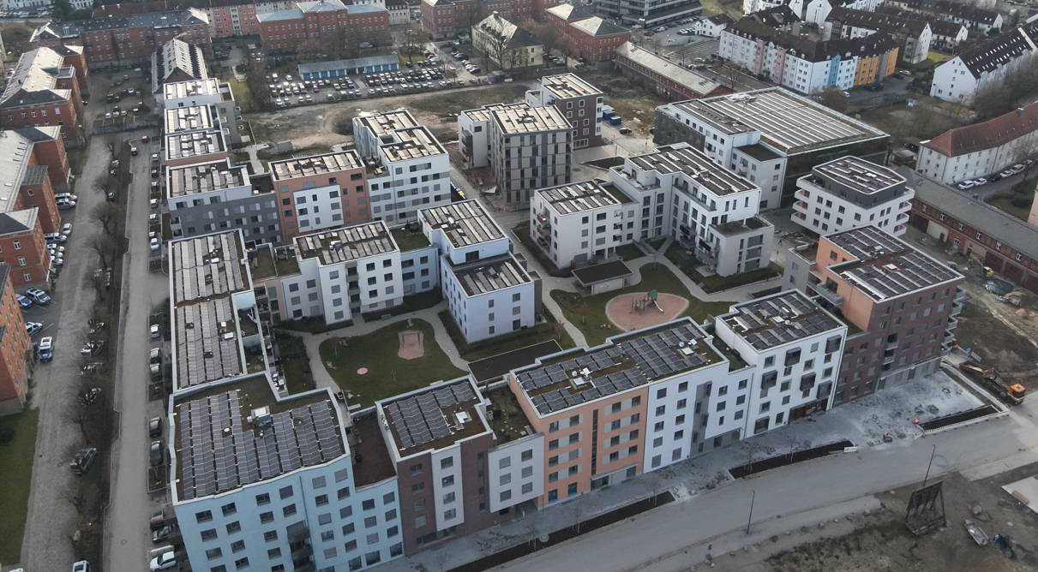
Fig. 1: Photo of the south-western part of the Lagarde-Campus (Source: Stadtwerke Bamberg)
With the energy supply concept operated by Stadtwerke Bamberg, thermal energy for new buildings is provided by heat pumps (HP) connected to a cold district heating grid that utilizes geothermal sources (soil collectors and boreholes) as well as waste‑water heat (Meyer et al.). For existing buildings, a combined heat and power (CHP) plant is supporting the district heat coming from a waste combustion power plant. In addition to the electric power from the CHP unit, a large proportion of the electricity for operating the HPs is generated by photovoltaic systems on the roofs of the campus buildings. Besides the warm and cold heating grids, an additional electricity grid has been integrated to utilize the electricity for the energy supply systems on campus level (Fig. 2).
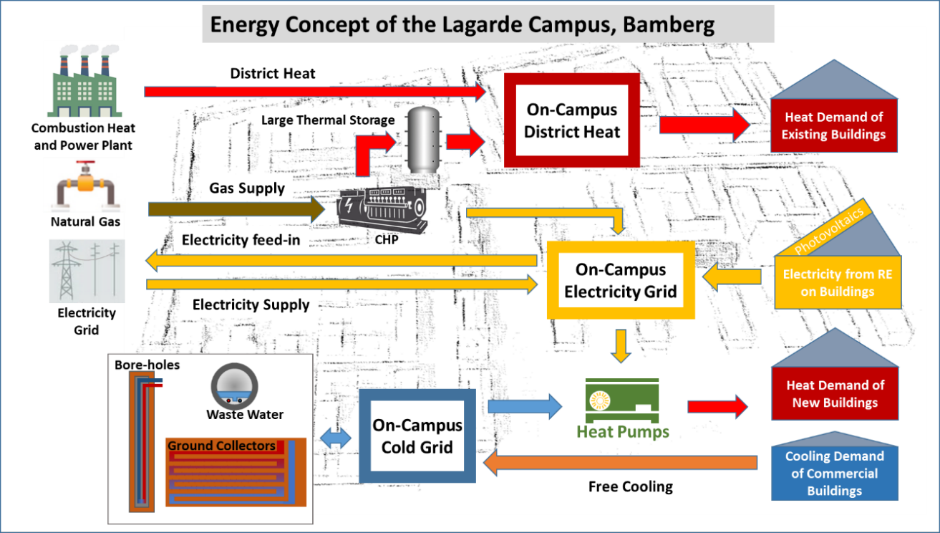
Fig. 2: Elements of the energy supply concept of the Lagarde-Campus
Within the research project Enable funded by the German Ministry for Economics and Energy (BMWE), an optimization of the cross-sector control of the district systems has been implemented. The optimization especially focuses on the utilization of the system flexibility including marketing of electricity demand and consumption (Langemeyer et al). For this, an information and communication (ICT) system for the complete interaction of sensors, components, forecasting systems, and interfaces to the grid operator, energy supplier, and a trading platform operated by SEtrade has been included. The aim of the project is to demonstrate this complete ICT chain in the field at the Lagarde-Campus and to evaluate energy efficiency as well as CO₂ and cost benefits of the flexible operation. For this, an automated energy management system has been implemented by Siemens Building Services in interaction with the conventional building management system and external services like weather, spot market prices and AI-based forecasting techniques.
- System Performance Analysis
Within the research project, the performance of the different HP systems being installed in the different multi-family houses at the Lagarde Campus has been evaluated. Until the end of 2025, the heat pump systems of 19 buildings have started their operation. Each HP system consists of one to four single brine-to-water heat pumps connected to the cold grid for the provision of space heating (SH) and/or domestic hot water (DHW). An exemplary buildings system design is shown in Fig. 3. The temperatures in the buffer tank for SH are controlled depending on the ambient temperature and differ between 35°C and 45°C. For DHW, even if building central fresh-water stations have been installed, minimum temperatures of 60°C for withdrawal have to be ensured at all times for preventing legionella growing. Within each building, a multitude of sensors have been implemented offering the energetic evaluation of each thermal circuit as well as all electrical consumers like heat pumps, circulation pumps and electric heaters. For the evaluation of the implemented system and its standard control, the Seasonal Performance Factor (SPF) is typically used. Hereby, SPF2 represents the fraction of the heat produced by the HP and its electric input and SPF5 stands for the fraction of the used thermal energy (including storage losses) divided by all electric inputs (including all peripheral equipment for operation).
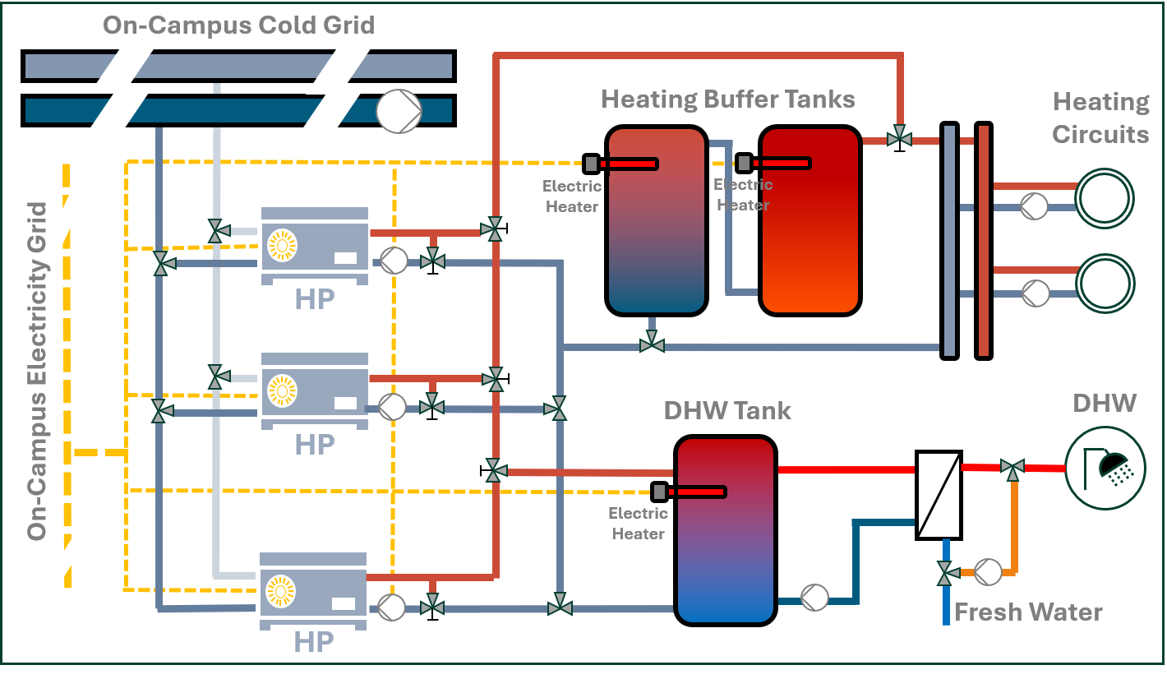
Fig. 3: Exemplary system design for heating and domestic hot water provision within the multi-family houses consisting of two low-temperature heat pumps for space heating and a high-temperature heat pump for domestic hot water provision, each connected to a cold grid, a storage tank for domestic hot water and two buffer tanks for space heating.
Regarding this, Fig. 4 shows the monthly SPF2 and SPF5 values for domestic hot water provision, Fig. 5 for space heating. As can be seen within the box-plots diagrams, the monthly values of SPF2 for DHW are for most buildings due to the required temperatures of 60°C in the range of 2.5-3, slightly decreasing in winter times due to lower cold grid temperatures. Only a few buildings, which provide pre-heating on a lower temperature level, and individual fresh-water stations in each apartment are achieving SPF values of more than 4. Regarding space heating, a significant variation of the SPF over the months and for different buildings has been observed. Typical values in spring and autumn are between 5-6 whereas due to higher system temperatures in winter, values are slightly below 5. However, in the transition times and partly in summer, SPF5 values are decreasing significantly due to higher relative storage losses related to the energy demand for space heating.
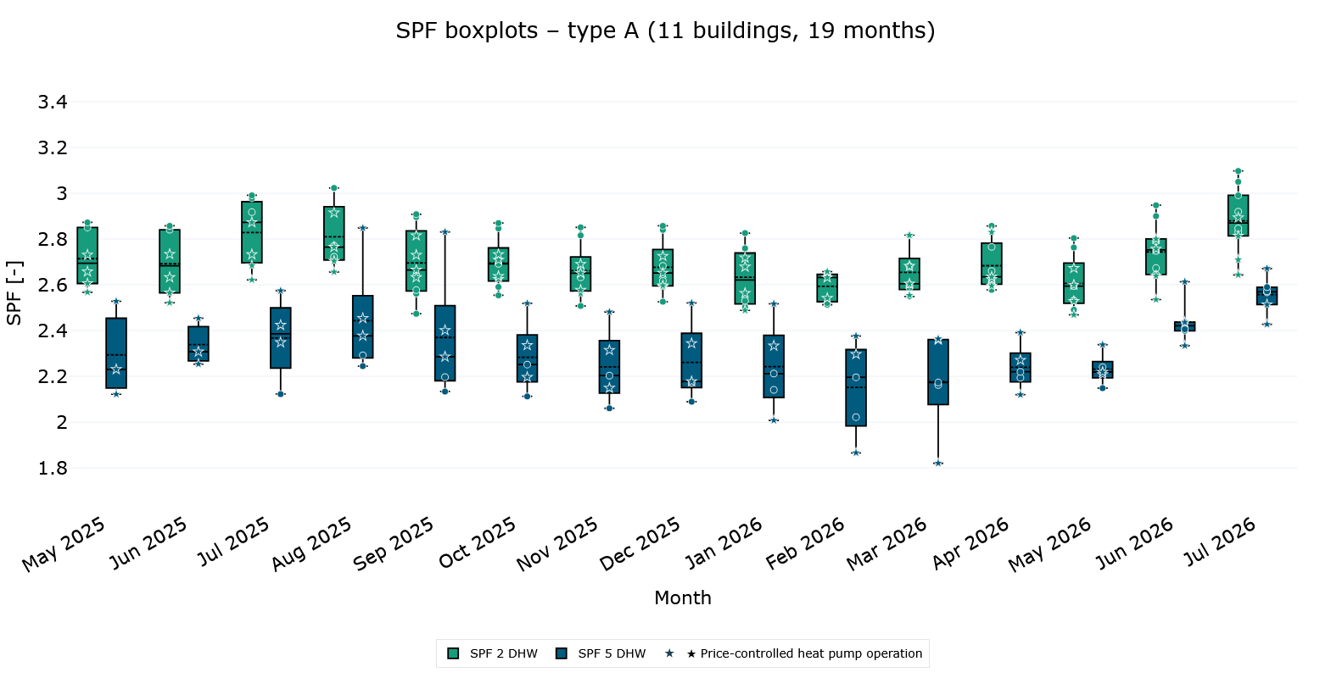
Monthly SPF for Domestic hot water in 10 Buildings
Fig. 4: Boxplots of the monthly seasonal performance factors (SPF2, SPF5) for the provision of domestic hot water of the monitored heat pump systems in 14 buildings at the Lagarde Campus from April 2025 to July 2026. Indicated stars within the boxplots represent buildings, in which a price-optimized control has been implemented.
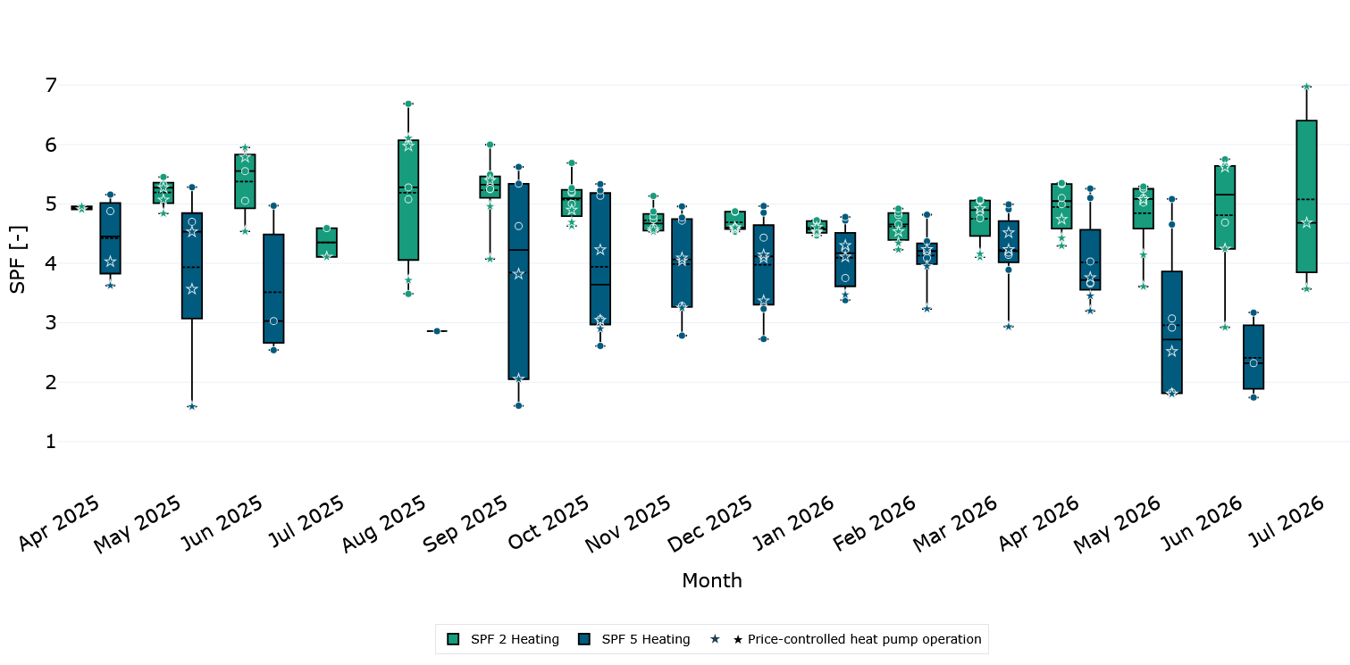
Monthly SPF for Space Heating in 10 Buildings
Fig. 5: Boxplots of the monthly seasonal performance factors (SPF2, SPF5) for the provision of space heating of the monitored heat pump systems in 14 buildings at the Lagarde Campus from April 2025 to July 2026. Indicated stars within the boxplots represent buildings, in which a price-optimized control has been implemented.
Altogether, a high performance of the heat pump operation for space heating can be observed due to relatively high temperatures in the cold grid and low service temperatures for the floor heating systems in the buildings. High variations within the transition times give an indication of future energy savings based on better space heating demand forecasts. Regarding DHW, the comparable moderate performance values are resulting from the high DHW temperatures due to the requirements of legionella prohibition. Individual freshwater stations in each apartment would have the potential to significantly increase the performance of the heat pumps.
Regarding the operation of the CHP units, different operation schemes are implemented in the Lagarde campus offering system flexibility. Hereby, the CHP operation is coordinated with aggregated PV and aggregated electrical loads in the Campus. The three main operation modes are:
- CHPs operate in partial load to cover electrical loads, which is usually observed in the evenings during times when electrical load and/or electricity prices are moderately high.
- CHPs in full operation mode during high energy prices to feed-in to the grid for revenue generation.
- CHPs are not in operation due to expected low electrical load during moderately low energy prices.
- Modelling of System Flexibility
Building up on the evaluation of the demand‑oriented operation of the heat pumps, the impact of the energy‑market‑oriented flexible operation of the entire system - including both heat pumps and CHP units -has been assessed. Regarding the operation of the heat pumps, temperature set values for heat pumps and the respective storage tanks have been shifted depending on the price signals. In case of DHW, the potential of increasing and decreasing set points is limited to the temperature range 60-65°C due to the legionella requirements as well as the maximum possible provision temperature of the DHW heat pump. Following this, the shift potential of the operation is quite limited as well. In terms of space heating, the theoretical potential for shifting operation is significantly higher. In winter months, a temperature range from 45-60°C can be assessed whereas in spring and autumn, a spread from 35-60°C is possible. However, since the total heat demand in the transition periods is significantly lower compared to the winter times (especially for new residential buildings), the shiftable thermal and electrical energy is much lower as well. In the current case of non-modulating heat pumps being installed in the buildings, the part-load behavior leads to additional constraints in the flexible operation.
In order to evaluate the potential of flexible operation, a simplified model of the heat pump systems has been developed. Within a python model, a thermodynamic system consisting of heat pumps, domestic hot water and space heating tanks have been implemented. Weather data for Bamberg, electricity prices based on a day-ahead market as well as measured space heating and domestic hot water demands are serving as input for the system simulation. In addition, two different control strategies have been investigated:
- Demand oriented control strategy for charging and discharging of storage tanks
- Energy market flexible control strategy based on day-ahead price scenarios and the forecasts of domestic hot water and space heating demand based on a 24-hour forecast horizon
Fig. 6 shows a comparison of the two control strategies for the domestic hot water preparation of 9 investigated buildings from May 2025 to July 2026. As can be seen, as an average over the different buildings, a theoretical potential for cost reductions of more than 10% is possible throughout the year.
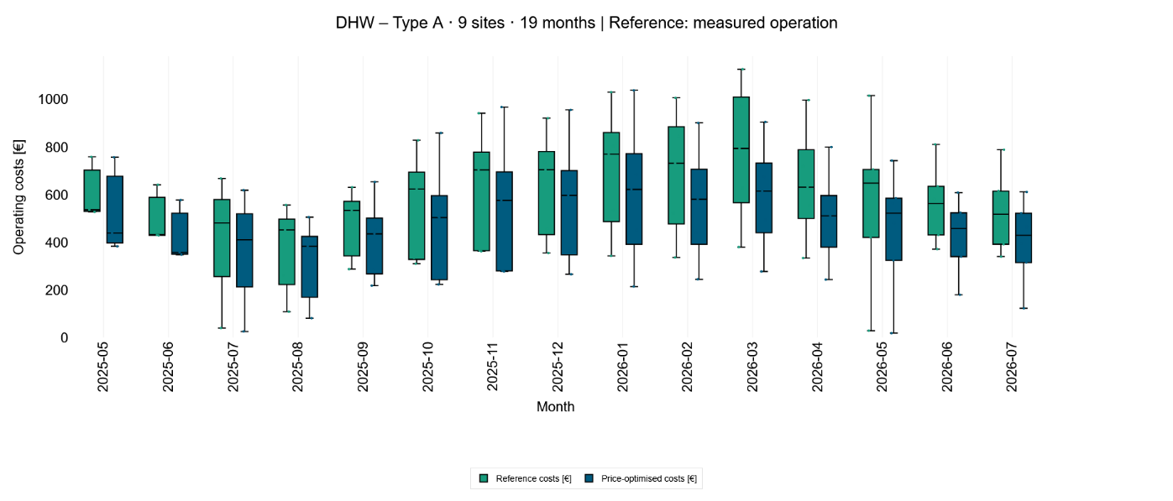
Cost saving for DHW – 9 buildings with central DHW systems
Fig. 6: Boxplots of monthly electricity costs on the basis of Day-Ahead prices: Comparison of standard (green) and flexible (blue), price optimized control strategies for domestic hot water preparation
In comparison to the shift potential of domestic hot water, the theoretical cost saving potential within the space heating sector has a very distinguished seasonal dependence. Given the negligible heat demand in summer and very low demand within the transition periods, the cost benefits are mainly limited to the winter period and reach values below 10%.
Compared to the heat pumps, the flexibility potential of the CHP units is much higher within the Lagarde Campus. Since the CHP units are an add-on to the district heat serving the existing buildings, the operation can easily being shifted or even limited to times of high electricity market prices. For the complete campus – including the uncontrollable loads – a saving potential of up to 10%, depending on price and weather conditions is expected. For activating the operational flexibility, limitations exist only with regard to number of starts of the units and minimum operation times for each day. However, high operation times of the CHP are still required to ensure good overall economic performance considering the investment cost of the CHP units.
- Implementation of flexible operation
For implementing flexible control in the Lagarde Campus, a system consisting of modelling, forecasting, optimizing as well as trading has been developed by Siemens. As shown in Fig. 7, a digital twin has been designed based on measured data and a model for heating and domestic hot water loads. In addition, forecasting systems for energy costs, weather and future flexibility within the system have been integrated and coupled with an optimization system to form a model predictive building energy management system. Depending on the optimization output, flexibility offers are traded within the intraday electricity market and operation schedules for heat pumps and CHP are assigned to the control system.
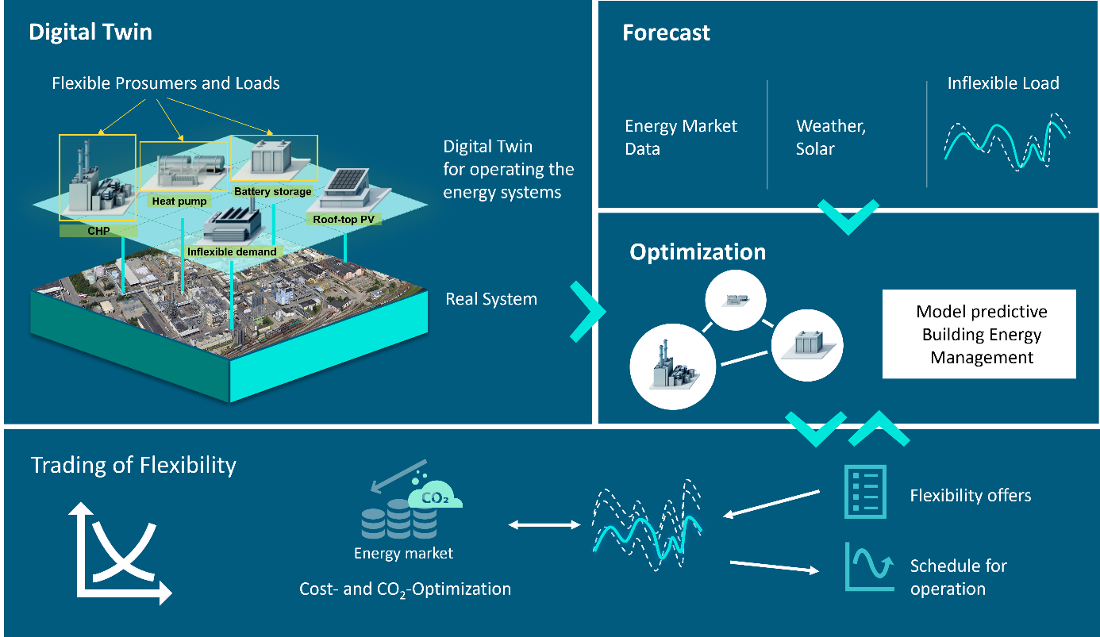
Fig. 7: Process for the implementation of flexible operation on campus level including measurement, modelling, forecasting, optimization and trading
Fig. 8 shows exemplarily the overheating of a buffer tank in one campus building on December 3rd 2025 during times of low electricity prices. As can be seen, the operation of the heat pump is shifted to times of lower prices whereas during peak price slots, no heat pump operation is required. Within a period of two weeks in December 2025, cost savings of 4.3 % for one building and 10.7 % for a second building can be observed.
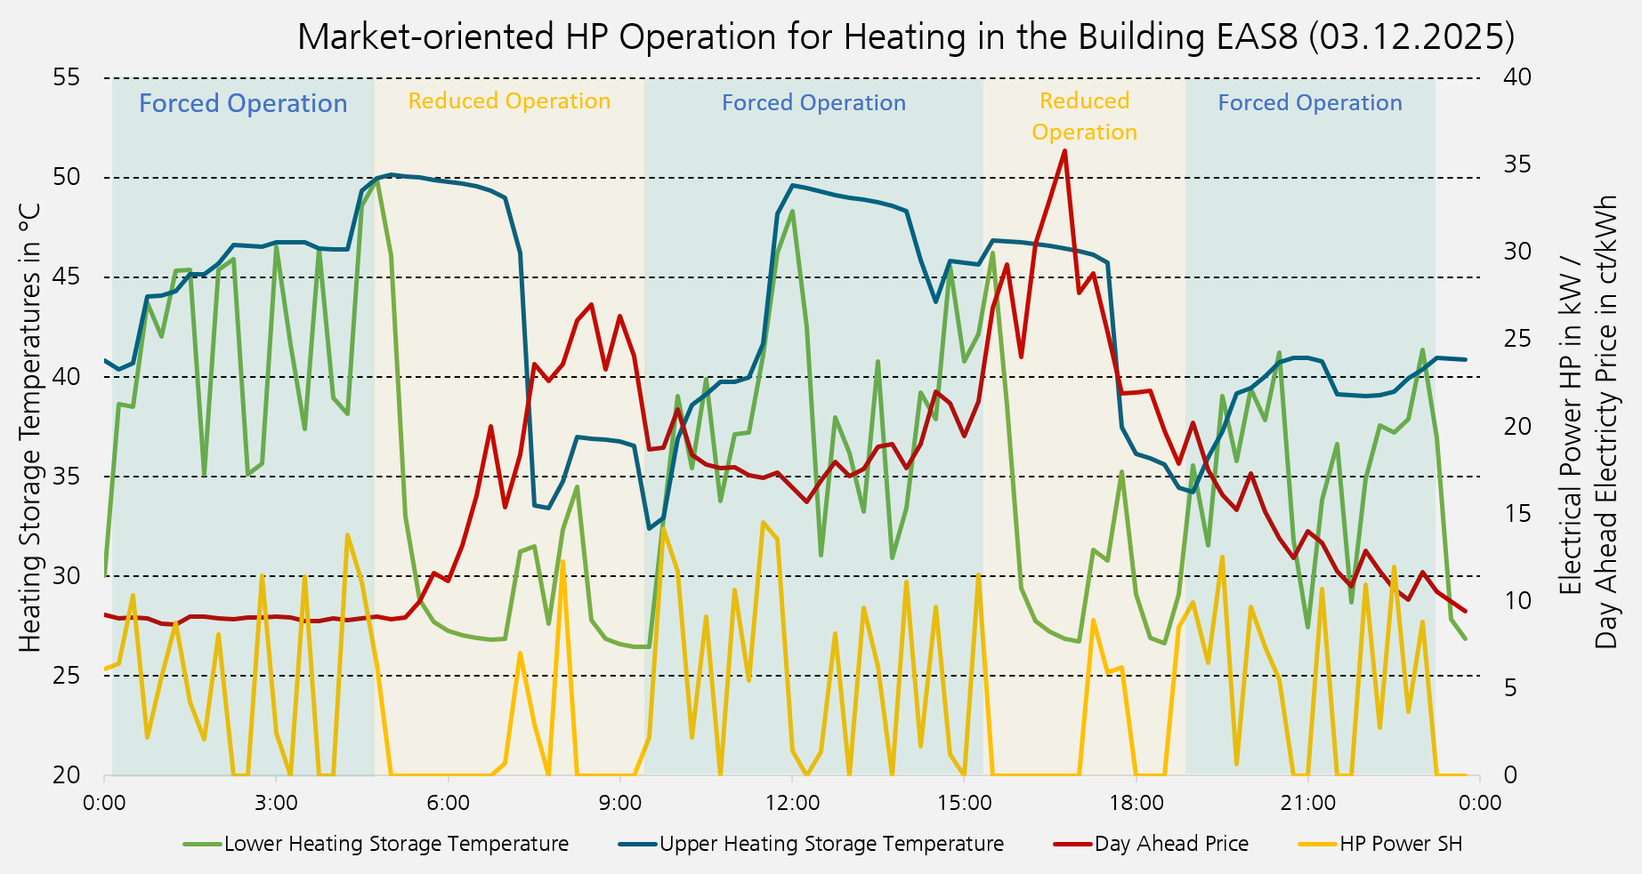
Fig. 8: Process of overheating of the storage tank for space heating during times of lower day-ahead prices and reduced charging during peak day-ahead prices
In addition, the cost saving of load shifting over a whole year as well as for different heat pump systems has been assessed. As an example, Fig. 9 shows the financial savings for one building over the space heating period September 2025 to April 2026. As shown, total savings of up to 90 €/month have been achieved. However, the total as well as the relative savings differ significantly over the different months. In months with very low energy demand like September, almost no saving can be achieved. Months with high heat demand like January, total savings are limited as well, the relative savings are in the range of 1%. However, in the transition period March to April, savings of up to 15% can be obtained. The investigation of the saving potential of the other 6 buildings with market-oriented control show similar results, with very low relative savings in winter and moderate savings in the transition period. In total, savings of around 15-30 €/month and building (depending on the size of the building) can be achieved.
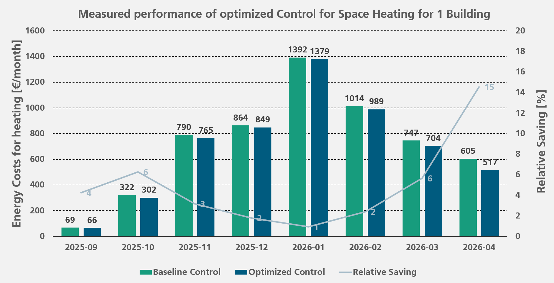
Fig. 9: Measured performance of optimized control at the building RKS12.
The results support the general theory of market-oriented operation of heat pumps for space heating:
- On cold days: high heat demand is needed but the potential for shifting operating shifting is low as well as the fluctuation of energy prices
- On warm days: only small amounts of thermal energy are needed (and thus, total savings are small) but with a high operating shifting potential and more and more low electricity prices
- Transition period: relatively high energy demand meets moderate flexibility and high fluctuating energy prices
Following this, it can be concluded that especially for new and energy efficient buildings, flexible control for domestic hot water provision offers higher saving potential and should be addressed within an overall optimized control system. However, in the current system design at the Lagarde Campus, a number of factors limit the possibility of activating flexible control for DHW:
- For preventing legionella growing, very high storage temperatures have to be ensured at all times limiting the possibility to increase the tank temperature with heat pump operation. Since the supply temperatures of the installed heat pumps are limited to about 70°C as maximum, system concepts with lower central temperatures would increase the potential
- The installed non-modulating heat pumps typically destroy temperature stratification in the storage tanks, which limits the shifting of operation. In addition, high discharging flow rates are leading to an additional mixing of storage temperatures. In addition, high tank temperatures, e.g. due to longer heating element operation in the storage tanks, are leading to operation faults of the heat pumps
Assessing the market-oriented control of the CHP units requires the definition of reference operation schemes, which have been integrated in the simulation and optimization environment. Hereby, electricity demand for the operation of heat pumps is either covered by the CHP production, by on-site PV generated or from the public electricity grid. During CHP operation, the produced thermal energy is sold to the high temperature district grid. Regarding the energy cost analysis, CHP maintenance and operation costs were ignored. Optimized profiles at the grid-connecting point consist of forecasts of PV, el. loads and CHPs operation and are placed in the Intraday Market.
Besides the flexible operation based on Day-Ahead and Intraday Market prices, two reference operation profiles have been defined:
- Ref 1 – CHPs off: During respective days, the CHPs are not in operation (no production of electric and thermal energy and thus no gas costs or thermal revenue)
- Ref 2 -180 kW: CHP is turned on and runs for at least 2 hours as soon as the power requirement of the whole district at the connection point to the public grid exceeds 180 kW. If, after 2 hours of operation, the power demand of the campus drops below 180kW, the CHP is turned off. Typically, this reference scenario would have been in operation in the Lagarde Campus given no market-optimized control would have been implemented.
Tab. 1 shows the comparison of the optimized, flexible control with the two reference operation modes for 3 exemplary days in December 2025 with different energy demands and energy prices. As can be seen, depending on the day, significant overall cost savings can be achieved compared to the reference operation schemes. Especially compared to the standard operation with respect to the 180 kW limit, savings of more than 20% are possible.
Tab. 1: Evaluation of the market-oriented flexible operation for the two CHP units in comparison to two simulated reference scenarios (Ref1, Ref2).
 | Operation Mode | Energy Costs in €/day |  |  |  | Saving
 | Operation Mode | Electricity | Gas | Heat | Total Costs | Saving
03.12.2025 | Flexible | -495 | 1821 | -530 | 797 | -
03.12.2025 | Ref 1 - CHPs off | 1274 | - | - | 1274 | 59,9%
03.12.2025 | Ref 2 - 180kW | 129 | 1190 | -346 | 972 | 22,1%
08.12.2025 | Flexible | 472 | - | - | 472 | -
08.12.2025 | Ref 1 - CHPs off | 472 | - | - | 472 | 0,0%
08.12.2025 | Ref 2 - 180kW | 154 | 597 | -174 | 578 | 22,4%
11.12.2025 | Flexible | 412 | 241 | -70 | 582 | -
11.12.2025 | Ref 1 - CHPs off | 584 | - | - | 584 | 0,3%
11.12.2025 | Ref 2 - 180kW | 211 | 574 | -167 | 617 | 6,0%

- Conclusions
The Lagarde Campus in Bamberg has been transformed into an energy efficient campus with an innovative thermal and electrical system design including heat pumps (HP) connected to a cold grid as well as combined heat and power (CHP) units and large PV installations. An extensive monitoring system shows the overall good performance of the heat supply system. To increase the on-campus use of the generated electricity of the PV and the CHP units as well as to reduce the energy costs for the overall operation, a market-oriented flexible control of both the installed HPs and the CHP units has been successfully implemented. Within the control, operation of HP and CHP has constantly been modeled and operation times were shifted to times of low market prices.
A theoretical investigation shows saving potentials for domestic hot water (DHW) and space heating (SH) within the building energy supply systems in the range of 10% over the year. Within the demonstration phase at 6 buildings, saving potentials between 1 and 15% for space heating depending on the time of the year have been observed. Maximum relative savings have been achieved during the transition periods. The activation of flexibility for DHW has been found to be much more difficult within the currently installed system design. However, since the theoretical potential within new developments is much higher for DHW, changes in the design are suggested for future developments. Regarding the flexible operation of the CHP units, savings of up to 20% on specific days are possible compared to standard operation schemes.
Within the project, an information and communication system for the complete interaction of sensors, components, forecasting systems, and interfaces to the grid operator, energy supplier, and a trading platform has been successfully implemented. The optimization of the control uses both day-ahead and intraday price scenarios as well as specific user demand forecasts for SH and DHW. The complete chain of necessary information flows was proven by the operation experience at the Lagarde Campus to be very reliable. However, technical constraints of the implemented thermodynamic system for maximizing the benefit of the market-oriented operation have been identified.
- References
Beier, C., Wrobel, P., Schnier, M., Kanngießer, A., Erhorn, H., Erhorn-Kluttig, H., Bretschneider, P., Dütz, A., Block, T., Löffler, J, Moltmann, S. Jank, R.: Eneff:Stadt – Wissenschaftliche Begleitung der Förderintiative “Energieeffiziente Stadt”, Oberhausen, 2016
Brahman, F., Honarmand, M., Jadid, S.: "Optimal electrical and thermal energy management of a residential energy hub, integrating demand response and energy storage system," Energy and Buildings, vol. 90, pp. 65–75, 2015, doi: 10.1016/j.enbuild.2014.12.039
Clauß, J., Finck, C., Vogler-Finck, P., Beagon, P.: “Control strategies for building energy systems to unlock demand side flexibility –A review”, in: IBPSA, 2017. https://researchrepository.ucd.ie/handle/10197/9016
Evens, M., Mugnini, A., Arteconi, A.: "Design energy flexibility characterisation of a heat pump and thermal energy storage in a Comfort and Climate Box," Applied Thermal Engineering, vol. 216, p. 119154, 2022, doi: 10.1016/j.applthermaleng.2022.119154
Freischlad, B., Yang, C., Engelter, A., Vossel, C., Reissner, F., Steinke, F., Niessen, S.: "Harnessing the flexibility of power-to-heat operation in building and district heating to support electricity systems: A review," Advances in Applied Energy, vol. 22, p. 100272, 2026, doi: 10.1016/j.adapen.2026.100272
Halvgaard, R., Poulsen, N. K., Madsen, H., Jorgensen, J. B.: "Economic Model Predictive Control for building climate control in a Smart Grid," 2012 IEEE PES Innovative Smart Grid Technologies (ISGT), pp. 1–6, 2012, doi: 10.1109/ISGT.2012.6175631
Krause, M., Gerhardt, N., Giron Cruz, P., Huang, M., Herkel, S., Zapf, M.: The impact of heat pumps on the electricity load: Evaluation of large sets of operational data including the simulation of future situations, Smart Energy, Volume 22, May 2026, doi: 10.1016/j.segy.2026.100255
Langemeyer, S., Krause, M., Kaiser, J., Loskarn, S., Schneider, C.: ENABLE: Vertikale Integration von Kommunikations- und Regelungssystemen zur Aktivierung von Flexibilität für eine quartiersweite Energieoptimierung, 14. Projektetreffen EnergieWendeBauen, Bamberg, Germany, 2023
Leeuwen, W.J.A., Bongaerts, M., Vanalme; G.M.A., Asare-Bediako, B., Kling, W.L.: “Load Shifting by Heat Pumps using Thermal Storage”, Proceedings of the UPEC 2011 conference, Soest, 2011
Meyer J., Zeh R., Schmid M., Stockinger V.: Innovative Wärmeversorgung im innerstädtischen Quartier: Wärme- und Monitoringkonzept, Northern-German Conference for Heat Research, Göttingen, Germany, 2023
Molitor, C., Ponci, F., Monti, A., Calì, D., Muller, D.: "Consumer benefits of electricity-price-driven heat pump operation in future smart grids," Proceedings, 2011. [Online]. Available: https://www.semanticscholar.org/paper/Consumer-benefits-of-electricity-price-driven-heat-Molitor-Ponci/6cea71ca12f3f4b28e845bdb9305edf66724edeb
Nykamp, S., Molderink, A., Bakker, V., Toersche, H. A., Hurink, J. L., Smit, G.: "Integration of heat pumps in distribution grids: Economic motivation for grid control," Innovative Smart Grid Technologies (ISGT Europe), 2012 3rd IEEE PES International Conference and Exhibition on, pp. 1–8, 2012,
doi: 10.1109/ISGTEurope.2012.6465605

