Effect of Al moderator addition on in situ TiC nano particles formation in cast aluminum based composite

E. Olejnik¹, W. Maziarz², G. Piwowarski¹, A. Wójcik², Ł. Szymański¹
¹AGH University of Science and Technology, Faculty of Foundry Engineering, 23 Reymonta Str. Krakow, Poland
²Institute of Metallurgy and Materials Science, Polish Academy of Sciences, 25 Reymonta Str. Krakow, Poland
Abstract
This work concerns an investigation of influence of Al moderator addition on in situ TiC nano particles formation in Al matrix via casting process. The moderator addition was applied in order to change the parameters of crystallization process consisting of nucleation and growth of TiC phase. With the increase of Al content degree of supercooling during formation of TiC also increases which has a main influence on the number of nuclei and final TiC particle size. For this purpose, powders of TiC reactants (pure Ti and C powders) and Al (50, 60, 70, 80, 90 and 95 wt %) were mixed and then compacted. These compacts were used for Differential Scanning Calorimetry (DSC) measurement for determination of temperature range and enthalpy of TiC formation in the presence of Al moderator. Two heating rate 10 and 100 °C/min were used in order to evaluate a kinetic of TiC formation. Figure 1a shows an example of DSC results obtained for two different heating rates of compacted powders containing 50 % wt Al moderator. As is clear seen, with increase of heating rate from 10 to 100 °C/min energy increase is observed for first exothermic pick near 784 °C. This can be explained by faster the TiC reaction completion. Additionally, maximum of the first exothermic peak moves to the right direction with the increase of heating rate. For lower heating rates the oxidation of powders may occur, which limited contact of reactants. Then powder compacts were used for in situ production of Al-based composites reinforcement with TiC nano particles. For this purpose compacts contained the mixture TiC powder reactants and 50, 60, 70, 80, 90, 95 wt % Al moderator addition, were subsequently introduced into the Al melt. Figure 1b shows an example Scanning Electron Microscopy (SEM) microstructure of cast TiC nano particles reinforced composite, obtained with using green compacts with powder mixture of 50 wt % TiC reactants and 50 wt % Al moderator. The two important observations result from microstructure study of this composite. The first thing is that, a large number of particles obtained in situ via casting process has a nanometer size. The second one is that, these particles are arranged in interdendritic spaces. This indicates that the particles were repulsive through the solid-liquid interface during crystallization process [1]. The microstructure observations of other composition revealed that addition of Al as moderator strongly influences on morphology, size and distribution of TiC nano particles.

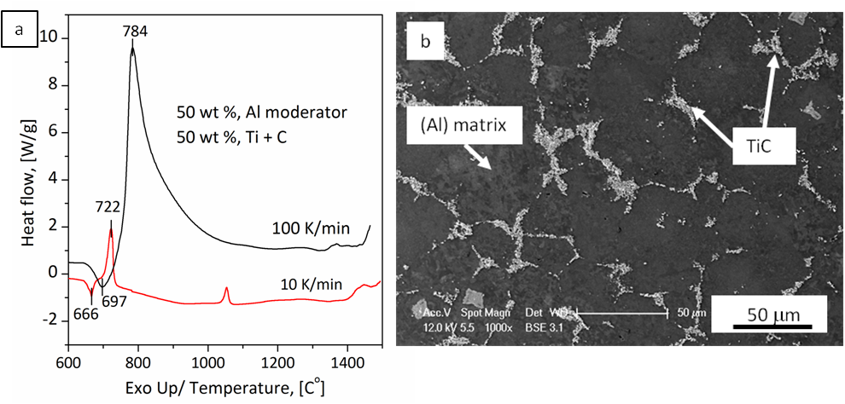
Fig. 1. Set of DSC and SEM results showing the heat flow of compacted powder mixtures contained 50 wt % Al moderator and 50 wt % TiC reactants during heating with two rate 100 and 10 K/min, respectively (a) and microstructure of cast Al-TiC nano particle reinforced composite (b).

Acknowledgements
This work was performed in the frame of Polish National Science Centre (NCN) research project No. 2016/21/B/ST8/01181.

Literature
- D.M. Stefanescu, B.K. Dhindaw, S.A. Kacar, A. Moitra, Behavior of Ceramic Particles at the Solid-Liquid Metal Interface in Metal Matrix Composites, Metallurgical Transactions A, 19 (1988) 2874-2855.

