TEMPERATURE DEPENDENCE OF STATISTICAL STATIC STRENGTHS FOR UNIDIRECTIONAL CFRP WITH VARIOUS CARBON FIBERS

Atsushi Koma¹, Masayuki Nakada² and Yasushi Miyano³

¹ Graduate School, Kanazawa Institute of Technology, Japan
^{2,3}Materials System Research Laboratory, Kanazawa Institute of Technology, Japan
¹Email: b6701347@planet.kanazawa-it.ac.jp,
²Email: miyano@neptune.kanazawa-it.ac.jp, ³Email: nakada@neptune.kanazawa-it.ac.jp,
^{2,3}Web Page: http://wwwr.kanazawa-it.ac.jp/MSRL/

Keywords: CFRP, bending load, static strengths, viscoelasticity, temperature dependence

Abstract
The statistical static strengths under the tension loading along the longitudinal direction of unidirectional CFRP with various kinds of carbon fibers are measured at various temperatures and discussed in the role of the viscoelasticity of matrix resin. First, the formulation for time and temperature dependent statistical static strength for CFRP laminates is performed based on the viscoelasticity of matrix resin. Second, the statistical static strengths of four kinds of carbon fibers, those are high strength and high modulus PAN based carbon fibers and low and high modulus pitch based carbon fibers, are measured by using single fibers of these four kinds of carbon fibers. Third, the temperature dependent tensile static strengths of unidirectional CFRP with four kinds of carbon fibers are statistically measured at various temperatures by using resin impregnated carbon fiber strands (CFRP strands) as the specimens of unidirectional CFRP. Finally, the temperature dependences of tensile static strengths are discussed from the role of the viscoelasticity of matrix resin.

1. Introduction

The mechanical behavior of matrix resin of CFRP exhibits time and temperature dependence, called viscoelastic behavior, not only above the glass transition temperature T_{g}, but also below T_{g}. Consequently, it can be presumed that the mechanical behavior of CFRP depends strongly on time and temperature [1-5]. Our earlier reports have proposed the formulation of statistical static, creep, and fatigue strengths of CFRP based on the viscoelasticity of matrix resin [6, 7].

The tensile strength along the longitudinal direction of unidirectional CFRP constitutes important data for the reliable design of CFRP structures. The authors developed a test method for creep and fatigue strengths as well as the static strength at elevated temperatures for resin-impregnated carbon fiber strands (CFRP strands) combined with T300-3000 and epoxy resin [8]. Furthermore, the authors have confirmed that the time and temperature dependent tensile static strength is controlled by the viscoelastic behavior of matrix resin based on the Rosen’s shear lag model [9].

In this study, the statistical static strengths under the tension loading along the longitudinal direction of unidirectional CFRP with various kinds of carbon fibers are measured at various temperatures and discussed in the role of the viscoelasticity of matrix resin. First, the formulation for time and temperature dependent statistical static strength for CFRP laminates is performed based on the viscoelasticity of matrix resin. Second, the statistical static strengths of four kinds of carbon fibers, that is high strength and high modulus PAN based carbon fibers and low and high modulus pitch based carbon fibers, are measured by using many specimens of these four kinds of carbon fibers. Third, the temperature dependent tensile static strengths of unidirectional CFRP with four kinds of carbon fibers are statistically measured at various temperatures by using resin impregnated CFRP strands as the specimens of unidirectional CFRP. Finally, the temperature dependences of tensile static strengths are discussed from the role of the viscoelasticity of matrix resin [10].

2. Statistical Prediction of Creep Failure Time of Unidirectional CFRP

We have proposed the formulation for the statistical static strength σ_{s} of CFRP laminates based on Christensen’s model of viscoelastic crack kinetics, as shown in the following equation in our previous paper [7] as
, | (1)
where P_{f} signifies the failure probability, t denotes the failure time, t₀ represents the reference time, T is the temperature, T₀ stands for the reference temperature, σ₀ and α_{s} respectively denote the scale parameter and the shape parameter on Weibull distribution of static strength, n_{R} is the viscoelastic parameter, and D_{c} and D* respectively represent the creep and viscoelastic compliances of matrix resin. The viscoelastic compliance D* for the static load with a constant strain rate is shown by the following equation.
(2)

Rosen’s model is well known as the failure model for the tensile static strength under the longitudinal direction of unidirectional CFRP [8]. The viscoelastic parameter n_{R} in Eq.1 can be shown by the following equation based on Rosen’s model.

(3)

where α_{c} signifies the shape parameter of tensile strength of single carbon fiber.

3. Molding of CFRP Strands

Four kinds of carbon fibers were employed in this study. They are high strength PAN based carbon fiber T300-3000 and high modulus PAN based carbon fiber M40J-6000 (Toray Industries Inc.) and low modulus pitch based carbon fiber XN05-3000 and high modulus pitch based carbon fiber XN50-3000 (Nippon Graphite Fibers Corp.). Four kinds of carbon fibers employed in this study and their mechanical properties by catalogs are shown on Table 1.

Four kinds of CFRP strands combined with each fibers and a general purpose epoxy resin jER828 (Mitsubishi Chemical Corp.) was molded using a filament winding system developed by the authors [8]. Actually, 200 specimens for four kinds of CFRP strands were molded at one time using this system, respectively. The composition of epoxy resin and the cure condition of CFRP strand are presented in Table 2. The gage length of CFRP strands are approximately 200 mm. The glass transition temperatures T_{g} = 160ºC of the epoxy resin are determined from the peak of loss tangent against temperature at 1 Hz using the DMA test. The fiber volume fraction V_{f} = 55% of CFRP strand is ascertained from the weight of CFRP strands.

Table 1. Four kinds of carbon fiber and their mechanical properties.
Name | PAN  or Pitch | Density  [g/cm³] | Tex  [g/km] | Elastic modulus  [GPa] | Tensile Strength  [MPa]
T300-3000  M40J-6000  XN05-3000  XN50-3000 | PAN  PAN  Pitch  Pitch | 1.76  1.75  1.65  2.14 | 198  225  410  450 | 230  377  54  520 | 3,530  4,400  1,100  3,830

Table 2. Composition and cure schedule of four kinds of CFRP strand.
CFRP strand | Carbon fiber | Composition of resin (weight ratio) | Cure schedule
T300/EP  M40J/EP  XN05/EP  XN50/EP | T300-3000  M40J-6000  XN05-3000  XN50-3000 | Epoxy: jER828 (100)  Hardener: MHAC-P (103.6)  Cure accelerator: 2E4MZ (1) | 70°C × 12 h  + 150°C × 4 h  + 190°C × 2 h

4. Creep Compliance of Matrix Resin and Static Strength of Carbon fibers

The dimensionless creep compliance D_{c}/D_{c0} measured at various temperatures is shown on the left of Fig. 1. The long-term D_{c}/D_{c0} at T=120°C is obtained by shifting horizontally those at various temperatures, as shown in the right of Fig. 1. The reference temperature and time are selected as T₀=25°C and t₀=1 min in this study. The creep compliance at reference temperature and reference time D_{c0} is 0.33 GPa⁻¹. The dashed curve is the dimensionless viscoelastic compliance D* of matrix resin under the constant strain rate at T=120°C.

The tensile strengths of four kinds of carbon fibers σ_{c} measured statistically at room temperature is obtained using the following equation. The gage length of carbon fibers is 25 [mm]. The number of specimens for each fiber is 50.

(4)

Therein, W_{max} is the maximum load [N]. ρ, t_{e} and N are the density of the carbon fiber [kg/m³], the tex of the carbon fiber strand [g/1000 m] and the numbers of fiber in one strand. Figure 2 shows the Weibull distributions for the tensile strengths of four kinds of carbon fibers and the table in this figure shows the shape parameters α_{c} and scale parameters β_{c} for these carbon fibers.

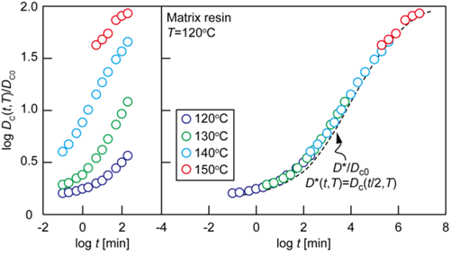
Figure 1. Dimensionless creep compliance of matrix resin at T=120°C.
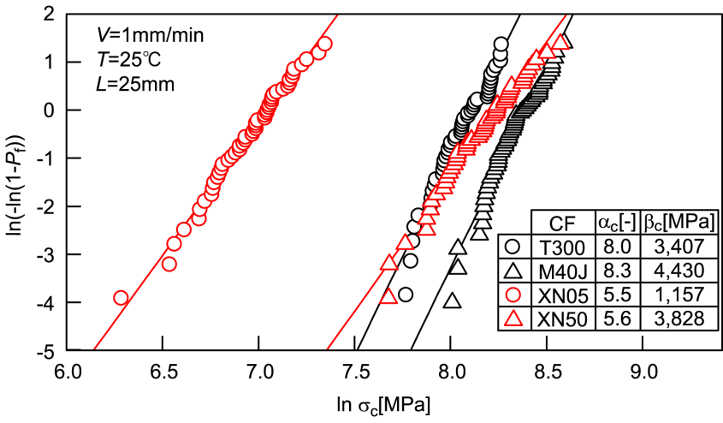
Figure 2. Weibull Distributions of tensile strengths for four kinds of carbon fiber.

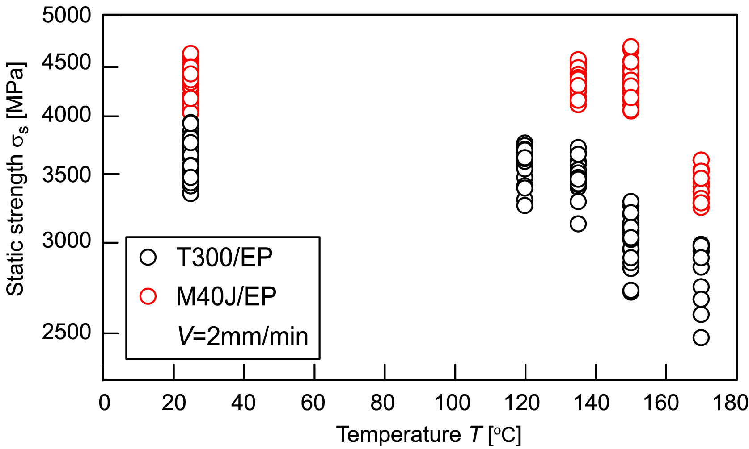
Figure 3. Static strength versus temperature for PAN based CFRP strands.

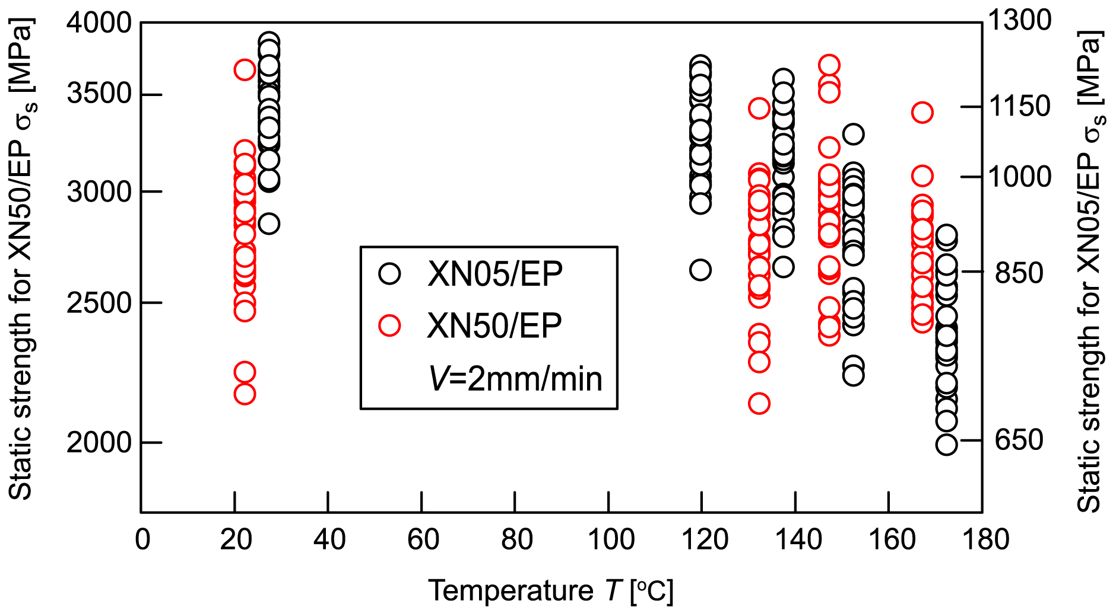
Figure 4. Static strength versus temperature for pitch based CFRP strands.

5. Tensile static strengths of CFRP strands at various temperatures

The static tension tests for four kinds of CFRP strands were conducted at four or five temperature levels, 25°C, (120°C), 135°C, 150°C and 170°C with cross-head speed 2 mm/min. The tensile strength of the CFRP strand σ_{s} is obtained using the following equation
(5)
Therein, W_{max} is the maximum load [N]. ρ and t_{e} are the density of the carbon fiber [kg/m³] and the tex of the carbon fiber strand [g/1000 m].

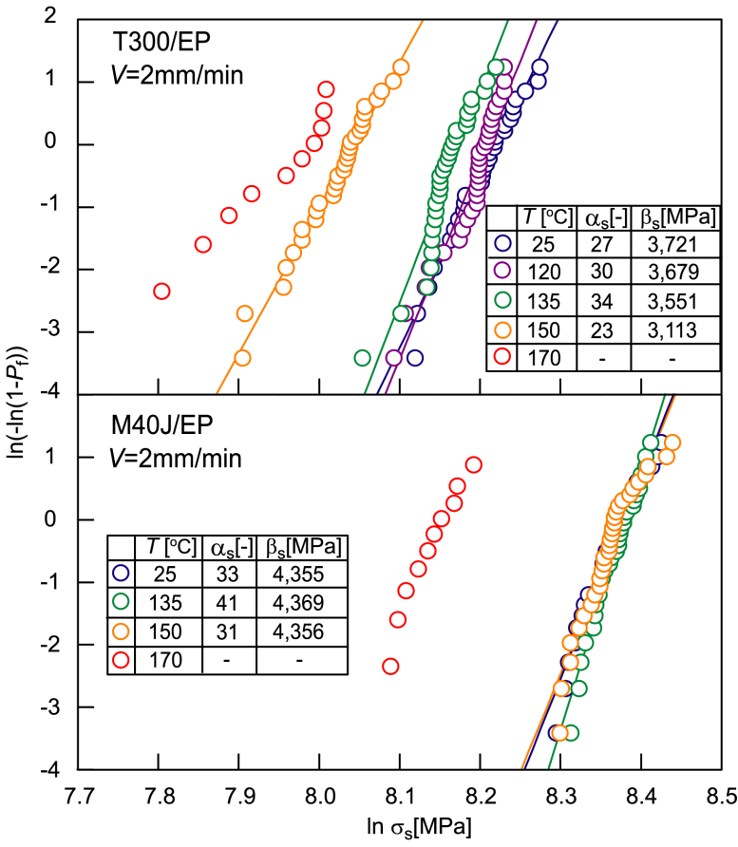
Figure 5. Weibull distributions of static tensile strength of PAN based CFRP strands.

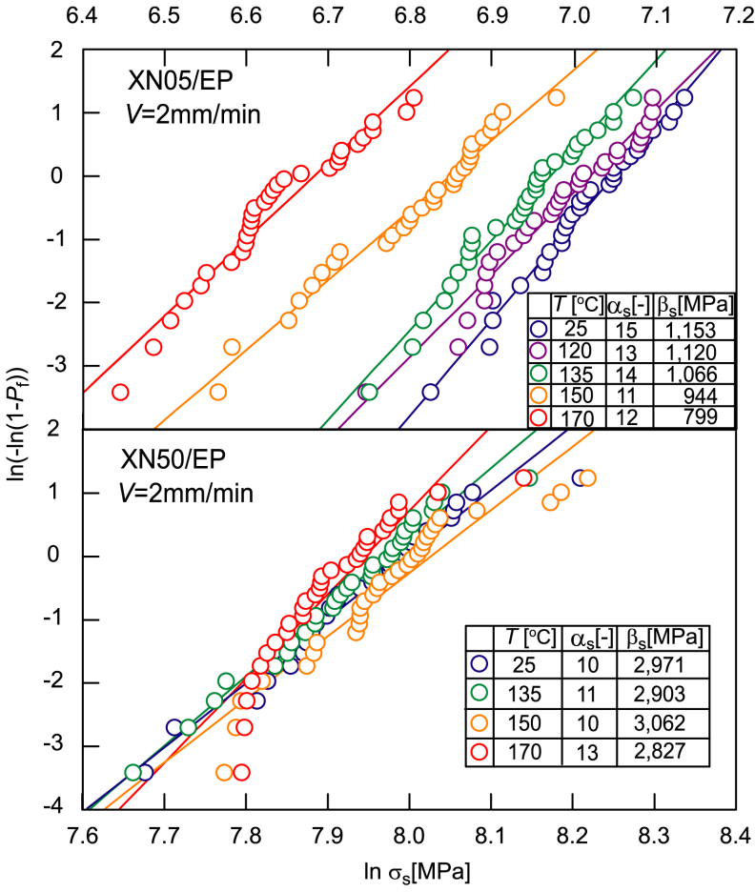
Figure 6. Weibull distributions of static tensile strength of pitch based CFRP strands.
Figures 3 and 4 show the static strengths versus temperature for four kinds of CFRP strands. The static strengths for T300/EP and XN05/EP decrease clearly with increasing temperature, and this strength for M40J/EP decreases scarcely with increasing temperature, and that for XN50/EP keep a constant for increasing temperature.

The Weibull distributions for the static strength at various temperatures are shown in Figs. 5 and 6 for each CFRP strands. α_{s} is the shape parameter and β_{s} is the scale parameter of CFRP strand in these figures. Although the scale parameter decreases or keeps a constant value according to the temperature raise, the shape parameter maintains almost a constant value for all of four kinds of CFRP strands to the temperature raise. The shape parameter α_{s} and the scale parameter β_{s} at the temperature T=25°C in these figures can be presumed as the shape parameter α_{s} and the scale parameter σ₀ of static strength at the reference temperature T₀=25°C and the reference failure time t₀=1 min used in Eq. 1.

6. Static tensile strength of CFRP strand against viscoelastic compliance of matrix resin

Figures 7 and 8 show the dimensionless static strength σ_{s}/σ₀ of CFRP strand against the dimensionless viscoelastic compliance of matrix resin D*/D_{c0} at the same time and temperature for four kinds of CFRP strands. The relation of σ_{s}/σ₀ against D*/D_{c0} can be shown by one or two solid straight lines with the slope of n_{R}, which is the viscoelastic parameter in Eq. 1. The dotted lines in these figures are the straight lines with the slope of viscoelastic parameters n_{R} obtained by substituting the shape parameter α_{c} of single carbon fiber strength into Eq. 3 based on Rosen’s model.

The slopes of four kinds of CFRP strands in Figs. 7 and 8 show characteristic behaviors with each other. The slopes of T300/EP and XN05/EP coincide well with those obtained from the shape parameter α_{c} of single carbon fiber strength based on Rosen’s model. The slopes of M40J/EP and XN50/EP is approximately zero in the wide range of compliance except high compliance of matrix resin.

7. Conclusions

The temperature dependences of statistical static strengths under the tension loading along the longitudinal direction of unidirectional CFRP with typical four kinds of carbon fibers were cleared based on the viscoelasticity of matrix resin. There are two kinds of viscoelastic parameter n_{R} on static tensile strength of unidirectional CFRP. The viscoelastic parameter n_{R} of CFRP with relatively low modulus carbon fiber is equal to the n_{R} obtained from Rosen’s model. On the other hand, the static tensile strength of CFRP with relatively high modulus carbon fiber is independent on the viscoelasticity of matrix resin. All of CFRP shows the tensile strength of CFRP decreases with softening of matrix resin.

Acknowledgement

This work was supported by Office of Naval Research (ONR) and US Air Force Office of Scientific Research (AFOSR) / Asian Office of Aerospace R & D (AOARD). The authors thank Dr. Yapa Rajapakse (ONR), Dr. Ming-Jeng Pan (ONR), Dr. Scott Robertson (AOARD) and Dr. Jeremy Knopp (AOARD). The authors thank Professor Richard Christensen of Stanford University as a consultant on ONR project.

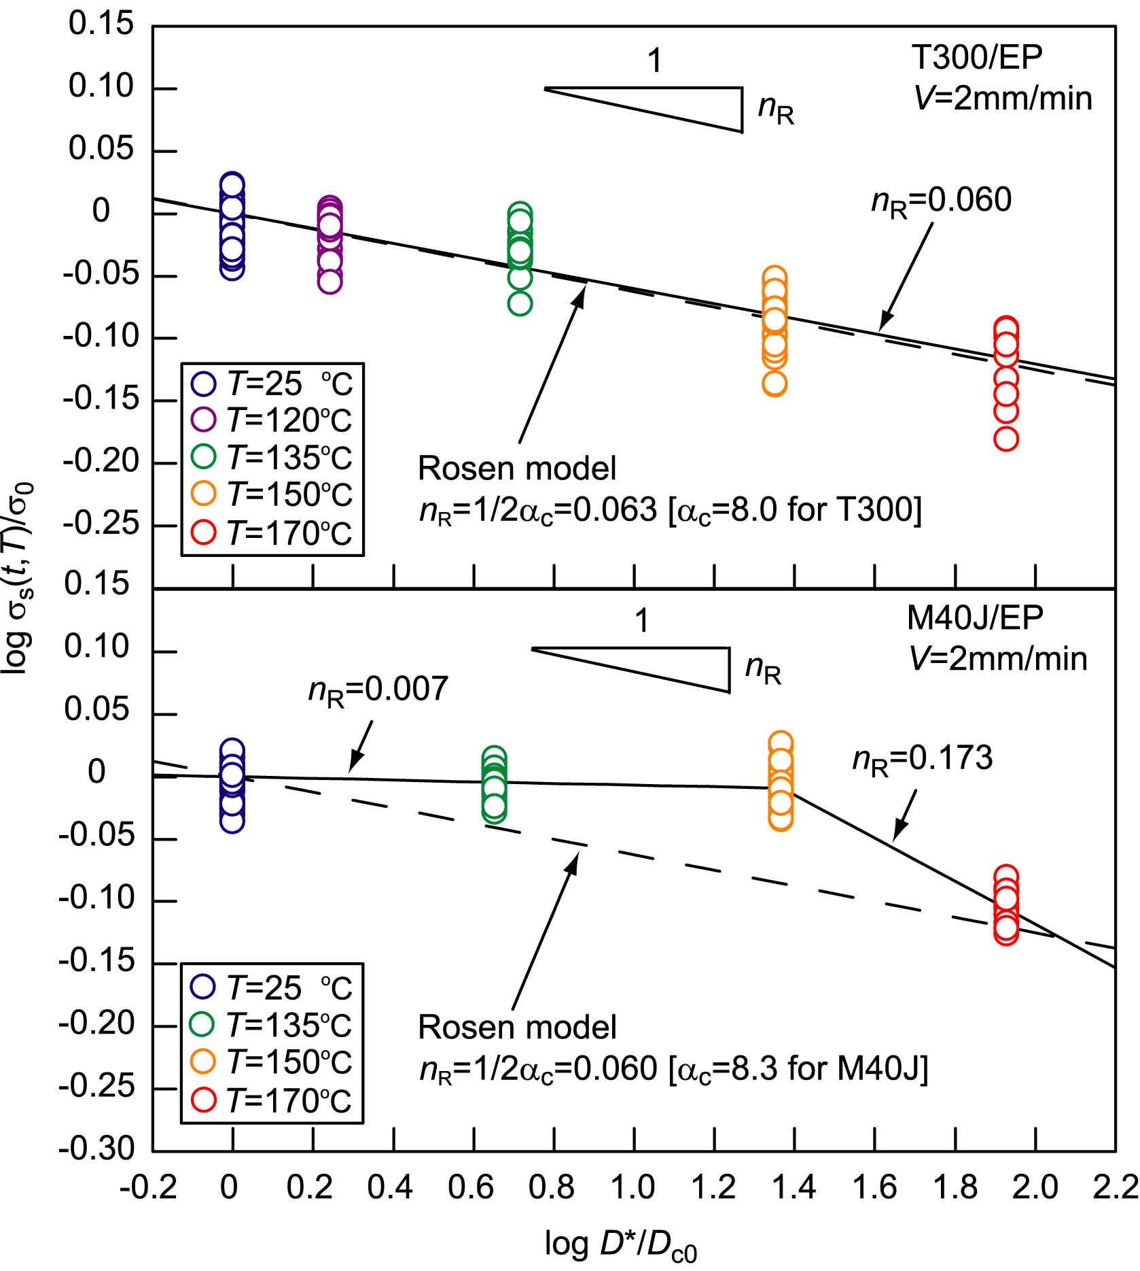

Figure 7. Static strength of PAN based CFRP strands against viscoelastic compliance of matrix resin.

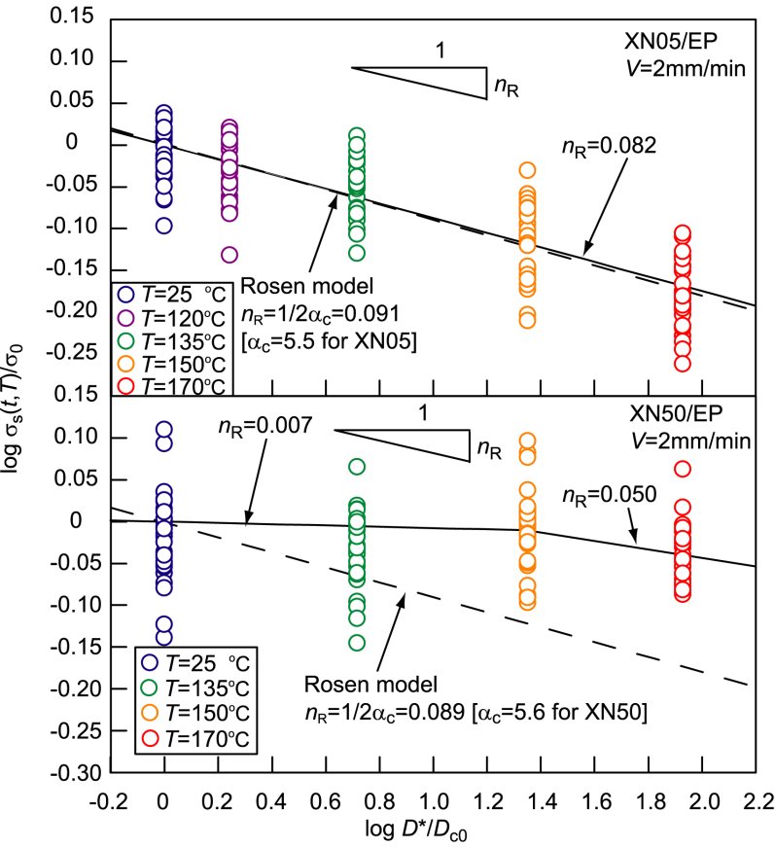

Figure 8. Static strength of pitch based CFRP strands against viscoelastic compliance of matrix resin.

References

- J. Aboudi, and G. Cederbaum. Analysis of Viscoelastic Laminated Composite Plates. Composite Structures, 12: 243–256, 1989.
- J. Sullivan. Creep and Physical Aging of Composites. Composite Science and Technology, 39: 207–232, 1990.
- T. Gates. Experimental Characterization of Nonlinear, Rate Dependent Behavior in Advanced Polymer Matrix Composites. Experimental Mechanics, 32: 68–73, 1992.
- Y. Miyano, M. Nakada, M. K. McMurray, and R. Muki. Prediction of Flexural Fatigue Strength of CFRP Composites under Arbitrary Frequency, Stress Ratio and Temperature. Journal of Composite Materials, 31: 619–638, 1997.
- M. Kawai, Y. Yagihashi, H. Hoshi, and Y. Iwahori. Anisomorphic Constant Fatigue Life Diagrams for Quasi-isotropic Woven Fabric Carbon/epoxy Laminates under Different Hygro-thermal Environments. Advanced Composite Materials, 22: 79–98, 2013.
- Y. Miyano, M. Nakada, and H. Cai. Formulation of Long-term Creep and Fatigue Strengths of Polymer Composites Based on Accelerated Testing Methodology. Journal of Composite Materials, 42: 1897–1919, 2008.
- M. Nakada, and Y. Miyano. Advanced Accelerated Testing Methodology for Long-Term Life Prediction of CFRP Laminates. Journal of Composite Materials, 49: 163-175, 2015.
- Y. Miyano, M. Nakada, H. Kudoh, and R. Muki. Prediction of Tensile Fatigue Life under Temperature Environment for Unidirectional CFRP. Advanced Composite Materials, 8: 235–246, 1999.
- M. Nakada, Y. Miyano, M. Kinoshita, R. Koga, T. Okuya, and R. Muki. Time-Temperature Dependence of Tensile Strength of Unidirectional CFRP. Journal of Composite Materials, 36: 2567-2581, 2002.
- R. Christensen, and Y. Miyano. Stress Intensity Controlled Kinetic Crack Growth and Stress History Dependent Life Prediction with Statistical Variability. International Journal of Fracture, 137: 77–87, 2006.

