EuroSun2026
Affordable photovoltaic and heat pump water heating for cold climates
Isabelle Kosteniuk_{a}, Lucio Mesquita_{a}, David Bradley_{b}, Jeff Thornton_{b}
ªNatural Resources Canada, ^{b}Salas O’Brien
isabelle.kosteniuk@nrcan-rncan.gc.ca, lucio.mesquita@nrcan-rncan.gc.ca, david.bradley@salasobrien.com, jeff.thornton@salasobrien.com
Summary
The low cost of PV panels has expanded the market for new applications, including residential water heating. Given the trend towards high efficiency water heating technologies across North America, this study compares PV water heating to alternative technologies including heat pump water heaters, PVT-heat pump water heaters, and conventional electric water heating. The technical and economic performance of photovoltaic water heaters in 14 Canadian cities was assessed using energy modelling in TRNSYS. The PV water heaters use inverters and maximum power point tracking (MPPT) with varying array sizes of 1.5 kW to 3.0 kW, resulting in solar fractions ranging from 0.45 to 0.91. Findings suggest that there is significant regional variation, with provincial electricity costs and space heating loads impacting the performance and affordability of the different low-carbon options. Compared to conventional electric water heating, heat pump water heaters require an average subsidy of $1504 to be cost-competitive, PVT-heat pump water heaters on average $6,330, and PV water heaters on average $2,968, excluding northern locations with extremely high electricity costs. Considering a low-cost PV scenario, this average falls to $2,002. The analysis found that while PV water heating is not yet economic compared to conventional electric water heating, the low-cost PV water heating system is on average only $498 more expensive than a comparable heat pump water heater, ranging from -$13 in Regina to $1,157 in St. John’s.
PV-to-heat, solar water heating, techno-economic, PV water heating
Field of application for the findings: building energy efficiency, electrification of building energy systems, energy policy and residential decarbonization
Addressed audience: researchers and policymakers in renewable heating and building decarbonization, utilities and energy planners
- Introduction
In 2022, domestic water heating made up 18.3% of total energy used in Canadian households, equivalent to 266.8 PJ, making water heaters the second highest energy consumer in the home behind only total home heating (Natural Resources Canada, 2025). In single detached households, over 70% of hot water heating in Canada is supplied by natural gas, as shown in Figure 1. Estimates show that in the quest towards electrification, the Canadian electrical grid will need significant capacity upgrades to meet NetZero by 2050 targets (Canadian Climate Institute, 2021). The residential sector has the opportunity to support emissions targets while avoiding unnecessary and costly grid infrastructure investment through adoption of low-carbon, grid-friendly water heating technologies.
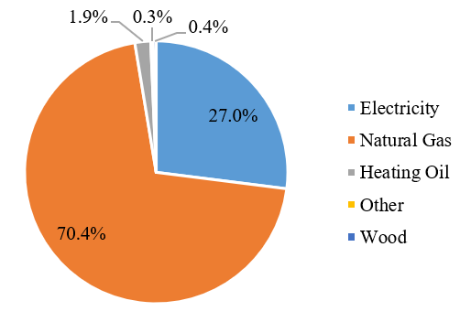
Figure 1: Water heating in Canadian residential sector by energy source
There are a suite of low-carbon water heating options which may be effective and cost-efficient in Canada, including heat pump water heaters (HPWH), solar thermal and photovoltaic-thermal (PVT) water heaters, and photovoltaic water heaters (PVWH). HPWH have much higher efficiencies than standard electric water heaters due to their use of vapour compression cycles which upgrade energy from the ambient to provide hot water. (Kegel et al., 2017) conducted a TRNSYS-based technoeconomic analysis of HPWH in the Canadian residential market and found that HPWH reduced space temperatures and increased energy use of the space heating system. Additionally, they found that system costs and tank temperature recovery rate were barriers to the uptake of HPWH systems in Canadian markets. (Treichel and Cruickshank, 2021) studied the technoeconomic performance of HPWH and solar assisted-HPWH and found that HWPH are generally more economic than solar assisted-HPWH, despite the space cooling impact of the HPWH in cold climates. The exception to this is in locations with high electricity costs, long heating seasons, or high electricity emission factors, in the case of carbon pricing. The study found that the addition of a solar air collector decreased space heating and cooling loads by 1–3% and 7–15%, respectively.
Residential water heating using PV is a nascent technology, though it has been gaining momentum in recent years. From 2018 to 2023, over 34,000 PV water heating systems were installed in South Africa (Taylor et al., 2025). Systems range in complexity but generally consist of a single tank, a PV array, and power electronics such as inverters (Clift and Suehrcke, 2021). Research efforts have been underway in various cold climate countries considering the overall opportunity for PV water heaters in the national market. In Canada, (Hachchadi et al., 2023a) recommend a direct coupled system with customized element resistance based on annual radiation levels in cold climates due to simplicity and low operating costs. The authors found PVWH to be the most economic solar water heating technology for two Quebec locations (Hachchadi et al., 2023b). In Denmark, Neilsen et al. developed an inverter-based PVWH, using wraparound heating coils (Nielsen et al., 2024), with the levelized cost of heat calculated as 0.28 €/kWh.
The present work investigates the energy performance and economic feasibility of three low carbon water heating systems for locations across Canada compared to standard electric water heaters. The objective of this study is to analyze the potential for PV water heating and other high efficiency water heating technologies to provide Canadian residences with cost-effective, reliable water heating while mitigating impacts to electricity demand. In this way, water heating will play a role in supporting Canada’s energy transition and the goal of NetZero by 2050.
- APPROACH
To conduct an energy analysis and comparison of a suite of low-carbon hot water heaters, TRNSYS models were developed of four representative domestic hot water (DHW) systems: PVWH, HPWH, PVT-HPWH, and a conventional electric resistance water heater (EWH) for baseline comparison. The HPWH and PVT-HPWH models include a housing component to account for the impact on space conditioning that the HPWH has on the total house load, while the PVWH and EWH systems are standalone and assume constant ambient indoor air temperature in relation to the tank. The models were simulated in 14 major population centers across Canada using Canadian Weather for Energy Calculation (CWEC) weather files, with simulations run for a period of 1 year, providing ambient temperature and solar radiation inputs to the models including the solar collectors and the housing archetype. The 14 locations were selected to represent a wide range of climactic and economic conditions across the country, such as electricity costs. Table 1 lists the climate conditions for the selected locations. The daily average temperature ranges from 10.3°C in Victoria, British Columbia, to -8.6°C in Iqaluit, Nunavut.
The low-carbon systems were sized generally to achieve a 50%-70% reduction in the amount of electricity required to meet the load. They each use a 170L tank (actual volume) and a daily draw profile of 50 gallons per day based on ASHRAE 90.2 standard. The systems are all standalone and do not interact directly with the other house loads (space heating, electrical), or bidirectionally with the grid. A parametric study was performed for the PVWH considering array size and tank size. Tank sizes of 50, 80, and 120 gallons were considered, and the tank was ultimately sized at 50 gallons –larger tanks reduced the solar fraction and associated electricity savings due to increased losses, though for higher draw profiles a larger tank may be necessary.
Once energy results were obtained for the four types of DHW systems, an economic analysis was conducted including a cost survey and life cycle cost analysis to determine the overall cost of each system over the full lifespan of the equipment.
Table 1: Climate conditions for the selected locations
Location | Degree Days Below 18 °C | Daily Average Temperature (°C) | Mean annual global insolation (kWh/m²)
Edmonton | 5697 | 2.4 | 1257
Charlottetown | 4517 | 5.9 | 1075
Fredericton | 4601 | 5.8 | 1257
Halifax | 4189 | 6.9 | 1237
Iqaluit | 9642 | -8.6 | 953
Ottawa | 4434 | 6.5 | 1308
Quebec | 4977 | 4.7 | 1237
Regina | 5626 | 2.8 | 1348
St. John's | 4690 | 5.3 | 1136
Toronto | 3434 | 9.7 | 1348
Victoria | 2878 | 10.3 | 1278
Whitehorse | 6491 | 0.2 | 1014
Winnipeg | 5672 | 2.9 | 1318
Yellowknife | 8009 | -4.0 | 1054

PV water heater system
The PVWH considered in this study consists of a single tank with 170 L capacity and an inverter-connected PV array that uses MPPT. The PV array consists of 300 W panels with an area of 1.8 m² each and the panel tilt set to the location latitude to represent a best-case scenario. Simulations were performed with array sizes varying from 5 to 10 panels, equivalent to 1.5 kW to 3.0 kW systems. Table 2 lists the PV parameters used in the modelling, selected to be representative of commercially available panels. Figure 2 provides diagrams of the three considered low-carbon systems.
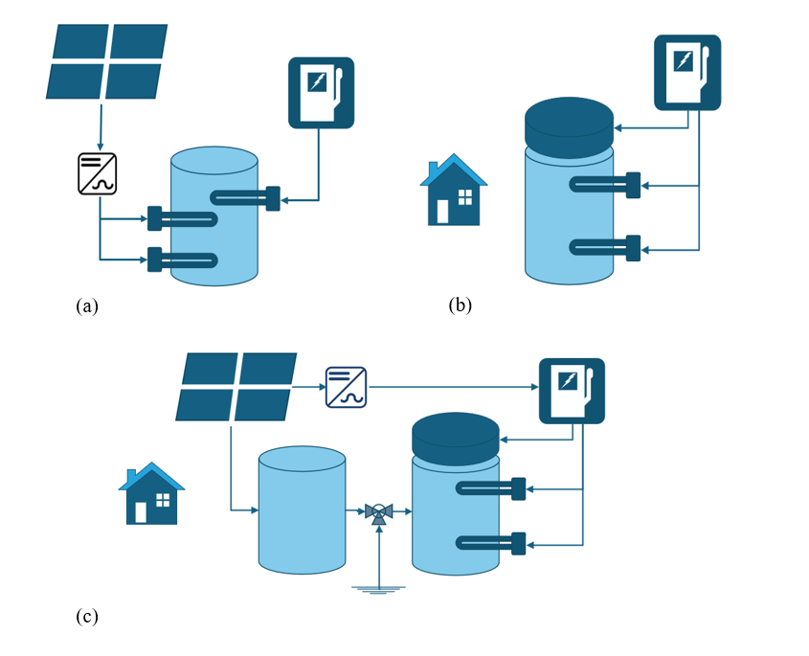
Figure 2: (a) Simplified schematic diagram of PVWH system, (b) HPWH system. (c) PVT/HPWH system. The HPWH and PVT-HPWH systems incorporate a housing archetype with a cold climate air-source heat pump (CCASHP) heat source.
The tank is represented by 12 evenly spaced nodes and is equipped with three electric resistance elements. Two are situated at node 6, halfway up the tank and one is located at node 12, at the bottom of the tank. Two of the elements have a wattage of 3.0 kW each and are connected to the PV array. Table 3 lists the control conditions for the three elements. The middle PV element located at node 6 is controlled by an aquastat with a setpoint temperature of 51.7-55 °C (deadband of 2.7 °C). The bottom PV connected element has a setpoint of 87.8 – 93.3 °C to allow for “overheating” of the tank to maximize the amount of solar energy that can be collected. The bottom element is only enabled when the middle PV element is satisfied, and is located at node 12. The third element is grid-connected with a wattage of 4.5 kW and draws energy on demand to maintain a setpoint temperature of 48.9 °C. This element is located at the same height as the node 6 PV element but is only activated when there is not enough solar energy available to maintain the aquastat at node 6 at 51.7 °C. The PVWH system modelled in this study uses simple controls to charge the tank when there is solar availability, relying on the grid connected element as backup. The PV water heater is standalone, modelled without a home archetype and assuming a constant indoor temperature. Due to the assumption of a constant indoor temperature in the tank room, the total annual DHW load considered in the PVWH scenarios varies slightly compared to the HPWH and PVT-HPWH systems but remains within 1% on an annual basis.
Table 2: PV module parameters used in PVWH system modelling
Parameter | Value | Unit | Parameter | Value | Unit
Short circuit current | 9.65 | A | Slope | Latitude | °
Open circuit voltage | 39.3 | V | Module area | 1.8 | m²
Current at max power point | 9.18 | A | Inverter efficiency | 94 | %
Voltage at max power point | 32.7 | V | Number of panels | 5-10 | -
Temperature coefficient of short circuit current | 0.0048 | A/K | Array rated capacity | 1.5 – 3.0 | kW
Temperature coefficient of open circuit voltage | -0.1415 | V/K | Maximum power | 300 | W
Table 3: Operating conditions of PV water heater elements
Element | On conditions | Off condition
Upper PV Element (Node 6) | T_{stat,6} < 51.7 °C, PV available | T_{stat,6} > 54.4 °C
Lower PV Element (Node 12) | T_{stat,6} > 55 °C , T_{stat,12} < 87.8 °C, PV available | T_{stat,12} > 93.3 °C
Electric element (Node 6) | T_{stat,6} < 51.7 °C, no PV available | T_{stat,6} > 54.4 °C

HPWH system
The HPWH in this study is a single tank integrated model and includes a building component to reflect the impact the water heater has on its surroundings and vice versa. The HPWH cools the environment, drawing energy from the air as it operates. The building component used was a post-1980 home archetype with multiple zones representing the basement, 1st floor, and 2nd floor. The component includes an infiltration schedule, mixing between zones (natural and fan-driven). For the current work, the fan is operating 24/7 to equalize the temperatures between the zones. In addition to the CWEC weather files, data files with soil temperatures specific to each location are input to the model and impact the basement zone temperature. Internal gain schedules are included, consisting of plug, light, and occupant loads. The space conditioning system is assumed to be a cold climate air source heat pump with a 21.1 °C heating setpoint and a 24 °C cooling setpoint. The building controls rely on a thermostat located on the first floor. The HPWH is located in the basement therefore its thermal losses and the effect on the air temperature of the energy it absorbs primarily impacts the basement zone.
The 2.8 kW HPWH is equipped with two auxiliary 4.5 kW electric resistance heater elements. The model uses sample catalogue data to map the HPWH performance. Table 4 lists the control conditions of the tank elements. The heat pump operates when the thermostat temperature, T_{stat}, drops below 0.8 °C under the tank setpoint temperature of 54.4 °C, T_{set}. If either electric element turns on, or once the temperature reaches T_{set} , the heat pump turns off.
Table 4: Control conditions of HPWH elements
Element | On condition | Off condition
Heat pump | T_{stat} < T_{set} – 0.8 °C | Actication of either element, or T_{set} met
Lower Electric Element | T_{stat} < T_{set} – 13.9 °C or T_{stat} < T_{set} (if upper element previously on) | Activation of upper element, or T_{set} met
Upper electric element | T_{stat} < T_{set} – 25 °C | T_{stat} > T_{set} – 8.3 °C

PVT-assisted heat pump:
The PVT-assisted HPWH scenario is built on the HPWH model and adds a preheat tank which is supplied by the thermal output of the PVT. The electrical output from the PVT is accounted for and reported for its contribution on an annual basis. The solar thermal and photovoltaic parameters of the collector are listed in Table 5 below. The collector tilt and area was selected based on the location, ranging from 5.88 m² to 13.72 m².
This scenario uses the same building archetype and primary DHW system as the HPWH scenarios. The preheat tank is 170L with immersed coil tube heat exchanger. There is an ON/OFF pump control with a delta T of 2.2 °C.
Table 5: PVT array parameters
Parameter | Value | Unit | Parameter | Value | Unit
Intercept Efficiency | 0.7 | - | Current at max power | 8.86 | A
1st Order Loss Coefficient (a1) | 5.98 | W/m²K | Voltage at max power | 39.86 | V
2nd Order Loss Coefficient (a2) | 0 | W/m²K² | Temp coefficient of short circuit current | 0.005496 | A/K
Short-circuit current | 9.16 | A | Temp coefficient of open circuit voltage | -0.1361 | V/K
Open-circuit voltage | 48.61 | V | - | - | -
- Energy Analysis
Metrics
The main energy metric considered in this work is the annual energy savings that can be realized from installation of a low-carbon water heating system. The annual electricity consumption associated with domestic hot water using an electric water heater is compared to the consumption when using the PVWH, HPWH, and PVT-HPWH systems. Additionally, this study analyses the seasonal performance factor of the systems, which describes how much heating is delivered compared to how much electricity is consumed.
The reference energy use, that is, the energy consumed by the EWH system, is equivalent to the grid electricity consumed by the water heater over the course of one year in each location. The electricity consumption of the three low-carbon options is calculated as follows: electricity consumed by the PVWH systems is equal to the total electricity that goes to the water via the element, E_{element}, minus the electricity provided from the collectors, E_{coll}. Similarly, the electricity consumed by the HPWH system is equal to the electricity consumed by the element, plus the fan and the compressor (E_{fan}, E_{comp}), with no energy generation term. Energy consumed by the PVT-HPWH system is equal to the energy consumed by the HPWH components minus the electrical energy produced by the PVT panels (E_{coll,elec}), net of required pumping power (E_{pump}). The energy savings, E_{savings} for each system is therefore the energy used by the reference system, EWH, minus the energy used by the low carbon system. Equations 1 and 2 below describe the PVWH system as an example.
$E_{PVWH}= E_{element}- E_{coll}$ (eq. 1)
$E_{savings,PVWH}= E_{EWH}- E_{PVWH}$ (eq. 2)
To take into account the thermal performance of the three systems, a seasonal performance factor (SPF) can be used, defined as the ratio between the delivered heating and the consumed electricity. In the case of the renewables-integrated systems (i.e. the PV and PVT systems), the net consumed electricity is used in Equation 3 below, again using the PVWH system as an example.
${SPF}_{PVWH} = \frac{Q_{delivered}}{E_{PVWH}}$ (eq. 3)
Heat pump water heaters can have an impact on the space heating load of a home, as they remove energy from their surroundings to increase the temperature within the tank. This causes an increase in space heating load in the winter and a decrease in cooling load in the summer. To determine the overall performance of the HPWH, an overall energy balance on the household is conducted, considering the DWH energy in addition to the total space heating and cooling.
The total DWH energy used by the HPWH system is defined by Equation 4:
$E_{HPWH}= E_{comp,HPWH}+ E_{fan,HPWH}+ E_{element,HPWH}$ (eq. 4)
Equation 5 describes the total space heating and cooling energy, E_{space}, which includes the power used by the CCASHP compressor for both heating and cooling (E_{comp,heat} and E_{comp,cool}), the fan power for indoor and outdoor fan units (E_{fan,indoor} and E_{fan,outdoor}), and the backup electric heating used when the outdoor air temperature is below -20 °C and the CCASHP does not operate (E_{aux}):
$E_{space}= E_{comp,heat}+ E_{comp,cool}+ E_{fan,indoor}+E_{fan,outdoor}+ E_{aux}$ (eq. 5)
The difference in electricity consumed for the purposes of heating and cooling when using the HPWH system versus the EWH system is calculated using Equation 6:
${∆E}_{space}= E_{space,EWH}- E_{space,HPWH}$ (eq. 6)
As a result, the net SPF for the HPWH (and similarly for the PVT-HPWH) can be defined by Equation 7:
${SPF}_{HPWH,net} = \frac{Q_{delivered}}{E_{HPWH}+{∆E}_{space}}$ (eq. 7)
Energy results
For the PVWH, six scenarios were run for each location, with various array sizes ranging from 1.5 kW to 3 kW (9 to 18 m² collector area). PVWH solar fractions for each location and array size are shown in Figure 3 below. For the smallest array size considered, solar fractions range from a maximum of 0.64 in Toronto, Winnipeg, and Regina to a minimum of 0.45 in Iqaluit. For the 3 kW array size, solar fractions range from 0.91 in Winnipeg to 0.71 in Iqaluit.
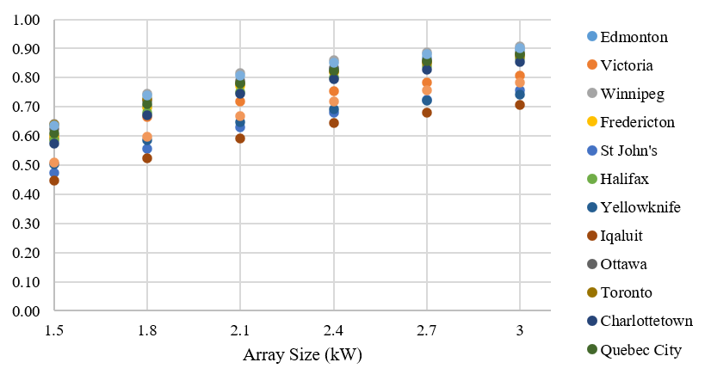
Figure 3: Solar fractions of PVWH systems for 14 locations, array sizes ranging from 1.5 kW to 3.0 kW
To directly compare the energy performance of the various systems, Figure 4 shows the SPF achieved by each configuration. The SPF of the EWH is of course under 1, as the energy conversion when taking losses into account is below 100%. The PVWH performance ranges from 1.8 to 2.2 for the smallest array size considered, and from 2.5 to 10 for the largest 3 kW system. The HPWH achieves an SPF of approximately 4 for each city before considering space heating effects, while the PVWH and PVT-HPWH are more dependent on location due to varying temperature and solar availability. The net SPF of the HPWH and PVT-HPWH systems demonstrate the influence of climate and location on the system performance, as the net increase to the annual space heating load results in lower SPF that varies from city to city. When considering the net SPF, the HPWH achieves performance comparable to the 1.8 kW PVWH.
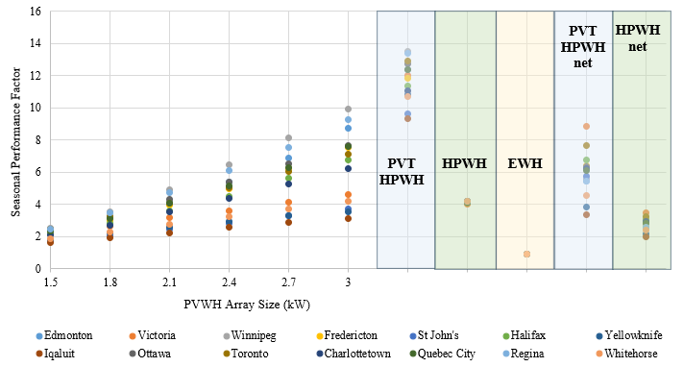
Figure 4: SPF of the PVWH, HPWH, PVT/HPWH systems for each location
The impact on HPWH performance from environmental conditions is dominated by outdoor air temperature, while the PVWH is more impacted by solar availability, so the performance of each system varies according to location, as shown in Figure 5. That is, the PVWH performs better than the HPWH in a sunny but cold location like Winnipeg (SPF_{PVWH} of 3.56 vs. SPF_{HPWH,net} of 2.6) while the HPWH performs better in a mild but low solar resource location like Victoria (SPF_{PVWH} of 2.67 vs. SPF_{HPWH,net} of 3.51).
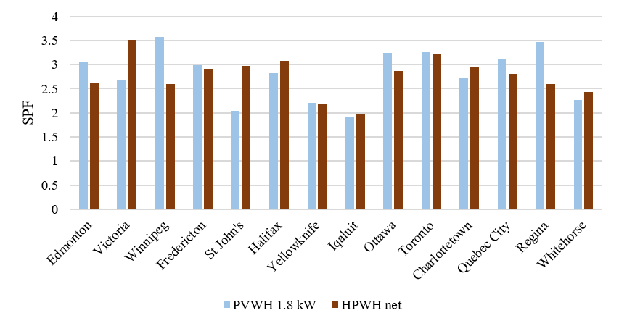
Figure 5: Seasonal Performance Factor of HPWH and PVWH (1.8 kW) in the 14 locations.
For the end user, the main impact on cost effectiveness is electricity consumption. The annual electricity consumption of each modelled scenario is shown in Figure 6 below. The addition of each 300 W PV panel reduces the electricity requirements of the system in an inverse exponential relationship, and, as indicated by the SPF results, the HPWH is comparable in most locations to the 1.8 kW PVWH.
Figure 6 incorporates the overall savings from the HPWH, and Figure 7 breaks down the annual energy savings associated with a HPWH compared to a base EWH, with the increase in space heating load shown in orange. The PVWH is excluded from this analysis given that there is no heat pump element to the water heating, and therefore no reliance on ambient energy in the tank room. The results of the simulations show that the DHW savings outweigh the penalty to space heating. One contributing factor for this is that the water heater is located in the basement, and small fluctuations in air temperature do not immediately trigger the need for space heating. Additionally, on an annual basis, the heat pump is removing energy from the surrounding air during periods of both space heating and space cooling, so the overall annual impact is balanced somewhat. The results show that total energy savings are greatest in areas with lowest space heating requirements and lowest reliance on backup auxiliary heating. The maximum savings are found in Victoria, with 29% for HPWH and 35% for PVT-HPWH, which has 5222 kWh space heating and zero auxiliary electric heating load. The lowest percent savings are in Iqaluit, which depends heavily on backup resistance heating given the extremely low outdoor air temperatures in the winter, with savings of 5% and 6% for HPWH and PVT-HPWH respectively.

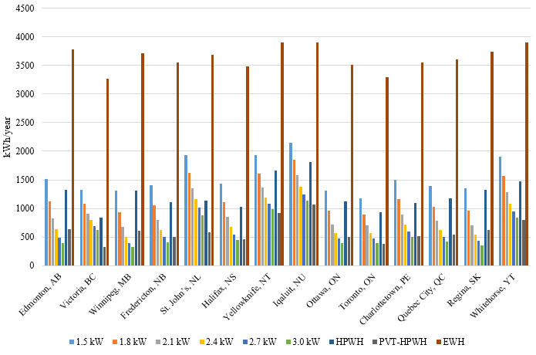
Figure 6: Comparison of the annual electricity consumption of PVWH systems ranging from 1500 to 3000 W, HPWH, PVT/HPWH, and EWH systems for 14 locations across Canada

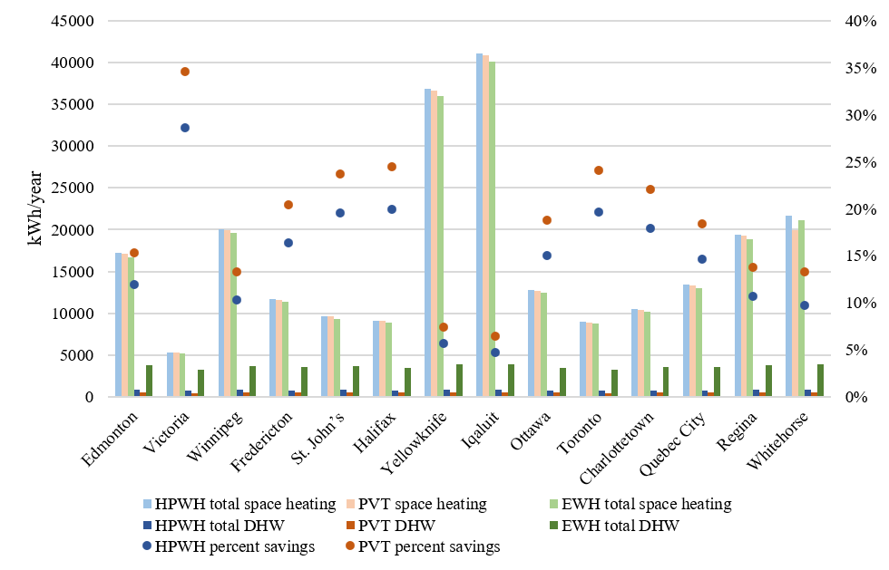
Figure 7: Impact of water heating on electricity consumption for houses equipped with HPWH or PVT/HPWH systems

- Economic Analysis
Capital and Operating Costs
There is a lack of published data for recent, national scale costing for residential water heating technologies in Canada. This study estimates CAPEX for PVWH, HPWH, EHW, and PVT-HPWH using a variety of data sources including quotations from local suppliers based on personal communications, commercially available products, Greener Homes program data (Natural Resources Canada, 2022), and U.S.-based costing (Maguire et al., 2013). Based on the collected information, average values for the CAPEX of each water heating technology were used in the analysis. For example, the range of costs of installed PV systems is between $2,486 and $3,534 CAD per kW, including inverter costs, therefore an average of $3,162 CAD per kW is used. In addition, a low-cost PVWH scenario was used to represent favourable conditions for PV installation, using the lower bound of cost data points.
Table 5: CAPEX of example scenarios with no location factor.
System | Array size (kW) | Installed Tank cost | Installed solar cost | Total CAPEX
PVWH | 1.5 | $1,625 | $4,743 | $6,140
PVWH | 1.8 | $1,625 | $5,646 | $7,043
PVWH | 2.1 | $1,625 | $6,549 | $7,946
PVWH | 2.4 | $1,625 | $7,452 | $8,849
PVWH | 2.7 | $1,625 | $8,355 | $9,752
PVWH | 3.0 | $1,625 | $9,258 | $10,655
PVWH – Low Cost | 1.8 | $1,625 | $4,475 | $6,100
HPWH | N/A | $5,589 | N/A | $5,589
EHW | N/A | $1,625 | N/A | $1,397
PVT-HPWH | 0.7 | $6,206 | $ 4,567 | $10,695
Electricity costs are as shown in Table 6 based on provincial values (Treichel and Cruickshank, 2021). RSMeans location factors were applied to the CAPEX values for each scenario to represent regional cost differences. There is no factor available for Iqaluit so the Yellowknife figure is used, though Iqaluit is significantly more remote so this is likely an underestimate. Operating costs were calculated based on the annual electricity consumption for the DHW load, plus the difference in electricity costs related to space heating and cooling in the case of the HPWH and PVT-HPWH scenarios.
Table 6: Location dependent costs for electricity and CAPEX/OPEX
Location | RSMeans Location Factor | Electricity cost (¢CAD/kWh)
Edmonton | 1.08 | 6.80
Victoria | 1.02 | 9.45
Winnipeg | 0.96 | 8.74
Fredericton | 0.93 | 10.91
St. John’s | 1.05 | 12.00
Halifax | 1.02 | 8.68
Yellowknife | 1.12 | 30.10
Iqaluit | 1.12 | 58.56
Ottawa | 1.05 | 9.40
Toronto | 1.10 | 9.40
Charlottetown | 0.90 | 14.37
Quebec City | 1.08 | 6.08
Regina | 1.07 | 15.65
Whitehorse | 1.03 | 12.14

Lifecycle cost Analysis
To determine the economic feasibility of the PVWH, HPWH, and PVT-HPWH systems across Canada for the full life of the equipment, a Lifecycle Cost Analysis (LCA) was conducted. The CAPEX and OPEX costs for each scenario are used to calculate the Lifecycle Costs, $LCC$, the Breakeven Cost, $B$ at which point the system is competitive with the base EWH, and the required subsidy to reach breakeven, $S$. A lifetime of 15 years is assumed, an inflation rate of 2%, and a discount rate of 3%.
Life Cycle Costs are equal to the CAPEX plus the OPEX over the lifetime of the system:
$LCC=CAPEX+NPV\sum_{t=0}^{n}{OPEX}$ (eq. 8)
The annual OPEX costs are constant over the lifetime of the system and equal to the electricity costs, therefore the present value of the annuity, $M$, is calculated using Equation 9:
$M=OPEX*{\left(1-\frac{1}{({1+i)}^{t}}\right)}^{-i}$ (eq. 9)
Where the interest rate, $i$, is calculated according to
$i=\left( 1+d\right)\left(1+p\right)-1$ (eq. 10)
To determine how competitive the various scenarios are against the EWH and against one another, the breakeven cost is calculated with Equation 11. From the breakeven cost, the required subsidy to achieve cost parity with the reference system can be determined using Equation 12.
$B={CAPEX}_{EWH}+(M-M_{EWH})$ (eq. 11)
$S=CAPEX-B$ (eq. 12)
Economic results
Figure 8 below shows the total installed cost for PVWH systems with three array sizes, as well as the HPWH, PVT-HPWH, and low-cost 1.8 kW PVWH scenarios compared to an EWH for that location. The subsidy required to achieve the breakeven cost is shown with bars corresponding to each scenario. In most cases, the low-carbon water heating option does not break even over the course of the 15 year lifetime, and a subsidy is needed to make the system cost competitive with EWH. In 11 out of 84 total scenarios there is no subsidy required, and the low-carbon option is less expensive over 15 years than a EWH; these scenarios are for northern cities with very high electricity costs, plus the HPWH scenario for Charlottetown. The lowest required subsidies for a 1.8 kW PVWH are in Charlottetown ($1,337) and Regina ($1,333) as well as the two northernmost cities of Yellowknife and Iqaluit, which have negative subsidy prices and where EWH is unlikely to be installed largely due to high electricity prices. Excluding those two locations, the average subsidy for the 1.8 kW PVWH is $2,942. The highest subsidy is in Quebec City, which has an electricity price of only 6.08 ¢CAD/kWh, with a value of $3,221. The rightmost bar indicates the low-cost PVWH scenario, using the lower bound of installed PV costs in place of an average. All other system costs remain constant. Considering this low-cost PVWH option, the required subsidy is $849 to $1,037 lower, with the greatest decrease in Toronto, resulting in an average subsidy of $2,002 excluding the three northernmost cities. PVT-HPWH subsidies are significantly higher than all other considered systems, ranging from $3737 in Charlottetown to $8169 in St. John’s. HPWH are the most economic option across all locations, with subsidies ranging from -$87 in Charlottetown (indicating HPWH is slightly more economic than EWH in that city) to $2753 in Quebec City. Overall, the low electricity prices in cities like Quebec City and Edmonton result in low OPEX costs for EWH systems, so regardless of energy reduction the high upfront investment required for low-carbon systems renders them less affordable. Conversely, the high electricity costs in Charlottetown make low-carbon options relatively attractive despite fairly low solar resource. Regina, with both high electricity costs and high solar resource, is the most favourable city for solar-integrated options. While the HPWH is still economic in Regina, the high space heating load results in low overall household energy savings for the HPWH compared to other locations, with savings of only 11%.

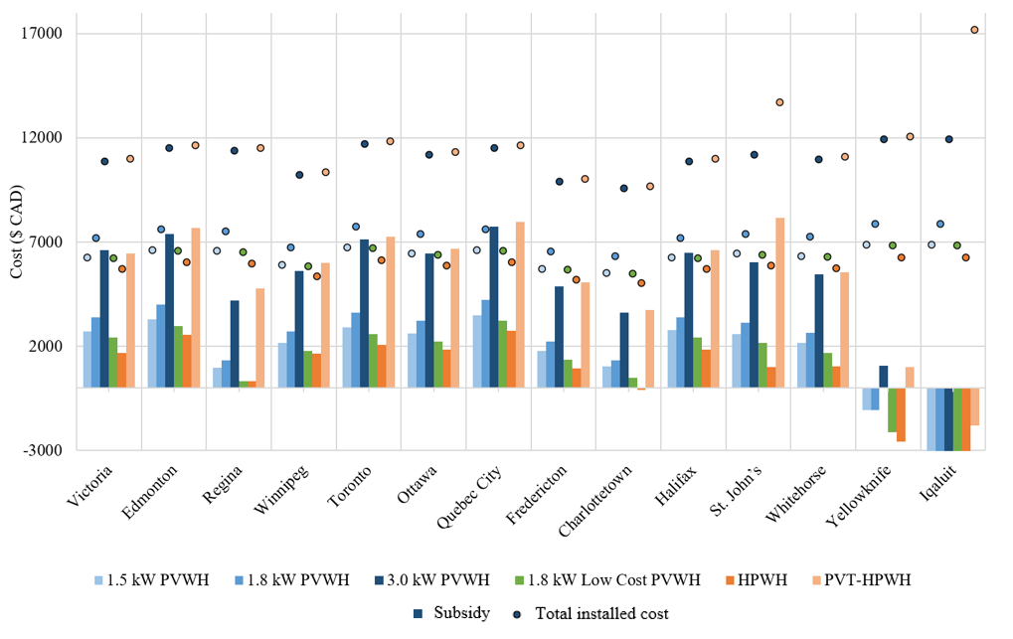
Figure 8: Subsidies required to achieve breakeven cost for each scenario. Subsidy costs are represented by the transparent overlay on top of the breakeven costs. The green data series represents the low-cost PVWH scenario where the lower range of PV installed costs are used. The vertical axis cuts off at -$3,000 for readability.
Figure 9 illustrates the geographic variability in the comparative affordability of PVWH and HPWH systems, with the subsidy cost of PVWH relative to HPWH overlaid. Regina and Winnipeg, the sunniest cities considered in the analysis, have the most favourable conditions for the PVWH, with the PVWH costing $13 less in Regina than HPWH over the system lifetime. The PVWH system is generally costlier than HPWH, even considering the lower range of PV installation costs. The average subsidy value of PVWH compared to HPWH is $498 excluding northern cities, a figure that could potentially be reduced further through cost-reducing design elements.
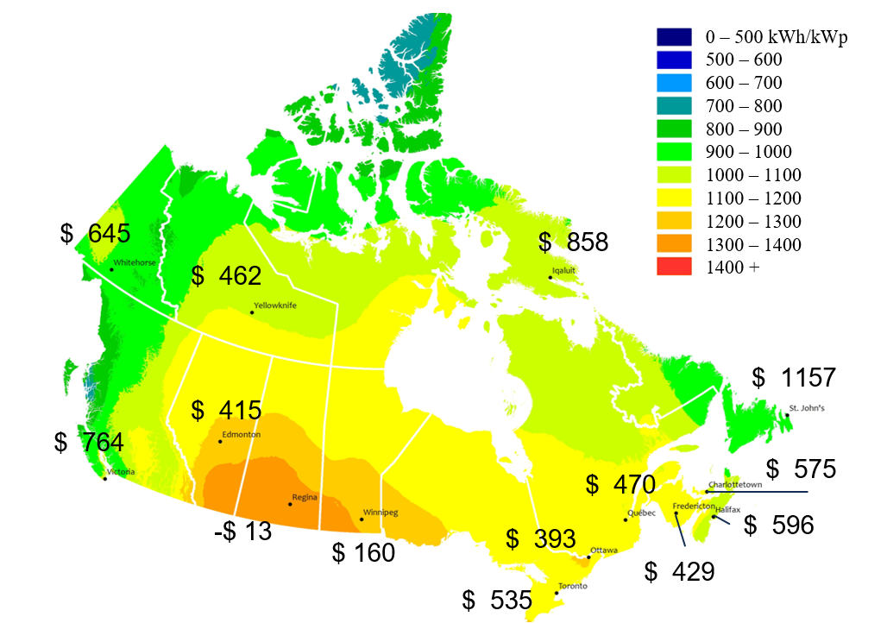
Figure 9: Subsidy required for low-cost 1.8 kW PVWH to be cost-competitive with HPWH in 14 Canadian cities. Overlaid on map of Annual Photovoltaic potential (south facing with latitude tilt) (Natural Resources Canada, 2024)
- CONCLUSIONS
The current research investigated the techno-economic performance of several solar and low-carbon water heating options for 14 locations across Canada, compared to a base electric water heater. The purpose of this study is to identify the opportunities for mitigating grid impacts of electric water heating, as the residential sector in Canada strives towards electrification and decarbonization. There is significant regional variation, with provincial electricity costs and space heating loads impacting the performance and affordability of the different low-carbon options Compared to conventional electric water heating, heat pump water heaters require an average subsidy of $1504 to be cost-competitive, PVT-heat pump water heaters on average $6,330, and PV water heaters on average $2,968, excluding northern locations with extremely high electricity costs. Considering a low-cost PV scenario, the PVWH average falls to $2,002. The analysis found that while PVWH is not yet economic compared to conventional electric water heating, the PVWH system is on average only $498 more expensive than a comparative HPWH, ranging from -$13 in Regina to $1,157 in St. John’s.
Methods of reducing cost of PVWH could include the use of advanced controls to maximize energy performance of smaller array systems, for example charging only during low time-of-use electricity rates or using weather forecasts to avoid the use of the grid-connected element when high solar irradiance is predicted. Lower cost PV panels, such as flexible panels could avoid costs associated with labour and installation, like structural assessments which are required in some jurisdictions. Additionally, DC systems, though they have lower energy performance compared to AC, could be investigated to avoid costs associated with an inverter. Although the investigated systems are not cost-competitive with conventional electric water heating in Canada, due largely to low electricity in Canada, they have the potential to provide benefits to households and the grid while contributing to Canada’s goal of NetZero by 2050.
- References
Canadian Climate Institute, 2021. Canada’s Net Zero Future.
Clift, D.H., Suehrcke, H., 2021. Control optimization of PV powered electric storage and heat pump water heaters. Solar Energy 226, 489–500. https://doi.org/10.1016/j.solener.2021.08.059
Hachchadi, O., Rousse, D.R., Irandoostshahrestani, M., Mechaqrane, A., 2023a. Techno-economic assessment and environmental impact of photovoltaic and conventional solar water heating systems in cold climates. Energy Conversion and Management 297, 117725. https://doi.org/10.1016/j.enconman.2023.117725
Hachchadi, O., Tapsoba, G.R., Dery, P., Mechaqrane, A., Bourbonnais, M., Meloche, P., Izquierdo, R., 2023b. Experimental optimization of the heating element for a direct-coupled solar photovoltaic water heater. Solar Energy 264, 112037. https://doi.org/10.1016/j.solener.2023.112037
Kegel, M., Tamasauskas, J., Sunye, R., Giguere, D., 2017. Heat Pump Water Heaters in the Canadian Residential Market.pdf. Presented at the 12th IEA Heat Pump Conference, Rotterdam.
Maguire, J., Fang, X., Wilson, E., 2013. Comparison of Advanced Residential Water Heating Technologies in the United States. Renewable Energy.
Natural Resources Canada, 2025. Residential Sector - Energy Use Analysis. https://oee.nrcan.gc.ca/corporate/statistics/neud/dpa/showTable.cfm?type=AN&sector=res&juris=00&year=2022&rn=11&page=0 (accessed 7.16.25).
Natural Resources Canada, 2024. Photovoltaic Potential and Solar Resource Maps of Canada - Open Government Portal.
Natural Resources Canada, 2022. Canada Greener Homes Initiative. https://natural-resources.canada.ca/energy-efficiency/home-energy-efficiency/canada-greener-homes-initiative/canada-greener-homes-initiative (accessed 8.7.26).
Nielsen, E., Furbo, S., Fan, J., 2024. Domestic hot water heating with direct electricity from PV panels and the grid. https://doi.org/10.18086/eurosun.2024.02.14
Taylor, R.A., Day, T., Yildiz, B., Clift, D., Suehrcke, H., Liu, X., 2025. The Emergence of PV Hot Water Systems: A Technology Brief. https://doi.org/10.18777/ieashc-task69-2025-0001
Treichel, C., Cruickshank, C.A., 2021. Economic analysis of heat pump water heaters coupled with air-based solar thermal collectors in Canada and the United States. Journal of Building Engineering 35, 102034. https://doi.org/10.1016/j.jobe.2020.102034

