NATURAL FIBERS ACTUATORS FOR SMART BIO-INSPIRED HYGROMORPH BIOCOMPOSITES

A. Le Duigou¹, J. Beaugrand², F. Scarpa³ and M. Castro¹

¹ Université de Bretagne-Sud IRDL UMR CNRS 6027, Rue Saint-Maudé, B 92 116 ; 56321 Lorient

Antoine.le-duigou@univ-ubs.fr; mickael.castro@univ-ubs.fr

² Biopolymères Interactions Assemblages (BIA), INRA, rue de la Géraudière, F-44316 Nantes, France

Johnny.beaugrand@inra.fr

³ Bristol Composites Institute (ACCIS), University of Bristol, BS8 1TR Bristol, UK
F.Scarpa@bristol.ac.uk

Keywords: natural fiber 1, biocomposite 2, moisture 3, actuation 4, morphing 5

Abstract
‘Top-down biomimetic process” enables to solve engineering concerns thanks to solutions found in Nature. The motivation of the present work is to exploit the observed “natural” weakness of natural fibers i.e. their hygroscopic behaviour, so it can be used as a driving force in autonomously self-shaping smart materials, Hygromorph Biocomposite (HBC). This kind of actuator could be used for example in autonomous climate adaptive building structures with humidity/temperature interactions.
In this work we present the “top-down framework” dedicated to the HBC development based on pine cone inspiration (microstructure and actuation). Then, a series of design guidelines for HBCs with improved performance, low environmental footprints in severe environments is discussed. The actuation response is evaluated as a function of material parameters : The actuation performance is directly related to the fibre microstructure and its biochemical composition also as fibre content and Interfacial Shear Strength. We also provide a demonstration on how HBCs can be used to trigger deployment of more complex structures based on Origami designs.

1. Introduction

Natural reinforcements such as bast (e.g., flax, hemp, jute, or kenaf) and fruit fibres (coir) are derived from local feedstocks, which feature a moderate environmental footprint [1][2] and potential recyclability and compostability at their end of life. Nevertheless, one of the major drawback of vegetal fibres for composite reinforcement is their high water absorption, often leading to reduction of biocomposite lifetime. Today most of researcher chemically or physically treat the fibres.
A potential solution to overcome these issues is to change of paradigm. Biomimetics is a term that gathers the words Biology and mimesis (imitation). Two principally different approaches can be distinguished as “bottom-up process” and “top-down process”[3]. In the “top-down” process, engineering concerns are expected to be solved thanks to solutions found in Nature. To go further, the extended “top-down” process is based on several iterations between fundamental biological data and the engineering products.
The purpose of the present work is to present the extended “top-down process” dedicated to the development oa novel class of smart material i.e. Hygromorph BioComposite (HBC) that actuate (self shaping) under a moisture variation . Then, we will establish a framework to design HBC with improved performance. The natural actuation ability of the fibres will be discussed according to their content within the composite, their Interfacial bond strength as well as their microstructure and biochemical composition.
Finally, kinematic amplification of the actuation will be proposed through a simple deploying structures using Origami designs.

2. Material and Methods

2.1. Material selection

In this study flax, jute, kenaf and coir fibre composites have been selected as the actuating fibres. These fibres are available as off-the-shelf industrial products in several countries, which makes feasible the concept of producing HBCs using local resources. Flax fibres (Linum usitatissimum) were harvested in France and then dew-retted before being scotched and hackled. Unidirectional flax fibre tape (200 g/m² and 50 g/m²) was supplied by Lineo®. Jute fibres (Corchorus capsularis L) of the Tossa variety were supplied by Gold of Bengal. Kenaf fibres (Hibiscus cannabinus L.) were obtained from La Chanvrière de l’Aube, whereas Coir fibres were provided by a car-seat padding manufacturer in Indonesia. The fibres were hand-hackled to form a unidirectional tape without any transverse.
Extruded and film-cast PP (PPC 3660 from Total Petrochemicals, 70g/m²) and maleic anhydride (MA)-compatibilized polypropylene (MAPP) have been used.

2.2 Manufacturing of laminates and HBCs
Composite laminates with different natural fibers were manufactured using a custom device that places fibre ribbons manually hackled and aligned before being hot pressed with MAPP films (20 bar, 190°C for 8 min). This approach reduces the numbers of defects and misalignments [4]. The fibre content within the HBC vary form 17-40 to 60% of volume for flax fibres. The cooling rate was 15°C/min. The HBCs have been designed with varying passive-to-active thickness ratio (m =tp/ta).
Five stripes with dimensions of 70 mm × 10 mm were then cut for the bending actuation experiments. For further information please see references [5][6][7][8][9].

3. Results and Discussion

3.1 Biomimetic : “Top-down” process

Figure 1 presents the approach followed in the present work. Resulting from a well-known drawback of natural fibres i.e their moisture sensitivity which causes the composite degradation, an extended “top-down” approach is applied by screening natural products that currently take benefit of moisture variation with original functonnality (actuation). Pine cone scale is an example of natural hydraulic actuators, whose actuation (opening/closure of scales) is triggered by moisture variation.
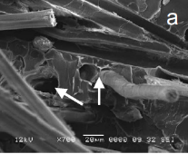
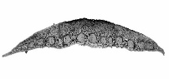
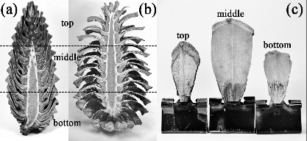
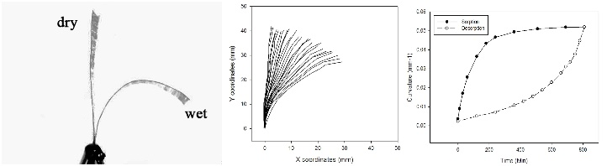
Biological concept generator
Technical problem
Asymetric biocomposite
Operating principle
Bilayer
Technical application
Abstraction

Hygromoph BioComposite

Figure 1 “Top down” approach applied to natural fibre composite towards Hygromoph BioComposites (inspired from [3] and after [6][7][10])

In this case, a hierarchical plant tissue architecture constitued of single cells with a composite structure, i.e. stiff cellulose fibrils oriented in a swellable matrix [11], generate anisotropic swelling. When the plant tissues are strongly bonded together in a bilayer architecture, a complex mechanical response is generated that can involve folding, curling, twisting or bending [12][13]. When natural fibres are used in asymmetric laminates (bilayer-like), their anisotropic swelling induces curvature because of the accommodation of the hygroscopic stresses.Thus, the orientation of natural fibres is 0° and 90° in the passive and active layers, respectively. This stacking sequence mimicks the topology present in the sclerenchyma fibres and and within the sclereids of a pine cone scale [12]. Plant fibres function in this case as hygroscopically active building blocks for Hygromorph BioComposite, rather than a simple polymer reinforcement material.
Extended “top-down” approach is used as the actuation mechanism of pine cone is not properly described yet. Current work is going on biochemical composition on the scale, their anticlastic actuation as well as the inter-tissues bond strength durability. These information will insure further development of HBC.

3.2 Hygromorph BioComposites

HBCs represent a disruptive approach to use natural fibres. They are autonomous actuators whose reversible response is triggered by a moisture/temperature gradient. Using thermoplastic polymer matrix, they can be shapable, thermoformable and recyclable.

3.2.1 Actuation Performance evaluation

Figure 2 (a-b) show respectively the actuationof HBC illustrated by a change of curvature with a variation of moisture and then a typical characterization of the actuation performed on a wetting (immersion)/drying (50% RH) cycle. Actuation speed during sorption and desorption (dK/dt) is named reactivity while maximal curvature (K_{max}) corresponds to the responsiveness of the actuator.
The curvature recovery (%) calculated via the return curvature (K_{r}) correspond to the reliability of the HBC associated with degradation during actuation.

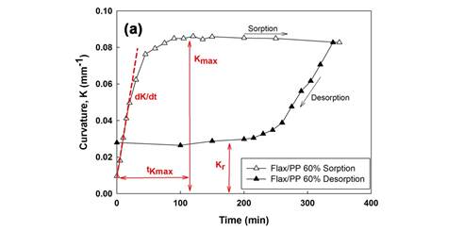
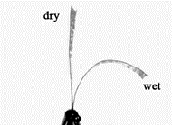

Figure 2 Actuation of HBC (https://www.youtube.com/watch?v=N0fW_3u4lAU) (a), Typical curvature and straightening behavior of Flax/PP 60% HBC sample (b) [5]

3.2.2 Design framework : bimetallic theory

HBC are assumed to behave hygroscopically like a bilayer composed of two well-bonded beams. The analytical solution of a beam subjected to bending due to difference in coefficient of hygroscopic expansion Δβ and moisture content ΔMt is given by Timoshenko [14] where only the longitudinal curvature is considered :
$= \frac{∆β∆Mt f(m,n)}{h}$ (1)
Where $f(m,n)= \frac{6{\left(1+m\right)}^{2}}{3{\left(1+m\right)}^{2}+\left(1+mn\right)\left(m^{2}+ \frac{1}{mn}\right)}$ (2)
With m $=\frac{t_{p}}{t_{a}}$ , where t_{p} and t_{a} represent the passive layer (0° layer) and the active layer (90° layer) thicknesses, respectively. The parameter n is equal to $\frac{E_{p}}{E_{a}}$ , where E_{p} and E_{a} represent the tensile moduli (in the beam direction) of the passive and active layers, respectively. The differential hygroscopic expansion coefficients in the beam direction between the active β_{a} and passive β_{p} layer is represented by Δβ. The changes in moisture content in HBC between RH _{i} and RH _{i+1} is $∆Mt$.
Figure 3 presents the evolution of the experimental data and Timoschenko model as a function of m ratio for different fibre content and fibre/matrix interface quality.
Modified Timoschenko’s model yields results in good agreement with the measured curvature whatever the modified parameters. m ratio (tp/ta) which represents the ratio of layers thickness is a key parameter that induces the targeted actuation (curvature). HBC could be considered as programmable matter.
This simple model is used as a tool to select the best geometrical parameters (m ratio) and the best materials (n ratio) to design HBC. By shaping the HBC with an elongated geometry (high length-to-width ratio) we are able to reduce the double (anticlastic) curvature. In this way, we were also able to generate a cylinder as the actuated shape. Thus, designing HBC with more complex shape will require a more complex model.
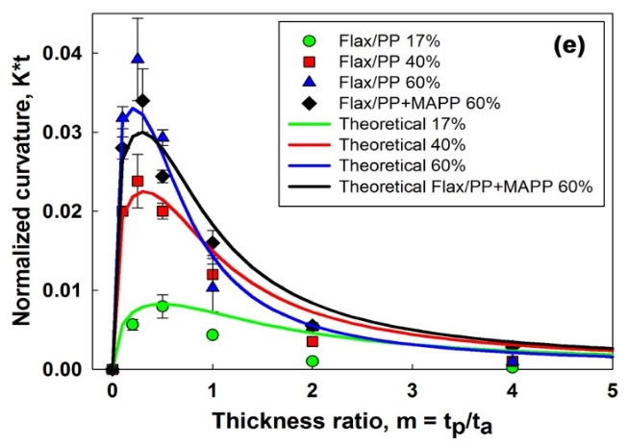

Figure 3 Evolution of the normalized curvature (actuation responsiveness) as a function of m ratio [5]

3.2.2 Effect of fibre content, Interfacial Shear Strength and fibre type on actuation

Responsivness and reactivity of HBC are evaluated as a function of several material parameters. Figure 4 evidences that flax fibre content and the interfacial bonding strength control the actuation properties (reactivity and responsiveness). Indeed, increasing the fibre content from 17 to 60% in volume has drastically improved the actuation amplitude (x4) and speed (≈ x90) leading to competitive performance with synthetic actuators. Improving interfacial strength by using PP+MAPP leads to more efficient actuation (≈ x2) with water uptake even if actuation amplitude is slightly reduced (-12%). Assuming that flax fibres were the major sorption sites, their sorption mechanism and global water transport within HBC controlled actuation speed.
Wicking was basically influenced by the distribution of pore structure and connectivity, i.e. here induced by the presence of both single fibres as well as bundles embedded in the apolar polymer matrix. Hence, when high fibre content was achieved in HBC, this has provided a larger number of channels, which means that all fibres could connect together so that water molecules were transported via faster pathways. Thus, above a certain amount of flax fibres, water transport was rising so that HBC actuation appeared quicker. Compatibilized PP matrix have led to stronger interactions with free hydroxyl group of fibre surface which have led to reduced water transport within HBC [6].

Figure 4 Evolution of (b) normalized maximal curvature (K_{max}.t) and (c) curvature speed (dK/dt) as a function of volume fibre content (Vf) and with interfacial modification (Flax/PP+MAPP 60%). [5]

As put in evidence by the SEM micrographs [9] and by the image analysis, the internal porosity (i.e., free volume) of the kenaf (v_{p} = 13.8 ± 0.23%) and coir (v_{p} = 39.1 ± 0.7%) is very high compared to the one present in the flax (v_{p} = 0.1 ± 0.02%) and jute (v_{p} = 6.4 ± 0.17%) fibres. In addition, the kenaf and coir reinforcements exhibit a microstructure mainly composed by bundles of single fibres.
These two features tend to influence the water transport characteristics through the material, the hygroexpansion and the mechanical properties. For this reason it is important to carry out a careful examination on how the hygroelastic properties of the plant fibres affect the overall behaviour of the biocomposite actuators. Table 1 gathers the hygroelastic properties of different natural fiber composite as well as the theoretical curvature estimated by Timoschenko model.

Table 1. Input parameters and theoretical actuation (curvature) of HBC with different fibre species

Specimen Type | Δβ = βa - βp (ε/Δm) | ε_{hygro}= ε_{hygro (a)} - ε_{hygro (p)} (%) | n = Ep/Ea  (wet state) | K  (mm⁻¹) | K.thickness
Flax/MAPP | 0.107 | 3.55 | 10.9 | 0.095 | 0.044
Jute/MAPP | 0.11 | 3.70 | 9.95 | 0.094 | 0.043
Kenaf/MAPP | 0.07 | 2.80 | 9.1 | 0.088 | 0.040
Coir/MAPP | 0.03 | 1.10 | 2.1 | 0.027 | 0.013

The differences in swelling between the laminates and their hygro-elastic properties are explained by the particular fibre microstructure at the cell-wall scale. The lower MFA in flax and jute leads to a higher radial swelling potential compared to the one present in coir laminates, which possess a higher MFA. The biochemical composition also plays an important role in determining the swelling ability of fibres and, in determining therefore their actuation property. A high lignin content inhibits swelling [15]. A higher fibre division promotes swelling [15], particularly in the case of flax. Thus, combination of microstructure, biochemical composition and fibre bundle division control the swelling ability of biocomposites. The plant fibre microstructural and biochemical composition, as well as the fibre bundle divisions, also tend to affect the mechanical properties of the laminates. Because of their high cellulose fraction and relatively low MFA, bast fibres (flax, jute and kenaf) show a greater longitudinal stiffness (or passive layer) than fruit fibres, i.e., coir laminates [9]. In the case of the flax laminates, the high fibre division and their filling ratios provide the highest tensile stiffness. The transverse properties of the laminates (or their active layer) are more sensitive to the matrix and fibre/matrix bond strength than to the topology of the fibre itself.
On the basis of the aforementioned results, the natural fibers exhibit strong potential for their use as HBCs in shape morphing, and also to provide some blocking force as evidenced elsewhere [6]. Amongst the investigated fibres, flax and jute are the best actuating reinforcements in high-performing HBCs with the highest curvature. The kenaf and coir/MAPP are clearly less promising.
In a real environment HBCs could be subjected to cyclic variations of their moisture content. To this end, immersion/desorption at RH = 50% are performed. The flax/MAPP exhibited a loss of curvature return (–20%) after 40 cycles [9]. Unlike the flax/MAPP ones, the jute actuators however exhibited some interesting durable performance in severe environments, by providing an almost constant response during cycling (Figure 4a). The analysis of the released matter—more specifically, sugar—highlights that the leachate amounts differ for the flax and jute actuators (-3.6% for flax and -0.6 for jute/MAPP). The jute fibre has higher lignin content than flax, and the lignin is well known to be water resistant. Plant fibres with a high anisotropic ratio (E_{L}/E_{T}) and rich lignin composition must be selected to properly design HBCs capable of being immersed in a severe environment.

3.2.3 Kinematic amplification of HBC actuation : Curve creased origami

Planar HBCs are essentially produced by thermocompression. The question arises as to how to use and develop HBC structures capable of complex deployment. Origamis (oru, ‘ fold’, and kami, ‘paper’) are widely employed to develop autonomous self-folding systems in climate adaptive building shells for example [16]. Both elements of the sheets are constrained by each other because of the curved line. Thus, a small uniaxial bending will force the thin shell element to bend with a reverse curvature. The exploitation of the anisotropic behaviour of the HBCs and their placement on the backbone element during the planar state the generation of a continuous bending of this element during sorption (Figure 5a, RH = 50%). The forces and the moment are therefore transmitted through the crease to the adjacent face and trigger autonomous self-snapping.

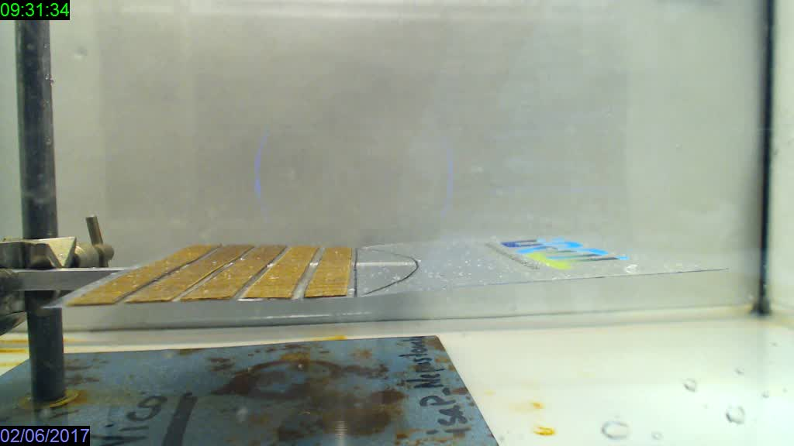
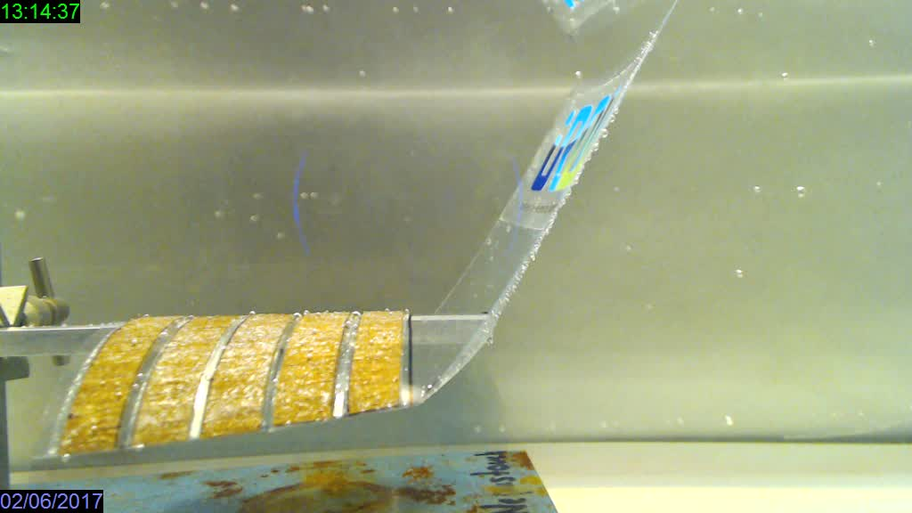

Immersion
Figure 5. Example of hygromorph biocomposite (Flax/Maleic anhydride Polypropylene) with programmed moisture induced curvature (a) and mixed curvature/twist (b) https://www.youtube.com/watch?v=kmlm1UHoj18

3. Conclusions

“Top-down” Biomimetic process have led to a disruptive use of natural fibres with a novel actuation functionnality. HBCs are also inexpensive, locally available and environmentally friendly. The development and use of hygromorph biocomposites also potentially opens different sets of applications for natural fibre producers, enabling them to diversify the market share away from the traditional textile industry
The bilayer or asymmetric lay up configuration allows the triggering of a large out-of-plane displacement response when a moisture gradient is present.
Beyond stripe samples, HBCs were used to trigger the deployment of adaptive structures. Origami techniques currently used to develop smart material systems were applied to design HBCs, and confirmed their potential applications in moisture-induced self-shaping systems. Although essentially triggered by a moisture variation, the HBCs and their actuating plant fibres are also sensitive to temperature.
Unlike common “high tech” electromechanical smart deployable structures which require sensors and actuators but are oftebn complex, expensive and failure prone, HBC included both sensing and actuation. Thus, with complementary developments, they could be used in low tech autonomous Climate Adaptive Building structures with humidity/temperature interactions. Combining these HBCs with SMPs could therefore enlarge their response spectrum and design envelope.

Acknowledgments

The authors wish to thank Kazuya Saito (Univ Tokyo) and Tomohiro Tachi (Univ Tokyo) for fruitfull discussions about curved line origami. We also wish to thank Etienne Reyssat (ESPCI Paris) for discussion and Samuel Requile for its involvement.

References
[1] Le Duigou A, Davies P, Baley C. Environmental impact analysis of the production of flax fibres to be used as composite material reinforcement. J Biobased Mater Bioenergy 2011;5. doi:10.1166/jbmb.2011.1116.
[2] Le Duigou A, Baley C. Coupled micromechanical analysis and life cycle assessment as an integrated tool for natural fibre composites development. J Clean Prod 2014;83:61–9. doi:10.1016/j.jclepro.2014.07.027.
[3] T. Speck, O. Speck. Process sequences in biomimetic research. Des Nat IV 2008:https://www.witpress.com/Secure/elibrary/papers/DN.
[4] Coroller G, Lefeuvre A, Le Duigou A, Bourmaud A, Ausias G, Gaudry T, et al. Effect of flax fibres individualisation on tensile failure of flax/epoxy unidirectional composite. Compos Part A Appl Sci Manuf 2013;51. doi:10.1016/j.compositesa.2013.03.018.
[5] Le Duigou A, Castro M. Hygromorph BioComposites: Effect of fibre content and interfacial strength on the actuation performances. Ind Crops Prod 2017;99. doi:10.1016/j.indcrop.2017.02.004.
[6] Le Duigou A, Castro M. Evaluation of force generation mechanisms in natural, passive hydraulic actuators. Sci Rep 2016;18105.
[7] Le Duigou A, Castro M. Moisture-induced self-shaping flax-reinforced polypropylene biocomposite actuator. Ind Crops Prod 2015;71. doi:10.1016/j.indcrop.2015.03.077.
[8] Le Duigou A, Castro M, Bevan R, Martin N. 3D printing of wood fibre biocomposites: From mechanical to actuation functionality. Mater Des 2016;96:106–14. doi:10.1016/j.matdes.2016.02.018.
[9] A Le Duigou, S Requile, J Beaugrand, F Scarpa, M Castro,. Natural fibres actuators for smart bio-inspired hygromorph biocomposites. Smart Mater Struct 2017;26.
[10] Le Duigou A, Davies P, Baley C. Seawater ageing of flax/poly(lactic acid) biocomposites. Polym Degrad Stab 2009;94. doi:10.1016/j.polymdegradstab.2009.03.025.
[11] Fratzl P, Elbaum R, Burgert I. Cellulose fibrils direct plant organ movements. Faraday Discuss 2008;139:275–82.
[12] Dawson C, Vincent J, Rocca A. How pine cone open. Nature 1997;390:668.
[13] Reyssat E, Mahadevan L. Hygromorphs: from pine cones to biomimetic bilayers. J R Soc Interface 2009;6:951–7. doi:10.1098/rsif.2009.0184.
[14] Timoshenko S. Analysis of bi-metal thermostats. J Opt Soc Am 1925;11:233–55.
[15] Roy M, Sen M. The swelling of jute fiber in water (transverse swelling). J Text Inst Trans 1952;43:396–401.
[16] Peraza-Hernandez. EA, DJ Hartl, RJ Malak Jr and DL. Origami-Inspired Active Structures: A Synthesis and Review. Smart Mater Struct 2014;23:094001.

