Open Hole Tensile and Compressive Fatigue Strengths of Interlaminar Toughened CFRP Laminates
Using Benzoxazine Resin as Matrix

Shota Yamanaka¹, Masayuki Nakada², Yasushi Miyano³ and Takayuki Matsumoto⁴

¹ Graduate School, Kanazawa Institute of Technology, Japan
Email: b6701288@planet.kanazawa-it.ac.jp
^{2,3} Materials System Research Laboratory, Kanazawa Institute of Technology, Japan
² Email: nakada@neptune.kanazawa-it.ac.jp, ³Email: miyano@neptune.kanazawa-it.ac.jp
^{2,3} Web Page: http://wwwr.kanazawa-it.ac.jp/MSRL/
⁴ JXTG Nippon Oil & Energy Corporation, Japan
Email: matsumoto.takayuki@jxtg.com
Web Page: https://www.noe.jxtg-group.co.jp

Keywords: CFRP, Open hole tension, Open hole compression, Static strength, Fatigue strength, Toughened interlayer, Benzoxazine resin

Abstract
The open hole tensile (OHT) and open hole compressive (OHC) static and fatigue tests were conducted for the interlaminar toughened and un-toughened quasi-isotropic CFRP laminates using benzoxazine resin as the matrix. The influence of toughened interlayer as the interlaminar on the OHT and OHC static and fatigue strengths of quasi-isotropic CFRP laminates is discussed. As results, the fatigue strength as well as the static strength by OHT loading is clearly larger than that by OHC loading. The strengthening by toughened interlayer is found in OHT loading, however this strengthening is not found in OHC loading. It was clarified by the observatation of damages that the resin cracks and delaminations generated before fiber breakings during fatigue loadings are suppressed by the existence of toughened interlayers in the case of OHT loading.

1. Introduction

Carbon fiber reinforced plastics (CFRP) have high strength, high modulus and light weight. Therefore, the CFRP is widely used as structural materials such as airplane, automobile and so on. CFRP are generally used as the laminated plates, and CFRP laminates are often failed by the initiation of delamination during loadings. Therefore, there is T800/3900-2B developed by Toray Industries, Inc. as the interlaminar toughened CFRP laminates which is dispersed thermoplastic particles in interlayers [1].

The flame retardant property is required to CFRP laminates for the structures of transportation. Benzoxazine resin has been developed as flame-retardant resin of CFRP laminates [2]. The evaluation of the durability of CFRP laminates using benzoxazine resin as matrix is required to develop the high reliable structures using this CFRP laminates.

In this paper, the open hole tensile (OHT) and open hole compressive (OHC) static and fatigue tests were conducted for interlaminar toughened and un-toughened quasi-isotropic CFRP laminates using benzoxazine resin as matrix. The influence of toughened interlayer on OHT and OHC static and fatigue strengths of quasi-isotropic CFRP laminates is discussed.

2. Experiments

2.1. Preparation of specimen

Two kinds of quasi-isotropic CFRP laminates are prepared. One is T800S/BXZ (UT) using carbon fiber T800S and benzoxazine resin without interlaminar toughened (UT) layers, the other is T800S/BXZ_ILT (ILT) using same carbon fiber and matrix with interlaminar toughened (ILT) layers where thermoplastic particles are dispersed on the surface of the prepreg as shown in Figure 1. The stacking sequence of CFRP laminates is [45/0/-45/90]_{2S}. The thickness of CFRP laminates is approximately 2.5mm.

The configuration of OHT and OHC static and fatigue tests specimen is shown in Figure 2. The length, width and thickness of the OHT specimen are 190mm, 38.1mm and 2.5mm, respectively. The length, width and thickness of the OHC specimen are 305mm, 38.1mm and 2.5mm, respectively. The test specimens are cut from quasi-isotropic CFRP laminates by using diamond wheel blade. And then center hole of diameter 6.35mm is opened by using drilling machine (YD5-94CTN: manufactured by DMG MORI). A diamond coated carbide drill (D-GDN 6.2mm, OSG) is used to open the hole and a carbide straight reamer (CRM 6.4 mm, OSG) is used finishing the hole.

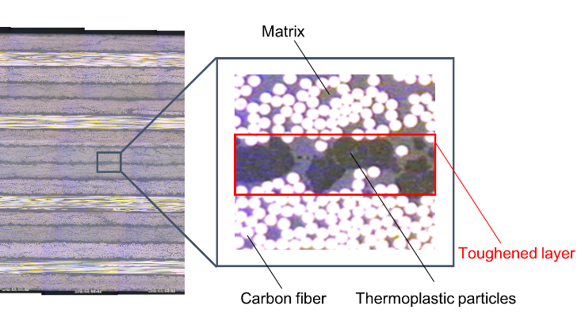

Figure 1. Interlaminar toughened CFRP laminates

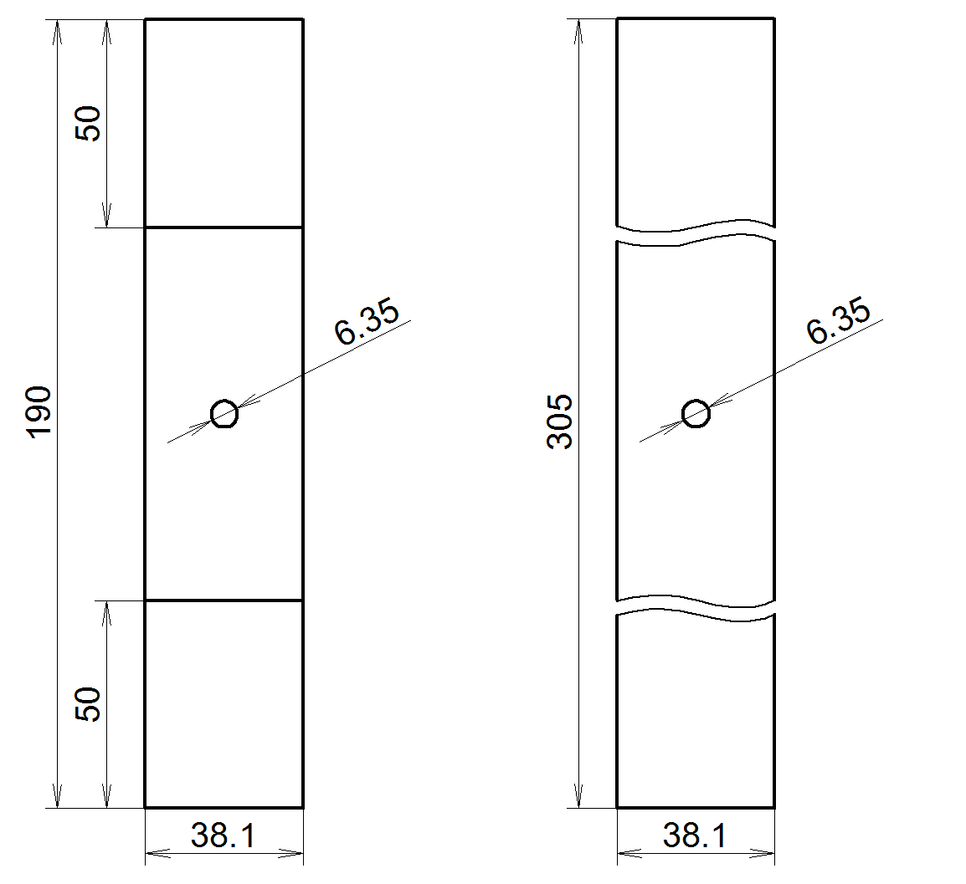

(a)OHT tests (b)OHC tests

Figure 2. Test specimens.

2.2 Test method

The OHT static and fatigue tests were conducted for UT and ILT specimens. These tests were conducted according to ASTM D 5766. The electro-hydraulic servo testing machine (EHF-EB10, SHIMADZU) was used for OHT static tests. The test speed was V=1.0mm/min and the test temperature was room temperature. The OHT static strength was calculated by the following equation.
$$σ=\frac{P_{max}}{bt}$$ | (1)
Where σ is static strength, b is the width of the specimen, P_{max} is maximum load, t is thickness of the specimen.

OHT fatigue tests were carried out using a same test machine in OHT static tests. The maximum stresses were selected as 70% to 85% of the OHT static strength. Stress ratio R (= minimum stress/maximum stress) was 0.05. The loading frequency was f=2Hz and the test temperature was room temperature.

The OHC static and fatigue tests were conducted for UT and ILT. These tests were conducted according to ASTM D 6484. OHC tests were carried out using a same test machine in OHT tests. Test fixture for OHC is shown in Figure 3. The test speed was V=1.27mm/min and the test temperature was room temperature. The OHC static strength was calculated by Eq. 1.

OHC fatigue tests were carried out that the maximum stresses were selected as 70% to 90% of the OHC static strength. Stress ratio R was 0.05. The loading frequency was f=2Hz and the test temperature was room temperature.

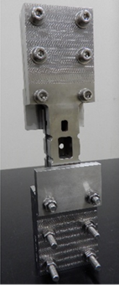

Figure 3. Test fixture for OHC tests (ASTM D 6484).

3. Results and Discussion

3.1 Static test

Figure 4 shows the load - deformation diagrams for OHT and OHC static tests for UT and ILT specimens. The static maximum load by OHT loading is clearly larger than that by OHC loading and the maximum loads for OHT tests is twice of those for OHC tests. Then the static strength by OHT loading is almost twice of that by OHC loading, because all of specimen sizes and laminate configurations without specimen length are the same for both of OHT and OHC specimens.
In case of OHT test, the load-deformation diagrams for both UT and ILT specimens form the same non-linear pathway but the load and deformation at the maximum load point for ILT specimen is larger than that for UT specimen. It is considered that the difference of maximum load point for UT and ILT specimens at OHT static tests is due to the influence of toughened interlayer.In case of OHC test, the load - deformation diagrams for both UT and ILT form the same linear pathway. It is considered that there is almost no influence of the toughened interlayer at OHC static test.

Figure 4. Load-deformation diagrams under static loading.

3.2 Fatigue test

Figure 5 shows the S-N curves by fatigue test of UT and ILT specimens. The decreasing of OHT fatigue strengths against the increasing of number of cycles to failure for ILT specimens is more moderate than those for UT specimens. It is considered that the difference in OHT fatigue strength is caused by the toughened interlayer.The OHC static strengths for ILT specimens are almost same as those for UT specimens. Futheremore, the decreasing behavior of OHC fatigue strengths against the increasing of number of cycles to failure for ILT and UT specimens are almost the same, too. It can be presumed that there is almost no influence of the toughened interlayer at OHC fatigue test since the resin cracks and delamination hardly occur before the fibers breaking.

Figure 6 shows the deformations at the cyclic peak loads under OHT and OHC fatigue tests of UT and ILT specimens. In case of OHT test, the deformation at peak load increases gradually with increasing number of load cycles and rapidly increases just before fracture. In case of OHC test, the deformation at peak load increases scarecely with increasing number of load cycles and rapidly increases just before fracture.

Figure 5. S-N curves for two kinds of CFRP laminates.

(a)OHT tests (b)OHC tests

Figure 6. Deformations at cyclic peak load points during fatigue tests.

3.3 Fracture appearances of specimens after static and fatigue tests.

Figure 7 and Figure 8 show the fracture appearances after the OHT and OHC static and fatigue tests of UT and ILT specimens, respectively. The difference of fracture modes for the two kinds of specimens for OHT and OHC tests can not be observed. The influence of toughened layer can not be observed from the fracture appearences after both of OHT and OHC static and fatigue tests.

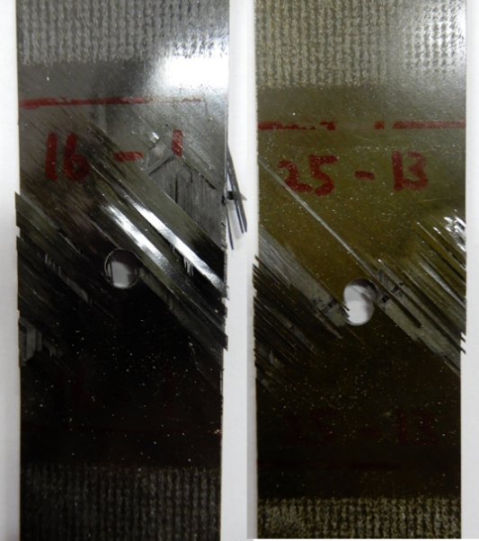

UT ILT
σ_{s}=551MPa σ_{s}=567MPa

(a) Static tests
(V=1.0mm/min, T＝25℃)
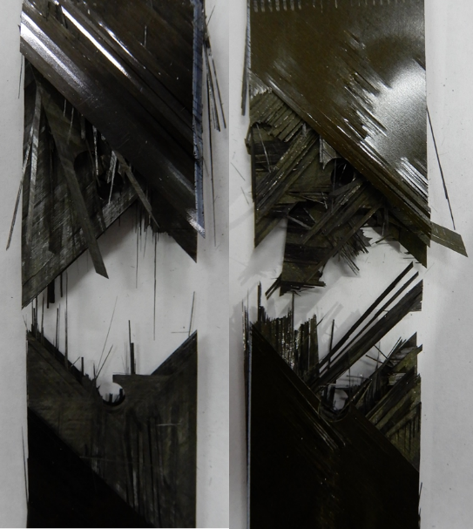
UT ILT
N_{f}=1.2x10⁵ N_{f}=1.2x10⁶

(b) Fatigue tests
(σ_{max}=441MPa, f=2Hz, R＝0.05, T＝25℃)

Figure 7. Fracture appearances of specimens after OHT static and fatigue tests.

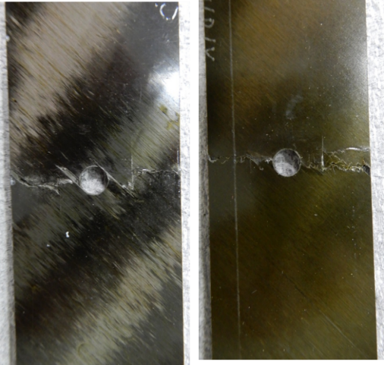

UT ILT
σ_{s}=323MPa σ_{s}=315MPa

(a) Static tests
(V=1.27mm/min, T＝25℃)
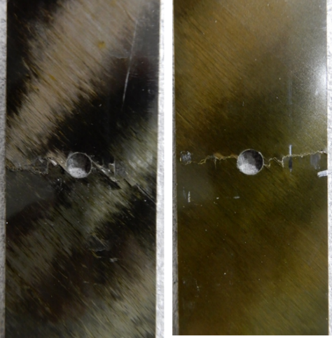

UT ILT
N_{f}=4.5x10³ N_{f}=3.2x10⁵

(b) Fatigue tests
(σ_{max}=243MPa, f=2Hz, R＝0.05, T＝25℃)

Figure 8. Fracture appearances of specimens after OHC tests.

3.4 Damage process for OHT fatigue loading

Figure 9 shows the ultrasonic flaw image of specimens removed from fatigue test machine after stopping fatigue test at the number of cycles of 1x10², 1x10³, 1x10⁴, 1x10⁵, 5x10⁵ for OHT loads. The maximum stress applied for the fatigue tests is 80% of OHT static strength. The delamination in edges of hole and side of specimens are observed. The area of delamination for UT specimens is larger than that for ILT specimens.

Figure 10 shows the side edge view of the specimen observed using a digital microscope for OHT fatigue loading. The multiple delamination were observed in interlayers between 90° and 90°, -45° and 90°, 45° and 90° for UT specimens. On the other hand, a single delamination was mainly observed in the interlayer between 90° and 90° for ILT specimens, and the pass of this delamination moves to neighboring interlayers.

Figure 11 shows the hole edge view of the specimen ,removed from fatigue test machine after stopping fatigue test at the number of cycles of 1x10⁴, observed using a digital microscope. The test specimens are cut in half obserbed the cross section of each 1mm. Unlike the side edge delamination, the hole edge delamination is caused near the surface of the specimen.

It can be presumed from the observation of the damages during fatigue loadings that the improvement of fatigue strength for the toughened CFRP laminates is caused by the suppress of delamination in the side surfaces as well as the hole edge of specimen.

UT
(N_{f}=1.2×10⁵)

ILT
(N_{f}=1.2×10⁶)

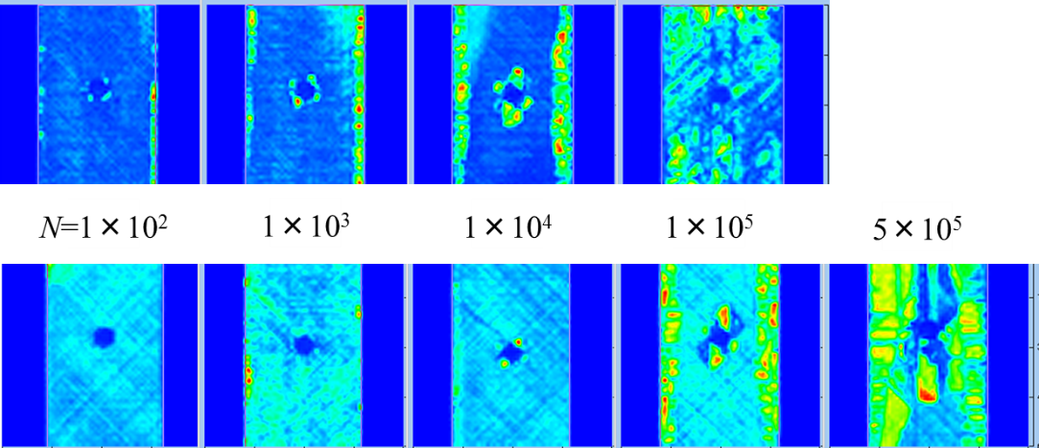

Figure 9. Ultrasonic flaw image during OHT fatigue test.

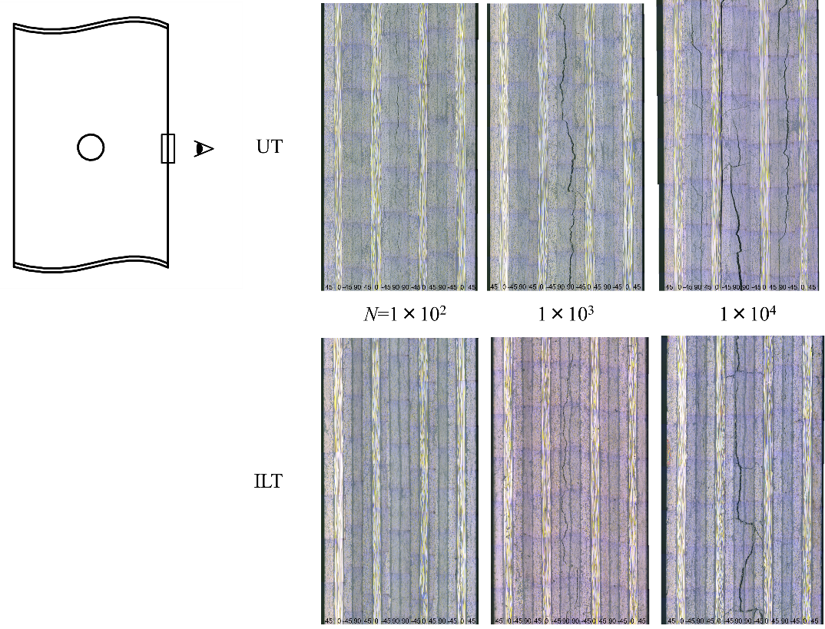

Figure 10. Side edge delamination of the specimens during OHT fatigue test.

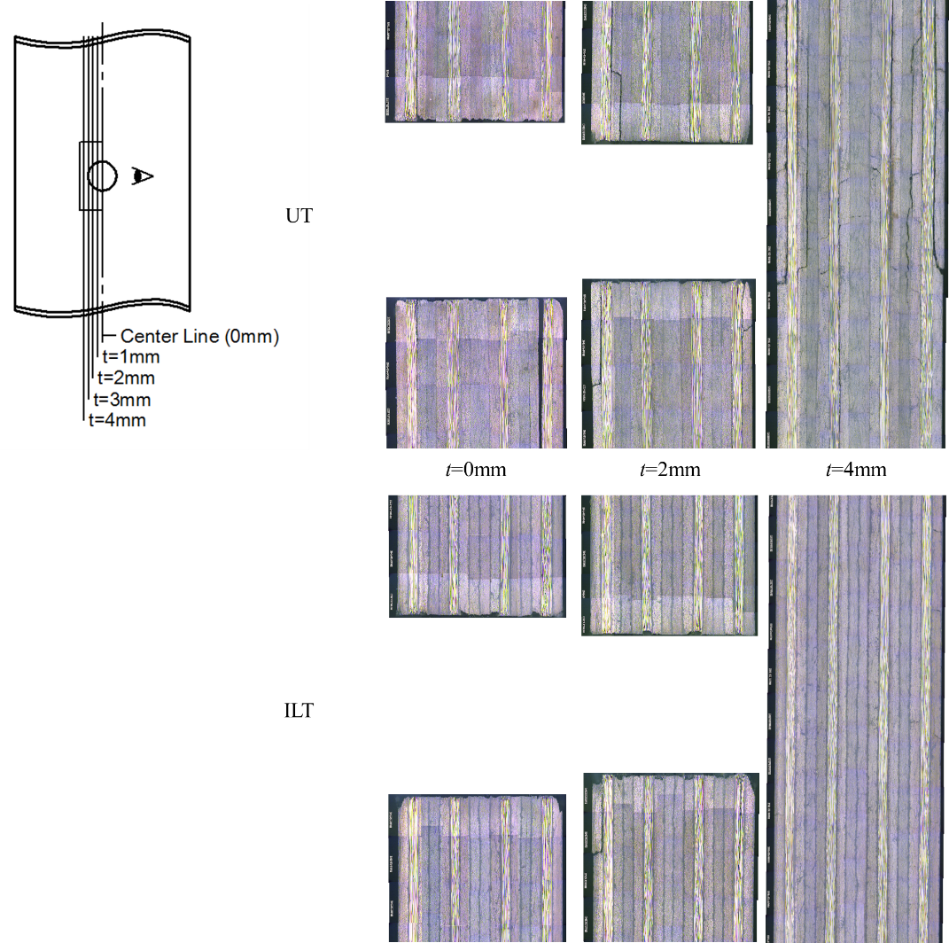

Figure 11. Hole edge delamination of the specimens during OHT fatigue test.

5. Conclusions

The open hole tensile (OHT) and compressive (OHC) static and fatigue tests were conducted for interlaminar toughened and un-toughened quasi-isotropic CFRP laminates using benzoxazine resin as matrix, respectively. As results, the fatigue strength as well as the static strength by OHT loading is clearly larger than that by OHC loading. The strengthening by toughened interlayer is found in OHT loading, however this strengthening is not found in OHC loading. It was clarified by the observatation of damages that the resin cracks and delaminations generated before fiber breakings during fatigue loadings are suppressed by the existence of toughened interlayers in the case of OHT loading.

References

[1] S. Matsuda, M. Hojo, and S. Ochiai. Mesoscopic fracture mechanism of mode II delamination fatigue crack propagation in interlayer-toughened CFRP. JSME International Journal, Series A, 40:423-429, 1997.
[2] R. Tietze, C. Hubschmid, and T. Truong. Benzoxazine Chemistry and Application Overview. Proc. Int. SAMPE Symp, The Woodlands, TX, 2009.

