LEVERAGING DECENTRALIZED BUFFERS FOR PEAK SHAVING AND LOAD SHAPING IN 100% RENEWABLE DISTRICT HEATING

Sandra Forndran¹, Luca Vittorio Valentini¹, Alexander Thür¹
¹University of Innsbruck, Unit of Energy Efficient Building, Technikerstr. 13, 6020 Innsbruck
sandra.forndran@uibk.ac.at
Summary
District heating (DH) systems play a key role in integrating renewable heat sources but require additional operational flexibility to balance fluctuating heat generation and demand. This paper investigates decentralized buffer storage charging strategies as a source of consumer-side flexibility in multi-unit residential buildings. Two typical hydraulic configurations are analyzed: a system with a domestic hot water (DHW) storage tank and a system with a centralized fresh water unit. For both configurations, a peak-shaving strategy and a peak-shifting strategy are evaluated using simulations in Polysun (Vela Solaris AG). The results show that the peak-shaving strategy reduces substation power peaks by up to 26.6%, while the peak-shifting strategy decreases the transmitted thermal energy during defined peak periods by up to 22.5%. Furthermore, simplified Temporal Fusion Transformer (TFT) models are developed to predict the resulting power and return temperature at the substation for all investigated hydraulic concepts and charging strategies. The prediction models achieve mean absolute percentage errors below 4% for peak-shaving and below 10.3% for the more dynamic peak-shifting strategy, while return temperature is predicted with errors close to 1%. The results demonstrate that decentralized buffer storages can provide significant operational flexibility and that the proposed TFT models enable an accurate representation of building-side flexibility for future DH simulation and optimization.
Keywords: district heating, decentralized buffer storage, thermal load peak shaving, neural network
Field of application for the findings: district heating operation
Addressed audience: researchers
- Introduction
District heating (DH) networks can become a key infrastructure for the transition towards renewable heat supply, especially in dense urban areas, because it can integrate different renewable heat sources and provide an interface to coordinate supply and demand. Renewable heat sources such as PV-driven heat pumps and industrial waste heat have limited programmability and are therefore not well suited to cover short-term load peaks directly, which are still often supplied by gas boilers (Moser et al., 2026). Consequently, the transition towards renewable DH requires the exploitation of operational flexibility to align temporal mismatches between heat supply and heat demand.
The consumer side can contribute substantially to transforming to renewable DH operation. There are several options of consumer-side flexibility, which were assessed in literature (Guo et al., 2024). Consumer-side flexibility can be provided by using thermal mass of buildings (Olsthoorn et al., 2017), adapted heating schedules (Karasu et al., 2024), demand response (Knudsen et al., 2025), or decentralized thermal storage. Among these options, decentralized buffer storages are especially interesting because they are already present in many building installations and can decouple heat consumption from heat supply over short time periods. Such storages enable peak shaving and inter-hour or inter-day load shifting without compromising thermal comfort. However, many buffer storages are charged by simple step-wise pump control logics, which can create artificial load peaks that are larger than the actual heat demand peaks. Suitable charging control logic can therefore transform decentralized storage from a passive hydraulic component into an active flexibility resource.
Previous work has shown that this flexibility potential can be substantial. In a multi-residential building setup with a decentralized buffer storage, a conventional step-wise charging strategy led to distinct recurring power peaks at the DH substation (Forndran et al., 2026). A peak-shaving charging strategy reduced these short-term peaks by adapting the charging process instead of switching the loading pump only according to fixed temperature thresholds by 53.3%. Nevertheless, this work does only cover one specific hydraulic configuration of SH and DHW supply. Multi-unit residential buildings can differ in their hydraulic configurations. In systems with a DHW storage tank, parts of the DHW consumption peaks are already buffered before it affects the DH substation. In contrast, systems with a centralized fresh water unit, DHW peaks can have a more direct influence on the substation power profile. Although both concepts can satisfy the same SH and DHW demands, their thermal power and return temperature profiles at the DH substation will differ. Therefore, flexibility strategies developed for one hydraulic concept cannot automatically be assumed to perform similarly in another.
In addition to the physical control strategy, prediction models are required to make consumer-side flexibility usable for DH network operation. Network-level simulation and optimization require simplified, but accurate representations of how building-level heat demand is transformed into substation power and return temperature under a given control strategy. Detailed building simulations are useful for analyzing hydraulic configurations and control concepts, but data-driven models enable more computationally efficient integration into DH simulation tools. This is particularly relevant because future DH modelling environments need to represent dynamic thermal storage behavior, demand-side flexibility, advanced control strategies, and interoperability with optimization environments (Valentini et al., 2026).
Previous work investigated data-driven models, including neural network approaches, for load predictions of buildings and networks (Chen et al., 2023; Hua et al., 2024). Others go beyond load prediction and use data-driven models to optimize charging of central thermal storages with the goal of peak reduction (Du et al., 2025). Also, for the specific use of the resulting DH substation power profile and return temperature following a peak-shaving strategy using decentralized storages, data-driven prediction models were developed (Forndran et al., 2026). The models used SH and DHW demand as input variables, while the DH substation power and secondary return temperature served as prediction targets. Neural network approaches, especially CNN-LSTM models, were investigated to capture temporal patterns and nonlinear system behavior. The resulting models achieved high prediction accuracy for both substation power and return temperature, supporting the use of data-driven surrogate models for the representation of storage-based flexibility.
However, several research gaps remain. First, previous analyses of decentralized buffer storage control focused mainly on peak shaving, whereas future renewable DH systems also require strategies that actively redistribute thermal loads in time. Peak shifting can be used to move heat demand away from periods of high network utilization and thereby reduce the need for peak boilers. Second, existing work on storage-based control has considered one hydraulic setup, while typical multi-residential buildings may use fresh water units instead of DHW storage tanks. Prediction models are required not only for one control strategy and one hydraulic configuration, but for different combinations of hydraulic setup and charging logic, if consumer-side flexibility is to be integrated into network-level simulations and optimization tools. Against this background, this paper investigates decentralized buffer storage control as a source of consumer-side flexibility in multi-unit residential buildings. Two typical hydraulic concepts are compared: a configuration with DHW storage and a configuration with a centralized fresh water unit. For both hydraulic concepts, two charging strategies are analyzed: a peak-shaving strategy that reduces short-term thermal power peaks and a peak-shifting strategy that intentionally redistributes thermal demand over time. Furthermore, data-driven prediction models are developed to forecast the resulting thermal power and return temperature at the DH substation for each combination of hydraulic concept and charging strategy. The objective is to extend the applicability of decentralized storage-based flexibility concepts and to provide computationally efficient models that can support the integration of consumer-side flexibility into DH network operation.
- Methodology

  - Hydraulic setup
To extend the applicability of the proposed control approaches with prediction models, two different hydraulic concepts are investigated. Both systems represent typical hydraulic configurations used in multi-unit residential buildings and are simulated using Polysun (Vela Solaris AG). In order to enable a direct comparison of the charging strategies, both hydraulic concepts and both charging control concepts are combined with the same heat demand profiles for SH and DHW preparation. Consequently, differences in the behavior of the system can solely be attributed to the hydraulic configuration and the applied charging strategy. The first hydraulic concept corresponds to the setup investigated in the previous work of (Forndran et al., 2026) and is illustrated in Figure 1. The DH network supplies thermal energy via the substation to a buffer storage, which is charged by a secondary loading pump, that is controlled by one of the two proposed logics. The buffer storage decouples heat generation from heat consumption and therefore provides the flexibility required for predictive charging strategies. SH is supplied from the storage, while DHW is prepared using a heat exchanger and a primary and secondary loading pump to charge a DHW storage tank. Even though this storage and the buffer storage before can buffer the direct DHW consumption peaks, for a typical step-wise charging control, there occur short-term power peaks due to fixed high set flow rates of the DHW loading pumps.
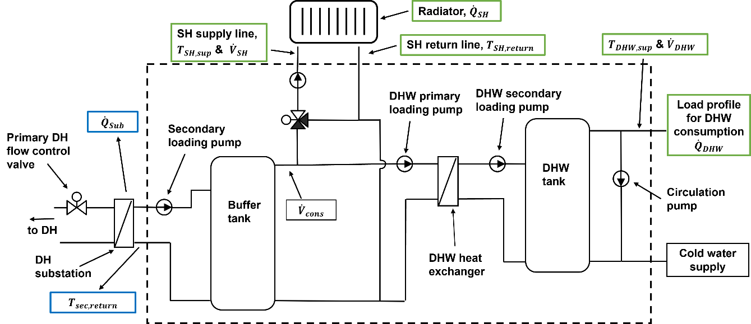
Figure 1: Hydraulic setup for a multi-unit residential building including a thermal buffer storage and a DHW storage
In the second hydraulic concept, the DHW storage tank is replaced by a centralized fresh water unit. In contrast to the previous setup, DHW peak loads cannot be buffered by the DHW tank anymore, therefore have a stronger influence on the power profile at the substation.
Although both hydraulic concepts are designed to satisfy identical SH and DHW demands, the different hydraulic layouts can lead to different thermal load profiles at the DH substation. The comparison of both systems therefore allows the influence of the hydraulic configuration on the thermal load profile and provides prediction models for peak-shaving and peak-shifting logics for two common setups.

  - Charging strategies
- Peak-shaving
The first charging strategy aims to reduce the thermal power peaks at the DH substation. The underlying control algorithm corresponds to the peak-shaving strategy presented in (Forndran et al., 2026) and is therefore adopted without modification in this work. A detailed description of the charging logic can be found in the previous publication and is not repeated here. In general, instead of the typical step-wise control, where switching on and off of charging is determined by temperature thresholds, charging is based on a variable that combines the energy and exergy content of the storage resulting in a continuously varying signal from 0% to 100% for the loading pump. Since the total thermal energy demand of the building remains unchanged, the strategy reduces the magnitude of short-term power peaks without significantly altering the daily energy consumption.
- Peak-shifting
 | Charging window | Charging volume flow rate factor | Discharging window | Discharging volume flow rate factor
Winter | 6-8 a.m. &  5-7 p.m. | 1.4 | 8-10 a.m. &  7-9 p.m. | 0.7
Mid-season | 6-8 a.m. &  5-7 p.m. | 1.35 | 8-11 a.m. &  7-10 p.m. | 0.75
In addition to reducing maximum power peaks, DH systems increasingly require operational strategies capable of actively redistributing thermal loads over time. Therefore, a second charging strategy based on peak shifting is investigated in this work. Unlike the peak-shaving approach, which primarily limits the magnitude of load peaks, the objective of peak shifting is to intentionally relocate thermal demand from periods of high network utilization to periods with lower demand. This avoids the use of so-called peak-boilers, while simultaneously increasing the operational flexibility of the DH network. For this charging logic, the volume flow rate at the secondary loading pump for the buffer storage normally equals the consumption volume flow rate that is leaving the storage for heat supply, ${\dot{V}}_{cons}$. In periods before peak loads are expected, this volume flow rate is multiplied with a factor larger than one to charge the buffer storage. In the following period of typically high heat consumption, it is multiplied with a factor smaller than one. In case the temperature in the buffer storage drops below a critical value, this is overruled by a charging with 110% of ${\dot{V}}_{cons}$. The exact multiplication factors and time windows vary during the year due to varying SH demand and are displayed in Table 1. Winter season includes January, February and December and allows only a discharging time window of two hours, while requiring charging with a volume flow factor of 1.4. Mid-season means the months from March to May and October and November, where the discharging window is extended to three hours, while the charging volume flow factor can be a bit reduced to 1.35. Summer time is excluded from this consideration, since the changed load profile requires different strategies.
Table 1: Peak-shifting charging strategy; charging and discharging time windows and multiplication factor for the consumption volume flow rate ${\dot{V}}_{cons}$

- Evaluation
The different charging strategies in combination with the two hydraulic configurations are evaluated for one test year, which has a yearly SH demand of 211 MWh and 88 MWh DHW demand. The evaluated period excludes the summer months from June to October, since there is no SH demand during this time, therefore significantly lower heat demand. On one hand, this means that the need for peak-shaving and peak-shifting strategies is lower, because there is sufficient backup capacity in the network and the load utilization in the network is significant lower. On the other hand, during summer the buffer tank in the morning typically has already a high charging state due to high return temperatures mainly from DHW circulation, which does not allow extra charging. Since the peaks are only caused by DHW consumption peaks, other strategies might be more beneficial during summer time than the two proposed charging strategies.

  - Prediction model
    - Approach
For both charging strategies and for both hydraulic setups, neural network models are trained, which enable the prediction of the resulting thermal power and return temperature at the DH substation. The model gets as input features SH power, SH volume flow rate, SH return temperature, DHW power and DHW volume flow rate. The model predicts for each timestep the resulting thermal power at the DH substation and the return temperature to DH as target features. In the previous work of (Forndran et al., 2026), two classes of data-driven models, Autoregressive models with Exogeneous Inputs (ARX) and Convolutional Neural Network (CNN) – Long Short Term Memory (LSTM), were investigated and compared for the peak-shaving strategy. For the peak-shifting strategy a simplified Temporal Fusion Transformer (TFT) showed more accurate results, while it also works for the peak-shaving strategy, which is why this neural network type is used in this work. The architecture set-up and training process is implemented using Keras (Chollet, 2015).

    - Temporal Fusion Transformer
The TFT is a neural network architecture specifically developed for multivariate time-series forecasting. It combines recurrent neural networks with transformer-based attention mechanisms, allowing both short-term temporal dynamics and long-term dependencies within historical measurements to be captured. The architecture is described in (Lim et al., 2021). In contrast to conventional recurrent neural networks, which process information sequentially, the attention mechanism enables the model to selectively focus on those historical observations that are most relevant for the current prediction. This capability is particularly beneficial for load forecasts, where the thermal load depends on both, recent operating conditions and delayed thermal effects resulting from the buffer storage.
The model consists of an encoder branch and a decoder branch. The encoder receives a historical sequence containing past observations and related explanatory variables. This sequence represents the temporal context from which relevant patterns, trends, and dependencies are extracted. In parallel, the decoder receives known variables for the future prediction period. These variables represent information available before the target values are observed and provide additional context for the transformation into the target sequence. Both input streams are initially projected into a shared latent feature space, allowing heterogeneous variables with different dimensions and characteristics to be represented in a common feature space.
The historical input sequence is encoded using a bidirectional long short-term memory network (BiLSTM). Theory on principal LSTM architecture is explained by (Hochreiter and Schmidhuber, 1997). The encoder learns temporal dependencies within the observation window and generates a sequence of hidden representations. Due to its bidirectional structure, information from both temporal directions within the input window is considered, resulting in a more comprehensive representation of the historical dynamics. These hidden states contain information about short-term variations as well as longer-term temporal patterns relevant for the target prediction.
The decoder processes the known future variables and transforms them into a latent representation of the expected future state. The initial decoder states are generated from an aggregated representation of the encoder outputs, allowing the decoder to incorporate information from the historical context. Consequently, the prediction is conditioned on both previously observed temporal patterns and future explanatory variables.
The central component of the architecture is the temporal fusion mechanism based on multi-head attention. The attention mechanism was first introduced by (Vaswani et al., 2017). The purpose of this mechanism is to identify, which parts of the historical sequence provide the most relevant information for a given prediction step. The decoder representation is used as the query, whereas the encoder hidden states are used as keys and values. The attention mechanism therefore learns dynamic importance weights over the historical time steps and selectively combines relevant information from the past. The attention operation is based on scaled dot-product attention,
$Attention \left(Q,K,V\right)=softmax\left(\frac{Q ∙K^{T}}{\sqrt{d_{k}}}\right)V$ Eq. (1)
where Q, K (transformed), and V denote the query, key and value representations, respectively, and dk represents the dimensionality of the key vectors. Instead of applying this operation only once, multi-head attention performs the attention calculation in parallel across multiple representation subspaces. For each attention head_{i}, separate projections of the input representations are generated:
${head}_{i}=Attention (QW_{i}^{Q}, KW_{i}^{K}, VW_{i}^{V})$ Eq. (2)
where i is the head index and W is the weight matrix. The individual attention heads are subsequently concatenated and linearly transformed:
$MultiHead \left(Q,K,V\right)=Concat({head}_{1}, …, {head}_{h})W^{0}$ Eq. (3)
This multi-head formulation allows the model to capture different types of temporal relationships simultaneously, such as short-term dependencies, recurring patterns, or longer-term influences within the historical sequence. The resulting attention context is combined with the decoder representation through a residual connection and subsequently processed by a gated residual network (GRN). The GRN introduces a learnable gating mechanism that controls the contribution of transformed features and residual information. This enables the model to preserve relevant temporal features while reducing the influence of less informative representations.
Finally, the fused latent representation is mapped to the target variable through a linear output layer. By applying this transformation for all time steps within the prediction horizon, the model generates the complete target trajectory. The overall data flow can be summarized as:
Historical observations + known future variables (Input) => Temporal Encoding => Multi-Head Attention Fusion => GRN => Output
    - Data preparation
The training data (input features and target features) are obtained by Polysun (Vela Solaris AG) simulations with the corresponding hydraulic setups and two buffer charging strategies. The dataset consists of five training years, one validation year and three evaluation years in 15 min timesteps. The SH and DHW consumption profiles, which are needed for the Polysun (Vela Solaris AG) simulation are obtained from monitoring data (SH and DHW), a systematic variation of the monitoring data (SH) and the statistical tool DHW_calc (Jordan and Vajen, 2017). Since thermal energy systems exhibit pronounced temporal dependencies, the available training data are extended by several additional features. First, cyclical time features are introduced to represent the periodic behavior of the system. Sine and cosine values of the time of the day, as well as of the day of the year are added. To further improve the representation of the system dynamics, lagged variables are generated for most variables. These include previous values of the substation power, the substation return temperature (both target values), the SH power and DHW power. Multiple lag intervals are considered in order to represent both short-term dynamics and longer recurring operating patterns. While short lags describe the immediate thermal response of the hydraulic system, longer lags allow the model to exploit similarities between consecutive daily operating cycles.
Besides lagged variables, first-order differences are calculated for the same variables. These features provide information about the temporal gradients of the measured quantities and therefore enable the forecasting model to distinguish between stationary operating conditions and rapidly changing values. Such information is particularly beneficial during periods of increasing or decreasing DHW demand, where large load variations occur within short time intervals. In addition, rolling statistical features are generated by calculating moving averages and moving standard deviations over different window lengths. The moving averages provide information about the recent operating trend, whereas the moving standard deviations describe the short-term variability of the thermal loads. These statistical descriptors complement the instantaneous measurements and enable the neural network to distinguish between stable operating conditions and highly dynamic system behavior.
Prior to model training, all continuous input variables are standardized using z-score normalization. The corresponding scaling parameters are determined exclusively from the training data and are subsequently applied to the validation and test datasets. This procedure prevents information leakage from unseen datasets and ensures that all input variables contribute equally during network optimization despite their different physical units and numerical ranges. The cyclic time features are excluded from the normalization process because they are already bounded within the interval from −1 to 1. Furthermore, the continuous time series are transformed into sequences using a sliding-window approach. The used sequence length covers 96 timesteps, corresponding to one day.

    - Model evaluation
The trained models are first assessed with the same test year as used for testing the effectiveness of the charging strategies (SH demand of 211 MWh and 88 MWh DHW demand). The yearly mean absolute percentage error (MAPE) is calculated based on the reference values and the model predictions for the test year excluding the summer months from June to September. Power and return temperature prediction are evaluated separately. Furthermore, to test the generalizability of the models for other buildings with varying SH and DHW demand, the models are evaluated similarly for two more test years with a SH demand of 354 MWh (or 74 MWh) and a DHW demand of 43 MWh (or 88 MWh), accounting also for buildings with different SH to DHW ratios (see Table 2).
- Results
  - Charging strategies
- DHW tank configuration
The peak-shaving strategy for the hydraulic configuration with a DHW tank leads to 26.6% peak reduction for the SH season, which excludes the months June, July, August and September, compared to the direct heat consumption. The peak-shifting strategy can reduce the transmitted heat energy in the discharging windows (8-10 a.m. and 7-9 p.m. during January, February and December and 8-11 a.m. and 7-10 p.m. during the other months) by 12.3% compared to the peak-shaving strategy. Figure 2 shows the graphic comparison of the peak-shaving and peak-shifting strategy with the direct heat consumption for three exemplary days in February. The blue line, representing the power of the peak-shaving strategy, shows a much smoother profile than the dotted black line, displaying the power profile of the direct system. The red line, showing the power profile of the peak-shifting strategy, is less smooth, but shows a clear shift of the power profile in the morning and evening hours, referring to the charging and discharging windows, during times of typical low and high DHW consumption. The average secondary return temperature to DH should not exceed certain limits, because too high return temperatures are unfavorable for the efficiency of the DH system. Typical limits are 50°C, while lower temperatures are preferred. The yearly average, energy-weighted return temperature is 43.3°C for the peak-shaving strategy and 42.7°C for the peak-shifting strategy, assuming that the strategies are applied during the whole year. The return temperature evaluation considers the full year instead of only SH season for a better comparability to other approaches, since often the summer period is critical regarding high return temperatures.
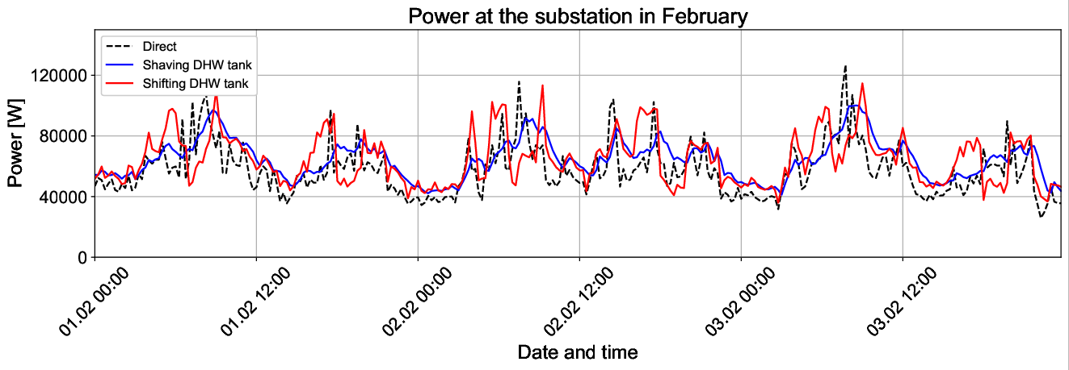
Figure 2: Comparison of the power profile for peak-shaving and the peak-shifting strategy with the profile of direct heat consumption for an exemplary period of three days during heating season for the hydraulic concept with a DHW tank

- Central freshwater unit configuration
The peak-shaving strategy for the hydraulic configuration with a central fresh water unit leads to 13.4% peak reduction for the SH season (all months except June, July, August and September) compared to a direct system without any buffer storage. This means that the peak-shaving strategy in combination with the central freshwater unit is less effective than in combination with a DHW storage. This is plausible, since the DHW storage can additionally buffer the DHW consumption peaks. The transmitted heat energy in the discharging windows (8-10 p.m. and 7-9 a.m. during January, February and December and 8-11 p.m. and 7-10 p.m. during the other months) is reduced by 22.5% through the peak-shifting strategy compared to the peak-shaving strategy. Figure 3 shows the comparison of power profiles for peak-shaving, peak-shifting and the direct system for the configuration with a central freshwater unit, analogous to Figure 2. The yearly average, energy-weighted return temperature is 43.3°C for the peak-shaving strategy and 42.9°C for the peak-shifting strategy, showing that both average values are well within favorable limits.
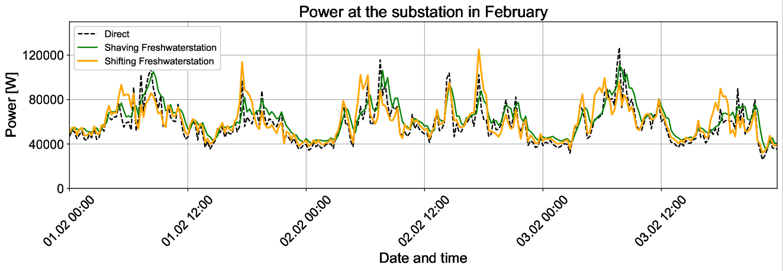
Figure 3: Comparison of the power profile for peak-shaving and the peak-shifting strategy with the profile of direct heat consumption for an exemplary period of three days during heating season for the hydraulic concept with a central freshwater station
- Comparison of charging strategies
The results demonstrate that both charging strategies provide operational flexibility, although they pursue different objectives. The peak-shaving strategy minimizes short-term thermal power peaks by distributing the charging process more continuously over time. In contrast, the peak-shifting strategy intentionally relocates heat supply from periods of high expected demand to preceding charging windows. Consequently, it accepts temporarily higher charging power in exchange for lower thermal loads during predefined peak periods.
For the hydraulic configuration with a DHW storage tank, the peak-shaving strategy reduces the maximum substation power during the space-heating season by 26.6% (13.4% for the configuration with central freshwater unit) compared to the direct heat consumption. This confirms that the storage charging algorithm effectively avoids the artificial power peaks caused by conventional on/off charging control. The smoother power profile shown in Figure 2 indicates that the available storage capacity is utilized more continuously, thereby reducing short-term fluctuations at the district heating substation. In contrast, the peak-shifting strategy reduces the transmitted thermal energy during the defined discharge windows by 12.3% (22.5% for the configuration with central freshwater unit) relative to the peak-shaving strategy. Instead of minimizing the absolute maximum power, the strategy deliberately transfers part of the heat demand to earlier charging periods. Such behavior can be advantageous for DH operators because thermal energy consumption can be scheduled outside periods of high network utilization.
The more intensive charging during the charging windows slightly does not increase the average secondary return temperature, it is even reduced slightly from 43.3 °C to 42.7 °C for the configuration with DHW tank. Although this increase reduces the thermodynamic performance of the district heating network to some extent, the resulting temperature remains well below commonly accepted operational limits of approximately 50 °C. The additional flexibility therefore appears to outweigh the moderate increase in return temperature. For the configuration with central fresh water unit, the peak-shifting strategy decreases the return temperature slightly from 43.3°C (peak-shaving) to 42.9C.

- Influence of hydraulic configuration
The comparison of both hydraulic concepts clearly illustrates the influence of the DHW preparation system on the achievable flexibility with the peak-shaving strategy compared to a direct system without any buffer storage. While the DHW storage configuration achieves a peak reduction of 26.6%, the reduction decreases to 13.4% when a centralized fresh water unit is used. This behavior can be explained by the different hydraulic buffering mechanisms. In the DHW storage configuration, domestic hot water demand is buffered twice, first by the DHW storage tank and subsequently by the decentralized buffer storage . Consequently, short-term DHW demand peaks are only partially transferred to the district heating substation. In contrast, the centralized fresh water unit supplies domestic hot water instantaneously. The corresponding thermal demand therefore appears almost directly at the substation, leaving less flexibility for the decentralized storage controller. Interestingly, the opposite trend is observed for the peak-shifting strategy. The reduction of transmitted thermal energy during the discharge windows increases from 12.3% for the DHW storage configuration to 22.5% for the centralized fresh water unit. Since DHW demand reaches the substation more directly in this configuration, a larger fraction of the thermal load can intentionally be shifted away from predefined peak periods. The hydraulic concept therefore not only affects the achievable peak reduction but also determines which flexibility strategy provides the greatest operational benefit.

  - Performance of the prediction models
Figures 4 and 5 illustrate exemplary predictions of the DH substation power and the secondary return temperature obtained with the TFT for the hydraulic configuration with a DHW storage tank and the peak-shaving charging strategy. Overall, the predicted values are close to the reference simulations, indicating that the model successfully captures both the dynamic charging behavior of the decentralized buffer storage and the resulting temperature at the substation. Figure 4 compares the simulated and predicted thermal power over an exemplary one week period of the first test year during the SH season. The TFT reproduces the overall shape of the power profile very accurately, including the characteristic charging and discharging phases of the buffer storage. Both the timing and magnitude of the dominant power peaks are predicted well. Likewise, periods of low thermal demand are represented with only minor deviations from the reference simulation. The largest discrepancies occur during rapidly changing operating conditions, where steep power gradients are found. In these situations, the predicted peaks are occasionally slightly underestimated or shifted.

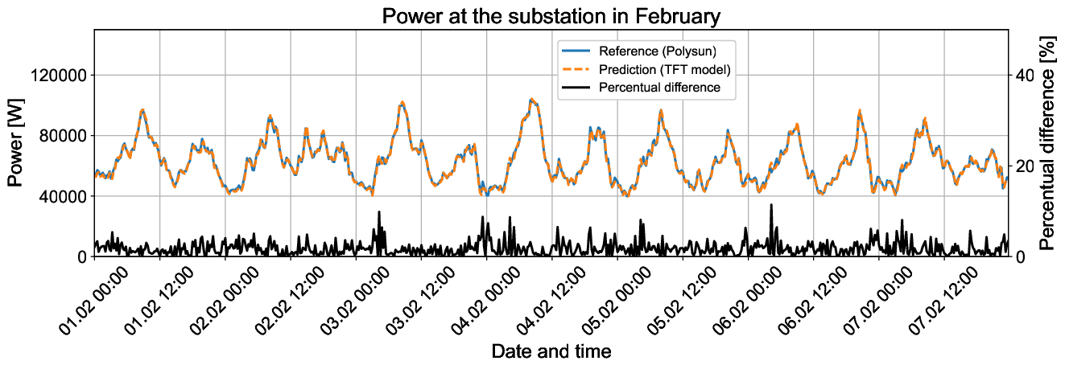
Figure 4: Comparison of the reference power profile at the substation and the TFT model prediction for the peak-shaving strategy applied to the system with DHW storage
Nevertheless, the overall agreement between prediction and reference remains high throughout the complete observation period. Figure 5 presents the corresponding prediction of the secondary return temperature. Compared to the thermal power profile, the return temperature varies considerably more smoothly due to the thermal inertia of the hydraulic system and the mixing processes inside the buffer storage. Consequently, the TFT almost completely reproduces the reference curve, indicating that the thermal dynamics are represented consistently.

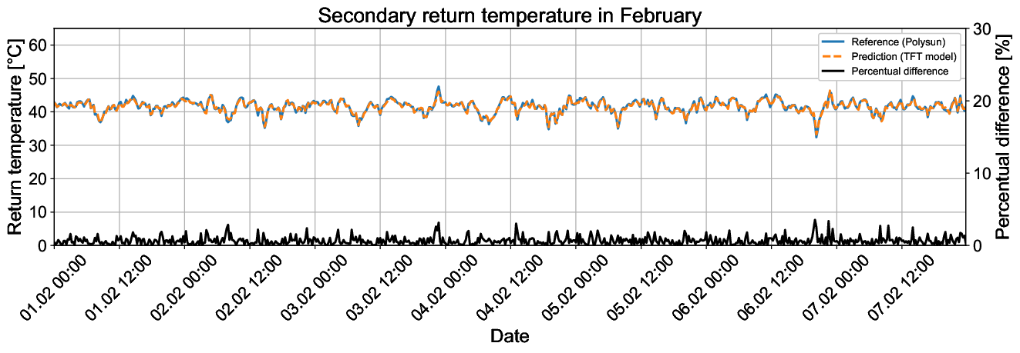
Figure 5: Comparison of the reference return temperature profile at the substation and the TFT model prediction for the peak-shaving strategy applied to the system with DHW storage
Table 2: Performance of the different TFT models for power and return temperature prediction, indicated by the average MAPE for the SH season
 |  | Peakshaving |  | Peakshifting
 |  | Power | Return temperature | Power | Return temperature
Test year 1  211/88 MWh | DHW tank | 2.1% | 0.7% | 6.2% | 1.0%
Test year 1  211/88 MWh | Central Freshwater | 2.8% | 0.9% | 8.0% | 1.1%
Test year 2  354/43 MWh | DHW tank | 3.8% | 0.9% | 9.1% | 1.9%
Test year 2  354/43 MWh | Central Freshwater | 3.3% | 1.0% | 3.3% | 1.0%
Test year 3  74/88 MWh | DHW tank | 2.6% | 0.9% | 10.3% | 1.1%
Test year 3  74/88 MWh | Central Freshwater | 4.0% | 0.9% | 4.0% | 1.1%

The quantitative prediction performance for all investigated hydraulic configurations and charging strategies is summarized in Table 2. For the peak-shaving strategy, the TFT achieves excellent prediction accuracy for all three test years. The MAPE of the thermal power prediction ranges from 2.1% to 4.0%, while the return temperature is predicted with errors between 0.7% and 1.0%. These low prediction errors demonstrate that the comparatively smooth operating behavior generated by the peak-shaving controller can be represented reliably by the neural network. Since the charging strategy suppresses abrupt charging events and distributes the charging process more evenly over time, the resulting temporal patterns are comparatively easy to learn. For the peak-shifting strategy, prediction errors increase, particularly for the thermal power. Depending on the hydraulic configuration and test year, the MAPE ranges between 3.3% and 10.3%. This behavior is expected because the peak-shifting controller intentionally introduces stronger temporal dynamics and steeper load gradients. During the charging windows, additional heat is supplied to the storage, while during the discharging windows the charging rate is intentionally reduced. These rapid changes create more complex temporal relationships, making the prediction task considerably more challenging than for the peak-shaving strategy. Despite these increased dynamics, the prediction accuracy remains sufficiently high for practical applications in DH network simulations and optimization environments. Even the highest observed MAPE of 10.3% occurs only for one individual test year, whereas the remaining results are substantially lower. Furthermore, no systematic prediction bias can be observed, indicating that the model generalizes well across different heat loads.
The return temperature prediction remains consistently accurate for all investigated scenarios. Across all hydraulic configurations, charging strategies and test years, the MAPE remains between 0.7% and 1.9%. The considerably lower prediction errors compared to the thermal power suggest that the thermal state of the hydraulic system evolves more continuously than the instantaneous thermal power. While the substation power is directly influenced by highly stochastic DHW consumption, the return temperature is dependent on the layering in the buffer and DHW tank and on the return from the heat distribution system.
The influence of the hydraulic configuration on the prediction accuracy is less pronounced than the influence of the charging strategy. For the first test year, the configuration with the DHW storage tank achieves slightly lower prediction errors than the centralized fresh water unit for both target variables. This behavior is plausible because the buffer tank dampens short-term load peaks before they reach the DH substation, resulting in smoother power and temperature profiles. In contrast, the centralized fresh water unit transfers load peaks, especially from SH, almost directly to the substation, producing steeper gradients and stronger short-term fluctuations. However, this tendency is not observed consistently for all three test years. While the prediction model for the DHW tank configuration performs better in some cases, the centralized fresh water unit achieves lower prediction errors for the peak-shifting strategy in test years 2 and 3. These results indicate that the prediction performance depends not only on the hydraulic configuration itself but also on the specific demand characteristics of the respective test year. Nevertheless, the prediction errors remain within a comparatively narrow range for both hydraulic concepts, demonstrating that the proposed TFT architecture is sufficiently robust to represent both building configurations.

- Discussion
The presented results demonstrate that the proposed charging strategies and prediction models are suitable for representing consumer-side flexibility of decentralized buffer storages while maintaining a sufficient high prediction accuracy. While the peak-shaving strategy primarily reduces short-term thermal power peaks, the peak-shifting strategy intentionally redistributes thermal loads to predefined periods of lower network utilization. Consequently, the appropriate strategy can be selected depending on the current operational requirements of the district heating network. The corresponding TFT surrogate model then provides the resulting substation power and return temperature profiles for the selected charging strategy, enabling its integration into network-level simulation and optimization. In particular, the TFT models accurately reproduce both the thermal power and the return temperature for the two hydraulic concepts and charging strategies, making them promising surrogate models for substation profiles. The computational effort of the TFT models is higher than that of simpler data-driven approaches investigated in previous work, the prediction of one simulation year requires approximately 80 s. This runtime is still well suited for automated simulations of large building portfolios and remains considerably more practical than detailed hydraulic simulations, which require individual model setup, manual handling of input and output data in the case of Polysun (Vela Solaris AG), and therefore cannot easily be integrated into large-scale DH network simulations. Compared to detailed simulation models, the proposed surrogate models offer a high degree of scalability. Once trained, they can be loaded directly into simulation environments with a Python interface and applied automatically to a large number of buildings. This makes them particularly attractive for DH operators, where aggregated building models are required for network-level analyses, flexibility assessments, and operational optimization in a digital-twin model. Combined with given statistical DHW demand estimation and heat demand forecasts, the developed models provide a computationally efficient representation of decentralized flexibility that can support future renewable DH operation.
Nevertheless, several limitations remain. First, the current models are trained for a fixed buffer storage size, limiting their direct applicability to buildings with similar storage capacities. Likewise, the training data cover a specific range of annual space-heating demands and SH-to-DHW demand ratios, so prediction accuracy outside this operating range cannot yet be guaranteed. Furthermore, circulation heat losses are currently represented implicitly by the training data and therefore remain fixed characteristics of the learned system. As a result, buildings with substantially different circulation losses would require a correction procedure. Including circulation losses as explicit input features could eliminate the need for this procedure. Overall, the results indicate that data-driven surrogate models constitute a promising compromise between physical accuracy and computational efficiency. While they cannot completely replace detailed hydraulic simulations, they enable the representation of storage-based flexibility for many buildings simultaneously and therefore provide an important prerequisite for future DH network simulation, optimization and operational control.

- Outlook
Future work will primarily focus on integrating the developed surrogate models into district heating network simulation and optimization tools in order to assess their applicability for network-level operational planning and flexibility management. Furthermore, the approach will be extended to additional hydraulic configurations commonly found in multi-unit residential buildings to broaden its applicability. The current models will also be generalized by treating currently fixed system characteristics, such as circulation losses, as learnable model features through an adapted system boundary. In addition, future work will investigate methods to account for varying buffer storage sizes and a wider range of building heat demands, enabling the prediction models to be applied to a broader spectrum of building types and operating conditions.

6. References
Chen, Y., Ye, Y., Liu, J., Zhang, L., Li, W., Mohtaram, S., 2023. Machine Learning Approach to Predict Building Thermal Load Considering Feature Variable Dimensions: An Office Building Case Study. Buildings 13 (2), 312.
Chollet, F.e.a., 2015. Keras. Google LLC.
Du, H., Zhou, X., Nord, N., Carden, Y., Cui, P., Ma, Z., 2025. Development of a robust data-driven surrogate model to improve energy flexibility of an integrated district heating system with a thermal storage system. Energy 336, 138398.
Forndran, S.J., Valentini, L.V., Thür, A., Streicher, W., 2026. Introduction of a thermal peak-shaving strategy for buffer storage utilization in multi-residential buildings and prediction of the dampened power profile by data driven models. Energy Conversion and Management: X 31, 102069.
Guo, Y., Wang, S., Wang, J., Zhang, T., Ma, Z., Jiang, S., 2024. Key district heating technologies for building energy flexibility: A review. Renewable and Sustainable Energy Reviews 189, 114017.
Hochreiter, S., Schmidhuber, J., 1997. Long short-term memory. Neural computation 9 (8), 1735–1780.
Hua, P., Wang, H., Xie, Z., Lahdelma, R., 2024. District heating load patterns and short-term forecasting for buildings and city level. Energy 289, 129866.
Jordan, U., Vajen, K., 2017. DHWcalc. University of Kassel, Institute for Thermal Energy Technology.
Karasu, M.B., Yanıkoğlu, İ., Aykut, A., Ay, D., Özpoyraz, İ., 2024. Thermal request optimization of a smart district heating system. Energy and Buildings 324, 114841.
Knudsen, B.R., Zotică, C., Rohde, D., Foslie, S.S., Walnum, H.T., 2025. Assessing demand response in district heating with waste-heat utilization. Sustainable Cities and Society 124, 106270.
Lim, B., Arık, S.Ö., Loeff, N., Pfister, T., 2021. Temporal Fusion Transformers for interpretable multi-horizon time series forecasting. International Journal of Forecasting 37 (4), 1748–1764.
Moser, S., Pflügl, M., Knöbl, M., Volkova, A., 2026. Peak load provision in district heating networks: a survey on the status quo and decarbonisation options. Energy 344, 140006.
Olsthoorn, D., Haghighat, F., Moreau, A., Lacroix, G., 2017. Abilities and limitations of thermal mass activation for thermal comfort, peak shifting and shaving: A review. Building and Environment 118, 113–127.
Valentini, L.V., Forndran, S., Ochs, F., Thür, A., Streicher, W., 2026. District heating modeling tools: A review based on design and simulation of renewable district heating networks. Energy Conversion and Management: X 29, 101414.
Vaswani, A., Shazeer, N., Parmar, N., Uszkoreit, J., Jones, L., Gomez, A.N., Kaiser, L., Polosukhin, I., 2017. Attention Is All You Need.
Vela Solaris AG. POLYSUN. Vela Solaris AG.

