INTERNAL STRUCTURE INVESTIGATION OF DISCONTINUOUS CFRTP USING X-RAY MICRO-CT METHODS

Y. Wan¹, and J. Takahashi¹

¹ Department of Systems Innovation, the University of Tokyo, Japan
Email: wan-yi@cfrtp.t.u-tokyo.ac.jp

Keywords: CFRTP, structure, X-ray micro-CT

Abstract
Discontinuous CFRTP are regarded as potential substitutes for metallic materials applied in mass-production fields (e.g. automotive manufacturing industry). However, the lack of comprehensive understanding of material properties is regarded as the main barriers obstructing the discontinuous CFRTP from industrial applications at present. In the present study, one MIL based X-ray micro-CT method (named 3D-BON) and one “voxel model” based X-ray micro-CT method (named VoxTex) is applied to investigate two discontinuous CFRTP with different fabricating processes. The advantages and disadvantages of the introduced two methods are revealed practically. The VoxTex show strong capability on multi-scale structure investigation, especially on discontinuous CFRTP with locally layered structure (randomly oriented strands). While the 3D-BON exhibit considerable real-structure reproducibility on discontinuous CFRTP especially in general SMC structure.

1. Introduction

Carbon fiber reinforced polymers (CFRP) are now generally regarded as the substitutes for metallic materials where high mechanical properties and light weight are required. Conventionally, epoxy and other thermoset resins were selected as the matrix material. In recent years, carbon fiber reinforced thermoplastics (CFRTP) have attracted attentions from both researchers and engineers and significant progress have been made in the relative developments. It is because compared to the traditional thermoset polymers, thermoplastics show superiorities on short cycle molding time and good in-plant recyclability as well as omitting the curing process. On the other hand, randomly oriented discontinuous carbon fiber reinforced polymers (DFRP) are the preferred composites for applications involving the mass-productions (e.g. automotive manufacturing industry) because the randomly oriented discontinuous fiber systems generally show achievability of high cycles molding and high capability of being manufactured in complex geometries without internal structural damage. Consequently, the combination of the thermoplastic polymers with the randomly oriented discontinuous carbon fibers is considered to mix their advantages, and the discontinuous carbon fiber reinforced thermoplastics (DCFRTP) are regarded as potential substitutes for metallic materials applied in mass-production of automotive parts.

To ensure the reliability and safety of DCFRTP in industrial applications, the material’s structure and properties must be comprehensively analyzed. X-ray micro-computed tomography (micro-CT) is a powerful non-destructive method for the characterization and visualization of the internal geometry in composite materials. DCFRTP generally have complex internal geometry due to strands distribution during fabricating, and X-ray micro-CT is considered to be an efficient method to provide higher accuracy in the characterization of fiber orientation distribution (FOD), fiber length distribution (FLD) and multi-scale geometry quantification. The X-ray micro-CT researches of fiber reinforced composite materials were mainly concentrated on the injection molding compound [1-6], laminates [7-9] and woven fabric composites [10-13]. The distributions of fiber morphologies were studied by Alemdar et al. [1]. Local average orientation distribution and visualized 3D orientation modeling of GF/PA6 injection materials were investigated by Bernasconi et al. [2] using the Mean Intercept Length (MIL) technique. Fiber orientation and effect of injection flow on injecting molded glass fiber reinforced nylon (GF/PA6) and carbon fiber reinforced polypropylene (CF/PP) were analyzed respectively [5, 6]. The orientation distribution together with local volume fraction of CF/Aluminum and CF/epoxy unidirectional laminates were investigated through 3D micro-CT method [7]. 2D laminated preform and random felt carbon-carbon composites were fabricated, and studied by Dietrich et al. focusing on distribution of the fibers, porosity and other internal geometries [8]. The porosity of CF/epoxy laminates were also studied and the X-ray micro-CT aided mechanical simulations were conducted by Tserpes et al. [9]. The internal geometries of carbon woven fabric [10] and woven textile CF/epoxy composites [11] were analyzed using a structural tensor based micro-CT method. The combination of the reconstructed 3D model of both short fiber composites and textile composites with the FE mesh generation and numerical analysis have been reported [4, 12]. However, none of the referenced studies considered the X-ray micro-CT analysis of DCFRTP.

In the present research, two different transversely isotropic DCFRTP were prepared in order to analyze the internal geometry properties of DCFRTP. Two different computed tomography (CT) methods were proposed to measure and quantify the internal geometry of DCFRTP after the X-ray images of the material were collected using X-ray scanner. One method is the general MIL based image binarization processing, which can simply separate the fibers from the matrix based on the gray value of the image. Another method based on the structure tensors generated from the CT structure based on the gray value distributions. After the meso-structures of DCFRTP were rebuilt by the two image processing methods, the fiber orientation distributions, the tape morphology and the 3D structure and orientation misalignment of DCFRTP were discussed in detail.

2. Materials and Processes

2.1. Materials

Two kinds of DCFRTP with different molding processes and structure features are introduced in this study (Fig. 1). Both of these two materials are considered to be the potential substrates for mass-production vehicles.

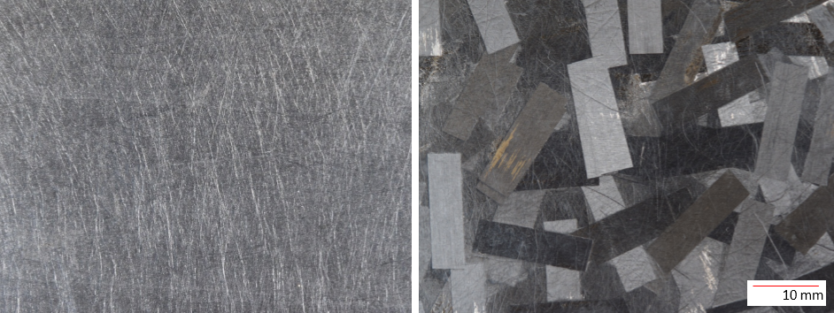
Figure. 1 Appearance of CPT (Left) and UT-CTT (right).
One material is CPT (carbon fiber paper reinforced thermoplastics), which is composed of PP (polypropylene) and CF papers (randomly oriented carbon fiber monofilaments). CPT is the typical mat structure composite that shows very good in-plane isotropy appearance, and is suitable for making complex shape parts. But the carbon fiber volume fraction () of CPT is restricted below 35% because the paper-like structure needs an enormous molding pressure to reach the required impregnation condition in high [14], hence this material is not appropriate for applications in main stressed parts of the vehicles.

The other material is UT-CTT (ultra-thin chopped carbon fiber tape reinforced thermoplastics), which is composed of randomly oriented ultra-thin unidirectional prepreg tapes that provided by the Industrial Technology Center of Fukui Prefecture. The tape is manufactured with carbon fiber (TR 50S, Mitsubishi Rayon Co., LTD.) and Polyamid-6 (PA6), and the thickness of this tape is relatively thin (40 μm to 50 μm) compare with the conventional one (about 100 μm or more), and that is the reason we called this tape materials as ‘UT (ultra-thin)’. The composites molded by this ultra-thin tape show superiorities in suppress microcracking, delamination and splitting damage for static, fatigue and impact loadings compare with the conventional tape [15]. The tape is cut into 18mm. Through random distribution and compression molding processes, the UT-CTT materials are made. This material shows good in-plane isotropy, and because the fibers were impregnated before material molding, the UT-CTT have good flowability and suitable for complex shape molding. Additionally, the of this material can reach over 50%, hence this material is presumed to be applied to the critical members of vehicle.

2.2. Processes

The materials are fabricated to plates with 2 mm thickness under heating and cooling compression molding. After the plates are made, the specimens for X-ray measurement are prepared. The 2*2*20 mm specimens were cut from the plates for this study. 3D X-ray scanner (TDM1000-II from Yamato Scientific Co., Ltd.) were used to collect the meso-structure image of DCFRTP. The specimens were fixed on a rotating stage, and the 3D X-ray images were collected during the rotation of the stage. The X-ray tube voltage was set to 40 kV and X-ray tube current was set to 40 μA for all the specimens. The reconstructed pixel size of the 3D micro-CT images is fixed to 4 μm, and the images in-plane-stacked were applied for image processing and calculations (Fig. 2).

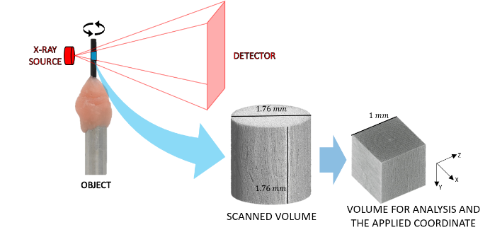
Figure. 2 Schematic of scanning process and scanned volume of the UT-CTT specimen on the rotation stage [16].

Two different CT image processing methods were adopted in the present study. The two methods were conducted through different software with different algorithm. One software named TRI/3D-BON (RATOC System Engineering Co., Ltd.), and the basic algorithm of this software based on the general MIL image binarization process. The in-plane and out-of-plane orientation distribution and visualized meso-structure model of DCFRTP were built by this software.

Another software named VoxTex, which is developed by the composite materials group (CMG) from the Department of Materials Engineering (MTM), KU Leuven [10, 11, 16]. The basic algorithm of this software based on the three-dimensional grey value structure tensor of the stacked X-ray images. In this software, the volume of interest (VOI) through thickness direction is set to 44 μm, which is the thickness of a single tape of UT-CTT. This procedure can provide more readable orientation information in the structure quantification and visualization. The specific meso-structural properties of DCFRTP, like the in- and out-of-plane fiber deviations, “splitting” and “sticking” of embedded fibers, and the fiber morphology, were collected by this software.

3. Results and discussions

After the X-ray scan of CPT and UT-CTT, the 3D models rebuilt by stacked images were generated (Fig. 3). As the origin data, this 3D model with gray value information of the images were put into the two different software to conduct different CT image processing methods.

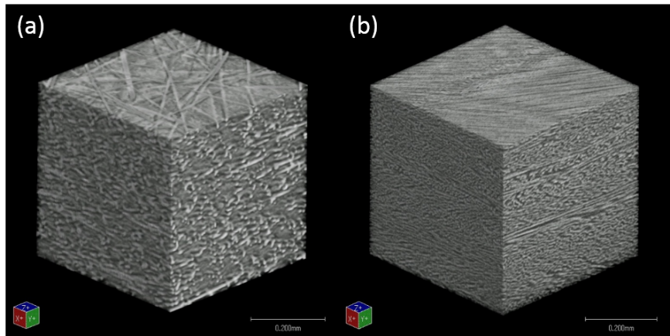
Figure. 3 rebuilted 3D models of CPT (a) and UT-CTT (b) [17].

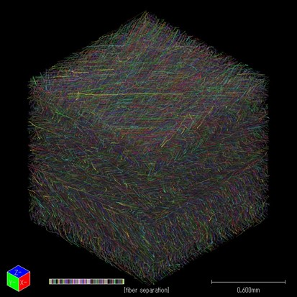
Figure. 4 3D model build by 3D-BON method under fiber level resolution.

The 3D-BON method first separated the fiber monofilaments from the X-ray images and rebuild 3D model under the resolution of single fibers (Fig. 4). In this figure, fiber monofilaments can be observed easily.

In the next step, the image binarization process was running for the calculation and modeling of both in-plane and out-of-plane orientation properties of the meso-structure. The 3D model with the in-plane orientation information and out-of-plane information of CPT and UT-CTT are illustrated in Fig. 5. Studying the figures, the in-plane orientation information of individual fibers can be clearly distinguished (Fig. 5 (a, b)). The CPT demonstrate the general paper structure fiber distribution that most fibers are in-plane randomly oriented, on the other hand, the UT-CTT show good aligned in-plane orientation through thickness direction, which is the orientation feature of randomly oriented strands that the structure have locally laminated property. Additionally, both in the CPT and UT-CTT, the out-of-plane orientation indicated that most of the fibers are lie down in the in-plane direction, but there are still some fibers oriented through out-of-plane direction show blue and yellow colors in Fig. 5 (c, d and e).

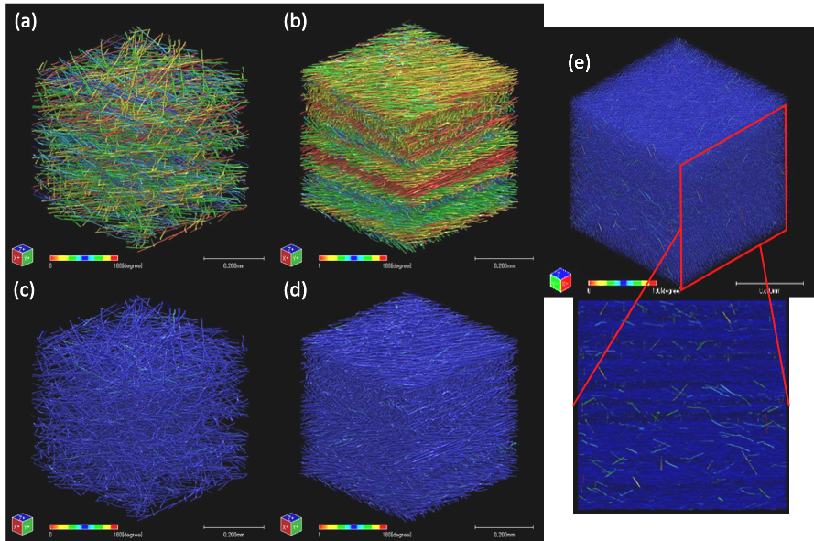
Figure. 5 In-plane fiber orientation of CPT (a) and UT-CTT (b); out-of-plane fiber orientation of CPT (c) and UT-CTT (d, e).

In addition, because of the monofilament-separated modeling process in 3D-BON, the fiber-level detailed micro structure model of composites is possible to be generated. By exporting the 3D model, the CAD (computer-aided design) model of the corresponding composite can be generated combined with the mesh cutting process, which provide a possibility for a new approach of real-structure FEM analysis based on X-ray micro-CT (Fig. 6).

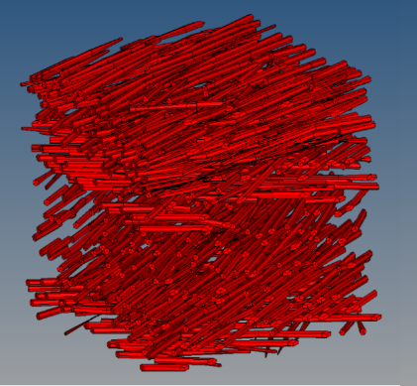
Figure. 6 CAD model sample of CTT acquired from 3D-BON.

The first method, 3D-BON show some advantage on realisticity and fiber-level structure visualization as well as 3D modeling extension, but it is difficult to distinguish the multi-scale orientation and the multi-scale structure morphology. On the other hand, the VoxTex method show different results.

The in-plane orientation distribution models of CPT and UT-CTT was also built by VoxTex. Because the out-of-plane thickness of the VOI is defined to 44 μm in this study, which is much larger than the fiber diameter. So the fiber monofilament cannot be observed in this model. The 3D model and the extracted in- / out-of-plane orientation of both CPT and UT-CTT through thickness direction are illustrated in Fig. 7.

For the UT-CTT results, the 3D model show layered structure (Fig. 7 (right)). The in-plane orientation distribution of tapes through thickness direction in this study reveal the characteristics of tape orientation and tape morphology in UT-CTT. Siginificant orientation concerntrations through thickness direction are observed in the in-plane orientation distribution (Fig. 7 (a)), which indicate the oritation of tapes embedded in the material. also the out-of-plane orientation distribution is closely concertrated in the 90 degree area which indicat that the tapes are mostly in-plane distributed. On the other hand, the 3D model of CPT is more randomly distribution. Also the in-plane orientation show chaos distribution and cannot display the advantage of VOI definition which can give better multi-scale visurlazation. The out-of-plane orientation of CPT is also more discreted than UT-CTT.

This result indicate that the VoxTex method can provide more information in multi-scale structure visulazation of randomly orientetd strands. But it is not a good choice for general paper/mat based DCFRTP because it averaged the fiber level orientation information.

Becaseu the VoxTex show superiotly on UT-CTT, further study have been done. Fig. 8 illustrated the in-plane orientation of the tapes, the tape concentration and tape clusters were selected and the corresponding 3D models of these regions were built. The 3D models exhibit tapes’ morphology after compression molding. Also the tapes in some area were stacked together and observed by the models. This result indicate that VoxTex can provide detailed multi-scale properties of randomly oriented strands on both the visulazation and quantification aspects.

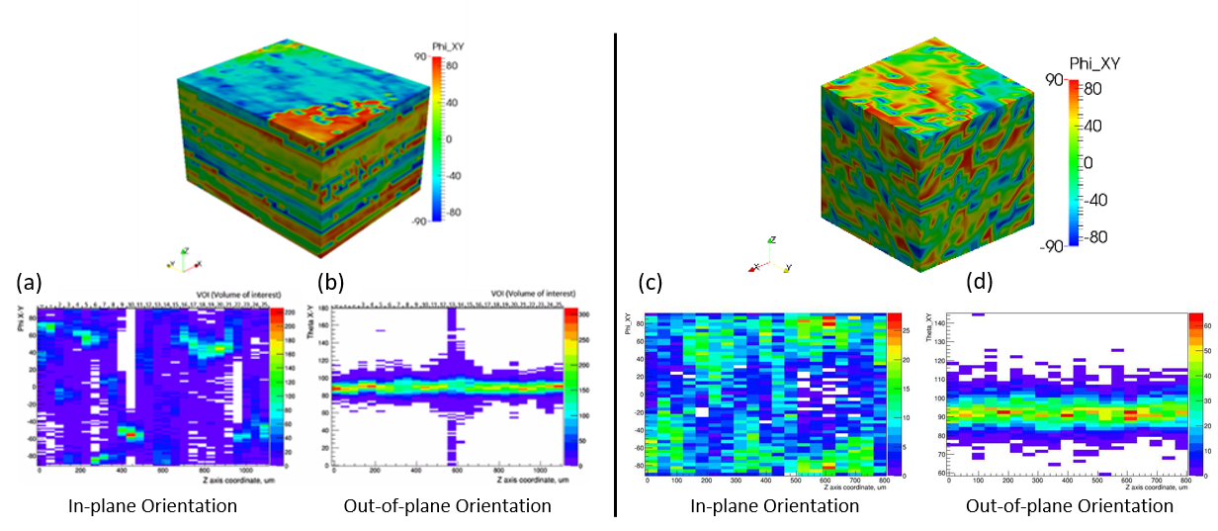
Figure. 7 3D models with visualized in-plane fiber orientation distribution and unfolded histograms of in-plane (a, c) and out-of-plane (b, d) orientation distribution of UT-CTT (left) and CPT (rigth).

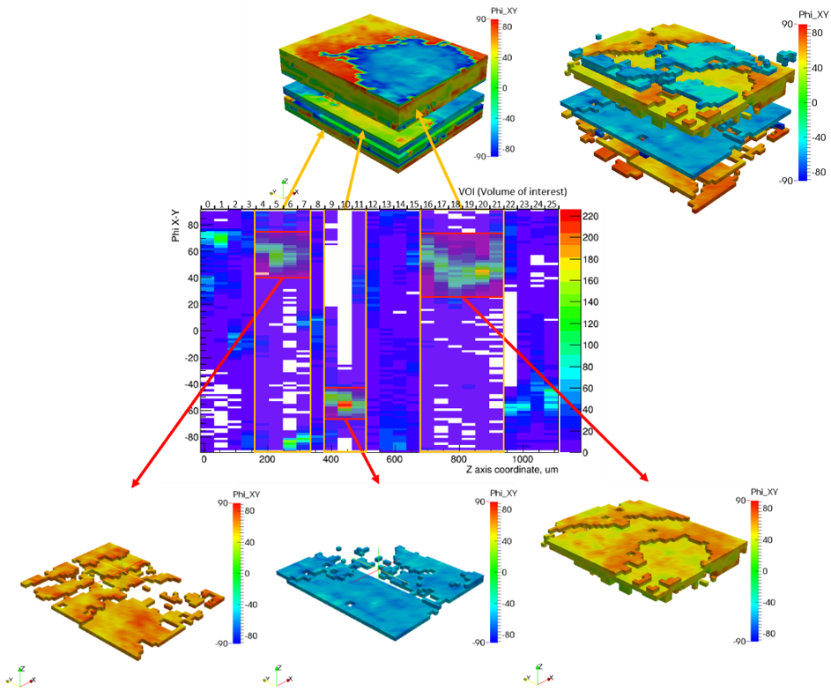
Figure. 8 In-plane orientation distribution of tapes in UT-CTT and the corresponding tape clusters 3D models [18].

4. Conclusions

In this study, two different X-ray CT methods were proposed to measure and quantify the meso-structure properties of CPT and UT-CTT. The results indicated that the 3D-BON method can provide considerable high resolution orientation visualization (fiber monofilament level) and fiber orientation information. On the other hand, the VoxTex method show advantage in the quantification and visualization of two-scale fiber orientation distributions (orientation of the tapes and of the fibers inside the tapes), the tape morphology and the 3D structure and orientation misalignment of UT-CTT.

Both the proposed two X-ray CT methods were considered can provide important input data in the further mechanical simulation of DCFRTP. But the 3D-BON show advantage on real-structrue visulazation and modeling when the fibers are randomly/individually distribut, which the VoxTex cannot achieve. Also the VoxTex can rebuilt the tape morphology after molding of UT-CTT and isolate each tape and orientation concertration part in the multi-sacle randomly oriented strand, which the 3D-BON is not promising. Consequently, selection of different method for internal geometry analysis of DCFRTP shouled take the purpose and object material into consideration.

Acknowledgments

Japan Society for the Promotion of Science, Grant-in-Aid for JSPS Research Fellow Grant Number JP15J09248 support parts of this study.

Part of this study was conducted as Japanese METI project "the Future Pioneering Projects / Innovative Structural Materials Project" since 2013 financial year. Authors would like to express sincerely appreciation to the project members who have provided valuable information and useful discussions.

References

[1] A. Alemdar, H. Zhang, M. Sain, G. Cescutti, J. Mussig. Determination of fiber size distributions of injection moulded polypropylene/natural fibers using X-ray microtomography. Adv Eng Mater. 2008;10(1-2):126-130.
[2] A. Bernasconi, F. Cosmi, D. Dreossi. Local anisotropy analysis of injection moulded fibre reinforced polymer composites. Compos Sci Technol. 2008;68(12):2574-2581.
[3] A. Bernasconi, F. Cosmi, P. J. Hine. Analysis of fibre orientation distribution in short fibre reinforced polymers: A comparison between optical and tomographic methods. Compos Sci Technol. 2012;72(16):2002-2008.
[4] Y. Abdin, S. V. Lomov, A. Jain, G. H. Van Lenthe, I. Verpoest. Geometrical characterization and micro-structural modeling of short steel fiber composites. Compos Part a-Appl S. 2014;67:171-180.
[5] Thanh Binh Nguyen Thi, Mizuki Morioka, Atsushi Yokoyama, Senji Hamanaka, Katsuhisa Yamashita, Chisato Nonomura. Measurement of fiber orientation distribution in injection-molded short-glass-fiber composites using X-ray computed tomography. J Mater Process Tech. 2015;219:1-9.
[6] Xianjun Sun, John Lasecki, Danielle Zeng, Yuan Gan, Xuming Su, Jie Tao. Measurement and quantitative analysis of fiber orientation distribution in long fiber reinforced part by injection molding. Polymer Testing. 2015;42:168-174.
[7] Guillermo Requena, Georg Fiedler, Bernhard Seiser, Peter Degischer, Marco Di Michiel, Thomas Buslaps. 3D-Quantification of the distribution of continuous fibres in unidirectionally reinforced composites. Composites Part A: Applied Science and Manufacturing. 2009;40(2):152-163.
[8] S. Dietrich, J. M. Gebert, G. Stasiuk, A. Wanner, K. A. Weidenmann, O. Deutschmann, I. Tsukrov, R. Piat. Microstructure characterization of CVI-densified carbon/carbon composites with various fiber distributions. Compos Sci Technol. 2012;72(15):1892-1900.
[9] K. I. Tserpes, A. G. Stamopoulos, Sp G. Pantelakis. A numerical methodology for simulating the mechanical behavior of CFRP laminates containing pores using X-ray computed tomography data. Composites Part B: Engineering. 2016;102:122-133.
[10] M. Barburski, I. Straumit, X. W. Zhang, M. Weyers, S. V. Lomov. Micro-CT analysis of internal structure of sheared textile composite reinforcement. Compos Part a-Appl S. 2015;73:45-54.
[11] Ilya Straumit, Stepan V. Lomov, Martine Wevers. Quantification of the internal structure and automatic generation of voxel models of textile composites from X-ray computed tomography data. Composites Part A: Applied Science and Manufacturing. 2015;69:150-158.
[12] N. Naouar, E. Vidal-Salle, J. Schneider, E. Maire, P. Boisse. 3D composite reinforcement meso F.E. analyses based on X-ray computed tomography. Compos Struct. 2015;132:1094-1104.
[13] Garrett W. Melenka, Eric Lepp, Benjamin K. O. Cheung, Jason P. Carey. Micro-computed tomography analysis of tubular braided composites. Compos Struct. 2015;131:384-396.
[14] Y. R. Kim, S. P. Mccarthy, J. P. Fanucci. Compressibility And Relaxation Of Fiber Reinforcements during Composite Processing. Polym Composite. 1991;12(1):13-19.
[15] S. Sihn, R. Y. Kim, K. Kawabe, S. W. Tsai. Experimental studies of thin-ply laminated composites. Compos Sci Technol. 2007;67(6):996-1008.
[16] Yi Wan, Ilya Straumit, Jun Takahashi, Stepan V. Lomov. Micro-CT analysis of internal geometry of chopped carbon fiber tapes reinforced thermoplastics. Composites Part A: Applied Science and Manufacturing. 2016;91, Part 1:211-221.
[17] D Leblanc, Benoit Landry, M Jancik, Pascal Hubert. Recyclability of randomly-oriented strand thermoplastic composites. the 20th International Conference on Composite Materials. Copenhagen, Denmark2015. p. 3409-1.
[18] Yi Wan, Jun Takahashi. Meso-structural quantification and visualization of ROS of thermoplastic composites. 8th Japan Conference on Composite Materials. Tokyo, Japan2017.

