mechanical performance of composite materials developed using novel re-entrant star auxetic fibrous architectures

Rui Magalhães¹, Sohel Rana², Raul Fangueiro³, Clara Gonçalves⁴, Pedro Nunes⁵ and Gustavo Dias⁶

¹Fibrous Materials Research Group, Centre for Textile Science and Technology (2C2T), University of Minho, Campus de Azurém 4800-058 Guimarães, Portugal
Email: ruimagalhaes@fibrenamics.com, Web Page: http://www.fibrenamics.com
² Fibrous Materials Research Group, Centre for Textile Science and Technology (2C2T), University of Minho, Campus de Azurém 4800-058 Guimarães, Portugal
Email: soheliitd2005@gmail.com, Web Page: http://www.fibrenamics.com
³ Department of Civil Engineering, University of Minho, Campus de Azurém 4800-058 Guimarães, Portugal
Email: rfangueiro@dem.uminho.pt, Web Page: http://www.fibrenamics.com
⁴ Institute for Polymers and Composites (IPC), University of Minho, Campus de Azurém 4800-058 Guimarães, Portugal
Email: a68476@alunos.uminho.pt
⁵ Institute for Polymers and Composites (IPC), University of Minho, Campus de Azurém 4800-058 Guimarães, Portugal
Email: d1078@dep.uminho.pt
⁶ Institute for Polymers and Composites (IPC), University of Minho, Campus de Azurém 4800-058 Guimarães, Portugal
Email: grdias@dep.uminho.pt

Keywords: Auxetic fibrous structures, auxetic composites, Poisson’s ratio, energy absorption, mechanical performance

Abstract

In this research, novel high performance auxetic fabric structures (and composites) were produced using the flat knitting technology and their auxetic and tensile behaviors were characterized. The fabrics were produced using two types of high performance fibres (para-aramid and polyamide) and by varying the structural and process parameters. Subsequently, the produced fabrics were impregnated with an epoxy resin using the vacuum infusion technique to produce composite materials. It was observed that all fabrics and composites produced based on the re-entrant star design were auxetic in nature, though the negative Poisson ratio (NPR) was much higher in case of the auxetic fabrics than the composites. The maximum NPR obtained in the wale and course directions for fabrics and composites were -0.5 and -0.32, and -0.17 and -0.20, respectively. Overall, all auxetic fabrics and composites showed a superior strength and energy absorption capability as compared to their non-auxetic counterparts, except the polyamide auxetic composites, which showed a lower strength than the non-auxetic composites.

1. Introduction

Auxetic materials are a special class of materials having negative Poisson’s ratio (NPR), i.e. the stretching of these materials in the longitudinal direction results in widening in the transverse direction. This type of materials are becoming very attractive to the scientific community due to their interesting properties such as enhanced strength, better acoustic behavior, improved fracture toughness, superior energy absorption, damping improvement and indentation resistance [1]. Nowadays, there exists an increasing demand in the personal protection and defense area for the materials possessing high strength-to-weight ratio, high energy absorption capability, high impact and indentation resistance and so on. To achieve these requirements, advanced auxetic fibrous and textile structures are being considered as the potential materials. Currently, the personal protection materials are fabricated in 2D sheet materials, like woven fabrics or unidirectional sheets using ultra-high performance fibres [2]. The previous research work by the authors demonstrated that the high performance fibres like Kevlar can be knitted into auxetic textile structures and the composites produced using these textiles showed a superior impact resistance [3]. In the present study, a new type of auxetic design, namely re-entrant star, was employed to develop high performance auxetic textiles and the auxetic as well as mechanical performance of the composites produced from them have been thoroughly investigated.

2. Experimental Work

2.1 Production of Auxetic Fibrous Structures
Different type of fabric structures were produced based on the re-entrant star design by varying the material type, fabric structural (loop length) and process parameters (take down load). A flatbed knitting machine (Figure 1) was used to produce these structures using two types of high performance fibres (polyamide HT and para-aramid HT) using a needle gauge of 10 needles/inch.

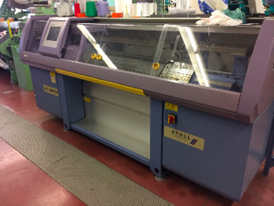
Figure 1. Flatbed knitting machine (Stoll, model CMS 320 TC)

In order to compare the behavior of these auxetic structures with non-auxetic ones, jersey plain knitted fabrics were also produced using the same parameters as used for the auxetic fabrics. The parameters used to produce the plain and auxetic fabrics are listed in Table 1 and their pictures are provided in Figure 2. The loop length and take down load were varied in case of polyamide based auxetic fabrics (see Table 2), in order to see the effect of these parameters on the auxetic as well as mechanical properties.

Table 1. Parameters used to produce plain jersey and auxetic knitted fabrics
Parameters | Plain knit | Auxetic Structure 1 | Auxetic Structure 2
Material | Polyamide HT | Polyamide HT | Para-aramid HT
Linear density (tex) | 97 | 97 | 172
No. of yarns | 1 | 1 | 1
Loop length* | 11 | 11 | 11
Take down load* | 8 | 8 | 8
* in machine unit

Table 2. Variation of parameters in case of polyamide based auxetic fabrics
Sample name | Auxetic Structure 1.1 | Auxetic Structure 1.2 | Auxetic Structure 1.3 | Auxetic Structure 1.4
Linear density (tex) | 97 | 97 | 97 | 97
No. of yarns | 1 | 1 | 1 | 1
Loop length* | 12 | 10 | 11 | 11
Take down load* | 8 | 8 | 9 | 7
* in machine unit

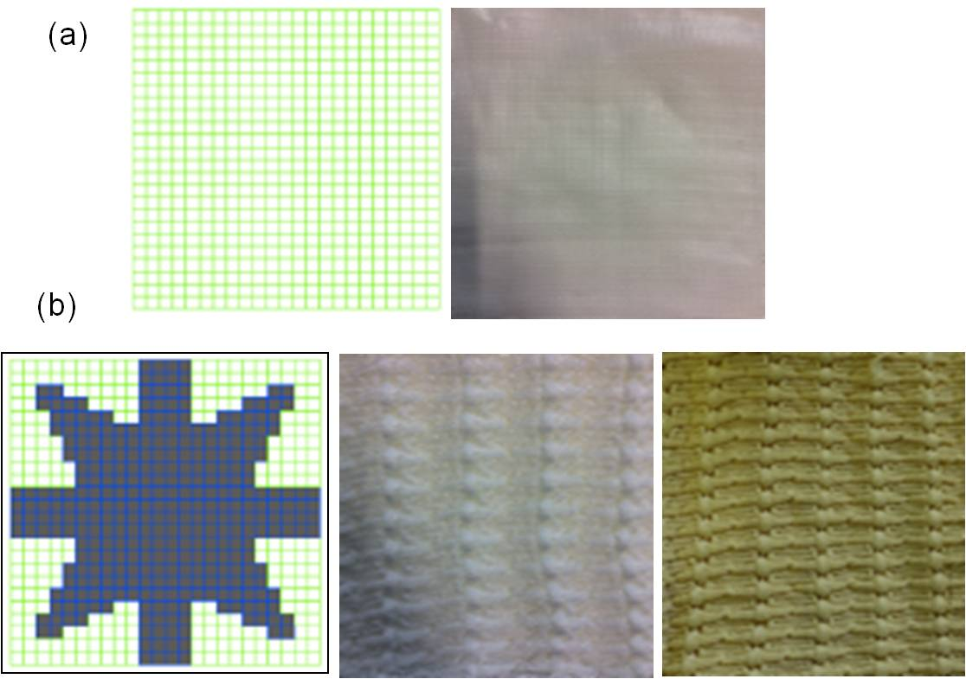

Figure 2. Schematic design and fabrics produced using plain knit (a) and re-entrant star designs (b)

2.2 Production of Composites using Auxetic Fibrous Structures

The produced fabric structures were subsequently impregnated with an epoxy resin (Biresin® CR83) using the vacuum infusion technique. Table 3 lists the produced composite specimens. In all specimens, one layer of fabric was used and the average resin weight was ~50%.

Table 3. Details of Composite Specimens
Name | Material | Fabrics used
Plain Composite | Polyamide HT | Plain knit
Composite Auxetic 1 | Polyamide HT | Auxetic Structure 1
Composite Auxetic 2 | Para-aramid HT | Auxetic Structure 2

2.3 Characterization of Physical, Auxetic and Mechanical properties

The thicknesses of the fabrics produced was measured using NP EN ISO 5084:1999 Textiles (Determination of the thickness of textile and textile products) standard. Mass per unit area of the fabrics, i.e. the areal density was calculated from the mass of a given area of the fabric divided by the same area, according to Eq. (1). The area of the fabrics was measured through image analysis using Image J software.

$M=\frac{m}{A}$ (1)

Where:
M – mass per unit area (g/m²);
A – area of the sample (m²);
m - mass of the sample (g)

The tensile characteristics of the developed textile fabrics was carried out according to the methodology described in ISO 13934-2 Textiles (Tensile properties of fabrics – Part 2 Determination of maximum force using the grab method) standard. The equipment used was a universal testing machine, Hounsfield H 100 KS with a load cell of 10 kN. The mechanical properties of the developed composites were characterized using ASTM D3039/D 3039M-00 standard (Standard Test Method for Tensile Properties of Polymer Matrix Composite Materials) using the same machine, but with a different clamp. The testing setup for tensile testing of fabrics and composites is shown in Figure 3.

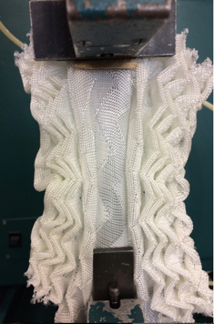 | 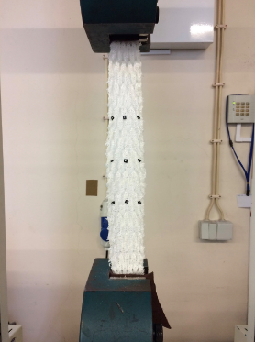
(a) | (b)
Figure 3. Tensile testing setup of: (a) fabric structures and (b) composite materials

Poisson’s ratio of the materials was measured from the longitudinal and transverse strains, which were measured using the digital image correlation (DIC) method. The measurement setup was fixed to the tensile testing machine (see Figure 4) in which the structures were vertically attached to the jaws of the machine in order to measure their displacements in both directions. The recording was preformed with 3840x2160 pixels with a frame rate of 24 images/second. The fabrics and composites were tested for Poisson’s ratio in both wale and course directions (i.e longitudinal and transverse directions, respectively).

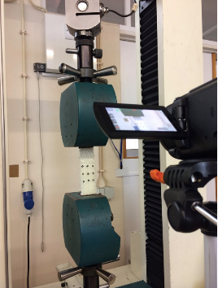 | 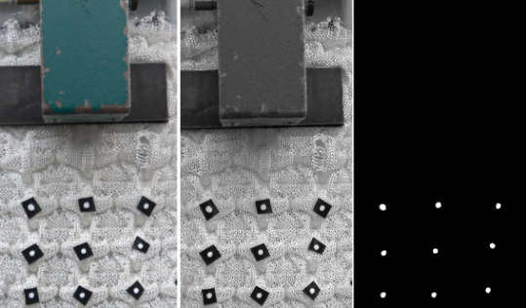
a) | b)
Figure 4. Poisson’s ratio measurement: (a) setup of testing and (b) image processing steps

The longitudinal and transverse strains in the samples were calculated using the following equations:
$$ℇ_{x}=\frac{x_{n}-x_{0}}{x_{0}}$$ | (2)
$$ℇ_{y}=\frac{y_{n}-y_{0}}{y_{0}}$$ | (3)
Where:
$ℇ_{x}$ – Strain in xx direction,
$ℇ_{y}$ – Strain in yy direction,
$x_{n}$ – Displacement between the points marked at each frame in xx direction,
$y_{n}$ – Displacement between the points marked at each frame in xx direction,
$x_{0}$ – Displacement between the points marked at the first frame in xx direction,
$y_{0}$ – Displacement between the points marked at the first frame in yy direction.

4. Experimental results and discussion

The results of thickness, areal density and NPR measurement of the produced fabrics and composites are listed in Table 4. It can be observed from Table 4 that the auxetic fabrics exhibited significantly higher thickness and areal density as compared to the plain knit fabrics produced using the same parameters. The same trend was also observed for the composites, i.e. the composites produced with the auxetic fabrics had much higher thickness and areal density as compared to those produced using the plain knitted fabrics. This was attributed to the different arrangement of the knitted loops in the auxetic fabrics, which increased the thickness and mass per unit area of the fabrics and reinforced composites. The fabrics with Para-aramid yarns exhibited higher thickness and areal density as compared to the polyamide fabrics mainly due to the higher linear density of Para-aramid fibres. The composites produced with Para-aramid fabrics also had a higher areal density as compared to the polyamide composites. However, the auxetic fabrics produced with polyamide yarns but with different loop lengths and take down loads (Auxetic structure 1.1, 1.2, 1.3 and 1.4) exhibited similar thickness and areal density indicating that these structural and processing parameters did not have much influence on the thickness and weight of the fabrics.

Table 4. Thickness, areal density and NPR of produced fabrics and composites
Material | Thickness (mm) | Areal density (g/m²) | Maximum NPR
Material | Thickness (mm) | Areal density (g/m²) | Wale | Course
Plain Knit Fabric | 0.88 (2)* | 245.6 (3) | - | -
Auxetic Structure 1 | 10.48 (5) | 895.8 (2) | -0.47 | -0.32
Auxetic Structure 1.1 | 11.07 (5) | - | -0.30 | -0.10
Auxetic Structure 1.2 | 10.25 (5) | - | -0.50 | -0.31
Auxetic Structure 1.3 | 11.46 (5) | - | 0.40 | -0.16
Auxetic Structure 1.4 | 11.55 (5) | - | -0.17 | -0.08
Auxetic Structure 2 | 13.90 (4) | 1453.7(7) | -0.08 | -0.29
Plain Composite | 1.57 (12) | 404.1 (5) | - | -
Auxetic Composite 1 | 14.20 (6) | 1380.4 (11) | -0.17 | -0.05
Auxetic Composite 2 | 13.25 (7) | 1976.6 (8) | -0.10 | -0.20
* the figures within the brackets are the CV% of the results.

It can be noticed from Table 4 that all fabrics and composites produced using the auxetic designs exhibited NPR whose value, however, was strongly dependant on the type of structure (i.e., fabric or composite), type of yarns as well as structural and process parameters. Overall, the auxetic composites showed a lower NPR as compared to the auxetic fabrics. This is obvious as the structural movement and rearrangement became more restricted in the composites due to the stiffer epoxy matrix, reducing the lateral expansion of the samples. It is also noteworthy that the NPR values in the course and wale direction of the fabrics or composites were different. The structures or composites with polyamide yarns showed higher NPR in the wale direction, whereas the opposite was the case for the structures/composites with Para-aramid yarns. Further, the fabrics or composites with Para-aramid yarns showed significantly lower NPR as compared to those produced with polyamide yarns. This could be due to the higher flexibility of the polyamide yarns, which resulted in better structural movement/rearrangement under tensile loading leading to superior auxetic behaviour.

The mechanical properties of produced fabric structures and composites are listed in Table 5 and 6. It is clear from Table 5 that the auxetic fabrics exhibited significantly higher strength, extension as well as energy absorption as compared to the plain knitted fabrics. This indicates the positive influence of the auxetic design in improving the performance of fabric structures. The auxetic composites produced with polyamide yarns (i.e, auxetic composite 1), however, provided a lower strength as compared to the plain fabric composites. Nevertheless, their elongation and energy absorption were higher as compared to the plain composites. On the contrary, the composites with Para-aramid yarns showed a higher strength as well as energy absorption as compared to plain as well as polyamide based auxetic composites (except, the elongation and energy absorption were lower in the course direction). Therefore, the auxetic fabrics showed a completely different behaviour when they were combined with the polymeric matrix. Although the auxetic fabrics with polyamide yarns performed better as compared to the plain knitted fabrics, their composites showed significantly lower strengths. On the other hand, the Para-aramid auxetic fabrics showed a similar strength as the polyamide auxetic fabrics, but their composites showed a remarkably higher strength and lower elongation as compared to both polyamide auxetic and plain knitted composites. Hence, the matrix material played a major role in deciding the mechanical properties of the developed auxetic composites.

Table 5. Mechanical properties of the produced fibrous structures
Material | Maximum Force (N) | Elongation at Maximum Force (mm) | Energy absorption (kN.mm)
Plain Knit Fabric | 1304.0 (6) | 104.7 (8) | 30.3 (22)
Auxetic Structure 1 | 1465.5 (10) | 177.4 (7) | 41.9 (14)
Auxetic Structure 2 | 1610.0 (10) | 234.0 (2) | 68.0 (17)
. * the figures within the brackets are the CV% of the results.

Table 6. Mechanical properties of the produced auxetic composites
Material | Direction | Maximum Force (N) | Elongation at Maximum Force (mm) | Energy absorption (kN.mm)
Plain Composite | Wale | 1337.7 (6) | 113.7 (6) | 56.3 (11)
Plain Composite | Course | 750.7 (6) | 222.5 (4) | 68.3 (9)
Auxetic Composite 1 | Wale | 777.5 (15) | 238.5 (9) | 69.3 (16)
Auxetic Composite 1 | Course | 699.2 (8) | 279.0 (5) | 80.7 (6)
Auxetic Composite 2 | Wale | 2488.6 (5) | 88.2 (7) | 119.6 (12)
Auxetic Composite 2 | Course | 2681.5 (8) | 48.6 (19) | 59.1 (23)
* the figures within the brackets are the CV% of the results.

5. Conclusions

In the present research, novel auxetic textile structures and composites were developed based on the re-entrant star design using the flat knitting technology. Two types of high performance fibres, namely polyamide and Para-aramid, were used to produce different types of auxetic structures by varying material type, loop length and take down load, and the selected fabric structures were impregnated with an epoxy resin to produce composite materials. It was observed that all produced fabrics based on the re-entrant design were auxetic in nature, exhibiting a maximum NPR of -0.5 in the wale direction and -0.32 in the course direction. The produced composites also exhibited NPR which was, however; significantly lower as compared to the fabric structures. All auxetic fabrics showed higher thickness, higher areal density as well as higher strength, extension as well as energy absorption capability as compared to the plain knitted fabrics. However, only the auxetic composites produced with Para-aramid fibres possessed a superior strength and energy absorption capability. Although the polyamide auxetic composites showed a higher extension and energy absorption as compared to plan auxetic composites, their strength reduced significantly. Further studies are underway to understand properly the influence of the polymeric matrix on the auxetic as well as mechanical behaviour of the composites. The developed composites will also be tested for their impact resistance to verify their application potential in the defense sector.

Acknowledgments

This work was funded by the Operational Program of Competitiveness and Internationalization (POCI), Lisbon Operational Program, with support from the European Regional Development Fund (FEDER), and the Foundation for Science and Technology I. P, with support from the State Budget – OE, under project nº. 016893, entitle “Development of Auxetic Fibrous Composite for Personal Protection (POCI-01-0145-FEDER-016893 and PTDC/CTM-POL/5814/2014).

References

[1] Rana, S.; Fangueiro, R. Advanced Fibrous Composite Materials for Ballistic Protection. Woodhead Publishing, 2016.
[2] Chen, X. Advanced Fibrous Composite Materials for Ballistic Protection. Woodhead Publishing, 2016.
[3] Steffens, F.; Rana, S.; Fangueiro, R.. Development of novel auxetic textile structures using high performance fibres. Materials & Design, September 81-89 2016.

