EuroSun2026
MEASUREMENT SYSTEM DESIGN FOR THE EXPERIMENTAL EVALUATION OF HIGH-VACUUM MULTILAYER INSULATION IN MID-TEMPERATURE APPLICATIONS
Fabio Capolupo^{1,2} (corresponding author), Rossana Riccardi¹, Annalisa Di Napoli^{1,2}, Mara Pesapane^{1,2}, Alessandro Vitaliano Anacreonte^{1,2}, Carmine D’Alessandro³, Benedetta Catalano^{2,4}, Antonio Caldarelli⁵, Eliana Gaudino^{1,2}, Emiliano Di Gennaro^{2,4}, Marilena Musto^{1,2} and Roberto Russo²
¹ Industrial Engineering Department, University of Napoli “Federico II”, Piazzale Vincenzo Tecchio, 80, Napoli, 80125, Italy
² Institute of Applied Sciences and Intelligent Systems, National Research Council of Italy, via Pietro Castellino 111, Napoli, 80131, Italy
³ TVPSOLAR SA, 10 rue du Prè-de-la-Fontaine, 1242 Satigny, Geneva, Switzerland
⁴ Physics Department, University of Napoli “Federico II”, Via Cinthia, 21, Napoli, 80126, Italy
⁵ CNR-SPIN Napoli, c/o Complesso Universitario di Monte Sant’Angelo – Via Cinthia, 21 – Building 6, 80126, Napoli, Italy
fabio.capolupo@unina.it; rossanariccardi.1999@gmail.com; annalisa.dinapoli@na.isasi.cnr.it; mara.pesapane@na.isasi.cnr.it; vitalianoalessandro.anacreonte@unina.it; benedetta.catalano@na.isasi.cnr.it; antonio.caldarelli@na.isasi.cnr.it; eliana.gaudino@na.isasi.cnr.it; dalessandro@tvpsolar.com; emiliano.digennaro@unina.it; marilena.musto@unina.it; roberto.russo@na.isasi.cnr.it
Summary
Thermal insulation plays a critical role in improving the efficiency of solar thermal systems by reducing heat losses, particularly in heat transfer fluid pipelines and thermal energy storage applications. High-Vacuum Multilayer Insulation (HVMLI) has demonstrated promising performance due to its ability to minimize heat transfer in the mid-temperature range up to 250 °C. This work identifies the most relevant design parameters through thermal and mechanical analyses and subsequently evaluates the proposed HVMLI configurations experimentally between 100 °C and 250 °C. The proposed apparatus consists of an annular high-vacuum gap containing the HVMLI between two concentric stainless-steel tubes. Experimental tests, based on the Guarded Hot Pipe approach to minimize axial heat losses, were conducted on two HVMLI configurations employing one and ten aluminium layers. Both samples exhibited lower thermal losses than conventional rockwool insulation. While the experimental results confirmed the improved performance of the multilayer configuration, discrepancies with analytical predictions suggest the need for further investigation of unpredicted heat transfer mechanisms.
Keywords: High Vacuum, Multilayer Insulation, Guarded Hot Pipe, Measurement System
Field of application for the findings: Solar thermal fields, Thermal energy storage and distribution
Addressed audience: Researchers, engineers, and industry professionals in solar thermal energy
- Introduction
The concept of thermal insulation is fundamental for limiting heat transfer within a system and plays a central role in current strategies for energy transport and conservation. Enhancing insulation performance substantially decreases energy consumption, thereby supporting global efforts to mitigate climate change.
Global energy consumption is primarily distributed among four main sectors: industry, buildings, transportation, and agriculture. In all these sectors, fluid distribution pipelines are often characterized by non-optimized thermal performance (Lund and Mohammadi, 2016).
The large temperature difference between the Heat Transfer Fluid (HTF), typically operating between 100 °C and 250 °C, and the surrounding environment leads to significant thermal losses. Consequently, the HTF temperature decreases along the pipeline, negatively affecting the overall efficiency of the system. Effective pipe insulation is therefore essential to maintain a constant HTF temperature throughout the distribution network and minimize heat losses (Ucar and Balo, 2009).
When expressed in cylindrical coordinates, Fourier’s law describes radial heat transfer from the inner pipe wall to the outer surface of the insulator exposed to the surrounding environment. The heat flux is reduced by covering the outer surface of the carrier pipe with an insulating material characterized by low thermal conductivity, k (W m⁻¹ K⁻¹) (Rohsenow, 1998). Materials commonly employed to insulate HTF pipelines include fiberglass (Abu-Jdayil et al., 2019; Choudhary and Eastes, 2023), polyurethane foam (Wu et al., 1999; Zhang et al., 2017), rockwool (Mohammed W. Muhieldeen et al., 2021), and aerogel (Pastushkov et al., 2020; Sen et al., 2022). Among these materials, aerogel exhibits the lowest thermal conductivity, with values of approximately 0.02 W m⁻¹ K⁻¹. However, its widespread application remains limited by its relatively high production cost, complex manufacturing process, mechanical fragility, and handling requirements (Koebel et al., 2012). Rockwool therefore represents a widely adopted compromise for industrial pipelines operating between 100 °C and 250 °C. Although its thermal conductivity is about twice that of aerogel (approximately 0.04 W m⁻¹ K⁻¹), rockwool combines adequate thermal performance with lower cost, commercial availability, mechanical robustness, and straightforward installation.
The thermal properties of insulating materials vary depending on the surrounding environmental conditions. In particular, the thermal conductivity of fibrous materials, such as rockwool and fiberglass, is strongly affected by air humidity. Even limited moisture absorption increases their thermal conductivity and, as a result, enhances heat losses along the pipeline (Abdou and Budaiwi, 2013). Recent papers, for example, reported an increase in the thermal conductivity of rockwool from 0.036 W m⁻¹ K⁻¹ under dry conditions to 0.052 W m⁻¹ K⁻¹ at a moisture content of 5% (Hayrullin et al., 2022).
Vacuum insulation represents a promising approach for improving thermal performance while overcoming some of the limitations associated with rockwool, including its large thicknesses and sensitivity to atmospheric conditions. Under high-vacuum conditions, heat transfer is reduced by suppressing convection and limiting conduction through residual gases. Consequently, thermal radiation becomes the dominant heat-transfer mechanism, governed by the Stefan–Boltzmann law with thermal emittance ε representing the key parameter.
To compare the insulation performance of a Vacuum Insulated Tube (VIT) with that of conventional insulating materials, the overall heat transfer is commonly expressed in terms of an equivalent thermal conductivity k_{eq} (W m⁻¹ K⁻¹) (Kubačka and Karayiannis, 2024). This parameter is obtained by representing the total radial heat transfer through the VIT as an equivalent one-dimensional conduction process through a cylindrical insulation layer.
The thermal performance of a VIT is improved by using low-emittance materials. Aluminium, copper, and silver are among the most employed materials for this purpose. Silver provides particularly low thermal emittance, with values ranging from below 0.01 near room temperature to approximately 0.02 at 250 °C, depending on temperature and surface condition (Ramanathan and Yen, 1977; Woods et al., 2014).
Thermal insulating performance is further enhanced by adopting Multilayer Insulation (MLI), which uses multiple radiation shields to suppress radiative heat transfer. This configuration is well established in cryogenics and consists of thin foils, typically aluminized Mylar, wrapped around the cold pipe. Ideally, the overall heat flux can be reduced by a factor equal to the number of installed foils. Such MLI systems are widely employed in cryogenic applications at temperatures below -150 °C, including pipelines and storage vessels for liquid nitrogen and helium. At -196 °C, these systems achieve k_{eq} as low as 10⁻⁵ W m⁻¹ K⁻¹ (Jacob et al., 1992).
Standardization in methodologies for the testing and evaluation of MLI systems has included test apparatus, design approaches, and analytical techniques with a focus on the total cryogenic-vacuum system performance (Bapat et al., 1990a, 1990b). Evaporation or “boil-off” calorimetry has been a valuable technique for evaluating the thermal insulating performance of materials for more than 50 years (Fesmire and Johnson, 2018). The Cryostat-100 apparatus—following the guidelines of ASTM C1774, Annex A1—is guarded on top and bottom for absolute thermal performance measurement in the vertical layout (Fesmire and Dokos, 2014).
In the mid-temperature range, between 100 °C and 300 °C, the MLI technology has been employed in the oil recovery sector for steam injection, where the lowest k_{eq} and the smallest thickness of the component are required (Guillet-Lhermite et al., 2017). Different papers investigated three different commercial VITs, and the best one achieved a thermal transmittance of 0.6 W m⁻² K⁻¹ at 300 °C for an 89 mm overall diameter (Damour and Johannson, 2016). The lowest obtained k_{eq} of 0.01 W m⁻¹ K⁻¹ for a VIT, is also the lowest k_{eq} found in the literature for pipeline insulation in the range from 100 ºC to 250 °C (Sapinska-Sliwa et al., 2020).
The use of the MLI has been extended to the high-temperature range for the Thermal Protection System (TPS) in aerospace vehicle re-entry (Daryabeigi, 2002). An experimental and numerical study has been developed to evaluate the performance of the MLI above 800 °C (Chen et al., 2018).
In the mid-temperature range, the typical boil-off measurement of MLI for cryogenic applications is not feasible. The proposed setup covers the temperature range from 100 °C to 250 °C rather than targeting a single temperature, as in the boil-off approach.
Thermal conductivity of novel materials in hot conditions is typically evaluated with the Hot Guarded (HG) method (Selzer et al., 2009). In the Guarded Hot Plate configuration, a flat specimen is positioned between a heated plate and a cooled plate, which establishes a well-defined temperature difference across the material. The central metering section of the hot plate is surrounded by a guard heater maintained at the same temperature (Scoarnec et al., 2015). This arrangement minimizes lateral heat losses and promotes one-dimensional heat transfer through the specimen. Once steady-state conditions are achieved, the thermal conductivity is calculated from the measured heat input, specimen thickness, heat-transfer area, and temperature difference according to Fourier’s law.
For insulating systems with cylindrical geometries, such as pipe insulation, the corresponding Guarded Hot Pipe (HGP) method is more representative. In this configuration, the test material is installed around an electrically heated pipe, while independently controlled guard sections are placed at both ends of the metering section. These guards reduce axial heat losses, enabling the radial heat transfer through the insulation to be evaluated (Hayrullin et al., 2022). Guarded hot methods are therefore suitable for characterizing newly developed insulation materials over their intended operating-temperature range, although they require accurate temperature control and long stabilization times.
In this work, we designed and constructed an optimized measurement system based on the Guarded Hot Pipe method. The system was used to evaluate the insulating performance of two HVMLI configurations for industrial fluid pipelines between 100 °C and 250 °C: a single aluminium layer (1-Al) and ten aluminium layers (10-Al) surrounding the inner pipe.
- Main idea and conceptualization
Fig. 1 shows the two configurations adopted in this paper for the thermal insulation of an industrial HTF pipe in the range from 100 °C to 250 °C. On the left, the traditional solution of rockwool contained within aluminium cladding is depicted. On the right, the proposed solution, a vacuum insulated tube (VIT) with HVMLI is shown.
The main heat exchange mechanism of rockwool insulation is conduction, described by Fourier’s law for cylindrical geometries in eq. 1:
$$\dot{Q}=\frac{2πLk_{r}}{ln \left(\frac{D_{out}}{D_{in}}\right)} \left(T_{in}-T_{out}\right)$$ | (eq. 1)
where $\dot{Q}$(W) is the thermal power, L (m) is the length of the pipe, k_{r} is the thermal conductivity of rockwool (0.04 W m⁻¹ K⁻¹), D_{out} (m) is the outer diameter of the insulator, D_{in} (m) is the outer diameter of the inner tube, T_{in} (°C) is the temperature of the inner tube, equal to the HTF one, ranging between 100 °C and 250 °C, and T_{out} (°C) is the temperature of the outer surface, set equal to the ambient laboratory temperature (25 °C). In this analysis, contribution of thermal resistance due to the thickness of the hot pipe is negligible, returning a formally uniform temperature distribution within the thickness itself. Looking at eq. 1, when L, (T_{in}-T_{out}) and k_{r} are fixed, $\dot{Q}$ can be reduced only by increasing the ratio D_{out}/D_{in}, by increasing the thickness of the insulator.
The 100 mm thickness of rockwool surrounding the hot pipe is a common value for industrial pipelines and is provided by an optimization analysis balancing heat loss reduction, component size, and costs (Ertürk, 2016). The $\dot{Q}$ is computed as a function of T_{in} using the geometrical parameters of a commercially available AISI 304 pipe to provide a comparative analysis among different insulation solutions, as in fig. 2. The outer diameter is equal to 54 mm, and the length is assumed equal to 1 m.
The VIT replaces the rockwool layer with a high-vacuum annular gap surrounding the inner tube. This solution also employs an aluminium HVMLI surrounding the hot pipe. The heat transfer mechanism of MLI is described by the Lockheed equation for a cryogenic pipeline (McIntosh, 1994). The Lockheed model combines the radiative heat exchange, the residual gas conduction among the layers, and the solid conduction through the MLI.
As a first assumption, conductive mechanisms are neglected and $\dot{Q}$ exchanged through the HVMLI is expressed in eq. 2, according to the radiative shields theory.
$$\dot{Q}=\frac{πD_{in}Lε_{al}σ\left(T_{in}^{4}-T_{out}^{4}\right)}{n+1}$$ | (eq. 2)
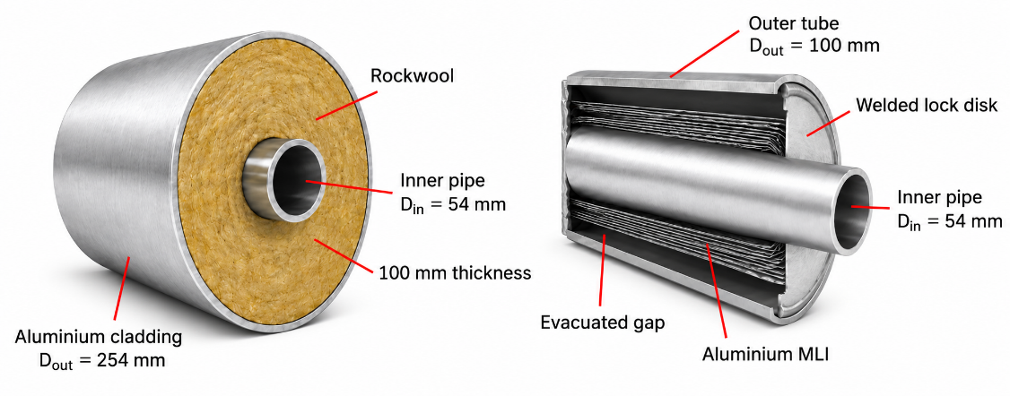
Fig. 1 – Schematic representation of two thermally insulated heat-transfer-fluid pipelines. On the left, the 54 mm inner pipe is surrounded by a 100 mm-thick rockwool layer enclosed by an aluminium cladding. The cross-sectional view of the High-Vacuum Multilayer Insulation configuration is shown on the right, illustrating the aluminium MLI surrounding the inner pipe within the 23 mm evacuated annular gap.
where $σ$ is Stefan-Boltzmann constant (W m⁻² K⁻⁴); ε_{al} is the thermal emittance of aluminium (Frolec et al., 2019); n is the number of layers; the temperatures T_{in} and T_{out} (here expressed in Kelvin), the outer diameter of the inner tube D_{in} and the length of the pipe L, are the same as those defined for eq. 1. Aluminium (ε=0.035) is chosen as low-ε material because it is cheaper and lighter than copper and silver.
Fig. 2 shows the thermal power as a function of the inner temperature for four different solutions. The thermal power of the rockwool insulation is calculated according to eq. 1 for two different external solutions: D_{out} = 254 mm, which is the typical value of industrial pipelines (red line + squares), and D_{out} = 100 mm as a reduced diameter configuration (blue line + circles), selected to provide a comparison with the VIT at the same overall diameter. As already mentioned, the rockwool thickness plays a key role in reducing the heat transfer by conduction.
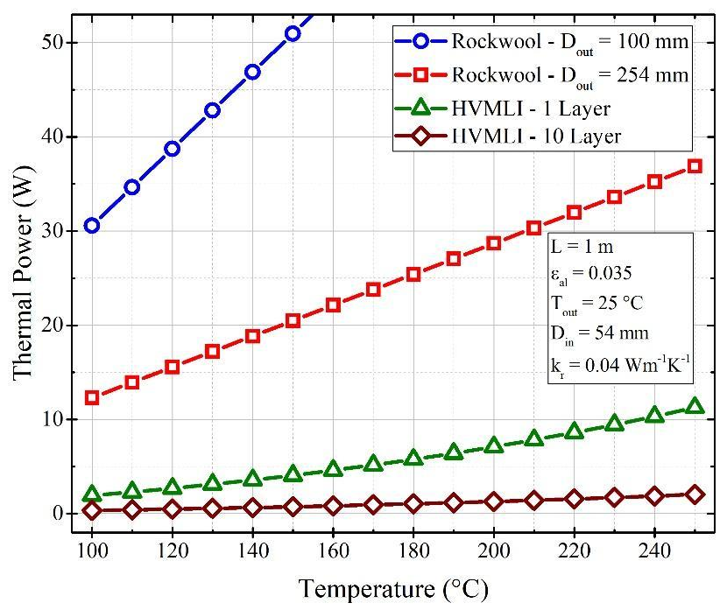
Fig. 2 – Thermal power as a function of the inner temperature for four different insulation solutions, according to eq. 1-eq. 2: 100 mm outer diameter rockwool insulation (blue line + circles), 254 mm outer diameter rockwool insulation (red line + squares), HVMLI with 1 aluminium layer (green line + triangles), HVMLI with 10 aluminium layers (brown line + diamonds).
The thermal power exchanged by HVMLI solutions is calculated according to eq. 2, with n = 1 for the single aluminium layer, and n = 10 for the 10 layers solution. Increasing the number of low-emittance layers proportionally reduces the radiative heat transfer in vacuum, with an enhanced difference at elevated temperatures: at 250 °C the HVMLI reduces the heat exchange of about 5 times compared to the single aluminium layer.
The preliminary analysis shows the benefits of replacing the traditional thermal insulator (i.e. rockwool) with the high-vacuum insulation combined with HVMLI. The heat transfer is reduced by a factor of 3.5 at 250 °C with the 1-Al configuration and by a factor of approximately 18 with the 10-Al configuration. An experimental analysis is necessary to confirm the advantages of the proposed solution, as additional heat transfer mechanisms arise in real-world components.
- Design and Thermal Analysis
As a novel solution, the design of an experimental measurement system for the evaluation of the HVMLI performance involves different analyses in the mechanical engineering field. The thermal analysis conducted in Section 2 shows the expected advantages of employing the HVMLI as an insulation system in the temperature range between 100 °C and 250 °C. A structural analysis is required to design a proper vacuum chamber to resist atmospheric pressure due to internal high-vacuum conditions (i.e. pressure below 10⁻⁵ mbar). Accordingly, a dedicated experimental apparatus must be designed and constructed to characterize the thermal performance of the proposed HVMLI configurations under representative operating conditions. The apparatus must combine sufficient measurement sensitivity to resolve the expected low heat-transfer rates with a mechanically robust and leak-tight vacuum chamber capable of maintaining and continuously monitoring the required high-vacuum conditions throughout the tests.
3.1 Thermal Design
Fig. 3 shows the architecture of the proposed experimental setup developed to assess the performance of the two HVMLI configurations. The system consists of an inner AISI 304 stainless-steel tube wrapped with aluminium layers arranged in a spiral pattern. A high-vacuum condition is created in the annular space between the inner and outer AISI 304 stainless-steel tubes.
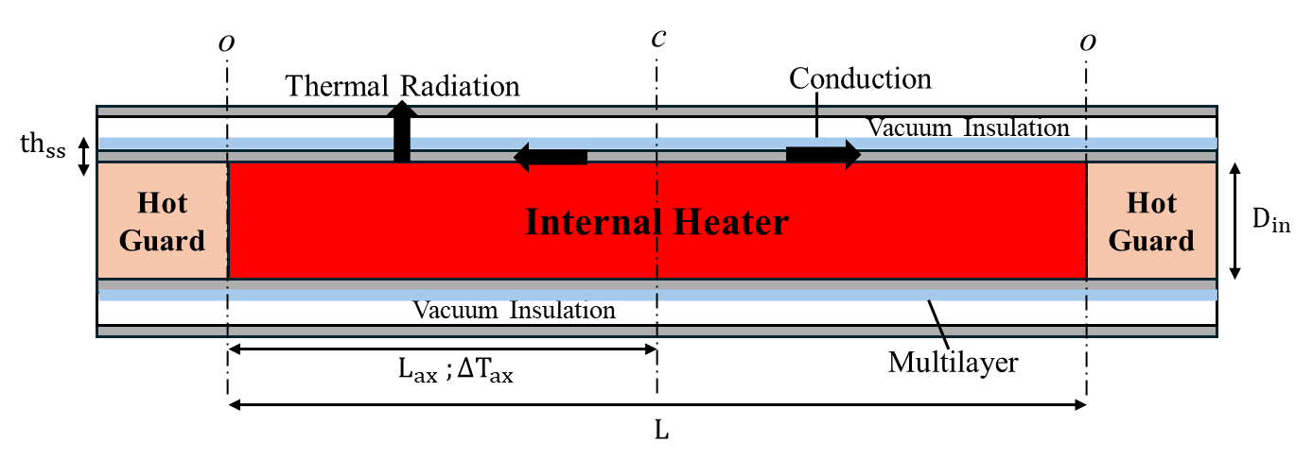
Fig. 3 - Schematic view of the Guarded Hot Pipe setup design. The black arrow shows the pathway of heat exchange mechanisms. Main geometrical parameters are reported.
In this scheme, two main heat exchange mechanisms are involved: the thermal radiation ${\dot{Q}}_{r}$ (W) in the radial direction calculated according to eq. 2, and the thermal conduction in axial direction ${\dot{Q}}_{ax}$ (W) through the thickness of the inner pipe calculated in eq. 3 according to Fourier’s law.
There are two symmetrical contributions between the central section “c” and the outer section “o” adjacent to the Hot Guard, as represented in fig. 3, to the right and to the left. L_{ax}=L/2 (m) is the distance between sections “c” and “o”, ΔT_{ax} (K) is the temperature difference between those two sections, th_{ss} (m) and k_{ss} (W m⁻¹ K⁻¹) are, respectively, the thickness and the thermal conductivity of the stainless-steel tube.
$${\dot{Q}}_{ax}=2\frac{\left(k_{ss}πD_{in}th_{ss}\right)}{L_{ax}}∆T_{ax}$$ | (eq. 3)
Fig. 4 presents the main outcomes of the thermal analysis conducted on the proposed configuration to determine both the geometric characteristics of the experimental setup and the appropriate measurement chain. The left y-axis shows the radiative heat loss, calculated as in eq. 2 as a function of the sample axial length for three different inner diameters. The 10-Al sample, with 1 m length and inner diameters of 50 mm and 100 mm, yields a thermal loss of at least 0.5 W. Even if these values refer to theoretical conditions, they are a clear indication of the low thermal losses expected to be measured with an experimental setup.
The right y-axis reports the ratio between axial heat loss, calculated as in eq. 3, and the radial thermal loss, which defines the maximum measurement resolution achievable by the system. Analysis is reported for ΔT_{ax} = 1 °C, as a realistic value consistent with the expanded uncertainty of the type-K thermocouples. The thickness of th_{ss} = 0.1 mm is considered as a best-case scenario, but additional mechanical constraints should be considered for the design of such a thinner sample. However, the black-dashed line also represents a scenario with th_{ss} = 1 mm and ΔT_{ax} = 0.1 °C (the two curves overlap), that could be achieved by introducing Pt100 sensors for temperature measurements. The analysis indicates that, for a stainless-steel tube thickness of 1 mm, an axial length of approximately 0.75 m is necessary to reduce axial heat losses to a negligible level, below 1% of the radiative contribution.
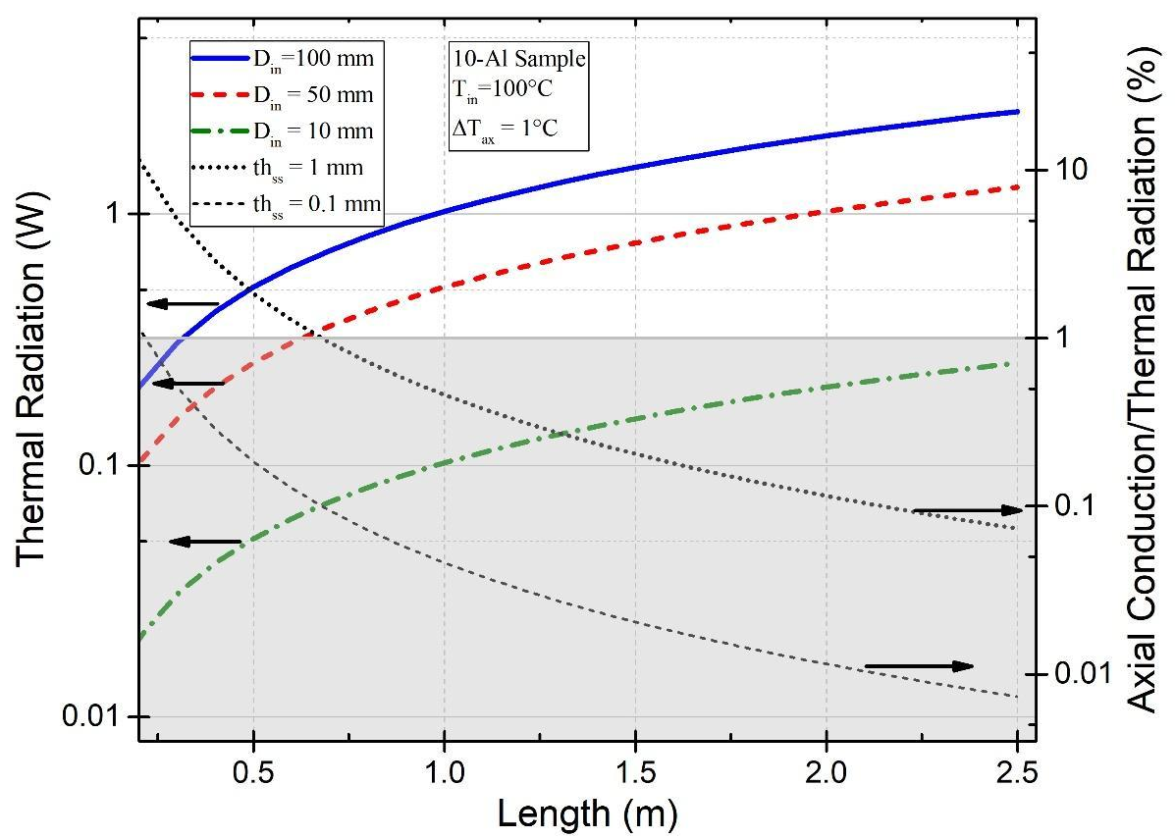
Fig. 4 - Thermal radiation (left y-axis) as a function of the length of the internal tube for three different internal diameters. Ratio between axial thermal conduction and thermal radiation as a function of the length for two different thicknesses of the stainless-steel tube. The internal box reports simulation parameters.
3.2 Mechanical Design
The mechanical behaviour of the proposed system is assessed by separately considering the inner and outer AISI 304 tubes, as they are subjected to different pressures (Fig. 5). The annular gap between the tubes is evacuated to a pressure below 10⁻⁵ mbar, while atmospheric pressure is assumed both outside the external tube and inside the inner tube.
The inner tube is subjected to a pressure difference acting from the inside towards the evacuated annulus. Under the thin-cylinder assumption, the circumferential stress σ_{θ} (Pa), described according to eq. 4, is more critical compared to the longitudinal one (Goodno and Gere, 2018).
$$σ_{θ}=\frac{∆pD_{in}}{2th_{ss}}$$ | (eq. 4)
where Δp (Pa) is the pressure differential. Considering the minimum 0.2% proof strength of AISI 304 at 250 °C according to EN 10028-7:2016, and a safety factor of 3, the allowable stress is 39.3 MPa. Considering a maximum diameter of 200 mm as the most demanding condition, it results in a theoretical minimum thickness of 0.258 mm.
Conversely, the outer tube is subjected to atmospheric pressure on its external surface and near-zero pressure on its internal surface. This loading produces compressive circumferential stresses and causes elastic instability before material yielding. Geometrical imperfections and welded lock-disk connections are not modelled explicitly and are accounted for through the adopted safety factor.
The design condition is expressed according to eq. 5, under the long-cylinder approximation (Salahshour and Fallah, 2018).
$${th}_{min}={D_{out}\left(\frac{f_{s}p_{atm}\left(1-ν^{2}\right)}{2E}\right)}^{\frac{1}{3}}$$ | (eq. 5)
where th_{min} (m) is the minimum required thickness, f_{s} = 3 is the safety factor, p_{atm} (Pa) is the atmospheric pressure. The calculations are performed using the Young’s modulus E = 193 GPa and a Poisson’s ratio ν = 0.29 for AISI 304 at the maximum outer temperature of 30 °C (Davis, 1999).
The minimum length L_{min} required for the applicability of the model is expressed in eq. 6.
$$L_{min} ≥D_{out}{\left(\frac{5D_{out}}{8th_{min}}\right)}^{\frac{1}{2}}$$ | (eq. 6)
The parametric analysis is performed for external tube diameters ranging from 50 to 200 mm, as shown in fig. 5. Within this range, the calculated minimum thickness increases from approximately 0.45 to 1.80 mm, while the minimum length required to satisfy the long-cylinder assumption increased from approximately 0.42 to 1.67 m. These results identify external-pressure buckling of the outer tube as the governing mechanical design condition, whereas the inner tube remains safely within the membrane-stress limit.
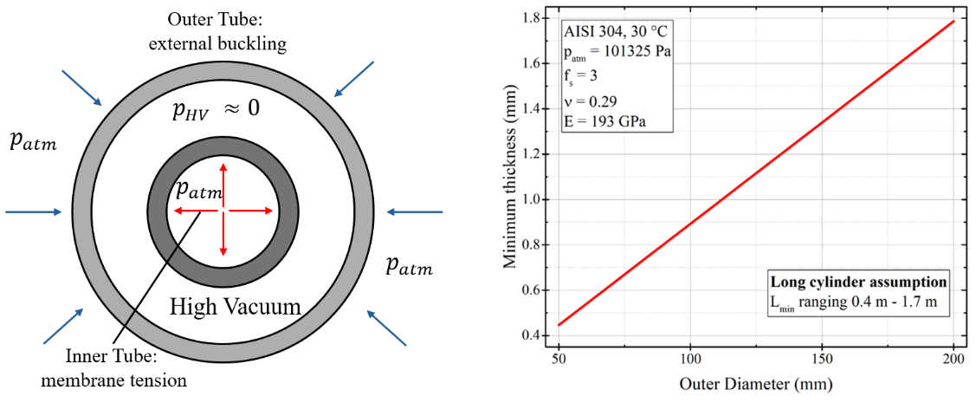
Fig. 5 – On the left, pressure distribution and dominant mechanical response of the concentric tubes: membrane tension in the internally pressurized inner tube and external-pressure buckling of the outer tube. On the right, minimum outer-tube wall thickness as a function of the external diameter for a sufficiently long AISI 304 cylindrical shell.
- Design and Construction
The design process and thermal analysis of the proposed architecture provided the main parameters for the realization of the experimental setup. The system is based on a welded concentric-tube arrangement composed of two stainless-steel tubes, as shown in fig. 6. The inner tube is 1.7 m long, with an outer diameter of 54 mm and a thickness of 1.5 mm, consistent with commercial standards for heat transfer fluid pipelines. The selected length and diameter were defined according to the results discussed in fig. 4, while the thickness was verified against the membrane-stress requirement. The outer tube is 1.4 m long, with a 100 mm diameter and 1 mm thickness; these dimensions ensure that the tube can withstand atmospheric pressure without buckling, according to fig. 5.
Two additional components are welded on the external surface of the outer tube. A stainless-steel tube is used as a pumping port to evacuate the annular gap through the pumping system. Additionally, a Compact Cold Cathode Full Range Gauge is mounted to continuously monitor the pressure inside the evacuated gap.
Two different configurations of the HVMLI are built for the experimental activity. The first configuration consists of a single layer of 15-μm-thick crinkled aluminium foil wrapped around the outer surface of the inner tube. The second prototype has ten layers of aluminium (10-Al) mounted in a spiral assembly around the external surface of the inner tube.

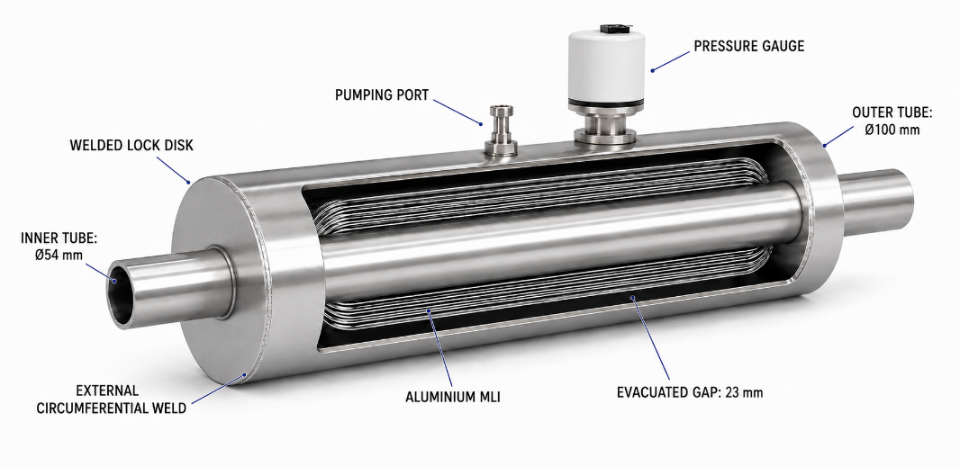
Fig. 6 – Schematic view of the prototype with the detail of the components.
The thermal performance of the prototypes was assessed experimentally using the HGP method. The HGP scheme includes three heater cartridges separated by Teflon spacers (50 mm each) and placed in the inner tube as shown schematically in fig. 7. The central section of the set-up is one meter long and it is the one under test, while the lateral ones are 15 cm long and they act as thermal guards. The heating elements are inserted in a copper tube to provide uniform heating sources; the copper tube is surrounded by an AISI 304 tube that contains the channel for the thermocouple and is placed in intimate contact with the hot tube. The central thermocouple measures the inner temperature of the prototype, as reference for the performance evaluation. The lateral thermocouples on the main heater define the axial temperature difference, as ΔT = 1 °C is the maximum admissible temperature difference required to neglect the axial thermal losses, according to the results shown in fig. 4.
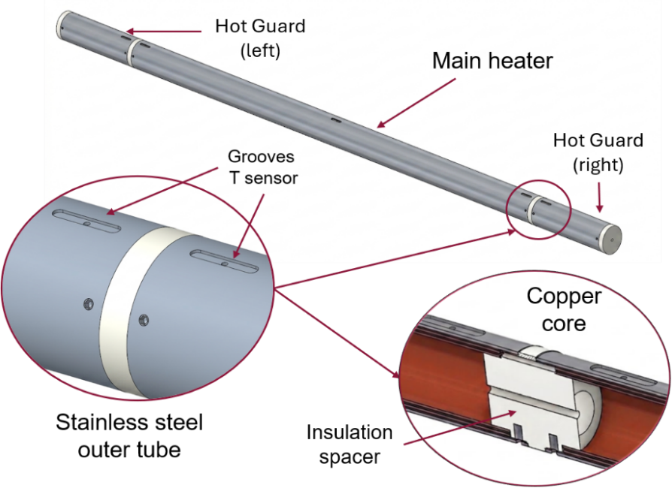
Fig. 7 – Schematic view of the heater designed for the Guarded Hot Pipe method. Magnified views provide the detail of the thermocouple accommodation and the Teflon spacers between the main heater and the lateral sections.
- Results and Discussion
The central heater is supplied with a fixed DC voltage to provide the heat dissipated according to the theoretical calculation of eq. 2 at the desired inner temperature. The power supplied to the guarding units is iteratively adjusted until the temperature difference ΔT_{ax}, required to ensure a negligible ${\dot{Q}}_{ax}$, is reached in steady-state conditions. ΔT_{ax} is evaluated as the difference between central temperature, T_{c} and the mean of the temperatures measured at the two lateral sections of the tested unit. Fig. 8 shows the thermal power as a function of the internal temperature of the single layer prototype. The solid line represents the theoretical value calculated according to eq. 2, while the markers represent the experimental points. For each thermal power supplied to the main heater (2.0 W, 4.5 W, 8.1 W), a different inner temperature is reached depending on the axial temperature difference ΔT_{ax}. The power supplied to the lateral heaters is adjusted to progressively reduce ΔT_{ax} from its maximum value (filled square) until ΔT_{ax} < 1 °C. For the two lower-temperature conditions, the experimental points obtained with ΔTax < 1 °C closely align with the theoretical predictions. A larger discrepancy is observed for the highest-temperature condition, corresponding to a supplied thermal power of 8.1 W and an inner temperature of approximately 220 °C. This mismatch originates from the simplified assumption of the thermal model. The discrepancy may arise because the simplified model neglects additional heat-transfer mechanisms, such as residual-gas conduction, does not account for the temperature dependence of thermal emittance, and applies a radiation-shield formulation that is more representative of configurations containing multiple layers.
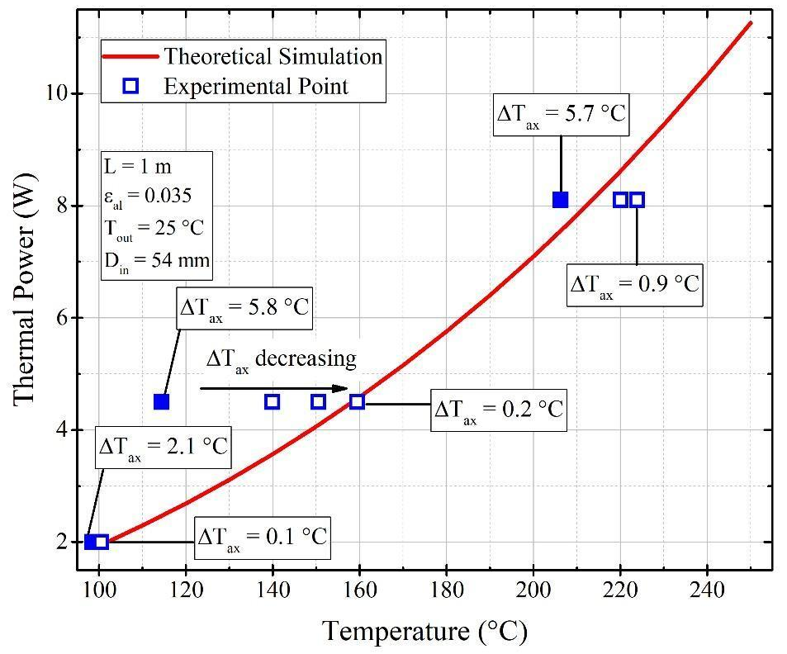
Fig. 8 – Thermal power as a function of the inner-pipe temperature for the single-layer prototype. The solid line represents the theoretical trend calculated using eq. 2, whereas the squares represent experimental data obtained at three different main-heater power levels and axial temperature differences. Filled squares identify the maximum ΔT_{ax} investigated for each power level.
Fig. 9 summarizes the main results of the experimental activity. The experimental results are shown for an axial temperature difference ΔT_{ax} < 1 °C for all six data points. The ${\dot{Q}}_{ax}/{\dot{Q}}_{r}$ ratio ranges between the minimum value of 0.05% for the 1-Al sample at 160 °C and the maximum value of 0.36% for the 10-Al sample at 186 °C. As already shown in fig. 8, the 1-Al solution shows a good agreement between the theoretical value (red dashed line) and the experimental points (red empty squares), with the only exception of the point at 220 °C.
This solution decreases the thermal loss of industrial fluid pipelines by about 4 times when compared to the traditional solution employing rockwool (as in fig. 2). Moreover, additional improvement is obtained by reducing the insulator thickness, from the total 254 mm outer diameter of the rockwool component to the 100 mm outer diameter of the VIT. At approximately 220 °C, the measured thermal power of the 10-Al configuration was about 30% lower than that of the 1-Al configuration, but with a considerable discrepancy with the theoretical values. This discrepancy may arise from heat-transfer mechanisms neglected in the simplified model, including solid conduction between contacting layers, residual-gas conduction, and temperature-dependent surface emittance.

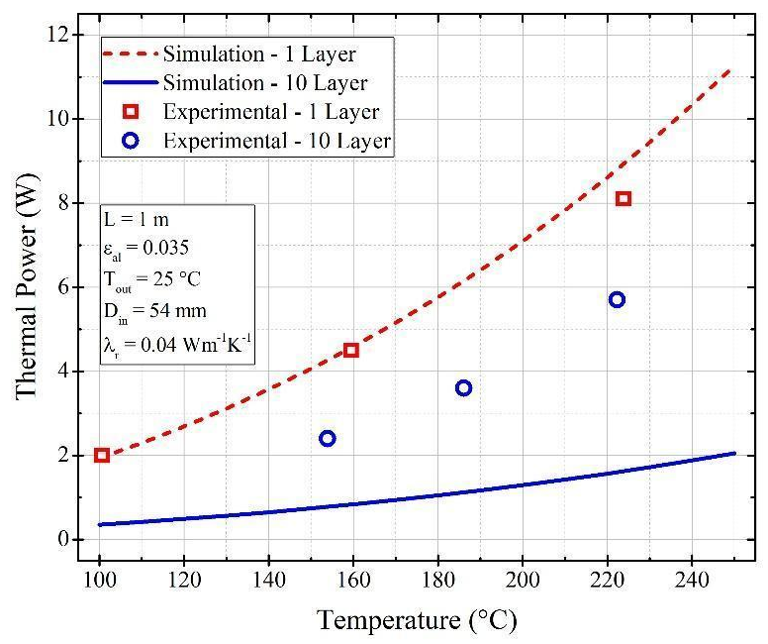
Fig. 9 – Thermal power as a function of the inner temperature for the two HVMLI prototypes. The lines represent the theoretical trend, and the markers represent the experimental points.
- Conclusions
The High Vacuum Multilayer Insulation (HVMLI) is an insulation technique that ensures high performance. The high-vacuum environment reduces thermal convection and gas conduction to negligible values, while the Multilayer Insulation reduces the thermal radiation by employing low-emittance foils. The characterization of the HVMLI is mainly limited to the cryogenic range (i.e. temperature below -150 °C) through boil-off calorimetry measurements. A different approach is needed to extend the use of HVMLI to the industrial pipeline temperature range between 100 °C and 250 °C.
An optimized measurement setup based on the Guarded Hot Pipe (HGP) is proposed in this paper to adequately measure the thermal loss of two different HVMLI samples: a single aluminium layer (1-Al) and a 10-layer insulation configuration (10-Al).
The preliminary thermal and structural analyses provided the main geometrical parameters to design a high-resolution experimental setup. The setup consists of an evacuated gap between concentric tubes with the MLI wrapped around the outer surface of the inner tube. The HGP method employs a three-section heater, with the central section serving as the test section and the two lateral sections balancing the axial heat losses.
The experimental results of the 1-Al configuration showed good agreement with the analytical model, supporting the capability of the experimental setup when the temperature difference in the axial direction is below 1 °C. The 10-Al configuration reduced the total exchanged power, although significant discrepancies with theoretical values remain.
The results showed that the HVMLI technology reduces the thermal loss of industrial heat transfer fluid pipelines in the temperature range between 100 °C and 250 °C while substantially reducing the overall dimensions of the insulation system. These findings support the need to improve the experimental setup to identify the cause of the discrepancy between the theoretical and experimental values of the 10-layer configuration.
Future work will focus on the development of a dismountable vacuum chamber, allowing different HVMLI configurations to be tested more easily and facilitating the identification of the most effective design solution. At the same time, the experimental setup will be upgraded with additional sensors to investigate other physical phenomena, such as residual gas conduction.
- References
Abdou, A., Budaiwi, I., 2013. The variation of thermal conductivity of fibrous insulation materials under different levels of moisture content. Constr. Build. Mater. 43, 533–544. https://doi.org/10.1016/j.conbuildmat.2013.02.058
Abu-Jdayil, B., Mourad, A.-H., Hittini, W., Hassan, M., Hameedi, S., 2019. Traditional, state-of-the-art and renewable thermal building insulation materials: An overview. Constr. Build. Mater. 214, 709–735. https://doi.org/10.1016/j.conbuildmat.2019.04.102
Bapat, S.L., Narayankhedkar, K.G., Lukose, T.P., 1990a. Experimental investigations of multilayer insulation. Cryogenics 30, 711–719. https://doi.org/10.1016/0011-2275(90)90235-5
Bapat, S.L., Narayankhedkar, K.G., Lukose, T.P., 1990b. Performance prediction of multilayer insulation. Cryogenics 30, 700–710. https://doi.org/10.1016/0011-2275(90)90234-4
Chen, M., Zhang, P., Li, Q., 2018. Design and heat transfer analysis of a compound multi-layer insulations for use in high temperature cylinder thermal protection systems. Sci. China Technol. Sci. 61, 994–1002. https://doi.org/10.1007/s11431-017-9250-x
Choudhary, M.K., Eastes, W., 2023. Effective thermal conductivity of fiberglass insulation. Int. J. Appl. Glass Sci. ijag.16652. https://doi.org/10.1111/ijag.16652
Damour, J.., Johannson, D.., 2016. What Vacuum Insulated Tubings Or Vacuum Insulated Casings Bring To Thermal Wells, in: Day 4 Thu, December 01, 2016. Presented at the SPE Thermal Well Integrity and Design Symposium, SPE, Banff, Alberta, Canada, p. D041S011R004. https://doi.org/10.2118/182515-MS
Daryabeigi, K., 2002. Thermal Analysis and Design Optimization of Multilayer Insulation for Reentry Aerodynamic Heating. J. Spacecr. Rockets 39, 509–514. https://doi.org/10.2514/2.3863
Davis, J.R. (Ed.), 1999. Stainless steels, 3. print. ed, ASM specialty handbook. ASM International, Materials Park, OH.
Ertürk, M., 2016. Optimum insulation thicknesses of pipes with respect to different insulation materials, fuels and climate zones in Turkey. Energy 113, 991–1003. https://doi.org/10.1016/j.energy.2016.07.115
Fesmire, J.E., Dokos, A.G., 2014. Insulation Test Cryostat with Lift Mechanism.
Fesmire, J.E., Johnson, W.L., 2018. Cylindrical cryogenic calorimeter testing of six types of multilayer insulation systems. Cryogenics 89, 58–75. https://doi.org/10.1016/j.cryogenics.2017.11.004
Frolec, J., Králík, T., Musilová, V., Hanzelka, P., Srnka, A., Jelínek, J., 2019. A database of metallic materials emissivities and absorptivities for cryogenics. Cryogenics 97, 85–99. https://doi.org/10.1016/j.cryogenics.2018.12.003
Goodno, B.J., Gere, J.M., 2018. Mechanics of materials, Ninth edition. ed. Cengage Learning, Boston, MA.
Guillet-Lhermite, J., Robert, B., Bimperling, F., Nkoukou, C., Congo, P., Damour, J., Ollier, P., 2017. Vacuum Insulated Tubing Efficiency for Offshore Steam Injection: Case Study from Emeraude Field Congo.
Hayrullin, A., Haibullina, A., Sinyavin, A., 2022. Insulation thermal conductivity heating networks during transportation thermal energy under dry and moisturizing condition: a comparative study of the guarded hot plate and guarded hot pipe method. Transp. Res. Procedia 63, 1074–1080. https://doi.org/10.1016/j.trpro.2022.06.109
Jacob, S., Kasthurirengan, S., Karunanithi, R., 1992. Investigations into the thermal performance of multilayer insulation (300-77 K) Part 1: Calorimetric studies. Cryogenics 32, 1137–1146. https://doi.org/10.1016/0011-2275(92)90328-8
Koebel, M., Rigacci, A., Achard, P., 2012. Aerogel-based thermal superinsulation: an overview. J. Sol-Gel Sci. Technol. 63, 315–339. https://doi.org/10.1007/s10971-012-2792-9
Kubačka, J., Karayiannis, T.G., 2024. Performance of vacuum-insulated central pipes for deep borehole heat exchangers in geothermal systems. Int. J. Low-Carbon Technol. 19, 2068–2085. https://doi.org/10.1093/ijlct/ctae132
Lund, R., Mohammadi, S., 2016. Choice of insulation standard for pipe networks in 4 th generation district heating systems. Appl. Therm. Eng. 98, 256–264. https://doi.org/10.1016/j.applthermaleng.2015.12.015
McIntosh, G.E., 1994. Layer by Layer MLI Calculation Using a Separated Mode Equation, in: Kittel, P. (Ed.), Advances in Cryogenic Engineering. Springer US, Boston, MA, pp. 1683–1690. https://doi.org/10.1007/978-1-4615-2522-6_206
Mohammed W. Muhieldeen, Lim Chong Lye, M.S.S. Kassim, Tey Wah Yen, K.H Teng, 2021. Effect of Rockwool Insulation on Room Temperature Distribution. J. Adv. Res. Exp. Fluid Mech. Heat Transf. 3, 9–15.
Pastushkov, P.P., Gutnikov, S.I., Pavlenko, N.V., Zheldakov, D.Y., Stolyarov, M.D., 2020. Heat conductivity of aerogel-based rolled materials for high-thermal isolation for equipment and pipelines. IOP Conf. Ser. Mater. Sci. Eng. 896, 012103. https://doi.org/10.1088/1757-899X/896/1/012103
Ramanathan, K.G., Yen, S.H., 1977. High-temperature emissivities of copper, aluminum, and silver. J. Opt. Soc. Am. 67, 32. https://doi.org/10.1364/JOSA.67.000032
Rohsenow, W.M. (Ed.), 1998. Handbook of heat transfer, 3. ed. ed, McGraw-Hill handbooks. McGraw-Hill, New York, NY.
Salahshour, S., Fallah, F., 2018. Elastic collapse of thin long cylindrical shells under external pressure. Thin-Walled Struct. 124, 81–87. https://doi.org/10.1016/j.tws.2017.11.058
Sapinska-Sliwa, A., Sliwa, T., Twardowski, K., Szymski, K., Gonet, A., Zuk, P., 2020. Method of averaging the effective thermal conductivity based on thermal response tests of borehole heat exchangers. Energies 13. https://doi.org/10.3390/en13143737
Scoarnec, V., Hameury, J., Hay, B., 2015. A New Guarded Hot Plate Designed for Thermal-Conductivity Measurements at High Temperature. Int. J. Thermophys. 36, 540–556. https://doi.org/10.1007/s10765-014-1794-y
Selzer, M., Keller, K., Reimer, T., Ritter, H., 2009. HIGH TEMPERATURE THERMAL CONDUCTIVITY MEASUREMENT APPARATUS.
Sen, S., Singh, A., Bera, C., Roy, S., Kailasam, K., 2022. Recent developments in biomass derived cellulose aerogel materials for thermal insulation application: a review. Cellulose 29, 4805–4833. https://doi.org/10.1007/s10570-022-04586-7
Ucar, A., Balo, F., 2009. Effect of fuel type on the optimum thickness of selected insulation materials for the four different climatic regions of Turkey. Appl. Energy 86, 730–736. https://doi.org/10.1016/j.apenergy.2008.09.015
Woods, S.I., Jung, T.M., Sears, D.R., Yu, J., 2014. Emissivity of silver and stainless steel from 80K to 300K: Application to ITER thermal shields. Cryogenics 60, 44–48. https://doi.org/10.1016/j.cryogenics.2014.01.002
Wu, J.-W., Sung, W.-F., Chu, H.-S., 1999. Thermal conductivity of polyurethane foams. Int. J. Heat Mass Transf. 42, 2211–2217. https://doi.org/10.1016/S0017-9310(98)00315-9
Zhang, H., Fang, W.-Z., Li, Y.-M., Tao, W.-Q., 2017. Experimental study of the thermal conductivity of polyurethane foams. Appl. Therm. Eng. 115, 528–538. https://doi.org/10.1016/j.applthermaleng.2016.12.057

