Structural Health Monitoring via online Impedance Mapping Topography on Fiber Reinforced Composites (FRC) with Carbon Nanotube (CNT)-modified epoxy resin

G. Foteinidis¹, A.S. Paipetis²

¹ Department of Materials Science and Engineering, University of Ioannina, 45110 Ioannina, Greece
Email: georgefotinidis@gmail.com, Web Page: http://www.http://csmlab.materials.uoi.gr
² Department of Materials Science and Engineering, University of Ioannina, 45110 Ioannina, Greece
Email: paipetis@cc.uoi.gr, Web Page: http://www.http://csmlab.materials.uoi.gr

Keywords: composites, structural heath monitoring, impedance spectroscopy, mapping, carbon nanotubes

Abstract

In this study, a conventional composite was converted into a multifunctional material to provide crucial information for Structural Health Monitoring (SHM). A specific lamination sequence of carbon and glass fabrics in combination with a ternary epoxy matrix offered SHM topography capabilities. The matrix reinforcement consisted of homogenously dispersed Carbon Nanotube and Carbon Black. A sinusoidal electric field was applied between the established local capacitors using Impedance Spectroscopy technique. The layout of the laminas enabled the damage assessment after medium velocity impact. Hence, the damaged area was depicted in a 2D contour topographical image which reviled useful information about the structural integrity of the composite.

1. Introduction

Structural Health Monitoring is a vital tool enabling on-line damage detection and topography on epoxy matrix reinforced composites. Among several SHM techniques, the ones related with the electrical response to damage are capable of providing information about the structural degradation of the material with high sensitivity and precision. The recent years, numerous studies focused on developing such a reliable self-monitoring system based on Impedance Spectroscopy (IS). In a representative work, the IS sensors were embedded in the FRC laminate, however despite the promising results in terms of defect monitoring, the sensors could act as damage initiation sites, resulting to degraded mechanical performance [1]. Another approach introduced two metallic sheets at the outer surfaces of the FRC laminate, thus creating a capacitor structure [2,3,4].
One major obstacle to the multifunctionality of composites is the highly dielectric character of the epoxy resin. The addition of a conductive nano- or micro-scaled filler inside the dielectric epoxy matrix led to the improvement of the mechanical, electrical and thermal properties of the composites [5,6]. According to various studies the most promising nano-fillers are Carbon Nano Tubes (CNT) due to their exceptional properties [7]. As an alternative filler, Carbon Black (CB) is a widely used carbonaceous filler, capable of enhancing these properties [8]. Hence, the homogenous dispersion of these fillers overcomes the obstacles of imparting functional properties to the epoxy resin [9,10].
Within the scope of this research was to provide the composite self-monitoring capabilities. This was achieved using the carbon fabrics both as reinforcing elements and embedded sensors, thus eliminating the need for “external” sensors. A connection with an IS spectrometer can provide all the online records for the structural integrity of the studied material. Furthermore, a targeted layout of local capacitors can enable mapping topography of structural integrity of the composite.

2. Material and methods

2.1. Materials

Graphistrength C100 Multi Wall CNTs (MWCNTs) supplied by ARKEMA were used as the primary filler in this study. The diameter of the MWCNTs varies between 10 and 15 nm and the length ranges from 1 μm to 10 μm. The nanotubes were provided in the form of agglomerated bundles with average diameter of 400 μm ranging from 50 to 900 μm. Μilled Carbon Black (CB) provided by R&G composites, GmbH was selected as the secondary reinforcement with agglomerate sizes ranging from 5 μm to 50 μm.
The two part low viscosity epoxy resin LY5052 and hardener Aradur 5052 was selected as a matrix provided by Huntsman Advanced Materials, at a mix ratio of 100:38 % w/w. The curing cycle was 24 h at 25 ºC.
Unidirectional glass fabric with areal density 320 g/m² and lamina thickness of 0.26 mm and unidirectional carbon fabric with areal density 218 g/m² and lamina thickness of 0.235 mm were used for the manufacturing of the smart laminates. Both fabrics were provided by R&G, Germany.

2.2. Composite manufacturing

Homogenous dispersion of fillers was performed by high shear stirring. The dispersion was conducted in a laboratory dissolver, by Dispermat AE, Gentzman, with a double wall vacuum container and under controlled temperature. High shear mixing with impeller was selected among other dispersion techniques to avoid degradation of the fillers and the matrix. A 45mm diameter toothed impeller disk, offering medium shear forces to dispersion, to reduce agglomerates size. The conditions of dispersion protocols were rotary speed of 3000 rounds per minute (rpm) and temperature of 25 ºC.
A fundamental condition for the manufacturing of the smart composite with SHM topography capabilities was the nano-reinforcement concentration of the matrix to exceed the percolation threshold. Therefore, the conductive network would be interrupted upon damage, and this would be reflected by an impedance increment. The optimum conditions enabling the SHM mapping were estimated during preliminary studies. 8 laminas of unidirectional glass fabric were chosen as the primary reinforcement and 0.5% w/w MWCNTs and 2% w/w CB dispersed in epoxy as the matrix system. Three carbon fabrics were introduced in the form of strips with 2 cm width and 2 cm gap between them in the first layer. Three more carbon fabric strips, with the same width and gap, were placed as the last layer, forming a 90º angle with the direction of the first layer. The aim of this specific layout was the formation of local capacitors in the junction points of the carbon fabric strips, on both the X and Y axes. At the edge of each carbon fabric strip a copper wire was implanted with conductive silver tape. The layout of the smart composite with SHM topography capabilities is illustrated in Figure 1.

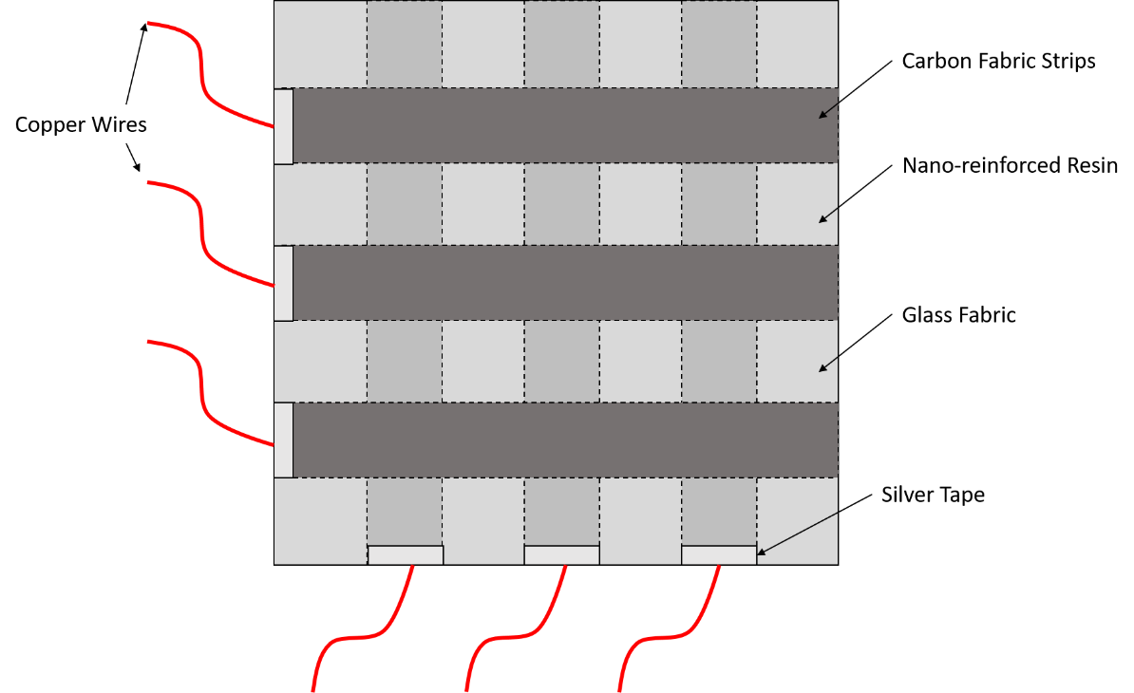

Figure 1. Smart composite layout for SHM mapping monitoring.

2.3. Characterization techniques

Impedance measurements were performed using the Advanced Dielectric Thermal Analysis System (DETA-SCOPE) supplied by ADVISE, Greece. The copper wires of electrodes were connected directly to the spectroscope. A sinusoidal voltage of 10V was applied to the capacitor. Scans were performed between two frequency values (0.01 Hz to 100 kHz), at 14 different frequencies with the duration of each scan to be approximately 275 seconds.
The specimen was subjected to medium velocity impact by a custom design ballistic impact device.

3. Results and discussion

Figure 2 depicts impedance results for SHM topography of the smart composite. Initially, a reference scan was performed before impact test. The IS scans after medium velocity impact revealed an extensive increase of the magnitude of impedance spectra near the damage area, which occurred between embedded capacitors with coordinates 3,1 and 3,2. Remarkably, an expanded damage to a more distant zone of the laminate was recorded, stemming from the high sensitivity of the local capacitors.

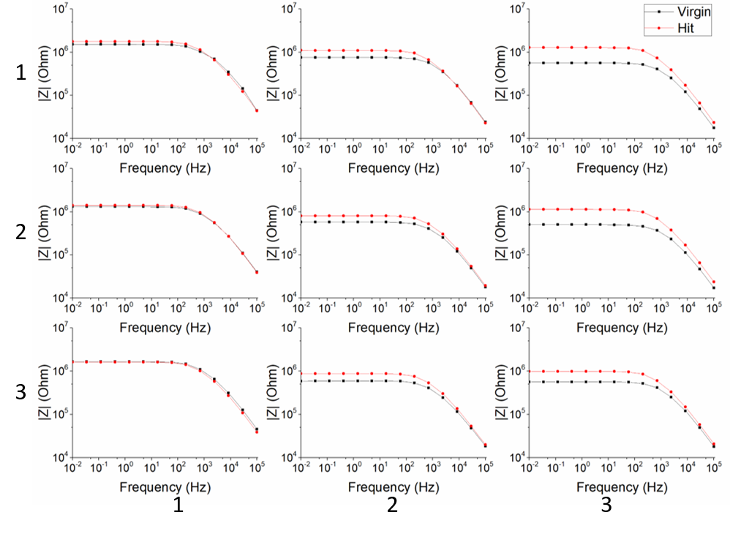

Figure 2. Impedance results for SHM mapping- bode plots.

A simple equivalent circuit was applied to simulate the electrical behavior of the composite. This circuit consisted of a resistance and a capacitor in parallel. The impedance values were analyzed using the Complex Nonlinear Least Squares Fitting Program (LEVM / LEVMW, Version 8.11, Copyright: James Ross Macdonald). The resistance values of the specimen after damage were normalized by the reference values, acquired during the reference scan before impact. The 2D contour topographical image of the smart composite is presented in Figure 3, illustrating the extension of the damage in terms of defective area and degree of structural degradation.

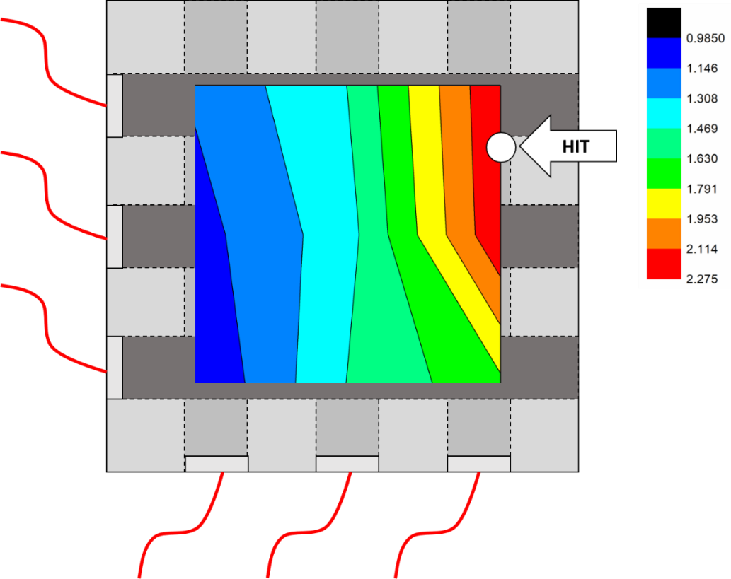

Figure 3. 2D contour topographical image of SHM.

4. Conclusion

The manufacturing of the composite with a specific lamination sequence of carbon and glass fabrics in combination with a CNT and CB reinforced epoxy resin matrix offered SHM topography capabilities converting a conventional composite into a smart material. The local capacitors, which were established at the crossovers of the carbon fabric strips, acted as imbedded electrodes measuring in the through thickness direction and thus enabled a sensitive SHM functionality. Furthermore, this study exhibited that the smart self-sensing composite capabilities eliminated the need of “external” sensors, which may act as internal defects.

References

[1] Herold S, Mook G, Michel F. Damage detection in smart CFRP. J urgen. Mater Eng, 2001
[2] Bekas DG, Paipetis AS. Damage monitoring in nanoenhanced composites using impedance spectroscopy. Compos Sci Technol, 134:96–105, 2016.
[3] Fazzino PD, Reifsnider KL, Majumdar P. Impedance spectroscopy for progressive damage analysis in woven composites. Compos Sci Technol, 69:2008–14, 2009.
[4] Raihan R, Adkins JM, Baker J, Rabbi F, Reifsnider K. Relationship of dielectric property change to composite material state degradation. Compos Sci Technol, 105:160–5, 2014.
[5] Hernandez-Perez A, Aviles F, May-Pat A, Valadez-Gonzalez A, Herrera-Franco P. J, Bartolo-Perez P. Effective properties of multiwalled carbon nanotube/ epoxy composites using two different tubes. Compos. Sci. Technol. 68:1422-1431, 2008.
[6] Mittal G. Dhand V, Rhee K.Y, Park S.J, Lee W.R, A review on carbon nanotubes and graphene as fillers in reinforced polymer nanocomposites. J. Ind. Eng. Chem. 21:11-25, 2015.
[7] Allaoui A, Bai S. Cheng H.M, Bai J.B. Mechanical and electrical properties of a MWNT/epoxy composite. Composites Science and Technology. 62:1993–1998, 2002.
[8] Burmistrov I. Gorshkov N, Ilinykh I. Muratov D, Kolesnikov E. Anshin S, Mazov I, Issi J.P, Kusnezov D. Improvement of carbon black based polymer composite electrical conductivity with additions of MWCNT. Composites Science and Technology. 129:79-85, 2016.
[9] Baltopoulos A, Polydorides N, Pambaguian L, Vavouliotis A. Kostopoulos V. Exploiting carbon nanotube networks for damage assessment of fiber reinforced composites. Composites Part B. 76:149-158, 2015.
[10] Baltzis D, Bekas D.G, Tzachristas G, Parlamas A, Karabela M, Zafeiropoulos N.E, Paipetis A.S. Multi-scaled carbon reinforcements in ternary epoxy composite materials: Dispersion and electrical impedance study. Composites Science and Technology. 153:7e-17, 2017.

