EuroSun2026
Techno-economic analysis of a low-cost polymeric heat absorber for PV/Thermal and ground source heat pump applications

Axel Lund¹, Francisco Beltrán¹*, Iván Acosta-Pazmiño^{2,3}, Damu Murali³, Nelson Sommerfeldt¹
- KTH Royal Institute of Technology, Brinellvägen 68, 100 44 Stockholm, Sweden
- MG Sustainable Engineering AB, S:t Olofsgatan 9B, 753 21 Uppsala, Sweden
- University of Gävle, 801 76 Gävle, Sweden

*Corresponding author: fbeltran@kth.se
Summary
This study evaluates a low-cost photovoltaic thermal (PVT) prototype intended as a supplementary and alternative heat source for a ground source heat pump (GSHP). The prototype combines a conventional PV module with a polymeric heat exchanger designed for pool heating and is compared with a standard aluminum sheet-and-tube PVT collector. The measured thermal behavior is characterized using a simplified ISO 9806:2017 regression model and the resulting coefficients are used in a 20-year dynamic simulation of a PVT+GSHP system for a multi-family building in Stockholm. The prototype achieved a higher zero-loss efficiency than the reference collector (0.39 compared with 0.37), while both PVT alternatives produced nearly identical long-term system performance, with an average seasonal performance factor of approximately 2.98 compared with 2.84 for the GSHP-only case. The low-cost prototype also produced the lowest total life-cycle cost, at k€ 365, compared with k€ 401 for the reference PVT system and k€ 377 for the GSHP-only case. The results indicate that a polymeric absorber can retain the system-level benefits of conventional PVT at substantially lower collector cost, although improved bonding, reduced weight, and long-term durability testing are required before commercial deployment.
Keywords: PVT, GSHP, experimental testing, solar energy, heating electrification
Field of application for the findings: solar heating and cooling systems for buildings
Addressed audience: researchers, practitioners, developers, building owners, solar PVT manufacturers
- Introduction
Photovoltaic-thermal (PVT) collectors are a promising technology for integration into modern heating systems. By combining a photovoltaic (PV) module with a rear-side thermal absorber, they generate electricity and heat simultaneously. In water-based systems, a fluid circulates through the absorber to recover heat from the incoming solar irradiance, and, in some cases, from the surrounding air. In doing so, PVT collectors recover heat that would otherwise be lost to ambient, and cool the PV cells, which can improve electrical efficiency.
Collector design plays a key role in performance, with glazing, insulation, absorber material, and channel arrangement all affecting the balance between thermal and electrical output (Aste et al., 2014; Herez et al., 2020). In particular, absorber geometry and rear-side heat-exchange design strongly influence thermal behavior, with configurations such as sheet-and-tube, box-channel, and fin-enhanced absorbers offering trade-offs between efficiency, complexity, and cost (Beltrán et al., 2025; Herrando et al., 2019).
PVT collectors can also be effectively combined with ground-source heat pumps (GSHPs), where they contribute to borehole regeneration, improving long-term system performance and reducing borehole sizing requirements (Bakker et al., 2005; Sommerfeldt & Madani, 2019). Previous work has also shown that PVT-assisted GSHP systems can reduce borehole sizing requirements and perform competitively in buildings where land constraints limit conventional ground-source design options (Bakker et al., 2005; Sommerfeldt & Madani, 2019). However, wider adoption has been limited by high manufacturing and material costs, making simpler and lower-cost designs particularly relevant (Abdul-Ganiyu et al., 2021).
For heat-pump integration, unglazed water-based PVT collectors operate at relatively low fluid temperatures and can recover heat from both solar irradiance and the ambient air (Bertram et al., 2012; Giovannetti et al., 2019). This operating range changes the design requirements compared with conventional higher-temperature solar thermal applications, as heat transfer from the ambient can contribute positively to thermal output when the working fluid is below ambient temperature. Absorber geometry, material use, thermal contact, hydraulic characteristics and manufacturability therefore become important design considerations (Brötje et al., 2018; Herrando et al., 2019). Metallic absorbers provide high thermal conductivity but can increase collector weight and material requirements, whereas polymeric absorber designs offer opportunities to reduce weight and investment cost despite their lower thermal conductivity (Herrando et al., 2019; Xu et al., 2017). The relevant question for PVT+GSHP applications is therefore not only whether a polymeric absorber performs as well as a conventional metal absorber at collector level, but whether any performance penalty remains important after integration into the complete heating system.
This study evaluates a low-cost water-based PVT prototype, developed using inexpensive materials and simple manufacturing methods, against a reference sheet-and-tube PVT panel through experimental testing and 20-year simulations of a PVT+GSHP system. The work focuses on three questions: how the simplified polymeric absorber affects measured thermal behavior, whether differences between collector designs remain significant at system level, and whether the reduction in collector investment cost is sufficient to improve long-term economic performance.
- Methods
2.1. Collector configurations
The prototype, hereon referred to as “Pool PVT”, combines a 425 Wp PV panel with a heat exchanger originally designed for pool heating. The 1.95 m² PV module contains 108 monocrystalline half-cells, while the heat exchanger is made of polyvinyl chloride (PVC) and closely matches the rear dimensions of the PV panel. The absorber is attached using spray adhesive together with mechanical pressure from springs and horizontal metal bars, as shown in Fig. 1 (left). This assembly method was selected to minimize the number of dedicated manufacturing steps and to evaluate the performance that can be achieved with commercially available low-cost components.
The reference collector, shown in Fig. 1 (right), uses an aluminum sheet-and-tube absorber with a serpentine flow arrangement. It has the same external dimensions and monocrystalline half-cells as the prototype, but a slightly lower rated PV capacity of 420 Wp. The aluminum sheet provides continuous thermal contact over a larger fraction of the rear surface and is therefore expected to provide more uniform PV cooling than the polymeric channel structure. The comparison is intentionally focused on the absorber construction: the two collectors have closely matched PV areas and are tested simultaneously under the same outdoor conditions.
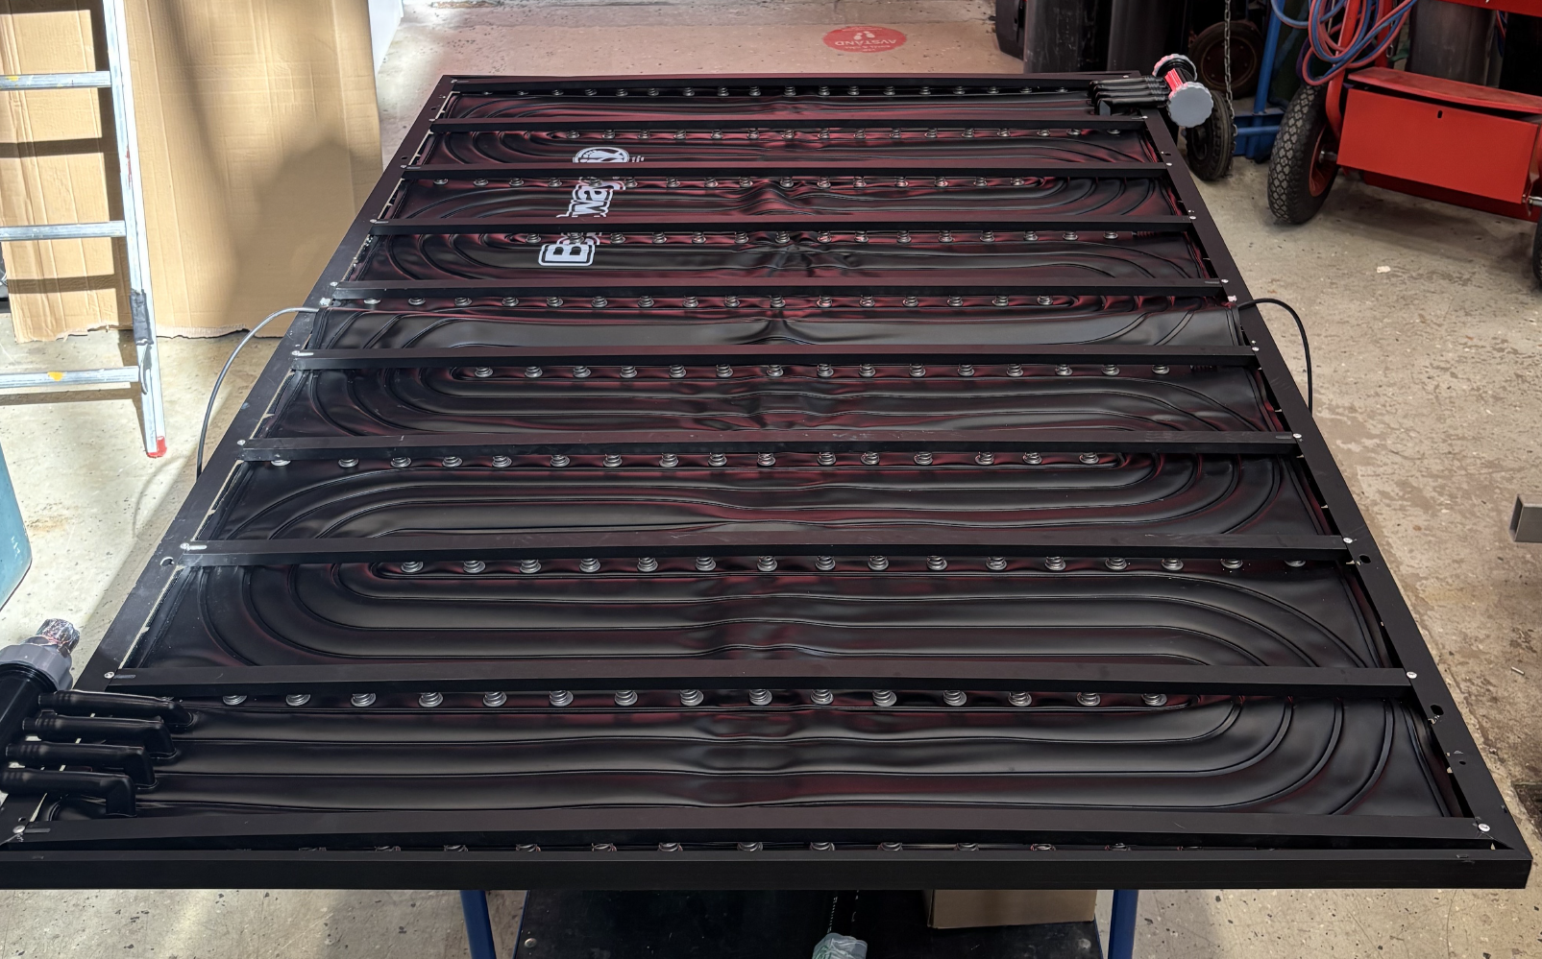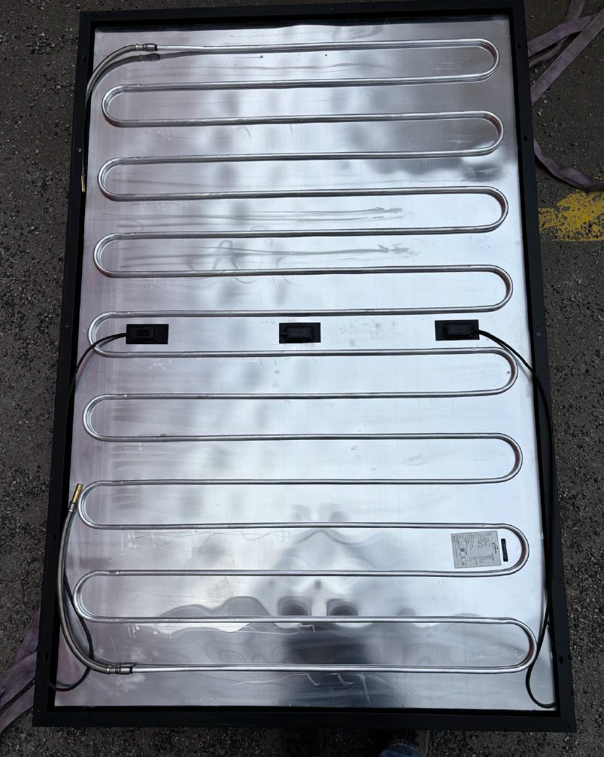
Fig. 1: Rear side of: assembled polymeric absorber (left) reference sheet-and-tube collector (right)
2.2. Experimental setup
The outdoor testing facility is equipped with a mounting rack, circulation pumps, water tanks, and measuring instruments. The two collectors are mounted facing south at a 45° tilt (Fig. 2) and connected to separate working-fluid circuits, allowing their thermal response to be compared under the same weather conditions without hydraulic interaction. A variable-speed heat pump cools a cold storage tank and rejects heat through a water-to-air heat exchanger. This enables collector inlet temperatures between approximately -5 °C and 10 °C, representative of the low source-side temperatures that can occur in heat-pump applications. A 35 % propylene glycol solution is used to provide freeze protection, with a freezing point well below the temperatures encountered during the tests.
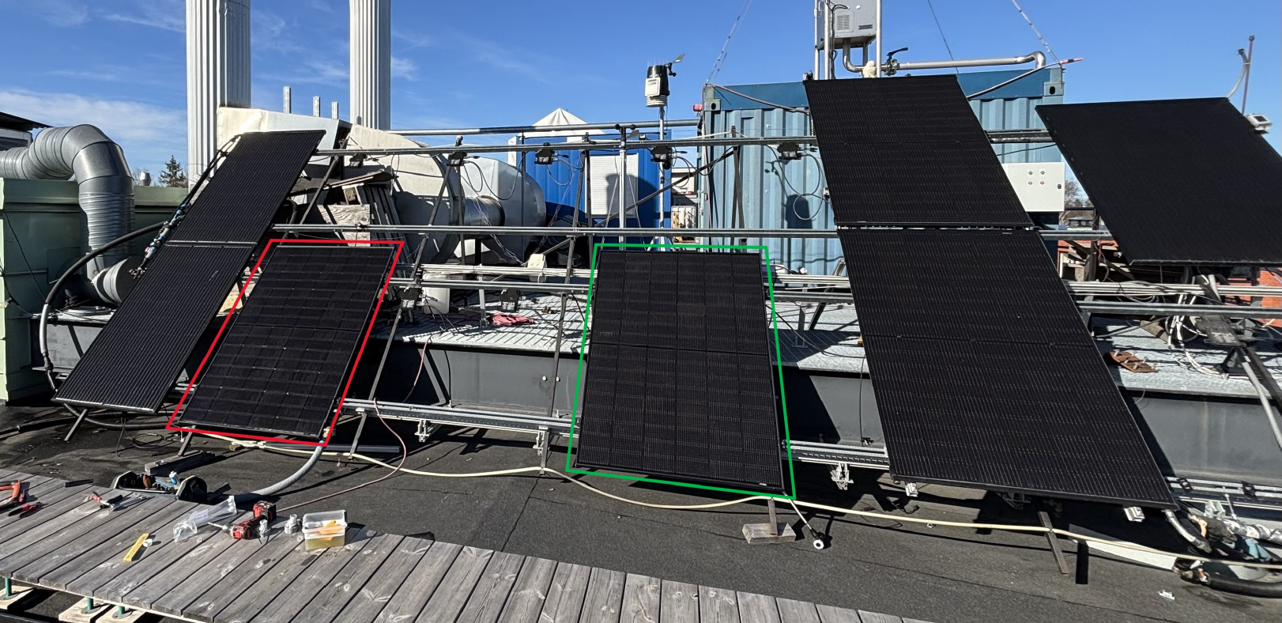
Fig. 2: PVT outdoor testing facility with prototype collector (red) and reference panel (green)
The collectors were monitored from 7 to 30 April 2025, with measurements recorded at one-minute intervals. Testing was performed under natural spring weather in Stockholm and therefore included periods of clear sky, variable irradiance, wind, overcast conditions, and precipitation. Data affected by rain or heavy overcast were excluded from the regression analysis because they are not well represented by the quasi-dynamic formulation. The remaining dataset was used both to compare the collectors directly and to derive performance coefficients for long-term simulation.
2.3. Thermal performance characterization
The monitored variables include volumetric flow rate, collector inlet and outlet temperature, ambient air temperature, plane-of-array solar irradiance, and wind speed. Specific thermal output is calculated from the measured flow rate, the density and specific heat capacity of the glycol mixture, the temperature increase across the collector, and the collector area. The resulting thermal output is then used to obtain the collector coefficients through regression with a simplified version of the ISO 9806:2017 quasi-dynamic equation (eq. 1) (ISO, 2017):
$${\dot{q}}_{th}={(η}_{0,hem}-c_{6}u')G_{hem}-(c_{1}+c_{3}u')\left(T_{m}-T_{a}\right)$$ | (eq. 1)
where $η_{0,hem}$, represents the zero-loss efficiency; $c_{1}$ the first-order heat loss coefficient; $c_{3}$ the wind-dependent term of the heat loss coefficient; $c_{6}$ the wind dependence of the zero-loss efficiency; $G_{hem}$ the solar irradiance incident on the plane of the array (W/m²); $u'$ is the reduced wind speed (m/s); $T_{m}$ is the mean fluid temperature (°C) through the collector; $T_{a}$ is the ambient air temperature (°C).
The regression coefficients describe the zero-loss response to irradiance, first-order heat exchange with the surroundings, and wind dependence. Together they provide a compact representation of collector behavior over a range of operating temperatures and weather conditions. Because the simplified formulation does not explicitly represent all transient effects, the regression results are also checked against measured temperature rise and thermal output during representative sunny and cloudy periods.
2.4. Long-term system and economic assessment
The coefficients are then used in a TRNSYS model for 20-year PVT and GSHP system simulations. The model, originally developed by Sommerfeldt & Madani (2019), represents a 2,000 m² multi-family building in Stockholm, demand 250 MWh/yr of space heat and 76 MWh/yr of hot water supplied by a 21-88 kW variable-speed heat pump, eight 300 m boreholes, and 120 roof-mounted PVT collectors. Three configurations are compared: a GSHP-only reference, GSHP combined with the Pool PVT prototype, and GSHP combined with the reference sheet-and-tube PVT collector. The model captures the long-term interaction between collector output, borehole temperature, heat-pump electricity use, and backup heating.
System-level performance is evaluated using the seasonal performance factor (SPF₄₊), and total life-cycle cost (TLCC) following the definitions presented by Sommerfeldt & Madani (2019). SPF₄₊ accounts for the total useful heat supplied relative to the electricity consumed by the heat pump and auxiliary components, while TLCC captures the long-term economic performance of the complete system.
For the economic comparison, all system cost assumptions are held equal between the two PVT alternatives except for the collector investment cost. The common assumptions include a fixed PVT installation cost of approximately € 11,820 and a variable installation cost of € 400 per collector for the 120-collector array, a heat-pump investment cost of approximately € 68,180, and a borehole-field investment cost of approximately € 70,450. Equipment operation and maintenance costs are assumed to correspond to 1 % of the heat-pump investment cost. Electricity is purchased at approximately € 0.145/kWh and exported at € 0.055/kWh, with electricity prices increasing by 1 % annually. The estimated retail-equivalent cost of the Pool PVT collector is € 242 per panel, based on the prototype materials and the market cost of the PV module, while the reference PVT panel is valued at € 504 per panel. Total life-cycle cost (TLCC) accounts for the main system investments and electricity use over the modeled period. A sensitivity analysis is additionally used to test how uncertainty in the future retail cost of the polymeric prototype affects the economic ranking of the alternatives.
- Results
3.1. Experimental collector performance
After filtering the measurements for unsuitable weather periods, the regression analysis used 10,358 data points, corresponding to 7.2 full days or 173 hours of usable measurements. The fitted models show good agreement with the experimental data, with R² values of 0.835 for Pool PVT and 0.855 for the reference collector. The Pool PVT prototype achieved a zero-loss efficiency of 0.389 compared with 0.372 for the reference panel. The first-order heat loss coefficients were 11.67 and 12.22 W/m²K, respectively, while the reported effective U-values were 17.68 and 18.08 W/m²K. The results indicate that the prototype responds particularly well when irradiance is high, whereas the reference collector has a small advantage extracting heat from the ambient air.
Table 1. Thermal coefficients obtained from the regression analysis.
Parameter | Pool PVT | Reference | Unit
Zero-loss efficiency | 0.389 | 0.372 | -
First-order heat loss coefficient | 11.67 | 12.22 | W/m²K
Wind-dependent heat-loss term | 4.62 | 4.50 | J/m³K
Wind dependence of zero-loss efficiency | 0.032 | 0.037 | s/m
Effective U-value | 17.68 | 18.08 | W/m²K
R² | 0.835 | 0.855 | -
Direct comparison of the monitored periods supports the regression results. On high-irradiance days, the Pool PVT collector produced a slightly larger temperature rise and thermal output, while the reference collector performed somewhat better during low-irradiance periods. Infrared imaging also showed a clear difference in rear-side heat transfer (Fig. 3). The aluminum reference collector cooled the PV surface more uniformly, whereas the polymeric prototype extracted heat mainly along the fluid channels and showed warmer regions around areas with weaker contact, particularly close to the junction box. Despite this less uniform cooling pattern, the larger contact area of the polymeric channel structure was sufficient to produce comparable overall thermal performance.
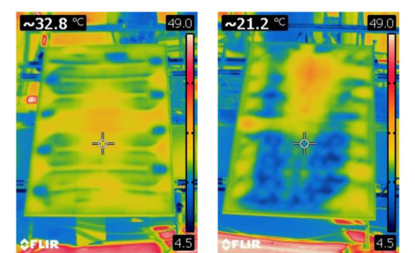
Fig. 3: Infrared image of the front side of the Pool PVT prototype (left) and reference S&T collector (right).
3.2. Long-term system performance
The TRNSYS simulations show that the differences observed at collector level become small after integration into the complete heating system. Both PVT configurations maintain higher source temperatures than the GSHP-only case and consequently reduce the long-term decline in heat-pump performance. As shown in Fig. 4, the average SPF₄₊ over the 20-year simulation is approximately 2.98 for both PVT+GSHP systems, compared with 2.84 for the GSHP-only configuration. The two PVT systems also require less backup heating because borehole temperatures remain more stable. Annual specific thermal output from the collectors increases gradually over the modeled period as the working-fluid temperature decreases relative to the ambient air, increasing the opportunity for low-temperature heat recovery.
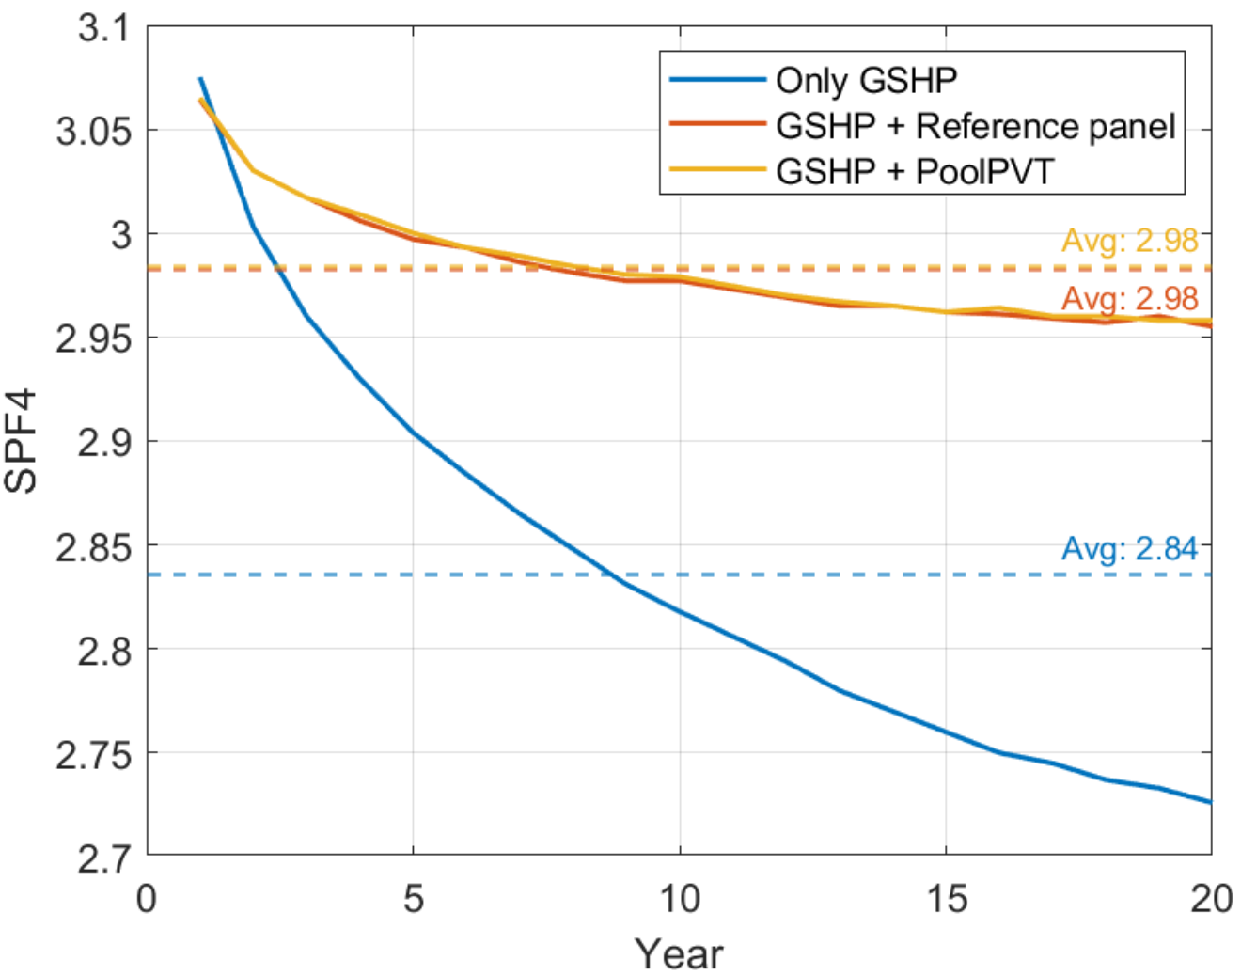
Fig. 4: SPF of the GSHP-only system compared to PVT+GSHP systems with the Pool PVT and the S&T panel.
3.3. Economic performance and sensitivity
The economic results show a larger separation between the alternatives than the technical performance indicators. As shown in Fig. 5, the Pool PVT system has the lowest TLCC at approximately € 365 thousand, compared with € 377 thousand for the GSHP-only system and € 401 thousand for the reference PVT system, using an exchange rate of 1 € = 11 SEK. The lower collector investment cost therefore allows the Pool PVT configuration to convert the technical benefit of PVT-assisted borehole regeneration into a net life-cycle cost reduction. In contrast, the reference PVT panel provides nearly the same long-term system performance but at an investment level that is not recovered within the assumptions of the 20-year analysis.
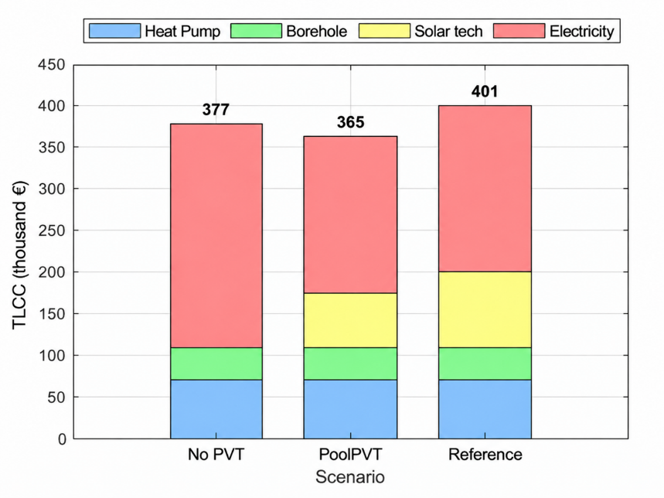
Fig. 5: TLCC of the different system configurations: GSHP-only, and PVT+GSHP with both Pool PVT and S&T.
3.4. Sensitivity to collector cost
Because the prototype was assembled from commercially available components rather than manufactured as a finished product, its eventual retail price is uncertain. The sensitivity analysis therefore varies the Pool PVT collector price while keeping the remaining system assumptions unchanged. As shown in Fig. 6, the Pool PVT configuration remains less expensive than the GSHP-only system until the collector price increases to approximately € 331 per panel, about 37 % above the € 242 base estimate. It also remains below the TLCC of the reference PVT system across a substantially wider price range. This result indicates that the economic advantage is not dependent on achieving the exact prototype cost and leaves room for improvements in materials and manufacturing that may increase the collector price while improving robustness and scalability.
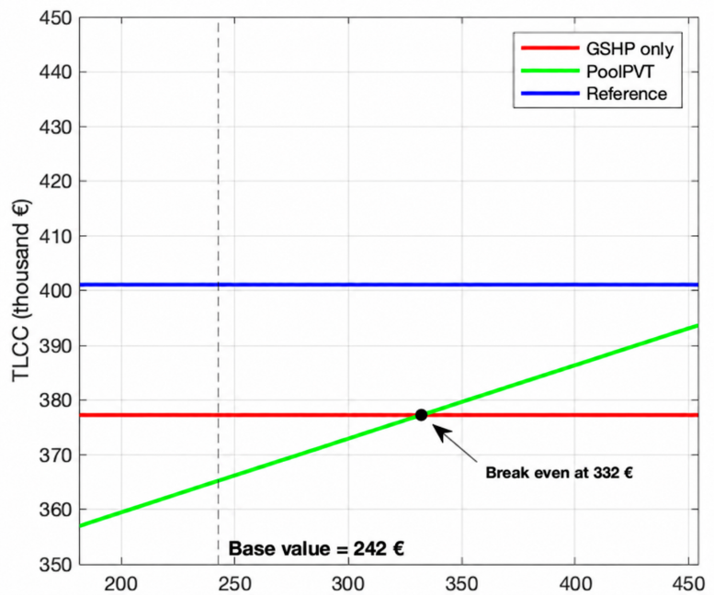
Fig. 6: Sensitivity of Pool PVT system TLCC to the assumed prototype collector price.
- Discussion
The experimental and simulation results show that the most relevant difference between the two PVT designs is economic rather than technical. At collector level, the aluminum sheet-and-tube absorber provides more uniform rear-side cooling, which is consistent with its higher material conductivity and continuous contact with the PV module. The polymeric absorber, by contrast, transfers heat mainly along the channel paths and is more sensitive to local contact quality. Nevertheless, the Pool PVT prototype achieves comparable thermal coefficients and performs slightly better during high-irradiance periods. This confirms that high material conductivity is not the only factor governing useful heat recovery in low-temperature PVT operation; absorber contact area, channel distribution, flow conditions, and the temperature difference between the fluid and surroundings are also important (Aste et al., 2014; Herrando et al., 2019).
The similarity becomes even stronger at system level. Both PVT alternatives support borehole regeneration and maintain the heat-pump source temperature, resulting in almost identical average SPF₄₊ over 20 years. This agrees with the role of low-temperature PVT described in previous PVT+GSHP studies, where collector output is valuable not only as direct solar heat but also as a means of limiting long-term ground cooling (Bakker et al., 2005; Sommerfeldt & Madani, 2019). The result is particularly relevant for collector design because it suggests that small differences in instantaneous thermal efficiency may have limited value if they do not produce a meaningful change in heat-pump or borehole performance. For this application, reducing the cost of the absorber can therefore be more important than maximizing collector-level performance, provided that sufficient thermal output is retained.
The economic analysis supports this interpretation. The reference PVT collector improves the technical performance of the heating system but does not compensate for its higher investment cost under the assumptions used here. The lower-cost Pool PVT design, on the other hand, reaches the lowest TLCC and remains competitive even when its assumed collector price is increased substantially. However, this cost advantage should be interpreted together with the limitations of the prototype. During assembly, the commercial pool absorber showed imperfect fit to the PV module, weak adhesive bonding in some areas, and relatively high weight due to the larger water volume. These issues are not fully represented in the 20-year economic model and would affect installation effort, product lifetime, maintenance requirements, and manufacturability in a commercial product. That said, if durability and reliability can be solved, the economies of scale available to a plastic absorber would be advantageous for broader PVT adoption.
The performance characterization also has limitations. The usable dataset corresponds to 7.2 days during a spring test campaign, and the regression uses a simplified ISO formulation that does not explicitly represent thermal inertia. This reduces accuracy during rapid irradiance fluctuations (Sommerfeldt & Ollas, 2017) however, the coefficients are supported by direct comparisons during representative sunny and cloudy periods and the fitted R² values are similar for the two collectors. The simulations should therefore be interpreted primarily as a comparison under common assumptions. Long-term polymer durability, pressure and flow-rate limits, and aging of the bonding layer still require dedicated testing before commercial service life can be assessed.
- Conclusions and future work
This study shows that a low-cost polymeric heat absorber can provide PVT performance comparable to a conventional aluminum sheet-and-tube collector in a GSHP application. The Pool PVT prototype achieved a higher measured zero-loss efficiency (0.389 compared with 0.372), while both PVT+GSHP configurations reached an average SPF₄₊ of approximately 2.98 over 20 years, compared with 2.84 for the GSHP-only case. The results confirm the benefit of PVT-assisted borehole regeneration while showing that the two tested absorber designs have little influence on complete system performance.
The main advantage of the prototype is its potential to reduce cost. At estimated collector costs of € 242 per panel for Pool PVT and € 504 for the reference collector, the Pool PVT system reaches the lowest TLCC at € 365 thousand. The sensitivity analysis shows that its advantage over the GSHP-only system is retained up to € 332 per panel, supporting simplified absorber concepts where low-temperature system performance is relatively insensitive to small efficiency differences.
Future work should convert the proof-of-concept absorber into a design suitable for manufacturing and long-term operation. Priorities include reducing thickness and weight, improving bonding and thermal contact, refining the exchanger geometry around the junction box, and defining pressure and flow-rate limits. Long-duration outdoor testing should assess polymer stability, adhesive aging, leakage risk, and performance degradation, while a broader seasonal test campaign would reduce uncertainty in the quasi-dynamic model and long-term techno-economic assessment.
- References
Abdul-Ganiyu, S., Quansah, D. A., Ramde, E. W., Seidu, R., & Adaramola, M. S. (2021). Techno-economic analysis of solar photovoltaic (PV) and solar photovoltaic thermal (PVT) systems using exergy analysis. Sustainable Energy Technologies and Assessments, 47(November 2020), 101520. https://doi.org/10.1016/j.seta.2021.101520
Aste, N., del Pero, C., & Leonforte, F. (2014). Water flat plate PV-thermal collectors: A review. Solar Energy, 102, 98–115. https://doi.org/10.1016/j.solener.2014.01.025
Bakker, M., Zondag, H. A., Elswijk, M. J., Strootman, K. J., & Jong, M. J. M. (2005). Performance and costs of a roof-sized PV/thermal array combined with a ground coupled heat pump. Solar Energy, 78(2), 331–339. https://doi.org/10.1016/j.solener.2004.09.019
Beltrán, F., Sommerfeldt, N., Reichl, C., & Madani, H. (2025). Cold solar: PVT heat exchanger designs for heat pump integration. Applied Thermal Engineering, 261(November 2024). https://doi.org/10.1016/j.applthermaleng.2024.125020
Bertram, E., Glembin, J., & Rockendorf, G. (2012). Unglazed PVT collectors as additional heat source in heat pump systems with borehole heat exchanger. Energy Procedia, 30, 414–423. https://doi.org/10.1016/j.egypro.2012.11.049
Brötje, S., Kirchner, M., & Giovannetti, F. (2018). Performance and heat transfer analysis of uncovered photovoltaic-thermal collectors with detachable compound. Solar Energy, 170(October 2017), 406–418. https://doi.org/10.1016/j.solener.2018.05.030
Giovannetti, F., Lampe, C., Kirchner, M., Littwin, M., Asenbeck, S., & Fischer, S. (2019). Experimental investigations on photovoltaic-thermal arrays designed for the use as heat pump source. Proceedings of the ISES Solar World Congress 2019 and IEA SHC International Conference on Solar Heating and Cooling for Buildings and Industry 2019, 177–188. https://doi.org/10.18086/swc.2019.05.03
Herez, A., El, H., Lemenand, T., & Ramadan, M. (2020). Review on photovoltaic/thermal hybrid solar collectors: Classifications, applications and new systems. Solar Energy, 207(May), 1321–1347. https://doi.org/10.1016/j.solener.2020.07.062
Herrando, M., Ramos, A., Zabalza, I., & Markides, C. N. (2019). A comprehensive assessment of alternative absorber-exchanger designs for hybrid PVT-water collectors. Applied Energy, 235(November 2018), 1583–1602. https://doi.org/10.1016/j.apenergy.2018.11.024
ISO. (2017). ISO 9806:2017 Solar energy - Solar thermal collectors - Test methods.
Sommerfeldt, N., & Madani, H. (2019). In-depth techno-economic analysis of PV/Thermal plus ground source heat pump systems for multi-family houses in a heating dominated climate. Solar Energy, 190(July), 44–62. https://doi.org/10.1016/j.solener.2019.07.080
Sommerfeldt, N., & Ollas, P. (2017). Reverse engineering prototype solar pv/thermal collector properties from empirical data for use in TRNSYS Type 560. ISES Solar World Congress 2017 - IEA SHC International Conference on Solar Heating and Cooling for Buildings and Industry 2017, Proceedings, 1121–1132. https://doi.org/10.18086/swc.2017.18.11
Xu, P., Zhang, X., Shen, J., Wu, Y., Connelly, K., Yang, T., Tang, L., Xiao, M., & Wei, Y. (2017). A review of thermal absorbers and their integration methods for the combined solar photovoltaic/thermal (PV/T) modules. In Renewable and Sustainable Energy Reviews (Vol. 75). https://doi.org/10.1016/j.rser.2016.11.063

