Study on process-induced degradation of cellulose fibers in thermoplastic composites

Martina Prambauer¹, Oleksandra Voronych¹, Christoph Burgstaller¹

¹Transfercenter für Kunststofftechnik GmbH, Franz-Fritsch-Straße 11, 4600 Wels, Austria
Email: martina.prambauer@tckt.at; oleksandra.voronych@tckt.at; christoph.burgstaller@tckt.at;

Keywords: Polypropylene, Cellulose fibers, Fiber degradation, Fiber length distribution

Abstract
Cellulose based natural fibers have high potential to find application as reinforcement in thermoplastic composite materials. Especially pulp and paper fibers show suitably high mechanical properties due to their high cellulose content and homogenous quality. In this work, the process-induced degradation of cellulose fibers was investigated. Polypropylene composites, which were reinforced with paper fibers, were produced by twin-screw extrusion and injection molding. Different fiber volume fractions and multiple reprocessing steps were carried out in order to observe the influence on the composites mechanical properties and fiber degradation. The increase of fiber fraction had no significant effect on the resulting fiber length distribution. However composite recycling led to a gradual degradation of the cellulose fiber length. Even though the fiber length decreased with every processing cycle, the mechanical properties increased from the first to the second cycle and also stayed at a high level after third and fourth processing.

1. Introduction

Environmental concerns and stricter legal regulations have led to an increasing interest in the production of more environmentally friendly material throughout numerous industrial fields. This is also valid for the development of new composite products, where promising materials where obtained by replacing the synthetic reinforcement phase by cellulose based plant fibers. Plant fibers have high specific properties, are of low cost and density and are characterized by low energy input during their production. They were evaluated as competitive replacement for glass fibers in some applications [1]. However, the natural variation of plant fibers is considered as one of their main drawbacks, as the quality of natural fibers strongly depends on several external conditions, such as weather, climate, soil properties and harvesting time [2, 3].

In this work, paper fibers were used as reinforcement material, due to their more homogenous properties. Paper fibers, especially those obtained by chemical pulping processes, have high cellulose contents and high fiber homogeneity resulting in suitable mechanical properties for reinforcing polymers [4]. However the thermal stability of cellulose and other plant components is limited and thermal degradation during processing is frequently observed [5]. Furthermore, when shear intensive processing methods are chosen for composite production, fiber degradation is even accelerated. For processing the paper fiber reinforced composites in this work, two shear inducing processes – twin screw extrusion and injection molding – were applied. In the first testing series, the influence of paper fiber content on fiber degradation was evaluated and composites with 15, 30 and 45 wt.% paper were produced. In the second testing series, the impact of multiple processing cycles on the fibers was observed. The aim of this work was to investigate the process-induced fiber degradation and the according effect on the mechanical properties of the produced composites.

2. Methods and Materials

2.1. Materials

For all composites polypropylene (PP) HD 120 MO was used as a matrix material, which was supplied from Borealis AG and had a melt flow rate of 8 g/10min. Maleic anhydride grafted polypropylene (MAPP – Scona TPPP 8112 GA), obtained from Byk Kometra was added with 5 wt.% to the compounds, which increased the fiber matrix compatibility. A commercially available copy paper type Xerox Transit (CP), which was purchased from Xerox Austria GmbH was used as reinforcement. The grammage of the paper was 80 g/m² and the thickness was approximately 100 µm.

2.2. Composite Production

The paper sheets were first shredded into strips by a manual feed paper shredder from Rexel, type P210 CD. Afterwards the stripes were milled with a MAS1 cutting mill from Wittman into snippets with an approximate particle size of 5 x 5 mm².

The compounding processes were carried out with a TSE 24 HC co-rotating twin-screw extruder from Thermo Prism. The compounder was equipped with gravimetric dosing systems and a twin-screw side feeder. The maximum barrel temperature was set to 210 °C, a throughput of 5 kg/h was adjusted and the screw diameter was 28 mm. The MAPP was added via gravimetric dosing and the paper snippets were added with a side feeder after approx. half the processing length of the screw configuration at different mass fractions (15, 30 and 45 wt. %). The produced melt strands were cooled in a water bath and then granulated. Afterward the compounds were dried in a hot air drier (Motan Luxor 120) at 80 °C. The granulate was then injection molded with an Engel Victory 80 machine into universal test specimens according to ISO 294-1, type 1A. The maximum barrel temperature was set to 210 °C. In the production cycle of the composites is depicted. For the recycling study, composites at 15 wt. % paper were milled after mechanical testing, compounded, granulated and again injection molded to universal test specimens. This way, four production cycles were carried out with the same material.

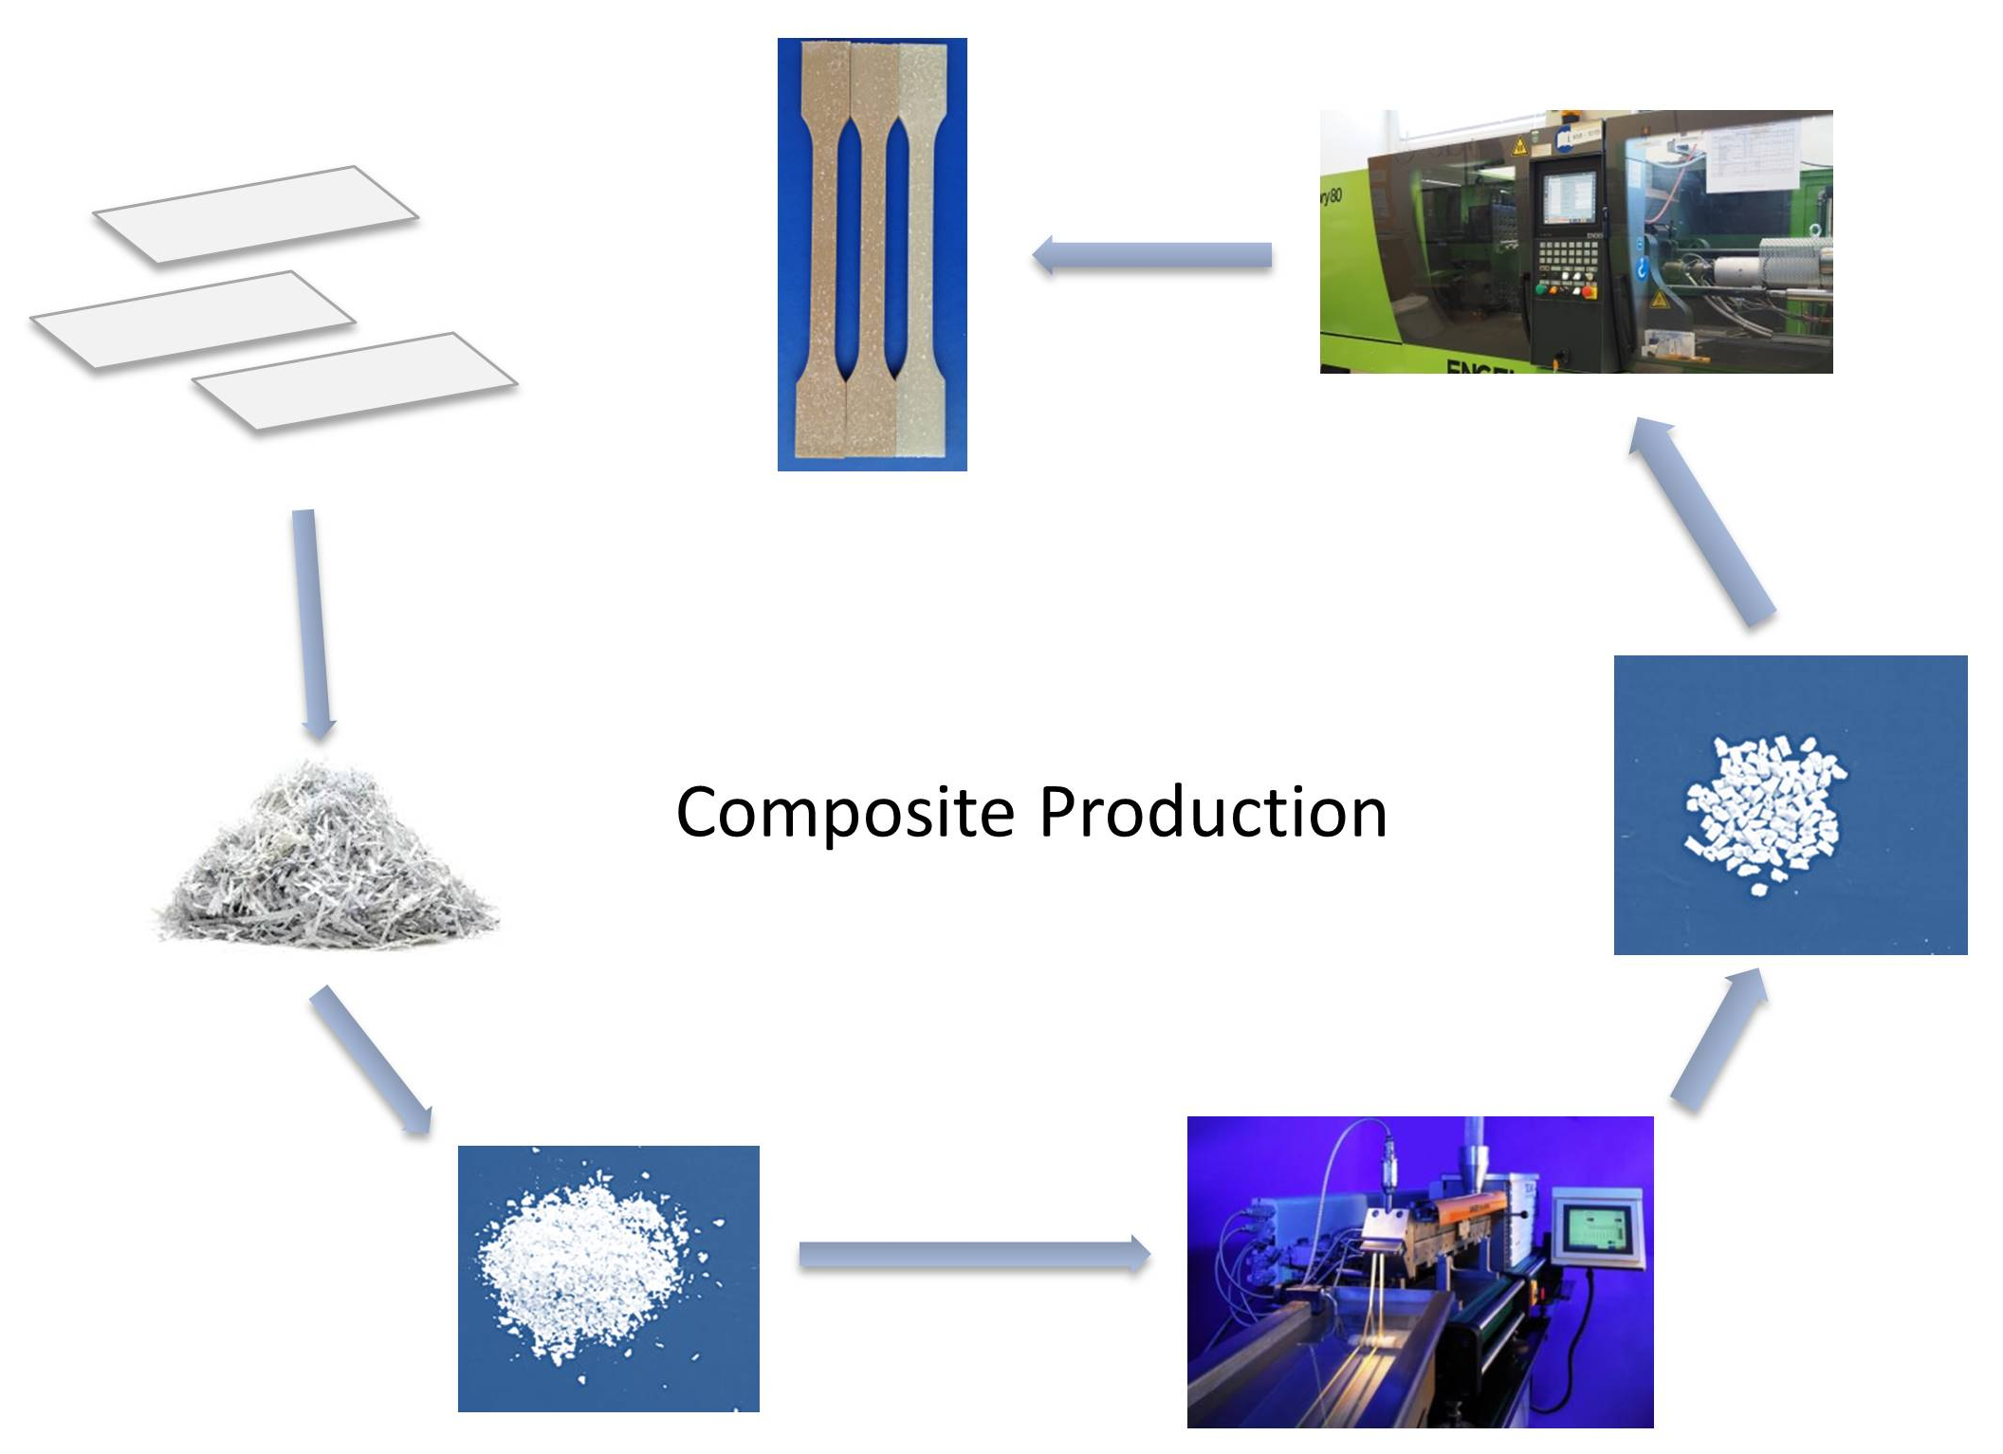

Figure 1. Production cycle for fabricating the paper polypropylene composites

2.3. Mechanical Testing and Microscopy

Mechanical characterization of the injection molded composites was carried out by tensile testing with a Zwick-Roell Z020 20 kN universal testing machine according to ISO 527-2. For determination of the elastic modulus a crosshead speed of 1 mm/min was applied, afterwards the measurement was continued with 5 mm/min. The composite’s flexural properties were characterized by a Zwick–Roell ZMART.PRO 10 kN universal testing machine, according to ISO 178 with a testing speed of 2 mm/min.

SEM analysis was carried out by a Vega Tescan II electron microscope with an accelerating voltage of 5 kV and a secondary electron detector. The cryo-fractured surfaces of the composite samples were investigated after gold sputtering.

2.4. Fiber Extraction and Fiber counting

After mechanical testing, the specimens were used for fiber extraction. Approximately 1 g of composite was dissolved in p-xylene at 130°C for 1 h to free the fibers from the matrix. Afterward the solution was filtrated and washed with hot p-xylene for multiple times. The obtained pulp fibers were diluted in 50 ml distilled water and stirred for 4 h at room temperature. Subsequently, some droplets of the fiber suspension were transferred to a microscopy glass slide and investigated with a light microscope (Olympus BX 61). For obtaining values for the original fiber length, plain paper snippets were also stirred in 50 ml water until they disintegrated into single fibers and transferred to glass slides. For every sample, three slides were prepared and the lengths of approximately 3000 fibers were counted manually from the image obtained by the Olympus Stream software. The frequencies of certain fiber length classes and cumulative frequencies were obtained by the according analysis tool in Microsoft Excel.

3. Results and Discussion

3.1. Effect of increasing Fiber Mass Fraction

In Figure 2 the mechanical properties of the composites are depicted. Tensile as well as flexural moduli show an increase with increasing paper fiber content. Tensile modulus increases from 1500 MPa (plain PP) to 3500 MPa at 45 wt. % paper. Flexural modulus increases in a similar way with slightly lower values. The incorporation of cellulose fibers into a PP matrix increases the material’s stiffness, which was already stated in the literature [6].

The tensile strength of the composites shows only a slight increase with increasing paper content. Plain PP samples show a tensile strength of 35 MPa, which was increased to 40.5 MPa at 45 wt.% paper content. At 15 wt.% paper, the strength even decreases and lower values than for the plain PP matrix were produced. In contrast to this, flexural strength shows a significant increase with increasing fiber mass fraction. The flexural strength was increased from 41 MPa to 65 MPa at 45 wt.% paper content. This deviation of strength values were attributed to the remaining fiber bundles in the composite. It has to be considered that paper snippets were applied instead of separated cellulose fibers as reinforcement. In paper sheets, the cellulose fibers show strong adhesion by hydrogen bonding which were not broken up entirely by the processing methods applied in this study. As whole fiber bundles were embedded into the matrix the contact surface between the fibers and the polymer was reduced. Therefore, the strength of the cellulose fibers could not contribute to the composite’s strength in the according fiber fraction. Furthermore, paper does not only consist of cellulose fiber, but also of other wood components, fillers and additives, which may have a negative effect on the composite’s tensile strength. For flexural testing, the surface properties have a significant influence on the composite’s properties, additionally to fiber matrix adhesion and shear strength. Here, also the non-fibrillated paper snippets led to an increase in flexural strength, as the applied compression forces could be taken up more effectively than the tensile forces by the coiled fibers bundles.

Figure 2. Tensile and flexural properties of PP and the injection molded paper composites at 3 different mass fractions.

A fiber length distribution was generated from the cellulose fibers obtained from the composites. The fibers were distributed in length classes of 50 micrometers ranging from 50 to >2000 µm. In order to obtain information about fiber degradation due to processing, un-processed paper snippets were also disintegrated in water and used for generating a fiber length distribution. The cellulose fiber length distributions of paper snippets and the composites are depicted in Figure 3 in the form of a cumulative frequency distribution. As expected, un-processed paper fibers clearly show a higher percentage of longer fibers with maximum fiber lengths up to 2000 µm. It was observed that 90% of the fibers were below 850 µm. Compounding and injection molding are both shear-intensive processes, which led alongside with thermal degradation to a significant shortening of the cellulose fibers. For processed fibers, 90% of the fibers were below 500 µm. The fiber volume fraction did not seem to affect fiber degradation in a specific way and a similar length distribution was obtained for all composites.

Figure 3. Cumulative fiber length distribution of plain paper fibers and the three composites.
3.2. Effect of Multiple Processing

In Figure 4 the mechanical properties of injection molded PP and the reprocessed paper composites at 15 wt.% paper are depicted. The flexural properties of the fourth production cycle are missing due to the lack of material induced by constant material loss during recycling. It was observed that modulus as well as strength values increase from the first to the second processing cycle even though the cellulose fibers were expected to degrade with every processing step. The third and fourth cycle show slightly lower values, but they are still higher compared to the properties of the first cycle. Again, the flexural strength is significantly higher that the tensile strength in all processing cycles. The reason for the increase between the first and second cycle was attributed to the defibrillation of the snippets during processing. The high shear forces during compounding do not only result in fiber length degradation, but also in a separation of fiber bundles, which improves bonding between fiber and matrix. As a result, the mechanical properties of the composite increase even though the average fiber length decreases.
Figure 4. Tensile and flexural properties of PP and the recycled composites at 15 wt.% paper.

In Figure 5, the cumulative fiber length distributions of un-processed paper fibers and the recycled composites are depicted. As expected, multiple processing steps led to significant fiber degradation, which is most obvious when un-processed fibers and first cycle fibers are compared. From first to second cycle the degradation is less pronounced. Here, 90% of the second cycle fibers are below 450 µm, while first cycle fibers reach this value at 500 µm. However, it is expected that the additional process cycle has a positive impact regarding fiber defibrillation, which results in an increase of surface area. At this recycle step, the fiber length could be still maintained at a relatively high level resulting in the high mechanical properties, which were measured for the second cycle. The third and the fourth cycle show significant fiber degradation. 90% of the fibers of the third processing cycle were below 200 µm. For the last processing cycle mainly particles and a few short fibers in the 100 µm class were observed. Also the mechanical properties decreased from second to third cycle but stayed constant for the fourth cycle. Tensile and flexural modulus are still higher than the ones for plain PP and the first process cycle, as the degraded fibers and particles still have a positive effect on the material’s stiffness. The tensile strength of the composites increased slightly at the second production cycle, while the other samples were comparable to plain PP. For the tensile strength, the critical fiber length is an important factor. When the average fiber length falls below this critical value, the fibers are pulled out of the matrix at a certain tensile stress and cannot fully function as reinforcement. Therefore, no reinforcing effect could be observed at higher processing cycles.

Figure 5. Cumulative fiber length distribution of plain paper fibers and the reprocessed composites.

4. Conclusion

Natural fibers are used for various products as reinforcement in polymers and can potentially replace synthetic fibers in some applications. Their advantages include sustainability, abundant availability, low cost and suitable mechanical properties. However, they are also prone to degrade under the influence of high temperature and shear intensive-processing as it is present during composite production in plastic processing machinery. In order to observe this effect paper fiber reinforced PP composites with different volume fractions were processed and reprocessed in this work. A distribution of the cellulose fiber length was generated for every composite and process cycle and compared to the tensile and flexural properties of the composites. Multiple processing steps gradually decreased the fiber length in the composites, but the mechanical properties increased during the first and second processing cycle. Also after repeated processing, the mechanical properties stayed at a high level, which was especially observed for modulus values and flexural properties. It was expected that the reprocessing had a positive influence on fiber defibrillation, which decreased fiber agglomeration and increased the mechanical properties despite the significant degradation of fiber length.

Acknowledgments

The authors are grateful to the province of Upper Austria for financial support of the project “Reactive processes in polymeric multiphase systems”.

References
1. Wambua P, Ivens J, Verpoest I (2003) Natural fibres: can they replace glass in fibre reinforced plastics? Composites Science and Technology 63(9): 1259–1264.
2. Prambauer M, Paulik C, Burgstaller C (2016) Evaluation of the interfacial properties of polypropylene composite laminates, reinforced with paper sheets. Composites Part A: Applied Science and Manufacturing 88: 59–66.
3. Prambauer M, Paulik C, Burgstaller C (2015) The influence of paper type on the properties of structural paper – Polypropylene composites. Composites Part A: Applied Science and Manufacturing 74: 107–113.
4. Prambauer M, Paulik C, Burgstaller C (2018) Influence of Paper Content and Matrix Selection on the Porosity, Crystallinity and Water Uptake of Thermoplastic Paper Composites. J Polym Environ 26(5): 2007–2017.
5. Azwa ZN, Yousif BF, Manalo AC et al. (2013) A review on the degradability of polymeric composites based on natural fibres. Materials & Design 47: 424–442.
6. Faruk O, Bledzki AK, Fink H-P et al. (2012) Biocomposites reinforced with natural fibers: 2000–2010. Progress in Polymer Science 37(11): 1552–1596.

