EuroSun2026
RESULTS OF IEA SHC TASK 70 / EBC ANNEX 90 “LOW CARBON, HIGH COMFORT INTEGRATED LIGHTING”
Jan de Boer¹, Luo Tao², Barbara S. Matusiak³, Mandana S. Khanie⁴, David Geisler-Moroder⁵, Eleanor Lee⁶, Natalia Giraldo Vasquez⁷, Niko Gentile⁸
¹ Fraunhofer Institute for Building Physics IBP, Stuttgart (Germany), jan.deboer@ibp.fraunhofer.de
² China Academy of Building Research, Beijing (China)
³ Norwegian University of Science and Technology NTNU, Trondheim (Norway)
⁴ UCL Institute for Environmental Design and Engineering (IEDE), London (United Kingdom)
⁵ University of Innsbruck, Innsbruck (Austria)
⁶ Lawrence Berkeley National Laboratory, Berkeley (U.S.A.)
⁷ DTU Civil Engineering, Kongens Lyngby (Denmark)
⁸ Lund University, Lund (Sweden)
Summary
Lighting is responsible for 5% of global CO2 emissions and 15% of electrical energy use, posing significant challenges in decarbonization efforts. The SHC Task 70 / EBC Annex 90 initiative aims to promote low-carbon, high-comfort integrated lighting through a holistic approach involving electric lighting, daylighting, and façade technologies. Key objectives include broadening perspectives from component-based to system-oriented solutions, emphasizing life cycle assessment, and considering regional energy markets. The project also addresses digitization in lighting design and operation, incorporates evolving user needs, and fosters collaboration among stakeholders. Outcomes target improvements in regulations, standardization, and building certification.
Keywords: decarbonization, daylighting, complex fenestration systems, electric lighting, lighting requirements
Field of application for the findings and addressed audience: lighting design / industry, façade design / industry, architecture, and interior architecture
- Introduction
Lighting accounts for 5% of the global CO2 emissions. Its carbon footprint has a significant impact on global warming. Also, in the transition to mainly electricity-based energy systems, lighting with 15% of the electrical energy consumption is in strong competition with other existing or new consumers, e.g. e-mobility or heat pumps. With rising electricity prices and steadily higher directly taxed CO2 emissions also lighting costs increase significantly. Thus, to make today’s high comfort lighting installation more efficient, the consumption of electric lighting systems must be cut further, and benefits of daylight used better. And, moreover, embodied energy for electric and daylighting – i.e. façade technology – must be taken into account. Thus, widening the rating perspective of lighting solutions to a more holistic view of its impact on CO2 emissions, encompassing the whole life cycle (the “lighting value chain”) also in context of regional energy markets aspects, interaction with other building trades etc. is urgently deemed necessary. This goes far beyond pure LED lamp driven efficiency gains and can allocate big additional potentials.
- Objectives
The aim of SHC Task 70 / EBC Annex 90 “Low Carbon, High Comfort Integrated Lighting” is to identify and support implementing the potentials of lighting (electric, façade: daylighting and passive solar) in the decarbonization on a global perspective while aligning the new integrative understanding of humans’ light needs with digitized lighting on a building and a building related urban scale:
- Support broadening the view on lighting solutions as a whole in decarbonization. Bridge the gap between a component view (manufacturer’s focus) and design-oriented system approaches. Support the transition from energy focused views to a LCA perspective. Identify key impact factors and develop the most effective strategies and roadmaps while including regional specifics.
- Contextualize this with the fast-developing digitization of buildings / lighting installations on the technology, design, and operational side. Add to selected open points in the digital chain like better design processes.
- Align this with the still growing understanding of user needs; here especially build upon results from earlier tasks (e.g. Task 61).
- Integrate competencies: Bring the different involved players (electric lighting, façade, industry, controls) so far not connected on low carbon solutions together in workshops and specific projects. Create added value also by transferring into standardization, regulations, and building certificates.
SHC Task 70 – Annex 90 is collaborative research activity with the IEA Energy in Buildings and Communities Programme (EBC). The joint research projects brings together around 60 experts from 14 countries from 35 entities. It runs from 1/2023 throughout 6/2026.
- Deliverables
The deliverables of the task cover the four fields “Low Carbon Lighting: Scenarios, Strategies and Roadmaps”, “Visual and Non-Visual User Requirements”, “Digitalized Lighting Solutions for Low Carbon Build Environments”, “Low Carbon Daylighting and Lighting Solutions: Practical Applications”.
Results are made available in the form of IEA reports, a book in the IEA SHC book series with Wiley/Ernst & Sohn, white-papers, position papers, case study reports and the link to standardization: ISO TC 274’s ISO 10916 “Calculation of the impact of daylight utilization on the net and final energy demand for lighting” and ISO/CIE CD 25176: “BSDF data generation for complex fenestration systems”. The group of experts continuously organized industry workshops and seminars for practitioners. Final task results will be made available in fall 2026 under https://task70.iea-shc.org/.

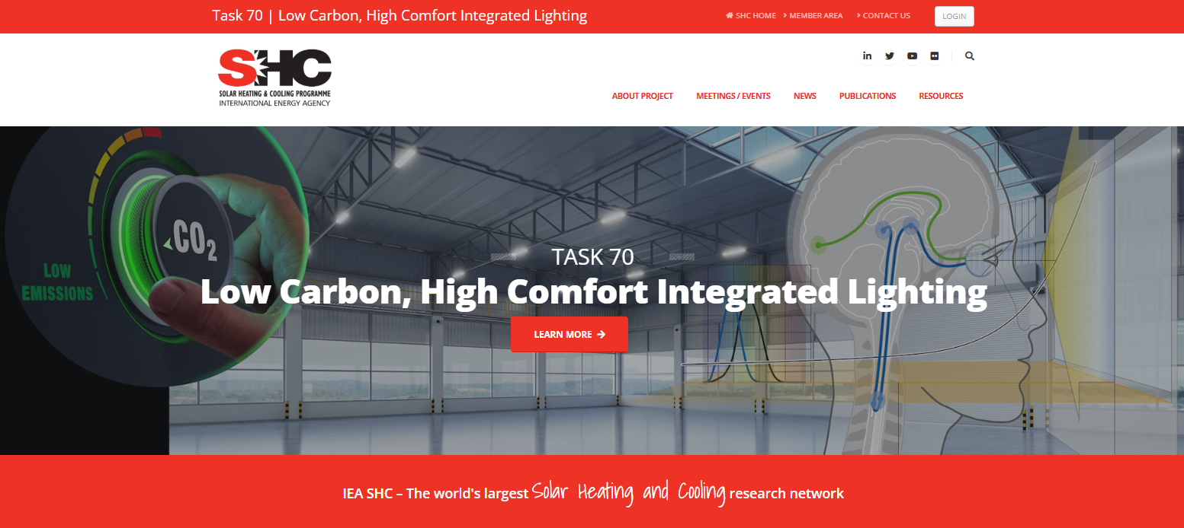
Fig. 1: Project website under https://task70.iea-shc.org/

