EuroSun2026
V2G SCHEDULING STRATEGY FOR NET LOAD LEVELING
IN PV-INTEGRATED COMMERCIAL BUILDINGS

Ji-Young Eum, Gyeong-Seok Choi (corresponding author)
Korea Institute of Civil Engineering and Building Technology (KICT), Department of Building Energy Research, Goyang (Republic of Korea)
eumjiyoung@kict.re.kr, bear717@kict.re.kr
Summary
Commercial buildings increasingly combine on-site PV with expanding EV charging infrastructure. Uncontrolled EV charging can intensify duck-curve-like net load patterns by concentrating additional demand during the evening ramp, when PV generation declines while building demand remains high. Although smart charging can shift EV demand to daytime PV generation hours, unidirectional charging cannot reduce the evening ramp once it occurs. This study evaluates a rule-based vehicle-to-grid (V2G) scheduling strategy for a mid-scale office building equipped with rooftop PV and facade BIPV through a simulation-based comparison of four EV charging configurations. Both DC fast and AC slow chargers are assumed to support bidirectional operation to assess the technical potential of building-level V2G flexibility. A net load target of 120 kW, corresponding to approximately 80% of the baseline peak net load, is set for the scheduling analysis. The results show that charging during PV generation hours and discharging when the net load exceeds this target hold the net load at the target during both the morning occupancy peak (09:00–10:00) and the evening ramp (17:00–19:00). The daily load factor increases from 56.2% under uncontrolled charging to 72.6% under V2G. These results indicate that bidirectional V2G operation can provide additional net-load-leveling capability beyond PV-aligned smart charging across both AC and DC charger types.
Keywords: vehicle-to-grid, vehicle-to-building, net load leveling, building-integrated photovoltaics, bidirectional charging
Field of application for the findings: EV-integrated building systems, commercial building energy management, PV-EV integration, demand-side management, grid flexibility
Addressed audience: Building energy researchers, EV charging infrastructure designers, building energy managers, grid operators, energy policy makers

- Introduction
Commercial buildings are increasingly equipped with photovoltaic (PV) systems as a primary means of on-site renewable energy generation, while EV charging infrastructure is simultaneously expanding as part of broader decarbonization efforts in the transport sector. Among commercial building types, office buildings show temporal alignment between PV generation hours and occupancy-driven electricity demand, so PV can already contribute to reducing daytime net load. However, as PV penetration grows across the grid, net load drops sharply during midday and ramps steeply after sunset, a pattern widely referred to as the duck curve. Uncontrolled charging concentrated at the end of the working day adds demand during the evening ramp, when PV generation is falling and building demand often remains high. If similar charging patterns are aggregated across many commercial buildings, they may contribute to additional grid-side ramping stress.
PV-EV integration has been studied primarily from a self-consumption and self-sufficiency perspective. Fachrizal et al. (2022) evaluated optimal PV-EV sizing at workplace charging stations under smart charging schemes and reported that coordinated charging improves on-site PV self-consumption relative to uncontrolled operation. At the building scale, previous studies have extended this discussion to V2B operation, peak shaving, and economic performance. Luo et al. (2024) conducted a techno-economic evaluation of PV-building-EV integrated systems and quantified V2B impacts on both building energy costs and EV owner economics. Ghafoori et al. (2023) developed a machine learning-based demand prediction system to optimize V2B charging and discharging schedules for peak shaving in commercial buildings. Rehman et al. (2026) reviewed global V2G research and pilot projects and reported that coordinated EV scheduling can support grid balancing, load factor improvement, and renewable integration. Yang et al. (2024) showed that strategic TOU tariffs can shift EV charging demand, although effective load shifting requires sufficiently large price differences.
However, many V2G studies have focused on residential applications, individual-vehicle operation, or economic performance. Building-level scheduling strategies that explicitly target net load leveling across both the morning occupancy peak and the evening ramp remain less clearly quantified, particularly in commercial buildings where slow chargers are widely installed for long-duration parking. This study therefore evaluates the additional building-level net-load-leveling capability provided by bidirectional V2G scheduling beyond unidirectional smart charging, under an upper-bound case in which both AC slow and DC fast chargers support bidirectional operation.
South Korea provides a relevant context for this analysis because EV charging infrastructure is expanding under mandatory installation requirements, while the prevailing TOU tariff structure only partly supports PV-aligned daytime charging. By the end of 2024, cumulative EV registrations in South Korea reached approximately 684,000 vehicles (Ministry of Land, Infrastructure and Transport, 2025). The revised Act on the Development and Dissemination of Environment-Friendly Motor Vehicles mandates EV charger installation in 5% of parking spaces in new buildings and 2% in existing facilities (Ministry of Trade, Industry and Energy, 2022). Under the 2026 EV charging tariff schedule, the daytime V2G charging window overlaps with mid-load periods and partly with peak-load periods, depending on the season, creating a partial misalignment between charging cost incentives and the PV generation window required for V2G operation (KEPCO, 2026).
This study addresses the research gap with two objectives: (1) quantify the impact of uncontrolled EV charging on the building net load profile and discuss its potential grid-side implications; and (2) evaluate the net load leveling performance of V2G scheduling and clarify why bidirectional discharge provides additional peak-reduction capability beyond unidirectional smart charging under the evaluated conditions. A simulation-based scenario analysis was conducted for a representative mid-scale office building in South Korea equipped with a combined rooftop PV and facade BIPV system, comparing four EV charging configurations to distinguish the effects of uncontrolled charging, PV-aligned unidirectional charging, and target-based bidirectional scheduling on the building net load profile.
- Methodology
2.1 System Configuration and Data
A mid-scale office building is selected as the analysis target. The building is assumed to have a floor area of 4,800 m² and a peak demand of 200 kW. The hourly load pattern is based on a standard Korean commercial building load profile reported by Moon and An (2014). Daily electricity consumption is 2,807.6 kWh on a representative summer weekday, with peak demand occurring around 14:00 due to cooling loads. The load rises from 08:00 with occupancy and remains above 185 kW from 10:00 to 17:00. The building is assumed to be equipped with a 110 kW PV system, comprising 77 kW of rooftop modules and 33 kW of facade BIPV. The capacity is assumed to be representative of the roof and facade area available in a building of this size. PV generation is calculated by applying the regional hourly generation profile from the Korea Power Exchange database (KPX, 2024) to the rated capacity. The resulting daily generation is 776.1 kWh, with a peak of approximately 110 kW at around 13:00. PV generation is concentrated during daytime hours and declines to near zero by the early evening, while building load remains elevated.
The EV charging infrastructure consists of three 7 kW slow chargers and one 50 kW fast charger, installed in line with commercial building EV infrastructure requirements. The hourly EV charging load profile is derived from measured usage patterns at public charging stations (KPX, 2021), applying utilization rates of 10% for the fast charger and 37.5% for the slow chargers to the normalized hourly KPX charging profile. Here, the utilization rate denotes the ratio of the peak hourly charging power to the rated charger power, which scales the measured profile shape to a level representative of commercial building operation. In this profile, slow-charger load is concentrated after the morning arrival period, while fast-charger load increases toward the end of the working day. EV operation is assumed during building hours only (08:00–21:00); charging during off-peak nighttime hours (22:00–07:00) is excluded as vehicles are assumed absent from the site. This yields a daily fast-charging load of 55.3 kWh and slow-charging load of 91.9 kWh, totaling 147.2 kWh/day. This system configuration was previously applied in Eum and Choi (2026) to analyze EV charging operation types.
All chargers are assumed to support bidirectional power flow. In this study, V2G operation is implemented as a behind-the-meter vehicle-to-building (V2B) configuration, in which the EV batteries act as building-level energy storage. The discharged energy offsets the building net load rather than being exported to the grid, so the building is treated as a single prosumer whose net demand, and therefore its contribution to grid-level peaks, is reshaped by bidirectional EV operation. Because bidirectional AC charging is not yet widely commercialized, the S3 case should be interpreted as an upper-bound technical-potential scenario for building-level V2G flexibility, rather than as a representation of current charger deployment. Charging and discharging efficiencies are each set to 90.0%, corresponding to a round-trip efficiency of 81.0%. For the V2G scenario, EV battery capacity is set at 63 kWh per vehicle, or 252 kWh in total for four vehicles, based on a mid-size EV model currently available in the Korean market. The initial SOC at arrival is assumed to be 50%, representing a mid-range commuting condition, and the SOC operating range is limited to 20–90% to protect battery lifetime. The hourly profiles of building load, PV generation, and uncontrolled EV charging load are summarized in Fig. 1.
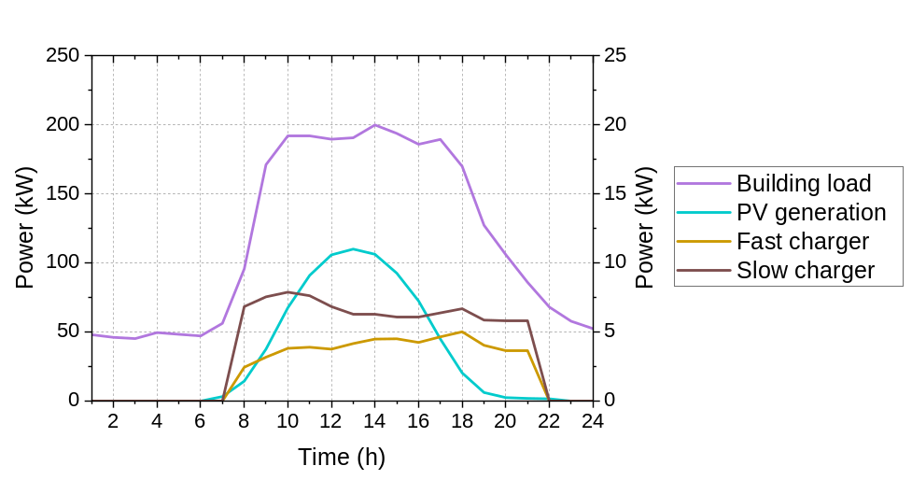
Fig. 1: Hourly profiles of building load, PV generation, and EV charging load
2.2 Scenario Design and Analysis Method
Four scenarios are defined to isolate the effects of EV charging timing and V2G discharge capability on the building net load profile (Tab. 1). The baseline (S0) represents building and PV operation without EV. Uncontrolled charging (S1) reflects current common practice where EVs charge on arrival or at the end of the working day without scheduling, following the hourly pattern described in Section 2.1. Smart charging (S2) refers to controlled unidirectional charging in which EV charging is scheduled to coincide with the PV peak hours (11:00–15:00), shifting load away from the evening ramp without discharge capability. The total daily EV load is redistributed uniformly across this window at 29.4 kW, with no charging permitted outside this period.
The V2G scenario (S3) adds bidirectional discharge to a non-uniform charging schedule. During the PV generation period (11:00–16:00), V2G charging is allowed according to the available net load capacity below 120 kW, subject to the SOC upper limit. The 120 kW target corresponds to approximately 80% of the S0 baseline peak net load (149.8 kW) and was adopted as a representative peak-reduction target for the scheduling analysis. A different target would change the achievable leveling under the same charger power and SOC constraints. Discharge occurs whenever the building-only net load (S0) exceeds the 120 kW target. This condition occurs at both the morning occupancy peak (09:00–10:00) and the evening ramp (17:00–19:00), allowing the EV batteries to suppress net load peaks across the operating day. Therefore, S2 and S3 differ not only in charging logic but also in the role of the EV battery. S2 uniformly redistributes the daily EV charging load over 11:00–15:00. In contrast, S3 uses available headroom below the 120 kW target for SOC-constrained V2G charging.
Tab. 1: Scenario definitions
Scenario | EV Operation | Charging | Discharging
S0 | No EV (baseline) | – | –
S1 | Uncontrolled | On arrival / end of day (unscheduled) | None
S2 | Smart charging | 11:00–15:00  (PV peak hours) | None
S3 | V2G scheduling | 11:00–16:00,  subject to SOC limit | 09:00–10:00, 17:00–19:00

A simulation-based scheduling analysis is conducted to evaluate the net load profile of each scenario at hourly resolution for a representative summer weekday. For S1 and S2, the net load is obtained directly from the building load, PV generation, and the EV charging schedules. For S3, a rule-based dispatch strategy is applied. The dispatch is subject to a maximum combined output of 71 kW, SOC bounds of 20–90%, and a prohibition on simultaneous charging and discharging. To avoid relying on net battery depletion, the V2G schedule is verified against a minimum departure SOC requirement. The final SOC at the end of the operating period is confirmed to remain no lower than the initial SOC of 50%. Unlike S1 and S2, S3 is not constrained to reproduce the full 147.2 kWh daily mobility charging demand. Its peak-load and load-factor results should therefore be interpreted as an SOC-constrained flexibility potential rather than an energy-equivalent comparison with S1 and S2. The load factor is used as a performance metric and is defined as the ratio of average to peak net load over the 24-hour daily profile. A higher value indicates a flatter profile.
At each hourly time step, the building-only net load is first calculated as the building demand minus PV generation. When this value is below the 120 kW target during the charging window, EVs are charged within the available headroom between the target and the building-only net load, subject to charger power and SOC constraints. When the building-only net load exceeds 120 kW during the discharge window, EVs discharge to offset the excess above the target. The hourly charging and discharging power are determined by eq. 1 and eq. 2, respectively.

$P_{ch,t}=\min\left(P_{ch,max}, 120-P_{net,0,t}, ({SOC}_{max}-{SOC}_{t})∙E_{batt}/η_{ch} \right)$ (eq. 1)
$P_{dis,t}=\min\left(P_{dis,max}, P_{net,0,t}-120, ({SOC}_{t}-{SOC}_{min})∙E_{batt}∙η_{dis}\right)$ (eq. 2)

where P_{ch,max} and P_{dis,max} denote the maximum combined charging and discharging power (71 kW), and P_{net,0,t} is the building-only net load at hour t. SOC_{max} and SOC_{min} are the upper and lower SOC bounds (0.9 and 0.2), SOC_{t} is the SOC at hour t, E_{batt} is the total battery capacity (252 kWh), and η_{ch} and η_{dis} are the charging and discharging efficiencies (0.9 each). P_{dis,t} denotes the power delivered at the building side, so that the corresponding battery drawdown is P_{dis,t}/η_{dis}. The third term of each equation limits the power as the battery approaches its respective SOC bound.
- Results and Discussion
3.1 Baseline Net Load Profile
In the baseline scenario (S0), PV generation reduces daytime net load due to the partial overlap between generation and building demand hours. The net load drops to a minimum of 80.7 kW at 13:00 during the building operating hours, coinciding with peak PV generation, before rising to a peak of 149.8 kW at 18:00 as PV generation falls and building loads remain elevated. Two distinct net load peaks are evident: a morning occupancy peak of 133.8 kW at 09:00 and an evening ramp peak of 149.8 kW at 18:00 (Fig. 2). This indicates that net load management in the building analyzed here requires addressing both peaks, which PV alone cannot resolve.
The evening ramp toward this second peak, following the PV-induced midday trough, can be interpreted as a duck-curve-like pattern at the building level, whereas the morning occupancy peak is a separate demand-driven feature. The key challenge is the steep afternoon transition between the trough and the evening peak, during which the net load rises to its daily maximum within a few hours. PV output is already low during this period, so additional PV capacity alone may not sufficiently reduce the ramp. Mitigating it requires a resource that can supply energy during the peak period, which motivates the V2G strategy evaluated in the following scenarios.
3.2 Scenario Comparison
Uncontrolled charging (S1) raises the evening net load peak to 161.5 kW at 18:00, an increase of 11.7 kW over the S0 baseline, driven by the combined fast and slow charger load concentrated at end-of-day. This directly increases the building-level evening ramp and, from the grid perspective, may contribute to duck-curve-related stress when similar charging patterns are aggregated across buildings.
Smart charging (S2) eliminates this evening spike by redistributing the total EV load to the PV peak hours (11:00–15:00) at 29.4 kW. This restores the evening net load profile to the S0 level but leaves the evening ramp itself unaddressed. Under the evaluated scheduling conditions, unidirectional charging alone does not suppress the evening ramp because it cannot provide discharge during the peak period.
The V2G strategy (S3) suppresses both peaks through bidirectional operation. During the allowed PV generation period (11:00–16:00), V2G charging follows the 120 kW target-tracking rule rather than the uniform smart-charging schedule used in S2. Charging begins at 11:00 when the building-only net load falls below 120 kW. Charging follows the available headroom below the target, peaking at 39.3 kW at 13:00, and continues until the battery reaches its 90% SOC limit at 15:00, so no further charging occurs at 16:00. The total V2G charging amount is 134.8 kWh. Discharge is activated when the S0 net load exceeds 120 kW, covering the morning occupancy peak (09:00–10:00) and the evening ramp (17:00–19:00), with a maximum discharge of 29.8 kW at 18:00 and a total of 74.3 kWh. Fig. 2 shows the hourly net load profiles of the four scenarios. Only S3 keeps the net load at the 120 kW target across the peak periods considered, whereas S1 raises the evening peak and S2 restores it to the S0 level without reducing the ramp.
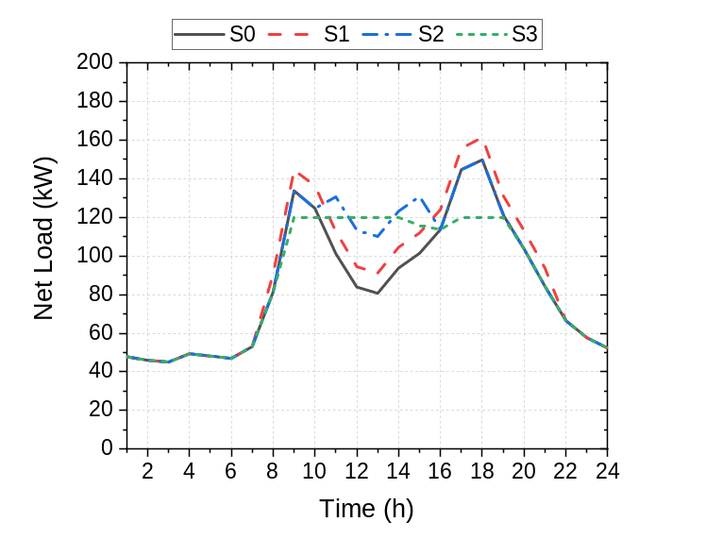
Fig. 2: Hourly net load profiles for S0–S3 scenarios
Tab. 2 summarizes performance across all scenarios. The results show a clear progression from S0 to S3. S1 increases peak net load by 11.7 kW and reduces the load factor to 56.2%, while S2 restores the peak to the S0 level and improves the load factor to 60.6% through daytime load redistribution. This gain reflects a higher average net load at an unchanged peak rather than peak reduction itself. S3 achieves the lowest peak net load among the evaluated scenarios, reducing the peak by 29.8 kW relative to S0 and S2 and by 41.5 kW relative to S1, and the daily load factor reaches 72.6%. These values should be read within the SOC-constrained flexibility formulation of S3, which does not supply the full 147.2 kWh daily charging demand that S1 and S2 provide for vehicle use. The daily net load under S3 is 2,092.0 kWh, which is lower than that under S1 and S2 at 2,178.7 kWh. This is because the EV batteries in S3 are operated as building-level storage, with charging determined by the 120 kW target. Under the target-based dispatch, V2G charges 134.8 kWh and discharges 74.3 kWh, giving a net increase of 60.5 kWh in daily building demand.
Tab. 2: Net load performance comparison across scenarios
Indicator | S0 Baseline | S1 Uncontrolled | S2 Smart | S3 V2G
Peak net load [kW] | 149.8 (18:00) | 161.5 (18:00) | 149.8 (18:00) | 120.0  (09:00–14:00,  17:00–19:00)
Net load at 17:00 [kW] | 144.7 | 155.7 | 144.7 | 120.0
Net load at 18:00 [kW] | 149.8 | 161.5 | 149.8 | 120.0
Daily load factor [%] | 56.5 | 56.2 | 60.6 | 72.6
Daily net load [kWh] | 2,031.5 | 2,178.7 | 2,178.7 | 2,092.0
Duck curve contribution | Neutral | Intensifies evening ramp | Eliminates evening spike; ramp unchanged | Suppresses both peaks

As shown in Fig. 3, the SOC reaches 90% at 15:00 and declines to 65% by 19:00 as discharge capacity is progressively utilized across both peak periods. Because the final SOC (65%) remains above the arrival SOC of 50%, the peak reduction in S3 is achieved without net battery depletion over the day. The charging phase (11:00–15:00) coincides with the period of lowest net load and highest PV contribution, when additional EV charging can be accommodated with minimal increase in grid stress. The discharging phase follows in two distinct intervals corresponding to the morning and evening net load peaks. The SOC trajectory shows that the 252 kWh total battery capacity is sufficient to cover both discharge events within a single operating day without depleting below the 20% lower bound.
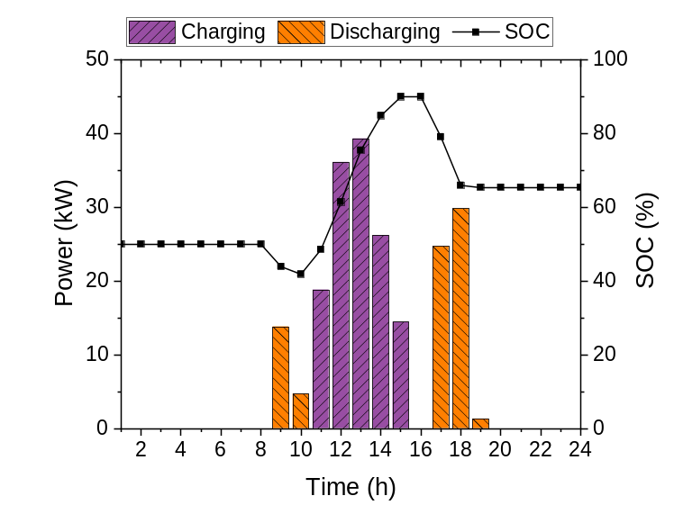
Fig. 3: V2G charging/discharging schedule and SOC profile under S3
3.3 Implications and Policy Considerations
The scenario comparison suggests several practical implications for building energy management and grid integration. The S1 findings indicate that as EV penetration in commercial buildings increases, uncontrolled charging may intensify the evening ramp, particularly when charging is concentrated near the end of the working day. The comparison between S2 and S3 indicates that unidirectional scheduling alone cannot address the evening ramp, since reducing it requires energy to be supplied during the peak period. The load factor improvement under S3 suggests that V2G-equipped buildings could function as dispatchable demand-side flexibility resources when coordinated at scale.
In S3, the AC slow chargers participate in bidirectional operation alongside the DC fast charger. The flexibility potential of building EV infrastructure therefore depends not only on charger count but also on bidirectional capability and rated power, a consideration that may become more relevant as bidirectional AC charging matures.
The 2026 tariff revision moved the midday block toward mid-load and the evening block toward peak-load, which improves the alignment between the tariff structure and PV-aligned daytime charging. A partial misalignment nevertheless remains for the V2G charging window required for net load leveling. Under the 2026 tariff schedule, the 11:00–16:00 charging window overlaps with mid-load periods and partly with peak-load periods, depending on the season. This can weaken the economic incentive for daytime V2G charging, even when it is technically beneficial for evening discharge. Park et al. (2023) reported that grid-friendly EV charging infrastructure and AC V2G systems have been developed and demonstrated in Korea, although practical deployment remains at the pilot stage. Kim et al. (2023) found that Korean households have a positive willingness to pay for V2G-related charging infrastructure. However, a clear compensation mechanism for building-side V2G discharge remains limited. Establishing such a mechanism, beyond the time-of-use structure itself, therefore remains a key policy gap for building-level V2G deployment.
- Conclusions
A rule-based V2G scheduling strategy was evaluated for a mid-scale office building equipped with rooftop PV and facade BIPV, using four EV charging configurations. The net load target was set at 120 kW, approximately 80% of the baseline peak. Uncontrolled charging raises the evening peak, and PV-aligned smart charging removes this increase but does not reduce the underlying evening ramp. Only the V2G scenario, which discharges when the building-only net load exceeds the target, holds the peak net loads at that target and improves the daily load factor from 56.2% under uncontrolled charging to 72.6%. Additional peak reduction is therefore achieved through a dispatchable resource, represented in this study by bidirectional V2G operation.
These results should be interpreted as an SOC-constrained V2G flexibility scenario rather than as a direct energy-equivalent replacement for S1 or S2 charging demand. The analysis also assumes full bidirectional availability of both AC slow and DC fast chargers, together with a representative summer weekday and deterministic EV availability. The reported V2G performance is therefore a scenario-based estimate rather than a year-round operational outcome. Within these conditions, the participation of AC slow chargers as bidirectional resources suggests that bidirectional functionality may expand building-level flexibility. In practice, implementation will depend on charger standards, vehicle compatibility, communication protocols, and appropriate compensation mechanisms. Future work should extend the analysis to multiple building types and seasons, incorporate stochastic EV availability, and evaluate the aggregated V2G potential for demand response market participation. As building PV capacity continues to expand across rooftops and facades, the interaction between on-site generation and EV operation will require further study at the building level.
- Acknowledgment
This work was supported by the Korea Institute of Energy Technology Evaluation and Planning (KETEP) and the Ministry of Climate, Energy & Environment (MCEE) of the Republic of Korea (No. RS-2024-00459594).
- References
Eum, J.Y., Choi, G.S., 2026. Effects of EV charging operation types on energy self-sufficiency rate and electricity cost in building PV-EV systems. Journal of the Korean Solar Energy Society. 46(3), 77-87.
Fachrizal, R., Shepero, M., Åberg, M., Munkhammar, J., 2022. Optimal PV-EV sizing at solar powered workplace charging stations with smart charging schemes considering self-consumption and self-sufficiency balance. Applied Energy. 307, 118139.
Ghafoori, M., Abdallah, M., Kim, S., 2023. Electricity peak shaving for commercial buildings using machine learning and vehicle to building (V2B) system. Applied Energy. 340, 121052.
Kim, J.H., Hyun, M.K., Yoo, S.H., 2023. Households' willingness to pay for interactive charging stations for vehicle to grid system in South Korea. Sustainability. 15(15), 11563.
Korea Electric Power Corporation (KEPCO), 2026. Electricity Tariff Schedule Effective August 1, 2026. KEPCO, Naju.
Korea Power Exchange (KPX), 2021. Analysis of Electric Vehicle and Charger Dissemination and Usage Status. Korea Power Exchange, Naju.
Korea Power Exchange (KPX), 2024. Regional Hourly Solar and Wind Power Generation Data. Public Data Portal, Republic of Korea. https://www.data.go.kr/data/15065269/fileData.do (accessed 26 March 2026).
Luo, J., Cao, X., Yuan, Y., 2024. Comprehensive techno-economic performance assessment of PV-building-EV integrated energy system concerning V2B impacts on both building energy consumers and EV owners. Journal of Building Engineering. 87, 109075.
Ministry of Land, Infrastructure and Transport (MOLIT), 2025. Total Registered Motor Vehicles. MOLIT, Sejong.
Ministry of Trade, Industry and Energy (MOTIE), 2022. Act on the Development and Dissemination of Environment-Friendly Motor Vehicles. MOTIE, Sejong.
Moon, H.J., An, K.A., 2014. Analysis of electric energy consumptions using load profiling and load shape parameters in commercial buildings, in: Proceedings of the SAREK Summer Annual Conference. pp. 234-246.
Park, K., Jang, D., Kim, S., Lim, Y., Lee, J., 2023. A grid-friendly electric vehicle infrastructure: the Korean approach. IEEE Power and Energy Magazine. 21(6), 28-37.
Rehman, A.U., Lu, J., Du, B., Bai, F., Sanjari, M.J., Hossain, M.A., 2026. Vehicle-to-grid technology for load balancing and energy management: A comprehensive review of technical, economic and environmental perspectives. Applied Energy. 402, 126974.
Yang, S.Y., Woo, J.R., Lee, W., 2024. Assessing optimized time-of-use pricing for electric vehicle charging in deep vehicle-grid integration system. Energy Economics. 138, 107852.

