AUTOMATED TEST SYSTEM FOR CRACK GROWTH RATES EVALUATION ON ADVANCED CFRP

M. Jiménez¹, F. Moreno¹ , R. Cabrera¹, D. Rodríguez¹, K. Muñoz¹ and C. Arellano¹

¹Element Materials Technology Seville, Seville, Spain
Email: miguel.jimenez@element.com, Web Page: https://www.element.com/locations/europe/seville

Keywords: delamination, crack growth, composite, automated test system, image detection

Abstract
An automated dynamic test system has been developed and applied for the characterization of mode I fatigue delamination propagation. This crack detection and monitoring system has enabled to investigate crack growth rates of different advanced CFRP materials. Likewise, the effect of crack opening displacement on the fatigue delamination growth on mode I has been studied on DCB specimens. The developed delamination monitoring system proved to be a suitable tool to perform mode I fatigue tests providing enough accuracy and time optimization. For the same initial delamination length, the maximum displacement applied was proved to influence the values of G_{Imax}, but not significant differences were obtained for the final delamination lengths.

1. Introduction

Main manufacturers implemented primary structures made of composite materials in their aicrafts in the late 1980s. First structural parts such as vertical and horizontal tail planes showed excellent performance and the use of composite structures has increased gradually in civil aircrafts, up to the Airbus A350 XWB, which went one step beyond using carbon fibre reinforced polymers (CFRP), achieving more than 50% of the structure in terms of weight made of composite materials. The increasing use of composite materials in primary aerospace structures requires a complete knowledge of their mechanical properties. For airframe design, it is critical to know interlaminar delamination properties in order to determine the energy levels that aero-structures can sustain before fracture failure mechanisms appear.

The methodology for the study of delamination properties under static loads is well-established. Several standards describe test procedures to determine mode I interlaminar fracture toughness of CFRP laminates. Regarding dynamic testing, two different approaches can be distinguished: no-growth criterion, which aims to ensure that no propagation will ever occur over the lifetime of the component, and damage tolerance approach, which is based on a structure remaining capacity to safely sustain in-service loads, even with the presence of delaminations. The determination of mode I onset of fatigue delamination is covered by ASTM D6115. The study of fatigue crack propagation enables to estimate the behavior of existing delaminations, which may cause significant decresease in stiffness and strength, as well as a massive reduction of the fatigue life of CFRP components. However, there is still a lack of standardization into the characterization of interlaminar delamination growth rates under dynamic loads. Due to this fact, there have been several attempts to develop a procedure for crack propagation tests, which evaluate the crack growth rate as a function of the energy release rate.

Interlaminar delamination growth dynamic testing requires a large amount of loading cycles and multiple measurements of crack lengths during the test which mean long and costly testing. Different methodologies for the tracking of delamination growth along mode I fatigue tests have been developed. Visual observation of crack length, or by means of a travelling microscope are commonly used ways for delamination monitoring. However, these methods are operator-dependent, thus causing high costs and time consuming tests. Another approach is based on a separate measurement of the modulus of elasticity of the DCB specimen and back-calculating the delamination length from the measured compliance. Machine data recorded during the test at specific intervals allow for the changing specimen compliance to be determined and the corresponding delamination length to be back-calculated. This method avoids visual observation, but in some cases this effective crack length has proved to be less consistent than visual observation, yielding less conservative results. Another proposal combines selected visual crack length measurements (together with corresponding compliance data) with additional compliance data recorded automatically at selected intervals (named as Compliance-based approach). Automation of visual crack length tracking has also been carried out for static DCB tests, but it is limited to translucent samples, such as glass fiber-reinforced composites.

This research work is developed as part of the coupons test campaign of SHERLOC, a project belonging to the Clean Sky 2 JU aeronautical research and development program, whose main objective is to combine advanced Structural Health Monitoring (SHM) and smart repair technologies to develop new maintenance concepts. This set of tests is aimed to obtained the allowable values which will be used in the subsequent element design and modelization tasks. Particularly, the ultimate goal of the execution of mode I fatigue delamination tests is to determine the propagation crack rates.

2. Methodology

Materials evaluated in this test campaign are introduced, covering details of the specimens geometry, the developed crack detection and monitoring system is described and specimen preparation prior to test execution, test parameters, set-up and data acquisition system, and necessary steps for the use of automated crack measurement system are detailed in this text. Both because of the innovation of testing execution and the optimization of test performance, the development of this test experimental procedure does not only pursue a more accurate dynamic test, but also an improvement of time of test execution.

2.1. Materials and specimens

The validation campaign consists on the assessment of interlaminar crack growth of two different carbon-fibre reinforced (CFRP) composites, one with thermoset and one with thermoplastic matrix, named as M1 and M3, respectively. Moreover, two variants of the same thermoset composite (representing the second material) have been tested, named as VEIL and EME. The former is based on standard prepeg including a thermoplastic acoustic damping veil, while the latter has a thermoset matrix reinforced by CNTs. The thermoset laminate has unidirectional configuration (0º), while the thermoplastic laminate is a woven fabric material. All the specimens tested as part of this work were conditioned prior to testing according to the ASTM D5229/D5229M, Procedure B.

Quasi-static mode I interlaminar fracture toughness tests were previously conducted according to ISO 15024 standard. In this regard, some features of the fatigue delamination study, such as the coupons geometry, are based on ISO standard. Thus, Double Cantilever Beam (DCB) was used to characterize delamination under mode-I conditions for cyclic loading using a non-adhesive insert to provoke the initial delamination and adhesive bonded loading blocks as load-introduction device.

2.2. Crack detection and monitoring vision system

Crack detection and monitoring vision system is an acquisition, processing and picture manipulation software developed to detect cracks appearing onto specimens surfaces during test execution. With this purpose, a scan area camera is used with a proper lens and light systems previously selected based on the environmental conditions in order to maximize the system performance. The camera AVT Guppy Pro F-201B was used with a 35 mm lens. They were selected to visualize the entire specimen inside the acquired image. The camera has a resolution of (1624x1234) 2Mpix, achieving a ratio of 16 pix/mm. Lens focus and aperture parameters were adjusted in order to achieve maximum definition of the monitoring feature.

An algorithm was programmed linking actuation control to perform periodic stops, and image detection to measure crack length, continuing the test without any human interaction. The system is developed using software LabVIEW from National Instruments. The system is original and is not based in others existing vision systems. This system includes a Graphic User Interface (GUI) where the user can configure, control and monitorize the test. The interface contains a video player to visualize real-time video of the camera and a graph where the crack growth is displayed.

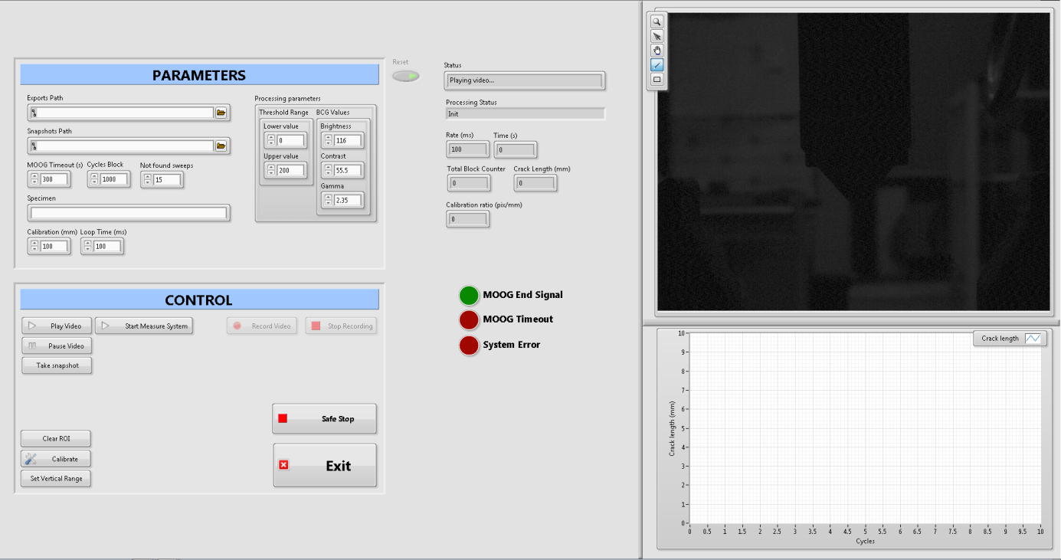

Figure 1. Crack detection and monitoring vision system interface.

Both monitoring vision system and test Controller are communicated and synchronized. In this way, both systems can act at the same time if anything goes wrong or the test finishes.

2.3. Experimental procedure

The test procedure is based on previous research works from the literature which attempted to develop a standardized methodology for the mode I fatigue delamination test.Error: Reference source not found
Before testing, the area of interest in the specimen needs to be carefully prepared to achieve the desired visualization in the monitoring vision system. In order to increase the constrast of the specimen against the surrounding elements, the area of interest of the specimen is white-painted, while the background is covered with a black-painted panel. The area is painted using a white matt water-based paint, obtaining an uniform painted surface. This area is painted starting from the end of the initial delamination area. Once the paint is dry, the tip of the insert is marked with a thin vertical pencil line. Likewise, the edges are marked limiting the desired pre-crack area.

Once prepared specimen is placed and aligned in the test set-up, the lighting system is positioned. Lighting of the area of interest must be carefully controlled so that it has optimum contrast and clarity. Furthermore, the illuminated area of interest also contributes to avoid external influences from the environmental light.
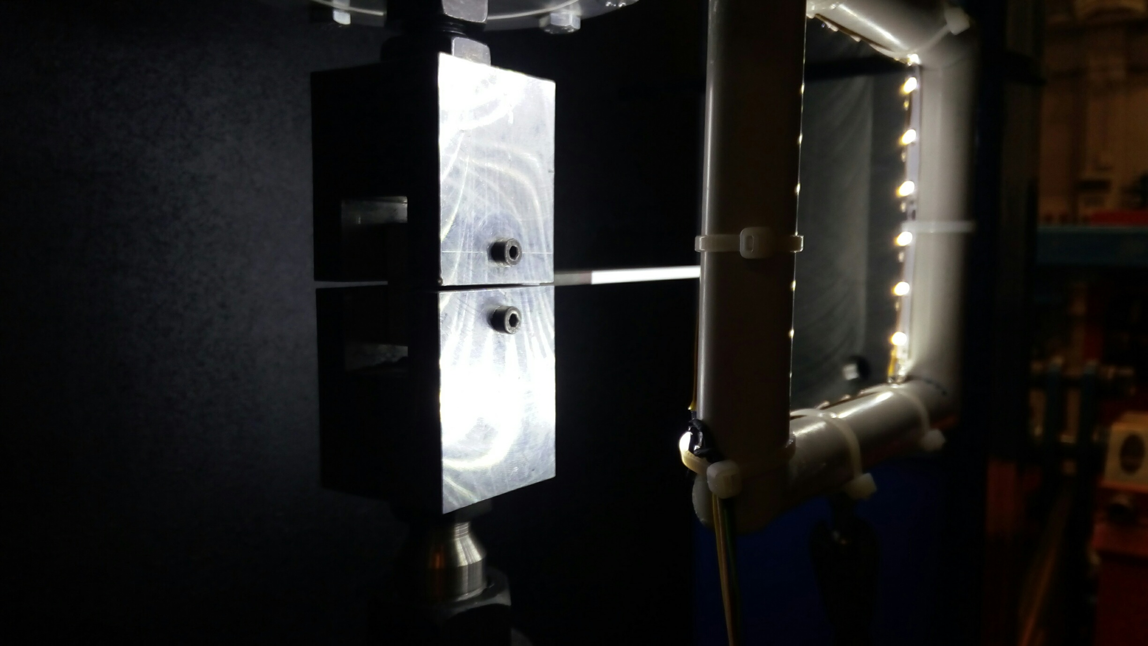

Figure 2. Lighting of test set-up.

Before fatigue testing, the specimen is subjected to a pre-crack under quasi-static loading conditions following ISO 15024 procedure. Thus, this pre-crack is performed at 0.5 mm/min, reaching a crack length ideally between 3 and 5 mm from the tip of the insert. Load and displacement data are recorded during loading and final pre-crack length is measured at both edges using a camera, moving the specimen from the test fixture. Pre-cracking allows to eliminate the influence of the insert and actually study the crack propagation due to material behaviour. Furthermore, for each specimen, maximum displacement achieved during pre-cracking is used as reference displacement for the fatigue test. Then, crack detection and monitoring vision system calibrates pixels per mm for each specimen.

Once crack monitoring system is set-up, fatigue test is programmed. The specimen is tested under displacement control. According to a previous research work,Error: Reference source not found crack opening displacement, δ_{max}, is selected as a percentage of the last displacement achieved in the quasi-static test performed for pre-cracking. Variations of the initial value of the control parameters were investigated. Particulary, three specimens per batch and two different batches are tested for each material, applying 100% and 90% of pre-crack last displacements, respectively. These values may involve high rates of delamination propagation in the initial cycles, but in any case the crack growth rate will decrease along delamination propagation. In order to compare the results of these fatigue tests, R-ratio was fixed at 0.1, since more conservative curves are usually obtained when low R-ratios are used.Error: Reference source not found As reducing the lead time is a priority, the test frequency is chosen as high as possible. Nevertheless, test frequencies higher than 10 Hz were not used with the purpose of avoiding potential thermal effects.Error: Reference source not found After some preliminary trials, the test frequency was fixed at 7.5 Hz, which involves a suitable balance between test duration and the capacity of actuators of accurately providing the selected displacement values.

The objective of this test campaign was to study the first stages of delamination growth, in order to determinate crack growth rates, instead of achieving threshold values of crack length. For the values selected as crack opening displacement, run-out of 1 million of cycles was proven to be enough to compare crack growth rates of different CFRP materials. Thus, we have focused on short-term fatigue tests with a duration of tipically less than 45h, including specimen pre-cracking.

To allow the measurement of delamination length (a) by means of the developed crack monitoring system, every 1000 cycles the systems hold the specimens at maximum displacement for a short time and the performs the measurement. At every 1000th cycle, maximum and minimum values of load (P_{max} and P_{min}, respectively) are also recorded. Thus, fatigue cycling is not interrupted for a long time and specimens are not removed from the test-fixture. In the following picture, it is shown the block diagram that the crack monitoring vision system follows to determine crack length at each programmed stop:
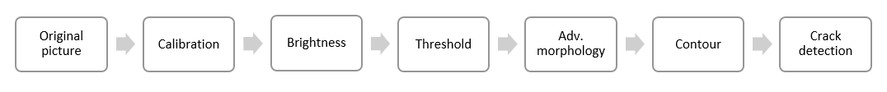
Figure 3. Crack detection and monitoring vision system block diagram.

When signal from test controller is received, a new image is acquired so that it can be processed. Firstly, this image must translate each measure in pixels to mm. Then the image is processed adjusting brightness, contrast and gamma correction. Modification of these parameters allows to optimize crack contrast in order to define those areas of the crack that are not simply appreciated with a naked eye. Thus, the precision for crack measurement is optimized. Followign, a threshold filtering is made selecting a proper grey threshold value. Thus, a binary picture (black and white) is obtained. Pixels with grey color above threshold are depicted as black, and viceversa. Applying this threshold to the previously modified picture, a perfectly defined crack for subsequent characterization and parametrization is achieved.

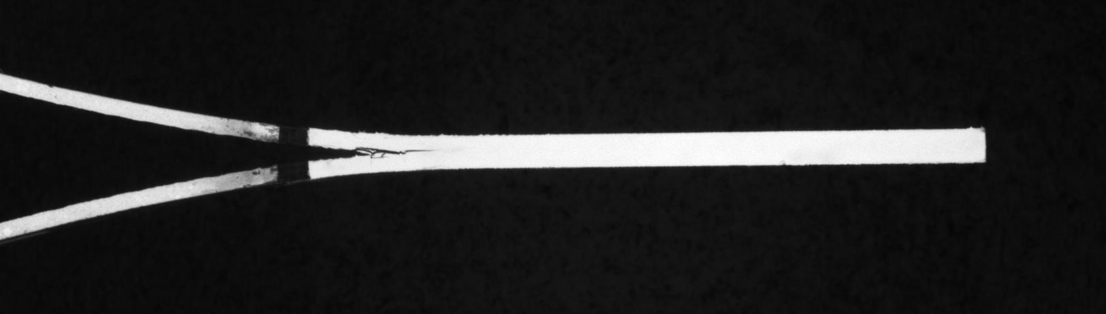 | 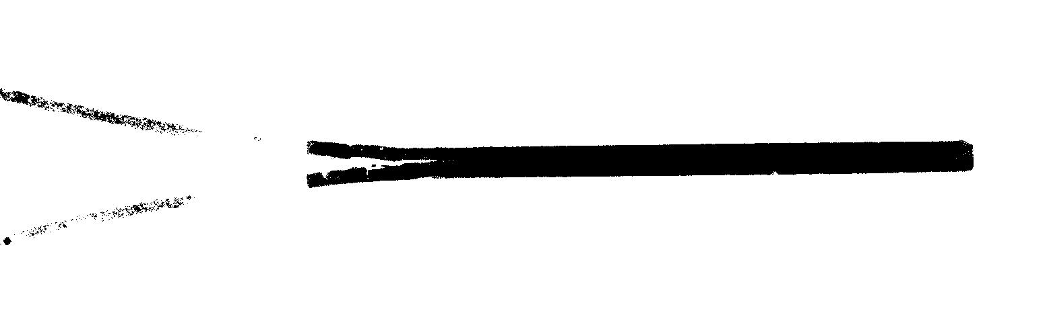

Figure 4. Original specimen picture (left) and after brightness, contrast and gamma corrections and applying grey threshold (right).

Advanced morphology is a security step which enables to remove from the picture those non-desired characteristics that could distort crack detection. Particularly, small objects removal is carried out, like some points or contours that could have remained after threshold step. These small objects may remain due to small pixel illumination variation, changing pixel color and filtering in the threshold block. Crack contour is then obtained making a horizontal scanner from initial crack position, we can detect every illumination change along the specimen. The area along the crack is well-defined by 4 vertical illumination changes, while the area without crack is defined by 2. Thus, crack end can be detected, following by a simple calculation to obtain crack length.

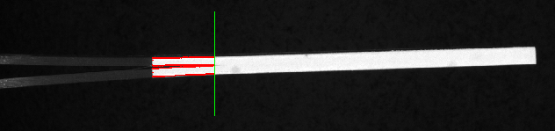

Figure 5. Image detection algorithm performing crack length measurement on DCB specimen.

Both quasi-static pre-cracking and fatigue tests were performed in a custom-built test rig including: Hydraulic actuator equipped with hydrostatic bearings which allows high speed cycle operations with 250 mm of total stroke. This actuator is installed in a fixed frame properly aligned. MTS digital displacement transducer. HBM Load Cell with 2.5 kN of capacity.

The test rig was controlled by means of MOOG’s Aerospace test controller which is a state of the art digital servo control system developed by MOOG for use in the aerospace testing industry. It is both capable of controlling and performing data acquisition tasks. The combination with crack detection software, by means of digital handshaking, allows to automatically stop the cycling to perform a crack measure.

3. Results
The growth of delamination length during the fatigue test is shown in next figure for all the specimens. In order to compare fatigue delamination behavior of different CFRP materials, crack length has been calibrated, subtracting the initial delamination length produced by the pre-cracking.

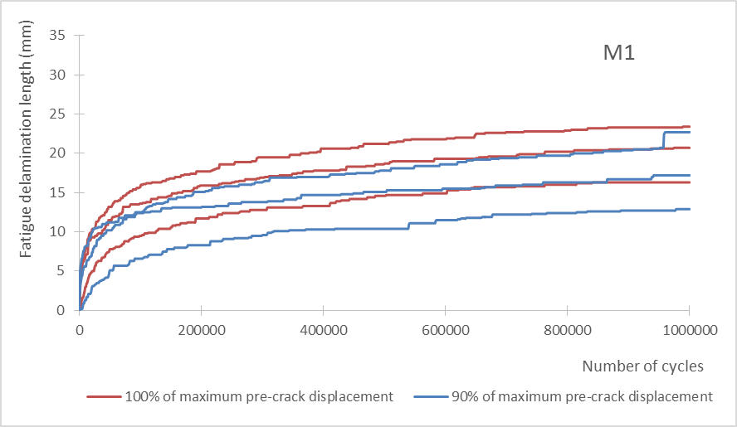 | 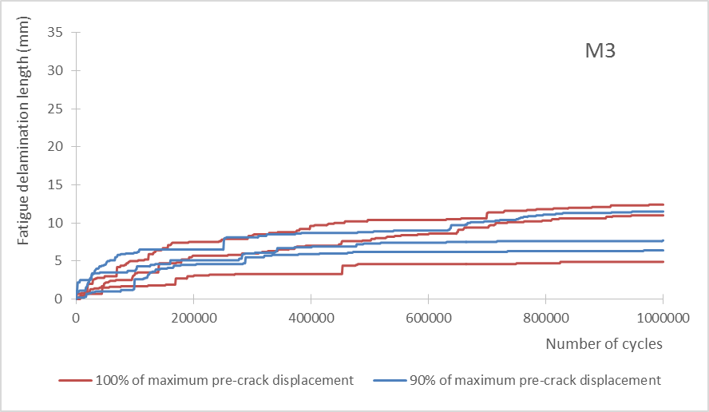
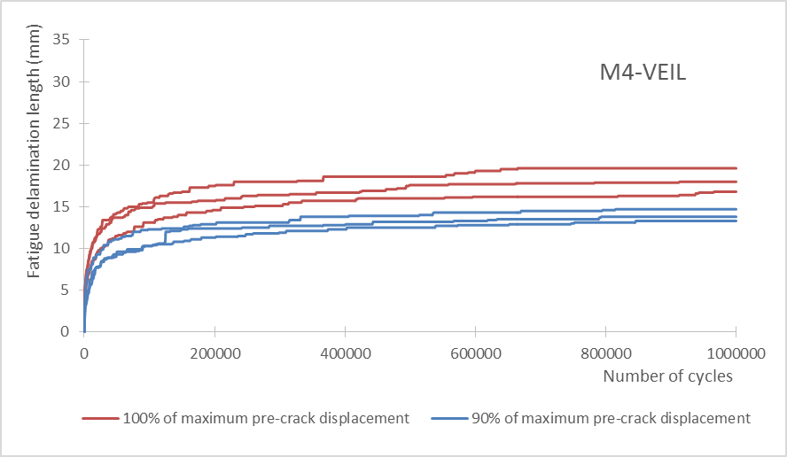 | 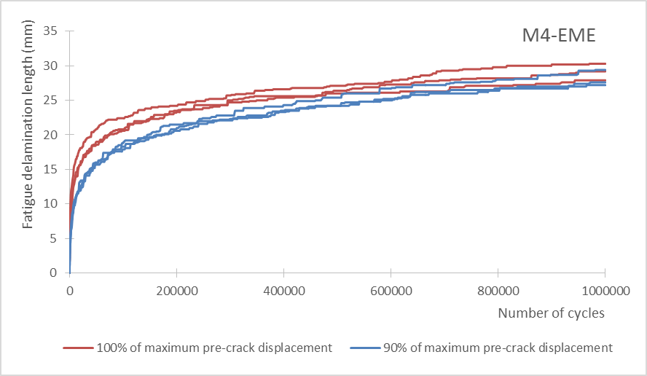
Figure 6. Crack growth curves for different CFRP materials.

According to the “simple beam theory” (SBT), the maximum cyclic strain energy release rate is

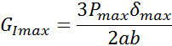 | (1)

where P_{max} is the maximum load applied during the cycle, δ_{max} is the opening crack displacement, a is the total crack length measured according to ISO 15024 standard, and b is the width of the specimen. G_{Imax} has been evaluated provided that length increment has been at least of 0.1 mm.

In order to determine the crack growth rate along fatigue test, the recorded data have been analysed by the averaging polynomial method using secant method.. The experimental values of the cyclic mode I tests resulted in the following power law relationship:

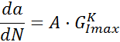 | (2)

where A and K are constansts calculated by a least square fit of the data points.

In order to contribute to the automatization of results analysis, a spreadsheet template was generated for the calculation of the Paris plots, i.e., da/dN as a function of G_{Imax}. In Figure 7 and , crack growth rate vs. G_{Imax} of thermoset materials (M1, VEIL and EME) have been plotted every 100.000 cycles. The results of material M3 have not been represented since high scatter was obtained for both test series.

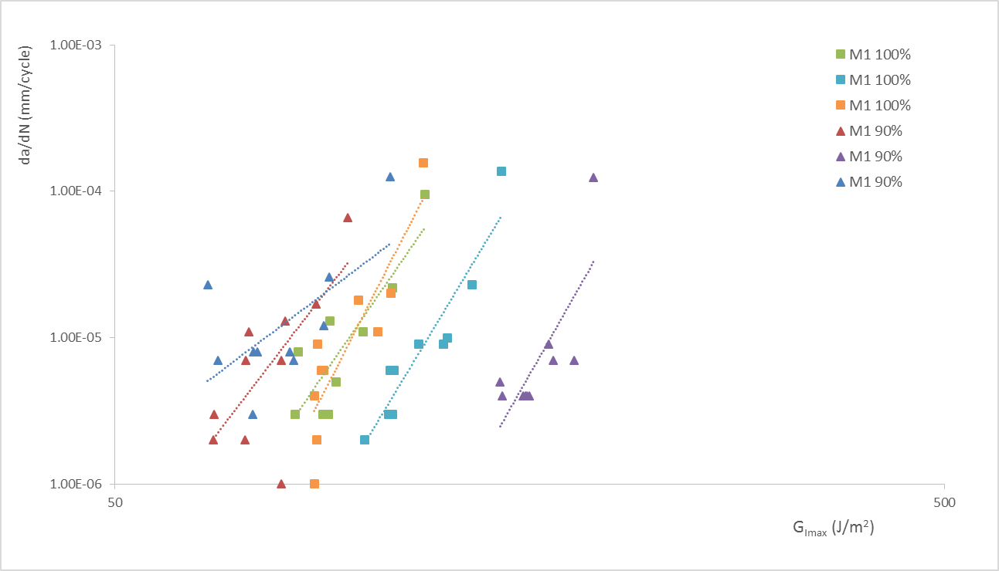

Figure 7. Paris plot for M1 material.

During the cyclic interlaminar tests, crack opening displacement was constant, the crack length increased, and the load was decreased due to the specimen compliance increment. Thus, the values of G_{Imax} decrease as the number of cycles increases. The crack growth rate was also decreased along delamination growth due to the reduction of the load.

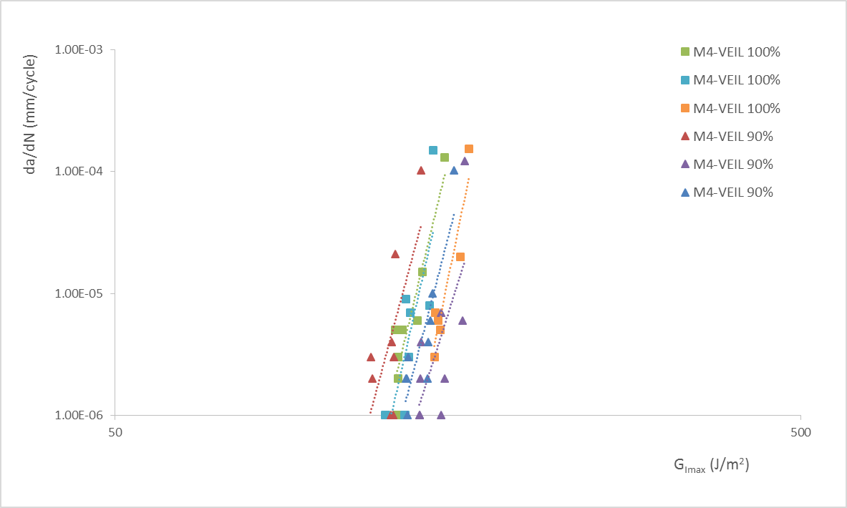 | 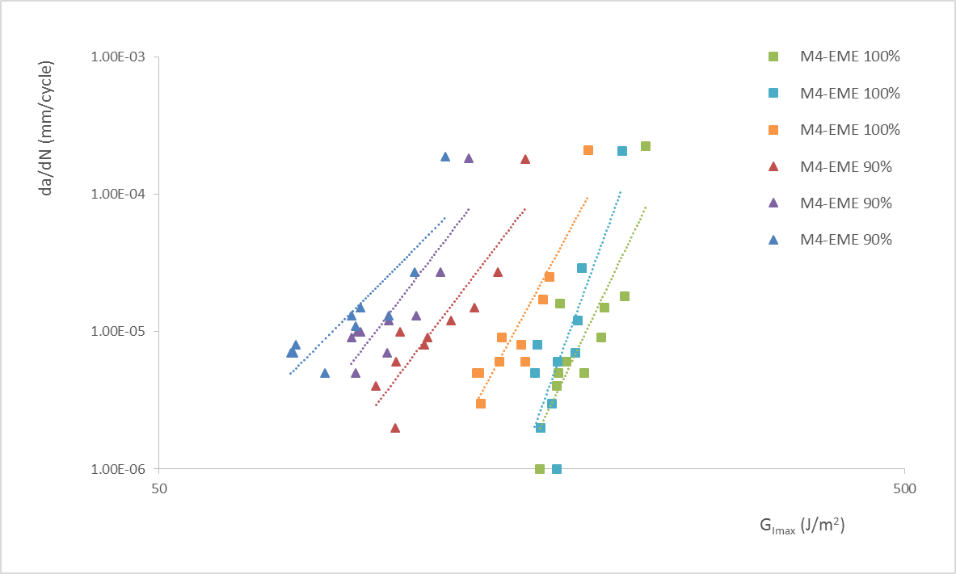

Figure 8. Paris plot for materials VEIL (left) and EME (right).

4. Discussion

Cyclic interlaminar crack growth tests are strongly dependent on the polymer matrix and the fibre arrangement within the composite material.Error: Reference source not found In fact, significant differences between the behavior of materials M1 and M3 have been obtained. Whereas thermoset materials reach fatigue delamination lengths between 12.9mm and 30.3 mm, thermoplastic composite crack only increases between 4.9mm and 12.4 mm. This is consistent with the results obtained in the static tests, where higher values of interlaminar fracture toughness were obtained for thermoplastic material.

The influence of applied displacement is observed in EME material’ Paris plots, where higher levels of G_{Imax} are obtained when opening displacement is 100% of the pre-crack displacement. Initial delamination lengths are similar for both batches and, in spite of the crack length is lower for 90% opening displacement during approximately first 500.000 cycles, load levels are higher for 100% opening displacement batch, yielding higher values of G_{Imax}. In M1 and VEIL materials, the difference between crack opening displacement are not significant, thus G_{Imax} evolution is similar for both batches.
Percentage of the last pre-crack displacement | Average initial delamination length (mm) | Average fatigue maximum displacement (mm) | Average final delamination length (mm)
100% | 58.3 | 9.28 | 87.5
90% | 58.8 | 7.56 | 86.9

Table 1. Mode I fatigue delamination propagation parameters for material EME.
Time execution has been evaluated against a manual fatigue test performed by an operator, with the test frequency and run-out established in this work procedure. It is estimated that manual crack tracking would imply a test duration of more than 6 days per specimen, due to the need of physical presence of a test operator. Instead, automated crack detection and monitory system allows to carry out these fatigue tests in 45 hours. Plus, automated system counts with the benefits that tests can be left running overnight and during weekends. Avoiding the need to stop and wait until an operator can measure manually the crack length.

5. Conclusions
The automated dynamic test system developed and applied to the study of interlaminar crack growth rates on mode I fatigue tests is based on a crack detection and monitoring vision system which allows delamination length to be automatically tracked. Automated crack length and data acquisition measurement system creates a test procedure that contributes to the total automation of fatigue test once the specimen is placed into the test set-up.

From the comparison of the results obtained, a significant influence of material fibre and matrix in the delamination propagation has been observed. Regarding test execution time, this automated dynamic test system demonstrates a great advantage compared to manual method, as it speeds up test execution by eliminating the need to stop the test to wait for the operator to measure the crack length for each increment of cycles. As a result, lead times can be reduced more than 75% by using this automated testing method. Thus, it has been proved to be a promising method to perform high cycle fatigue tests. Moreover, the automated fatigue test system developed eliminates human factor while measuring crack length and this results in lower dispersion.

This work is focused on mode I delamination propagation but mode II and mixed mode fatigue test are also expected to be addressed, adapting the crack monitoring system to these particular tests. Likewise, further investigation on automated analysis will be carried out in the development of these tests.

Acknowledgments
The authors wish to thank the research leading to these results has received funding from the European JTI-CleanSky2 program under the Grant Agreement n◦ 314768 (SHERLOC). Helpful discussions with Dr. Andreas Brunner are also gratefully acknowledged.

References

ISO Standard 15024. Fibre-reinforced plastic composites – Determination of mode I interlaminar fracture toughness, G_{IC}, for unidirectionally reinforced materials.
ASTM Standard D5528. Test Method for Mode I Interlaminar Fracture Toughness of Unidirectional Fiber-Reinforced Polymer Matrix Composites.
ASTM Standard D6115. Test Method for Mode I Fatigue Delamination Growth Onset of Unidirectional Fiber-Reinforced Polymer Matrix Composites.
A.J. Brunner, N. Murphy, G. Pinter. Development of a standardized procedure for the characterization of interlaminar delamination propagation in advanced composites under fatigue mode I loading conditions. Engineering Fracture Mechanics, 2009.
B. Krull, J. Patrick, K. Hart, S. White, N. Sottos. Automatic Optical Crack Tracking for Double Cantilever Beam Specimens. Experimental Techniques, Society for Experimental Mechanics, 2015.
ASTM Standard D5229/D5229M. Test Method for Moisture Absorption Properties and Equilibrium Conditioning of Polymer Matrix Composite Materials.
ASTM Standard E 647. Test method for measurement of fatigue crack growth rates. West Conshohocken, USA: American Society for Testing and Materials International; 2008.
G. C. Christopoulos, S.A. Paipetis, R. Walter, K. Friedrich. Effect of Testing Temperature on Interlaminar Fatigue Crack Growth in Fabric-Reinforced Thermoplastic Composites. Journal of Thermoplastic Composite Materials, Vol. 9, 1995

