EuroSun2026
Requirements for HVAC systems due to climate change

Wolfgang Streicher
University of Innsbruck, Unit of Energy Efficient Building
Technikerstrasse 13, A-6020 Innsbruck, Austria
wolfgang.streicher@uibk.ac.at
Summary
Temperature increase due to climate change means that summers but also winters become warmer which reduces space heating and increasingly entails space cooling even in Middle Europe. In Southern Europe heating will become negligible but cooling increases a lot. In Northern Europe cooling will still be negligible but heating decreases (Ochs, Streicher, et al. 2024). The following contribution shows the changing heating/cooling demand for a Single-Family House (SFH) with different insulation standards for a Middle European climate and derives needed changes for current hydraulic schemes of space heating/DHW (domestic hot water) systems to supply also cooling using reversible heat pumps. Also, the specific power ranges of heating surfaces for their maximum temperature limited by comfort criteria and low temperature heating systems (heating forward temperature 40°C), their ability to provide also cooling and the limitations due to higher dew point temperatures arising with climate change for cooling are addressed. In conclusion there are many options to easily adapt current heating systems to allow also for cooling. The characteristics for optimal heat pump use can be kept and in summer double use of condenser for DHW and evaporator for space cooling production can boost the COP. Such systems should be demanded in building standards and codes in order to make houses fit for climate change.
Keywords: climate change, combined heating/cooling system, low temperature heating
Field of application for the findings: Sustainable Heating and Cooling Systems
Addressed audience: Researchers, HVAC planers, HVAC companies
- Introduction
In 2024 the world average ambient temperature increased due to climate change by 1.5°C compared to the average of the years 1991 – 2020 (Copernicus, 2024). In Austria it was already 3.2°C warmer in the yearly average compared to the average of the years 1961- 1990. This means that summers but also winters become warmer which impacts space heating and increasingly entails space cooling even in Middle Europe. This demands a change in standard space heating (SH) and domestic hot water (DHW) systems to allow also for space cooling. As heat pumps are increasingly used for space heating, this is quite easy and it is already standard to let it run both ways as heater or cooler (reversible heat pumps). Hydraulics that allow SH, DHW and cooling delivery including summer double use of cooling and DHW production as well as the systematic of heating/cooling delivery systems (radiators, floor/ceiling, wall, fan coils etc.) with their capability of heating and cooling are slowly coming into the marked but are not at all standard. Systems built today must be able to supply all functions in Middle Europe to be sustainable in times of climate change.
- Space heating and cooling adaptation for climate change
For a single-family house (SFH, slightly adapted from a references SFH building of several IEA tasks, Dott et al. 2013) the annual space heating and cooling demand as well as the design heating and cooling loads according to ASHRAE standards were simulated with the software package Rhino8/Pollination/OpenStudio/EnergyPlus (RobertMcNeel, 2025, Pollination). Today’s climate and two climate projections with +2°C and +4°C average seasonal ambient temperature were defined using IPCC RCP scenarios represented in the climate data generator Meteonorm 8 (2025) for specific future years. Fig. 1 shows as example the results for the city of Innsbruck for a house with 45 kWh/m²a space heating demand for today’s climate. Space heating demand [kWh/a] will be reduced more than space cooling demand increases but cooling load will be similar to heating load [kW]. Whereas the total energy demand is reduced the demand for cooling will become a normal need in future in all Middle Europe but still not the dominant energy demand. The energy shift is releasing the burden of the electricity network in winter and the increased electricity demand in summer matches with increased solar PV production and partly with hydro power availability. More details can be found in Ochs, Streicher, et al. 2024. From this point climate change does not induce a risk for building energy demand.

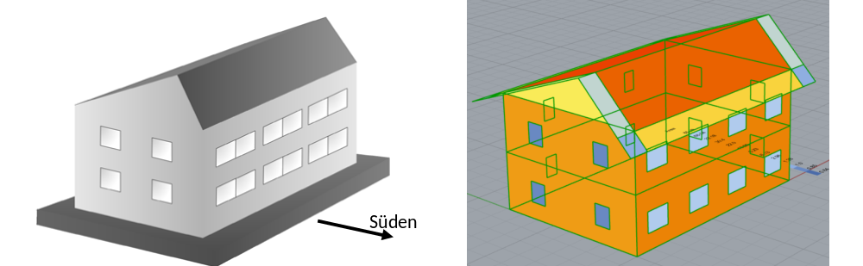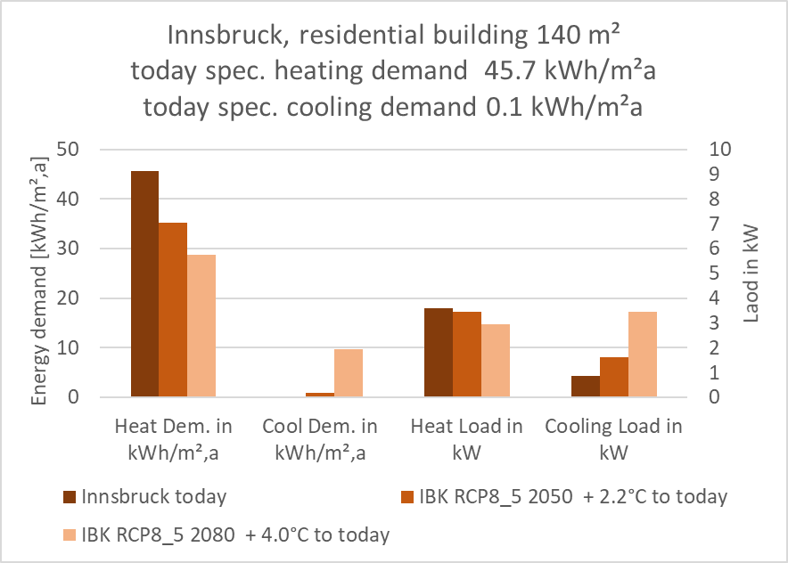
Fig. 1: Sketch of the simulated building (left) and seasonal energy demands and loads for heating and cooling for climate change of today, +2°C and +4°C and seasonal average for a medium insulated SFH (today 45 kWh/m²a space heating) (right), Streicher, Thür, 2025.
- Adaptation of HP hydraulics
3.1. Possibilities of heat delivery and heat rejection systems for heating/cooling
Table 1 shows the maximum specific power for heating and cooling of different air- and water-based heat/cold delivery systems to rooms. The maximum Temperature T_{max} for space heating relates to the hot air inlet or the hot water inlet temperature of the heat rejection systems and is limited in order to keep thermal comfort. There is a temperature drop from heating water to the surface of the heat rejection system taken into account, which is related to the thickness and the thermal conductivity of the material around the tubes. The maximum temperature of the ceilings due to comfort and health reasons should not be above 30°C, the one of the floors should not exceed 27°C. Additionally, the one for activated walls should not be above 40°C. Radiators could go up to 80°C, but this should be avoided if e.g., if a small child touches the radiator, it becomes dangerous. The maximum hot water inlet temperature to the different heat delivery systems and the specific power that can be released at such maximum surface temperatures are then given in lines 3 and 4 of Table1. The heat delivery form surface to room is performed via radiative and convective heat exchange. Radiation heat exchange is depended on the temperature of the surrounding surfaces of the room, their emission coefficients and the view factors of the surfaces to each other. The convection (induced by heat conduction from surface to air) means that the heated air is expanding and therefor the density becomes lower than that of the surrounding air and it is flowing upwards. Whereas this is very good working for wall and floor heating systems the hot air stays at the ceiling heating systems (and cannot flow further upwards) and the heat transfer into the room becomes pure radiative, the convective part is missing.
Figure 2 shows the heat transfer coefficients for radiation and convection for different orientated surfaces calculated with VDI heat Atlas (2006). Radiation is especially for low temperature differences between the room temperature (20°C, $T_{Room}$) and the heated surface $T_{surface}$ the biggest heat transfer for all orientations. The specific heat released per heated area for the heat transfer coefficients of radiation and convection can be calculated with Equation 1. If it is assumed that the surrounding surfaces have the same temperature as the room ais temperature. Radiative heat transfer $α_{rad}$ and convective heat transfer $α_{conv}$ coefficients can be summed up for the total heat transfer coefficient. Therefore the heat transfer increases over-linear with the temperature difference because of also changing heat transfer coefficients.
$\dot{q}=\left(α_{rad}+α_{conv}\right)∙\left(T_{surface}-T_{Room} \right)$ [W/m²] (eq. 1)

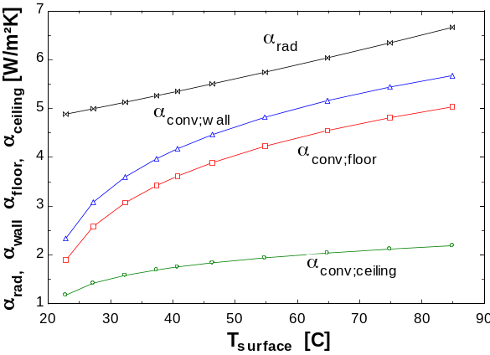
Fig. 2: Heat Transfer coefficients α for radiation and convection of heated surfaces to a room with 20 °C for different surface orientations and temperatures (calculated from VDI Wärmeatlas, 2006)
Due to these effects floor and wall heating systems have a higher power than a ceiling heating system, because of higher convective heat transfer coefficients.
When the ventilation air is used to heat rooms in winter it firstly has to be heated from outdoor temperature to room temperature thus covering the ventilation losses. This can be done partly (up to 85%) by air heat recovery and additional heat. If the inlet air is heated above room temperature, infiltration and transmission losses can be additionally partly or even fully covered. If there is no ventilation but only recirculated indoor air, ventilation infiltration and transmission losses have to be covered by heating, as in any other heating system without ventilation. With the above points a combined ventilation of n=0,5 with air heat recovery and post-heating the inlet air to 50°C 10 W/m² of infiltration and transmission heat losses can be covered. This defines Passive-Houses. If an only recirculating air flow equal to an air exchange rate of 3 1/h (e.g., fan coils) is heated up to 50°C 60 W/m² can be heated by air (ventilation, infiltration and transmission losses). With this high value nearly all newly built or thermal renovated houses can be heated.
The low values for air heating systems (heating per hot inlet air flow) come from the low volumetric thermal capacity ${\left(ρ∙c_{p}\right)}_{Air}$ of 0.34 Wh/(m³K) and a specific room volume $V_{spec}$of 2.5 m³/m² (2.5 m room height) and an air exchange rate n of 0.5 1/h out of Equation 2. The room temperature was chosen with 20°C. The maximum air inlet temperature $T_{max}$ was set to 50°C in Table 1.
$\dot{q}=n∙V_{spec}∙{\left(ρ∙c_{p}\right)}_{Air}∙ \left(T_{max}-T_{Room} \right)$ [W/m²] (eq. 2)
When the maximum hot water temperature is reduced to 40°C (line 5 of Table 1) which is the upper end of low temperature heating systems with already a high COP of heat pumps, the maximum specific heating power of floor heating and ceiling heating system is not reduced, as 40°C is still at or above the maximum allowed space heating water temperature. For systems with higher allowed maximum temperature like air systems, radiators and wall heating is significantly reduced. So larger heated areas are needed. The specific power of ventilation systems with additionally heated inlet air flow reduces to only 5 W/m². With the above-described high airflow of 3 a/h the specific heating power reduces to 18 W/m². 5 W/m² is about the half of power needed for passive houses, so an additional heating system would be needed. Even with 18 W/m² only very well insulated houses (far better than the current building codes) can be heated.
When cold water is flown to the same surfaces the temperature differences from surface to room become smaller because of comfort and condensation of moisture in the air. Normally the temperature of the surface and or of the inlet for cooling air should not be below 18°C. With a room temperature of maximum 26°C the temperature difference is then only 8°C. Table 1, line 7 shows the maximum cooling powers that can be achieved under these assumptions. Air cooling with an air exchange rate reduces to negligible 3.5 W/m². Floor cooling is reduced to 20 W/m² as convection is now not working (cold air stays on the ground) and cooling becomes purely radiative, but feet are standing on a cold ground. In the opposite in ceiling cooling, convection and radiation work well and the specific power is about 40 W/m². Wall cooling can be even higher, but is must be assured, that the cold air is not again accumulating at the bottom like for floor heating systems. Condensation on cooling surfaces for cooling is in these numbers not taken into account.
Nevertheless, the dew point temperature is rising up to 24°C for a +2°C average temperature rise climate scenario and 26°C for a +4°C scenario due to climate change (Fig. 3). When the cooling surface temperatures are below the dew point condensation takes place, water occurs and dripples down and/or mold occurs on the cooled surfaces. Therefore, cooling is not possible any more (no temperature difference to the room left) for such high ambient temperatures and humidity any more. Additional dehumidification measures have to be taken into account. Figure 3 Shows the hourly course of the dew point for Innsbruck today (left) and +2°C and +4°C respectively (right). Only the circulating air systems (fan coils and single split, multisplit or VRF systems) can dehumidify the air in the apparatus itself.
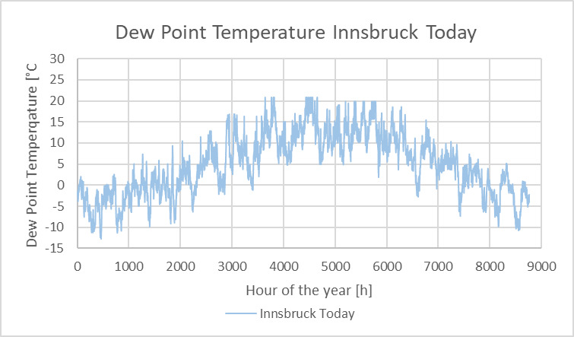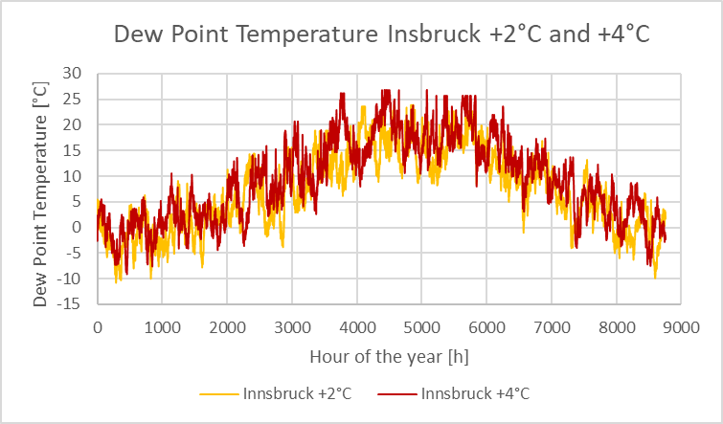
Fig. 3: Dew point temperature for Innsbruck today and +2°C and +4°C average temperature increase (calculated using Meteonorm, 2025)
Tab. 1: Specific thermal power for heat delivery and heat rejection to/from the room for different heating/cooling surfaces (Streicher, Thür, 2025)
 | Air Systems | Water Systems
Heating |  | Wall | Floor | Ceiling | Radiator
T_{max} (comfort)  Air/Water Flow Temperature for space heating | 50°C | 50°C | 40°C | 35°C | 90°C
Heating Power  (at T_{max}) | 10 W/m²_{Linving_area} at  n = 0.5 1/h  60 W/m² bei n= 3.0 1/h (Vent+Fan Coils) | 200 W/m²_{Heat_area} | 80  W/m²_{Heat_area} | 40  W/m²_{Heat_area} | 1300 W/m²_{Heat_area}
Spec. Heating Power at 40°C Flow Temperature | 5 W/m² _{Linving_area.} at  n = 0,5 1/h | 130 W/m²_{Heat_area} | 80  W/m²_{Heat_area} | 40  W/m²_{Heat_area} | 260 W/m²_{Heat_area}
Cooling
Possible spec. Cooling Load  Suspended Cooling Ceiling, activated concrete ceiling | 3 W/m² _{Linving_area} at  n = 0,5 1/h  18 W/m² _{Linving_area} at n= 3,0 1/h (Vent+ Fan Coils) | 50 W/m²_{Cool_area} | 20 W/m²_{Cool_area} | 80  W/m²_{Cool_area}  40  W/m²_{Cool_area} | Nearly none  except: Additional Fans on the radiator => Fan Coils

3.2. Flexible high-efficient water-based heat pump hydraulics for space heating (SH), domestic hot water (DHW) and cooling
The only heating device that allows also cooling are reversible heat pumps. Using a 4-way valve (Fig. 6) they can reverse the refrigerant flow thus exchanging condenser (hot side) and evaporator (cold side). Now, to bring hot or cold to the rooms and the heat to the DHW production, the heat pump has to be coupled to the heat/cold distribution system in an easy way to allows also room cooling. Fig. 5 and Fig. 7 show possibilities to change existing heat pump hydraulics for only SH and DHW production to deliver also space cooling in summer and allow for heat pump double use if DHW and space cooling occur simultaneously thus increasing the COP (produced heat/cold / total electricity demand of the heat pump plus heat source) significantly. Several boundary conditions have to be taken into account generally for energetically optimal heat pump use.
- The smaller the temperature lift from evaporator to condenser ($T_{hot}-T_{cold}$) is the higher is the COP. The real COP can be estimated out of the heat pump Carnot COP (${COP}_{Carnot}$) using a reduction factor of about 0.45 as shown in Equation 3. The temperatures of the ${COP}_{Carnot}$ are defined as follows: $T_{hot}$ is the outlet temperature of hot water or hot air (outlet temperature of the heat sink), $T_{cold}$ is the inlet temperature of the heat source (ambient air, groundwater, brine, etc.). The temperatures have to be given in KELVIN and NOT in °C,
$COP=0.45∙{COP}_{Carnot}=0.45∙\frac{T_{hot}}{T_{hot}-T_{cold}}$ [-] (eq. 3)
- The condenser temperature is dependent on the heat sink (e.g. heated water for space heating or heated ambient air in the cooling mode) outlet temperature (see Fig. 4). The temperature lift on the hot side should therefore not higher than 5 K.
- The mass flow of heat sink and heat source should be not changed by the heating system. Otherwise, the temperature lift of the heat source/heat sink media increases, if the power of the heat pump is not adjusted accordingly and the condenser temperature rises. Fig. 4 shows this for the same inlet temperature of the heat sink but halving the mass flow of Fig 4 left in Fig 4 right. Therefor either a fixed mass flow in the heating system is needed (e.g. fixed mass flow settings in the heating circuits) or a mass flow decoupling of space heating water flow and water flow through the condenser by a water storage tank is needed. The second is needed for heating circuits with thermostatic valves or 3-way valves for ambient temperature controlled hot water temperature for space heating.
- The temperature produced by the heat pump should not be decreased (or very little) in the hydraulic system to the heated rooms, because this increases the condensing temperature for the hot water production. This means avoiding of 3-way valves mixing heating return water (cold) to the hot produced water if possible; water storages have to be built in a way, that as little as possible mixing of the hot water entering the storage is occurring). For such systems the heat pump has to produce higher temperatures as the heating delivery systems needs and the COP drops.
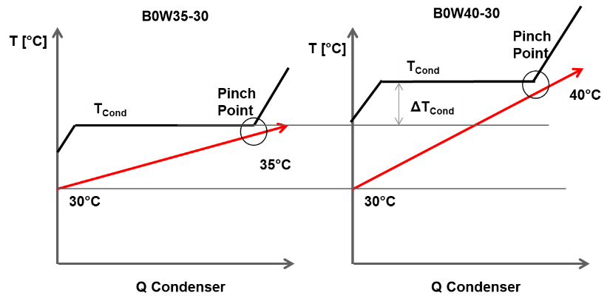
Fig. 4: Effect of increased temperature of the heat sink in the condenser on the condensing temperature (Streicher, Thür, 2025)
Fig. 4 shows the effect of higher temperature lift in the condenser in a Q-T diagram. As heat is only flowing from hot to cold, the temperature of the heat sink (red curve) must be always below the refrigerant (from right to left: desuperheating, condensing, subcooling). The pinch point shown in Fig. 4 is the location with the minimum temperature difference between the refrigerant and the heat sink for the entire heat exchanger (a pinch point is defined as the point of minimum temperature difference during heat transfer from one medium to another). The pinch point temperature difference is determined by the operating conditions, the heat exchanger’s surface area, and the heat transfer coefficient (U-value); it typically ranges between 2 and 5 K. It becomes lower the larger the area of the condenser becomes – so it is a question of investment costs (condenser size) and operating costs (COP). It can be clearly seen that the heat sink outlet temperature is defining the condensing temperature and therefor the COP, the effect of the heat sink inlet temperature is minor.
To allow also space cooling with simultaneous DHW production both solutions would need a second condenser either in the DHW store (example in Fig. 5.) or in the heat pump (example in Fig. 7) for the cooling case. All schemes produce in priority DHW compared to space heating and take into account a water temperature increase of only 5 K in the condenser and 5 K water temperature decrease in the evaporator of the heat pump.
Fig. 5 shows a space heating/cooling system with self-regulating effect of space heating/cooling and a DHW production via a DHW. In Fig. 5 left the heating mode for space heating and DHW is shown. The heat pump can switch between either space heating or DHW production mode. The modes should not run simultaneously on one heating circuit manifold, as different temperatures are needed. For space heating mode the hot water produced by the heat pump can is fed directly into the heating circuits at a constant mass flow rate. For self-regulating there is only one room temperature sensor for the entire house needed, which is installed in a room not exposed to direct sunlight. If the temperature in this room falls below its activation temperature setpoint (e.g., 21 °C), the heat pump turns on; conversely, if the room temperature exceeds the deactivation setpoint (e.g., 22 °C), the heat pump turns off. This assures long running tomes for space heating, as the thermal mass of the whole building is taken into account. Heat rejection systems could be floor heating or thermally activated concrete in ceiling or wall. If sunlight enters a room without a temperature sensor, that room heats up. With surface heating systems (activated concrete in ceiling or floor/wall), however, the temperature difference between the large heating surface and the room is very small (a maximum of 3 °C in homes built to current building standards and only 0.5 °C in passive houses). When a room heats up, the temperature difference between room and heated surface quickly becomes very small or even negative, and thus the heat transfer to the room automatically decreases or even becomes negative; in the latter case, the heating surface actually absorbs heat from the room. For such heating systems based on the self-regulating effect, a single pump can control both the heat pump and the heating circuits without the need of a hot water storage tank. The operating time of the heat pump is determined by its capacity and by the thermal storage masses of the radiant heating system and the building. There is no temperature loss due to valves and storages from the heat pump to the space heating system.
The DHW production in Figure 5 left is done in the space heating mode via an internal heat exchanger in the lower part of the DHW store. The hot water storage tank takes advantage of the stratification of water (i.e., cold water is denser than warm water). Because the heat exchanger—which transfers heat from the heat pump—is located in the lower part of the tank and the temperature sensor is positioned above it, the heat pump does not turn on until the domestic hot water temperature around the temperature sensor in the tank drops. At that point, the tank—from the bottom up to the sensor, and thus around the heat exchanger supplied with thermal energy by the heat pump—is filled with the cold water coming from the water supply line at a low temperature (typically around 8 to 12°C in Central Europe). Consequently, after the heat pump is turned on, the condensation temperature is initially low, and the coefficient of performance is correspondingly high. As the storage tank heats up slowly around the heat exchanger, the condensation temperature also rises, and the coefficient of performance (COP) of the heat pump decreases. Only when the temperature around the heat exchanger equals the temperature of the reserve volume in the upper part of the storage tank, the upper part of the storage tank begins to heat up. At that point, the condensation temperature is above the domestic hot water setpoint, and the heat pump’s coefficient of performance (COP) is at its lowest value. This reserve volume ensures that sufficient hot domestic water with high temperature is always available, even while the lower section of the storage tank is heating up slowly. The volume below the heat exchanger (dead volume) should be as small as possible, since the water below the heat exchanger is heated only by convection around the heat exchanger up to a certain depth below the heat exchanger (there is a vortex around the heat exchanger during heating).
When the system is switched to cooling the direction of the refrigerant flow by the compressor is reversed using a 4-way valve (ref. Figure 6) thus exchanging condenser and evaporator. Now as shown in Figure 5 an additional condenser is placed in the DHW tank and the now evaporator produces cold water for the now cooling surfaces in the rooms. The additional condenser can be also placed in the heat pump and delivering hot water to the same heat exchanger as in the heating mode. The principle can be seen in Figure 7 right. When space cooling and DHW production occurs simultaneously both sides of the heat pump are used (double use) and the COP is very high. Of course, DHW production can be shifted to times when also cooling occurs to benefit from the double use as often as possible. The 4-way valve at the space heating/cooling side is needed to assure always counterflow in the condenser/evaporator on the space heating side. When there is only room cooling without DHW production the heat from the now condenser is rejected to the ambient.
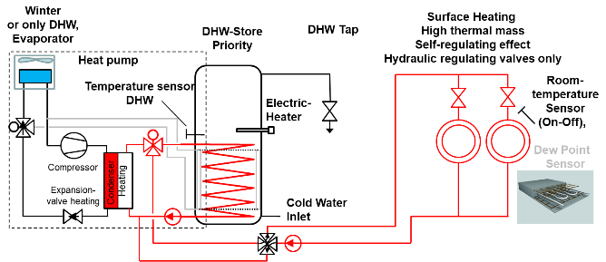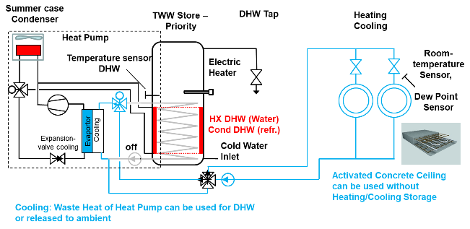
Fig. 5: Monovalent heat pump, space heating activated concrete self-regulating, additional condenser DHW, summer double use, left conventional winter und pure DHW production, right additions for summer cooling and DHW (Streicher, Thür, 2025)

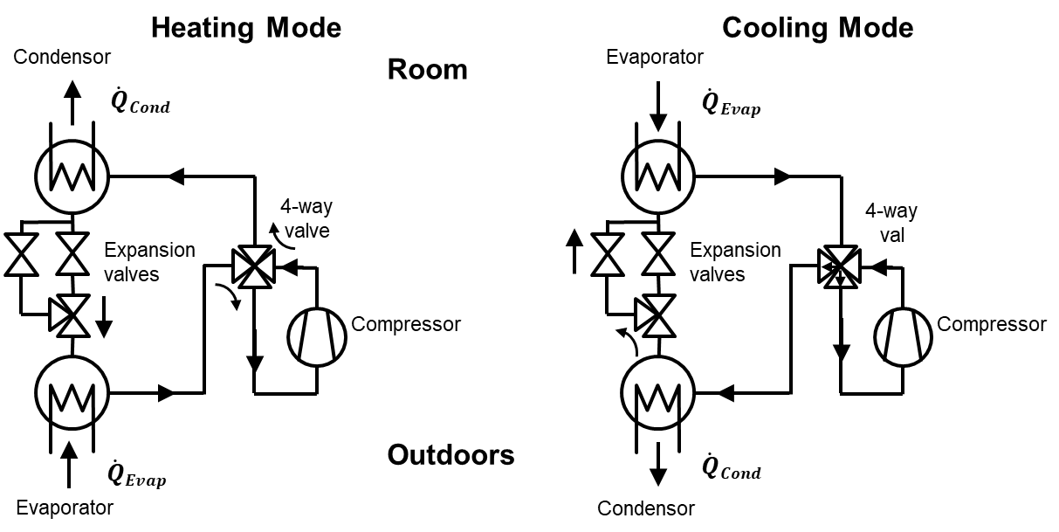
Fig. 6: Function of a 4 way valve to reverse the refrigerant flow of the compressor (Streicher, Thür, 2025)
Figure 7 shows a system with heating circuits for different characteristics with separate either ambient temperature-controlled flow temperatures or mass-flow controlled circuits (e.g., thermostatic valves) or both. The heat rejection systems could be activated concrete roofs, walls, floor, suspended heated/cooled ceilings or fan coil systems. Here a coupled space heating - DHW store (so-called combistore) is used in order to decouple mass flows of heat pump and heating system and increase the running time of the heat pump. The DHW production is performed from the highest part in the combistore via a once-through heat exchanger (DHW station). This assures legionella avoidance, if the DHW pipes to the final user are short (up to 6 m) legionella will be always washed out by DHW tapping, so the legionella concentration can not grow to critical values. 2 times a temperature loss occurs for DHW production (condenser – space heating water and space heating water to DHW).
In the shown case the combistore fulfills both purposes: heating space heating water to the final temperature to fulfill DHW temperature need is located in the upper part because of the highest temperature and SH but also preheating of the cold return temperatures from DHW heat exchanger and space heating production. Like in the example before the heat pump is either witched to the lower space heating/preheating part or the upper DHW part, thus only 5 K temperature increase in the condenser are needed. There is no danger of limestone in the evaporator, as only space heating water is heated and DHW is produced after the space heating store in a once through heat exchanger. The running time of the heat pump is depended on the size of the store respectively the positions of the temperature sensors in the stores. As the water in the lower part is heated already to 40°C for space heating there is just a topping to 50°C needed, which can be performed in one temperature lift in the condenser without losing too much of COP. For space heating, the lower part of the combistore is heated if the temperature sensor below the outlet to the space heating becomes lower than the setpoint, then the storage is heated up to a shutoff setpoint which must be higher than the temperature lift of the condenser starting from the space heating return temperature, which corresponds to the inlet temperature to the condenser in order to use the space heating volume for the running time of the heat pump for space heating.
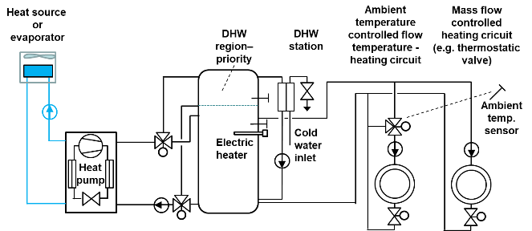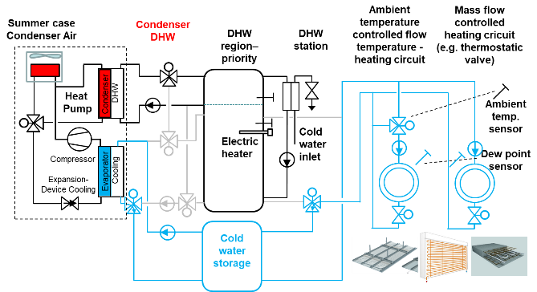
Fig. 7: Monovalent heat pump, combistore, conventional space heating circuits, DHW with ounce through heat exchanger, for cooling: additional condenser for DHW part in the combistore and cold water store, summer double use, left conventional winter, right additions for summer cooling and DHW (Streicher, Thür, 2025)
For cooling the compressor flow is again reversed by a 4-way valve and an additional condenser for DHW is placed in this example in the heat pump. The same inlet and outlet at the higher part of the store is used for the final DHW Temperature production. An additional cold storage is needed in order separate cold water and DHW hot water if both sides are used simultaneously. Theoretically, the cold water can be put in the bottom of the combistore below the hot DHW source, but there is a big temperature difference between cold and DHW temperature and a bit of mixing would destroys the needed temperature on the hot and the cold side.
Instead of a once-through heat exchanger for DHW production also a built in DHW-tank into the combistore can be used. (see Figure 8) The heat pump is attached in the same way and the same principle as in Figure 7 can be applied for cooling.
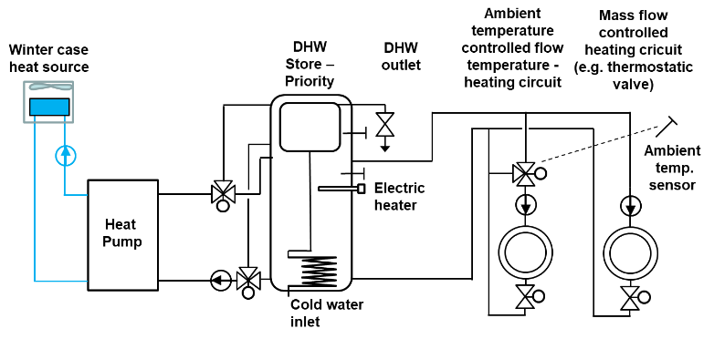
Fig. 8: Monovalent heat pump, combistore, conventional space heating circuits, DHW with ounce through heat exchanger (Streicher, Thür, 2025)
Fan coil units can also be used for heating and cooling in systems shown in Figure 7 or Figure 8. These are air-to-water heat exchangers through which water flows, assisted by a fan on the air side. They are therefore purely recirculating air systems or fan-assisted radiators. Hot water can flow through the heat exchangers for heating, or cold water for cooling. In 2-pipe systems the units are attached to a pipe network that can be switched either to heating or cooling water (Figure 9 left), in a 4-pipe system the unit is permanently attached to a cold water and a hot water network (Figure 9 middle). The fan ensures that the warm or cold air mixes with the room air to achieve a uniform indoor climate. They can be wall- or ceiling-mounted. With fan coil units, the resulting condensate can be drained directly from the unit, thereby automatically dehumidifying the air during cooling operation. Fan coil units are a very commonly used heating and cooling option in hot and humid climates, but they are likely to gain importance in Europe as well due to rising temperatures caused by climate change.
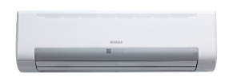
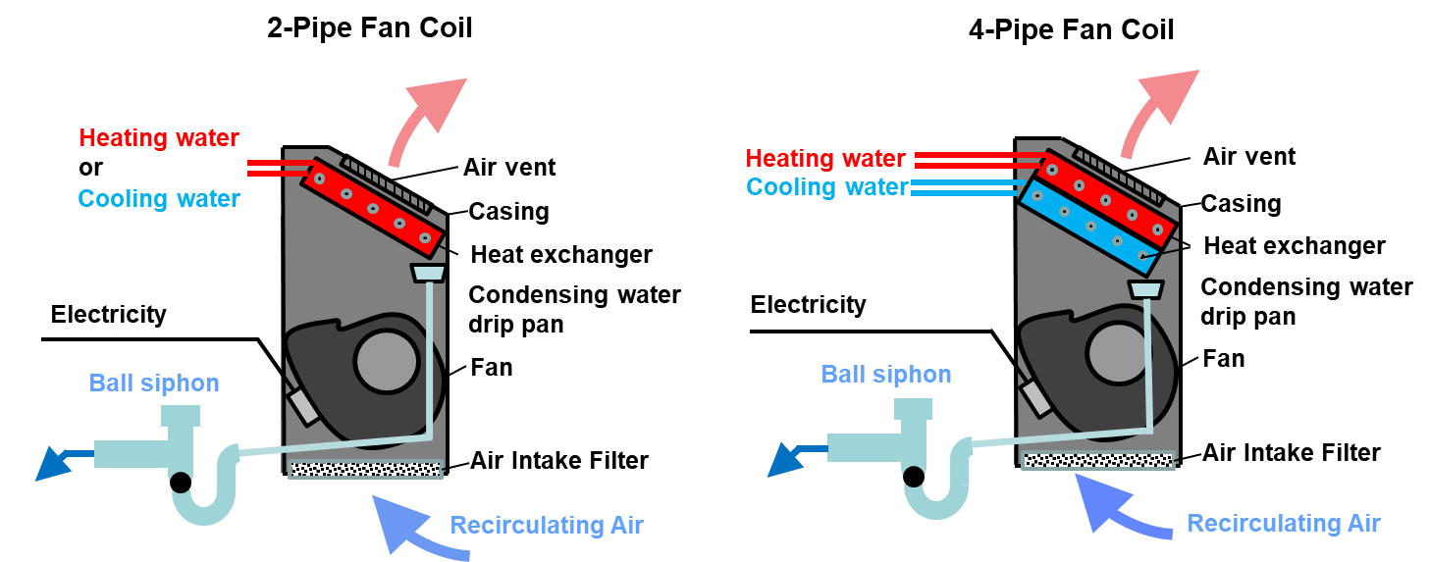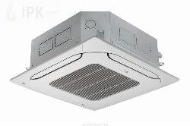
Fig. 9: Water driven fan coils, principle 2 pipe (left), and 4 pipe (middle), examples (right) (Streicher, Thür, 2025)
Another option for heating and cooling are so-called “Variable Refrigerant Flow” (VRF) systems, which have been in development since approximately 1982. The principle is shown in Figure 10. Here refrigerant is flowing directly to the fan coil units which operate either as condenser or evaporator. This technology allows the indoor units to be used individually and flexibly as heating or cooling elements; that is, some rooms can be heated while others are cooled at the same time (similar to 4 pipe fan coils) —and, in parallel, central or decentralized domestic hot water production can also be carried out. The indoor units can be used either with high-pressure gaseous refrigerant from the compressor for heating as condenser or with liquid or two-phase refrigerant collected from the condensers of the indoor units via a separate expansion valve for cooling as evaporator. For this purpose, a third refrigerant line is used between the condensers of the currently operating heating units and the evaporators of the currently operating cooling units. The outdoor unit absorbs heat from the outside when the demand for heating energy exceeds that for cooling, and releases heat to the outside when the demand for cooling energy exceeds that for heating. In cooling mode, the indoor units dehumidify the recirculated air when the temperature at the cooling surfaces falls below the dew point; the resulting condensate must then be drained via appropriate collection pans in the unit and pipes, e.g., into the ductwork. A drawback of this system is its high refrigerant content, which precludes the use of flammable refrigerants (e.g., propane), as well as its complex control system.
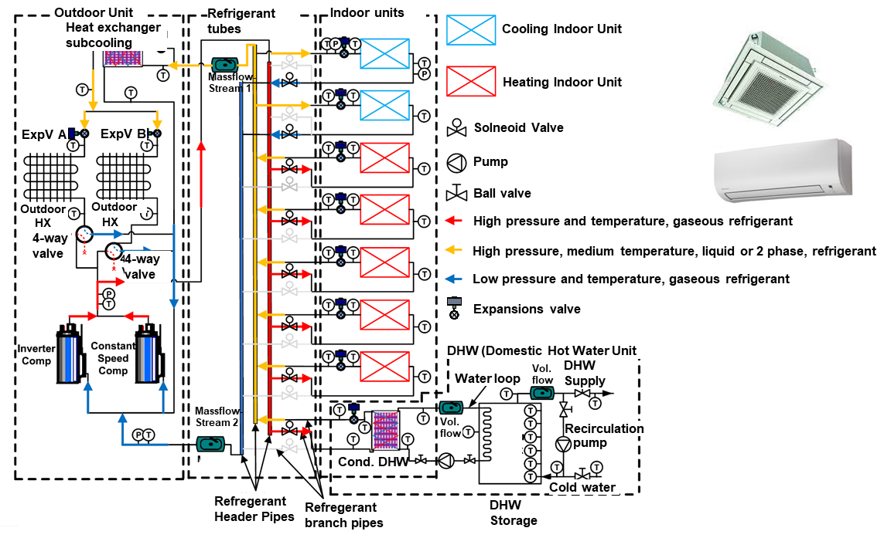
Fig. 9: Schematic of a VRF system (Kwon et al. 2014)
In conclusion there are many options to easily adapt current heating systems to allow also for cooling. The characteristics for optimal heat pump use can be kept and in summer double use of condenser and evaporator for DHW and space cooling production can boost the COP. Such systems should be demanded in building standards and codes in order to make houses fit for climate change. This could be seen as strategy for mitigation of climate change in the building sector.
- References
Copernicus 2024. EU Programme [online], „https://climate.copernicus.eu/sites/default/files/custom-uploads/GCH-2024/GCH2024-PDF-1.pdf,“ 10 1 2025, accessed 21 3 2025.
Dott, R., Haller, M. Y., Ruschenburg, J., Ochs F., Bony, J., 2013. The Reference Framework for System Simulations of the IEA SHC Task 44 / HPP Annex 38, Part B: Buildings and Space Heat Load,“ Internationale Energieagentur, Solar heating and Cooling Programme Task 44, 2013.
Kwon, L., Lee, H., Hwang, Y., Radermacher, R., Byungsoon, K.. 2014. „Experimental investigation of multifunctional VRF system in heating,“ Applied Thermal Engineering, Bd. Applied Thermal Engineering 66 (2014), pp. 355-364.
Meteonorm, 2025. S. Meteotest AG, „Meteonorm Software, Version 8,“ Meteotest AG, Schweiz, [Online]. Available: https://meteonorm.com/meteonorm-version-8, accessed 21 3 2025.
Ochs, F; Streicher, W., van Karsbergen, V., Thür, A. 2024. Space Heating And Cooling Demand Of Buildings With Climate Change For A Cold And A Hot Climate – Is This A Risk?, in EuroSun 2024. Available at: https://proceedings.ises.org/conference/eurosun2024/papers/eurosun2024-0008-Ochs.pdf
Pollination, 2024. „Pollination Solutions,“ 2024. [Online]. Available: https://www.pollination.solutions, accessed 21 3 2025.
Robert McNeel & Associates, 2025. „Rhinoceros, Rhino 8,“ 2025. [Online]. Available: https://www.rhino3d.com, accessed 21 3 2025.
Streicher, W., Thür, A., 2025. Gebäudetechnik – Lecture Book, Universität Innsbruck, Innsbruck, 2025.
VDI Wärmeatlas 2006, Verein Deutscher Ingenieure VDI Gesellschaft Verfahrenstechnik und Chemieingenieurwesen

