EuroSun2026
INFLUENCE OF MOUNTING CONFIGURATION ON THE THERMAL PERFORMANCE OF UNCOVERED PVT COLLECTORS AND ROOF SURFACE TEMPERATURES
Mark Dannemand, Elsabet Nielsen, Simon Furbo
Technical University of Denmark (DTU), Department of Civil and Mechanical Engineering, Kgs. Lyngby, Denmark
markd@dtu.dk, elsa@dtu.dk, sifu@dtu.dk
Summary
Two uncovered PVT collectors, one with backside insulation and one without, were experimentally investigated under operating conditions representative of their use as low-temperature heat sources for heat pumps in Nordic climates. The study investigates the effect of mounting configuration by comparing performance with and without barriers around the collectors. The barriers were installed to replicate a typical installation where multiple collectors are mounted side by side, limiting airflow beneath the panels. This configuration was compared to freely ventilated conditions without barriers. Results show that the barriers affected the thermal performance. The wind dependent heat loss coefficient was affected the most, especially on the non-insulated panel. Mounting configuration also affected the temperatures measured at the roof surface below the panels. Without barriers, the roof surface temperatures were close to the ambient air temperature, while barriers reduced the roof surface temperatures by up to 8 K under the test conditions.
Keywords: PVT, Heat pump source, operation below ambient temperature, roof mounting, thermal performance, airflow.
Field of application for the findings: PVT researchers and industry.
Addressed audience: Researchers, consultants, PVT industry
- Introduction
Photovoltaic-thermal (PVT) collectors are increasingly used as heat sources for heat pump systems, particularly in Nordic and other cold climates. In these systems, the collectors often operate with heat transfer fluid temperatures below the ambient air temperature and during periods with little or no solar irradiance. Under such conditions, heat extraction from the ambient air becomes important, and convective heat exchange contributes significantly to the thermal output of the collector. Experimental tests with PVT panels and system-level studies have elucidated the potential of uncovered PVT collectors as a source for heat pumps and have examined their performance under different climatic and operating conditions (Dannemand et al. 2019; Dannemand et al., 2020a; Dannemand et al., 2020b; Sifnaios et al., 2021; Beltrán et al., 2024; Beltrán et al., 2025; Beltrán and Sommerfeldt, 2026).
The thermal performance of PVT collectors is commonly characterized under test conditions with relatively unrestricted ventilation around the collector. However, actual installations often consist of several collectors mounted side by side in arrays on top of a roof. Such configurations can restrict airflow beneath and between the collectors, thereby altering the convective heat transfer compared with freely ventilated test conditions. This is particularly interesting for uninsulated collectors, where part of the heat transfer is occurring in the rear side of the collector. Therefore the temperature of the cavity between the collector and the roof becomes relevant to consider.
The influence of mounting configuration and restricted underside airflow is not sufficiently represented in standard collector characterization procedures. In particular, the effect of multiple collectors that reproduce array-like installation conditions on top of a structure remains poorly quantified.
In building-integrated and roof-mounted installations, the mounting configuration affects not only the airflow around the collectors but also the thermal interaction between the PVT array and the building envelope. The roof surface temperature beneath the collectors is influenced by the installation geometry, solar exposure, ventilation conditions and collector operating temperature. At the same time, the roof surface can affect the thermal environment beneath the collector. This creates coupled behavior in which the collector, the air cavity and the roof exchange heat and influence each other’s temperatures. Depending on the operating conditions and roof construction design, this interaction may increase heat losses from the building and allow the PVT system to extract heat from the roof structure. A better understanding of these effects is relevant for the design and assessment of PVT heating systems and how the panels are best mounted on the roof.
It is also necessary to determine whether collector efficiency expression coefficients obtained under freely ventilated test conditions remain representative for collectors installed in larger roof-mounted arrays.
This study addresses these knowledge gaps by experimentally investigating uncovered PVT collectors under different mounting configurations representing freely ventilated and array-like conditions. Two collectors, one with backside insulation and one without, were tested under outdoor conditions with temperatures that represent operation as heat pump sources. The study evaluates the influence of underside airflow restriction on the thermal performance and derived collector efficiency coefficients as well as the temperatures measured on the surface of the roof below the panels.
- Methodology
2.1. Experimental setup
Two 2.08 m² uncovered photovoltaic-thermal (PVT) collectors were tested side by side in an outdoor experimental test facility. The collectors were constructed using commercially available photovoltaic modules combined with roll-bond absorbers. One collector had exposed rear side without insulation, while the second collector had 10 mm insulation on the backside.
The collectors were installed on a free-standing structure consisting of a wooden roof structure covered with asphalt roofing felt. The south-facing roof surface was inclined at 45°, and the collectors were mounted with a distance of 50 mm between the rear side of the panel and the roof upper surface.
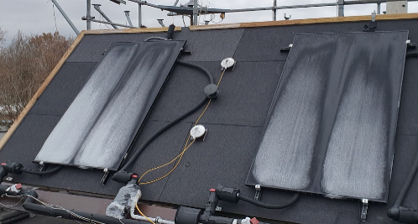
Fig. 1: PVT panels on roof surface.
The panels were connected to a test rig with a closed loop that allowed fixed flowrates and inlet temperatures down to –10°C. The heat transfer fluid was 30 % Clariant Antifrogen N (ethylene glycol) and 70 % water with a freeze protection down to approximately −17 °C. The flow rate through each absorber was approximately 1 L/min.
The electricity produced on the panel was exported to the grid via Emphase IQ7+ microinverters.
2.2 Mounting configurations
To investigate the influence of airflow beneath the collectors and the temperatures at the roof surfaces beneath the collectors, three mounting configurations were tested:
- Freely ventilated: No barriers, allowing relatively unrestricted airflow from wind and convection beneath the panel. Figure 2a.
- Partially restricted airflow: Barriers were installed around the collectors with an approximately 2 cm gap between the panel edges and the surrounding structures. The barriers consisted of elements extending from the plane of the PVT panel down to the roof surface, forming an enclosure around the collectors. This restricted direct wind-driven airflow beneath the panels from the surroundings. In addition, a horizontal extension approximately 15 cm wide was mounted along the edges in the same plane as the PVT panel. This extension acted as a flange, reducing edge effects and reducing turbulent inflow at the gap. This should represent conditions where multiple panels are mounted side by side. As a result, the airflow entering the cavity beneath the panels was limited, better representing array-like installation conditions. Figure 2b.
- Fully restricted airflow: in the configuration the gap between the barrier and the PVT panel was closed by mounting a board covering the gap. This should prevent airflow from the wind from going beneath the collectors. This configuration represents panels mounted side by side without any space between them. Figure 2c.
Figure 2a, 2b and 2c shows schematics of cross sections of the three mounting configurations with arrows representing wind and convection below and above the panels.
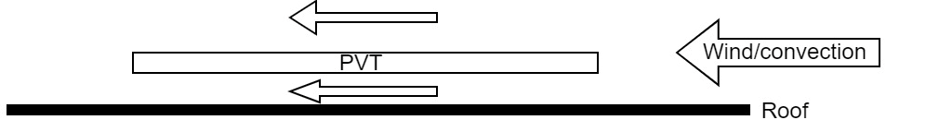
Fig. 2a: Cross section diagram of the freely ventilated PVT panel and roof configuration.
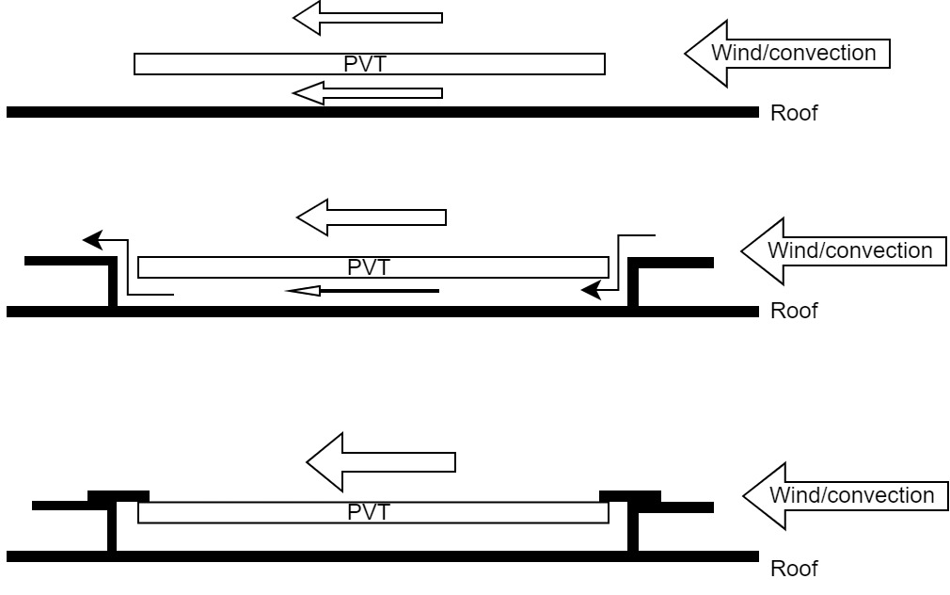
Fig. 2b: Cross section diagram of the partly restricted airflow configuration with barriers.
Fig. 2c: Cross section diagram of the fully restricted airflow configuration with barriers.
The measurements were carried out in separate periods for different mounting configurations during 2024. The data includes measurements from day and nighttime under varying weather conditions excluding periods with rain. Figures 3a, 3b and 3c shows the PVT panels mounted on the test roof in the different configurations with and without barriers.

Fig. 3a: PVT panels without barrier
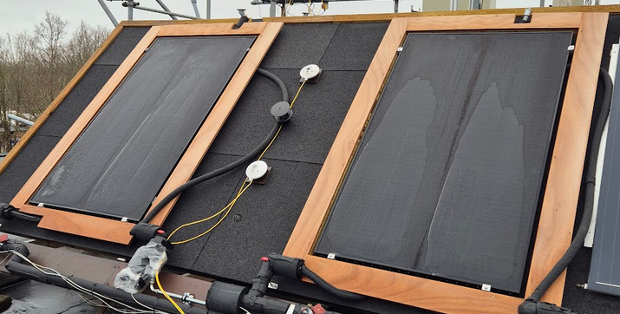
Fig. 3b: PVT panels with partly restricting barrier
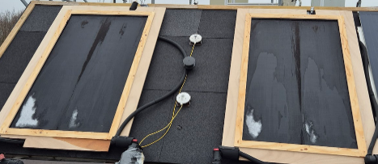
Fig. 3c: PVT panels with fully restricting barrier

2.3. Measurements
The experimental setup included continuous monitoring of thermal and environmental parameters including:
- Inlet and outlet temperatures measured using calibrated PT100 sensors (accuracy ±0.1 K)
- Flow rate measured using calibrated Brunata HGQ1-R0 electromagnetic flowmeters (accuracy ±2%)
- Solar irradiance measured using a Class A Kipp & Zonen CMP11 pyranometer (accuracy ±3%)
- Long-wave radiation measured using a Kipp & Zonen CG1 pyrgeometer (accuracy ±5%)
- Wind speed and direction measured using a WindSonic ultrasonic wind sensor from Gill instruments. (accuracy 2% RMSE at 12 m/s)
- Roof surface temperatures were measured using Type TT thermocouples mounted on the roof surface with clips (accuracy ±0.5 K).

2.4 Performance evaluation
The thermal performance of the collectors was evaluated using the quasi-dynamic test (QDT) method according to ISO 9806:2025. Collector efficiency coefficients were determined through regression analysis based on the measured data. The thermal performance coefficients, including the peak collector efficiency and heat loss coefficients, were derived for each configuration. Only statistically significant coefficients were retained based on standard significance criteria. Equation 1 shows the applied formula.
$\dot{Q}=A_{G}\left[\begin{aligned}η_{0,b}⋅K_{b}\left(θ\right)⋅G_{b}+η_{0,b}⋅K_{d}⋅G_{d}-a_{1}⋅\left(T_{m}-T_{a}\right)-a_{2}⋅\left(T_{m}-T_{a}\right) abs\left(T_{m}-T_{a}\right) \\ -a_{3}⋅u⋅\left(T_{m}-T_{a}\right) {+ a}_{4}\left(E_{L}-σT_{m}^{4}\right)-a_{5}\left(dT_{m}/dt\right)-a_{6}⋅u⋅\left(G_{b}+G_{d}\right)\end{aligned}\right]$ (eq. 1)
In addition to the full QDT regression, a simplified model containing only an effective peak collector efficiency, $η_{0,b}$, and an effective first-order heat-loss coefficient, $a_{1}$, as well as the effective thermal capacity, a₅, was fitted to the measurement data. Since the barriers were installed around the collectors and were not expected to affect their optical properties, $η_{0,b}$was constrained to a common value for the freely ventilated and partly restricted configurations. This allows for a more direct comparison of the heat loss characteristics with and without barriers when only one heat loss coefficient is changing. Separate values of $a_{1}$were then determined for the two configurations. This analysis provides a simplified comparison of their overall thermal performance. However, because wind-dependent and long-wave radiation terms were omitted, the resulting $a_{1}$values should be interpreted as effective heat-transfer coefficients representative of the measured conditions rather than as coefficients directly equivalent to those obtained from the full QDT model. Equation 2 shows the applied formula for the simplified analysis.
$\dot{Q}=A_{G}\left[η_{0,b}⋅K_{b}\left(θ\right)⋅G_{b}+η_{0,b}⋅K_{d}⋅G_{d}-a_{1}⋅\left(T_{m}-T_{a}\right)-a_{5}\left(dT_{m}/dt\right)\right]$ (eq. 2)
Separate datasets were collected for each mounting configuration. The data set used was 20 days without rain with varying weather conditions and different fixed inlet temperatures as required in the ISO 9806 standard.
The influence of mounting configuration was evaluated by comparing the derived coefficients across the different setups.
2.5. Roof temperature measurements and conditions
To investigate the influence of mounting configuration on roof surface temperatures, measurements were analyzed during selected periods with overcast conditions and low solar irradiance. These periods were chosen to minimize the influence of solar gains and thereby isolate the effect of airflow restriction on the thermal interaction between the collectors and the building structure. The selected conditions were characterized by ambient air temperatures between 6 and 10 °C, wind speeds between 1.4 and 2.4 m/s, and collector inlet temperatures of approximately −3 °C. Under these conditions, the collectors operated below ambient temperature, representing typical operation as heat sources for PVT-assisted heat pump systems. Roof surface temperatures beneath the collectors were compared with a reference measurement obtained from an exposed section of the roof. The roof surface temperature beneath each collector was measured using two Type TT thermocouples located at representative central positions below the panels. The sensors were mechanically fixed to the roof surface using clips to ensure good thermal contact and accurate measurement of the roof surface temperature.
- Results
3.1. Thermal performance coefficients
The thermal performance coefficients derived from the regression analyses are presented in Table 1. For collectors, the $a_{2}$coefficient did not meet the applied significance criterion for the partly restricted airflow configuration. The coefficient was therefore omitted, and the models were refitted. For the freely ventilated configuration, Table 1 presents the coefficients obtained both with $a_{2}$included and, in parentheses, with $a_{2}$omitted. The latter values allow a more direct comparison between the two mounting configurations including the same coefficients in the regression.
The fitted coefficients show a clear dependence on mounting configuration. The installation of barriers that restricted airflow beneath the collectors affected both the fitted peak collector efficiency and the heat-transfer characteristics.
The most pronounced change for the non-insulated PVT collector was observed in the wind-dependent heat-loss coefficient, $a_{3}$. When comparing the models without $a_{2}$, $a_{3}$decreased from 5.5 J m⁻³ K⁻¹ under freely ventilated conditions to 2.5 J m⁻³ K⁻¹ with barriers, corresponding to a reduction of approximately 55%. In contrast, the linear heat-loss coefficient, $a_{1}$, changed only slightly, from 10.3 to 10.2 W m⁻² K⁻¹. The fitted peak collector efficiency decreased from 0.56 to 0.52.
These results indicate that the barriers primarily reduced the wind dependence of the heat transfer rather than substantially changing the linear heat-loss coefficient of the non-insulated collector. This is consistent with a reduced contribution from wind-driven convective heat transfer when airflow beneath the collector is restricted.
For the insulated PVT collector, $a_{3}$decreased from 3.1 to 2.2 J m⁻³ K⁻¹.
The linear heat-loss coefficient $a_{1}$ increased from 4.9 to 5.6 W m⁻² K⁻¹, while the fitted peak collector efficiency decreased from 0.53 to 0.50. Thus, restricting the airflow also affected the coefficients of the insulated collector, although the reduction in wind dependence was less pronounced than for the non-insulated collector.
Overall, the results demonstrate that mounting configuration influenced the derived thermal performance coefficients. The clearest and most consistent effect was a reduction in the wind-dependent heat-loss coefficient when barriers were installed. This effect was particularly pronounced for the non-insulated collector, confirming the importance of unrestricted backside airflow for its convective heat transfer.

Tab. 1: Derived collector efficiency coefficient for PVT panels under freely ventilated and partly restricted airflow conditions.
 |  | Insulated PVT |  |  | Non insulated PVT
parameter | unit | Freely ventilated/  No barrier |  | Partly restricted/  Barrier w. gap | Freely ventilated/  No barrier |  | Partly restricted/  Barrier w. gap
η_{0,b} | - | 0.53 | (0.53) | 0.5 | 0.56 | (0.56) | 0.52
a₁ | W m⁻² K⁻¹ | 3.7 | (4.9) | 5.6 | 6.9 | (10.3) | 10.2
a₂ | W m⁻² K⁻² | 0.07 | ( - ) | N.S. | 0.22 | ( - ) | N.S.
a₃ | J m⁻³ K⁻¹ | 3.0 | (3.1) | 2.2 | 5.3 | (5.5) | 2.5
a₄ | - | 0.56 | (0.53) | 0.59 | 0.25 | (0.20) | 0.53
a₆ | m⁻¹ s | 0.07 | (0.07) | 0.04 | 0.09 | (0.09) | 0.04

Figures 4 and 5 shows the calculated thermal for both PVT collectors with and without the partly restricting airflow barriers in place, as a function of the windspeed, for conditions that represents operation in winter during nighttime and during sunny condition. In both cases the calculations are based on mean collector temperatures which are below ambient air temperature.
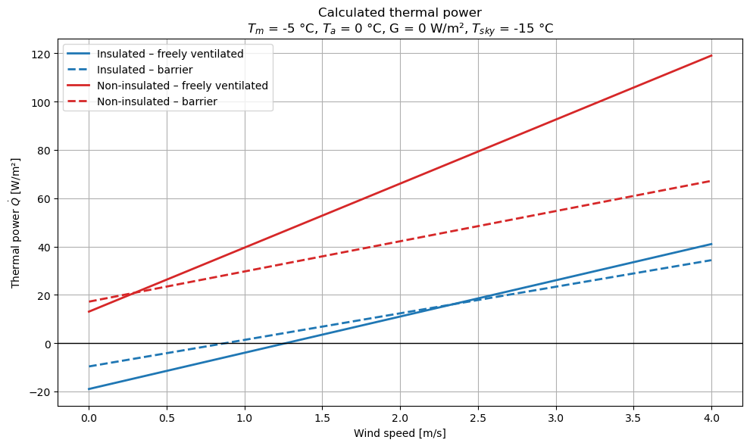
Fig. 4: Calculated thermal power output as function of wind speed during operation at nighttime in winter.

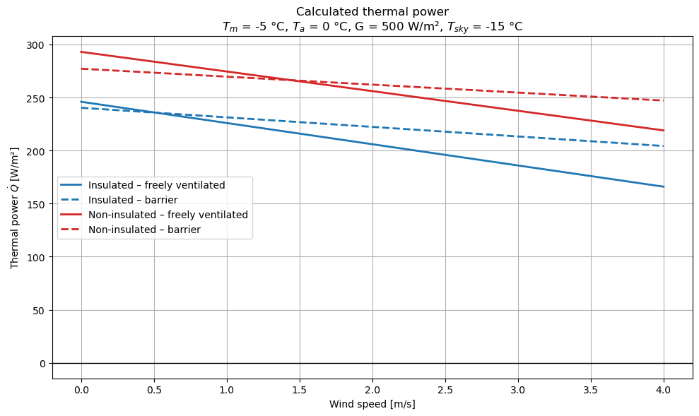
Fig. 5: Calculated thermal power output as function of wind speed during operation in sunny conditions in winter.

The diagrams indicate that especially during operation with no or little solar irradiance, during high wind speeds the difference in thermal power output is large between the freely ventilated and the partly restricted air flow mounting configurations.
Table 2 presents the results of the simplified analysis, in which the peak collector efficiency, $η_{0,b}$, was constrained to a common value and only the effective first-order heat-loss coefficient was allowed to vary between the configurations. For the non-insulated collector, the fitted heat-loss coefficient decreased from 15.9 to 14.1 W m⁻² K⁻¹ when the barriers were installed, corresponding to a reduction of approximately 11%. For the insulated collector, the coefficient decreased only slightly, from 9.8 to 9.6 W m⁻² K⁻¹, corresponding to approximately 2%. The larger reduction observed for the non-insulated collector indicates that its thermal performance was more sensitive to airflow conditions beneath the panel. This is consistent with the greater contribution of wind-dependent backside heat transfer for the non-insulated collector.
The effective zero-loss efficiencies obtained from the simplified regression, ranging from 0.41 to 0.44, were considerably lower than the peak collector efficiencies of 0.52–0.57 obtained from the full QDT regression. This difference results primarily from the omission of the wind-dependent zero-loss efficiency term, $a_{6}uG$, in the simplified model. Consequently, the effect represented by $a_{6}$was absorbed into the fitted effective zero-loss efficiency. The efficiencies obtained from the simplified and full regressions are therefore not directly comparable.
Tab. 2: Derived collector efficiency coefficients from the simplified analysis.
 |  | Insulated PVT |  |  | Non insulated PVT
parameter | unit | Freely ventilated/  No barrier | Partly restricted/  Barrier w. gap | Freely ventilated/  No barrier |  | Partly restricted/  Barrier w. gap
η_{0,b} | - | 0.41 |  |  | 0.44
a₁ | W m⁻² K⁻¹ | 9.8 | 9.6 | 15.8 |  | 14.0

3.2. Roof surface temperatures
The measured temperature differences between the ambient air temperature and the roof surface are summarized in Table 3. On average the temperature of the PVT panel was 11 K below the ambient air temperature and the temperature at the exposed roof was similar to the ambient air temperature.

Tab. 3: Temperature differences between the ambient air and the roof surface at different locations.
 |  |  | Insulated PVT |  |  | No insulation PVT
Parameter | unit | Roof exposed | Freely vent. | Part restricted | Fully restricted | Freely vent. | Part restricted | Fully restricted
Temperature difference | K | 0 | 0 | -2 | -7 | -1 | -4 | -8

The results show a clear influence of mounting configuration on the temperature of the roof surface beneath the collectors. For the freely ventilated configuration, the roof temperature was found to be close to the ambient air temperature, typically 0–1 K below. When barriers with a 2 cm gap were introduced, the roof temperature was reduced further to 2–4 K below ambient temperature. In the fully closed configuration, the reduction was most pronounced, reaching 7–8 K below ambient air temperature.
These results demonstrate that restricting airflow beneath the collectors enhances cooling of the roof surface. The reduced air exchange in the partially and fully restricted configurations increases the thermal coupling between the collector and the roof, resulting in greater heat extraction from the roof structure.
The results further indicate a strong thermal interaction between the collectors and the building. As airflow beneath the panels is restricted, the temperatures of the collector and roof surface become increasingly coupled. This interaction suggests that part of the heat absorbed by the PVT collectors may originate from the building structure rather than solely from the ambient environment.
Depending on the operating conditions, this may lead to increased heat losses from the building and contribute to the useful heat gain of the PVT system. The effect is most pronounced for the non-insulated collector, where the thermal coupling between the absorber, the air cavity, and the roof surface is strongest.
- Discussions
The analysis demonstrates that the mounting configuration of the PVT collectors significantly influences their thermal performance, particularly for the non-insulated collector. The largest effects were observed for the wind-dependent heat loss coefficient and the first-order heat loss coefficient, highlighting the strong dependence of uncovered PVT collectors on airflow conditions beneath the panels.
These findings raise important considerations regarding standard collector characterization methods, especially for non-insulated wind- and infrared-sensitive (WISC) collectors. Characterization tests are typically conducted under freely ventilated conditions and may therefore not capture the influence of installation-dependent airflow. Consequently, collector coefficients derived from standard testing may not accurately represent the performance of collectors installed in arrays where airflow beneath the panels is restricted. This is particularly relevant for PVT collectors used as heat pump sources, where heat transfer from the ambient environment plays a dominant role in system performance. The results therefore indicate that mounting configuration should be considered explicitly in both collector characterization and system modelling.
The observed reduction in roof surface temperatures under restricted airflow conditions demonstrates that the collectors interact not only with the ambient air but also with the building structure. When operating below ambient temperature, the collector can extract heat from both the surrounding air and, potentially also the roof, creating a coupled thermal system in which heat transfer depends on operating conditions and installation geometry. Consequently, part of the energy supplied to the heat pump may originate from the building envelope.
This interaction may be beneficial from a system perspective by increasing the available heat source for the heat pump. However, it may also increase heat losses from the building. The magnitude and direction of this effect are expected to depend on parameters such as roof design, insulation level, collector operating temperature, and airflow conditions beneath the panels. Reduced roof surface temperatures may furthermore create unfavorable conditions within the roof construction, which should be considered when integrating PVT collectors into buildings.
The results show that installation geometry constitutes an important design parameter in addition to collector design itself. Parameters such as airflow paths, panel spacing, and integration with the building envelope may influence both collector performance and the thermal interaction with the building.
The influence of mounting configuration is expected to be even more pronounced for PVT collectors with enhanced backside heat transfer, such as finned absorber designs. Since a substantial part of the heat transfer from the environment to the heat transfer fluid occurs through the rear side of the collector, particularly under low-irradiance conditions, increasing the backside heat transfer area is likely to increase the sensitivity to airflow conditions and cavity geometry.
The findings also point to potential implications for building durability. Prolonged operation with collector temperatures below ambient may result in conditions where condensation within the roof construction occurs. Over time, this may increase the risk of moisture accumulation, mold growth, or material degradation if not properly accounted for in the design.
Further investigation within this area is proposed. The distance between the collector and the roof is expected to influence both airflow behavior and thermal coupling, while the spacing between adjacent collectors may affect airflow distribution within larger PVT arrays. Future work should therefore investigate panel-to-roof distance, panel-to-panel spacing, finned or high-surface-area absorber designs, and the long-term effects of moisture transport and condensation in building-integrated PVT systems.
- Conclusions
This study has experimentally investigated the influence of different roof mounting configuration on the thermal performance of uncovered PVT collectors operating under conditions representative of their use as low-temperature heat sources for heat pumps in Nordic climates. The results demonstrate that airflow conditions beneath the collectors have a significant impact on both the thermal performance and the thermal interaction with the building below the PVT panels.
The key findings can be summarized as follows:
- Mounting configuration strongly influences the thermal performance and the collector efficiency coefficients of uncovered PVT collectors, with the effect being most pronounced for non-insulated collectors.
- Restricting airflow beneath the panels alters the heat transfer mechanisms and reduces the wind-dependent heat loss contribution.
- Collector characterization under freely ventilated conditions does not adequately represent real installation scenarios with an array of multiple panels, where airflow beneath the panels is restricted due to multiple panels mounted side by side with only minor gaps in between them.
- For certain mounting configurations, the collectors exhibit a strong thermal interaction with the roof surface, particularly during low-temperature operation where the roof temperature is reduced by the PVT collector. This interaction presents both opportunities and challenges, as heat extracted from the building structure may contribute to the useful heat gain of the PVT system, while simultaneously increasing heat losses from the building and potentially affecting the durability of the roof construction.
From a system perspective, the results highlight that installation geometry must be considered as an integral part of PVT system design, characterization, and modelling. Parameters such as airflow conditions and panel–roof interaction can significantly influence system performance and should not be neglected.
Furthermore, the findings indicate the need for future work addressing:
- the role of panel-to-roof distance and airflow control,
- the behavior of PVT collectors with enhanced backside heat transfer (e.g. finned designs),
- and the long-term implications related to moisture, condensation, and durability in building-integrated systems.
Overall, the study demonstrates that mounting configuration is a key parameter governing both collector performance and building interaction, and it should be explicitly accounted for in the development and application of PVT heat pump systems.
- Nomenclature and symbols
Quantity | Symbol | Unit
Heat loss coefficient | a₁ | W m⁻² K⁻¹
Second order heat loss coefficient | a₂ | W m⁻² K⁻²
Wind speed dependence of heat loss coefficient | a₃ | J m⁻³ K⁻¹
Sky temperature dependence of heat loss coefficient | a₄ | -
Effective thermal capacity | a₅ | J m⁻² K⁻¹
Wind speed dependence of peak collector efficiency | a₆ | m⁻¹ s
Gross area of the collector | A_{G} | m²
Direct solar irradiance | G_{b} | W m⁻²
Diffuse solar irradiance | G_{d} | W m⁻²
Incidence angle modifier for direct solar radiation | K(θ) | -
Incidence angle modifier for diffuse solar radiation | K_{d} | -
Time | t | s
Ambient air temperature | T_{a} | ⁰C
Mean temperature of heat transfer fluid in collector | T_{m} | ⁰C
Wind speed | u | m s⁻¹
Peak collector efficiency based on G_{b} | η_{0,b} | -
Angle of incidence | θ | ⁰
Stefan Boltzman constant | σ | 5.67*10⁻⁸ W m⁻² K⁻⁴

Acknowledgement
The research was financed by the Danish Energy Agency through EUDP project: iTB - integrated Triple energy Building elements, grant no. 64022-1036
References
Beltrán, F., Sommerfeldt, N., 2026. Techno-economic evaluation of PVT-sourced heat pump systems: Can solar compete with air and ground in cold climates? Solar Energy Advances 6, 100133. https://doi.org/10.1016/j.seja.2026.100133

Beltran, F., Sommerfeldt, N., Eskola, J., Madani, H., 2024. Empirical investigation of solar photovoltaic-thermal collectors for heat pump integration. Applied Thermal Engineering 248. 123175
https://doi.org/10.1016/j.applthermaleng.2024.123175

Beltrán, F., Sommerfeldt, N., Reichl, C., Madani, H., 2025. Cold solar: PVT heat exchanger designs for heat pump integration. Applied Thermal Engineering 261, 125020. https://doi.org/10.1016/j.applthermaleng.2024.125020

Dannemand, M., Perers, B., Furbo, S., 2019. Performance of a demonstration solar PVT assisted heat pump system with cold buffer storage and domestic hot water storage tanks. Energy & Buildings 188-189, https://doi.org/10.1016/j.enbuild.2018.12.042

Dannemand, M., Sifnaios, I., Jensen, A.R., Furbo, S., 2020a. Experimental investigation and characterization of façade integrated PVT collectors with and without insulation. In: Proceedings of the ISES Solar World Congress 2019 and IEA SHC International Conference on Solar Heating and Cooling for Buildings and Industry 2019.
International Solar Energy Society, pp. 1752–1759. https://doi.org/10.18086/swc.2019.35.02

Dannemand, M., Sifnaios, I., Tian, Z., Furbo, S., 2020b. Simulation and optimization of a hybrid unglazed solar photovoltaic-thermal collector and heat pump system with two storage tanks. Energy Conversion and Management 206, 112429. https://doi.org/10.1016/j.enconman.2019.112429

Sifnaios, I., Jensen, A.R., Dannemand, M., Dragsted, J., 2021. Demonstration of a domestic photovoltaic-thermal (PVT)-heat pump system, performance simulation, and economic analysis for different climates. In: Proceedings of the ISES Solar World Congress 2021. International Solar Energy Society, pp. 588–599. https://doi.org/10.18086/swc.2021.26.03

