EuroSun2026
INNOVATIVE ICE STORE CONCEPTS WITH REDUCED RESOURCE DEMANDS
Stephan Lang^{1*}, Christian Lodroner¹, Harald Drück¹, Ralf Dott²
1 Institute for Building Energetics, Thermotechnology and Energy Storage (IGTE), University of Stuttgart (Germany)
2 Viessmann Holding International GmbH, Allendorf (Eder) (Germany)
Email: stephan.lang@igte.uni-stuttgart.de
Summary
Ice stores offer considerable potential for heating and cooling buildings and districts, particularly in combination with cold solar district heating networks. However, conventional large-volume underground ice stores are typically constructed as concrete tanks, resulting in comparatively high costs, resource consumption, and greenhouse gas emissions. The “innoBeLs” project therefore investigates alternative concepts with volumes between 100 m³ and 1 000 m³. This paper outlines the main challenges associated with the investigated innovative ice store concepts and presents selected results for an infiltration crate ice store. As the infiltration crates must withstand the loads resulting from the store cover and traffic, their load-bearing behavior was investigated in compression tests. At the point during testing at which a specimen temperature of −8 °C was reached, the compressive stress exceeded the combined area load from a total cover depth of 1 m comprising soil and road pavement and the traffic load of 30 t vehicles by at least 20 %, while the compressive strain remained below 0.5 %. Lower temperatures increased the short-term compression strength but resulted in more brittle failure. No visible damage occurred during eight freeze–thaw cycles of a hollow support column from the same type of infiltration crate used in the compression tests. The results support the technical feasibility of the concept, although full-scale testing remains necessary.
Keywords: ice store, ice storage, thermal energy store, solar thermal, heat pump, cold district heating, life cycle assessment (LCA), life cycle costing (LCC)
Field of application for the findings: Solar thermal heating and cooling systems with seasonal storage; cold district heating networks, integration of ice store in building and district energy systems; reduction of resource demands
Addressed audience: Researchers and engineers in solar thermal energy, thermal energy storage, HVAC, and energy system planning for buildings and districts. Municipal decision makers.
- Introduction
Ice stores are becoming increasingly important for the heating and cooling supply of buildings and districts. They can serve both as a long-term heat store in combination with a heat pump and as a cold thermal energy store for cooling. In particular, the integration of ice stores combined with heat pumps into cold solar district heating networks offers considerable potential for reducing CO₂ emissions associated with space heating in the building sector. (Altuntas and Erdemir, 2022; Associated Press, 2023; ENGIE Refrigeration, n.d. (no date).; Drück et al., 2024; Guelpa and Verda, 2019; Mehdipour et al., 2025; Osterman and Stritih, 2022; Sivák et al., 2020; Viessmann, 2019; Vivian et al., 2023)
The work presented in this contribution was conducted as part of the research project “innoBeLs”, which focuses on the development and implementation of innovative underground ice store concepts for commercial application in solar cold district heating networks. These concepts are intended to provide both economic and ecological benefits. The project is carried out jointly by the Institute for Building Energetics, Thermotechnology and Energy Storage (IGTE) at the University of Stuttgart, Germany and Viessmann Deutschland GmbH. The project duration is from 01/2025 to 12/2028 (IGTE, n.d.). The ice store concepts are designed for volumes between 100 m³ and 1 000 m³ and are intended to be trafficable by heavy-duty vehicles.
Current ice stores predominantly use cost-intensive concrete tanks equipped with two heat exchanger coil loops (Baukobox GmbH, n.d.; GNV GmbH, n.d.; LowTEMP Project, 2021). The production of these tanks is comparatively energy-intensive and is therefore associated with substantial greenhouse gas emissions (Barbhuiya et al., 2024). By contrast, the newly developed innovative container concepts are intended to reduce environmental impacts and resource consumption by at least 50 % and costs by at least 20 % compared with conventional ice strores using concrete tanks. Achieving these targets would facilitate broader market penetration while reducing the ecological impacts associated with this promising technology.
The main stages of the research project comprise the elaboration of innovative container concepts, life cycle assessment (LCA) and life cycle costing (LCC) analysis for both existing and new container concepts. Another important objective of the project is to standardize the concept, the preliminary design, the documentation and the handover process. Furthermore, the most promising ice store concept will be implemented as a pilot system in a field environment and tested under various operating scenarios.
This contribution provides an overview of the most promising newly developed ice store concepts investigated within the research project “innoBeLs”, as well as selected project results.
- Description of selected innovative ice store concepts
Fig. 1 shows graphics and a photograph of the currently most widespread concept for large-volume underground ice stores. It consists of a concrete container and two polymer heat exchanger coil loops mounted on an aluminum frame. One heat exchanger coil loop is used for discharging, and the other for charging the ice store. Fig. 2 shows a selection of innovative alternative ice store concepts investigated in the research project innoBeLs.
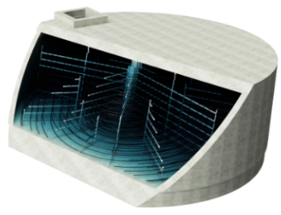 | 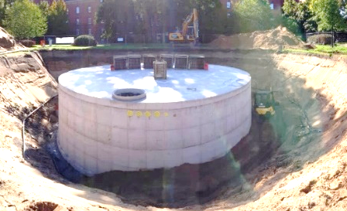 | 
Fig. 1: Concrete tank ice store concept. Left: 3D model providing an internal view of the ice store, showing the heat exchanger coils and their mounting (LTTT, n.d.). Middle: photograph taken during the construction phase (Krug, 2019). Right: simplified schematic illustration.
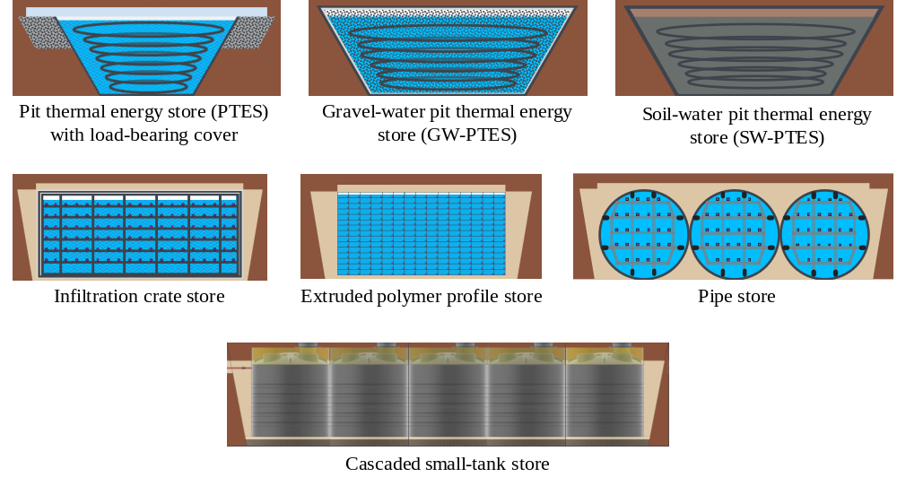
Fig. 2: Simplified schematics of a selection of innovative ice store concepts investigated within the research project.
Pit thermal energy stores (PTES) and gravel-water pit thermal energy stores (GW-PTES) have already been used as seasonal hot water stores for decades (Dahash et al., 2019; Novo et al., 2010; Xiang et al., 2022). However, to the author’s knowledge, PTES have never been constructed with a cover that allows trafficability by heavy-duty vehicles. GW-PTES provide the required trafficability due to the densified gravel fill (Benner et al., 2003; Novo et al., 2010). Neither concept was originally designed for use as an ice store. However, the formation of ice with a small volumetric fraction was considered in one low-temperature GW-PTES (Streit, 1996). In soil-water pit thermal energy stores (SW-PTES), the excavated soil is used as the load-bearing structure instead of gravel. This eliminates the need for gravel and its transportation, while also reducing the resources required for the removal and disposal of the excavated soil. The gravel or soil serves not only as a load-bearing structure to ensure trafficability, but also as a support structure for the heat exchanger coil loops.
Typically, infiltration crates are installed underground for rainwater infiltration in so-called infiltration trenches. An example of an infiltration trench unit is depicted in Fig. 3, right. If the rainwater is to be stored, several crates are assembled and enclosed within a waterproof liner. The crates are typically made of polypropylene (PP) and are designed to be trafficable by heavy-duty vehicles. An innovative approach is to use the crates as elements for an ice store. In this case the crates could be pre-assembled into modules of a size suitable for road transport and equipped with integrated heat exchanger pipes. Enclosure in a waterproof liner prior to installation is also feasible. On site, the heat exchanger pipes of the individual modules must then be connected to each other or to a supply and return manifold.
Using extruded polymer profiles for an ice store represents an innovative approach in which the main part of the container, including the heat exchangers, is manufactured in a single production step. The entire store can be assembled from multiple modules of a size suitable for road transport. This concept significantly reduces on-site assembly work, as the individual modules only need to be interconnected.
Underground, horizontally installed polymer pipes with diameters of around 3 m are currently used for the storage of drinking water or firefighting water (Amiblu Holding GmbH, n.d.; FRANK GmbH, n.d.). Equipped with heat exchangers, these pipes could in priciple also serve as ice stores.
Commercially available underground polymer tanks with volumes of up to 20 m³ are currently used as small-scale ice stores, mainly for single-family houses (Skoruppa, n.d.). These comparatively small tanks could be combined in a cascaded configuration to realize ice stores with total volumes between 100 m³ and 1,000 m³ (“cascaded small-tank store”). However, the tanks currently available still require structural stabilization to ensure trafficability by heavy-duty vehicles.
- Investigations and selected results for infiltration crates
In this chapter, the main areas of investigation for the different ice store concepts are described, and selected results for the infiltration crate store are presented.
For PTES, the main focus is on investigating different top cover structures including their structural supports. For GW-PTES and SW-PTES, design and sizing of load-bearing heat exchanger pipes represent one of the primary fields of investigation. In SW-PTES, the excavated on-site soil is intended to serve as the load-bearing material instead of gravel. Therefore, the suitability of the local soil must be assessed in advance. The concept is only advantageous over GW-PTES if the available soil is suitable for repeated freezing without causing significant frost heave or settlement, so that the surface above the store remains suitable for traffic loads.
The extruded polymer profile store must be developed entirely as a new concept. Initial investigations focus on the design and cost assessment of the extrusion die, as well as the dimensioning of the load-bearing structure using FEM simulations.
For the pipe store, different heat exchanger options and their mounting systems constitute the main areas of investigation, while for the cascaded small-tank store, various approaches to increasing the load-bearing capacity are being evaluated.
The structural stability of infiltration trenches composed of infiltration crates is guaranteed by the manufacturers only for frost-free operating conditions, and no data are available on their mechanical strength at temperatures below 0 °C. These data therefore need to be determined experimentally. The methodology and results of the initial tests conducted for this purpose are presented in the following two subsections.
3.1 Compression strength of infiltration crates at temperatures ≤ 0 °C
Most commercially available infiltration crates are primarily made of polypropylene (PP) and are not specified for use at temperatures ≤ 0 °C, as PP becomes brittle at such temperatures (Farotti et al., 2019; Mai and Williams, 1977). Therefore, testing the compression strength of the most promising types of infiltration crates was an important experimental investigation conducted for this ice store concept.
The infiltration crate “Rigofill ST-A half block“, manufactured by Fränkische Rohrwerke Gebr. Kirchner GmbH & Co. KG, was identified as the most promising type for the newly developed infiltration crate ice store concept, see Fig. 3, left.
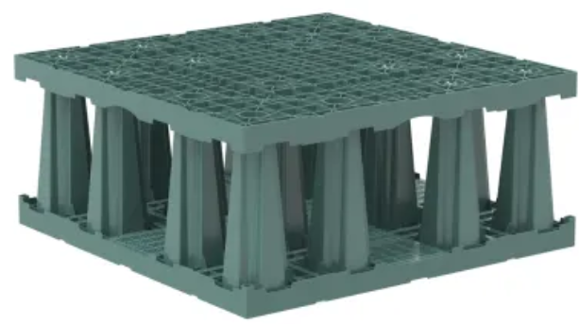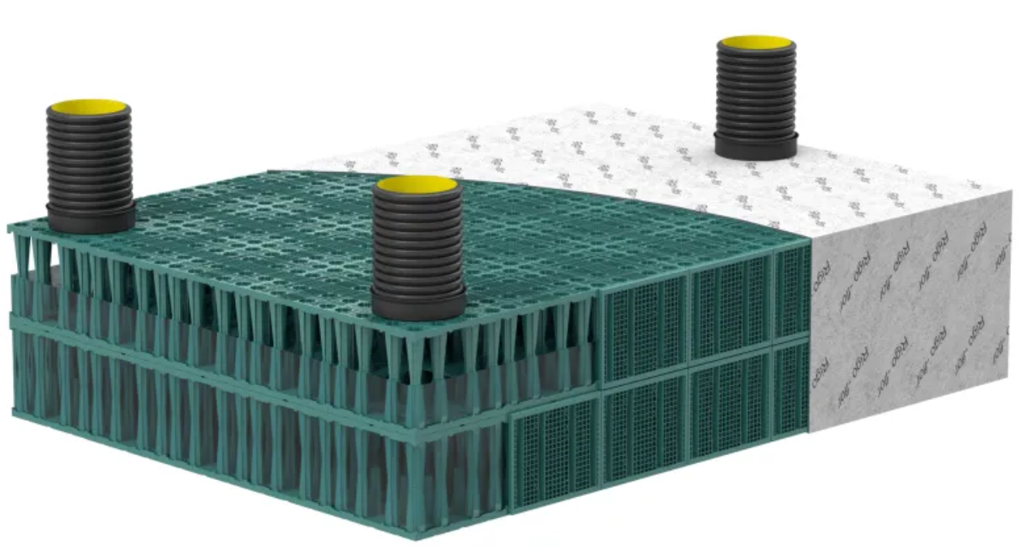
Fig. 3: Left: Infiltration crate „Rigofill ST-A half block“. Right: assembly of infiltration crates „Rigofill ST-A full block“ into an infiltration trench unit. Image sources: (Fränkische, n.d.-a; Fränkische, n.d.-b)
These infiltration crates have a square base with a side length of 800 mm, and a height of 350 mm. Crates of this type were tested for compression strength using a procedure based on the standard EN 17150:2019 at a test stand of the Material Testing Institute (MPA) of the University of Stuttgart. The tests were performed using the computer-controlled servo-hydraulic testing machine “Ernst HPM 1600” with a maximum load capacity of 1 600 kN and according to “Method B” of EN 17150:2019 with a constant displacement rate of (1.0 ± 0.1) mm/min. The load for the compression tests was applied by a loading platen, while the compression load and displacement were recorded synchronously.
The infiltration crates used as test specimens were conditioned in a climatic chamber prior to testing. However, temperature conditioning could not be maintained during the tests. The target specimen temperature was −8 °C, corresponding to the locally expected minimum temperature at the contact points between the heat exchangers and the crates. For comparison with the manufacturer’s test results, four specimens were additionally intended to be tested at approximately 23 °C and were therefore preconditioned to this temperature. Since the ambient temperature around the testing machine was approximately 10 °C, the temperatures of the specimens preconditioned to 23 °C decreased during testing and ranged from approximately 13 °C to 20 °C during the measurements. The three specimens intended for testing at −8 °C were preconditioned to temperatures between −19 °C and −18 °C. To reduce the temperature increase during testing, wood-fiber insulation boards were placed at the sides of these specimens. During the measurements, the temperatures of the three specimens ranged from −9 °C to 0 °C until the maximum compression load was reached. For ease of reference, the specimens pre-cooled to temperatures between −19 °C and −18 °C are hereinafter referred to as the “pre-cooled specimens”, whereas the specimens preconditioned at 23 °C are referred to as the “specimens tested at ambient temperature”.
Fig. 4 shows specimens in the testing machine, with and without insulation boards, prior to failure for the specimen during testing.
The maximum compression loads recorded for the specimens tested at ambient temperature ranged from 293 kN to 333 kN. Based on the cross-sectional area of the specimens of 0.64 m², these values correspond to short-term compression strengths ranging from 458 kN/m² to 520 kN/m². According to the manufacturer’s specifications, the short-term compression strength determined at a test temperature of 23 °C must be at least 420 kN/m² (Fränkische, 2025). This requirement was met in all tests. However, it should be noted that the actual specimen temperatures during testing were below this target temperature.
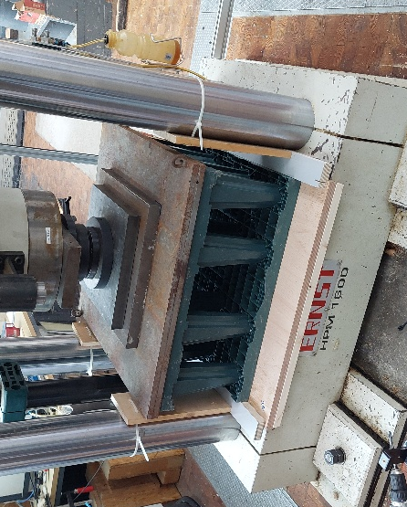 | 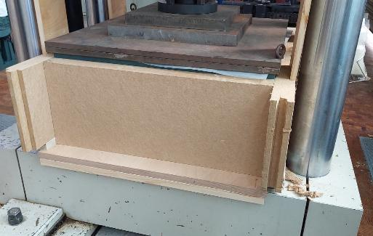
Fig. 4: Infiltration crate specimens in the compression testing machine “Ernst HPM 1600”. Left: without wood-fiber insulation boards. Right: with wood-fiber insulation boards.
For the pre-cooled specimens, the maximum compression loads ranged from 447 kN to 479 kN. Based on the specimen base area of 0.64 m², these values correspond to short-term compression strengths ranging from 698 kN/m² to 748 kN/m².
The displacement at the maximum compression load for all seven specimen ranged from 8.3 mm to 9.6 mm, which corresponds to a strain between 2.37 % and 2.74 % of the initial specimen height of 350 mm. These values are well below the maximum strain of 5 % at maximum compressive stress specified for Rigofill ST-A in the French CSTB technical appraisal (CSTB, 2026).
An overview of the test results at ambient temperature is provided in Tab. 1, and of the results at temperatures ≤ 0 °C are summarized in Tab. 2. Both tables include arithmetic means and standard deviations.
Tab. 1: Measured short-term compression strength of the infiltration crates at ambient temperature (13 °C–20 °C)
Specimen | Compression strength | Displacement | Strain
Specimen 1 | 520 kN/m² | 9.6 mm | 2.73 %
Specimen 2 | 498 kN/m² | 9.5 mm | 2.70 %
Specimen 3 | 491 kN/m² | 9.4 mm | 2.68 %
Specimen 4 | 458 kN/m² | 8.8 mm | 2.51 %
Arithmetic mean | 491.3 kN/m² | 9.33 mm | 2.66 %
Standard deviation | 26.6 kN/m² | 0.36 mm | 0.10 %

Tab. 2: Measured short-term compression strength of the infiltration crates at temperatures ≤ 0 °C
Specimen | Compression strength | Displacement | Strain
Specimen 5 | 698 kN/m² | 8.3 mm | 2.39 %
Specimen 6 | 748 kN/m² | 8.8 mm | 2.52 %
Specimen 7 | 725 kN/m² | 8.6 mm | 2.46 %
Arithmetic mean | 723.7 kN/m² | 8.57 mm | 2.46 %
Standard deviation | 25.0 kN/m² | 0.25 mm | 0.07 %

Because the pre-cooled infiltration crates, which were intended to be tested at –8 °C specimen temperature, warmed during testing, the maximum compression load could not be measured at the target temperature. Throughout the tests, the surface temperature of the pre-cooled specimens was measured by the pyrometer “Laserliner® ThermoSpot Pro”. Specimen 5 showed the highest temperature increase of all pre-cooled specimens. Its measured surface temperatures during testing are shown in the load-displacement curve in Fig. 5. The temperature was not measured continuously because this would have required removing one of the insulation boards, which would have accelerated specimen warming. Around maximum compression load, the measured surface temperatures of the three pre-cooled specimens were 0 °C, −4 °C, and −4.5 °C.
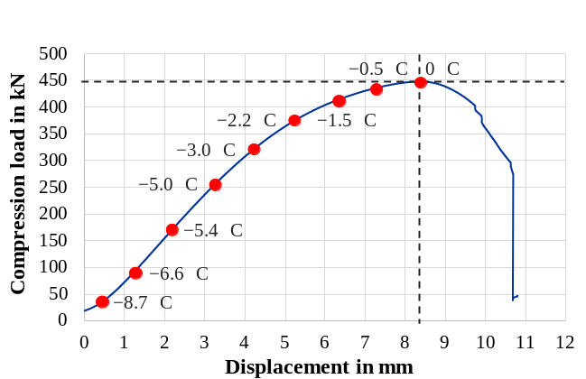
Fig. 5: Load-displacement curve of specimen 5, including measured specimen surface temperatures.
The compression loads at –8 °C specimen temperature for the specimens 5–7 were estimated by linear interpolation and ranged from 31.36 kN to 125.44 kN, which corresponds to compressive stresses between 49 kN/m² and 196 kN/m². According to the SLW 30 load model specified in DIN 1072:1985-12, which is commonly used to assess trafficability, an equivalent uniformly distributed load of 16.7 kN/m² shall be applied for vehicles with a total mass of up to 30 t. In addition, an earth cover of 1 m is required. For high-density soil, including the road pavement structure, a conservative unit weight of 24 kN/m³ is assumed (ABG Ltd., 2021; DIN EN 1991-1-1:2010-12), leading to an additional area load of 24 kN/m². Combined with the equivalent uniformly distributed traffic load, this results in a total area load of 40.7 kN/m².
At a specimen temperature of −8 °C, even the lowest estimated compressive stress exceeded this area load by 20.4 %, with compressive strains of less than 0.5 %. It can therefore be assumed that the reduced temperature alone does not preclude the use of the tested infiltration crates in an ice store. This conclusion is further supported by the fact that, for the planned ice store, trafficability for heavy-duty vehicles with a maximum mass of 18 t is sufficient and that, on a volume-averaged basis, the infiltration crates will be exposed to temperatures above −8 °C. The minimum temperature of −8 °C is expected to occur only locally at the contact points between heat exchangers and the infiltration crates.
In fact, lower temperatures resulted in higher short-term compression strengths and lower strains at maximum compression load. This behavior is consistent with the increased brittleness of polypropylene at lower temperatures. The arithmetic mean of the strain at maximum compression load was 7.5 % lower for the specimens tested at lower temperatures than for those tested at ambient temperature. However, the failure behavior differed between the two temperature ranges. At lower temperatures, failure was characterized more strongly by brittle fracture, whereas at higher temperatures it was characterized by pronounced plastic deformation. Nevertheless, failures occurred at compression loads far above those expected in the intended application. The load–displacement curves of all tested specimens are shown in Fig. 6, while photographs of selected specimens after failure are presented in Fig. 7.
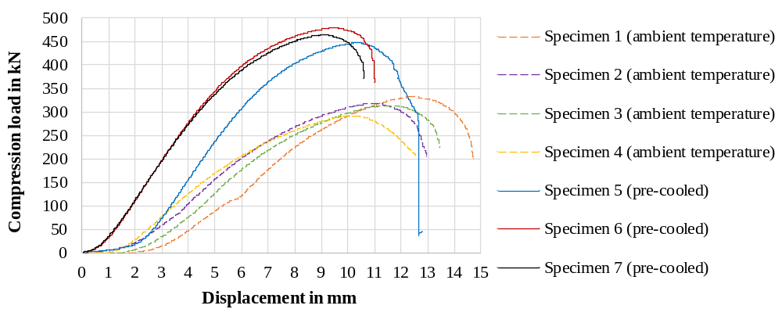
Fig. 6: Load-displacement curves of all tested infiltration crate specimens
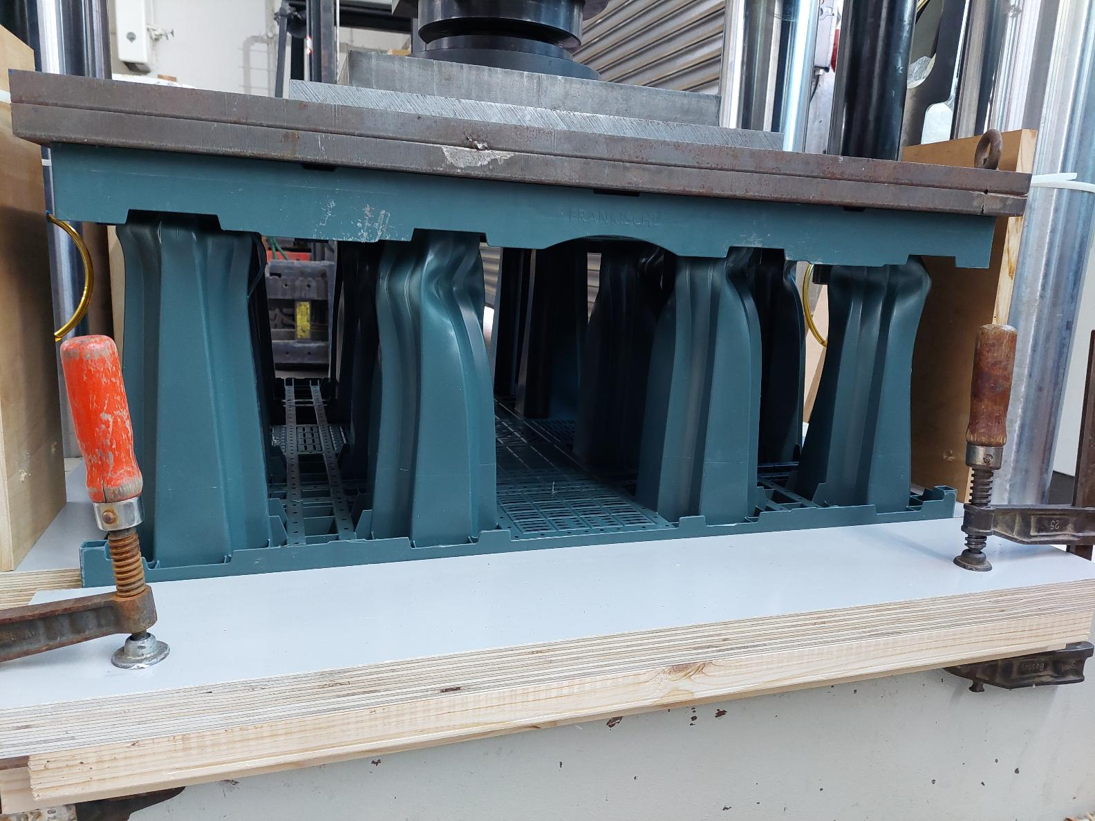 | 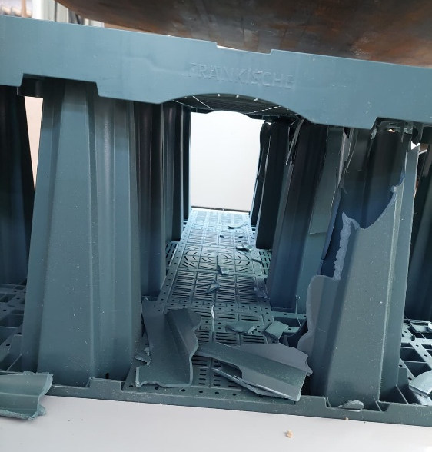
Fig. 7: Failure patterns of selected infiltration crate specimens.
Left: specimen tested at ambient temperature. Right: pre-cooled specimen tested at ≤ 0 °C.
Although the reduced temperature alone does not preclude the use of the tested infiltration crates in an ice store, it remains to be investigated whether pressure generated by ice formation within their hollow support columns could cause damage. The methodology and results of corresponding investigations are described in the following chapter 3.2.
3.2 Freezing of a hollow infiltration crate support column
In the installed configuration of the infiltration crate ice store, heat exchanger pipes will run between the support columns at each layer of the infiltration crates. As heat transfer medium a brine solution at a temperature below 0 °C will circulate through these pipes to freeze the ice store. As a result, the water-filled hollow support columns will freeze from the outside inward and from their ends toward the center, see Fig. 8. The expansion of the ice within the columns could generate pressure on the column walls. A laboratory test was therefore conducted to determine whether the freezing process described above could cause damage to the support columns.
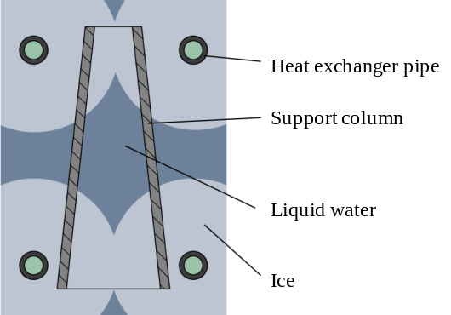
Fig. 8: Ice formation at an infiltration crates’ hollow support column
Fig. 9 shows the mounting arrangement of the support column and heat exchanger pipes used in the test. The support column was taken from a “Rigofill ST-S” infiltration crate, which is identical in design to the “Rigofill ST-A” crates used in the compression tests but has a 15.7 % lower compression strength due to a slightly different composition of the PP material (DIBt, 2026; Fränkische, 2025).
The left image in Fig. 10 shows the test setup, in which the support column was installed in a water-filled test chamber, while the right image shows the resulting ice formation. In subsequent tests, additional heat exchanger pipes were installed around the central section of the support column. Brine was circulated through these pipes after the ends of the column had been sealed by ice, ensuring that the central section of the support column was completely frozen. These subsequent tests were intended to represent the most critical condition with respect to pressure buildup inside the support column that could occur within an infiltration crate ice store. The heat flow rate and the ice growth rate were not determined.
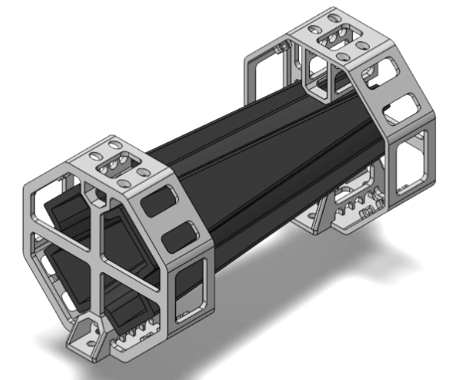 | 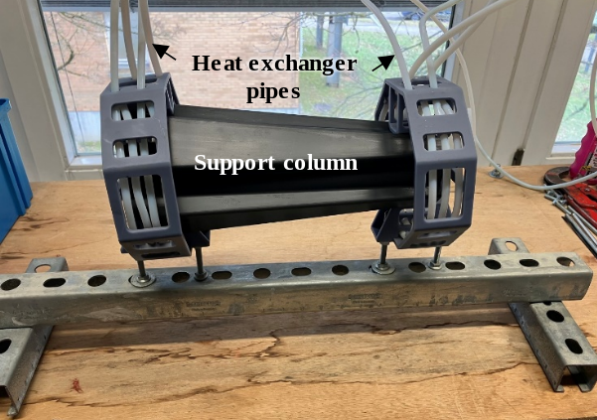
Fig. 9: Mounting arrangement of the support column and heat exchanger pipes for the freezing test.
Left: 3D model. Right: photograph.
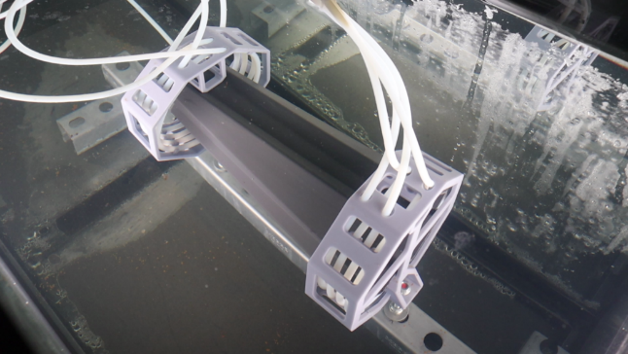 | 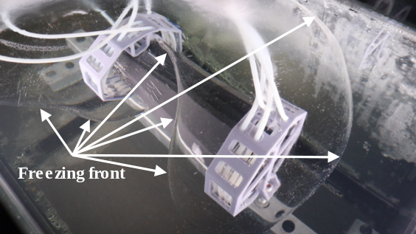
Fig. 10: Left: Test setup for the freezing tests before ice formation. Right: Visible ice formation around the heat exchanger pipes and the support column.
However, no damage to the support column was observed after a total of eight freeze–thaw cycles. This may be attributed to the conical shape of the column, which allows the ice to be displaced more easily. In addition, the ice layer surrounding the support column may have absorbed part of the forces generated by ice formation within the column, thereby reducing the load on the column wall. The deformability of the PP material may also have contributed to accommodating part of the stresses caused by ice expansion.
The results obtained with this simplified test setup indicate that ice formation within an infiltration crate ice store might occur without causing damage. However, further tests using a full-scale infiltration crate ice store configuration are required to confirm these findings. In such a configuration, the ends of the support columns are less permeable because they are bounded by adjacent infiltration crates, unlike in the simplified test setup.
- Conclusion and outlook
The investigations conducted within the “innoBeLs” project show that several alternatives to conventional concrete ice store tanks may offer technical, economic, and environmental advantages. The concepts considered include pit thermal energy stores, gravel-water and soil-water pit thermal energy stores, infiltration crate stores, extruded polymer profile stores, large-diameter polymer pipe stores and cascaded small-tank stores. Each concept requires further development in specific areas, including trafficable covers, load-bearing heat exchanger structures, material selection, structural stabilization, manufacturing processes and heat exchanger integration.
The experimental investigations presented in this paper focused on infiltration crates, as their use in ice stores requires verification of their structural behavior at temperatures at or below 0 °C. The tested “Rigofill ST-A half block” infiltration crates exhibited short-term compression strengths of 458–520 kN/m² at specimen temperatures between approximately 13 °C and 20 °C and 698–748 kN/m² for the specimens at temperatures between −9 °C and 0 °C. The displacement at maximum compression load remained below the maximum strain of 5 % at maximum compressive stress specified for “Rigofill ST-A” in the French CSTB technical appraisal (CSTB, 2026) for all specimens.
Lower specimen temperatures resulted in higher short-term compression strengths and slightly lower strains at maximum compression force. However, the failure behavior became more brittle as the temperature decreased. Although failure occurred only at loads well above those expected during operation, the increased tendency toward brittle fracture must be considered in the further development and structural assessment of the concept.
Because the specimens could not be actively cooled during testing, the surface temperature of the specimens pre-cooled to between −19 °C and −18 °C increased before and during the tests, reaching up to 0 °C. The primary target temperature was −8 °C. At this temperature, the specimens had not yet reached their maximum compression load.
Even the lowest compressive stress at −8 °C exceeded the minimum required combined area load of 40.7 kN/m² by at least 20 % at compressive strains below 0.5 %. This area load comprises the load from a total cover depth of 1 m comprising soil and road pavement and the equivalent traffic load of the SLW 30 load model specified in DIN 1072:1985-12. The SLW 30 load model represents a heavy-duty vehicle with a mass of 30 t.
The required trafficability of the planned ice store is less demanding than the SLW 30 load model because vehicles with a maximum mass of 18 t are considered sufficient. Moreover, only a small portion of the infiltration crates will reach temperatures as low as −8 °C. These results therefore indicate that reduced operating temperatures alone do not preclude the use of the tested infiltration crates in an ice store.
However, in addition to the effects of low temperatures, ice formation may induce mechanical stresses in the infiltration crates due to the expansion of freezing water. Laboratory-scale freezing tests were therefore conducted on a hollow support column of the selected infiltration crate type. These freezing tests showed that ice formation within the hollow support column did not cause visible damage during eight freeze–thaw cycles. This also applied when the ends of the column were first sealed by ice and the central section was subsequently frozen to represent a critical pressure buildup scenario. The conical geometry of the support column and the surrounding ice layer may have limited the mechanical loading of the column wall.
Overall, the results support the technical feasibility of using infiltration crates as structural elements in innovative underground ice stores. Nevertheless, the findings are based on a simplified load and freezing setup used for testing. Further investigations should therefore include tests on a full-scale infiltration crate assembly under representative boundary conditions, particularly with adjacent crates restricting the ends of the hollow support columns. Long-term cyclic loading, repeated freeze–thaw operation, temperature-dependent material behavior, and the interaction between the crates, heat exchanger pipes, watertight liner, cover structure and surrounding soil should also be investigated before the concept is implemented as a commercially viable product.
- Acknowledgment
The innoBeLs project is funded by the German Federal Ministry for Economic Affairs and Energy (BMWE) based on a resolution of the German Bundestag, through the Project Management Jülich (PTJ) under the grant number 03EN6049. The authors express their gratitude for the support and take full responsibility for the content of this publication.
- References
ABG Ltd., 2021. Soil properties: Unit weight. Technical Note, Rev. 0. https://abg-geosynthetics.com/wp-content/uploads/ABG-Soil-Properties-Unit-Weight-TECH-NOTE.pdf (accessed August 10, 2026)
Altuntas, M., Erdemir, D., 2022. An investigation on potential use of ice thermal energy storage system as energy source for heat pumps. Journal of Energy Storage 55, 105588. https://doi.org/10.1016/j.est.2022.105588
Amiblu Holding GmbH, n.d. GRP potable water pipes and water mains. https://www.amiblu.com/potable-water-pipes/ (accessed August 10, 2026).
Associated Press, 2023. Buildings are turning to ‘ice batteries’ for sustainable air conditioning. https://apnews.com/article/climate-ice-battery-energy-air-conditioning-ecbfe9bcfb255b45b3d5ad7a9a18bfdb (accessed March 10, 2026)
Barbhuiya, S., Kanavaris, F., Das, B.B., Idrees, M., 2024. Decarbonising cement and concrete production: Strategies, challenges and pathways for sustainable development. Journal of Building Engineering 86, 108861. https://doi.org/10.1016/j.jobe.2024.108861
Baukobox GmbH, n.d. Basic knowledge Ice Storage Heat Pump. https://baukobox.de/en/knowledge/1298-ice-storage-heat-pump (accessed March 11, 2026)
Benner, M., Mahler, B., Mangold, D., Schmidt, T., Schulz, M., Seiwald, H., 2003. Solar unterstützte Nahwärmeversorgung mit und ohne Langzeit-Wärmespeicher (Nov 1998 until Jan 2003), Final report of the German government funded research project with grant number 0329606 S (BMWi), ISBN 3-9805274-2-5, Stuttgart, Germany
CSTB, 2026. Rigofill inspect – Rigofill ST-A. Avis Technique 17.2/14-285_V7. https://www.batipedia.com/atecstream/pdfDoc/UMJU-6.pdf (accessed August 10, 2026).
Dahash, A., Ochs, F., Janetti, M.B., Streicher, W., 2019. Advances in seasonal thermal energy storage for solar district heating applications: A critical review on large-scale hot-water tank and pit thermal energy storage systems. Applied Energy 239, 296–315. https://doi.org/10.1016/j.apenergy.2019.01.189
DIBt – Deutsches Institut für Bautechnik, 2026. Allgemeine bauaufsichtliche Zulassung / Allgemeine Bauartgenehmigung Z-42.1-608: Versickerungsblöcke und -schächte mit der Bezeichnung “Rigofill ST-S” für die Versickerung und Speicherung von Niederschlagswasser mit zugehörigen Schächten mit der Bezeichnung “QuadroControl ST-S” [General technical approval/general construction technique permit Z-42.1-608: Infiltration blocks and shafts designated “Rigofill ST-S” for the infiltration and storage of precipitation water with associated shafts designated “QuadroControl ST-S”]. Berlin, Germany.
Drück, H., Lott, S., Juschka, W., Ullmann, J., Lang, S., Huber, P., Bonk, N., Bestenlehner, D., Hafner, B., Dott, R., Schaumann, J., Westermann, D., Hensel, S., Hilpert, J., Eisenmann, D., 2024. Entwicklung integrierter solarer Versorgungskonzepte für klimaneutrale Gebäude der „Stadt der Zukunft“ – Akronym „Sol4City“ (Jan 2019 – Feb 2024), Final report of the German government funded research project with grant number 03ETW019A+B (BMWK), Stuttgart, Germany. https://doi.org/10.34657/24202
ENGIE Refrigeration, n.d. Demand-based heating and cooling energy – ice storage system. https://www.engie-refrigeration.de/en/references/demand-based-heating-and-cooling-energy-ice-storage-system (accessed March 10, 2026)
Farotti, E., Mancini, E., Bellezze, T., Sasso, M., 2019. Investigation of the effects of mold temperature, test temperature and strain rate on mechanical behaviour of polypropylene. Journal of Dynamic Behavior of Materials 5, 344–360. https://doi.org/10.1007/s40870-019-00218-7
FRANK GmbH, n.d. FTW®-Trinkwasserspeicher | Bauwerke. https://www.frank-gmbh.de/de/produkte/versorgung/ftw_trinkwasserspeicher_versorgung.php (accessed August 10, 2026).
FRÄNKISCHE Rohrwerke Gebr. Kirchner GmbH & Co. KG, n.d.-a. Rigofill ST-A. https://www.fraenkische.com/de-DE/product/rigofill-st-a (accessed August 10, 2026)
FRÄNKISCHE Rohrwerke Gebr. Kirchner GmbH & Co. KG, n.d.-b. Rigofill® ST-A(dvanced) – system infiltration. https://www.fraenkische.com/en/product/rigofill-st-a-system-versickerung (accessed August 10, 2026).
FRÄNKISCHE Rohrwerke Gebr. Kirchner GmbH & Co. KG, 2025. Stormwater management – Stormwater storage – Rigofill® ST-Advanced – Storage/infiltration module. Datasheet. https://oxomi.com/p/3000470/catalog/10563793?oxDeeplink=e30%3D (accessed August 10, 2026).
GNV GmbH, n.d. Ice storage systems & energy fences. https://erdwaerme-gnv.de/en/ice-storage-systems-energy-fences/ (accessed March 10, 2026)
Guelpa, E., Verda, V., 2019. Thermal energy storage in district heating and cooling systems: A review. Applied Energy 252, 113474. https://doi.org/10.1016/j.apenergy.2019.113474
IGTE – Institute for Building Energetics, Thermotechnology and Energy Storage of the University of Stuttgart, n.d. Research project innoBeLs – Development and assessment of innovative container concepts for latent heat stores in cold solar heating networks, www.igte.uni-stuttgart.de/en/research/research_hrt/current-projects/innobels, (accessed March 5, 2026)
Krug, S., 2019. „Eisspeicher macht Stadt zum Vorbild“, URL: www.kn-online.de/lokales/rendsburg-eckernfoerde/eisspeicher-macht-stadt-zum-vorbild-JKVVH2G4SR5Z57C3GKLYB46YNM.html, (accessed April 17, 2025)
LowTEMP Project, 2021. Thermal, Solar Ice and PCM Storage: Background Information. https://www.lowtemp.eu/wp-content/uploads/2021/02/BackgroundInfo_Thermal-Solar-Ice-and-PCM-Storage_LowTEMP.pdf (accessed March 10, 2026)
LTTT – Department of Engineering Thermodynamics and Transport Processes of the University of Bayreuth, n.d. Ausstattung – Eis-Energiespeicher, URL: www.lttt.uni-bayreuth.de/de/forschung/ausstattung/index.php (accessed April 17, 2025)
Mai, Y.W., Williams, J.G., 1977. The effect of temperature on the fracture of two partially crystalline polymers; polypropylene and nylon. Journal of Materials Science 12, 1376–1382. https://doi.org/10.1007/BF00540851
Mehdipour, R., Garvey, S., Cardenas, B., Baniamerian, Z., Wood, C.J., 2025. Ice-source heat pump for residential heating: A case study on energy storage and pipeline repurposing in the UK. Case Studies in Thermal Engineering 73, 106579. https://doi.org/10.1016/j.csite.2025.106579
Novo, A.V., Bayon, J.R., Castro-Fresno, D., Rodríguez-Hernández, J., 2010. Review of seasonal heat storage in large basins: Water tanks and gravel–water pits. Applied Energy 87, 390–397. https://doi.org/10.1016/j.apenergy.2009.06.033
Osterman, E., Stritih, U., 2022. Review on compression heat pump systems with thermal energy storage for heating and cooling of buildings. Journal of Energy Storage 39, 102569. https://doi.org/10.1016/j.est.2021.102569
Sivák, M., et al., 2020. Analysis of the Combined Ice Storage (PCM) Heating System Installation with Special Kind of Solar Absorber in an Older House. Energies 13, 3878. https://doi.org/10.3390/en13153878
Skoruppa, D., n.d. System SolarEis. https://prezentacja.solareis.pl (accessed August 10, 2026).
Streit, D., 1996. „Freie Konvektion am horizontalen Rohr in einer Kies/Wasser-Schüttung mit Bildung und Schmelzen von Eis“, doctoral dissertation, University of Stuttgart, Germany
Viessmann Climate Solutions, 2019. Germany’s largest ice energy storage. https://www.viessmann-climatesolutions.com/en/newsroom/references/germanys-largest-ice-energy-storage.html (accessed March 10, 2026)
Vivian, J., Heer, P., Fiorentini, M., 2023. Optimal sizing and operation of seasonal ice thermal storage systems. Energy and Buildings 300, 113633. https://doi.org/10.1016/j.enbuild.2023.113633
Xiang, Y., Xie, Z., Furbo, S., Wang, D., Gao, M., Fan, J., 2022. A comprehensive review on pit thermal energy storage: Technical elements, numerical approaches and recent applications. Journal of Energy Storage 55, 105716. https://doi.org/10.1016/j.est.2022.105716
Standards and Regulations:
DIN 1072:1985-12 Road and foot bridges; design loads
EN 17150:2019 Plastics piping systems for non-pressure underground conveyance and storage of non-potable water - Test method for determination of short-term compression strength of boxes
DIN EN 1991-1-1:2010-12. Eurocode 1: Actions on structures – Part 1-1: General actions – Densities, self-weight, imposed loads for buildings; German version EN 1991-1-1:2002 + AC:2009.

