EuroSun2026
INFLUENCE OF MOUNTING CONFIGURATION ON THE THERMAL PERFORMANCE OF UNCOVERED PVT COLLECTORS AND ROOF SURFACE TEMPERATURES

Summary
Two uncovered PVT collectors with and without backside insulation were experimentally tested under operating conditions that represent being sources for a heat pump in Nordic climates. The study investigates the effect of mounting configuration by comparing performance with and without barriers around the collectors. The barriers were installed to replicate a typical installation where multiple collectors are mounted side by side, limiting airflow beneath the panels. This configuration was compared to freely ventilated conditions without barriers. Results show that the barriers affected the thermal performance. The heat loss coefficient and the wind dependent heat loss coefficient were affected, especially on the non-insulated panel. Mounting configuration also affected the temperatures measured at the roof surface below the panels. Without barriers, roof temperatures were close to ambient, while barriers reduced the roof surface temperatures by up to 8 K.
Keywords: PVT, heat pump source, mounting, thermal performance.
Field of application for the findings: Boundary condition definition for simulation and performance evaluation of uncovered PVT collectors in array-mounted configurations.
Addressed audience: Researchers, consultants, PVT stakeholders
- Introduction
Photovoltaic-thermal (PVT) collectors are increasingly used as heat sources for heat pump systems in Nordic climates, where they often operate at temperatures below ambient air temperature and under varying weather conditions. In such systems, the thermal performance of uncovered PVT collectors is strongly influenced by convective heat exchange with the surroundings. While collector characterization is typically carried out under well-defined and freely ventilated conditions, actual installations often consist of multiple collectors mounted side by side on roofs. This creates array-like conditions where airflow beneath the collectors is restricted, altering heat losses and overall performance.
Despite this, the effect of mounting configuration representing such installations is not well documented in standard collector testing. In particular, the influence of barriers that limit airflow beneath the collectors remains insufficiently quantified.
This study addresses this gap by experimentally investigating two uncovered PVT collectors with and without backside insulation under mounting configurations with and without barriers, replicating both freely ventilated and array-like installation conditions.
- Experimental setup
Two uncovered PVT collectors with collector areas of 2.08 m²were installed in an outdoor test facility. The panels were built from commercially available PV panels and roll bond absorbers. One collector had an exposed, non-insulated backside, while the other was covered with insulation on the back side. The collectors were operated with a flow rate of approximately 1 l/min and inlet temperatures ranging from −10 °C to 30 °C. Measurements of temperatures, flow rates, solar irradiance, long wave radiation, wind speed and electrical output were recorded and averaged over fixed intervals. Also, the temperature at the surface of the roof below the panels was logged. The distance between the roof and the panels was 50 mm. The collectors were tested both with and without barriers mounted around them to replicate array-like and freely ventilated installation conditions.
Three different ways of installing were investigated.
- No barriers, wind can easily pass below panel
- barriers with 2 cm gaps
- Fully closed.
In the case of “a” the panels were mounted so that air could easily pass below the panel. This installation is typical for testing a single collector. However, in an actual installation on a building multiple panels will be mounted side by side limiting the air to freely pass below. In the “b” installation barriers are mounted around the panel. There is an approximately 2 cm gap between the frame and the PVT panel. This can represent panels mounted side by side with a 2 cm gap between the panels. Finally, in “c” the gap is closed representing a PVT roof with multiple panels mounted side by side without any gaps between the panels.
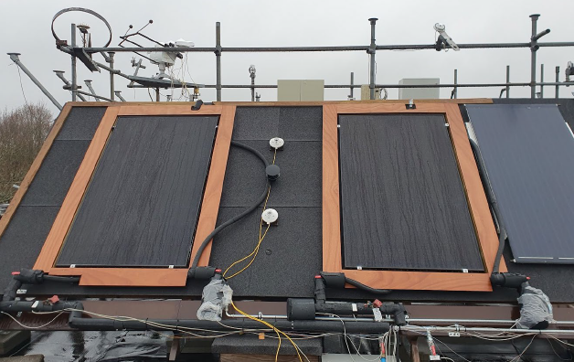
Fig. 1: Two PVT collectors with barriers mounted around the panels with a 2 cm gap.

Collector efficiency coefficients for the two panels are derived according to the ISO 9806:2017 standard for each setup. During testing the electrical parts of each panel were connected to Enphase IQ7+ microinverters.
- Results
3.1. Thermal collector coefficients
Results show that the barriers affected the thermal performance of the collectors. The heat loss coefficient and the wind dependent heat loss coefficient were influenced, particularly for the non-insulated collector. Removing the barriers resulted in higher optical efficiency η0, lower temperature dependent heat loss coefficient a1 and higher wind dependent heat loss coefficient a3 as seen in table 1.

Tab. 1: Derived thermal coefficients for PVT panel without insulation.
Coefficient | With barriers | Without barriers
η0,b (beam) | 0.52 | 0.57
a1 [W m⁻²K⁻¹] | 9.9 | 6.1
a2 [W m⁻²K⁻²] | Not significant | 0.2
a3 [J m⁻³K⁻¹] | 2.8 | 6.7
a4 [-] | 0.68 | 0.5
a6 [m s⁻¹] | 0.04 | 0.1
a7 [W m⁻²K⁻⁴] | 0.16 | 0.4

3.2. Roof temperatures
Temperatures below the panels were compared in periods with overcast conditions. Ambient air temperatures between 6 and 10⁰C, the windspeed was 1.4 to 2.4 m/s and a collector inlet temperature around -3⁰C. Table 2 gives an overview of the temperatures measured at the roof surface below the panels. The results show that the way of mounting the panels clearly impacted on the temperature at the surface of the roof below the panels.
Tab. 2: Relative temperatures at the surface of the roof below the PVT panels.
PVT installation | Roof surface temperature below panel without insulation | Roof surface temperature below panel with insulation
No barriers | 1 K below ambient air temperature | 0 K below ambient air temperature
Barrier with 2 cm gap | 4 K below ambient air temperature | 2 K below ambient air temperature
Fully closed | 8 K below ambient air temperature | 7 K below ambient air temperature

- Conclusions and perspective
The investigations showed that the thermal performance of uncovered PVT collectors, when operating as energy absorbers for heat pump systems, is affected by the presence of barriers around the panels. This indicates that collector characteristics may differ depending on whether panels are mounted side by side with limited airflow beneath them or installed under freely ventilated conditions.
The study further showed that the temperature at the roof surface below the panels can be reduced by up to 8 K compared to ambient air temperature in configurations with restricted airflow and no gaps between panels. This may lead to lower heat transfer fluid temperatures and consequently reduced heat pump performance.
These findings highlight the importance of considering mounting configuration and airflow conditions when characterizing PVT collectors and when designing and modelling PVT heat pump systems. Further investigations are needed to quantify the impact under different climatic and operational conditions and to incorporate these effects into performance models.

