EuroSun2026
FEASIBILITY OF CONCENTRATING SOLAR THERMAL TECHNOLOGY FOR PROCESS HEAT APPLICATION IN A RICE MILL IN INDIA
Dr. Dwipen Boruah (corresponding author), Mr. Pranab Kumar Nath
Global Sustainable Energy Solutions India Pvt. Ltd., New Delhi, India
dwipen.boruah@gses.in, pranab.nath@gses.in
Summary
Summary
Industrial process heat is an important target for industrial decarbonisation, particularly in small and medium-sized food-processing units. Rice milling requires heat for paddy cooking and hot-air drying, and part of this demand can be supplied by solar thermal energy. This paper assesses the technical and economic feasibility of integrating a crossed compound parabolic concentrator (xCPC) system with the existing biomass-fired boiler at a Rice Mill in Tamil Nadu, India. The study combines site assessment, process-heat mapping, solar-resource assessment, CST technology selection, system integration and annual performance simulation. The site receives an annual average global horizontal irradiance of 5.32 kWh/m²/day and direct normal irradiance of 3.67 kWh/m²/day. A CST system with 40 xCPC collector assemblies with approximately 180 m² gross aperture area are considered. The collectors operate in the 70 - 150 °C range and are integrated through heat exchangers for boiler-feedwater preheating and LSU dryer-air heating. Annual useful thermal output is estimated at 140 MWh_{th}. Financial analysis gives an internal rate of return of 10%, 13% and 17% for 0%, 15% and 30% financial assistance, respectively. Corresponding payback periods are 9.02, 7.05 and 4.03 years. The results indicate that xCPC technology is technically compatible with the rice milling process and that financial assistance can substantially improve project attractiveness. The hybrid configuration also retains the existing biomass boiler as a reliable backup heat source.
Key words: Concentrating solar thermal, solar heat for industrial processes, rice milling, crossed compound parabolic concentrator, process heat, decarbonisation
Field of application for the findings: Industrial process heat, food processing, rice milling and solar heat for industrial processes (SHIP).
Addressed audience: Solar thermal researchers, process engineers, energy managers, technology developers, policy makers and industrial MSMEs.
1. Introduction
Industrial process heat represents a substantial part of industrial energy demand. Low and medium temperature process heat is particularly relevant to food, textile, chemical and other manufacturing sectors because many processes require temperatures that can be supplied by solar thermal technologies. Sharma et al. (2017) reviewed solar industrial process heating and identified collector selection, process integration, performance assessment, economics and deployment barriers as the main elements governing successful applications. Farjana et al. (2018) similarly showed that solar process heat has broad technical potential, while commercial deployment remains limited.
Rice processing is a suitable application because paddy cooking requires steam and drying requires hot air. At the study site, these requirements are supplied by a biomass-fired boiler. The mill consumes approximately 840 t of cashew nut shells annually and spends about INR 8.4 million per year on fuel. Replacing the boiler completely is neither necessary nor desirable for reliability. A hybrid solar–biomass arrangement can instead use solar heat whenever it is available and retain the boiler as backup.
The present study evaluates such an arrangement for a Rice Mill in Tamil Nadu, India. The main objectives are to assess the solar resource, characterise the thermal load, select a suitable CST technology, design the integration concept, estimate annual useful heat and assess economic feasibility.
The main contribution is a complete feasibility assessment for a rooftop xCPC system in an operating rice mill. The analysis links process requirements and roof constraints to collector selection and identifies two practical heat integration points: boiler-feedwater preheating and LSU (Louisiana State University) dryer air heating. This system-level approach follows the process-integration principle recommended by IEA SHC Task 49 (IEA SHC, 2016).
2. Related Work and Literature Review
2.1. Solar heat for industrial processes
Solar heat for industrial processes has been investigated for several decades, with increasing attention to low and medium temperature applications. Sharma et al. (2017) showed that industrial process heating up to about 250 °C represents an important application range for solar thermal technologies. Farjana et al. (2018) reviewed industrial processes and solar technologies globally and concluded that integration opportunities are significant but depend strongly on temperature level, operating schedule and available solar resource.
IEA SHC Task 49 places particular emphasis on process integration rather than collector performance alone. Its integration guideline recommends identifying and ranking suitable integration points and selecting a solar thermal concept that matches the industrial process (IEA SHC, 2016). This principle is directly applicable to rice mills because the thermal demand is distributed between steam generation and hot-air drying.
2.2. Solar thermal in food processing
Food processing is an important SHIP sector because many operations require low-temperature heat. Ismail et al. (2021) reviewed solar heating integration in the food industry and found that preheating, cleaning and pasteurisation are common applications. They also highlighted that the integration point and operating temperature are central design variables. For rice milling, feedwater preheating is attractive because it reduces the boiler heat requirement, while dryer-air heating provides a second direct heat sink.
2.3. CPC and xCPC technology
Compound parabolic concentrators are non-imaging collectors designed to accept radiation over a relatively wide angular range. Pranesh et al. (2019) reviewed CPC development and applications and identified a useful downstream temperature range of approximately 60 - 240 °C. CPC systems can operate without continuous tracking at low to moderate concentration ratios, which can simplify industrial retrofits.
Field performance is nevertheless different from laboratory performance. Kurhe et al. (2020) compared CPC performance under standard test conditions with actual field conditions for industrial process heat in India and showed that field losses and operating conditions must be included in realistic yield estimation. This finding supports the use of detailed annual simulation and the need for post-installation monitoring.
2.4. Research gap
The literature establishes the suitability of solar thermal technology for industrial heat and the relevance of CPC collectors to low and moderate temperatures. However, fewer studies present an integrated, site-specific assessment for a rice mill that simultaneously considers rooftop constraints, process heat matching, xCPC selection, annual simulation and economic feasibility. The present work addresses this practical gap by treating the CST system as a hybrid subsystem of an existing biomass-based process-heat system.
3. Methodology
3.1. Site visit and data collection
The case study is Sushil Modern Rice Mill, Arni, Tamil Nadu, India. The reported coordinates are 12.692191° N and 79.268422° E. Site information included the existing boiler, process sequence, fuel use, operating temperatures, available roof area and physical constraints. The mill operates in batch mode for approximately 280 days per year.
Tab. 1: Principal site and process parameters used in the feasibility assessment.
Parameter | Value
Location | Arni, Tamil Nadu, India
Coordinates | 12.692191° N, 79.268422° E
Existing boiler | 2 TPH biomass-fired boiler
Boiler operating pressure | 8 bar
Process steam | Approximately 150 °C
Dryer air | 80 - 85 °C
Annual biomass use | 840 tonne
Annual fuel expenditure | INR 8.4 Million
Shadow-free roof area | Approximately 600 m²

3.2. Solar-resource assessment
NASA POWER data has been used for solar resource assessment which provides satellite and model based solar and meteorological data and is particularly useful where ground measurements are sparse (NASA POWER, 2026). The annual averages are GHI and DNI for the site are 5.32 kWh/m²/day and 3.67 kWh/m²/day respectively. The monthly averages values and variation of GHI and DNI is presented in the figure 1.
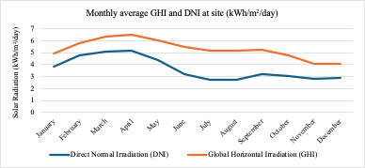
Fig. 1: Monthly average GHI and DNI used for the case-study solar-resource assessment.
3.3. Process heat assessment
The rice processing sequence includes soaking, steam cooking, drying, cleaning, dehusking, polishing, grading and packing. The thermal demand is concentrated in steam cooking and hot-air drying. The existing 2TPH (tonne per hour) boiler supplies steam at approximately 150 °C. The condensate is recovered and mixed with makeup water before entering the feedwater system.
3.4. CST technology selection
Parabolic trough, parabolic dish and CPC/xCPC technologies were compared using temperature range, tracking requirement, roof compatibility, structural loading, footprint, maintenance and integration complexity. The required temperature range of 70 -150 °C is well matched to xCPC technology. The selected system uses fixed-tilt collectors and therefore avoids continuous tracking.
Tab. 2: Qualitative comparison of CST technologies for the rice mill application.
Criterion | PTC | Paraboloid dish | xCPC
Technology type | Line-focus imaging | Point-focus imaging | Non-imaging
Tracking | Single-axis | Dual-axis | Fixed tilt
Application fit | Medium temperature | Medium/high temperature | Low/medium temperature
Rooftop retrofit | Possible after structural check | More demanding | Favourable
Mechanical complexity | Moderate | High | Low
Selected for case | No | No | Yes

3.5. System design and integration
The selected system configuration consists of 40 xCPC collector assemblies, each with approximately 2.5 m² aperture area, giving approximately 180 m² gross aperture area. The collectors are proposed on approximately 600 m² of shadow-free roof area. Solar heat is transferred through heat exchangers at two points: boiler-feedwater preheating and LSU dryer-air heating.
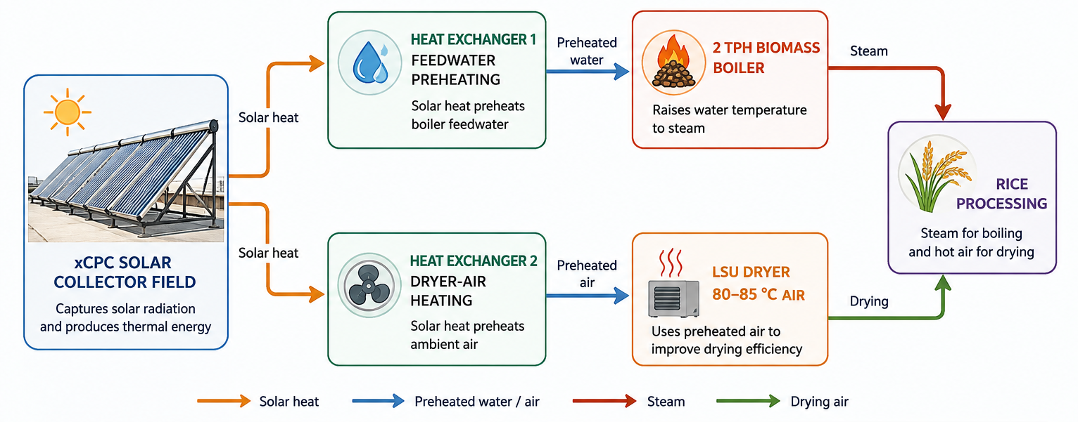
Fig. 2: Conceptual hybrid CST–biomass integration for boiler-feedwater preheating and LSU dryer-air heating.
3.6. Performance and economic modelling
Annual performance was modelled using Greenius software developed by DLR, while the economic assessment was performed using an Excel-based financial model. The simulation accounts for solar resource, collector characteristics, incidence effects, thermal losses and plant availability. The principal annual output is the useful heat delivered by the CST system rather than incident solar energy.
Qᵤ = ṁ cₚ (Tₒ − Tᵢ) (1)
where Qᵤ is useful thermal energy, ṁ is the heat-transfer-fluid mass flow rate, cₚ is its specific heat capacity, and Tₒ and Tᵢ are outlet and inlet temperatures. The annual useful energy is obtained by integrating the hourly useful heat output over the operating year.
The financial model uses a 25-year project life, 7% discount rate, 10% term loan interest rate, 3% annual fuel-price escalation and 3% annual O&M escalation. Financial assistance cases of 0%, 15% and 30% are evaluated.
4. Results
4.1. Solar resource
The annual average resource is suitable for CST deployment. The monthly profile shows stronger irradiation in March, April and May and lower values in other months due to southwest and northeast monsoon. Because xCPC performance depends on direct solar radiation and incidence angle, the DNI profile is particularly important for annual yield estimation.
4.2. Annual thermal output
The simulated useful thermal output for the 40-assembly configuration is 140 MWh_{th}/year. Monthly output ranges from 7 to 17 MWh_{th}, with the highest values in March and April. The seasonal variation demonstrates that the CST system can contribute useful heat throughout the year but cannot provide a constant heat supply independently of the biomass boiler.
Tab. 3: Monthly simulated useful thermal output of the proposed xCPC system.
Month | Ambient temperature (°C) | Thermal output (MWh_{th})
January | 23.1 | 12
February | 24.9 | 14
March | 27.3 | 17
April | 29.2 | 16
May | 31.8 | 15
June | 30.6 | 13
July | 29.5 | 9
August | 28.7 | 9
September | 27.8 | 11
October | 27.0 | 9
November | 24.6 | 7
December | 23.8 | 8
Annual total | — | 140

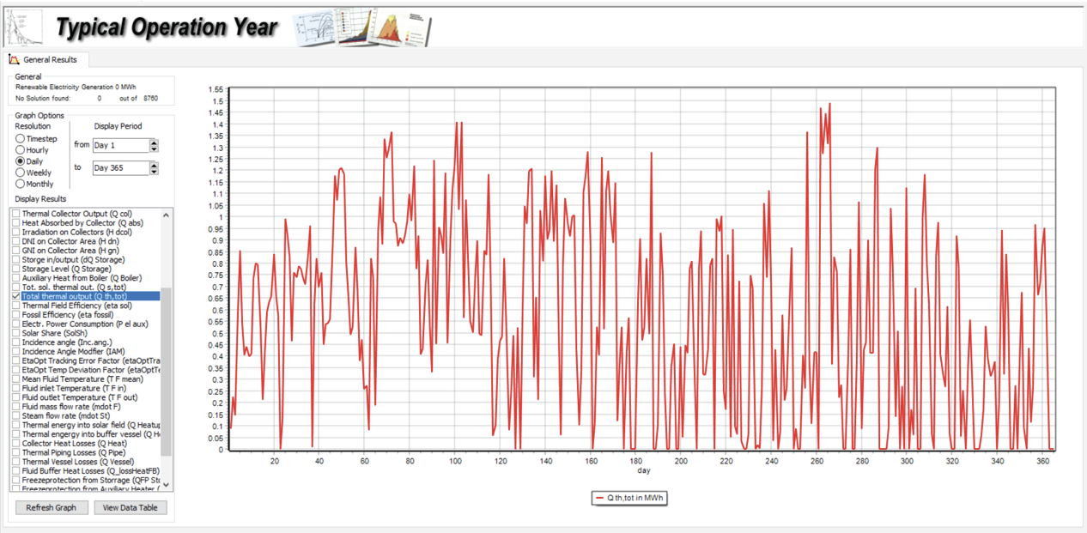
Fig. 3: Useful thermal output of 40-assembly xCPC system in a typical operational year
4.3. Integration of CST to the existing system
Thermic fluid is used as a heat transfer medium in a closed circuit xCPC system. The fluid transfers the heat to the feed water tank through a heat exchanger. This makes the system less prone to maintenance and increases the life of the solar collectors. The makeup water passes through the xCPC heat exchanger at an ambient temperature of 25ºC and the is heated to 60ºC to 70ºC by exchanging heat with the CST output of hot thermic fluid. This hot makeup water is fed to the feed water tank. The condensate water from the condensate water tank is fed to the feed water tank and then fed to the boiler.
The solar concentrators will heat up the thermic fluid up to 110ºC to 150ºC depending on the time of the day and the season. The hot water from the existing feed water tank can reach a temperature of 90ºC to 95ºC.
The CST can be integrated into the rice milling process in the following manner:
a. At the heat supply side or preheating the boiler feed water and
b. At the LSU heater side for heating the air with a thermic oil and air heat exchanger
The block diagram of the CST integration is shown in Figure 4 below:

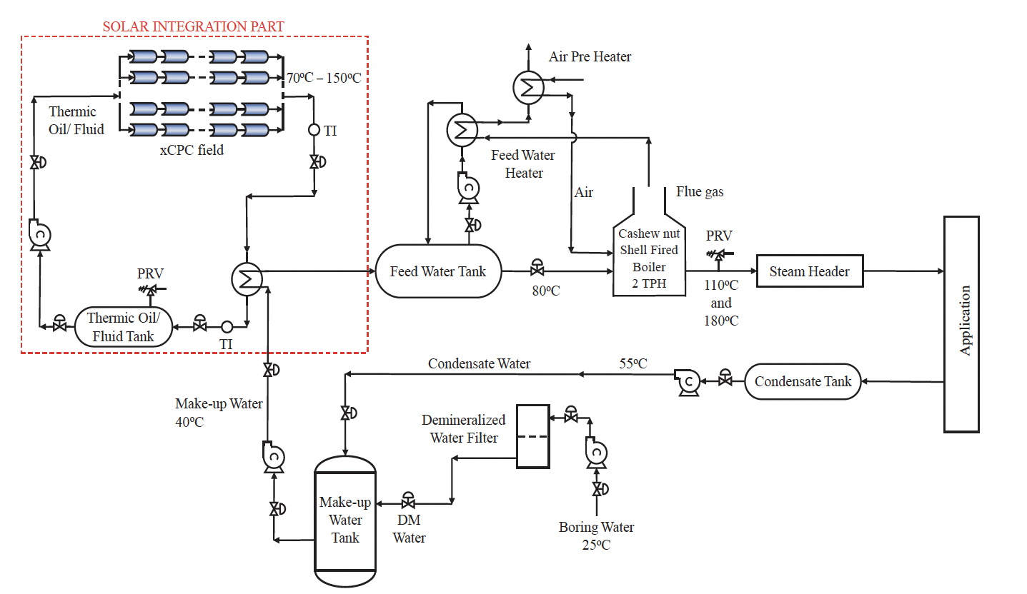
Fig. 4: Block diagram of CST integration with the existing system
4.4. Economic performance
The financial results are summarised in Table 4. Without financial assistance, the model gives an IRR of 10% and a payback period of 9.02 years. At 15% assistance, the IRR increases to 13% and payback decreases to 7.05 years. At 30% assistance, the IRR reaches 17% and payback decreases to 4.03 years.
Tab. 4: Financial performance under three financial-assistance scenarios.
Indicators | 0% assistance | 15% assistance | 30% assistance
IRR (%) | 10 | 13 | 17
Payback period (year) | 9.02 | 7.05 | 4.03
Average thermal energy cost (INR kWh_{th}/year) | 2.24 | 2.14 | 2.05
NPV (INR million) | 1.16 | 1.79 | 2.43
Average DSCR | 1.55 | 1.83 | 2.28

4.5. Environmental performance
The accepted study estimates avoided emissions of approximately 1,840 tCO₂ over 20 years. This value is retained as the reference environmental result for the 40-assembly configuration. The final project should verify the result using measured biomass displacement and a documented emissions factor.
5. Discussion
5.1. Technical interpretation
The results indicate a good temperature match between the xCPC system and the rice mill thermal load. The 70 - 150 °C operating range covers the dryer-air requirement and supports feedwater preheating. The use of two integration points also improves the probability that available solar heat can be absorbed by the process.
The hybrid arrangement is important for industrial reliability. Solar radiation varies with cloud cover, time of day and season, while rice processing requires predictable heat supply. Keeping the existing biomass boiler as backup avoids the need for a large storage system and allows the solar system to reduce boiler duty rather than replace the boiler.
5.2. Comparison with previous research
The present results are consistent with the broader SHIP literature. Sharma et al. (2017) identified process integration and economics as central issues in industrial solar heating. Ismail et al. (2021) emphasised the importance of integration points and operating temperatures in food processing. Pranesh et al. (2019) identified CPC as a suitable technology for approximately 60-240°C applications, while Kurhe et al. (2020) demonstrated the importance of accounting for actual field conditions in Indian CPC installations. The present case combines these principles in a rice mill retrofit.
5.3. Economic interpretation
The financial results show that the project is sensitive to the initial investment. The annual thermal output is modest compared with the mill's total process heat demand, but the solar system can displace part of the biomass use without affecting production reliability. Financial assistance improves the investment case substantially because the principal benefit is fuel saving while the capital cost is incurred at the beginning of the project.
5.4. Limitations
- The study is based on feasibility modelling and has not yet been validated by a full year of monitored field operation.
- Hourly process heat demand and measured boiler efficiency should be collected before final investment.
- Roof structural capacity, wind loading, attachment forces and maintenance access require detailed engineering verification.
- The environmental calculation should be checked against measured biomass displacement and an agreed emissions factor.
- The economic results should be updated using final EPC quotations, financing terms and prevailing biomass prices.
6. Conclusion and Future Work
This paper assessed the technical and economic feasibility of a rooftop xCPC CST system for process heat supply at a Rice Mill in Tamil Nadu, India. The site has an annual average GHI of 5.32 kWh/m²/day and DNI of 3.67 kWh/m²/day. The process heat requirement of approximately 70 - 150 °C is compatible with xCPC technology.
A CST system with 40 xCPC assemblies with approximately 180 m² gross aperture area are estimated to deliver 140 MWh_{th} per year. Solar heat is integrated through boiler-feedwater preheating and LSU dryer-air heating, while the existing biomass boiler remains available as backup.
The financial model gives IRRs of 10%, 13% and 17% for 0%, 15% and 30% financial assistance, respectively. The corresponding payback periods are 9.02, 7.05 and 4.03 years. These results indicate that xCPC CST can be an attractive industrial heat-saving measure when the capital cost is supported appropriately.
Future work should focus on field monitoring, measurement of biomass displacement, validation of the annual yield model, optimisation of control between the two integration points and evaluation of limited thermal storage.
7. References
Farjana, S.H., Huda, N., Mahmud, M.P., & Saidur, R. Solar process heat in industrial systems – A global review. Renewable and Sustainable Energy Reviews, 82, 2270–2286, 2018. DOI: 10.1016/j.rser.2017.08.065.
GSES India, 2023. Detailed Project Report on Concentrating Solar Thermal (CST) Plant for Process Heat Application at Sushil Modern Rice Mill, Arni, Tamil Nadu. Prepared under the UNIDO-GEF-MSME project.
IEA Solar Heating and Cooling Programme. Solar Heat for Industrial Processes (SHIP). IEA SHC, 2024.
IEA SHC Task 49. Solar Heat Integration in Industrial Processes: publications and integration guidelines. International Energy Agency Solar Heating and Cooling Programme, 2015–2020.
IEA SHC Task 64. Solar Process Heat: yield assessment, integration concepts, technology costs and business models. International Energy Agency Solar Heating and Cooling Programme, 2021–2024.
IRENA/IEA-ETSAP. Solar Heat for Industrial Processes. Technology Brief, International Renewable Energy Agency, 2015.
Ismail, M.I., Yunus, N.A., Hashim, H., 2021. Integration of solar heating systems for low-temperature heat demand in food processing industry – A review. Renewable and Sustainable Energy Reviews. 147, 111192. https://doi.org/10.1016/j.rser.2021.111192.
Lingayat, A.B., Chandramohan, V.P., Raju, V.R.K., & Meda, V. A review on indirect type solar dryers for agricultural crops – Dryer setup, performance, energy storage and important highlights. Applied Energy, 258, 114005, 2020. DOI: 10.1016/j.apenergy.2019.114005.
NASA POWER, 2026. POWER Data Methodology. NASA Langley Research Center. https://power.larc.nasa.gov/docs/methodology/.
Pranesh, V., Velraj, R., Christopher, S., Kumaresan, V., 2019. A 50 year review of basic and applied research in compound parabolic concentrating solar thermal collector for domestic and industrial applications. Solar Energy. 187, 293–340. https://doi.org/10.1016/j.solener.2019.04.056.
Kurhe, N., Pathak, A., Deshpande, K., Jadkar, S., 2020. Compound parabolic solar collector – Performance evaluation as per standard test method and actual field conditions for industrial process heat application in Indian context. Energy for Sustainable Development. 57, 98–108. https://doi.org/10.1016/j.esd.2020.06.001.
Ravi Kumar, K., Krishna Chaitanya, N., & Sendhil Kumar, N. Solar thermal energy technologies and its applications for process heating and power generation – A review. Journal of Cleaner Production, 282, 125296, 2021.
Sharma, A.K., Sharma, C., Mullick, S.C., & Kandpal, T.C. Solar industrial process heating: A review. Renewable and Sustainable Energy Reviews, 78, 124–137, 2017. DOI: 10.1016/j.rser.2017.04.079.
Suresh, N.S., & Rao, B.S. Solar energy for process heating: A case study of select Indian industries. Journal of Cleaner Production, 151, 439–451, 2017. DOI: 10.1016/j.jclepro.2017.02.190.
Widyolar, B., Winston, R., Jiang, L., & Poiry, H. Performance of the Merced demonstration xCPC collector and double effect chiller. Journal of Solar Energy Engineering, 136(4), 041009, 2014. DOI: 10.1115/1.4027726.

