EuroSun2026
Thermodynamic and Market-Oriented Optimization of a Bidirectional Supercritical CO₂ Brayton Cycle for Waste-Heat-Assisted Power-to-Heat-to-Power
Thomas Kraft^{1,a)}, Shahab Rohani¹, Farquleet Ahmad Khan¹, Nicholas Chandler¹, Peter Schöttl¹, Fadil Ayad², Gregor Bern¹

¹ Fraunhofer Institute for Solar Energy Systems ISE. Heidenhofstr. 2, 79110 Freiburg, Germany
² Thermal Design Solutions, 13 rue du Canal. 4050 Esch-sur-Alzette, Luxembourg
^{a)} corresponding author, email: thomas.kraft@ise.fraunhofer.de

Summary
This study investigates a bidirectional supercritical CO₂ (sCO₂) Brayton cycle for waste-heat-assisted power-to-heat-to-power (PtHtP) applications. The concept combines a closed Brayton heat pump for charging and a Brayton heat engine for discharging through a thermal energy storage (TES) system. The system is motivated by future AI data center infrastructures utilizing solid oxide fuel cells (SOFCs), where exhaust heat at 300–350 °C is available continuously. A comprehensive thermodynamic screening comprising 511,875 design configurations is combined with dynamic annual simulations and market-based dispatch optimization. Results reveal that thermodynamically optimal configurations can be economically suboptimal, highlighting the importance of market-oriented design methodologies for Brayton-based Carnot batteries. Configurations with the highest design-point RTE often exhibit only a limited storage temperature lift, reducing the practical value of thermal storage. The analysis further demonstrates that charging and discharging favor different Brayton cycle layouts: a simple Brayton heat pump is optimal for charging, whereas a recuperated Brayton heat engine is preferred during discharge. Annual simulations performed for different electricity market conditions indicate that local electricity price spreads dominate system profitability, while ambient effects are comparatively minor. The results highlight the importance of coupling thermodynamic optimization with market-oriented operation when designing Brayton-based Carnot batteries.
Data center, Waste heat recovery, Brayton cycle, Carnot battery, Thermal energy storage, Supercritical CO₂, Power-to-heat-to-power (PtHtP)
Field of application for the findings: industrial waste heat utilization, thermal energy storage
Addressed audience: Researchers and engineers in thermal energy storage, heat pumps, Brayton cycles, waste-heat recovery and energy-system optimization.
- Introduction
The increasing penetration of renewable electricity requires large-scale energy storage technologies capable of decoupling energy generation and demand. While electrochemical storage solutions dominate short-duration applications, thermal energy storage systems offer an attractive alternative for medium- and long-duration storage, particularly when low-cost thermal reservoirs and industrial waste heat streams are available.
Among emerging thermal storage concepts, Carnot batteries have attracted significant attention. These systems convert electrical energy into thermal energy during charging and recover electricity during discharge. Compared to conventional batteries, Carnot batteries potentially offer lower storage costs, long lifetime, and the possibility of integrating waste heat streams into the storage process.
Supercritical carbon dioxide (sCO₂) Brayton cycles are particularly attractive for such applications. Above the critical point of CO₂ (31.0 °C, 73.8 bar) (Weibel and Ober, 2003), the working fluid combines high density with favorable heat transfer and expansion characteristics, enabling compact turbomachinery and efficient thermal integration. These advantages have led to extensive research on sCO₂ heat pumps, recuperated Brayton power cycles, and pumped thermal energy storage (PTES) systems.
The present work investigates a bidirectional sCO₂ Brayton concept for waste-heat-assisted power-to-heat-to-power operation. The intended application is a future data center partially supplied by a solid oxide fuel cell (SOFC), where an afterburner and associated process components provide a continuous waste-heat source between 300 and 350 °C. SOFC systems are particularly attractive for such applications because their high operating temperatures provide a continuous source of high-grade waste heat. Previous studies have shown that integrating SOFCs with thermal bottoming cycles can substantially improve overall energy utilization and electrical efficiency by recovering otherwise unused thermal energy. Examples include SOFC-gas turbine, steam turbine, reciprocating engine, and organic Rankine cycle integrations, which demonstrated significant performance improvements compared to stand-alone SOFC systems (van Biert et al., 2018; Karimi et al., 2020). More generally, the recovery and utilization of SOFC waste heat has been identified as a key strategy for improving the overall efficiency and sustainability of advanced energy systems (Zhu et al., 2024). Building on these concepts, the present work investigates the use of SOFC waste heat within a waste-heat-assisted power-to-heat-to-power (PtHtP) system based on bidirectional sCO₂ Brayton cycles.
A key question addressed in this study is whether maximizing thermodynamic performance alone leads to optimal system performance. To answer this question, a large-scale thermodynamic design-space screening is combined with annual dynamic simulations and market-oriented dispatch optimization.
- Methodology
2.1. System Configuration and Operating Principle
The investigated system is a waste-heat-assisted power-to-heat-to-power (PtHtP) concept based on two thermodynamically independent supercritical carbon dioxide (sCO₂) Brayton cycles connected through a thermal energy storage (TES) system. The concept is motivated by future data-center energy systems partially supplied by solid oxide fuel cells (SOFCs), where high-temperature waste heat is continuously available from the afterburner and downstream process components.
The system consists of three major subsystems:
- a charging cycle operating as a Brayton heat pump,
- a thermal energy storage system,
- a discharging cycle operating as a Brayton heat engine.
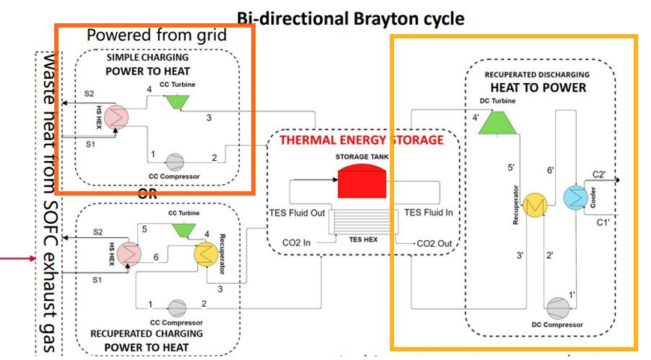
Fig. 1: Reference Pumped Thermal Energy Storage (PTES) configuration: simple charging, recuperated discharging (Shamsi et al., 2024)
Unlike conventional Carnot batteries, the charging process is assisted by an external waste-heat source. Consequently, part of the thermal energy stored in the TES originates from waste heat rather than electricity, allowing electrical round-trip efficiencies above unity without violating thermodynamic principles.
The waste-heat source considered in this work provides a constant thermal power of approx. 10 MW_{th} at temperatures between 300 °C and 350 °C. During charging, this energy is upgraded and transferred to the TES. During discharge, the stored thermal energy is converted back into electricity whenever favorable electricity market conditions occur.

2.1.1 Charging Mode
During charging operation, the sCO₂ cycle functions as a closed Brayton heat pump. The working fluid first absorbs heat from the available waste-heat source and is subsequently compressed to a higher pressure level. The compressor work increases the fluid temperature beyond the waste-heat temperature, enabling heat transfer to the TES at elevated temperature levels. After rejecting heat to storage, the CO₂ expands through a turbine and returns to its initial pressure level before re-entering the waste-heat heat exchanger. The primary objective of the charging cycle is not the maximization of internal cycle efficiency but rather the maximization of useful thermal energy delivered to storage. For this reason, both recuperated and non-recuperated configurations were investigated.

2.1.2 Discharging Mode
The discharging cycle operates as a Brayton heat engine. Thermal energy stored in the TES is supplied to compressed sCO₂ before expansion through a turbine. The turbine generates mechanical power that is converted into electricity via a generator. Downstream of the turbine, residual thermal energy is partially recovered by a recuperator before the fluid is cooled and recompressed. Contrary to the charging cycle, discharging aims to maximize electrical power output and thermal-to-electric conversion efficiency. Therefore, recuperation is expected to play a beneficial role by reducing the thermal demand placed on the TES.

2.1.3 Thermal Energy Storage
The charging and discharging cycles are coupled by a thermal energy storage system that enables temporal decoupling between waste-heat availability and electricity generation.
The TES is characterized by a hot storage temperature, a cold storage temperature, and the resulting storage temperature difference. The storage temperature levels are not predefined but instead emerge from the thermodynamic optimization of both Brayton cycles.
These temperatures strongly influence:
- storage exergy content,
- achievable discharge power,
- heat-pump coefficient of performance,
- heat-engine efficiency,
- overall system economics.
Consequently, TES temperatures are treated as active design variables throughout the study.

2.2 Thermodynamic Model
Both charging and discharging cycles were modeled including:
- compressor and turbine isentropic efficiencies,
- heat-exchanger pinch-point constraints,
- pressure losses,
- generator and motor efficiencies,
- real thermodynamic properties of carbon dioxide.

To identify thermodynamically favorable cycle architectures, simple and recuperated configurations were evaluated for both charging and discharging operation.
The electrical round-trip efficiency is defined as
 | $$RTE=\frac{W_{discharge}}{W_{charge}}$$ | (1)

Where $W_{charge}$ represents the electricity charged and $W_{discharge}$ represents the electricity recovered during discharge.
Since the charging process additionally utilizes free waste heat, electrical round-trip efficiencies exceeding 100 % are theoretically possible and do not violate the first law of thermodynamics.

2.3 Steady State Design Space Screening
The steady-state design point analysis is performed under a fixed set of boundary conditions and assumptions, summarized in Table 1. These constraints define the envelope within which the pressure ratios are varied.

Table 1: Boundary conditions and fixed parameters for the steady-state design analysis.
Parameter | Symbol | Value | Unit
Maximum allowable system pressure | P_{max} | 250 | bar
HP compressor inlet pressure | P_{in,HP} | 90 | bar
HE compressor inlet pressure | P_{in,HE} | 85 | bar
HE compressor inlet temperature (after cooler) | T_{1,HE} | 35 | °C
Waste heat source inlet temperature | T_{waste,in} | 350 | °C
Waste heat source mass flow rate | ṁ_{waste} | 45.3 | kg/s
Working fluid (both cycles) | — | sCO₂ | —
Minimum pinch point temperature difference (all heat exchanger) | ΔT_{pinch} | 15 | K
HP pressure ratio range investigated | PR_{HP} | 1.65 – 2.70 | —
HE pressure ratio range investigated | PR_{HE} | 1.80 – 2.70 | —

The following key assumptions apply:
- Steady-state operation at design point conditions; transient effects during start-up and shut-down are not considered in this step.
- Fixed isentropic efficiencies for all turbomachinery (compressors and turbines), reflected in the computed state point temperatures and pressures.
- The waste heat source is continuously available at the specified temperature and flow rate during charging, corresponding to approx. 10 MW_{th} waste-heat.
- Ambient/cooling water temperature for the HE cycle cooler is fixed at 35 °C (corresponding to HE compressor inlet conditions).
- The maximum pressure constraint (250 bar) limits the maximum achievable PR_{HP} to 2.78 (= 250/90) and PR_{HE} to 2.94 (= 250/85); all selected configurations remain within this limit.

The thermodynamic design space was explored through a large-scale parametric screening.
The investigated parameters included:
- charging-cycle pressure ratio PR_{HP}
- discharging-cycle pressure ratio PR_{HE}
- compressor inlet pressure,
- TES hot temperature,
- TES cold temperature,
- CO₂ mass flow rate,
- waste-heat temperature.
The thermal power supplied by the waste-heat source was fixed at 10 MWth.
For every operating point, complete energy and mass balances were solved and all relevant performance indicators were calculated. In total, 511,875 design configurations were evaluated.
This comprehensive design-space investigation enabled identification of thermodynamic trends and suitable candidate configurations for dynamic simulation.

2.4 Dynamic Simulation and Market-Oriented Optimization
Out of all design configurations, 12 individual configurations representing the whole range of RTE were subsequently transferred to a dynamic simulation environment implemented in Fraunhofer ISE inhouse software ColSimCSP (Fraunhofer ISE).
The dynamic models include:
- map-based compressor models,
- map-based turbine models,
- dynamic heat exchangers,
- thermocline TES models,
- real-gas property calculations.

Fig. 2 shows an example performance map for the turbine for one specific configuration.
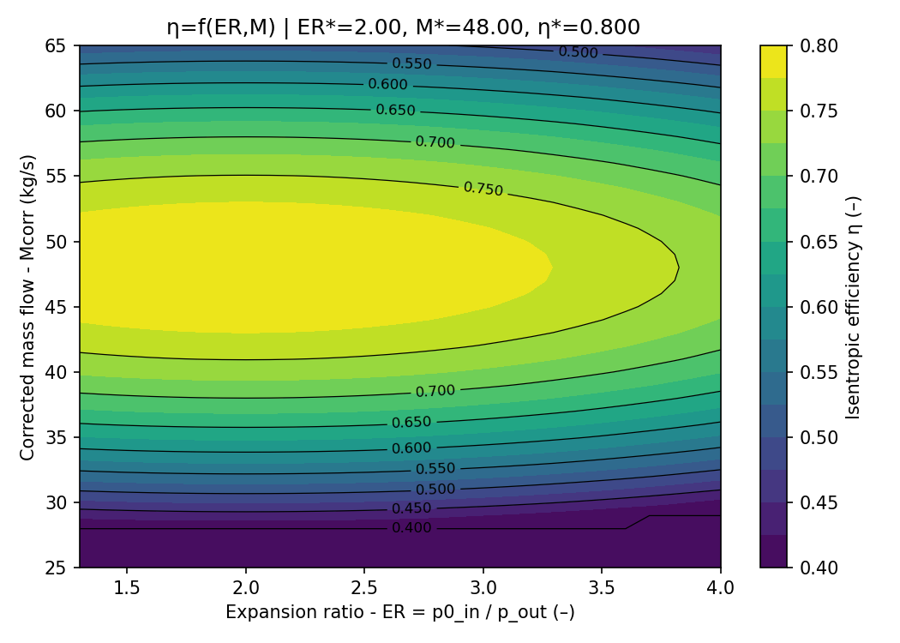
Fig. 2: Example performance map for the turbine
Annual simulations were performed using electricity price time series representing three different electricity market conditions in Europe and Asia. In contrast to the design-space screening, the optimization target was no longer thermodynamic efficiency but annual economic performance. Charging and discharging schedules were therefore determined based on electricity price signals. The annual net saving $S_{net}$ was calculated as
 | $$S_{net}=R_{discharge}-C_{charge}$$ | (2)
where $R_{discharge}$ denotes revenue generated during electricity production and $C_{charge}$ represents electricity costs incurred during charging.
This two-stage methodology enables a direct comparison between thermodynamically optimal and economically optimal designs and thereby reveals potential discrepancies between conventional efficiency-based optimization and market-oriented system operation.

2.5 Direct Heat-to-Power Conversion
Besides the power-to-heat-to-power conversion pathway based on thermal energy storage, the direct conversion of thermal energy into electrical power was also considered. The corresponding power cycle is again a supercritical CO₂ (sCO₂) recuperated Brayton cycle operating as a direct waste-heat-to-power conversion system. The cycle consists of a compressor, a recuperator, a waste-heat-driven heater, a turbine, and a cooler rejecting heat to the ambient. Table 2 summarises the fixed design assumptions applied throughout this study.

Table 2: Fixed cycle parameters for the sCO₂ recuperated Brayton cycle analysis.
Parameter | Value
Compressor inlet pressure | 84 bar
Compressor isentropic efficiency | 70%
Turbine isentropic efficiency | 85%
Generator electrical efficiency | 98%
Compressor mechanical efficiency | 98%
Pressure drop (each heat exchanger side) | 1%
Pinch: waste heat → turbine inlet | 15 K
Pinch: ambient → compressor inlet | 15 K
Minimum compressor inlet temperature | 35 °C

For each waste heat temperature in the range 300–350 °C (in 10 K increments), a parametric sweep of the pressure ratio (PR) was conducted at the design ambient temperature of 20 °C, corresponding to a compressor inlet temperature of 35 °C to maintain supercritical conditions (CO₂ critical point: 31.0 °C, 73.8 bar) (Weibel and Ober, 2003). Both thermodynamic and electrical thermal efficiencies were evaluated as a function of PR to identify the optimal operating point for each source temperature.
- Results and Discussion
3.1 Thermodynamic Configuration Selection
The design-space screening revealed a pronounced asymmetry between charging and discharging operation. The following combination emerged as the thermodynamically optimal baseline configuration:
Charging Cycle
Recuperation was found to be disadvantageous during charging. Although recuperators improve internal heat recovery, they simultaneously reduce the heat transferred to storage, which directly opposes the objective of the charging process. Consequently, the preferred charging architecture is a simple Brayton heat pump.
Discharging Cycle
For discharge operation, recuperation significantly improves cycle efficiency by reducing external heat demand from the TES. Therefore, the preferred discharge architecture is a recuperated Brayton heat engine.

3.2 Influence of Pressure Ratios
The pressure ratio of the heat pump strongly influences relevant system parameters. Figure 3 illustrates the round-trip efficiency as a function of the pressure ratio of the heat pump and the pressure ratio of the heat engine. The twelve data points represent the twelve representative configurations identified during the design space screening.
An increase in the heat pump pressure ratio results in a higher working-fluid temperature and, consequently, a higher upper storage temperature. At the same time, the required compressor power increases, leading to a reduction in the heat pump coefficient of performance (COP). As a result, lower pressure ratios, associated with reduced compressor power consumption, improve the overall system round-trip efficiency.
In contrast, an increase in the heat engine pressure ratio has the opposite effect. Higher pressure ratios lead to increased turbine power output and, consequently, to improved turbine efficiency and greater electricity generation. Therefore, the round-trip efficiency of the overall system increases with increasing heat engine pressure ratio.
Accordingly, the highest overall system efficiencies are achieved with low pressure ratios in the heat pump and high pressure ratios in the heat engine. This asymmetry indicates that a fully reversible Brayton-based PTES configuration is not optimal for maximizing round-trip efficiency. In a reversible Brayton system, the heat pump and heat engine operate as inverse processes of the same thermodynamic cycle and therefore require identical pressure ratios. The present results, however, indicate that maximum round-trip efficiency is achieved at low heat-pump pressure ratios and high heat-engine pressure ratios.

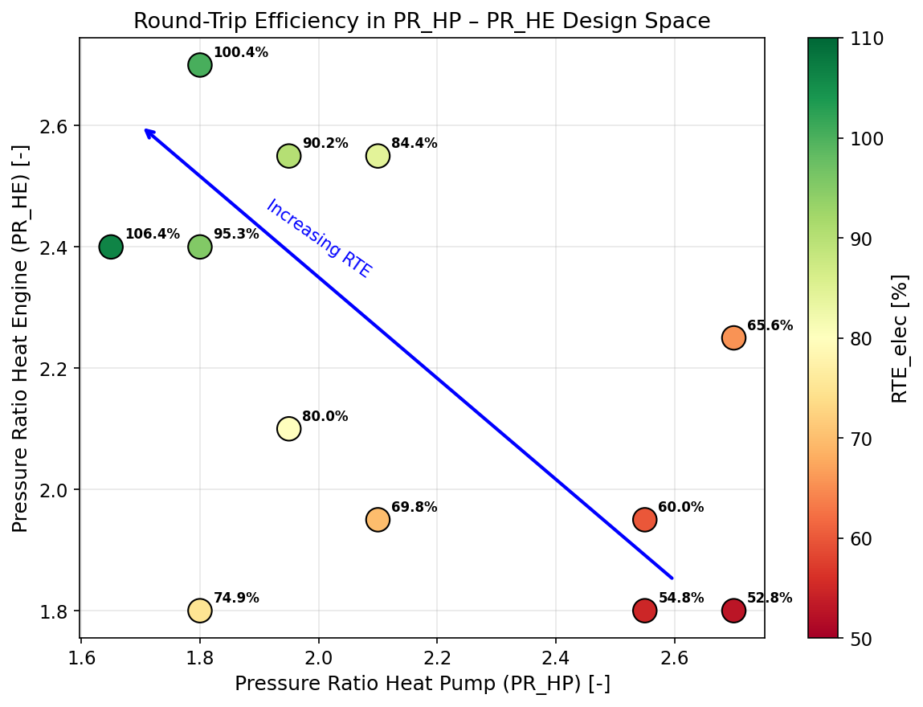
Figure 3: RTE for different pressure ratios
Figure 4 shows the round-trip efficiency for different combinations of charging power capacity and discharging power capacity. The results indicate that the highest round-trip efficiencies are obtained at low charging power capacities and moderate to moderately high discharging power capacities.
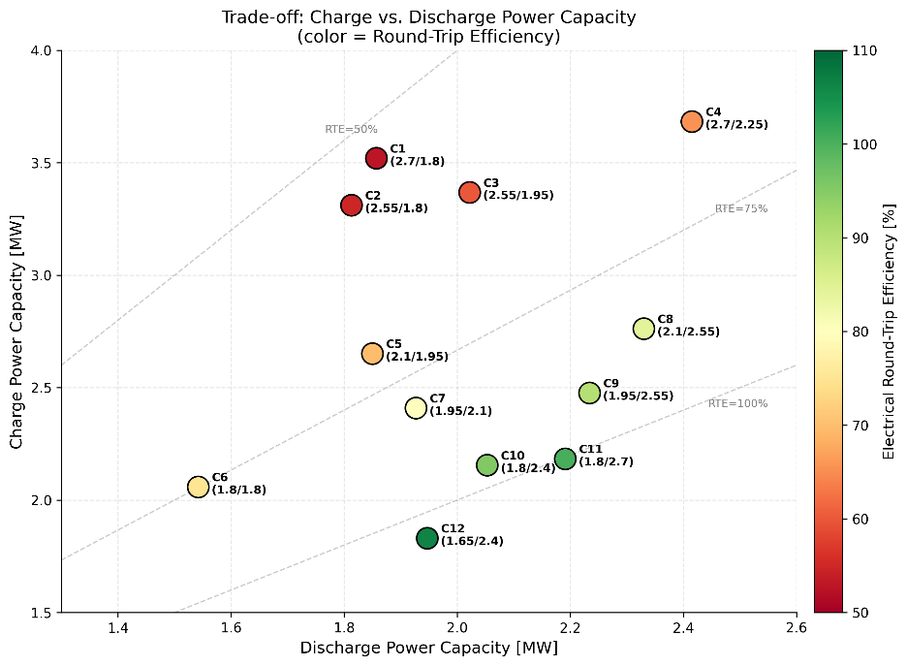
Figure 4: RTE for different power capacities

3.3 Round-Trip Efficiency versus Revenue
A key finding of this study is that maximizing round-trip efficiency (RTE) alone may lead to suboptimal system designs when economic performance is taken into account. As discussed in Section 3.2, the configurations exhibiting the highest RTE are typically characterized by very low charging pressure ratios, small temperature lifts across the thermal energy storage (TES), and reduced discharge power capacities.
While these operating conditions minimize thermodynamic losses and therefore maximize electrical round-trip efficiency, they simultaneously reduce the amount of exergy stored within the TES. As a result, the effective utilization of the thermal storage decreases, limiting the system's capability to shift energy over time and to capitalize on favorable electricity market conditions. Consequently, the economic value generated by the storage system is diminished, and the investment in thermal storage capacity becomes more difficult to justify from a financial perspective.
These findings challenge the frequently adopted assumption that design-point round-trip efficiency represents a sufficient objective function for system optimization. Instead, the results indicate that both thermodynamic and economic metrics must be considered simultaneously. In particular, the TES temperature lift and the associated usable storage exergy should be evaluated alongside round-trip efficiency when selecting system configurations. A design that achieves slightly lower RTE may ultimately provide greater economic value if it enables higher storage utilization and increased revenue generation. Therefore, the optimization of Brayton-based Carnot battery systems should extend beyond efficiency maximization and incorporate the interaction between storage performance, operational flexibility, and market value.

3.4 Direct waste-heat-to-power conversion
Figure 5 shows an example of this sweep for a waste heat temperature of 350 °C. The thermal efficiency exhibits a clear maximum at PR ≈ 3.0, reaching 23.58% (thermodynamic) and 22.48% (electrical). At low pressure ratios, the turbine work is insufficient to overcome compressor consumption; at high pressure ratios, the increasing compressor work and reduced recuperator benefit degrade performance.
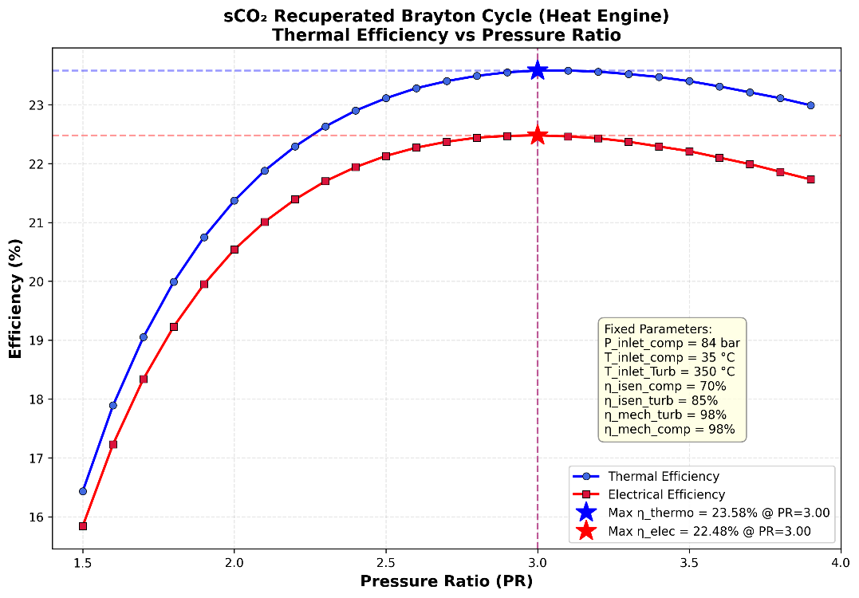
Figure 5: Thermodynamic and electrical thermal efficiency vs. pressure ratio for T_waste = 350 °C, T_comp_inlet = 35 °C.
Analogous sweeps were performed for all six waste heat temperatures. The optimal PR shifts slightly downward (from 3.0 to 2.7) with decreasing source temperature due to the reduced available temperature ratio across the turbine. The maximum (design) efficiencies including the corresponding pressure ratios across all temperatures are plotted in Figure 6. Both thermal and electrical efficiency increase approximately linearly with waste heat temperature over this range, gaining roughly 0.7 %-points per 10 K increase in source temperature.

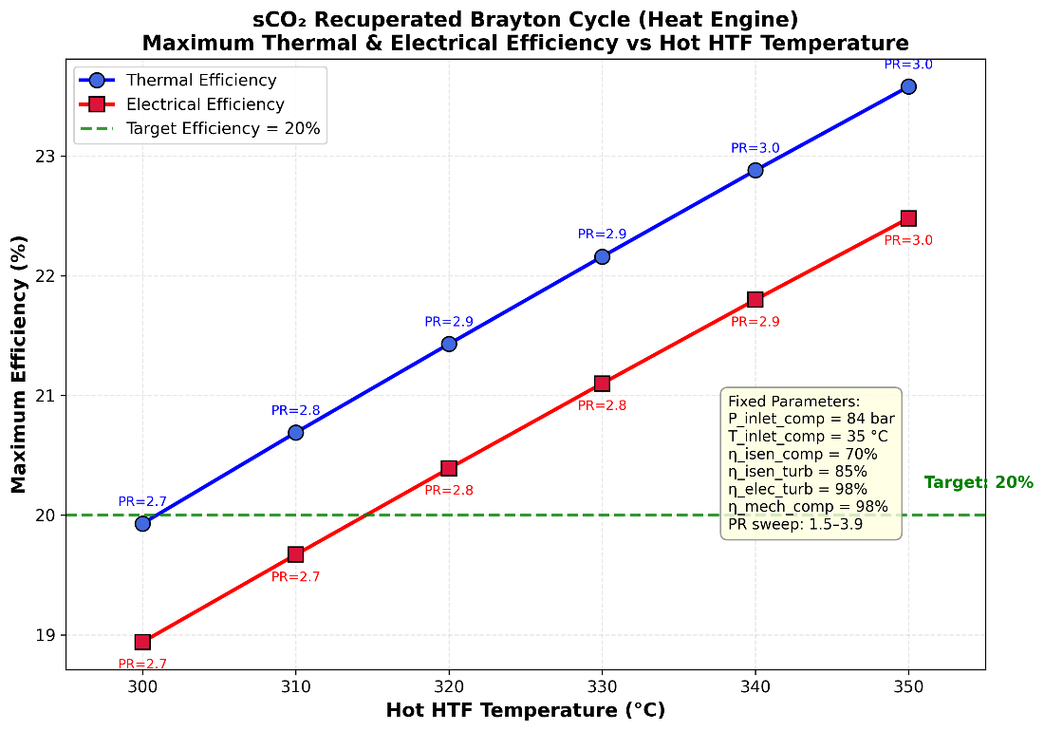
Figure 6: Maximum thermal and electrical efficiency at design conditions for different waste-heat temperature.
The efficiencies reported here correspond to a reference scenario in which ambient temperatures remain sufficiently low (≤ 20°C) so that the compressor inlet temperature continuously stays below the design temperature of 35°C. Depending on the site-specific climatic conditions, higher ambient temperatures occurring during certain periods of the day or year may lead to a reduction in the actual system efficiency. Across the locations investigated, this effect resulted in an average decrease in the time-averaged efficiency of approximately 2 percentage points.

3.5 Market-Oriented Optimization
The results of the annual simulations for three different locations show that profitability depends more strongly on local electricity price spreads than on any thermodynamic design variable. The higher the electricity price spread in the specific location, the higher the profitability. The most profitable configuration was not the thermodynamically optimal design. Instead, a design with slightly lower RTE and higher discharge power generated the largest annual revenue because more electricity could be delivered during peak-price periods. Due to the confidentiality requirements of the project partner, no quantitative techno-economic data are disclosed.

3.6 Implications for Future PTES Design
Several practical implications emerge from this study. First, charging and discharging cycles should be optimized separately before shared turbomachinery concepts are evaluated. Since different pressure ratios are favorable for charging and discharging, a reversible turbomachinery concept is not economically viable unless investment costs are very high. Second, electrical round-trip efficiency should not be treated as the sole design criterion. Third, market conditions can outweigh thermodynamic differences between candidate cycle configurations.
- Conclusions
This study investigated a bidirectional sCO₂ Brayton heat pump/heat engine system for waste-heat-assisted power-to-heat-to-power applications. The results demonstrate that the thermodynamically optimal system configuration differs significantly between the charging and discharging processes. While a simple Brayton heat pump was found to be the preferred configuration during charging, a recuperated Brayton cycle provided superior performance during discharging. Consequently, the operating conditions that maximize system performance are generally not identical for both modes. In particular, the optimal charging and discharging processes require different pressure ratios, highlighting the challenge of implementing shared reversible turbomachinery within a single system architecture.
The analysis further revealed that maximizing electrical round-trip efficiency alone is not sufficient for identifying the most attractive system design. Configurations exhibiting the highest RTE often operate with relatively small thermal energy storage temperature lifts, thereby limiting the effective storage value and reducing the flexibility of the system. As a result, the configuration with the highest thermodynamic efficiency is not necessarily the configuration that yields the highest economic return.
The economic assessment showed that electricity market conditions exert a substantially greater influence on system profitability than ambient temperature effects. In particular, local electricity price spreads were identified as a key driver of economic performance, whereas the impact of site-specific temperature variations was comparatively small. These findings underline the importance of considering market dynamics in addition to thermodynamic performance when designing and evaluating Carnot battery systems.
Overall, the results emphasize that economically optimal designs may differ considerably from thermodynamically optimal designs. Therefore, market-oriented optimization should become an integral component of future design methodologies for Brayton-based Carnot batteries.
Future work will focus on the investigation of reversible turbomachinery concepts, the development of comprehensive techno-economic optimization approaches that explicitly account for component costs, and a comparison of the proposed PtHtP concept with direct waste-heat-to-power sCO₂ Brayton cycle systems.

- References
Fraunhofer ISE. ColSIM. System simulation for thermal and electrical systems. https://colsim.de/. Accessed 24 July 2026.
Karimi, M.H., Chitgar, N., Emadi, M.A., Ahmadi, P., Rosen, M.A., 2020. Performance assessment and optimization of a biomass-based solid oxide fuel cell and micro gas turbine system integrated with an organic Rankine cycle. International Journal of Hydrogen Energy 45 (11), 6262–6277.
Shamsi, S.S.M., Barberis, S., Maccarini, S., Traverso, A., 2024. Thermo-economic performance evaluation of thermally integrated Carnot battery(TI-PTES) for freely available heat sources. Journal of Energy Storage 97, 112979.
van Biert, L., Woudstra, T., Godjevac, M., Visser, K., Aravind, P.V., 2018. A thermodynamic comparison of solid oxide fuel cell-combined cycles. J Power Sources 397, 382–396.
Weibel, G.L., Ober, C.K., 2003. An overview of supercritical CO2 applications in microelectronics processing. Microelectron Eng 65 (1-2), 145–152.
Zhu, W., Chen, B., Wang, L., Wang, C., 2024. Recovery of Solid Oxide Fuel Cell Waste Heat by Thermoelectric Generators and Alkali Metal Thermoelectric Converters. FHMT 22 (5), 1559–1573.

Appendix

Table 3 summarises the key performance parameters of the 12 selected configurations, ordered by increasing round-trip efficiency.

Table 3: Summary of the 12 selected design configurations.
Config | PR_HP | PR_HE | T_hot [°C] | T_cold [°C] | ΔT_storage [K] | W_charge [MW] | W_discharge [MW] | COP_HP,el [-] | η_HE,el [%] | RTE_el [%]
1 | 2.70 | 1.80 | 461.4 | 305.5 | 155.9 | 3.520 | 1.857 | 2.29 | 23.51 | 52.8
2 | 2.55 | 1.80 | 452.4 | 297.3 | 155.0 | 3.311 | 1.813 | 2.41 | 23.18 | 54.8
3 | 2.55 | 1.95 | 452.4 | 289.0 | 163.3 | 3.368 | 2.022 | 2.50 | 24.52 | 60.0
4 | 2.70 | 2.25 | 461.4 | 283.5 | 177.9 | 3.683 | 2.415 | 2.50 | 26.73 | 65.6
5 | 2.10 | 1.95 | 422.4 | 262.5 | 159.9 | 2.651 | 1.850 | 3.06 | 23.29 | 69.8
6 | 1.80 | 1.80 | 399.1 | 250.0 | 149.1 | 2.058 | 1.542 | 3.62 | 21.10 | 74.9
7 | 1.95 | 2.10 | 411.1 | 246.9 | 164.2 | 2.409 | 1.927 | 3.44 | 23.75 | 80.0
8 | 2.10 | 2.55 | 422.4 | 242.3 | 180.1 | 2.762 | 2.330 | 3.31 | 25.99 | 84.4
9 | 1.95 | 2.55 | 411.1 | 233.4 | 177.7 | 2.476 | 2.234 | 3.62 | 25.42 | 90.2
10 | 1.80 | 2.40 | 399.1 | 227.8 | 171.3 | 2.155 | 2.053 | 3.98 | 24.40 | 95.3
11 | 1.80 | 2.70 | 399.1 | 221.2 | 177.9 | 2.183 | 2.191 | 4.08 | 25.08 | 100.4
12 | 1.65 | 2.40 | 386.2 | 217.9 | 168.4 | 1.830 | 1.947 | 4.57 | 23.74 | 106.4

