MECHANICAL PROPERTIES OF POLYPROPYLENE (PP)/WOOD FLOUR COMPOSITES: EFFECT OF PULVERIZATION WITH AND WITHOUT WATER OF WOOD FLOUR

Md Minhaz-Ul Haque^{1,2}, Koichi Goda¹, Hirokazu Ito³, Shinji Ogoe⁴, Masaki Okamoto⁴, Tomoyuki Ema⁴, Keiko Kagawa⁴, Hidetaka Nogami⁵

¹Department of Mechanical Engineering, Yamaguchi University, 2-16-1 Tokiwadai, Ube, Yamaguchi, 755-8611 Japan
minhaz1978@gmail.com; goda@yamaguchi-u.ac.jp
²Department of Applied Chemistry and Chemical Engineering, Islamic University, Kushtia-7003, Bangladesh
³Cellulose Materials Group, National Institute of Advanced Industrial Science and Technology, 3-11-32 Kagamiyama, Higashihiroshima, Hiroshima 739-0046, Japan.
itou.hirokazu@aist.go.jp
⁴Technology Development Center, TOCLAS Co., 1370 Nishiyama-cho, Nishi-ku, Hamamatsu, Shizuoka 432-8001, Japan
shinji_ogoe@toclas.co.jp
⁵Okayama Prefectural Research Institute for Forest and Forest Products, 1884-2 Katsuyama, Maniwa, Okayama 717-0013 Japan
hidetaka_nogami@pref.okayama.lg.jp

Keywords: composites, mechanical properties, melt-viscosity, pulverization, wood flour

Abstract
This study analyses the effect of pulverization of wood flour with and without water to the tensile properties and impact behaviour of polypropylene (PP)/wood flour (WF) composites. The composites were processed in an extruder and subsequent injection moulding. The effects of initial wood flour particle size, type of trees (namely cypress and red pine trees) as well as plate gap (200 µm and 350 µm) in pulverization were also evaluated in terms of tensile properties and Izod impact strength of the prepared composites. Tensile strength values of composites were slightly affected by the pulverization of wood flour and the enhancement of tensile strength values were depended on the type of initial WF. From Izod impact test results of composites, it was found that the composites reinforced with pulverized WF with water displayed higher values of impact strength compared with the composites of pulverized WF without water. Composites with smaller particles displayed higher values of impact strength compared with the composites with larger particles. The composite of PP reinforced by smaller (165 µm) sized WF (obtained from cypress tree), which was pulverized with water displayed the highest value of impact strength (20 KJ/m²).

1. Introduction

In polymer composite probably the most inexpensive green filler is wood flour (WF). However, incorporation of wood flour into polymer matrix not only reduce the cost of the composite materials but also impart its physical and mechanical properties to the composite materials. Hence preparation and characterization of wood flour reinforced polypropylene composites considering several aspect such as effect of wood particle size and their distribution in PP, interfacial adhesion between WF particles and PP matrix, mechanical properties, thermal properties, weathering behavior etc. are being studying for last three decades in both academic institutions and industries[1-9].

In the recent years, researchers of PP/WF composites have focused their attention to further pulverization of WF and its effect to the mechanical properties of PP/WF composites. Zhihai Niu et al [10] developed solid-state shear milling method to prepare PP/WF composites. Their study reported that after pulverization, the aspect ratio of the obtained WF particles did not decrease but increased instead. The prepared PP/WF composite possessed an enhanced mechanical performance. However, Makise et al [11.] investigated that excessive pulverization of WF in dry condition had a negative effect to the mechanical properties of PP/WF composites. In our previous study [12] we found that pulverized WF with water reinforced PP composites displayed higher tensile strength than that of nonpulverized WF reinforced PP composites. Thus, further pulverization of wood flour with water has a positive effect to the mechanical properties of PP/WF composites. Moreover, pulverization of WF with water, a simple mechanical treatment, is a nonhazardous and a very suitable approach compared with any other existing treatment of wood flour. The aim of this study was to investigate the effect of further pulverization of different wood flour with and without water to the tensile properties and impact behaviour of PP/WF composites. In this study, three different types of wood flour are pulverized at different conditions. The obtained pulverized wood flour were used as reinforcement in PP matrix. The composites were analysed by tensile and Izod impact tests.

2. Experimentals

2.1. Materials

The raw materials used to prepare composites were wood flour (WF), polypropylene (PP) and maleic anhydride graft polypropylene (PP-g-MA). Wood flour obtained from cypress tree (short and large particle) and red pine tree were received from Maniwa. The average size of the wood flour particles were 165.0 µm, 379.2 µm and 265.0 µm for WF particles obtained from cypress tree (short particle), cypress tree (large particle) and red pine tree, respectively. Polypropylene pellet, trade name PPJ107G, melt flow rate of 30 g/10 min (230◦C/2.16 kg), a density of 0.9 g cm⁻³, and a melting point of 150 °C was received from by Prime Polymer Co., Ltd., Tokyo, Japan. Maleic anhydride modified polypropylene (PP-g-MA) powder containing 2 wt.% maleic anhydride (MA), average molecular weight 77000 was purchased from Kayaku Akzo Co., Ltd., Tokyo, Japan.

2.2. Pulverization of wood flours

Wood floor (WF) obtained from cypress and red pine trees was further pulverized by disc milling in Masscolloider MKZA 10 - 15 J, Whetstone, MKE 10 – 80, Japan. The wood flour before the disc milling process was subjected to an agitated flour, a canna refuse (Mulder scrap) by an impact pulverizer Grinding with Makino type crusher DD-3. The pulverization of WF was accomplished both in dry and wet conditions of WF. Pulverization of dry wood flour for different initial wood flour was done by setting the followings, rotational speed of plate1800 rpm, plate gap 200 µm or 350 µm, plate size 24 cm, pulverization time 30 min. For each load, the wood flour 50 g was pulverized and the wood flour was passed 5 times through the pulverizer. For wet conditions, at first an aqueous slurry of wood flour was prepared with solid content of 5 wt.%. Then the slurry was passed through the pulverizer for 5 times. Machine conditions set up for dry wood flour such as rotor speed, plate gap etc. were also fixed for the pulverization of wood flour with water. After pulverization the solid wood flour was separated from the slurry by using a centrifuge machine (Micro Refrigerated Centrifuge 3700, Kubota Manufacturing Co., Tokyo, Japan) and dehydrated using t-butyl alcohol (2-methyl- 2-propanol, Wako Pure Chemical Industries Ltd., Osaka, Japan). The water from wood flour was completely removed through the centrifugation and dehydration steps and finally freeze-dried. Based on plate gap 200 µm and 350 µm as well as dry and wet conditions in pulverization, five categories of wood flour were obtained from each type of initial wood flour as shown in Table 1.

2.1. Composite preparation

The composites of polypropylene matrix with pulverized and nonpulverized wood flours were prepared in two step processes. In the 1st step, masterbatches of PP and PP-g-MA with 70 wt% wood flour were obtained by a compounding machine Super Mixer SMV-20. The temperature of mixer tank was set at 200 °C and the compounding was finished at 190 °C. The rotating speed of stirring blade was 2000 rpm. Finally the compounded materials were ground. In the 2nd step the ground masterbatches were diluted in a twin-screw extruder, AS30, Nakatani, machinery, Co., Ltd. with required amount of PP to make 25 wt% wood flour content in each final material. The screw speed was 85 rpm and total throughput was 9-12 Kg/h. During processing of the composites the temperature at different zones in the extruder were maintained as following: (1) 165 °C, (2) 200 °C, (3) 215 °C, (4) 200 °C, (5) 190 °C, and (6) 190 °C. The processed composites based on different wood flour were coded as reported in the Table 1.

Table 1. List of different wood flours and composite samples with their code.
Sample code for |  | Wood flour sources (tree) | Pulverization conditions |  | Average wood particle size (µm)
Wood flour | Composites | Wood flour sources (tree) | Plate gap (µm) | Water | Average wood particle size (µm)
CF_{S}1 | CCF_{S}1 | Cypress | - | - | 165.0-
CF_{S}2 | CCF_{S}2 | Cypress | 200 | No | 165.4
CF_{S}3 | CCF_{S}3 | Cypress | 350 | No | 161.7
CF_{S}4 | CCF_{S}4 | Cypress | 200 | Yes | 135.0
CF_{S}5 | CCF_{S}5 | Cypress | 350 | Yes | -
CF_{L}1 | CCF_{L}1 | Cypress | - | - | 379.2
CF_{L}2 | CCF_{L}2 | Cypress | 200 | No | 313.9
CF_{L}3 | CCF_{L}3 | Cypress | 350 | No | 323.1
CF_{L}4 | CCF_{L}4 | Cypress | 200 | Yes | 245.9
CF_{L}5 | CCF_{L}5 | Cypress | 350 | Yes | 304.7
PF1 | CPF1 | Red pine | - | - | 265.7
PF2 | CPF2 | Red pine | 200 | No | 201.2
PF3 | CPF3 | Red pine | 350 | No | 213.9
PF4 | CPF4 | Red pine | 200 | Yes | 168.4
PF5 | CPF5 | Red pine | 350 | Yes | 198.7
*Subscripts _{S} and _{L} indicate small and large particles respectively

2.3. Characterization

The average particle size and size distributions of the dried wood flours of different samples were determined using a laser diffraction particle size distribution analyzer (Partica LA-950V2, Horiba, Ltd., Kyoto, Japan). The instrument was equipped with two different light sources, a 650 nm red laser diode and a 405 nm blue emitting diode, and used Mie scattering theory to accurately measure particle sizes from 3 mm to 10 nm. Particle sizes were reported as the equivalent spherical diameters of the irregularly shaped particles. The average particle size for a sample was the average calculated from the particle size distribution. The average particle size for different wood flours particle are reported in Table 1.

Tensile test: Tensile test of the prepared wood composites were carried out by a Material Testing Machine, EHF-F1, Shimadzu, Japan. The tensile tests were carried out using the load cell of 1 kN, gauge length of 18 mm and cross-head speed of 10 mm/min at 25 °C and 40% relative humiditys. Dumbbell shaped samples were obtained from injection mold. Before the testing, the samples were conditioned at 25 °C with 40% relative humidity (RH) for 5 days. Before conditioning a strain gage (Kyowa strain gage, KFGS-2N-120-C1-11, Japan) of 2 mm with a gauge factor 2.14±1.0% was inserted at about the middle point of each specimen surface. The maximum strength, the yield strength, the elongation at break and the Young´s modulus were determined from the stress–strain. The test was performed five times for each material and the average of the values was reported.

Izod impact test of unnotched specimens of the composites was carried out by a UF Impact Tester, manufactured by Ueshima Seisakusho Co., Ltd. the hammering capacity of the tester was 2 J. The dimensions of the tested sample specimens were 3 mm x 10 mm x 60 mm. At least five specimens of the prepared composites were tested and the average values of impact energy was reported.

3. Results and discussions

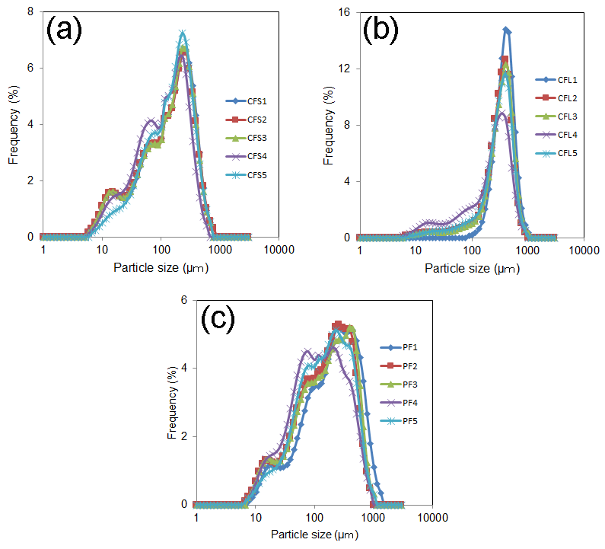

Figure. 1. Particle size distribution curves of different initial and pulveirsed wood flour (a) cypress wood flour (small sized), (b) cypress wood flour (larged sized), and (c) red pine wood flour.

The particles size distribution of different types of initial wood flour and pulverized wood flour with and without water are shown in Fig.1. The average particle size of different wood flour obtained from particle size distribution analysis are also reported in Table 1. Fig.1a and Fig.1b represent the particle size distribution curves for small sized and large sized cypress wood flour, respectively, whereas Fig.1c shows the particle size distribution curve for red pine wood flour. The decrease of particles size in pulverized WF with and without water compared with the initial WF particles is obvious from the particle size distribution curves of large sized cypress flour (Fig.1b) and red pine flour (Fig.1c). From particle size distribution curves, it is also noticed that due to pulverization of wood flour with water setting plate gap 200 µm the particles size is reduced significantly for every type of wood flour compared with the particle size of pulverized wood flour without water. Particle size analysis indicated that presence of water assisted to reduce particle size of wood flour. Water probably enhanced particle splitting by facilitating of breaking hydrogen bond within particle.

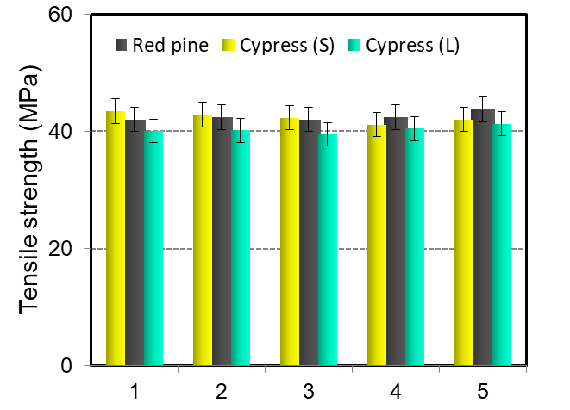

Figure. 2. Tensile strength of different wood flour reinforced PP composites: reinforced by (1) intial WF, (2) pulverized WF without water setting plate gap 200 µm, (3) pulverized WF without water setting plate gap 350, (4) pulverized WF with water setting plate gap 200 µm, (5) pulverized WF with water setting plate gap 350 µm.

The column diagram in Fig. 2 represents the tensile strength of different wood flour reinforced polypropylene composites. Tensile properties such as elastic modulus and tensile strength of PP matrix were significantly improved by incorporating 25 wt% of WF. However, strain percentage of PP was greatly reduced by WF. Comparing tensile strength of composites CCF_{S}1 and CCF_{L}1, same type of WF but different particle size, it seems that the tensile strength of PP/WF composites are affected by the size of the WF particles. CCFS1 also displayed a higher value of tensile strength compared with CPF1 because of the same reason. The increase order of tensile strength of these composites is CCF_{S}1˃CPF1˃CCF_{L}1. However, it has been reported by Stark et al [5] that tensile strength and stiffness of PP/WF composites are largely enhanced by the aspect ratio, not particle size, of WF particles. Hence, from tensile test results, it can be assumed that the increase order of aspect ratio among initial wood flours is CF_{S}1˃PF1˃CF_{L}1. A little lower of tensile strength values but similar trend is also noticed in pulverized WF without water i.e. the increase order of tensile strength is CCF_{S}2 ˃CPF2 ˃CCF_{L}2 for plate gap 200 µm and CCF_{S}3˃ CPF3 ˃CCF_{L}3 for plate gap 350 µm. From this result it can be concluded that due to the pulverization of WF without water the length of WF particles is decreased by particle breakage as a result the aspect ratio of particles is reduced. However, in case of composites of pulverized WF with water the increase order of tensile strength of the composites is not similar as mentioned above. Composites CPF4 displayed higher value of tensile strength compared with CCF_{S}4. In addition, the tensile strength values of PP/WF composites with pulverized small sized wood flour obtained from cypress tree are decreased. Whereas, in the case of large sized wood flour the tensile values of PP/WF composites are not decreased rather little increased. It seems that pulverization of WF with water may has positive effect to the tensile strength of PP composites compared with that of pulverization of WF without water. Thus, tensile test results also indicated, depending on the type of initial wood flour particle, pulverization of WF with water can enhance or decrease the aspect ratio of WF. Thus, the effectiveness of pulverization of WF with water to the tensile strength of composites depend on the type of initial wood flour particles.

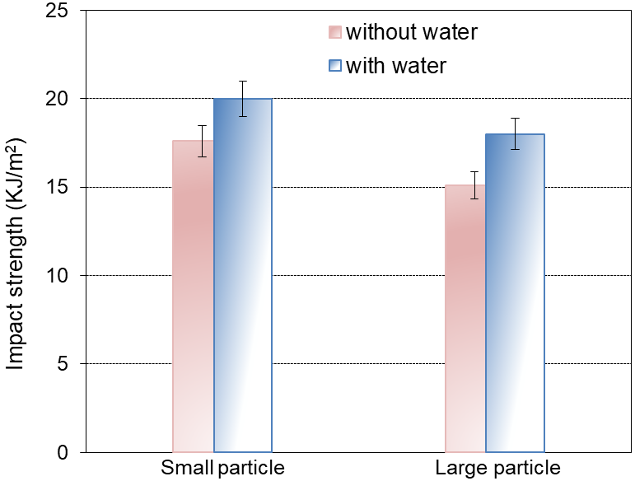

Figure 3. Impact strength of pulverized cypress wood flour reinforced polypropylene composites: effect of particle size and presence of water in pulverization.

Fig.3 shows the impact strength of pulverized cypress wood flour reinforced polypropylene composites. Izod impact test of unnotched specimens of the processed composites together with neat PP was carried out and it was found that incorporation of 25 wt.% WF in PP matrix dropped the impact strength of neat PP (50 KJ/m²) largely. This large drop of impact strength indicates that the ductility of PP matrix has greatly been reduced in PP/WF composites. However, the composites reinforced with pulverized wood flour with water setting plate gap 200 µm displayed higher values of impact strength compared with the composites pulverized without water (Fig.3). Composites with smaller (165 µm) particles also displayed higher values of impact strength compared with the composites with larger (265µm and 379 µm) particles. It was also found that the composite of PP with smaller (165 µm) particles (obtained from cypress tree), which was pulverized with water displayed the highest value of impact strength (20 KJ/m²). Hence, impact test results suggest that smaller particles has better effect to the impact behaviour of composites compared with larger particles. The effect of particle size to the impact energy of PP/wood flour composites has also been investigated by Stark et al [5]. They reported that the unnotched impact energy of PP/WF composites is increased with decreasing particle size due to reducing stress concentration. Hence, the impact test results indicates that the brittleness of PP/WF composites can be reduced by using pulverized WF with water.

4. Conclusions

This study investigated the effect of pulverization of wood flour with and without water to the tensile properties and impact behaviour of polypropylene (PP)/wood flour (WF) composites. The effects of initial wood flour particle size, type of trees (namely Cypress and European red pine trees) as well as plate gap (200 µm and 350 µm) in pulverization were also evaluated in terms of tensile properties and Izod impact strength of the prepared composites. The composites were processed in an extruder and subsequent injection moulding. The obtained composites were characterised by tensile and impact tests. From the test results it was observed that further pulverization of wood flour affected to the tensile strength values of composites. The tensile strength of the processed composites with 25 wt% of WF were found in the range of 39-43 MPa and improvement in tensile strength of composites were depended on the type of initial WF. Izod impact test results of unnotched specimens of the PP/WF showed that the composites reinforced with pulverized wood flour with water displayed higher values of impact strength compared with the composites of pulverized WF without water. Composites with smaller particles displayed higher values of impact strength compared with the composites with larger particles. It was found that the composite of PP reinforced by smaller (165 µm) sized WF (obtained from cypress tree), which was pulverized with water displayed the highest value of impact strength. From this study, it can be concluded that depending on initial wood flour particles, an improvement of mechanical properties such as tensile strength and impact strength of PP/WF composites can be obtained by further pulverization of WF with water.

References

[1] B.V. Kokta, R.G. Raj, and C. Daneault. Use of wood flour as filler in polypropylene: Studies on mechanical properties. Polymer-Plastics Technology and Engineering, 28:247-259, 1989.
[2] G.E. Myers, I.S. Chahyadi, C.A. Coberly, and D.S. Ermer. Wood flour/polypropylene composites: influence of maleated polypropylene and process and composition variables on mechanical properties. International Journal of Polymeric Materials, 15:21-44, 1991.
[3] L. Danyadi, T. Janecska, Z. Szabo, G. Nagy, J. Moczo, and B. Pukanszky. Wood flour filled PP composites: compatibilization and adhesion. Composites Science and Technology, 67:2838-2846, 2007.
[4] H.S. Kim, B.H. Lee, S.W. Choi, S. Kim, and H.J. Kim. The effect of types of maleic anhydride-grafted polypropylene (MAPP) on the interfacial adhesion properties of bio-flour-filled polypropylene composites. Composites Part A: Applied Science and Manufacturing, 38:1473-1482, 2007.
[5] S.N. Maiti, and M.R. Hassan. Melt rheological properties of polypropylene–wood flour composites. Journal of Applied Polymer Science, 37:2019-2032, 1989.
[6] M. Kiguchi, Y. Kataoka, H. Matsunaga, K. Yamamoto, and P.D. Evans. Surface deterioration of wood-flour polypropylene composites by weathering trials. Journal of Wood Science, 53:234-238, 2007.
[7] L. Soccalingame, D. Perrin, J.C. Benezet, and A. Bergeret. Reprocessing of UV-weathered wood flour reinforced polypropylene composites: Study of a natural outdoor exposure. Polymer Degradation and Stability, 133:389-398, 2016.
[8] Y. Peng, R. Liu, and J. Cao. Characterization of surface chemistry and crystallization behavior of polypropylene composites reinforced with wood flour, cellulose, and lignin during accelerated weathering. Applied Surface Science, 332:253-259, 2015.
[9] Y. Peng, R. Liu, J. Cao, and X. Guo. Effects of vitamin E combined with antioxidants on wood flour/polypropylene composites during accelerated weathering. Holzforschung, 69:113-120, 2015.
[10] Z. Niu, Y. Chen, and J. Feng. Preparation, structure, and property of wood flour incorporated polypropylene composites prepared by a solid‐state mechanochemical method. Journal of Applied Polymer Science, 133:10, 2016.
[11] R. Makise, M. Okamoto, T. Hasegawa, H. Ito, J. Minamino, A. Isa, and Y. Kojima. Effect of the shape of pulverized wood flour on the mechanical properties of wood-plastic composites. In Proceedings of the 11th Pacific Rim Bio-Based Composites Symposium, 461-466, 2012.
[12] A. Isa, T. Toyoda, S. Suzuki, Y. Kojima, H. Ito, R. Makise, and M. Okamoto. The effects of wet-milled wood flour on the mechanical properties of wood flour/polypropylene composites. Journal of Wood Chemistry and Technology, 34:20-30, 2014.

