EuroSun2026
ADVANCED PV TECHNOLOGIES FOR INTEGRATED APPLICATIONS – THE PARADIGM OF AGRIVOLTAICS
Evangelos Rikos¹ (corresponding author), Nick Kanopoulos², Duygu Kuzyaka³, Aphrodite Kakagia¹, Vasiliki Drosou¹, Hande Eryılmaz³
¹Centre for Renewable Energy Sources and Saving (CRES), Pikermi-Athens, Greece.
² Brite Hellas SA, Thessaloniki, Greece.
³ ODTU Gunes Enerjisi Uygulama ve Arastirma Merkezi (GUNAM), Ankara, Türkiye.
vrikos@cres.gr, nkanopoulos@britesolar.com, duygu.kuzyaka@odtugunam.org, a.kakagia@cres.gr, drosou@cres.gr, hande.eryilmaz@odtugunam.org
Summary
The integration of Photovoltaics applications in sectors such as construction and agriculture for energy efficient area and land usage for buildings and farming are of high priority for researchers and engineers. These applications are used to tackle spatial scarcity, and to optimize the design of structures by combining the benefits of electricity production with other application-specific parameters such as microclimate creation. In this context, the specific study addresses the use of Photovoltaics (PVs) in agricultural applications also known as agrivoltaics. The specific concept is gaining momentum among researches and engineers due to its high potential that enables a number of benefits connected to farming and energy production in rural and peri-urban areas. In this study, emphasis is placed on parametric analysis of the design requirements and the selection of novel products that lead to an optimal use of PV systems in order to improve specific conditions for the crop. The analysis includes assessment of technoeconomic, regulatory, and other critical aspects that engineers and other relevant stakeholders should consider towards optimal selection of an AgriPV design, in reference to a proposed setup, which makes use of new types of PV modules and supporting structures. Even though the analysis is particular to AgriPVs, the approach is potentially replicable in other sectors such as Building Integrated PVs.
Keywords: Photovoltaics, Agrivoltaics, PV Modules, Support Structures.
Field of application for the findings: Farming, Energy Production, Rural Areas, Peri-urban Areas.
Addressed audience: Engineers, Researchers.
- Introduction
Environmental concerns, including CO2 emissions and scarcity of energy reserves, have led to the ever-expanding usage of Renewable Energy Sources (RES). Policies at national, EU, and international level foresee specific targets regarding the CO2 emissions reduction by 2030 and 2050 (European Commission, 2019, 2020). These plans foresee a reduction in the greenhouse gas emissions of at 55% by 2030 climate neutrality by 2050 compared to the 1990 levels. With the rapid growth of RES applications, such as Photovoltaics, specific needs and constraints emerge. A case in point is the local generation of electricity for use on the spot by the owner of the PV installation in a self-consumption approach. The PV installations for local self-consumption come in a diversity of schemes that can be divided into individual or collective ones. Characteristic examples include individual self-consumption via net-metering and net-billing (Trela and Dubel, 2022), and collective self-consumption via schemes like Renewable Energy Communities (European Commission, 2018) or more advanced power system structures such as microgrids (Hatziargyriou et al., 2014).
Moreover, the use of private PV installations for covering their own energy needs has been proven to be a very efficient method, leading to its increased popularity among energy saving approaches in the residential, building, and other urban planning practices. However, this popularity results in specific challenges too that call for more holistic design approaches. These approaches take into account not only the optimization of the PV installation but also other crucial parameters related to the specific application. To this end, integration of the PV installation into the area of use has become very important in recent decades. Two particularly interesting areas of PV integration include Building Integrated PVs (BIPVs) and Agrivoltaics (AgriPVs), whereas other emerging similar approaches include floating PVs and Vehicle Integrated PVs (VIPVs), to name a few. The main issues connected to these sectors and the reasons that have led the research and engineering community into exploring integrated PV applications are the following:
- Spatial scarcity, namely lack of available surfaces that could be used for the installation of the PVs (Zainali et al., 2025), and,
- Impact of the PV installation on the occupied space underneath (Foroutanfar et al., 2025).
One very interesting application area is that of AgriPVs, which addresses the dual use of land for both electricity generation and farming. As can be seen in Zainali et al. (2025), AgriPV is an area with huge research and deployment interest in terms of design optimization. Due to this potential, alongside the rising concerns regarding use of land, several studies have been conducted to propose alternative solutions. As the results presented by Widmer et al. (2024) suggest, most analyses prove that the use of AgriPVs for the combined electricity and food production constitutes a viable solution with high potential even for light-demanding crops. On the other hand, the study concludes that the final outcome of an AgriPV in terms of crop is the result of many factors, with location and season being the most prominent factors. In the same vein, Walston et al. (2022) suggest that the use of AgriPVs may have positive impact not only on farming but also on biodiversity, water, and soil conservation.
Currently, despite their high potential and numerous benefits, there are still obstacles that prevent the rapid expansion of the technology. An overview of the most important challenges is provided by Chatzipanagi et al. (2023) and highlights the bottlenecks regarding legal, financial, and societal challenges that AgriPVs need to overcome. Among specific problems mentioned are: lack of a universal definition at EU level, intentional change of farming to prioritize energy production after installation, public awareness, prices for land, permitting and connection difficulties, as well as insufficiently defined strategic plans and national policies. In addition, from a technical point of view, the challenge of maximizing energy yield while minimizing impact on crop yield is of high importance. The specific challenge has led to several Research and Innovation projects to investigate potential solutions. From these approaches, especially those that involve pilot implementation and demonstration, the main takeaway is that there are two different approaches regarding the impact of the AgriPVs. On the one hand, there are studies focusing on the minimal intrusion of the PV installation on the crops, whereas, other more state-of-the-art approaches propose the use of new products, technologies, and designs in order to further optimize the farming process. In this context, this study focuses on the analysis of an AgriPV for tree crops (orchards and vineyards), used to produce electrical energy, improve the microclimate conditions, and protect the crop against extreme weather events. In addition, before presenting the specific architecture, the first part of the analysis focuses on a methodology that allows the designer to better understand ways of tackling the challenges mentioned earlier.
- Overview of high-level design methodology
The efficient design of an AgriPV project requires a good understanding and knowledge of a number of factors related to the challenges mentioned in the introduction. In this paper, a conceptual design framework is presented to tackle the problem at high level by taking into account diverse aspects, which can influence the design and performance of the design. The specific methodology was first presented by Rikos et al. (2024), and was developed as part of the EU funded project SolarHub to tackle a specific type of AgriPV application for tree crops (peach trees and grapevines) in the eastern Mediterranean region, particularly in two countries of interest, Greece and Türkiye. It should be noted that similar design and optimization approaches have been presented as part of other studies (Fernandez-Solas et al., 2023; Mehta and Zörner, 2025). Despite the effectiveness and accuracy of such proposed design methodologies, these approaches focus mainly on the technoeconomic assessments of such projects. In this respect, there seems to be a gap regarding more systematic, high-level guidelines, that can be used not only by specialists but also by researchers and designers who are interested in a more holistic treatment of the problem. As part of an approach to address the problem in full, this study presents a higher-level approach, which emphasizes all challenges of the problem in the form of a simplified guideline. This approach is not intended as a replacement of existing ones but it complements existing work by including aspects not covered by existing methodologies.
An overview of the proposed design methodology is shown in Fig. 1. As can be seen in the simplified flowchart of the specific figure, there are seven main steps that ought to be taken into account during the design phase of an AgriPV project in order to address the main challenges associated with AgriPV design. These steps are the following:
- Analysis of regulatory, societal, and market framework(s),
- Analysis of the impact the AgriPV could have on microclimate,
- Identification of crop requirements,
- Definition of a list of Key Performance Indicators for the assessment of design performance,
- Conceptual design for analysis of the optimal light-shadow balance that is beneficial for the crop,
- Cost-benefit analysis to evaluate the return on investment for the specific design project,
- Finalization of the design and dimensioning of the AgriPV.
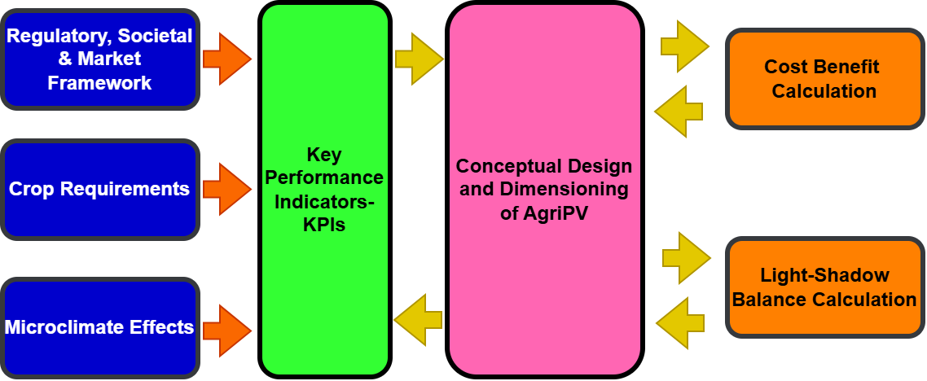
Fig. 1: Overview of the proposed design methodology illustrating the seven main stages in the analysis
It should be noted that, according to the proposed methodology, some steps are conducted only at the beginning of the analysis, whereas other steps are repeated in an iterative, feedback loop process to streamline the results of the AgriPV design. In this context, an example sequence could involve an initial design, a calculation of the shading effects, a cost benefit analysis, and an assessment of the KPI metrics. Based on the results and depending on the priorities set for the design project, improvements to the AgriPV design could be implemented in order to improve specific KPIs or aspects. For the sake of clarity, a brief overview of each step is presented below.
2.1. Regulatory, societal, and market framework
As a first step in the feasibility analysis, the assessment of the regulatory and market framework should be conducted. This analysis helps to better understand the obstacles and opportunities related to the AgriPV project in the selected country/region of implementation. Examples of what is relevant to this step of analysis include the definition of AgriPVs according to the local legislation, remuneration schemes, policy-related priorities, funding opportunities and market dynamics including value-chain suppliers and manufacturers. In addition, an analysis of societal acceptance of the AgriPV could be of interest, to upscale smaller projects and also sustain large-scale projects.
2.2. Microclimate impact
One particularly important aspect of analysing an AgriPV project is the potential impact the installation has on the local environmental conditions. Changes in ambient environment condition variables, such as temperature and humidity, can play a crucial role in the selection of the proper design for the AgriPV. Design parameters, such as transparency, height of installation and spacing requirements, can be determined through understanding the effects of the installation on the microclimate. The microclimate impact analysis can be tackled at two different levels of detailing:
- At high, more generic level, an analysis of AgriPVs impact on microclimate can provide insights regarding the potential of the installation at a specific site.
- A more specific assessment that takes into account the exact design characteristics of the AgriPV could also be adopted.
The latter approach requires knowledge of detailed, complex models for calculating the effects of an actual AgriPV setup on a crop. Based on the results of such an analysis that derive from simulations, a streamlining of the AgriPV can be achieved. In this case, the step of Microclimate Effects assessment of Fig. 1 becomes part of the iteration phase rather than the initial stage of the analysis. However, due to the complexity of this step, in the present study the microclimate impact has been assessed only based on existing knowledge and not by means of dedicated simulations or measurements, providing some more general insights on the microclimate impact AgriPVs have. An overview of the most important findings in the literature shows that AgriPVs can impact specific environmental variables such as temperature and humidity. In general, studies (e.g., Τrommsdorff et al., 2024) show that AgriPVs can moderate extreme temperatures during spells of heatwaves or frost, with more prominent impact in the soil than the air temperature. Furthermore, the use of AgriPVs reduces the evapotranspiration of plants resulting in lower irrigation needs. Lastly, it should be mentioned that the proper design and installation of the AgriPVs, and one of the key aspects of the present study, is the use of the AgriPV in order to provide protection against extreme or severe weather events such as heavy rainfall, snowfall, and hail. This aspect, combined with the possibility of collecting and reusing rainwater, provides a more agroecological protection of the crop, which constitutes further evidence of their significant impact on the microclimate. All the positive traits of AgriPVs in this context can also lead to improved farming conditions and subsequent crop yield quality.
2.3. Crop requirements
Identifying specific crop requirements is a prerequisite for a successful and optimized AgriPV design. In the framework of this study, two types of crops, namely vineyards and peach trees, are selected as the crops of interest regarding key requirements. Some crop requirements are particular to the selected type of crop, whereas other specific aspects can be generalized for nearly any kind of crop. A case in point is the amount of solar irradiation that reaches the plants underneath. The right balance between light and shadow for a crop can be expressed in terms of the Photosynthetically Active Radiation (PAR) and light-saturation curves. A definition for the PAR is provided in the following subsections. The key parameter determining the crop requirement, which is the light-saturation curve can be expressed in a generalized theoretical form as shown on the left-hand side diagram of Fig. 2 (Benedetti et al., 2018; Ghosh, 2023; Lu et al., 2022). This curve expresses the photosynthesis rate for plants and is an index of their productivity and growth rate. As can be seen in the diagram, there are three basic areas, within which the photosynthesis rate changes. These are the light-limitation area with a prominent linear region (constant slope), the photo-saturation region in which the photosynthesis plateaus and becomes maximum (P_{max}), and the photo-inhibition region, where further increase in the PAR levels may result in a reduction in the photosynthesis rate.
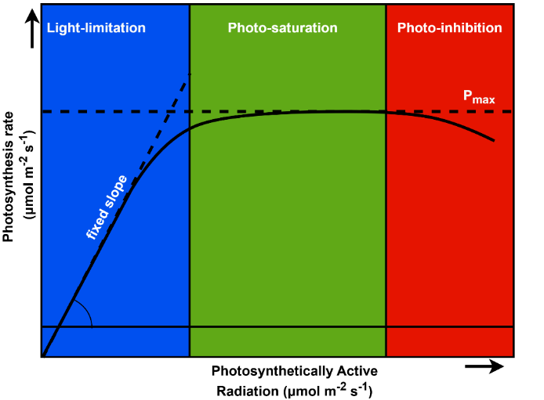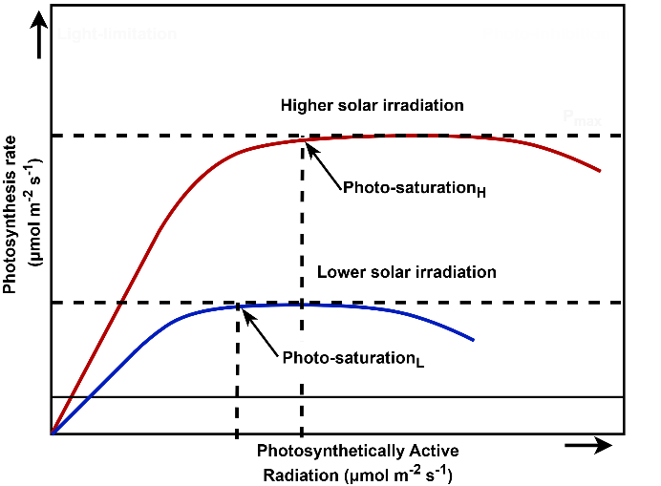
Fig. 2: Generalized model of light-saturation curves
Studies regarding selected crops (Greer and Weedon, 2012; Losciale et al., 2010), namely grapevines and peach trees, show that the generic photosynthesis model shown in Fig. 2 applies to actual plants where the photosynthesis rate increases within the first (light-limitation) region until it plateaus in the photo-saturation region. The exact values of the photosynthesis curves, such as P_{max,} photo-saturation range, etc. depend on a number of factors, such as the ambient temperature, the growth stage of the plants, but also on the amount of shading. Regarding the response of plants in different irradiation conditions, according to studies (Gjindali and Johnson, 2023) it can be seen that plants adapt their photosynthesis rate as a result of acclimation to solar irradiation variations. This results in a modified photosynthesis curve with different levels of P_{max} and photo-saturation limits (right-hand side diagram of Fig. 2).
2.4. Key Performance Indicators
When designing an AgriPV project the designer should decide on specific priorities and objectives for the installation. As mentioned in the introduction, AgriPV designs could be classified into two approaches, the one that minimizes the negative impact on the crop underneath and the one that aims to improve specific characteristics of the crop. In either case, the designer should select a set of parameters that can be used to assess the effectiveness of the AgriPV in the short and long term. These parameters, also known as Key Performance Indicators (KPIs), can be quantified by using specific target metric values that help quantify and validate the performance of the AgriPV. Example parameters that can be used include energy yield, crop yield, water savings, and payback period, to name a few. Specific values can be assigned to these parameters, which allow for the optimal design of the AgriPV and its performance evaluation during and after the project lifetime.
In the proposed approach, the scope of the AgriPV design is to improve specific aspects of the farming process by using state-of-the-art PV modules and supporting structures. As such, the selected KPIs to meet the requirements and expectations for the specific design are summarised in Tab. 1. It should be noted that the selected target metrics for our analysis are based on the assumptions for the specific target crops (peach trees and grapevines) and, in the more general case, are defined by the special characteristics and requirements of each AgriPV project separately.
Tab. 1: Overview of proposed KPIs
KPI name | Description | Target metric
KPI-1 | Crop production index: the average annual crop production per unit of area of the designed AgriPV system, compared to the production of the same piece of land without the PV system. | > 100%
KPI-2 | Solar energy production index: the annual energy yield per ground area (in MJm⁻² per year) of the designed PV system compared to the value of a fixed tilt PV system designed for optimum energy yield. | > 216
KPI-3 | Cost index: the cost of installation per unit of installed power of the AgriPV system, compared to the cost of a conventional PV system. | < 150%
KPI-4 | Water usage decrease compared to the reference scenario. | > 10%

2.5 Light-shadow balance calculation
One very important aspect of the design and dimensioning of the AgriPV is the calculation of the light-shadow balance affecting the crop. As was shown in the previous subsections, the amount of solar irradiance is connected to both the growth of plants and microclimate conditions. As such, the right use of shadowing and transparency could potentially lead to specific benefits for the crop. In the proposed design, the PV modules are especially designed with selected transparency that allows specific amounts of PAR to reach the crop. However, even in the more general case, the estimation of light-shadow balance is crucial to prevent any undesired and detrimental results.
The key parameter to identify the specific balance is the PAR which was introduced earlier. The PAR can be defined as a fraction of the total solar irradiance given by the formula below (eq.1):
$PAR \left(W∙m^{-2}\right)≈SR\left(W∙m^{-2}\right)×{Ratio}_{1}$ (eq.1)
where SR is the solar radiation and Ratio₁ is a coefficient usually approximated to 0.5 even though its exact value depends on the geographical location, the time of year, etc. (Akitsua et al., 2022). Also, the Photosynthetic Photon Flux Density (PPFD), which represents the usable photon flux, can be calculated by the following formula (eq.2):
$PPFD\left(μmol∙m^{-2}∙s^{-1}\right)=PAR\left(W∙m^{-2}\right)×{Ratio}_{2}$ (eq.2)
with Ratio₂ equal to 4.57 μmol J⁻¹.
The amount of shading cast by the AgriPV on the crop can be evaluated as a percentage of the maximum SR if the exact position of the sun in combination with the geometry of the AgriPV are known. The solar position can be calculated for a specific geographical location by calculating the solar altitude and azimuth angles (Iqbal, 1983) (eq.3 and 4):
$sina=sinδ∙sinφ+cosδ∙cosφ∙cosω$ (eq.3)
$cosψ=\left(sina∙sinφ-sinδ\right)∙cosφ/cosa$ (eq.4)
In the above formulas α corresponds to the solar altitude, ψ corresponds to the azimuth angle, δ is the solar declination, φ is the location latitude, and ω is the hour angle. Specific formulas for calculating each of the above parameters are also provided in literature (Iqbal, 1983).
In order to calculate the shading levels and patterns or, subsequently, the PPFD profiles on the crop one can choose among different calculation tools, based on either commercial or open-source licensing model. In this study, two different open-source tools were developed to facilitate the light-shadow balance calculation. The first tool is an application based on Python (ver. 3.13) that allows the calculation of the shading pattern for different locations and time of year. The specific tool is also equipped with a Graphical User Interface (GUI) to make its use easier for the public. Fig. 3 provides an overview of the proposed GUI tool, which consists of three main parts: the data input, the output regarding the solar position within a selected day, and the shadow (shaded area) pattern of a PV panel (blue rectangle, top view) on the ground.
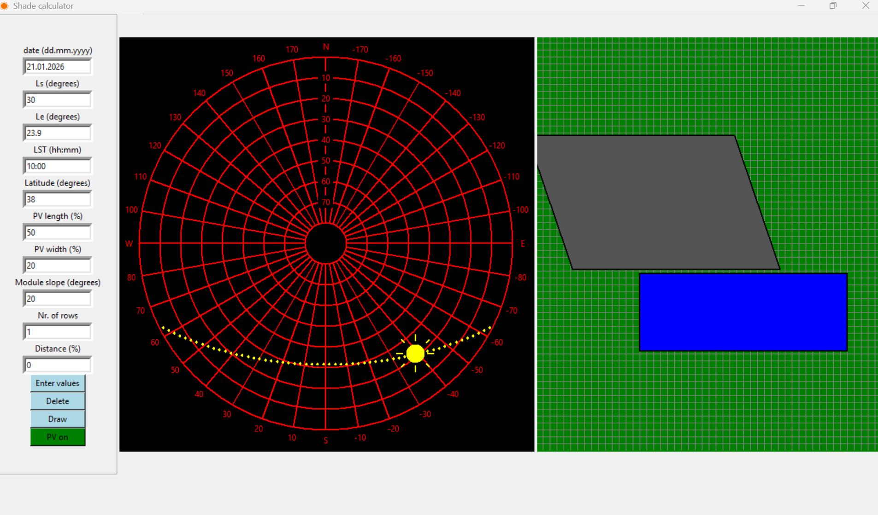
Fig. 3: Python-based tool for the calculation of light-shadow balance
The specific tool is an open-source one, which allows flexible use through appropriate modifications of the code in Python. However, to tackle specific needs regarding the controllability of selected parameters, an additional tool was developed as a MATLAB®/Simulink model. This is also an open-source tool that provides flexibility in modifying selected parameters. An indicative result of the use of the specific model is provided in Fig. 4. The diagrams of Fig. 4 show the shadow patterns for three different scenarios: on the left-hand side diagram, the shadow path is depicted by the black parallelograms. The PV panel is the red rectangle in the bottom-centre of the diagram. The shadow path corresponds to one full day, namely during summer solstice (21st of June). Similarly, the middle diagram shows the shadow path during winter solstice. The difference in the shadow path pattern is due to the difference in the solar azimuth and altitude angles for the selected days of year. In addition to this specific use, the developed model allows for other more complex actions and calculations such as the change of orientation of the PV panel for a specific solar location, e.g., in the case of solar trackers.
All in all, with the use of the proposed or other tools, designers can safely estimate potential issues with excessive or non-uniform shading on the crop and refine the design by selecting proper transparency and positioning of the PV panels. This is also why the use of such tools can be done in an iterative approach, where potential improvements in the design can further be tested in terms of shading effects until an optimal design is reached.
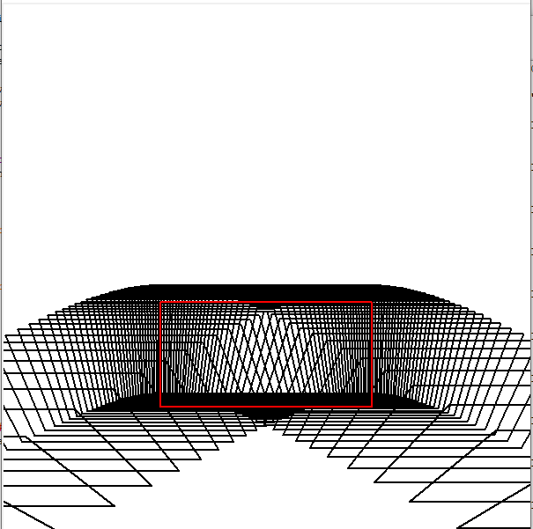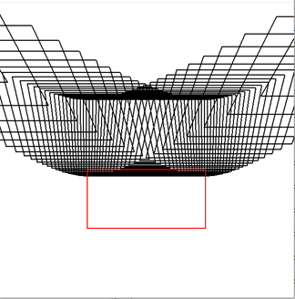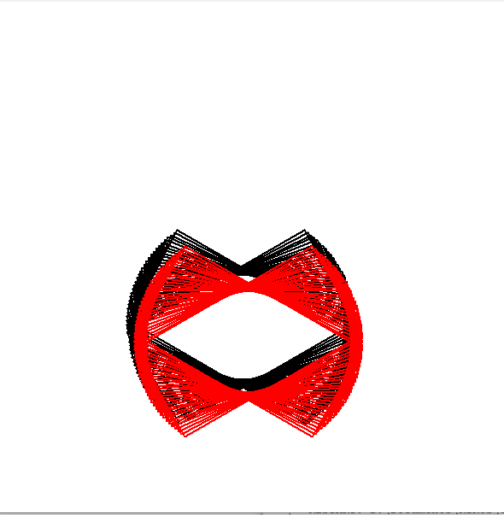
Fig. 4: Shadow patterns for three different scenarios: summer solstice (left), winter solstice (middle), and orientation change (right)
2.6 Cost-benefit analysis
The last step in the conceptual design process is that of the cost-benefit analysis for the AgriPV. This is a crucial step in terms of validation or even improvement of the design. It is also the connection step between analysis and investment/commercialisation of the concept because it provides specific insights regarding capital (CAPEX) and operational (OPEX) expenditures, revenues, payback time, etc., all crucial questions that facilitate the acceptance and faster adoption of the technology by the potential users. Since AgriPVs are specially designed PV systems, the long-term expertise of designers and engineers in the cost-benefit analysis of PV systems is a good starting point for such an analysis. To tackle the financial assessment of AgriPV installations, in the context of this study an open-source calculator in Python (ver. 3.13) was developed. The specific tool’s GUI is depicted in Fig. 5.
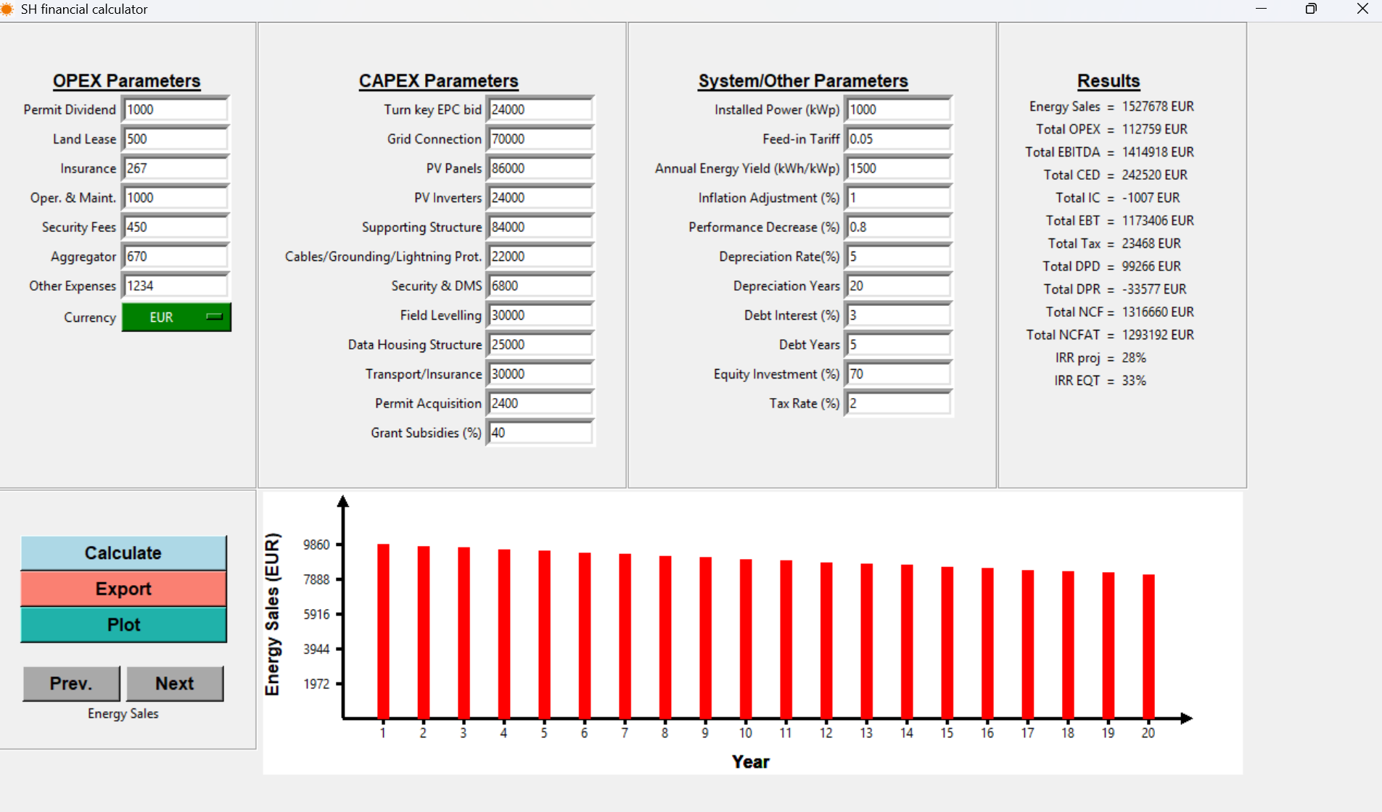
Fig. 5: Python-based financial calculator for the assessment of AgriPV projects
The development of the specific financial calculator is based on expertise from research as well as commercial applications and it provides an estimation of the key financial indices of the project based on data that the user can manually introduce (e.g., CAPEX, OPEX, dimensioning, etc.). The tool calculates and provides results for a 20-year horizon, however, due to its open-source structure, it can be modified to incorporate longer-term calculations or even additional aspects not included in the specific version. It should be stressed that the basic version of this as well as other existing tools treat the financial assessment of AgriPV projects as standard PV projects due to the predictability in specific aspects of the PV parts (energy yield, degradation, maintenance, tariffs, etc.). However, the impact of the specific AgriPV design on other crucial aspects, such as the water usage reduction, as well as potential crop yield improvement and increase, call for financial assessments which include these additional aspects. The main challenge regarding modelling the financial impact on these additional aspects is the high degree of uncertainty still existing in modelling those quantities. Unlike statistical models for the PV energy production, that are well established and accepted globally, estimating the amount of crop yield and/or water savings each year is not straightforward. An example model for the revenues from an AgriPV project could be formulated in the simplified equation below (eq.5):
$Cash_flow(t)=\sum_{year i}{\left({ER}_{i}+{WSR}_{i}+{CYR}_{i}-{OPEX}_{i}\right)-CAPEX}$ (eq.5)
In eq. 5 the cash flow at a specific time of the project (year i) could be calculated by taking into account the energy yield revenues (ER) but also revenues arising from water savings (WSR) and improved crop yield (CYR). Such a formula could be used to estimate the payback period as well as the total cash flows at the project’s end of life. Despite its importance, the approach followed in the present analysis does not take into account revenues other than the ones connected to energy generation.
- Design of the AgriPV
The use of the previously presented methodology aims at identifying specific design characteristics for the AgriPV setup. It should be noted that due to the diversity of crop requirements and the large number of involved parameters, the proposed design is not a unique one but rather a more generic approach that is tailored to the specific project needs. There are two core parts in the proposed design, which include the specially designed PV modules and support structures. More details regarding their characteristics follow. It is worth noting that both parts of the specific project design are commercially available products provided by Brite Hellas SA. The capacities of the industry partner Brite Hellas SA have helped develop the new design modules and its characteristics. The new AgriPV design under the SolarHub project has expanded the knowledgeability of the semi-transparent AgriPV technology and the products are commercially available by Brite Hellas SA and have been tested in several demonstration sites.

3.1 Semi-transparent PV modules
In the present approach, in order to achieve the optimal desired outcome, a special type of PV modules is proposed. A key characteristic of these modules it their transparency, which is configurable during manufacturing to the desired levels, depending on the application. The core idea behind this transparency is combining standard, high-performance, and affordable PV cells (mono-crystalline Si) in conjunction with standard or special types of glass panes in a configuration such as the one shown in Fig. 6.
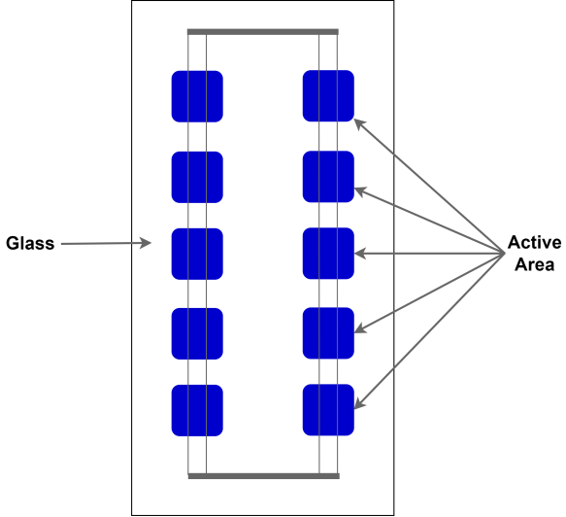
Fig. 6: Indicative arrangement of c-Si PV cells in order to achieve specific transparency
The transparency in the example of Fig. 6 is obtained by properly spacing the PV over the glass pane, leaving a specific portion of it uncovered. In this configuration, the area occupied by the PV cells is called the active area, since it is the PV module part that contributes to energy production. The glass pane in the proposed approach is made of either standard or special-type glass. The latter is covered with a layer of nano-coating that modifies some transparency characteristics in order to exploit more parts of the light spectrum. In Fig. 7 an example of commercially available PV modules with their transparency profile is provided. The specific module is of approximately 50% transparency (i.e., half of it is the active area), and produces a peak power of 250 W. The specific model can be equipped either with standard (plain) or solar (nano-coating) glass, with very similar transmittance profiles as the right-hand side diagram of Fig. 7 shows. The special impact of the nano-coating on the transmittance is separately illustrated in Fig. 8, which depicts the behaviour of the material as a filter and amplifier for specific wavelengths.
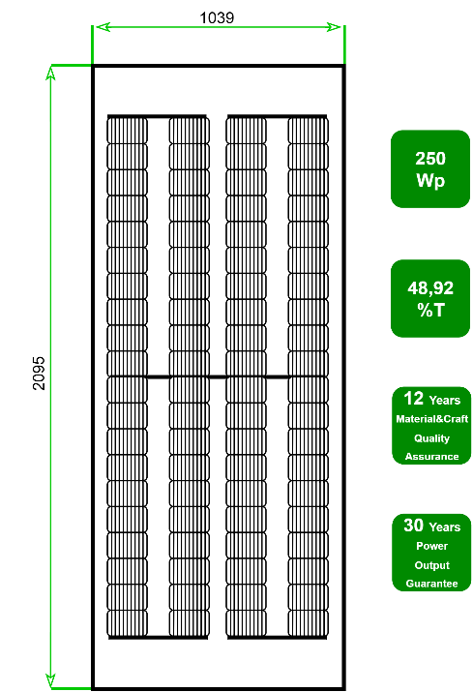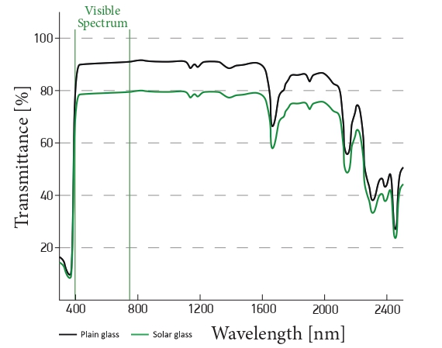
Fig. 7: Example of commercially available PV modules and transmittance profile
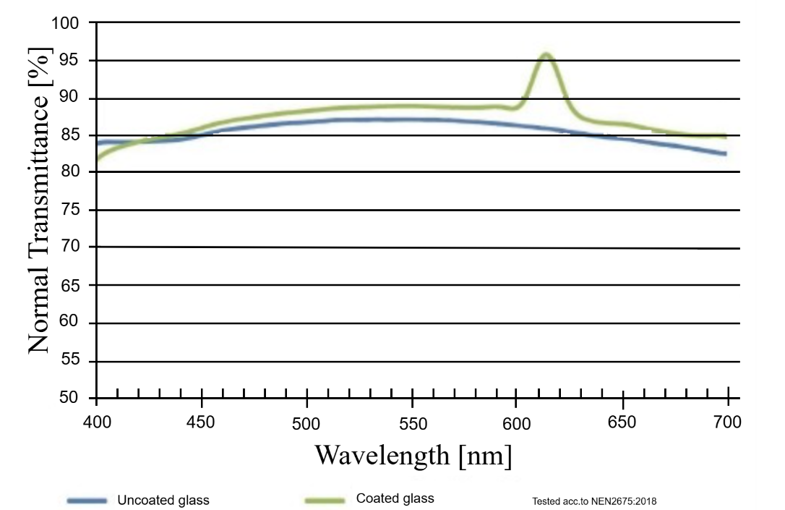
Fig. 8: Modification of visible spectrum with the use of selected nano-coating
3.2 Elevated support structures
The second key element of the proposed AgriPV design is the support structure that accommodates the PV modules. Given the assumption of use with trees (peach trees and grapevines), it becomes obvious that the support structure should meet some specific requirements in terms of dimensioning. Similar to the PV modules, there is not one unique type of supporting structure but a more generic design tailored to the specific project needs. One example of a variant of the structure can be seen in Fig. 9. The dimensions in the specific diagram are in mm and indicate the sufficient distancing and elevation of the structure to not hinder the farming process, which involves unimpeded movement of personnel and machinery as well as growth of trees. The specific support structure is specially designed to withstand extreme weather events including strong wind, snowfall, etc. while it is often equipped with parts that allow for the collection of rainwater for irrigation. The generic support structure designs have been developed in consultation with farmers and agronomists in order to take into account the needs and insights provided by the specific groups of users.
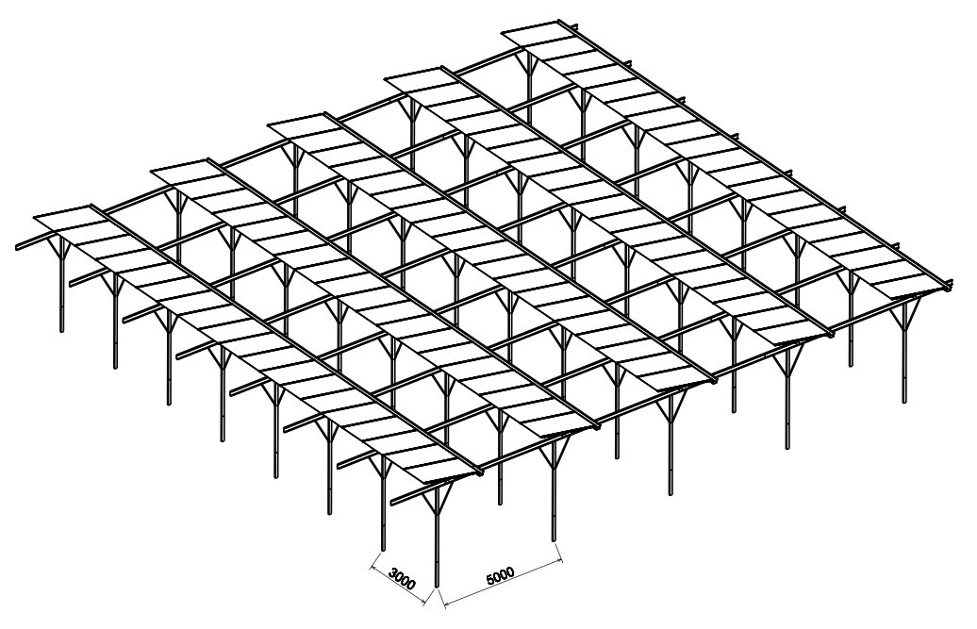
Fig. 9: Example of proposed supporting structure for use in tree-crop AgriPVs
3.3 Selected pilot examples
The AgriPV design described earlier constitutes a commercially available solution and specific projects have been installed in the area of Northern Greece using this design. Fig. 10 illustrates two indicative pilots. On the left, an installation with peach trees in the area of Veria, Greece, can be seen. The specific project is an 80-kW system.
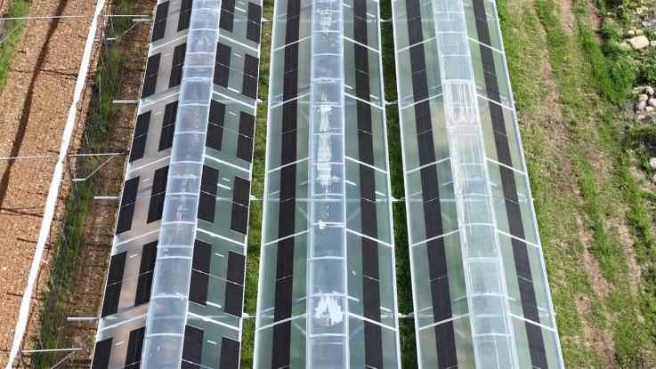
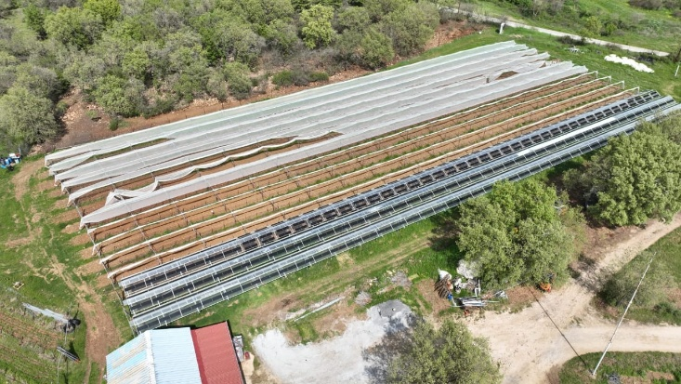
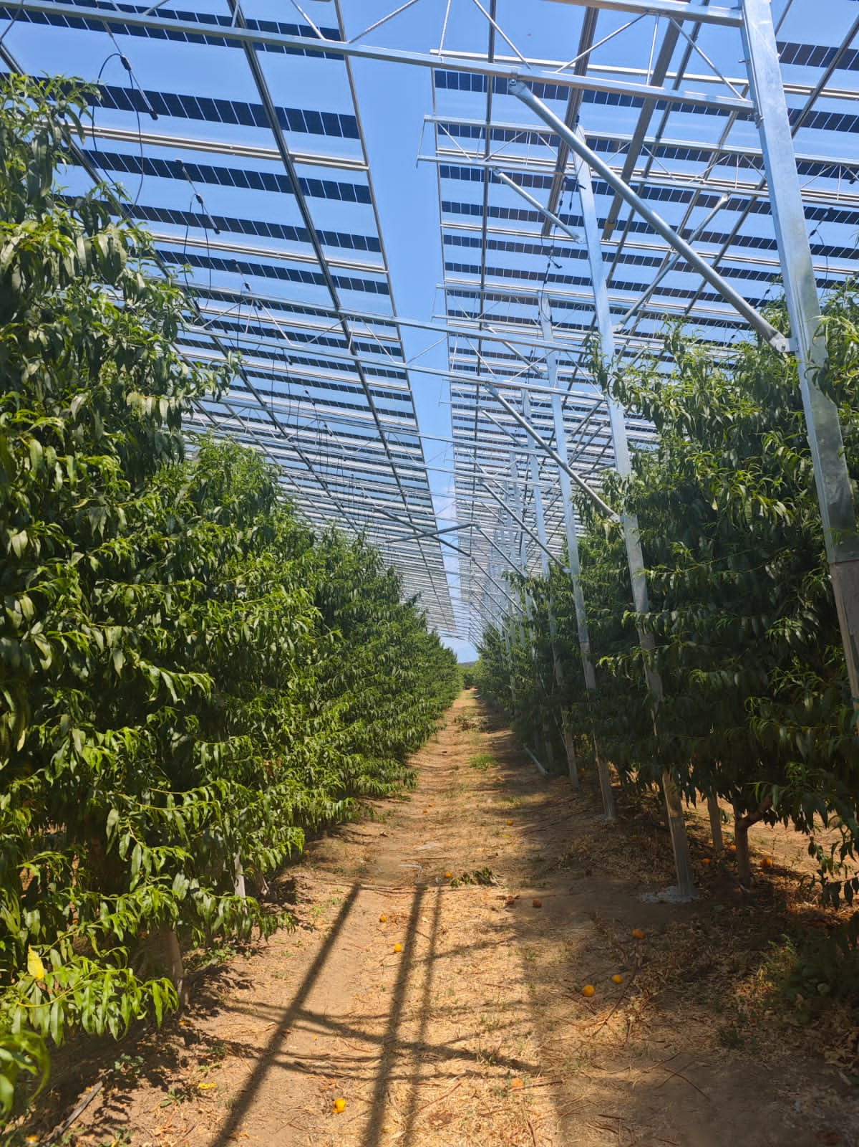
Fig. 10: Pilot installations in Greece with the use of the proposed AgriPV design
Likewise, the two pictures on the right-hand side illustrate another pilot installation in the area of Kilkis, Greece. The specific AgriPV is installed above a vineyard with an installed power of 50 kW. It is worth mentioning as the main takeaway for the two pilots that the total installation cost is around 700 € kW⁻¹, a strong indication of the technology’s affordability, in line with the foreseen projections for the costs of AgriPVs (Kost et al., 2024).
- Discussion and conclusions
The specific study presents an analysis regarding the potential of the AgriPV technology in rural and peri-urban areas. It is divided into three parts, one assessing the recent developments in the sector, with emphasis on dual use of PVs in the agri-food sector, one presenting a high-level methodological approach in order to properly design an AgriPV project, while the last part of the study refers to specific state-of-the-art designs of AgriPV components (semi-transparent PV modules and specially designed support structures).
The proposed technology combines numerous benefits of different sectors, particularly the energy generation and agri-food production. Despite its novelty and complexity, the feasibility of the proposed technology is evident through the popularity it is gaining as the installed pilots suggest. In parallel, research in the specific area is underway in order to provide more optimized and cost-effective solutions. Therefore, the specific technology’s potential is not only limited to farming but it may have application in other areas as well. The example of biodiversity preservation mentioned in the introduction (Walston et al., 2022) is a case in point. In addition, similar designs could potentially be used in peri-urban areas for the combined use of farming and landscape preservation. Furthermore, the development of new products such as semi-transparent PV modules with selective nano-coating and other state-of-the-art characteristics could play a crucial role in other application areas such as in BIPV, where similar requirements for transparency and microclimate creation are expected.
In the analysis for the design of an AgriPV project, the analysis shows that a diversity of aspects and parameters should be taken into account including regulatory, market, financial, societal, and technological aspects. All of these should be assessed during the initial and design stages in order to produce an optimized result. Usually, the analysis requires the use of software tools for calculations. Among different options, the present study proposes the use of open-source tools, which enable better understanding and knowledge transfer for back-of-the-envelope estimations, and, combined with more specialized tools, could produce optimal results. The selection of appropriate KPIs plays an important role, which help in quantifying the design in terms of target values.
Lastly, specific technological designs were presented in the form of state-of-the-art semi-transparent PV modules and support structures. The presented components and implementation uniquely expand theoretical designs and have already become commercial value with selected pilots showcasing their feasibility in terms of installation, operation, and cost.
- Acknowledgement
The SolarHub project (Grant Agreement No. 101086110) has been funded by the European Union under the HORIZON-WIDERA-EXCELLENCE HUBS Programme to support widening excellence. This work is based on the R&I activities for AgriPV design carried out under the SolarHub project.
- References
Akitsua T. K., Nasahara K. N., Ijima O., Hirose Y., Ide R., Takagi K., Kume A., 2022. The variability and seasonality in the ratio of photosynthetically active radiation to solar radiation: A simple empirical model of the ratio. International Journal of Applied Earth Observations and Geoinformation. 108, (https://doi.org/10.1016/j.jag.2022.102724)
Benedetti, M., Vecchi, V., Barera, S., Dall’Osto, L., 2018. Biomass from microalgae: The potential of domestication towards sustainable biofactories. Microbial Cell Factories, 17. (https://doi.org/10.1186/s12934-018-1019-3)
Chatzipanagi, A., Taylor, N., Jaeger-Waldau, A., 2023. Overview of the Potential and Challenges for Agri-Photovoltaics in the European Union, Joint Research Centre, Luxemburg. (https://doi.org/10.2760/208702)
European Commission, 2018. DIRECTIVE (EU) 2018/2001 OF THE EUROPEAN PARLIAMENT AND OF THE COUNCIL of 11 December 2018 on the promotion of the use of energy from renewable sources, Official Journal of the European Union.
European Commission: Directorate-General for Climate Action, 2019. Going climate-neutral by 2050 – A strategic long-term vision for a prosperous, modern, competitive and climate-neutral EU economy, Publications Office. (https://data.europa.eu/doi/10.2834/02074)
European Commission, 2020. Stepping up Europe’s 2030 climate ambition, Investing in a climate-neutral future for the benefit of our people, Brussels.
Fernandez-Solas, A., Fernandez-Ocana, A. M., Almonacid, F., Fernandez, E. F., 2023. Potential of agrivoltaics systems into olive groves in the Mediterranean region. Elsevier, Applied Energy. 352. (https://doi.org/10.1016/j.apenergy.2023.121988)
Foroutanfar, F., Tejedor, B., Casals, M., 2025. Rethinking BIPVs: Evaluating the thermal trade-offs of building-integrated photovoltaics. Elsevier, Energy & Buildings. 348. (https://doi.org/10.1016/j.enbuild.2025.116451)
Ghosh, A., 2023. Nexus between agriculture and photovoltaics (agrivoltaics, agriphotovoltaics) for sustainable development goal: A review. Elsevier, Solar Energy. 266. (https://doi.org/10.1016/j.solener.2023.112146)
Greer. D. H., Weedon M. M., 2012. Modelling photosynthetic responses to temperature of grapevine (Vitis vinifera cv. Semillon) leaves on vines grown in a hot climate. Plant, Cell and Environment. 35, 1050–1064, (https://doi.org/10.1111/j.1365-3040.2011.02471.x)
Hatziargyriou N., et al., 2014. Microgrids-Architectures and Control, John Wiley and Sons Ltd., West Sussex, UK.
Iqbal, M., 1983.An introduction to solar radiation, Academic Press Canada, Don Mills, Ontario.
Kost C., et al., 2024. Levelized Cost of Electricity – Renewable Energy Technologies, Fraunhofer ISE, Freiburg. (https://www.ise.fraunhofer.de/en/publications/studies/cost-of-electricity.html)
Losciale P., Chow W. S., Corelli Grappadelli L., 2010. Modulating the light environment with the peach ‘asymmetric orchard’: effects on gas exchange performances, photoprotection, and photoinhibition. Journal of Experimental Botany. 61, 1177–1192.
Lu, S.M., Zainali, S., Stridh, B., Avelin, A., Amaducci, S., Colauzzi, M., Campana, P. E., 2022. Photosynthetically active radiation decomposition models for agrivoltaic systems applications. Elsevier, Solar Energy. 244, 536–549. https://doi.org/10.1016/j.solener.2022.05.046.
Mehta, K., Zörner, W., 2025. Optimizing Agri-PV System: Systematic Methodology to Assess Key Design Parameters. MDPI Energies. 18, 3877. (https://doi.org/10.3390/en18143877)
Rikos, E., Nikoletatos, J., Kanopoulos, N., Kuzyaka, D., Theodoulidis, S., 2024. Systematic Design Approach Towards Optimizing Agri-PV Systems in Tree Crops: The Case of SolarHub. IEEE, SyNERGY MED 2024. Limassol, Cyprus. (https://doi.org/10.1109/SyNERGYMED62435.2024.10799489)
Trela, M., Dubel, A., 2022. Net-Metering vs. Net-Billing from the Investors Perspective—Impacts of Changes in RES Financing in Poland on the Profitability of a Joint Photovoltaic Panels and Heat Pump System. MDPI Energies. 15, 227. (https://doi.org/10.3390/en15010227)
Τrommsdorff Μ., et al., 2024. Agrivoltaics: Opportunities for Agriculture and the Energy Transition- A Guideline for Germany, Fraunhofer ISE, Freiburg. (https://www.ise.fraunhofer.de/en/publications/studies/agrivoltaics-opportunities-for-agriculture-and-the-energy-transition.html)
Walston, L. J., Barley, T., Bhandari, I., Campbell, B., McCall, J., Hartmann, H. M., Dolezal, A. G., 2022. Opportunities for agrivoltaic systems to achieve synergistic food-energy-environmental needs and address sustainability goals. Frontiers in Sustainable Food Systems, 6. (https://doi.org/10.3389/fsufs.2022.932018)
Widmer, J., Christ, B., Grenz, J., Norgrove, L., 2024. Agrivoltaics, a promising new tool for electricity and food production: A systematic review. Elsevier, Renewable and Sustainable Energy Reviews. 192. (https://doi.org/10.1016/j.rser.2023.114277)
Zainali, S., et al., 2025. Modelling, simulation, and optimisation of agrivoltaic systems: a comprehensive review. Elsevier, Applied Energy. 386. (https://doi.org/10.1016/j.apenergy.2025.125558)

