EuroSun2026
Solar Heat for Industrial Processes in Canada: Characterizing industrial heat demand

Isabelle Kosteniuk, Lucio Mesquita
Natural Resources Canada
isabelle.kosteniuk@nrcan-rncan.gc.ca, lucio.mesquita@nrcan-rncan.gc.ca

Summary
To assess the opportunity for solar and renewable heat in the industrial sector in Canada, this study characterizes the temperature levels used in Canadian light manufacturing from publicly available data, and identifies data gaps and limitations for Canadian facilities. A temperature profile of the manufacturing sector is created by estimating energy use at the facility level based on the Canadian Greenhouse Gas Reporting Program database, then applying temperatures and end-uses according to 6-digit NAICS classification based on U.S. data sources. Based on these assumptions, light manufacturing sectors are calculated to consume 81.7% of total energy for boiler, cogeneration, or process heat end-uses. Calculations estimate that 155 PJ or 19% of heat use is below 100 °C and 70% is below 300 °C, and therefore the theoretical potential for solar thermal in the light manufacturing sector is estimated to be 325 PJ. The technical potential for conventional solar thermal to meet loads at temperatures under 100 °C is 10.6 PJ or 2.3% of light manufacturing heat use assuming a solar fraction of 30%. For demands beneath 300 °C, this value is 39 PJ, equal to 6.8% of light manufacturing total energy use or 3.7% of all manufacturing total energy use. Using a more ambitious solar fraction of 70%, this value increases to 91 PJ or 8.5% of all manufacturing total energy use. While there is uncertainty implicit in these calculations due to the use of non-Canadian data sources, these figures represent a high-level estimate of low- and medium-temperature heat demand in Canadian industrial subsectors.
Solar thermal, Industrial decarbonization, Industrial process heat, Solar thermal for industrial processes
Field of application for the findings: Industrial decarbonization, renewable heat deployment, industrial energy planning, and energy policy development
Addressed audience: Policymakers, industrial decarbonization stakeholders, researchers in solar thermal for industrial processes
- Introducton and Background
Canada’s three main climate policy frameworks all explicitly target industrial decarbonization as a crucial component of achieving greenhouse gas (GHG) emission reduction goals, (Department of Justice Canada, 2016, 2023; Environment and Climate Change Canada, 2022a), while industrial energy use in Canada has grown from 3,167 PJ in 2000 to 3,829 PJ in 2019, with GHG emissions expected to continue rising. The manufacturing sector is responsible for 41.1% of total industrial GHG emissions and 56.4% of energy use equaling 2,191 PJ. National estimates find that meeting net-zero by 2050 will require Canadian electricity production to grow anywhere from 47% to over double the current capacity (Canadian Climate Institute, 2021; CanREA, 2021). While heavy industies such as Iron and Steel or Aluminium production consume the largest share of energy, requiring extremely high temperature inputs, there is noteworthy opportunity in light manufacturing sectors to improve energy efficiency and reduce fossil fuel usage. Solar thermal is a mature technology, proven to provide emissions-free, reliable heat to industrial consumers and reduce reliance on natural gas and other fossil fuels while at the same time mitigating pressure on the electricity system from increased loads. The heterogenous nature of industrial loads poses a challenge to matching low-carbon heating technologies like solar thermal, which are often dependent on the temperature and timing of loads, to applications.
To identify opportunities to employ solar and renewable heat including thermal energy storage and heat pumps to decarbonize light industrial energy use in Canada, this study used publicly available data to characterize the quantity and temperature level of thermal demands across Canadian manufacturing subsectors. The existing body of knowledge on Canadian industrial decarbonization focuses largely on heavy industry and often higher temperature applications. This study seeks to address the opportunity specifically for lower temperature applications suitable for solar thermal technologies. To generate a temperature profile of light manufacturing energy use in Canada, this work estimates heat use for facilities in the Canadian Greenhouse Gas Reporting Program database (GHGRP) (Environment and Climate Change Canada, 2022b) by applying information on temperature levels and process heat use from datasets published by the National Renewable Energy Laboratory (NREL) (McMillan and Ruth, 2019). The energy loads are then analyzed in a Canadian context considering regional variation and provincial energy prices.
National studies on industrial heat characterization and SHIP
National studies of the opportunity for solar heat for industrial processes have been conducted in many countries over the past two decades. The objective of these assessments is to characterize and quantify industrial heat loads for a wide range of jurisdictions and industrial sectors, separating the loads into temperature ranges to identify opportunities to employ solar and renewable heat. A 2002 project in Spain estimated that some sectors have low-temperature heat requirements in the range of 60% of total thermal energy use (Schweiger et al., 2002). A study of solar thermal for industrial processes in Germany (Lauterbach et al., 2012a) selected 11 sectors and analyzed their heating loads, considering loads under 300 °C appropriate for integration of solar thermal and found the theoretical potential to be 482 PJ per year. In the U.S., McMillan et al (McMillan et al., 2021, 2016) used publicly available GHG reporting data to conduct a facility-level analysis of heat demand in 14 industrial subsectors to identify key opportunities for decarbonizing industrial loads with renewable and low-carbon technologies. The study estimated SHIP could supply up to 1,480 PJ per year to 8 key sectors.
A vast amount of research in Canada has focused on industrial decarbonization pathways (Bergero et al., 2022; Clark et al., 2024; Joyo et al., 2025) but there are limited Canadian examples of low-temperature industrial heat characterization. One 1973 study considered paper, metals, and chemical industry sectors (Rogers et al., 1976), though the available industrial energy use data at that time was more limited than the currently available data. CanmetENERGY-Varennes of Natural Resources Canada conducted a bottom-up energy analysis of three sectors - Pulp & Paper, Petroleum Refining, and Food & Beverage - to assess the potential for high temperature heat pump integration (Rand et al., 2025). The study estimated the potential to reduce fossil fuel energy consumption by 148.1 PJ for the three sectors.
- Methodology - Assessing industrial heat demand in Canada
Data sources
To characterize light industrial heat use in Canada, this assessment used publicly available facility-level GHG emissions and assumed requirements for fuel mix and process temperatures based on analysis performed by NREL using technical process information and national U.S-based survey data. Three main data sources were used: The Canadian Greenhouse Gas Reporting Program (GHGRP) Database (Environment and Climate Change Canada, 2022b), NREL’s Manufacturing Thermal Energy Use in 2014 – Manufacturing Energy by Temperature and End Use (McMillan, 2019), and Canadian National Energy Use Database (NEUD) tables (“National Energy Use Database,” 2004).
Canada collects industrial energy use statistics at the national level through the Industrial Consumption of Energy (ICE) Survey, which is aggregated and published via the NEUD. The ICE survey collects information on fuel consumption at the facility level and amount consumed for energy or non-energy use, but does not collect detailed end-use information or temperature levels. Any facility producing over 10 kt of CO₂eq emissions per year is mandated to report to the GHGRP, representing 64% of Canada’s industrial sector emissions. No end-use or fuel type data is reported in the GHGRP. The NEUD reports on energy use, fuel mix, and GHG emissions by aggregated and disaggregated industrial subsectors at the national level. Emissions figures only represent energy end-use related GHG emissions, while the GHGRP database contains all GHG emissions and are not separated by end-use, i.e. it does not distinguish between energy and process-related emissions. For this reason, some industries that involve process-related emissions such as Industrial Gas Manufacturing and Fertilizer Manufacturing are overrepresented in the GHGRP compared to the NEUD. Conversely, as only facilities with emissions greater than 10 kt CO_{2eq} annually are mandated to report to the GHGRP, emissions of certain subsectors are underrepresented in the GHGRP database such as Food and Beverage, which is dominated by small to medium size businesses and producers, with 92% of all establishments having fewer than 100 employees (Agriculture Canada, 2009). The current study reports mainly on the estimates using the GHGRP database, with an adjustment factor applied to account for the variance compared to the more comprehensive NEUD values.
The U.S. Manufacturing Energy Consumption Survey (MECS) collects and publishes data on manufacturing energy use by end-use and fuel type, but not on temperature level. The estimated end-use percent consumption is collected for selected energy sources and for this reason contains inherent uncertainty due to the potential of reported data from facilities that do not explicitly measure energy flows to each piece of end-use equipment. NREL has released the Manufacturing Energy by Temperature and End Use dataset which provides estimates of these data points on a facility level, categorized according to end-use types defined in the U.S. MECS. The data is built off earlier estimates of industrial energy use first calculated at the facility and end-use levels for many of the largest energy-using industries (McMillan and Narwade, 2018). For the current study, only the following heat related end-uses are considered: Conventional Boiler Use, CHP and/or Cogeneration Process, and Process Heating.
Data analysis
For each subsector within the Canadian light manufacturing sector, this study estimated the amount of energy used for heat end-uses according to temperature, based on facility-level GHG reporting data from the GHGRP. A straightforward methodology was employed that converts the reported CO₂ emissions into energy usage by applying emissions factors according to fuel mix (Canada, 2023; U.S. Environmental Protection Agency, 2024) for the associated sector based on NREL data. NREL data on temperature levels and end-uses is then applied to each facility based on 6-digit NAICS code.
$E_{facility}=\sum{\frac{{GHG}_{fuel}}{{EF}_{fuel}}}$ (eq. 1)
The total energy used by a facility includes all end-uses: Indirect, Direct – Process and Direct – non-process (eq. 2). For the purposes of this study, the heat use at a facility includes only Indirect (Conventional Boiler Use, CHP and/or Cogeneration Process) and Direct (Process Heating), as described by eq. 3. Direct – non-process includes space heating, which is not considered in this analysis. The facility heat use is broken down into three temperature levels: less than 100 °C, between 100 °C and 300 °C, and above 300 °C (eq. 4).
$E_{facility}= E_{Indirect}+ E_{Direct, Process}+ E_{Direct,Non-Process}$ (eq. 2)
$E_{heat }= E_{Indirect}+ E_{Direct, Process, Process Heat}$ (eq. 3)
$E_{<100 }+ E_{100-300}+ E_{>300}=E_{heat }$ (eq. 4)
For each facility, NREL fuel mix information for the corresponding 6-digit NAICS subsector was used to determine the fraction of GHG emissions by each fuel source, $R_{fuel}$ (eq. 5). The fuel types included are: coal, coke and breeze, diesel, liquified petroleum gas/natural gas liquids, natural gas, electricity, other, and residual fuel oil.
${GHG}_{facility}= \sum{R_{fuel }{GHG}_{facility}}$ (eq. 5)
For each subsector, the fraction of total energy usage that is related to process heat end-uses, $R_{heat}$, including Conventional Boiler Use, CHP and/or Cogeneration Process, and Process Heating is calculated as:
$R_{heat}= \frac{E_{heat}}{E_{facility}}$ (eq. 6)
R_{heat} is the sum of the fractions of process heat end-uses broken down by temperature levels:
- less than 100 °C: $R_{<100°C}$
- between 100°C and 300°C: $R_{100-300°C}$
- over 300°C: $R_{>300°C}$
These ratios were then applied to facility-level GHG data as in eq. 1 to determine the overall energy use of the facility. Heat related energy use was determined using eq. 6 and finally the breakdown by temperature level was determined by eq. 4. The facility-level data is then aggregated by NAICS code to provide findings at the subsector and sector level.
There are several key assumptions required to implement this approach:
- Given the lack of publicly available data for Canadian sources, this analysis relies on estimates of temperature and end-use from U.S. sources. Energy from different end-uses and fuel mixes are assumed to be equal for each Canadian NAICS to the corresponding U.S. NAICS facilities.
- Temperature levels from the NREL data source are largely based on 1980 source which may not reflect energy saving measures from recent decades.
- The GHGRP reporting facilities are assumed to be representative of Canadian industrial energy use at large, however, using the GHGRP excludes small facilities with emissions under 10 kt CO2, excluding a large fraction of facilities in subsectors like Food and Beverage. To provide insight into the uncertainty introduced by using this data source, a comparison was performed using a factor, $F_{NEUD}$ (eq 7), applied to the facility level CO₂ emissions. For certain subsectors that are included in the GHGRP but not explicitly in any of the NEUD categories, a value of 1 is used.
$F_{NEUD}= \frac{{CO}_{2,NEUD}}{{CO}_{2,GHGRP}}$ (eq. 7)
- Results and Discussion
The industrial sector is divided into four subsectors: Manufacturing, Mining, Construction, and Agriculture, with this study focused mainly on Manufacturing. This analysis focuses on “light industrial” or “light manufacturing” which in this case excludes Cement, Lime, Glass, and Primary Metals. The subsectors in scope are: Food & Beverage, Chemical, Petroleum and Petrochemical, and Pulp & Paper. Indirect energy use (Boilers and CHP) and Direct energy use (Process heat) are considered in the analysis, while other end-uses (space heating and HVAC, facility lighting, onsite transportation, electricity generation, and other non-process end uses) are excluded.
In 2019, the NEUD reported that for all end-uses, industrial sectors used a total of 3,777.6 PJ, and 56% of this, or 2,133.7 PJ, was used in manufacturing sectors. Comparatively, for manufacturing, the total energy use calculated from GHGRP data is 1,841 PJ, about 49.8% of the NEUD value. Looking at only light manufacturing sectors, the annual energy consumption for all end-uses is 568 PJ.

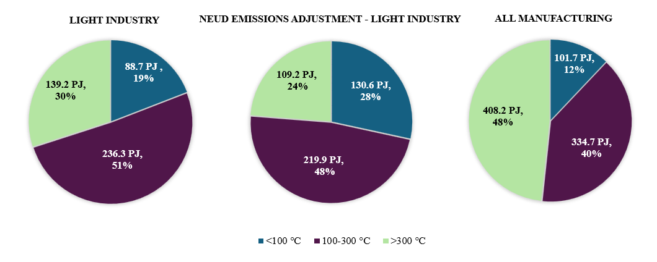

Figure 1: Energy use for heat-related processes by temperature level in (left) Light industrial sectors (middle) Light industrial sectors with NEUD emissions adjustment and (right) All Manufacturing sectors in Canada
Considering only heat-related end-uses, Figure 1 illustrates the estimate of temperatures for the manufacturing sector. All manufacturing uses 844.6 PJ for heat-related end uses, 79.5% of total energy. This figure is approximately equal to the total energy used for space heating in all residential buildings across Canada. Light manufacturing uses 464.2 PJ, or 81.7% of total use for heat. With adjustment factor $F_{NEUD}$ applied to each facility to normalize the GHG emissions against the total values reported in the NEUD, the total light industrial energy use decreases slightly to 459.7 PJ. This is caused by the inclusion of industries like Fertilizer manufacturing which have high non-energy related emissions reported in the GHGRP database. A total of 101.7 PJ of manufacturing heat use is less than 100 °C, including all sectors. For light manufacturing, this figure is 88.7 PJ. This represents 19% of the light industrial sector’s heat needs, which would be suitable for conventional solar thermal technologies including flat plate and evacuated tube collectors, or commercially available industrial heat pumps. Heat at temperatures between 100-300°C represents the largest need for light manufacturing, 48% of total heat use or 236.3 PJ. Higher temperature solar collectors such as concentrating collectors could feasibly meet a portion of these demands, especially when integrated with high temperature thermal storage to increase solar fractions. Steam generating heat pumps could also be employed for loads up to 300°C in cases where waste heat is available from higher temperature processes to supply source energy.(Klute et al., 2024)
Figure 2 shows the breakdown of energy use by temperature level for five manufacturing subsectors. The largest energy consuming sectors, Petroleum Manufacturing, and Chemical, have large absolute heat use at low temperatures, but fractionally less low temperature than medium or high temperature use. Petroleum Refineries specifically use 21 PJ of low temperature energy, with 148.95 PJ of energy use between 100 and 300 °C, and 67.58 PJ over 300 °C. Processes utilized in petroleum refining and chemical manufacturing require temperatures which are generally not achievable by conventional solar thermal and heat pumps, but may be feasible for other renewable heat sources like biomass or small modular reactors. Chemical and Petroleum Manufacturing sectors therefore could be good candidates for energy efficiency measures or the use of steam generating industrial heat pumps, given the potential for recapturing waste heat from higher temperature processes. Conversely, Pulp & paper and Food & Beverage have higher shares of low temperature heat use. The final calculated values for energy consumption for each 6-digit NAICS code broken down by temperature level are provided in Appendix A.

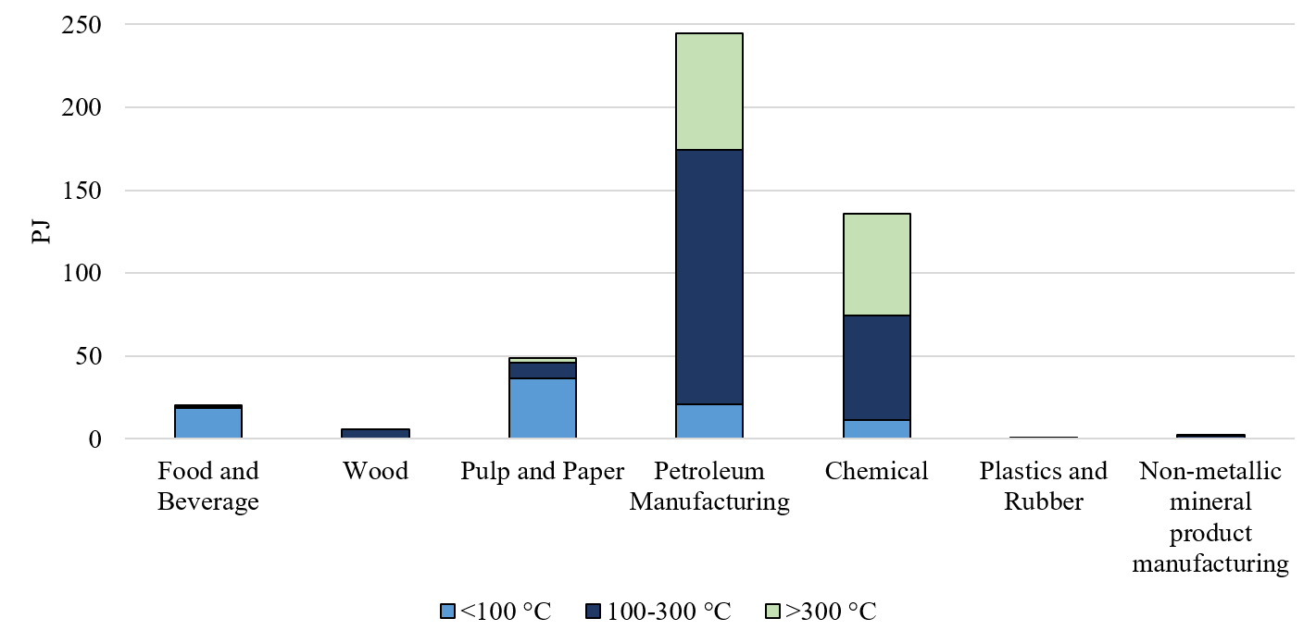
Figure 2: Energy use by temperature level for light industrial sectors in Canada
Figure 3 shows the geographic distribution of low temperature energy use below 100 °C in the light manufacturing sector in Canada. The maps show that most of the facilities use between 0.00 and 1.00 PJ of low temperature heat. Industrial activity is largely centered in populous areas with good solar resource, such as southern Ontario and Alberta, though significant activity takes place in more northern regions of Alberta, specifically in the Petroleum Refining and Manufacturing subsectors, and British Columbia mainly in Pulp & Paper and related subsectors. Figure 4 illustrates the impact the NEUD adjustment factor has on the total low temperature energy use in Food Manufacturing subsectors. Frozen Food, Dairy, and Meat subsectors have significantly more low-temperature energy use, with Butter, Cheese, and Dry and Condensed Dairy Products Manufacturing increasing from 2.85 PJ to 8.55 PJ. It is noted that Oilseed Manufacturing, Sugar, and Distilleries are all equivalent in both scenarios, as these subsectors are not explicitly represented in the NEUD data tables.
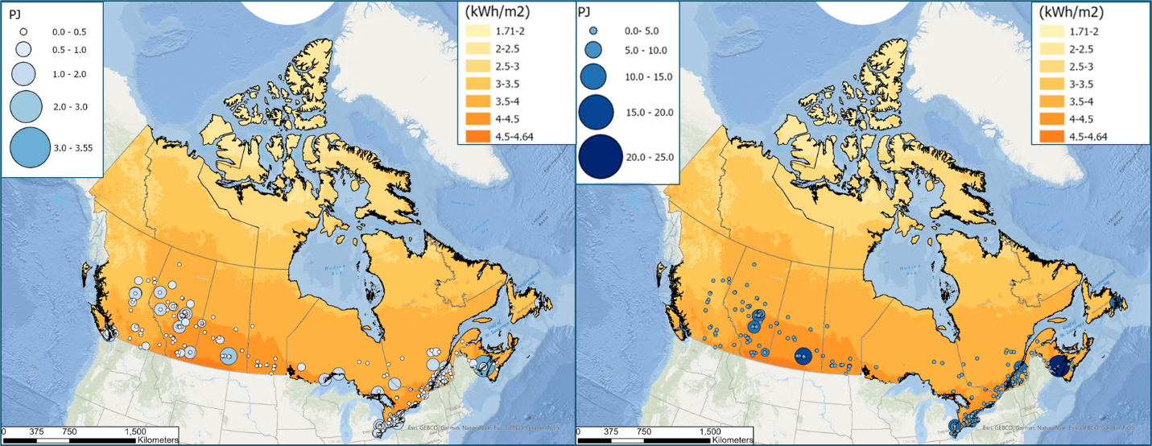
Figure 3: 2019 Energy Use in Canadian light industrial sector <100°C (top) 100-300°C (bottom) with daily average solar insolation on a fixed tilted surface of 0° relative to the horizontal plane

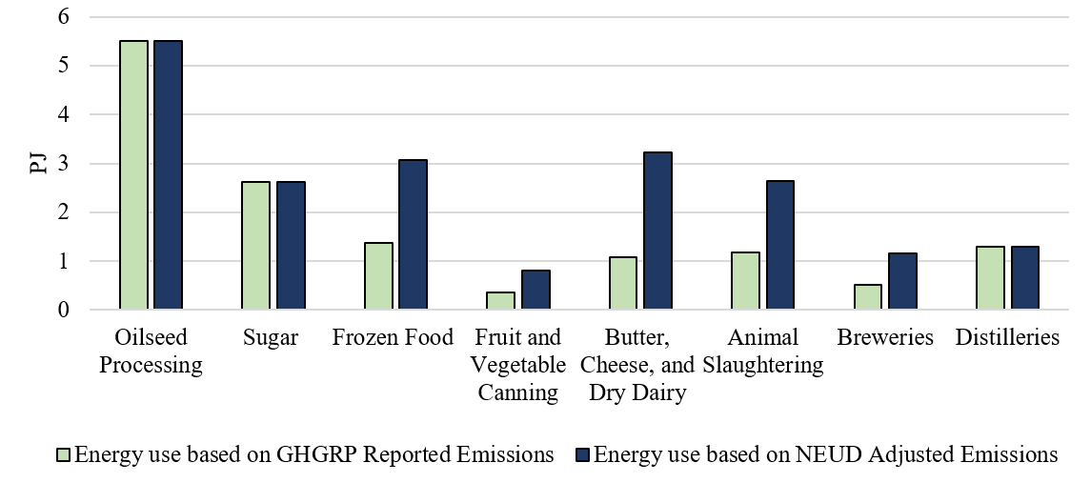
Figure 4: Low temperature energy use in Food and Beverage Manufacturing Subsectors, comparison of GHGRP reported emissions vs. NEUD adjusted emissions
Figure 5 shows the breakdown of process energy use by province and temperature level. Alberta and Ontario are the largest users of process energy, followed by Quebec and British Columbia. British Columbia has the second highest fractional use of low-temperature process energy, with 36% of the total process energy use being under 100 °C. The top user of low-temperature heat proportional to the total provincial process energy use is Prince Edward Island with 100%, though only a single facility, a frozen food manufacturer, is included in the GHGRP. No facilities in the GHGRP are in Nunavut, the Northwest Territories, nor the Yukon.
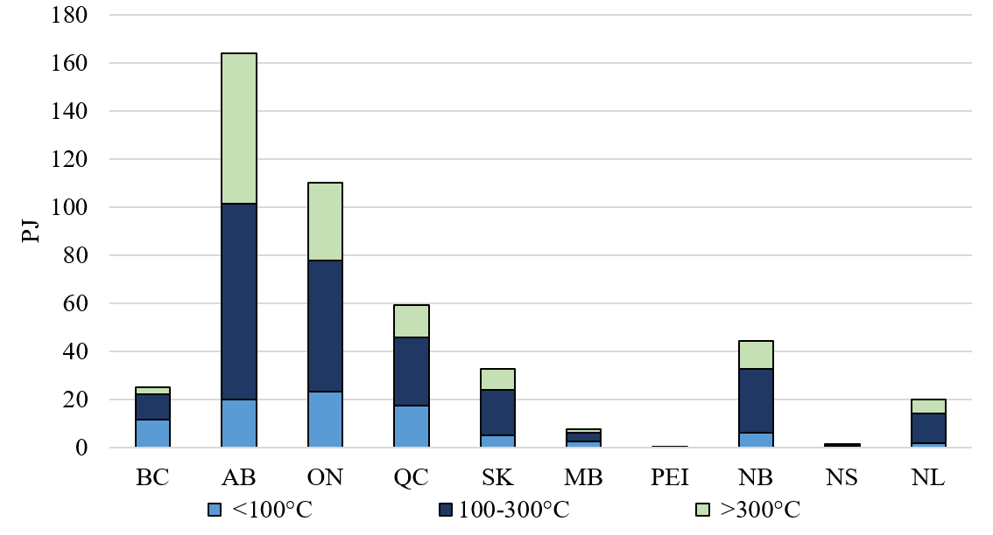
Figure 5: Energy use by temperature level in all Canadian provinces
Energy costs are highly variable throughout Canada, and the feasibility of electrifying industrial heat loads will depend largely on the ratio of electricity costs to other fuel costs, especially natural gas. Table 3 lists provincial energy costs, with a median national natural gas cost of 1.18 ¢/kWh and 9.57 ¢/kWh for electricity. Electricity prices for each province are based off of Hydro-Quebec 2024 figures for large consumers in major North American cities (Comparison of Electricity Prices in Major North American Cities, 2024). Costs for industrial consumers in each province are calculated from 2024 Canadian Monthly Natural Gas distribution tables (Statistics Canada, 2016). No natural gas costs are available for Newfoundland and Labrador, Prince Edward Island, or the territories. The spark gap ratio, defined as the cost ratio of electricity to natural gas, is used as an indicator of the economic viability of electric heating solutions, including heat pumps. The ACEEE states that industrial heat pump projects are likely to advance in jurisdictions with spark gap ratios below 3-4 (American Council for an Energy-Efficient Economy, 2025). In Canada, the spark gap ratio ranges from 4.19 in Quebec, a region with abundant hydroelectricity, to 19.14 in Alberta.
Table 3: Summary of light manufacturing heat use and energy costs for large consumers in Canadian provinces.
Province or Territory | Energy use (PJ) |  |  | Share of energy use |  |  | Electricity rate  (¢/kWh) | Natural gas rate  (¢/kWh) | Spark Gap Ratio
Province or Territory | <100°C | 100-300°C | >300°C | <100°C | 100-300°C | >300°C | Electricity rate  (¢/kWh) | Natural gas rate  (¢/kWh) | Spark Gap Ratio
British Columbia | 11.76 | 10.20 | 3.14 | 47% | 41% | 13% | 8.12 | 1.23 | 6.6
Alberta | 19.87 | 81.50 | 62.71 | 12% | 50% | 38% | 10.46 | 0.55 | 19.1
Ontario | 23.19 | 54.71 | 32.39 | 21% | 50% | 29% | 10.90 | 2.07 | 5.3
Quebec | 17.49 | 28.19 | 13.40 | 30% | 48% | 23% | 5.74 | 1.37 | 4.2
Saskatchewan | 4.94 | 18.92 | 8.70 | 15% | 58% | 27% | 9.57 | 1.60 | 6.0
Manitoba | 2.50 | 3.53 | 1.69 | 32% | 46% | 22% | 6.00 | 1.46 | 4.1
Prince Edward Island | 0.40 | 0.00 | 0.00 | 100% | 0% | 0% | N/A | N/A | N/A
New Brunswick | 6.15 | 26.45 | 11.60 | 14% | 60% | 26% | 9.80 | 0.92 | 10.7
Nova Scotia | 0.47 | 0.47 | 0.05 | 48% | 48% | 5% | 12.70 | 1.13 | 11.3
Newfoundland and Labrador | 1.91 | 12.33 | 5.58 | 10% | 62% | 28% | 10.18 | N/A | N/A
Canada | 11.76 | 10.20 | 3.14 | 19% | 51% | 30% | 9.69 | 1.18 | 8.2
Technical potential for Solar Heat for Industrial Processes in Canada
A simple approach is used to determine the technical potential for solar thermal to contribute to industrial decarbonization. The technical potential is calculated as a multiplation product of theoretical potential (all heat use below 300 °C), an assumed available fraction of land/roof space of 40%, and an assumed average solar fraction of 30% (Lauterbach et al., 2012a). This assumed solar fraction considers the variation of heat use over the year. Much higher solar fractions are achievable, but may not be cost-effective, therefore this figure is a conservative estimate of technical potential. This analysis does not explicitly include thermal storage, though diurnal or longer-term thermal storage would likely be required to achieve higher solar fractions. Heat pumps are also not included in this analysis, and would have different factors contributing to their overall potential for deployment, such as electrical infrastructure or waste heat availability. Table 4 lists the technical potential by province for low temperature only and for all processes below 300 °C (i.e. heat use below 100 °C and between 100 °C and 300 °C). For temperatures under 100 °C, the national opportunity is 10.64 PJ or 2.3% of light manufacturing heat use. As a comparison, a higher range estimate is also calculated using a more ambitious solar fraction of 70%, increasing the national potential to 5% of light manufacturing heat use for <100 °C and 20% for <300 °C.
Table 4: Technical potential of Solar Heat for Industrial Processes in Canada by Province assuming enough roof area to meet 40% of loads and a 30% solar fraction. The final row of the table also provides a national estimate assuming a 70% solar fraction.
Province | Technical opportunity <100 °C (PJ) | Share of total light industrial heat use | Technical opportunity <300 °C (PJ) | Share of total light industrial heat use
British Columbia | 1.41 | 6% | 2.64 | 10%
Alberta | 2.38 | 1% | 12.17 | 7%
Ontario | 2.78 | 3% | 9.35 | 8%
Quebec | 2.10 | 4% | 5.48 | 9%
Saskatchewan | 0.59 | 2% | 2.86 | 9%
Manitoba | 0.30 | 4% | 0.72 | 9%
Prince Edward Island | 0.05 | 12% | 0.05 | 12%
New Brunswick | 0.74 | 2% | 3.91 | 9%
Nova Scotia | 0.06 | 6% | 0.11 | 11%
Newfoundland and Labrador | 0.23 | 1% | 1.71 | 9%
Canada (30% Solar Fraction) | 10.64 | 2% | 39.00 | 8%
Canada (70% Solar Fraction) | 24.83 | 5% | 91.00 | 20%
Annually, 39 PJ represents 8% of light manufacturing heat use (as calculated by eq. 3) and 6.8% of light manufacturing total energy use (eq. 2). This represents 3.67% of all manufacturing total energy use as calculated from the GHGRP methodology. Equivalent to 10.83 TWh per year, the estimated opportunity in Canada is comparable to estimates from studies that have been performed in European countries. In Germany, a technical potential of 16 TWh or 3.4% was calculated, and similarly in the EU a potential of 72 TWh or 3.8% of industrial energy use (Lauterbach et al., 2012a; Vajen et al., 2012).
- Conclusion
For each sector within Canadian light manufacturing, this study estimated the amount of energy used for heat end-uses according to temperature levels based on facility-level GHG reporting data from the GHGRP. The targeted end-use categories are limited to process heat, boiler, and cogeneration, eliminating space heating and HVAC, facility lighting, onsite transportation, electricity generation, and other non-process end uses. Data limitations for Canadian industrial energy end-uses and temperature levels necessitate the use of U.S. data, introducing uncertainty into the analysis. This study is intended as a preliminary assessment of the opportunity for solar heat in industrial sectors in Canada, but the accuracy is limited by available information. Data collection from Canadian industrial facilities or modelling of specific subsectors would be beneficial in improving the accuracy of temperature level characterization of process heat demands.
Using the methodology reported in this study, light manufacturing sectors are calculated to consume 568 PJ of energy, of which 81.7% is heat related energy for boiler, cogeneration, or process heat end-uses. Calculations estimate that 155 PJ or 19% of heat use is below 100 °C and 70% is below 300 °C. For temperatures under 100 °C, the technical potential for solar thermal is 10.64 PJ or 2.3% of light manufacturing heat use assuming enough roof area is available to meet 40% of loads and an annual solar fraction of 30%, reflective of existing installations. As a comparison, a higher range estimate is also calculated using a more ambitious solar fraction of 70%, increasing the national potential to 5% of light manufacturing heat use for <100 °C and 20% for <300 °C. Solar fractions in this range are certainly achievable, though they are less cost-effective than systems which target 30% or lower. For this reason, the potential estimates presented here also integrate an element of economic feasibility.
This work finds that significant fractions of heat use in the Canadian manufacturing sector require temperatures achievable by conventional renewable heat technologies. Critically, the limited availability of public data and heterogeneity of industrial processes is a barrier to the implementation of renewable heating. A comprehensive national dataset, analogous to the U.S. dataset developed through the MECS survey, could help to fill this gap. More specific analysis is required on a sector-by-sector basis and at the facility level, but the estimates presented here can provide insight to policymakers on the opportunity for solar thermal in Canadian industry.
- References
Agriculture Canada, 2009. Overview of the Food and Beverage Processing Industry. https://agriculture.canada.ca/en/sector/food-processing-industry/overview-food-beverage (accessed 1.28.25).
American Council for an Energy-Efficient Economy, 2025. Industrial Electrification Across the United States. https://www.aceee.org/industrial-electrification-across-united-states (accessed 6.23.25).
Bergero, C., Binsted, M., Younis, O., Davies, E.G.R., Siddiqui, M.-S., Xing, R., Arbuckle, E.J., Chiappori, D.V., Fuhrman, J., McJeon, H., Macaluso, N., 2022. Technology, technology, technology: An integrated assessment of deep decarbonization pathways for the Canadian oil sands. Energy Strategy Reviews 41, 100804. https://doi.org/10.1016/j.esr.2022.100804
Canadian Climate Institute, 2021. Canada’s Net Zero Future.
CanREA, 2021. CanREA’s 2050 Vision: Powering Canada’s Journey to Net-Zero. CanREA.
Clark, G., Davis, M., Shibani, Kumar, A., 2024. Assessment of fuel switching as a decarbonization strategy in the cement sector. Energy Conversion and Management 312, 118585. https://doi.org/10.1016/j.enconman.2024.118585
Department of Justice Canada, 2023. Canadian Net-Zero Emissions Accountability Act.
Department of Justice Canada, 2016. Pan-Canadian Framework on Clean Growth and Climate Change.
Environment and Climate Change Canada, 2022a. 2030 Emissions Reduction Plan: Clean Air, Strong Economy.
Environment and Climate Change Canada, 2022b. Greenhouse Gas Reporting Program (GHGRP) - Facility Greenhouse Gas (GHG) Data.
Environment and Climate Change Canada, 2023. Emission factors and reference values. https://www.canada.ca/en/environment-climate-change/services/climate-change/pricing-pollution-how-it-will-work/output-based-pricing-system/federal-greenhouse-gas-offset-system/emission-factors-reference-values.html (accessed 6.3.25).
Joyo, F.H., Nastasi, B., Astiaso Garcia, D., 2025. Decarbonization pathways for the pulp and paper industry: A comprehensive review. Renewable and Sustainable Energy Reviews 223, 116070. https://doi.org/10.1016/j.rser.2025.116070
Klute, S., Budt, M., Van Beek, M., Doetsch, C., 2024. Steam generating heat pumps – Overview, classification, economics, and basic modeling principles. Energy Conversion and Management 299, 117882. https://doi.org/10.1016/j.enconman.2023.117882
Lauterbach, C., Schmitt, B., Jordan, U., Vajen, K., 2012a. The potential of solar heat for industrial processes in Germany. Renewable and Sustainable Energy Reviews 16, 5121–5130. https://doi.org/10.1016/j.rser.2012.04.032
Lauterbach, C., Schmitt, B., Jordan, U., Vajen, K., 2012b. The potential of solar heat for industrial processes in Germany. Renewable and Sustainable Energy Reviews 16, 5121–5130. https://doi.org/10.1016/j.rser.2012.04.032
McMillan, C., 2019. Manufacturing Thermal Energy Use in 2014. https://doi.org/10.7799/1570008
McMillan, C., Schoeneberger, C., Zhang, J., Kurup, P., Masanet, E., Margolis, R., Meyers, S., Bannister, M., Rosenlieb, E., Xi, W., 2021. Opportunities for Solar Industrial Process Heat in the United States (No. NREL/TP--6A20-77760, 1762440, MainId:30675). https://doi.org/10.2172/1762440
McMillan, C.A., Boardman, R., McKellar, M., Sabharwall, P., Ruth, M., Bragg-Sitton, S., 2016. Generation and Use of Thermal Energy in the U.S. Industrial Sector and Opportunities to Reduce its Carbon Emissions (No. INL/EXT-16-39680; NREL/TP-6A50-66763). Idaho National Lab. (INL), Idaho Falls, ID (United States); National Renewable Energy Lab. (NREL), Golden, CO (United States). https://doi.org/10.2172/1334495
McMillan, C.A., Narwade, V., 2018. The Industry Energy Tool (IET): Documentation (No. NREL/TP-6A20-71990). National Renewable Energy Lab. (NREL), Golden, CO (United States). https://doi.org/10.2172/1484348
McMillan, C.A., Ruth, M., 2019. Using facility-level emissions data to estimate the technical potential of alternative thermal sources to meet industrial heat demand. Applied Energy 239, 1077–1090. https://doi.org/10.1016/j.apenergy.2019.01.077
National Energy Use Database, 2004.
Rand, C., Bernier, E., Bédard, S., 2025. Opportunities of High Temperature Heat Pump Integration in Various Industrial Subsectors, in: Proceedings of the Canadian Society for Mechanical Engineering International Congress. Presented at the 32nd Annual Conference of the Computational Fluid Dynamics Society of Canada, Montreal.
Rogers, J.T., Gay, B., La Croix, M.J.B., Ophel, I.L., 1976. Industrial use of low-grade heat in Canada.
Schweiger, H., Farinha Mendes, J., João Carvalho, M., 2002. The Potential of Solar Heat for Industrial Processes - POSHIP Final Report.
U.S. Environmental Protection Agency, 2024. Inventory of U.S. Greenhouse Gas Emissions and Sinks: 1990-2022 (Reports and Assessments).
Vajen, K., Lauterbach, C., Schmitt, B., 2012. Solar heat for industrial processes – Potential, technologies and applications, in: Proceedings of the “International Conference on Solar Energy for MENA Region (INCOSOL).”
- Appendix A: Energy use for heat-related end-uses by 6-digit NAICS code

Canadian Facility NAICS Code | English Facility NAICS Code Description | <100 °C (PJ) | 100-300 °C (PJ) | >300 °C (PJ)
311119 | Other Animal Food | 0.81 | 0.06 | 0.00
311214 | Rice Milling and Malt | 0.80 | 0.00 | 0.00
311221 | Wet Corn Milling | 2.11 | 0.70 | 0.00
311224 | Oilseed Processing | 9.18 | 0.26 | 0.00
311310 | Sugar | 3.43 | 0.00 | 0.10
311410 | Frozen Food | 2.75 | 0.00 | 0.00
311420 | Fruit and Vegetable Canning | 0.82 | 0.00 | 0.00
311515 | Butter, Cheese, and Dry Dairy | 2.85 | 0.00 | 0.00
311611 | Animal Slaughtering | 2.19 | 0.00 | 0.00
311614 | Rendering and Meat Processing | 2.27 | 0.00 | 0.00
311615 | Poultry Processing | 0.98 | 0.00 | 0.00
311919 | Other Snack Food | 0.81 | 0.00 | 0.00
311940 | Seasoning and Dressing | 0.29 | 0.00 | 0.00
311990 | All Other Food | 1.70 | 0.00 | 0.00
312120 | Breweries | 1.25 | 0.00 | 0.00
312140 | Distilleries | 2.59 | 0.00 | 0.00
321114 | Wood Preservation | 0.00 | 0.08 | 0.00
321211 | Hardwood Veneer and Plywood Mills | 0.00 | 0.32 | 0.00
321212 | Softwood Veneer and Plywood Mills | 0.00 | 2.21 | 0.00
321216 | Particle Board and Fibreboard Mills | 0.00 | 0.00 | 0.00
321217 | Waferboard Mills | 0.00 | 0.00 | 0.00
322111 | Mechanical Pulp Mills | 45.03 | 0.00 | 3.20
322112 | Chemical Pulp Mills | 45.03 | 0.00 | 3.20
322121 | Paper (except Newsprint) Mills | 11.76 | 2.96 | 1.19
322122 | Newsprint Mills | 3.14 | 0.77 | 0.16
322130 | Paperboard Mills | 9.56 | 2.48 | 0.59
322220 | Paper Bag and Coated and Treated Paper Manufacturing | 0.30 | 0.10 | 0.13
322291 | Sanitary Paper Product Manufacturing | 0.36 | 0.12 | 0.12
322299 | All Other Converted Paper Product Manufacturing | 0.19 | 0.06 | 0.09
324110 | Petroleum Refineries | 26.02 | 184.27 | 83.61
324121 | Asphalt Paving Mixture and Block Manufacturing | 0.00 | 1.27 | 0.00
324122 | Asphalt Shingle and Coating Material Manufacturing | 0.00 | 0.76 | 0.00
324190 | Other Petroleum and Coal Products Manufacturing | 0.00 | 0.00 | 4.76
325110 | Petrochemical Manufacturing | 4.14 | 43.01 | 67.41
325120 | Industrial Gas Manufacturing | 1.55 | 0.52 | 15.05
325181 | Alkali and Chlorine Manufacturing | 4.73 | 0.00 | 2.72
325189 | All Other Basic Inorganic Chemical Manufacturing | 4.73 | 0.00 | 2.72
325190 | Other Basic Organic Chemical Manufacturing | 8.48 | 0.00 | 6.38
325210 | Resin and Synthetic Rubber Manufacturing | 1.08 | 0.00 | 0.00
325220 | Artificial and Synthetic Fibres and Filaments Manufacturing | 0.64 | 0.87 | 0.00
325313 | Chemical Fertilizer (except Potash) Manufacturing | 0.00 | 0.00 | 21.85
325410 | Pharmaceutical and Medicine Manufacturing | 0.00 | 0.00 | 0.00
325510 | Paint and Coating Manufacturing | 0.00 | 0.00 | 0.00
325999 | All Other Miscellaneous Chemical Product Manufacturing | 0.66 | 0.00 | 0.47
326114 | Unsupported Plastic Film and Sheet Manufacturing | 0.00 | 0.00 | 0.00
326130 | Laminated Plastic Plate, Sheet and Shape Manufacturing | 0.00 | 0.33 | 0.00
326140 | Polystyrene Foam Product Manufacturing | 0.00 | 0.22 | 0.00
326210 | Tire Manufacturing | 0.23 | 0.00 | 0.00
327120 | Clay Building Material and Refractory Manufacturing | 0.00 | 0.00 | 0.56
327420 | Gypsum Product Manufacturing | 0.00 | 4.20 | 0.00
327990 | All Other Non-Metallic Mineral Product Manufacturing | 0.13 | 0.00 | 3.92
331210 | Iron and Steel Pipes and Tubes Manufacturing from Purchased Steel | 0.00 | 0.28 | 0.79
331221 | Cold-Rolled Steel Shape Manufacturing | 0.00 | 0.18 | 1.18
331222 | Steel Wire Drawing | 0.00 | 0.30 | 0.48
331317 | Aluminum Rolling, Drawing, Extruding and Alloying | 0.17 | 0.00 | 1.06
331420 | Copper Rolling, Drawing, Extruding and Alloying | 0.00 | 0.02 | 0.66
332611 | Spring (Heavy Gauge) Manufacturing | 0.04 | 0.00 | 0.20
332810 | Coating, Engraving, Heat Treating and Allied Activities | 0.10 | 0.00 | 0.61
333110 | Agricultural Implement Manufacturing | 0.08 | 0.00 | 0.07
333920 | Material Handling Equipment Manufacturing | 0.08 | 0.00 | 0.07
336330 | Motor Vehicle Steering and Suspension Components (except Spring) Manufacturing | 0.06 | 0.00 | 0.11
336350 | Motor Vehicle Transmission and Power Train Parts Manufacturing | 0.20 | 0.00 | 0.35
336390 | Other Motor Vehicle Parts Manufacturing | 0.75 | 0.00 | 1.32
336410 | Aerospace Product and Parts Manufacturing | 0.81 | 0.00 | 0.14
337127 | Institutional Furniture Manufacturing | 0.00 | 0.01 | 0.00
337214 | Office Furniture (except Wood) Manufacturing | 0.00 | 0.06 | 0.00

