EuroSun2026
AGRI-PV BEYOND CROPLAND: A NATIONAL-SCALE SPATIAL SCREENING FRAMEWORK FOR SEMI-ARID AFRICA
Kedar Mehta¹, Florian Betz², Mathias Ehrenwirth^{3*}
¹ Campus Mainburg, Deggendorf Institute of Technology, Mainburg (Germany)
² Institute of Geography and Geology, Chair of Remote Sensing, University of Wuerzburg (Germany)
³ Technische Hochschule Nürnberg Georg Simon Ohm, Institute for Energy and Building, Nürnberg (Germany)
*Corresponding author: mathias.ehrenwirth@th-nuernberg.de
Summary
Agrivoltaics (Agri-PV) can reduce competition between solar-energy infrastructure and agricultural land, yet national evidence for livestock-dominated drylands remains scarce. This study presents a reproducible first-pass screening of relative suitability for grazing-compatible Agri-PV across Namibia. Six spatial criteria, annual global horizontal irradiation (GHI), grazing-compatible land cover, slope, distance to transmission lines, annual rainfall and mean annual temperature, were harmonised to a 0.01° grid and standardised to scores from 1 (least favourable) to 5 (most favourable). The author-defined baseline weights assigned 25% each to GHI and land cover, 15% each to slope and transmission access, and 10% each to rainfall and temperature. Protected areas and slopes above 10° were excluded before aggregation. The retained screening area was approximately 511,945 km². Oshana achieved the highest regional mean (3.88), followed by Khomas (3.86), Hardap (3.81), Erongo (3.77) and Omusati (3.75). Eleven of Namibia’s 14 regions had high mean suitability, while Kavango West (3.24), Kavango East (3.11) and Zambezi (3.03) were moderate. These averages conceal marked differences in retained area and within-region concentration: high or very high cells represented 92.8% of retained land in Khomas and 86.9% in Oshana, but 17.4% in Kavango East and 16.3% in Zambezi. An equal-weight scenario produced a similar regional ordering (Spearman’s ρ = 0.921, p < 0.001), although this single comparison does not remove uncertainty associated with the selected thresholds and weights. The framework identifies strategic search areas rather than construction-ready sites; tenure, grid capacity, water, forage, biodiversity outside formal protection, settlement constraints and community consent require project-level assessment. The contribution is a transparent, updateable national baseline that extends Agri-PV screening from cropland to Namibia’s grazing landscapes.
Keywords: Agri-PV, agrivoltaics, grazing-compatible solar systems, Namibia, livestock farming, spatial suitability, multi-criteria assessment, decentralised energy, rural mini-grids
Field of application for the findings: Regional renewable-energy planning, grazing-compatible Agri-PV development, livestock and rangeland management, decentralised rural electrification, agricultural mini-grids, and climate-resilient land-use planning
Addressed audience: Researchers in agrivoltaics and renewable energy, agricultural and spatial planners, livestock farmers, policymakers, rural-energy developers, utilities, local authorities, and stakeholders involved in sustainable agriculture and decentralised energy systems
- Introduction
Ground-mounted photovoltaic deployment can intensify competition among electricity generation, agriculture, biodiversity conservation and rural livelihoods. Agrivoltaics addresses this tension by deliberately co-locating PV infrastructure and agricultural use. In African settings, its relevance extends beyond land-use efficiency: electricity from Agri-PV can support pumping, refrigeration, processing and local supply, while panel shade and rainwater management may alter crop or livestock microclimates. Such benefits are conditional on design and site context rather than inherent outcomes. Most empirical Agri-PV evidence concerns crops. Evidence from East Africa indicates that partial shading can reduce irrigation demand and, for some crops and seasons, maintain or improve yield while generating electricity; responses nevertheless vary by crop, climate and array design [1,2]. Research on scaling further stresses finance, land rights, technical support, productive electricity use and farmer participation [3]. Evidence for grazing systems is thinner. International reviews identify potential complementarities between solar arrays, vegetation management and livestock shade, but also major gaps concerning forage dynamics, animal behaviour, heat stress, stocking density, safety and long-term rangeland condition [4]. Namibia is a useful case because high solar resources coincide with extensive livestock landscapes, large travel distances and uneven infrastructure. A cropland-only definition would omit much of the agricultural land on which dual-use solar concepts could be relevant. Conversely, a solar-resource map alone cannot represent Agri-PV suitability: a high-irradiation location may be steep, environmentally restricted, incompatible with grazing, or far from a transmission connection. A national assessment therefore requires a transparent combination of energy, land, terrain, climate and infrastructure evidence.
This study addresses three questions: (i) where the selected conditions jointly favour grazing-compatible Agri-PV at the national scale; (ii) how regional outcomes differ in mean suitability, retained area and concentration of high-scoring land; and (iii) how sensitive the regional ordering is to the chosen criterion weights.
- State of the art of Agri-PV in Africa
Agrivoltaic research in Africa is emerging mainly through the water–energy–food nexus. This perspective is particularly relevant because agricultural production, access to electricity and water availability are closely connected in many African regions. Agrivoltaic systems can potentially produce electricity while maintaining agricultural activities on the same land. The electricity generated can also support irrigation, water pumping, refrigeration, crop processing and other productive agricultural activities. However, the actual benefits depend on local climate, agricultural practices, system design and the intended use of the generated electricity. The regional opportunities and limitations identified in the literature are therefore treated here as context-dependent rather than universal outcomes [1,2].
Randle-Boggis et al. [1] outlined the main opportunities and constraints for Agri-PV development in East Africa. Their work identified potential benefits including improved land-use efficiency, renewable electricity production, reduced water demand and protection of agricultural activities from extreme climatic conditions. Subsequent field experiments demonstrated the simultaneous production of crops and electricity under both grid-connected and off-grid Agri-PV configurations [2]. The experiments also examined rainfall collection from PV modules and the use of collected water for irrigation. Some crops benefited from partial shading, particularly during hot and dry periods. Nevertheless, crop responses varied among locations, seasons and crop types. These results show that Agri-PV performance cannot be generalised without considering the local environmental and agricultural conditions.
Evidence from other African regions remains limited. A systematic review of Agri-PV research in West Africa identified potential benefits across the water–energy–food–environment nexus [5]. These benefits included renewable electricity generation, reduced land-use competition, improved water management and possible protection of crops from excessive solar exposure. However, the review also found that much of the available evidence was based on modelling, short-term experiments or results transferred from countries outside Africa. Long-term measurements of agricultural production, PV performance, water consumption, soil conditions and economic viability remain scarce. Existing studies therefore support further investigation of Agri-PV in African drylands but do not justify universal claims about its performance. Socio-institutional conditions are equally important for the successful adoption of Agri-PV. Cinderby et al. [3] found that locally useful energy services, inclusive system design, ownership arrangements, access to finance and long-term technical support strongly influence adoption. The local value of Agri-PV may be greater when electricity is used for productive activities such as pumping, refrigeration, processing or community supply rather than only being exported to the electricity network. Farmers and local communities must also be involved in decisions concerning land use, system ownership and benefit sharing. These social and institutional dimensions cannot be directly represented using national raster datasets. A spatial suitability model can identify areas for further investigation, but it cannot determine community acceptance, land-tenure legitimacy or the fairness of the proposed ownership structure. Most African Agri-PV studies have focused on crop production. Livestock-oriented Agri-PV remains especially under-studied, even though grazing occupies a large proportion of agricultural land in many semi-arid African countries. Grazing animals can contribute to vegetation management beneath PV arrays, potentially reducing the need for mechanical mowing. PV structures may also provide shade and reduce the exposure of livestock to direct solar radiation. However, these possible benefits depend on animal species, stocking density, grazing management, panel height, row spacing, water access and local climatic conditions [4].
The ecological effects of grazing-compatible Agri-PV are also uncertain. Partial shading can change soil temperature, soil moisture, vegetation composition and forage growth. These changes may be beneficial in some dry environments but unfavourable in others. Poorly designed systems could restrict animal movement, reduce usable grazing area or create safety and maintenance problems. Long-term field studies are therefore needed to examine livestock behaviour, animal heat stress, forage quantity and quality, soil conditions, biodiversity and the interaction between grazing management and PV operation.
Namibia is a particularly relevant case for livestock-oriented Agri-PV because extensive grazing represents an important agricultural land use, while the country also has strong solar resources. The large distances between farms, settlements and electricity infrastructure further create potential applications for decentralised electricity generation. Agri-PV could support water pumping, livestock watering, cold storage, agricultural processing and rural mini-grids. At the same time, low rainfall, limited water availability, protected landscapes and uneven transmission-network coverage can restrict development. A national assessment must therefore consider more than solar irradiation. For Namibia, the available field evidence is not yet sufficient to develop a predictive model of livestock or forage performance under PV systems. The present analysis consequently uses land cover, rainfall and temperature as broad screening indicators. The resulting map is described as showing “grazing-compatible suitability” rather than confirmed livestock or agricultural performance. It identifies locations where existing spatial conditions appear comparatively favourable, while claims concerning forage production, livestock welfare or farm income are reserved for future field validation. GIS-based multi-criteria decision analysis is appropriate for this first-stage assessment because it allows different spatial indicators to be transformed to a common suitability scale and combined within a transparent decision framework [6]. However, GIS-MCDA results depend on the selected datasets, scoring thresholds, weights and exclusion rules. Scientific transparency therefore requires each assumption to be reported explicitly. Sensitivity testing is also needed, although comparison with one equal-weight scenario evaluates only one dimension of model uncertainty.
The research gap addressed in this study is therefore both geographical and methodological. Geographically, national evidence on grazing-compatible Agri-PV in Namibia remains limited. Methodologically, existing solar suitability assessments often emphasise irradiation and technical construction conditions without giving equal attention to the continued agricultural function of the land. This study addresses these gaps by combining solar, land-cover, terrain, climate and transmission indicators within a reproducible national GIS–MCDA framework. The approach provides an initial spatial evidence base whose criteria, thresholds and weights can be examined and updated when higher-resolution data and locally validated knowledge become available.
- Materials and methods
A GIS-based multi-criteria decision analysis was applied to produce a national map of relative suitability for grazing-compatible Agri-PV in Namibia. The assessment combined six criteria (c.f. Fig. 1): annual global horizontal irradiation (GHI), land-cover compatibility, terrain slope, distance to the transmission network, annual rainfall and mean annual temperature. Protected areas and terrain with slopes greater than 10° were treated as exclusion zones. The analysis represents national first-stage screening rather than project-level land availability or technical feasibility. Namibia was represented using a regular 0.01° grid extending from 11°E to 26°E and from 29°S to 16°S. All spatial datasets were aligned to this grid and clipped to the national boundary. Continuous datasets, including GHI, rainfall, temperature and elevation, were resampled using bilinear interpolation; nearest-neighbour resampling was used for categorical land cover. Resampling standardised the analysis grid but did not increase the native information content of the coarser source layers. Regional administrative boundaries were then used to calculate area-weighted results for Namibia’s 14 regions.
Annual GHI and mean annual temperature were obtained from the NASA POWER climatology service [7]. For the irradiance-based source layer used in this assessment, annual irradiation was calculated as mean GHI, converting W/m² to kWh/m²/year. Land cover was obtained from the Copernicus Global Land Service 100 m Collection 3 product for epoch 2019 [8]. Grassland and herbaceous cover received the highest compatibility score, followed by cropland, shrubland and bare or sparsely vegetated land. Other land-cover classes received the lowest score. This ordinal classification represents broad compatibility with grazing or agricultural use; it does not measure forage productivity, livestock carrying capacity or legal land availability.
Terrain slope was derived from the USDA Foreign Agricultural Service World Elevation 90 m image service [9]. Flat and gently sloping land received higher scores because they generally present fewer construction and erosion constraints, while cells with slopes greater than 10° were excluded. Annual rainfall was obtained from the USDA FAS Average Annual Rainfall image service [10] and used as a broad climatic indicator relevant to vegetation and grazing. Mean annual temperature was included as a general thermal indicator. Rainfall and temperature were screening proxies rather than direct measurements of water availability, vegetation productivity or livestock heat stress.
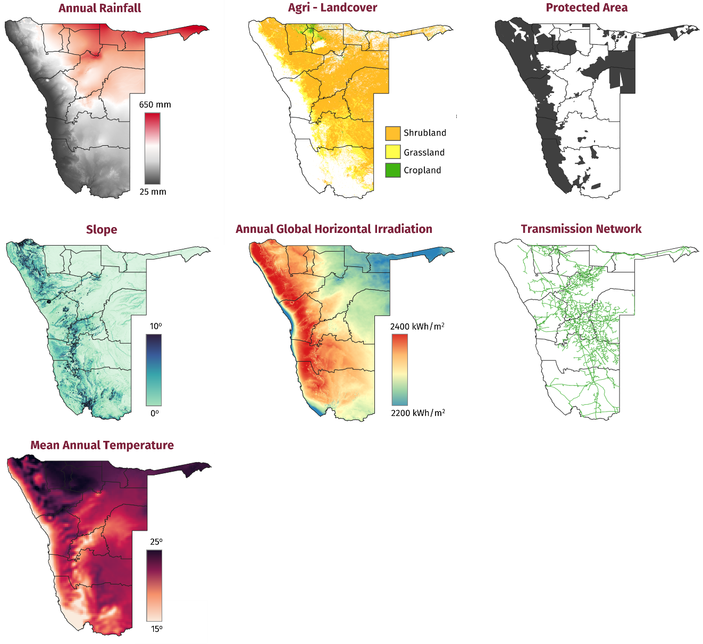
Fig. 1. Spatial input layers used in the national screening
Transmission infrastructure was obtained from the official NamPower GIS data portal [11]. Only power lines with a reported voltage of at least 66 kV were retained. Distance from each grid cell to the nearest retained line was calculated, with shorter distances receiving higher scores. This criterion represents relative network proximity, not substation access, spare grid capacity or connection cost. Protected areas were obtained from the RCMRD Namibia Biodiversity polygon layer, which contains World Database on Protected Areas attributes [12], and were removed before the final suitability index was calculated. Tab. 1 represents the input layers and associated sources.
Tab. 1 Spatial datasets and preprocessing used in the assessment.
Layer | Source/product
Annual GHI | NASA POWER climatology [7]
Land cover | Copernicus Global Land Service LC100 [8]
Slope | USDA FAS World Elevation 90 m image service [9]
Transmission | NamPower official GIS power lines [11]
Rainfall | USDA FAS Average Annual Rainfall [10]
Temperature | NASA POWER climatology (T2M) [7]
Protected areas | RCMRD Namibia Biodiversity layer [12]

All six criteria were transformed to a common scale from 1 to 5, where 1 represents the least favourable condition and 5 the most favourable (c.f. Tab. 2). The thresholds and baseline weights were author-defined screening assumptions rather than empirically calibrated cut-offs. GHI and land-cover compatibility each received 25% because the assessment gives equal emphasis to solar resource and continued agricultural land use. Slope and transmission distance each received 15%, while rainfall and temperature each received 10%. The weights sum to 100%. The lower climatic weights reflect the use of rainfall and temperature as broad proxies rather than direct measures of agricultural performance.
Tab. 2 Author-defined criterion scoring and baseline weights based on the literature review (Higher scores indicate greater relative suitability).
Criterion | Score 1 | Score 2 | Score 3 | Score 4 | Score 5 | Weight
Global horizontal irradiation  (kWh/m²/year) | <1,950 | 1,950–<2,075 | 2,075–<2,200 | 2,200–<2,325 | ≥2,325 | 25%
Land-cover compatibility | Other | Bare or sparse vegetation | Shrubland | Cropland | Grassland or herbaceous cover | 25%
Terrain slope (°) | >8–10 | >6–8 | >4–6 | >2–4 | ≤2 | 15%
Distance to transmission network (km) | >100 | >50–100 | >25–50 | >10–25 | ≤10 | 15%
Annual rainfall  (mm yr⁻¹) | <150 | 150–<275 | 275–<400 | 400–<525 | ≥525 | 10%
Mean annual temperature (°C) | ≥23 | 21–<23 | 19–<21 | 17–<19 | <17 | 10%

For each non-excluded spatial unit x, the overall suitability index was calculated as shown in Eq. 1.
$$S\left(x\right)=0.25C_{GHI\left(x\right)}+0.25C_{LC\left(x\right)}+0.15C_{SL\left(x\right)}+0.15C_{TN\left(x\right)}+0.10C_{RF\left(x\right)}+0.10C_{T\left(x\right)}$$ | Eq. 1
where $C_{GHI\left(x\right)}$, $C_{LC\left(x\right)}$ , $C_{SL\left(x\right)}$ , $C_{TN\left(x\right)}$ , $C_{RF\left(x\right)}$ , and $C_{T\left(x\right)}$ represent the standardised scores for GHI, land cover, slope, transmission access, rainfall, and temperature, respectively.
The index was classified into five categories: very low (1.00–1.80), low (>1.80–2.60), moderate (>2.60–3.40), high (>3.40–4.20) and very high (>4.20–5.00). Area-weighted regional statistics were calculated for retained land in each region, including mean suitability, retained area, retained share and the proportion classified as high or very high. To test one aspect of weight sensitivity, the baseline results were compared with an equal-weight scenario in which each criterion received a one-sixth weight (approximately 16.67%). Similarity between the two regional rankings was evaluated using Spearman’s rank correlation coefficient.
- Results
4.1 National Agri-PV suitability map
The analysis produced a national map of cell-level relative suitability for grazing-compatible Agri-PV in Namibia (Fig. 2). After protected areas and land with slopes greater than 10° were excluded, approximately 511,945 km² remained in the screening. Suitability scores ranged from 1 to 5 and were classified as very low, low, moderate, high or very high. Most retained land fell within the moderate and high classes, whereas very high suitability was more spatially concentrated. High and very high suitability occurred mainly in central, southern and north-central Namibia, reflecting combinations of strong solar irradiation, relatively flat terrain, compatible land cover and proximity to retained transmission lines. Moderate suitability was more prevalent in the north-east. White cells within the national boundary represent land removed by the protected-area or slope exclusions.
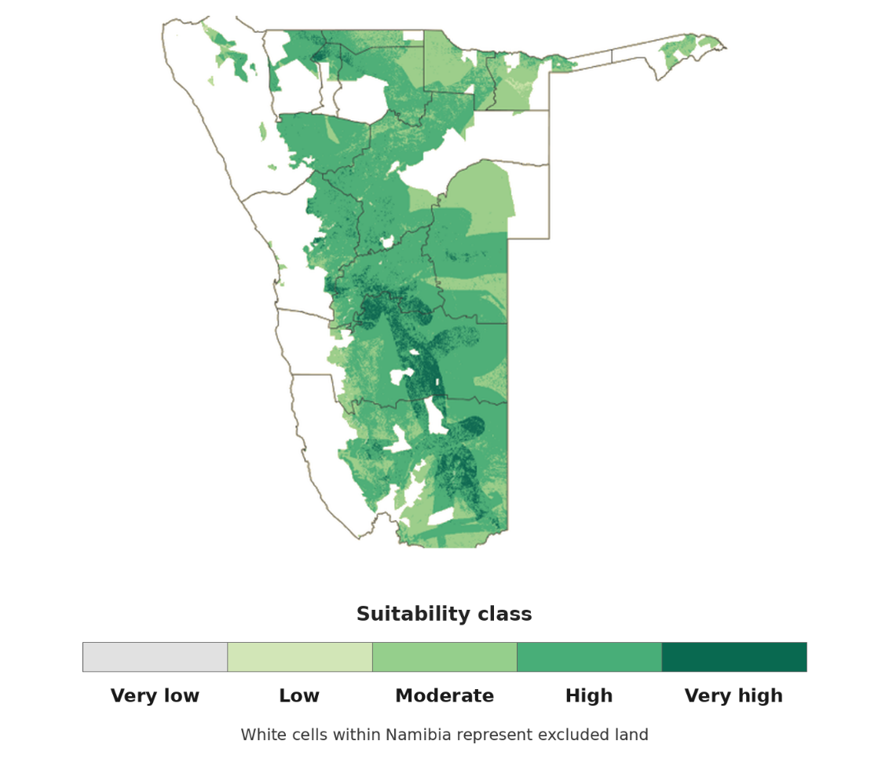
Fig. 2. Cell-level relative suitability for grazing-compatible Agri-PV in Namibia after the exclusion of protected areas and slopes greater than 10°. White cells within the national boundary represent excluded land.
4.2 Regional suitability results
Regional results show a clear separation between regions above and at or below the high-suitability threshold (Fig. 3). Oshana and Khomas have the largest positive margins, whereas Ohangwena and Omaheke lie closest to the class boundary. The north-eastern regions remain below the boundary and form a moderate-suitability cluster. These margins describe proximity to the baseline class threshold; they do not by themselves demonstrate robustness to changes in weights or input data.
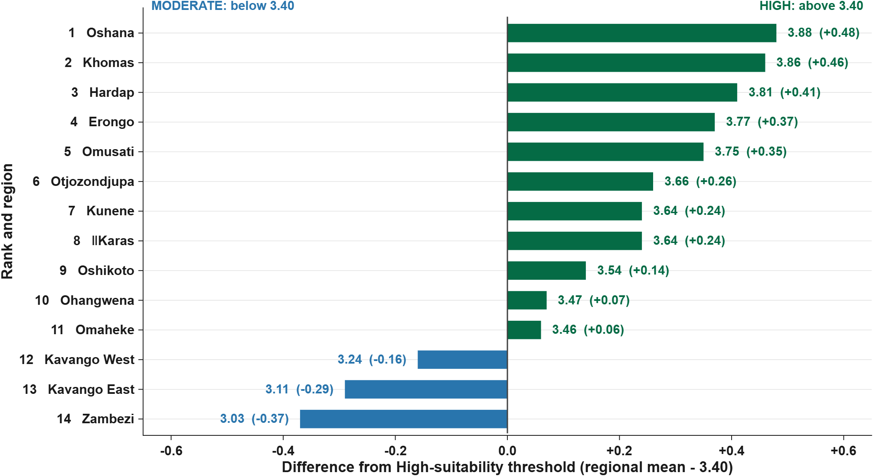
Fig. 3. Regional margins relative to the high-suitability threshold for grazing-compatible Agri-PV in Namibia.

4.3 Extent of retained screening area
The retained screening area differed considerably among regions. ǁKaras had the largest retained screening area, approximately 113,546 km², followed by Hardap (88,034 km²), Omaheke (66,322 km²) and Otjozondjupa (63,096 km²). Khomas combined a high mean score with a retained-land share of approximately 99.4%. Kavango West and Ohangwena also retained more than 85% of their regional areas. In contrast, the retained share was 27.0% in Kunene, 32.6% in Zambezi, 34.4% in Omusati and 38.9% in Erongo. High and very high classes accounted for 96.2% of retained land in Omusati, 92.8% in Khomas, 87.5% in Erongo, 86.9% in Oshana and 86.0% in Hardap, compared with 28.1% in Kavango West, 17.4% in Kavango East and 16.3% in Zambezi. These measures distinguish relative score from spatial extent. The retained area is land that passed the two national exclusion masks; it is not land confirmed as available for construction.
- Discussion
The national assessment produced predominantly high relative suitability under the selected criteria. After applying the protected-area and slope exclusions, approximately 511,945 km² remained in the screening. Eleven of the 14 regions had mean scores above 3.40, while Kavango West, Kavango East and Zambezi remained within the moderate class. The threshold margins shown in Fig. 3 indicate each regional mean’s proximity to the baseline class boundary. Oshana and Khomas lie furthest above the boundary, whereas Ohangwena and Omaheke lie closest to it. Regions close to the boundary could change class under alternative weights, thresholds or input datasets; however, the margins alone do not constitute a formal uncertainty or robustness analysis. These regional classes describe relative model outcomes and should not be interpreted as verified agricultural suitability or investment readiness.
The high regional means resulted from different combinations of criteria. Oshana achieved the highest composite score despite receiving the lowest temperature-criterion score. Its result was supported by a mean slope score of 5.00, together with favourable land cover, transmission access and rainfall scores of 4.05, 4.14 and 3.99, respectively. Khomas followed a different profile, combining a GHI score of 4.74 with favourable terrain at 4.68 and transmission access at 3.75. Hardap and Erongo were supported mainly by strong solar-resource scores of 5.00 and 4.96 and terrain scores above 4.70, while their rainfall scores were considerably lower at 1.93 and 2.11. These contrasts demonstrate that an identical composite class can arise from different underlying conditions. High suitability in Hardap and Erongo therefore reflects favourable solar and construction conditions, but does not confirm adequate water or forage availability for grazing-compatible development.
The criterion profiles also illustrate an important property of the weighted linear combination. Assigning equal baseline weights to GHI and land-cover compatibility reduces the possibility that solar irradiation alone determines the result. However, the additive model still permits a low value in one criterion to be compensated by higher values in others. Oshana’s low temperature score and the low rainfall scores in Hardap and Erongo did not prevent these regions from obtaining high composite means. The resulting index should therefore be interpreted as an overall balance among the selected criteria rather than evidence that every relevant condition is favourable. Project-level assessment must separately verify water availability, forage productivity, livestock requirements and other factors that may not be safely compensated.
Regional mean suitability must also be interpreted together with the spatial extent retained after the exclusions. Oshana achieved the highest mean, but approximately 3,883 km², corresponding to 45.9% of its regional area, remained in the screening. Khomas combined a similarly high mean with approximately 36,989 km² of retained land and a retained share of 99.4%. Hardap contained approximately 88,034 km², while ǁKaras had the largest retained area at approximately 113,546 km². Conversely, only 27.0% of Kunene, 34.4% of Omusati and 38.9% of Erongo remained after the exclusions. These findings show that a high regional mean does not necessarily correspond to a large spatial opportunity. For regional planning, mean suitability and retained extent should therefore be evaluated jointly. The distribution of high and very high cells provides a third dimension of regional performance. Such cells accounted for 96.2% of retained land in Omusati, 92.8% in Khomas, 87.5% in Erongo, 86.9% in Oshana and 86.0% in Hardap. The corresponding shares were substantially lower in Kavango West, Kavango East and Zambezi at 28.1%, 17.4% and 16.3%, respectively. Regional means therefore conceal considerable within-region variation. Omusati, for example, combines a relatively limited retained share with a high concentration of favourable cells, while Kavango West retains a large proportion of its regional area but contains a much smaller concentration of high-scoring land. The two regions consequently represent different planning situations that cannot be distinguished using the regional mean alone. The moderate results in north-eastern Namibia can also be explained by the criterion profiles. Zambezi recorded the lowest regional mean despite receiving rainfall and terrain scores close to the maximum. Its composite result was reduced by a GHI score of 3.00 and a land-cover compatibility score of 1.64. Kavango East and Kavango West similarly remained below the high-suitability threshold. These regional averages do not exclude locally suitable locations, particularly for decentralised applications such as water pumping, refrigeration, agricultural processing or rural mini-grids. They indicate that favourable sites are less spatially dominant and may require more targeted local screening than in the higher-scoring regions.
The sensitivity analysis provides limited but useful evidence regarding the influence of the baseline weights. The regional ordering under equal weights remained strongly correlated with the baseline ranking, with Spearman’s ρ of 0.921 and p below 0.001. This indicates that the broad regional pattern was not produced solely by the selected weighting scheme. However, the comparison represents only one alternative scenario. It does not capture uncertainty in the scoring thresholds, input datasets, exclusion rules or interactions among criteria. Regions positioned close to the high-suitability threshold remain particularly sensitive to such changes. The ranking should therefore not be interpreted as a fixed investment order.
Taken together, the findings support progressive screening rather than direct project prioritisation. Khomas, Hardap and ǁKaras combine comparatively favourable model outcomes with substantial retained areas, while Oshana and Omusati contain high concentrations of favourable cells within smaller retained extents. Erongo and Kunene benefit from strong solar resources, but their lower retained shares and dry conditions reinforce the need for local assessment of water, grazing and environmental constraints. Decentralised applications in the north-east may merit separate investigation based on local demand, storage requirements and economic conditions.
Several limitations remain material. The common analysis grid is finer than the native resolution of the climate datasets [7]. Interpolation created a consistent computational grid but did not generate additional fine-scale climatic information. Land cover, rainfall and temperature are broad proxies and do not directly represent forage production, livestock density, water availability or animal heat stress. Land-cover types grouped as “Other” received the lowest suitability score rather than being excluded, meaning that some retained cells may still be incompatible with grazing. Protected-area designations and boundaries also require local verification. The assessment does not incorporate land ownership, communal rights, settlements, roads, water points, biodiversity outside the selected protection layer, substations, grid capacity or connection costs. The retained screening area should therefore not be interpreted as land that is immediately available or suitable for Agri-PV development.
- Conclusion
This study developed a transparent national-scale framework for screening relative suitability for grazing-compatible Agri-PV in Namibia. Six spatial criteria, GHI, land-cover compatibility, slope, transmission distance, annual rainfall and mean temperature, were combined after protected areas and slopes above 10° were excluded. Approximately 511,945 km² remained in the screening. Eleven of Namibia’s 14 regions recorded high mean suitability and three were moderate. Oshana achieved the highest mean (3.88), followed by Khomas (3.86), Hardap (3.81), Erongo (3.77) and Omusati (3.75), while ǁKaras contained the largest retained screening area at approximately 113,546 km². The results show that solar irradiation alone does not determine the modelled pattern; land-cover compatibility, terrain and transmission proximity also contribute. The map should be used as a first-stage screening tool, not as evidence of construction-ready land. Future work should use higher-resolution solar and climate data and incorporate land ownership, settlements, roads, water availability, detailed biodiversity constraints, substations, grid capacity and connection costs. Thresholds and weights should be refined with farmers, communities, utilities and environmental authorities. Field experiments are also required to evaluate forage production, soil moisture, livestock movement, animal heat stress, water demand and PV performance under Namibian conditions, alongside technical and economic comparison of grid-connected and decentralised configurations.
- AI Statement
During preparation of this work, the authors used ChatGPT to refine the language and correct grammatical errors. The authors subsequently reviewed and edited the manuscript and take full responsibility for its content.

- References

[1] Randle-Boggis, R.J., Lara, E., Onyango, J., Temu, E.J. and Hartley, S.E. (2021). Agrivoltaics in East Africa: Opportunities and challenges. AIP Conference Proceedings, 2361, 090001. https://doi.org/10.1063/5.0055470
[2] Randle-Boggis, R.J., Barron-Gafford, G.A., Kimaro, A.A., Lamanna, C., Macharia, C., Maro, J., Mbele, A. and Hartley, S.E. (2025). Harvesting the sun twice: Energy, food and water benefits from agrivoltaics in East Africa. Renewable and Sustainable Energy Reviews, 208, 115066. https://doi.org/10.1016/j.rser.2024.115066
[3] Cinderby, S., Parkhill, K.A., Langford, S. and Muhoza, C. (2024). Harnessing the sun for agriculture: Pathways to the successful expansion of agrivoltaic systems in East Africa. Energy Research & Social Science, 116, 103657. https://doi.org/10.1016/j.erss.2024.103657
[4] Bacon, T., Monlezun, A.C., Hong, M., Macknick, J., de Vries, N., Edwards-Callaway, L. and Paustian, K. (2025). Agrivoltaic grazing systems for a sustainable future: A multi-disciplinary review and gap analysis. Earth’s Future, 13(8), e2024EF005429. https://doi.org/10.1029/2024EF005429
[5] Favi, S.G., Adamou, R., Godjo, T., Giri, N., Kuleape, R. and Trommsdorff, M. (2024). Agrivoltaic systems offer symbiotic benefits across the water-energy-food-environment nexus in West Africa: A systematic review. Energy Research & Social Science, 117, 103737. https://doi.org/10.1016/j.erss.2024.103737
[6] Malczewski, J. (2006). GIS-based multicriteria decision analysis: A survey of the literature. International Journal of Geographical Information Science, 20(7), 703–726. https://doi.org/10.1080/13658810600661508
[7] NASA Langley Research Center (2026). Prediction Of Worldwide Energy Resources (POWER): Data services and API documentation. https://power.larc.nasa.gov/docs/services/ (accessed 30 August 2026).
[8] Buchhorn, M., Smets, B., Bertels, L., De Roo, B., Lesiv, M., Tsendbazar, N.-E., Herold, M. and Fritz, S. (2020). Copernicus Global Land Service: Land Cover 100 m, Collection 3, epoch 2019, Globe, version 3.0.1. Zenodo. https://doi.org/10.5281/zenodo.3939050
[9] United States Department of Agriculture, Foreign Agricultural Service (USDA FAS) (n.d.). World Elevation 90 m image service. https://geo.fas.usda.gov/arcgis1/rest/services/G_Elevation/WorldElevation_90m/ImageServer (accessed 30 August 2026).
[10] United States Department of Agriculture, Foreign Agricultural Service (USDA FAS) (2017). Average Annual Rainfall image service. https://hub.arcgis.com/datasets/fasgis::average-annual-rainfall/about (accessed 30 August 2026).
[11] Namibia Power Corporation (NamPower) (2026). Geographical Information Systems data: Power lines. https://www.nampower.com.na/GIS-Downloads (accessed 30 August 2026).
[12] Regional Centre for Mapping of Resources for Development (RCMRD) (2023). Namibia Biodiversity Polygon Data. https://rcoe-geoportal.rcmrd.org/datasets/8a29578717d0496c98b224d048440cf7_0/about (accessed 30 August 2026).

